**DETAILED DEFECT REPORTS**

=======================================================

**DEFECT 1:** Functional Failure/State Corruption: 'Reset Filters' fails, resulting in an infinite loading spinner (UI Lock).

=======================================================

**SEVERITY:** CRITICAL

**PRIORITY:** HIGH

**DESCRIPTION:** The 'Reset All Filters' button fails to properly revert the search state when the page is in a "Zero Results" condition, leading to a User Interface Lock (UI Lock). The user is forced to manually reload the page to continue navigation.

**STEPS TO REPRODUCE:**

1. Apply filters that are guaranteed to return no search results (e.g., highly specific Location + very distant dates).

2. Verify that the page returns "Zero Results Found."

3. Click the 'Reset All Filters' button.

**ACTUAL RESULT:** The UI freezes, displaying a loading spinner indefinitely. The URL and filters are not cleared, and the Reset button functionality is rendered unusable.

**EXPECTED RESULT:** Upon clicking Reset, the loading spinner should display briefly, all filter parameters must be removed from the URL, and the page should reload to the default, broad search.

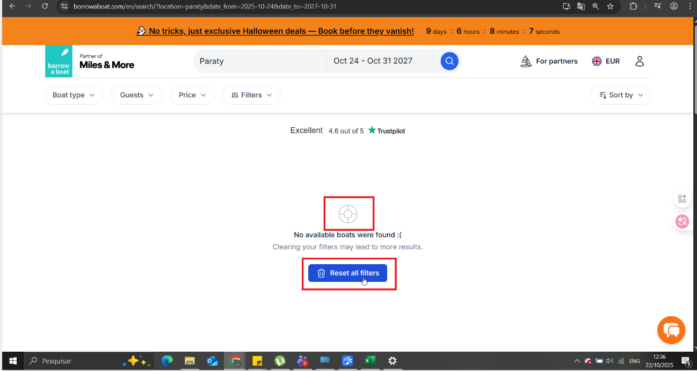

=======================================================

**DEFECT 2:** CRITICAL E2E FAILURE: URL Length Contamination blocks Email Subscription/Community Access (HTTP 413 Side Effect).

=======================================================

**SEVERITY:** CRITICAL

**PRIORITY:** HIGH

**DESCRIPTION:** The excessively long URL error (HTTP 413) contaminates the session, preventing low-volume engagement requests (like form submissions) from being processed. This critically blocks lead acquisition.

**STEPS TO REPRODUCE:**

1. Generate the longest possible search URL (by selecting all filters) to trigger the 413 error.

2. On the resulting error page or broken page, locate and fill out the newsletter form in the footer.

3. Click Submit/Subscribe.

**ACTUAL RESULT:** The form submission request fails (returns HTTP 413, 414, or 400 error) because the contaminated URL is passed as a "Referrer" or parameter, exceeding the server limits. The lead is not captured.

**EXPECTED RESULT:** Engagement form requests must be isolated from the page state. The submission should be processed successfully (Status 200/201), regardless of the length of the source URL.

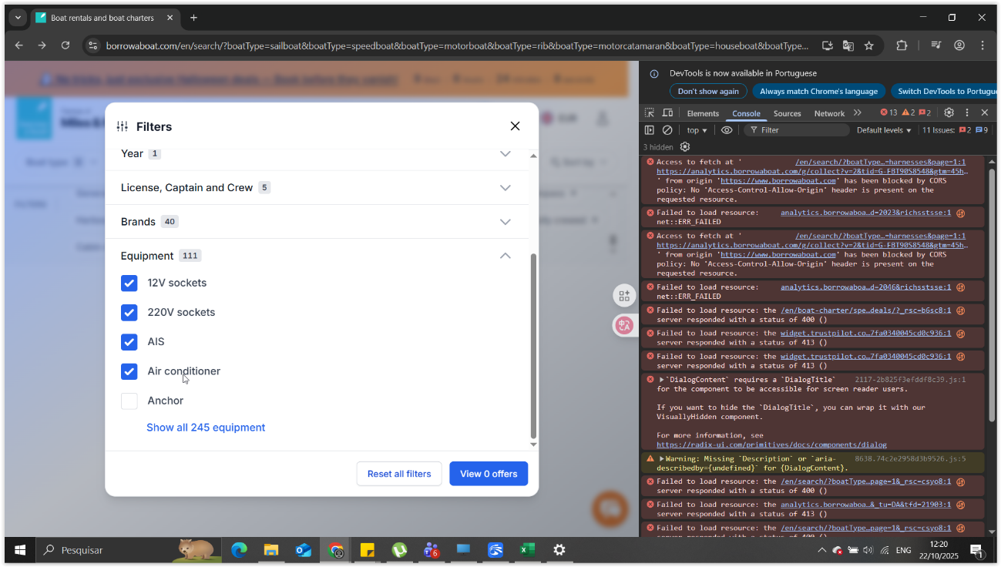

=======================================================

**DEFECT 3:** Search: HTTP 413 Error when applying excessive filters (URL too long).

=======================================================

**SEVERITY:** CRITICAL

**PRIORITY:** HIGH

**DESCRIPTION:** The application server cannot process search requests containing a large number of filters because the Query String exceeds the maximum character limit (typically 8KB). This makes complex, detailed searches unusable.

**STEPS TO REPRODUCE:**

1. Open the filter panel on the search page.

2. Select the maximum number of options available across all categories (Boat Types, Brands, Equipment, etc.).

3. Click to search.

**ACTUAL RESULT:** The search request fails, resulting in an HTTP 413 (Payload Too Large) or 414 (Request-URI Too Long) error. The user is unable to proceed with the search.

**EXPECTED RESULT:** The system should be robust enough to handle large requests. Alternatively, a warning must be displayed on the frontend (limiting selection) before the server limit is breached.



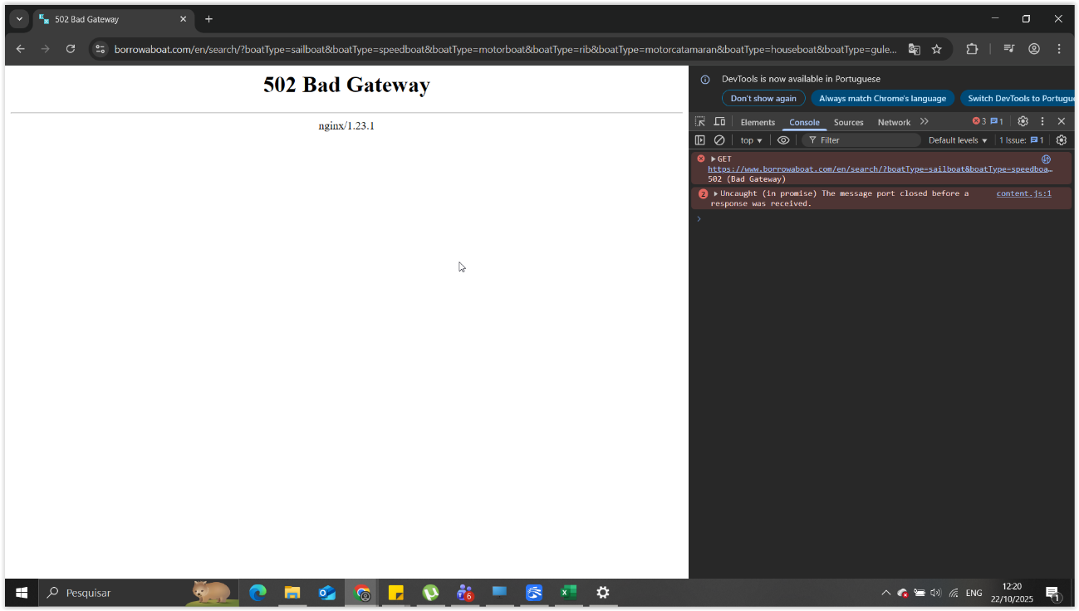

=======================================================

**DEFECT 4:** Functional/UX Barrier: Location Search Field cannot be manually cleared/reset after initial input.

=======================================================

**SEVERITY:** MAJOR

**PRIORITY:** HIGH

**DESCRIPTION:** The primary location search field does not allow the user to remove a previously selected destination to revert to a broader (global) search.

**STEPS TO REPRODUCE:**

1. In the 'Where are you going?' field, select a valid location (e.g., 'Croatia').

2. Click away, allowing the search to update.

3. Return to the field and delete the text using the keyboard (Backspace/Delete).

4. Attempt to submit the search or focus away from the field.

**ACTUAL RESULT:** The location field does not accept the empty state and refuses to clear the `location` parameter from the URL. The UI remains 'stuck' on the old value, forcing the user to reload the page for a wider search.

**EXPECTED RESULT:** The field must allow the user to empty it. Upon emptying and submitting the search, the `location` parameter must be removed from the URL, resulting in a broad (global) search.

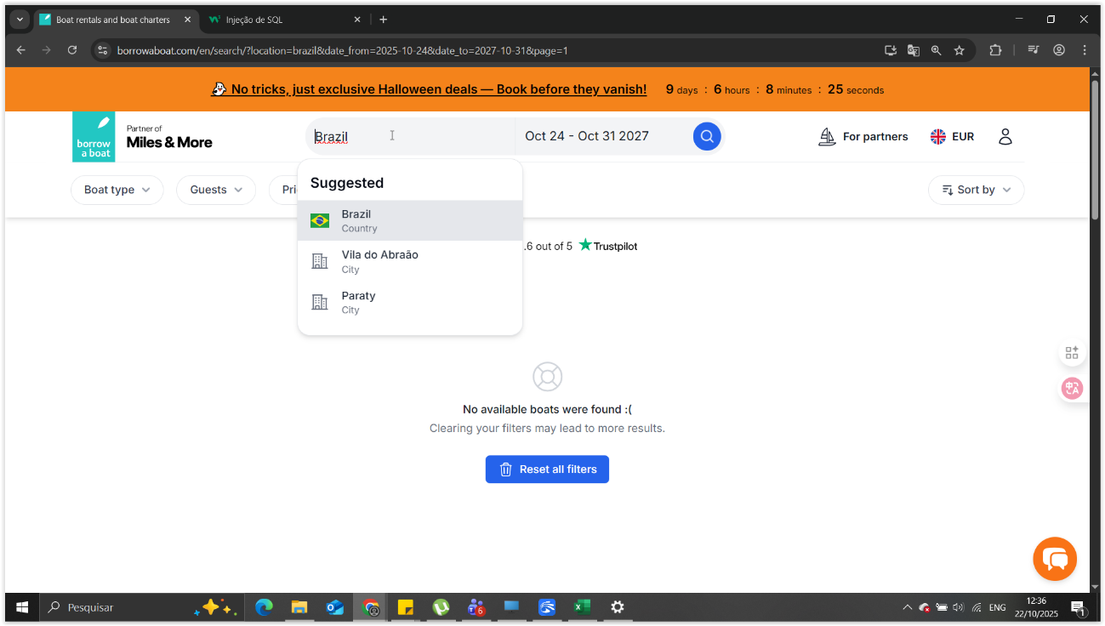

=======================================================

**DEFECT 5:** Localization/UX: Inconsistency in legal disclosure terminology ('Impressum' link leads to 'Imprint' page title).

=======================================================

**SEVERITY:** MINOR

**PRIORITY:** MEDIUM

**DESCRIPTION:** There is a mix of legal terminologies between the navigation link and the page title, which is a UX and localization standards error.

**STEPS TO REPRODUCE:**

1. Ensure the website language is set to English (/en/).

2. Locate the legal link in the footer labeled "Impressum".

3. Click the link and observe the destination page.

**ACTUAL RESULT:** The link is labeled "Impressum" (German/Latin), but the destination page title is "Imprint" (English).

**EXPECTED RESULT:** Terminology should be unified for the selected language. For the English language, the link and title should consistently be "Imprint."

**TECHNICAL SUGGESTION:** Ensure that localization assets or CMS strings are corrected so that the link string matches the page title string for every language, maintaining consistency across the user journey.

