**Arquitectura de Solución**

### **C4 software architecture model**

System Landscape Diagram

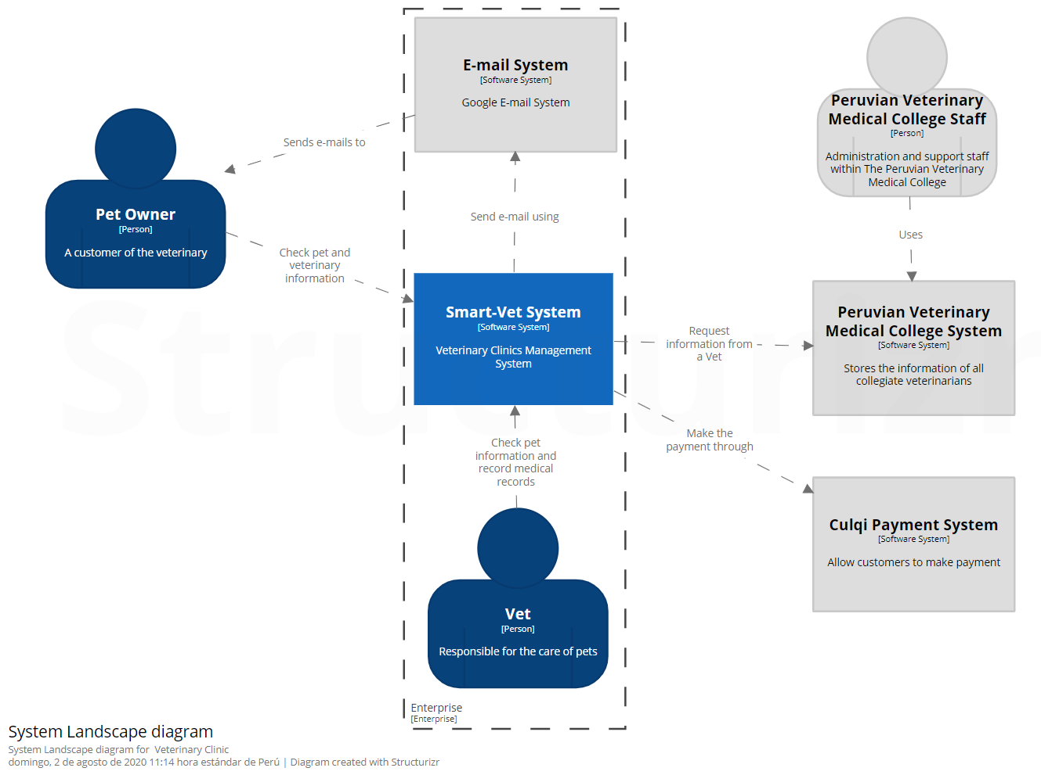

### **Context**

System Context Diagram for Smart-Vet System