**Arquitectura de Solución**

### **C4 software architecture model**

System Landscape Diagram

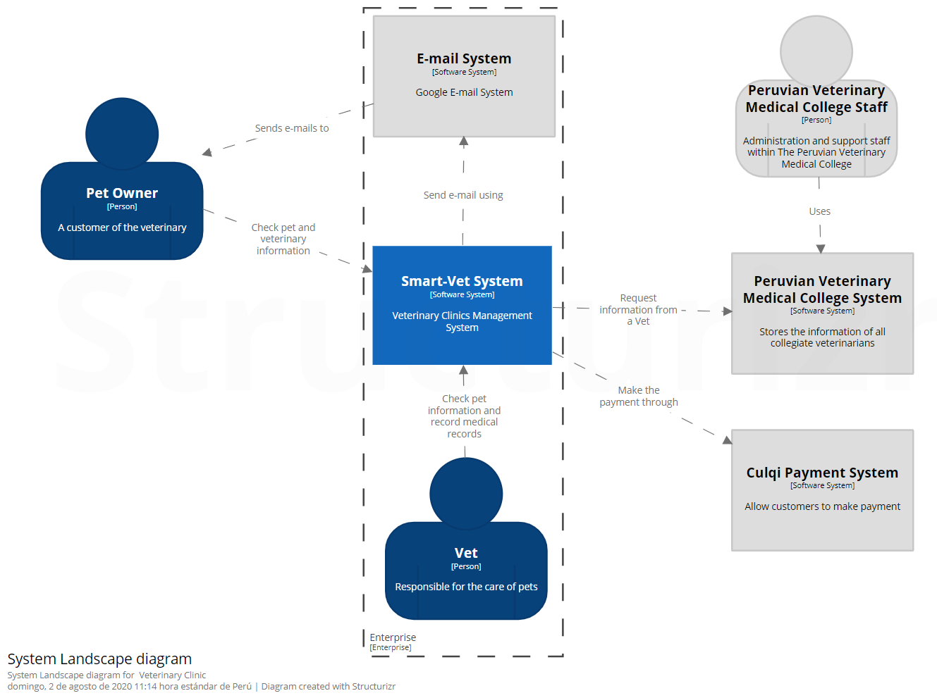

### **Context**

System Context Diagram for Smart-Vet System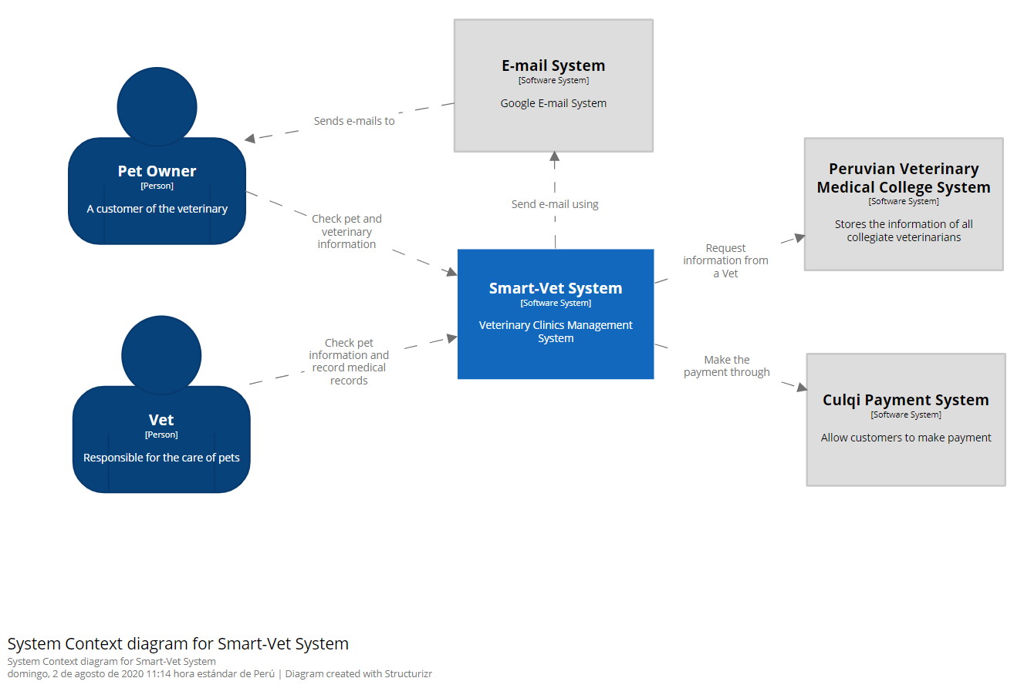

### **Containers**

Container Diagram for Smart-Vet System

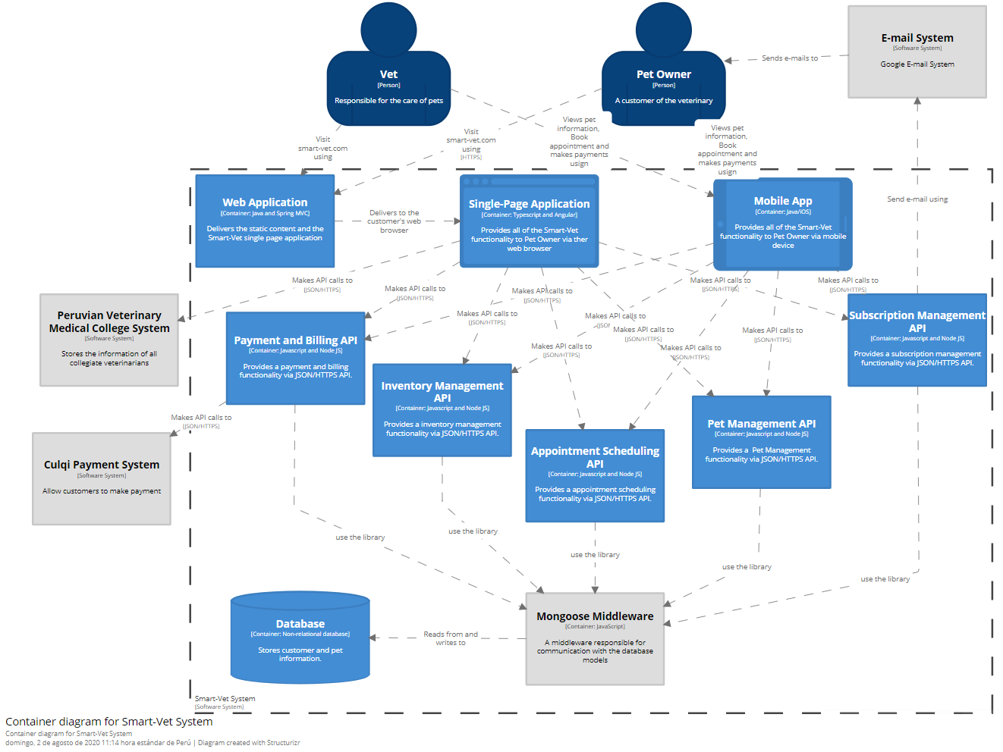

### **Components**

Componente Diagram for Smart-Vet – Appointment Scheduling API

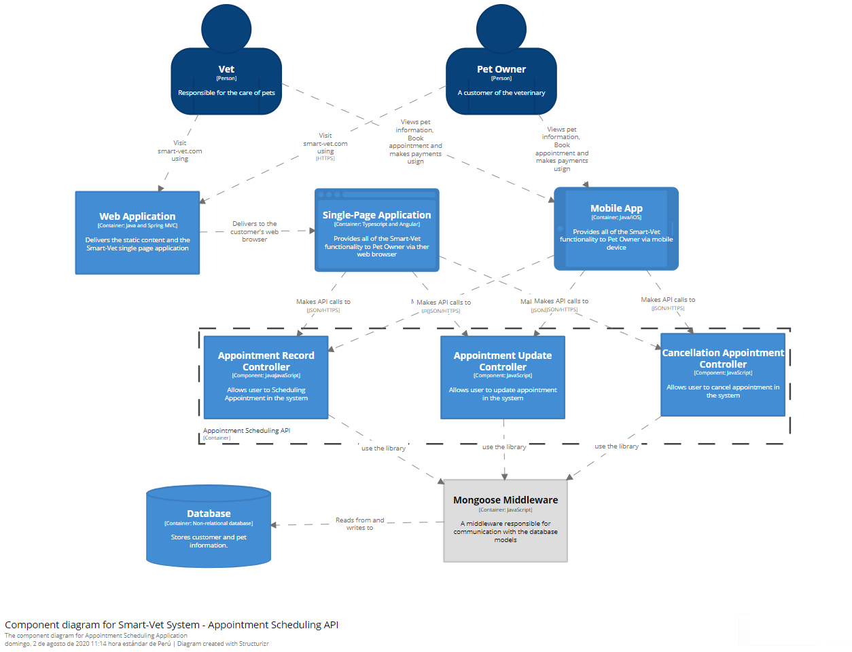

Componente Diagram for Smart-Vet – Inventory Management API

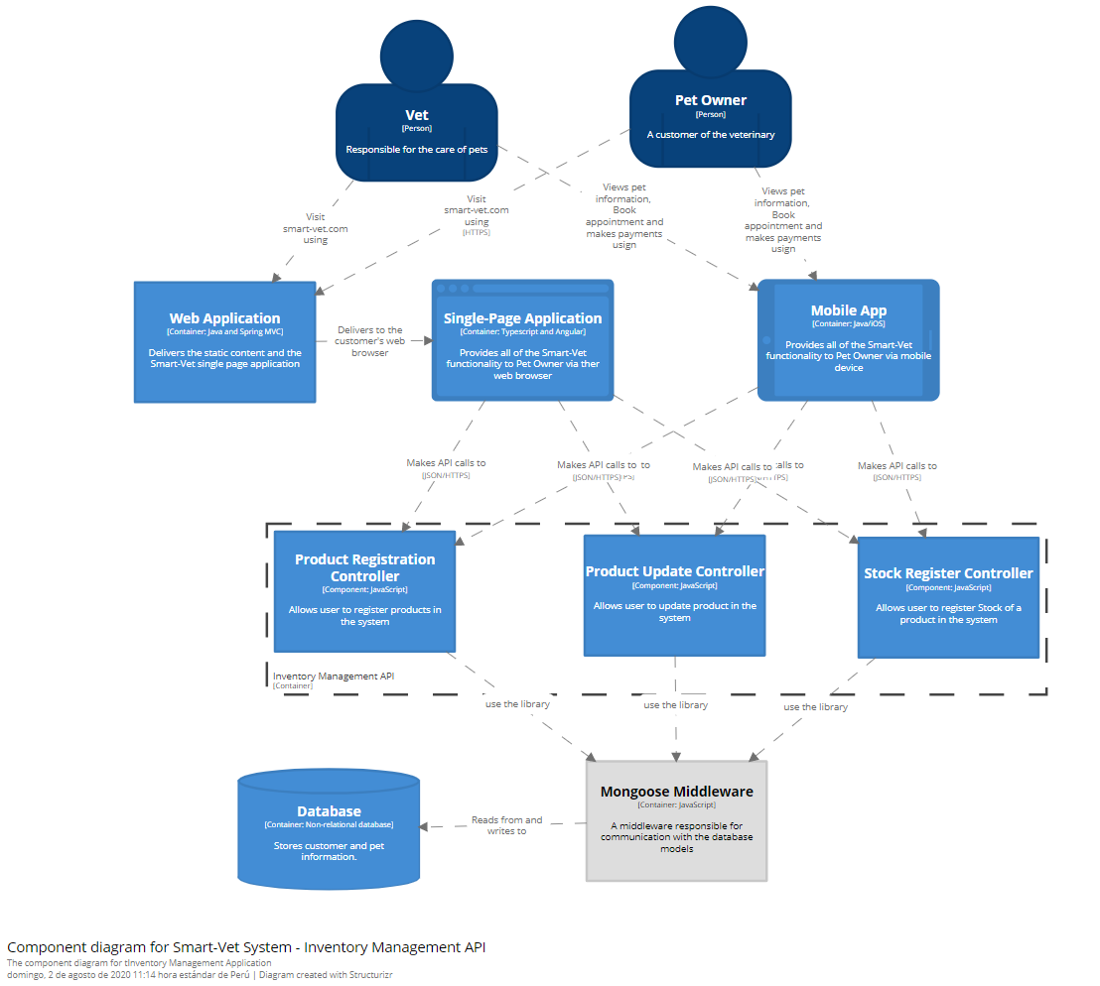

Componente Diagram for Smart-Vet – Payment and Billing API

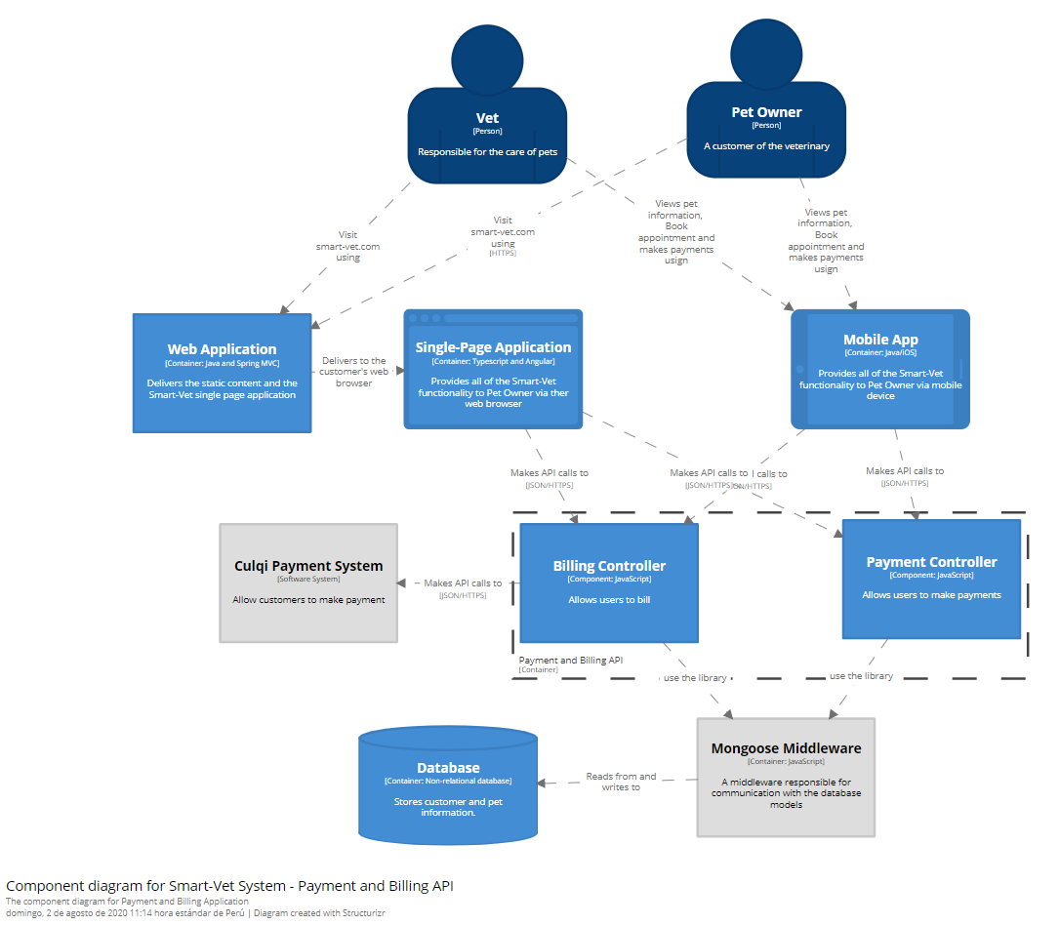

Componente Diagram for Smart-Vet – Pet Management API

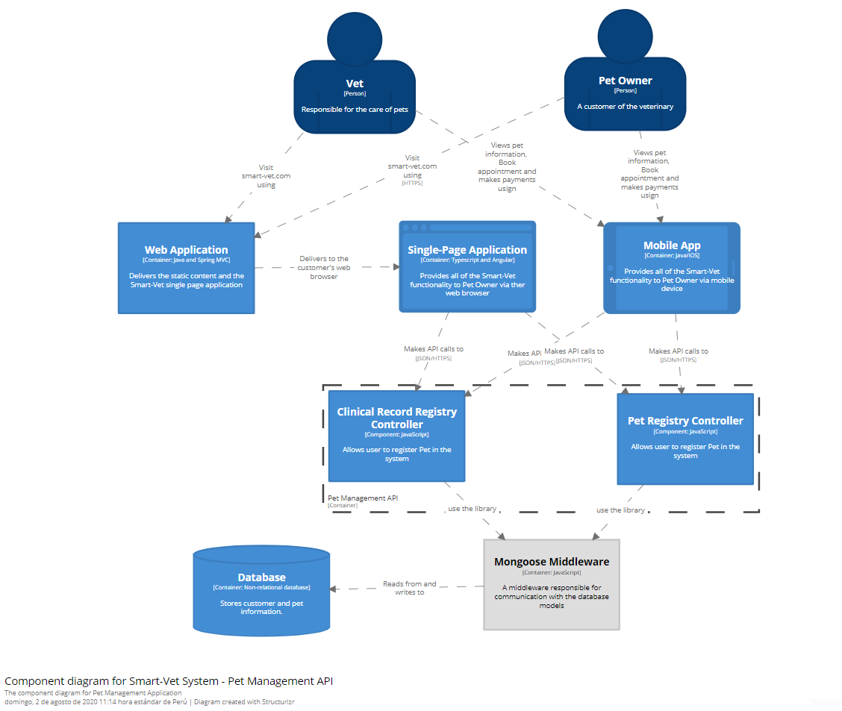

Componente Diagram for Smart-Vet – Subscription Management API

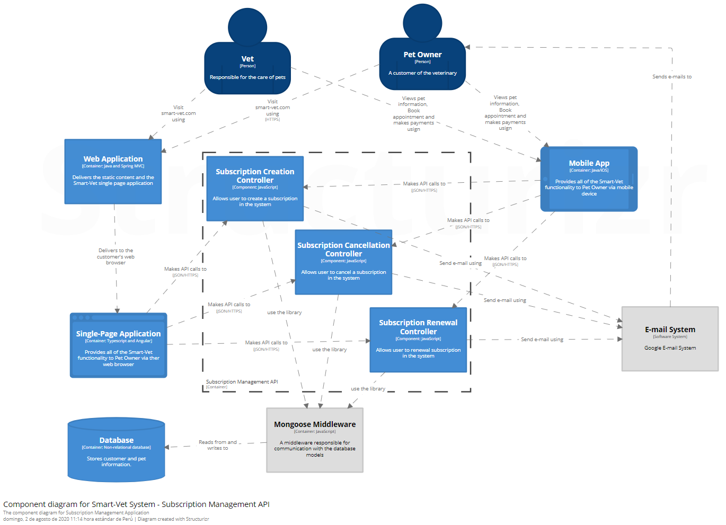

### **Classes**

