Quiz 1: Free Vibration Response of MDOF Systems
3-storey shear building, solved with the 5-step matrix method.

Given
- Masses: m₁ = m₂ = m₃ = 5,000 kg
- Storey heights: h₁ = h₂ = h₃ = 4 m
- Columns: 4 per floor, 350 × 350 × 12 mm square hollow tube, A36 steel
- E = 200,000 MPa = 200 × 10⁹ N/m²
- Mode shape factor of the topmost floor: φ₃ = 1.0
Find: (1) stiffness of one column and of one floor, (2) natural frequencies and periods, (3) mode shape factors per floor, (4) sketch of the mode shapes.

Question 1 Stiffness per column and per floor
Section: outside B = 350 mm, wall t = 12 mm, so the inside is B − 2t = 350 − 24 = 326 mm.
I = [B⁴ − (B − 2t)⁴] / 12 = [(0.350)⁴ − (0.326)⁴] / 12 = 3.0931 × 10⁻⁴ m⁴
EI = (200 × 10⁹)(3.0931 × 10⁻⁴) = 61,861,030.4000 N·m²
k_{c} = 12EI / h³ = 12(61,861,030.4000) / (4)³ = 11,598,943.2000 N/m (one column)
k₁ = k₂ = k₃ = 4k_{c} = 46,395,772.8000 N/m (4 columns per floor)
Answer 1 k_{c} = 11,598,943.2000 N/m, k = 46,395,772.8000 N/m per floor

Step 1 [K] and [M]
Stiffness matrix of a 3-storey shear building, with k₁ = k₂ = k₃ = k:
k₁ + k₂ | −k₂ | 0
−k₂ | k₂ + k₃ | −k₃
0 | −k₃ | k₃

k₁ + k₂ = k₂ + k₃ = 2k = 92,791,545.6000 N/m
92,791,545.6000 | −46,395,772.8000 | 0
−46,395,772.8000 | 92,791,545.6000 | −46,395,772.8000
0 | −46,395,772.8000 | 46,395,772.8000

Mass matrix, 5,000 kg on every floor:
5,000 | 0 | 0
0 | 5,000 | 0
0 | 0 | 5,000

Step 2 [K − ω²M] = 0
Divide everything by 5,000 and let B = ω². The mass matrix becomes the identity matrix.
18,558.3091 | −9,279.1546 | 0
−9,279.1546 | 18,558.3091 | −9,279.1546
0 | −9,279.1546 | 9,279.1546
minus B times [ 1 0 0 ; 0 1 0 ; 0 0 1 ] = 0
Combine the two matrices and name the cells a to i:
18,558.3091 − B | −9,279.1546 | 0
−9,279.1546 | 18,558.3091 − B | −9,279.1546
0 | −9,279.1546 | 9,279.1546 − B

a = e = 18,558.3091 − B, i = 9,279.1546 − B, b = d = f = h = −9,279.1546, c = g = 0

Step 3 Det [K − ω²M] = 0
Cofactor expansion along the first row:
a(ei − fh) − b(di − fg) + c(dh − eg) = 0
(18,558.3091 − B)[(18,558.3091 − B)(9,279.1546 − B) − (−9,279.1546)(−9,279.1546)]
− (−9,279.1546)[(−9,279.1546)(9,279.1546 − B) − 0] + 0 = 0
First bracket, simplified:
(ei − fh) = B² − 27,837.4637B + 86,102,709.3484
Expand, collect terms and multiply by −1:
B³ − 46,395.7728B² + 516,616,256.0902B − 798,960,348,078.2729 = 0
Solve the cubic (SHIFT + SOLVE, or polynomial mode on the calculator):
B₁ = 1,837.8504 B₂ = 14,428.6968 B₃ = 30,129.2256

Question 2 Natural frequencies and periods
B = ω², so ω = √B, f = ω / 2π and T = 2π / ω.
Mode | B = ω² (rad²/s²) | ω (rad/s) | f (Hz) | T (s)
1 | 1,837.8504 | 42.8702 | 6.8230 | 0.1466
2 | 14,428.6968 | 120.1195 | 19.1176 | 0.0523
3 | 30,129.2256 | 173.5777 | 27.6258 | 0.0362
Answer 2 ω = 42.8702, 120.1195, 173.5777 rad/s; T = 0.1466, 0.0523, 0.0362 s

Step 4 [K − ω²M]{φ} = {0}, with φ₃ = 1.0
Put each B back into the matrix and read the rows from the top floor down. Row 3 has only φ₂ unknown, row 2 then gives φ₁, and row 1 is the check (it must come out close to 0).
Mode 1 (B₁ = 1,837.8504)
16,720.4588 | −9,279.1546 | 0
−9,279.1546 | 16,720.4588 | −9,279.1546
0 | −9,279.1546 | 7,441.3042

Row 3: (−9,279.1546)(φ₂) + (7,441.3042)(1.0) = 0 ⇒ φ₂ = 0.8019
Row 2: (−9,279.1546)(φ₁) + (16,720.4588)(0.8019) + (−9,279.1546)(1.0) = 0 ⇒ φ₁ = 0.4450
Row 1 check: (16,720.4588)(0.4450) + (−9,279.1546)(0.8019) ≈ 0
Mode 2 (B₂ = 14,428.6968)
4,129.6123 | −9,279.1546 | 0
−9,279.1546 | 4,129.6123 | −9,279.1546
0 | −9,279.1546 | −5,149.5423

Row 3: (−9,279.1546)(φ₂) + (−5,149.5423)(1.0) = 0 ⇒ φ₂ = −0.5550
Row 2: (−9,279.1546)(φ₁) + (4,129.6123)(−0.5550) + (−9,279.1546)(1.0) = 0 ⇒ φ₁ = −1.2470
Row 1 check: (4,129.6123)(−1.2470) + (−9,279.1546)(−0.5550) ≈ 0
Mode 3 (B₃ = 30,129.2256)
−11,570.9165 | −9,279.1546 | 0
−9,279.1546 | −11,570.9165 | −9,279.1546
0 | −9,279.1546 | −20,850.0710

Row 3: (−9,279.1546)(φ₂) + (−20,850.0710)(1.0) = 0 ⇒ φ₂ = −2.2470
Row 2: (−9,279.1546)(φ₁) + (−11,570.9165)(−2.2470) + (−9,279.1546)(1.0) = 0 ⇒ φ₁ = 1.8019
Row 1 check: (−11,570.9165)(1.8019) + (−9,279.1546)(−2.2470) ≈ 0

Question 3 Mode shape factors per floor
Floor | Mode 1 | Mode 2 | Mode 3
3 (top) | 1.0000 | 1.0000 | 1.0000
2 | 0.8019 | −0.5550 | −2.2470
1 | 0.4450 | −1.2470 | 1.8019
Base | 0 | 0 | 0
Answer 3 φ₁ = {0.4450, 0.8019, 1.0}, φ₂ = {−1.2470, −0.5550, 1.0}, φ₃ = {1.8019, −2.2470, 1.0}

Step 5 Sketch the mode shapes — Question 4
Plot each floor at its factor φ against its height (4 m, 8 m, 12 m), with the base fixed at zero, and join the points.
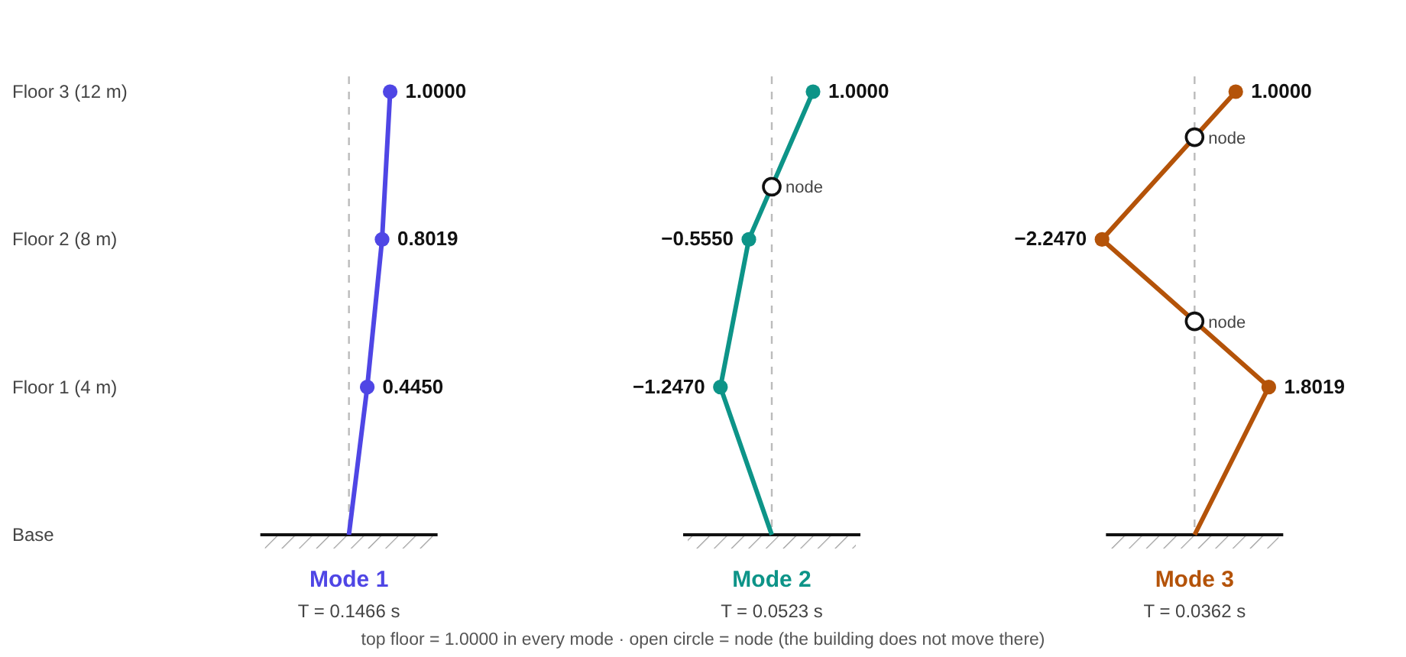
- Mode 1: all floors move the same way: no sign change, no node.
- Mode 2: one sign change, between floors 2 and 3.
- Mode 3: two sign changes, one between floors 1 and 2 and one between floors 2 and 3.
Answer 4 see the sketch above (mode r has r − 1 nodes)

