TUGAS I

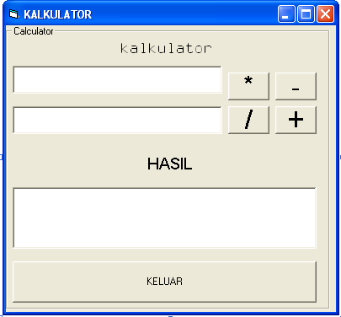

KODE

Private Sub cmdbagi_Click()
txthasil.Text = txtawal.Text / txtkedua.Text
End Sub

Private Sub cmdkali_Click()
txthasil.Text = txtawal.Text * txtkedua.Text
End Sub

Private Sub cmdmin_Click()
txthasil.Text = txtawal.Text - txtkedua.Text

Private Sub cmdplus_Click()
txthasil.Text = txtawal.Text + txtkedua.Text

Private Sub cmdkeluar_Click()
Unload Me

End Sub

