

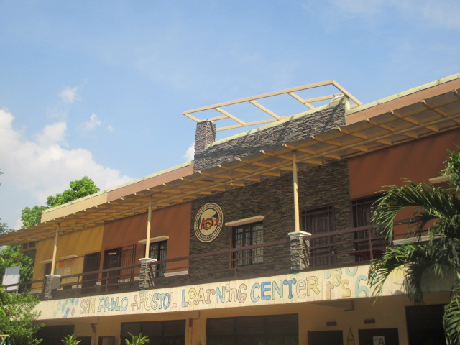

**CANOSSA-TONDO CHILDREN’S FOUNDATION, INC.**

**2279 VELASQUEZ STREET, TONDO, MANILA**

**Name**: Cubacub Micaella

**Course & Year:** DCVET 3-1

**Student Number:** 2022-11944-MN-0

**School:** Polytechnic University of Philippines

**Expected date of Graduation:** SY 2027-2028

**Academic Standing:** Good

**Birthday:** December 12, 2003

**Address:** 2483 Bonifacio St. Vitas Tondo Manila

**Barangay:** 101

**Contact No/s:** 09911545797

**Sponsors’ Name:** Zio Pretto Alberto & Zio Vincenzo e Zia Filomena

**LIST OF SUBJECT ENROLLED**

**1st** Semester – School Year **2024-2025**

Total number of units: **19**

Total no. of units allowed:**23**

|  |  |  |  |
| --- | --- | --- | --- |
| **Subject Code** | **Description** | **Units** | **Final Grade** |
| CIEN 202 | Fundamentals of Surveying 2 | 2.0 |  |
| ENSC 016 | Statics of Rigid Bodies | 3.0 |  |
| CETE 301 | Civil Engineering Technology | 3.0 |  |
| CETE 302 | Structural Detailing | 2.0 |  |
| CETE 303 | Building Info. Modeling | 2.0 |  |
| CETE 306 | Civil Eng. Tech. Project Dev. 1 | 2.0 |  |
| CIEN 404 | CE Law, Ethics and Contracts | 2.0 |  |
| ENSC 029 | Technopreneurship 101 | 3.0 |  |
|  |  |  |  |
|  |  |  |  |
|  |  |  |  |
|  |  |  |  |
|  |  |  |  |

**General Weighted Average: _________**

**CLASS SCHEDULE**

|  |  |  |  |  |  |  |  |
| --- | --- | --- | --- | --- | --- | --- | --- |
| **DAY** | **MON** | **TUE** | **WED** | **THU** | **FRI** | **SAT** | **SUN** |
| **START** |  | **7:30 AM** | **12:00 PM** | **7:30 AM** |  | **10:30 PM** |  |
| **END** |  | **9:00 PM** | **7:00 PM** | **9:00 PM** |  | **3:30 PM** |  |

**For verification, please subject your Registration Certificate to Kuya Benj. Thank you.**

**Noted by: Kuya Benj Rementilla – High School & College Coordinator**