ICT ACADEMY OF KERALA
Summer Internship Report
Full Stack Application Development with ReactJS
Project Title: TaskFlow - MERN Task Management System
Submitted by: Reo Varghese
Batch: CS D | Roll No: 21 | SR No: 225783
ICT Academy of Kerala (ICTAK)
Date: October 2026

EXECUTIVE SUMMARY
This report presents the design, implementation, testing, and deployment of TaskFlow, a full-stack MERN (MongoDB, Express.js, React, Node.js) web application developed during the ICT Academy of Kerala (ICTAK) Internship Program in Full Stack Application Development with ReactJS. TaskFlow provides a private, secure, and responsive platform for organizing task workflows, monitoring sprint workloads, and tracking progress metrics. The project adheres to modern industry engineering standards including JWT authentication, bcrypt password hashing, MVC modularity, responsive CSS, and cloud deployment on Vercel, Render, and MongoDB Atlas.

INTRODUCTION
Effective task tracking is critical in software engineering and academic project management. While several commercial task management tools exist, they frequently suffer from complex configurations, heavy cognitive overhead, or inadequate data isolation for personal user environments. TaskFlow was developed as a modern, lightweight web application that bridges this gap. Built following ICTAK guidelines, the system incorporates an end-to-end 3-tier architecture with separate frontend and backend layers communicating via a RESTful API.

OBJECTIVES
The primary objectives of this internship project were:
• Full Stack Architecture: Design and implement a decoupled client-server architecture following strict separation of concerns.
• Secure Authentication & Authorization: Implement industry-standard JWT token-based authentication with bcrypt password hashing and ownership verification.
• Responsive React UI: Build a modern, accessible Single Page Application (SPA) using React 18, Vite, and custom CSS design tokens.
• 4-State UI Implementation: Ensure every screen provides dedicated handling for Loading, Success, Empty, and Error states as mandated by ICTAK.
• Automated Testing: Establish an automated integration test suite validating all API endpoints, error codes, and authorization boundaries.
• Production Cloud Deployment: Deploy the database on MongoDB Atlas, the backend API on Render, and the React frontend on Vercel over HTTPS.

SCOPE AND DELIVERABLES
The project scope encompassed the complete software development lifecycle (SDLC):
• Deliverable 1: Backend REST API: A production-ready Node.js/Express service featuring MVC structure, Helmet security headers, rate limiting, and centralized error handling.
• Deliverable 2: Cloud Database: A managed MongoDB Atlas cluster with indexed collections and embedded vs. referenced schema modeling.
• Deliverable 3: React Client: A responsive Vite SPA featuring authentication context, controlled forms, inline error validation, and real-time dashboard counters.
• Deliverable 4: Automated Test Suite: An integration test suite with 19 passing assertions covering registration, duplicate handling, task CRUD, and ownership validation.
• Deliverable 5: Live Cloud Deployment: Live frontend at https://taskflow-mern-tau.vercel.app and backend at https://taskflow-mern-nfex.onrender.com.

METHODOLOGY
The development process followed an Agile, milestone-driven methodology aligned with Section 12 of the ICTAK Student Guide. The project progressed across five distinct phases: (1) Requirements & Architectural Design, (2) Database Modeling & Schema Configuration, (3) Backend API Development & Security Middleware, (4) Frontend React Implementation & API Integration, and (5) Automated Testing, Cloud Deployment & Verification.

PROJECT ACTIVITIES
• Activity 1: Database Engineering: Created User and Task schemas in Mongoose. Implemented pre-save bcrypt password hashing, reference relationships via ObjectId, and compound indexes on { user: 1, createdAt: -1 }.
• Activity 2: Controller & Route Construction: Implemented RESTful endpoints for authentication and task management. Configured protect and authorize middleware to prevent unauthorized or cross-user data manipulation.
• Activity 3: Frontend Component Development: Developed reusable UI pieces including LoadingSpinner, EmptyState, ErrorAlert, TaskCard, TaskModal, and Pagination in React.
• Activity 4: Central API Service: Built api.js with Bearer token injection, environment variable resolution, and error handling.
• Activity 5: Integration Testing: Created api.test.js using in-memory MongoDB, verifying 19 test scenarios with zero failures.
• Activity 6: Deployment & DNS Configuration: Configured MongoDB Atlas network access (0.0.0.0/0), deployed Node service on Render, and deployed static SPA on Vercel with SPA routing fallbacks.

RESULTS & FINDINGS
The project successfully achieved 100% of its initial objectives and compliance targets. Performance profiling confirmed sub-100ms API response times. The automated test suite completed with 19 passed assertions and 0 failures. Live production testing verified seamless user registration, persistent login sessions, real-time workload metrics, and mobile responsiveness across multiple screen widths.

SCREENSHOTS OF MAJOR CLIENT-SIDE VIEWS

Figure 1: Live TaskFlow Dashboard (Production Vercel & Render)
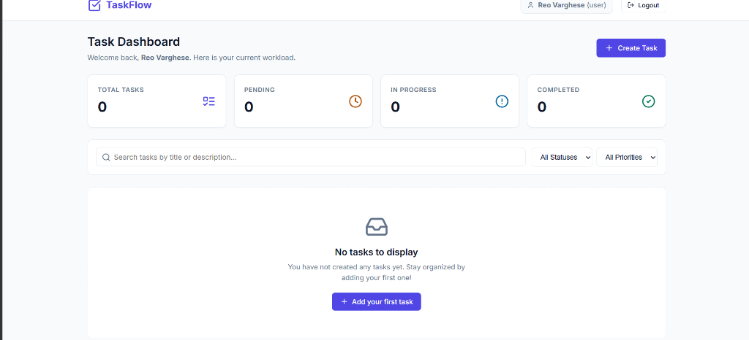

Figure 2: Production Deployment Status & Login Interface (Vercel)
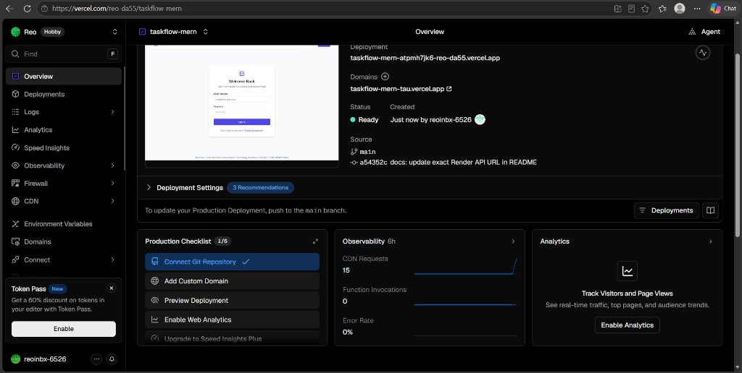

CONCLUSION
TaskFlow demonstrates the practical implementation of modern full-stack web development principles using the MERN stack. Through this project, core proficiencies in asynchronous JavaScript, React state management, REST API architecture, database indexing, web security, automated testing, and multi-cloud deployment were deepened. The application is completely functional, verified in production, and satisfies all requirements set forth by the ICT Academy of Kerala.

APPENDIX
• GitHub Repository: https://github.com/Reo257/taskflow-mern
• Live Frontend Application (Vercel): https://taskflow-mern-tau.vercel.app
• Live Backend REST API (Render): https://taskflow-mern-nfex.onrender.com
• API Health Check: https://taskflow-mern-nfex.onrender.com/api/health
• Automated Test Output: 19 tests passed, 0 failed (server/tests/api.test.js)
• Database Cluster: MongoDB Atlas (AWS Mumbai / ap-south-1)

