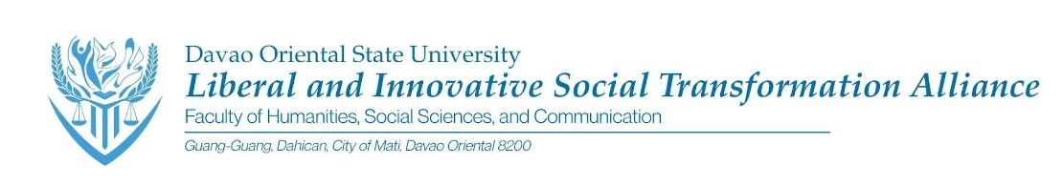
LIBERAL AND INNOVATIVE SOCIAL TRANSFORMATION ALLIANCE
NOTICE OF MEETING
TO: LIBERALISTA Officers & Senators
DATE: 21 August 2026Madayaw na adlaw!
Please be informed that we will be having an emergency meeting later to discuss the following agenda:
DATE: Friday, August 21, 2026
TIME: 3:00- 4:00 PM
VENUE: GMeet
AGENDA ITEMS:
- Updates for Buwan ng Wika Preparation
- Updates for Panaghigalaay 2026
- Siglakas 2026
- Launching of LIBERALISTA- TRACKER
- General Assembly

Your attendance and participation are highly encouraged as important organizational matters will be discussed. Thank you, and we look forward to your presence.
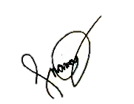
Sincerely,
MAEBEL BEATRIZ S. NAMOC
LIBERALISTA Governor
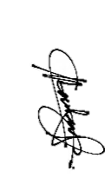
Prepared by:
CLAIRE L. MACUNLAY
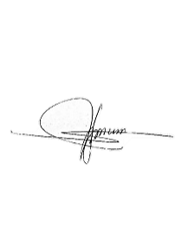
LIBERALISTA Asst. Secretary

Approved by:

JERICO E. FUNCION
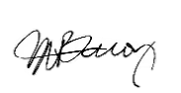
LIBERALISTA Advicer

MILLENNI A. BACOY
LIBERALISTA Co- Advicer

