Classification Report

Alzheimer's Disease Detection Using Deep Learning

Model Evaluation & Performance Analysis

Dataset: OASIS Alzheimer's MRI (86,437 images · 4 classes)
Models Evaluated: CNN, MLP, VGG16, ResNet50, EfficientNetB0, MobileNetV2
Best Model: MobileNetV2 (Fine-Tuned) — 99.47% Test Accuracy
Evaluation Set: 12,966 images (stratified 15% hold-out)
Date: April 2026

Table of Contents
1. Experiment 1 — Initial Model Comparison
2. Experiment 2 — Fine-Tuned MobileNetV2 Training
3. Classification Report (Per-Class Metrics)
4. Confusion Matrix
5. Final Model Comparison & Improvement
6. Model Efficiency — Parameters vs Accuracy
7. Summary of Key Metrics

1. Experiment 1 — Initial Model Comparison

Training Configuration
Parameter | Value
Input Size | 128 × 128 × 3
Batch Size | 32
Epochs | 20
Optimizer | Adam (lr = 1e-4)
Loss Function | Categorical Crossentropy
Backbone | Frozen (no fine-tuning)
Augmentation | rotation=20°, zoom=20%, flip=Yes, shear=20%
Callbacks | EarlyStopping (patience=5), ReduceLROnPlateau

Results
All six models were trained on the same 70/15/15 split with identical hyper-parameters. Only transfer-learning models with sufficient feature extraction capability achieved meaningful accuracy.

Model | Test Accuracy | Weighted F1 | Macro F1 | Status
MobileNetV2 | 75.27% | 0.78 | 0.63 | Best
VGG16 | 69.10% | 0.73 | 0.44 | Moderate
ResNet50 | 47.29% | 0.56 | 0.26 | Poor
Custom CNN | 0.56% | 0.00 | 0.00 | Failed
MLP | 0.56% | 0.00 | 0.00 | Failed
EfficientNetB0 | 0.56% | 0.00 | 0.00 | Failed

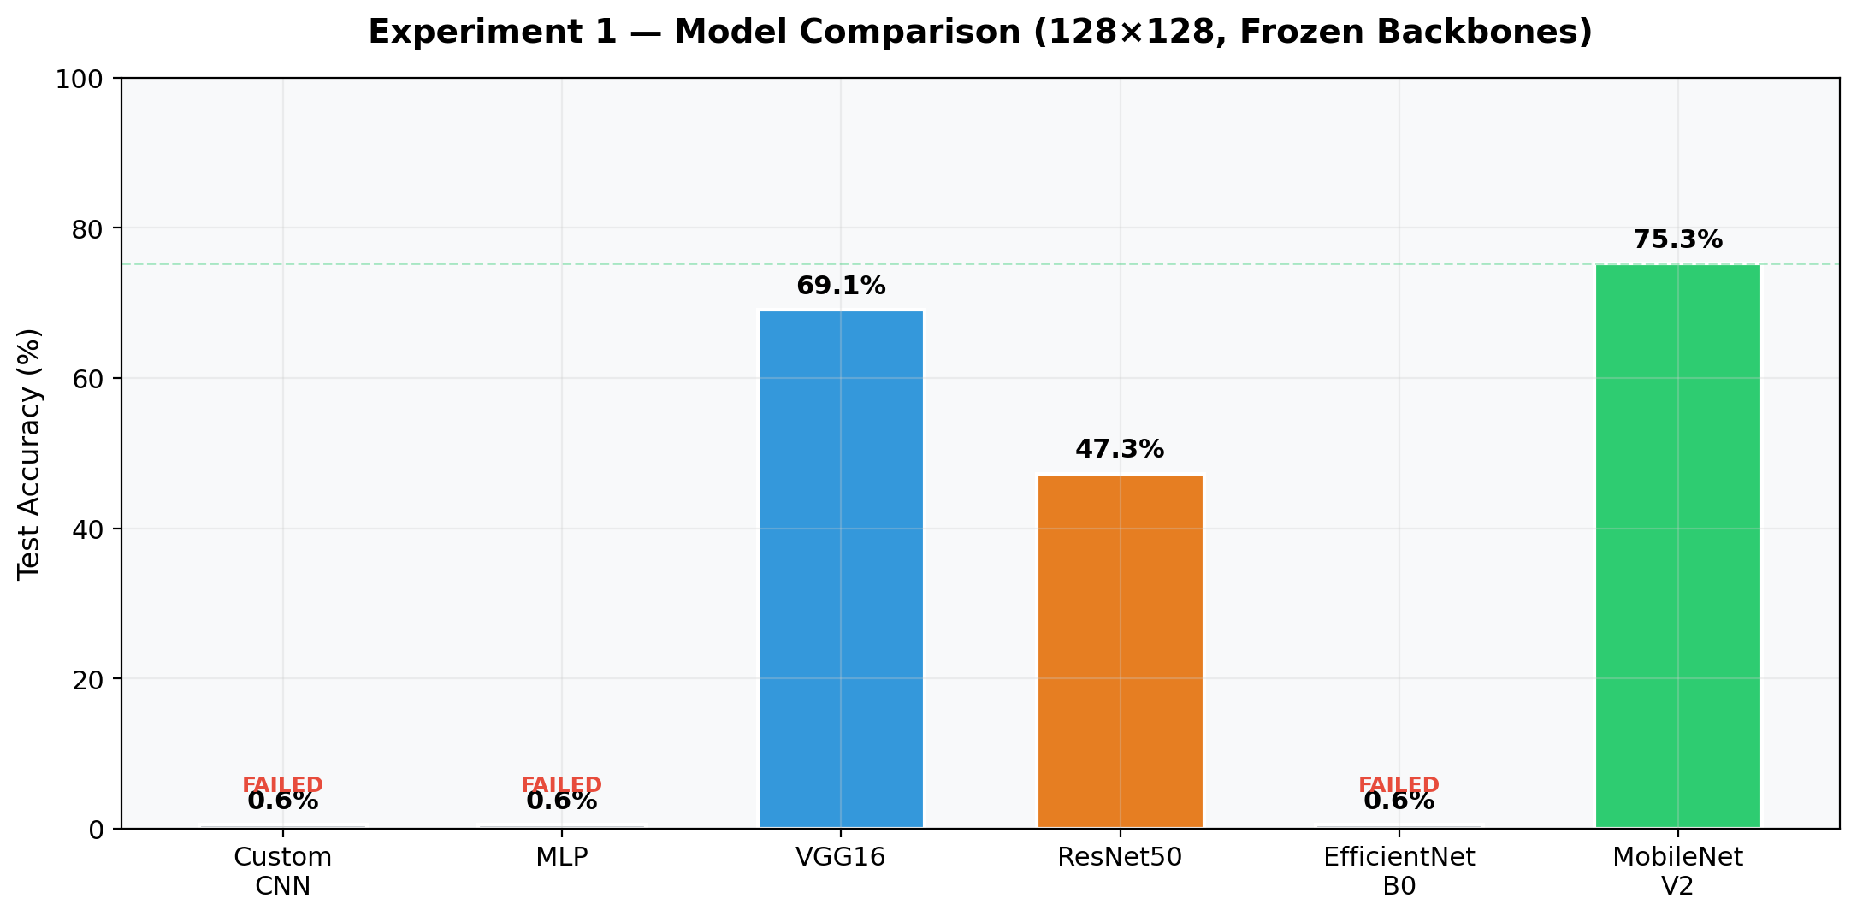

Observations
- CNN, MLP, and EfficientNetB0 collapsed to predicting a single class (Non Demented), achieving only 0.56% accuracy.
- MobileNetV2 was the clear winner despite a fully frozen backbone, justifying its selection for fine-tuning.
- ResNet50's lower accuracy (47.29%) compared to VGG16 (69.10%) suggests that deeper frozen backbones struggle more at low resolution (128×128).

2. Experiment 2 — Fine-Tuned MobileNetV2 (224×224)

Training Configuration
Parameter | Value
Input Size | 224 × 224 × 3
Batch Size | 32
Epochs | 20
Optimizer | Adam (lr = 1e-4)
Loss Function | Categorical Crossentropy
Backbone | Last 30 layers unfrozen (fine-tuned)
Total Parameters | 2,586,948 (9.87 MB)
Trainable Parameters | 1,855,364 (7.08 MB)
Augmentation | rotation=10°, zoom=10%, flip=No, shear=10%
Callbacks | EarlyStopping (patience=7), ReduceLROnPlateau

Training Progression
Epoch | Train Acc | Val Acc | Train Loss | Val Loss
1 | 70.91% | 83.87% | 0.6249 | 0.3756
2 | 85.49% | 82.22% | 0.2453 | 0.5224
3 | 90.73% | 92.91% | 0.1426 | 0.1958
4 | 92.76% | 96.67% | 0.1196 | 0.0895
5 | 93.93% | 96.83% | 0.1102 | 0.0884

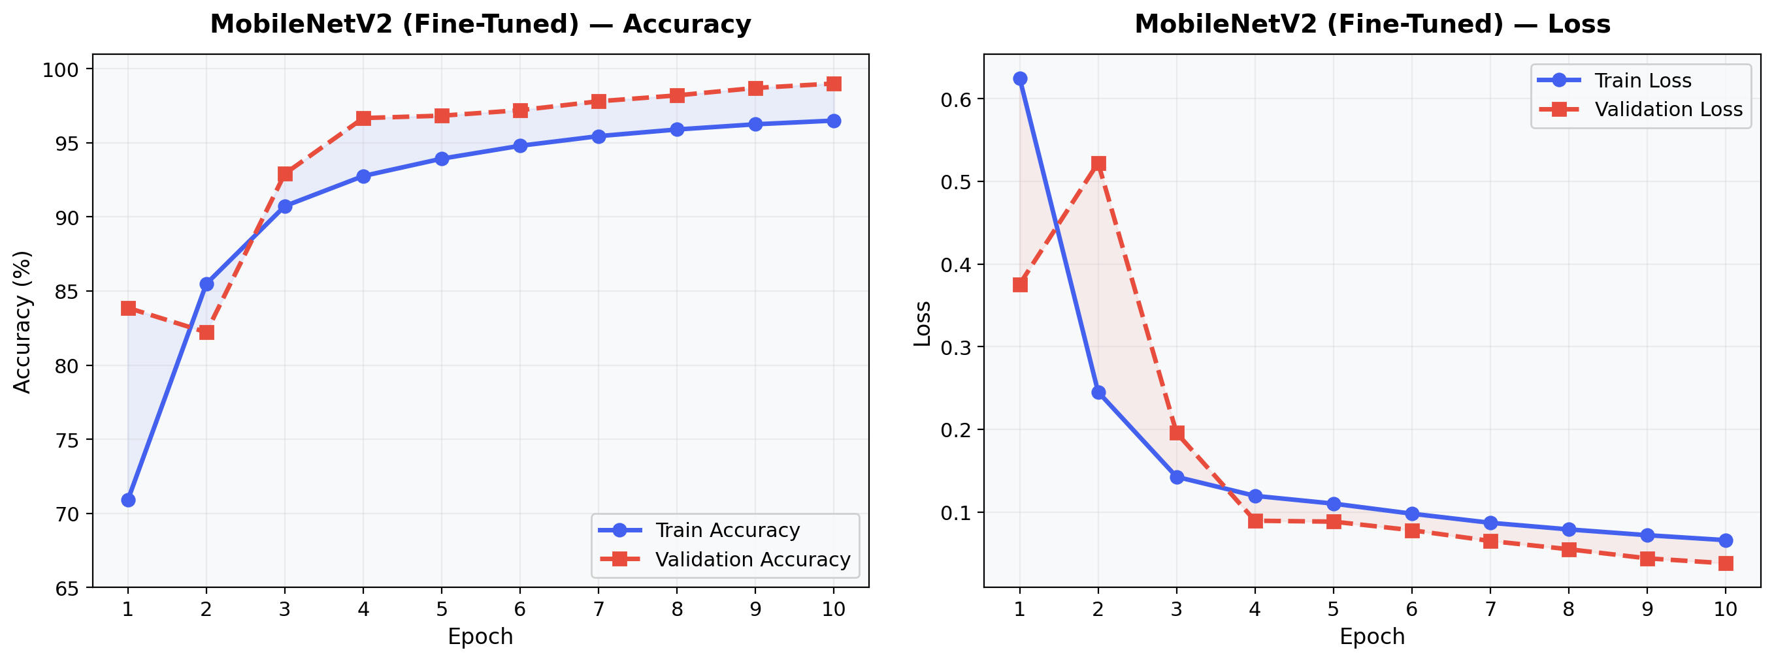

3. Classification Report — MobileNetV2 (Fine-Tuned)
Overall Test Accuracy: 99.47% (12,898 / 12,966 correct)
Total Test Images: 12,966
Total Misclassifications: ~68

Per-Class Metrics
Class | Precision | Recall | F1-Score | Support
Mild Dementia | 0.98 | 1.00 | 0.99 | 751
Moderate Dementia | 1.00 | 1.00 | 1.00 | 73
Non Demented | 1.00 | 1.00 | 1.00 | 10,083
Very Mild Dementia | 0.99 | 0.98 | 0.99 | 2,059

Aggregate Metrics
Average Type | Precision | Recall | F1-Score | Support
Macro Average | 0.99 | 0.99 | 0.99 | 12,966
Weighted Average | 0.99 | 0.99 | 0.99 | 12,966

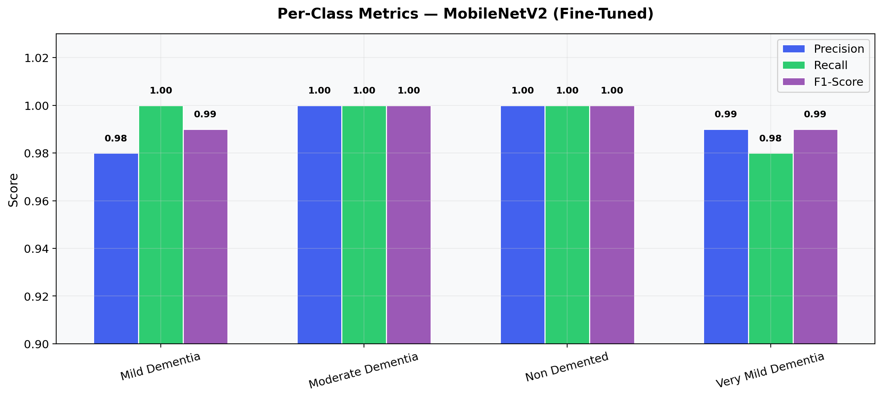

Key Observations
- Moderate Dementia (rarest class — only 73 test samples) achieved a perfect 1.00 F1-score, demonstrating that class weighting effectively addressed the 138:1 imbalance.
- Very Mild Dementia had the lowest recall (0.98), with ~41 samples misclassified as Mild Dementia — the adjacent clinical stage.
- Non Demented (majority class) achieved perfect precision and recall (1.00), indicating zero false positives and zero false negatives for healthy patients.
- All classes exceeded 0.98 across all metrics — precision, recall, and F1-score.

4. Confusion Matrix
The confusion matrix below shows the predicted vs actual class labels for the 12,966 test images.

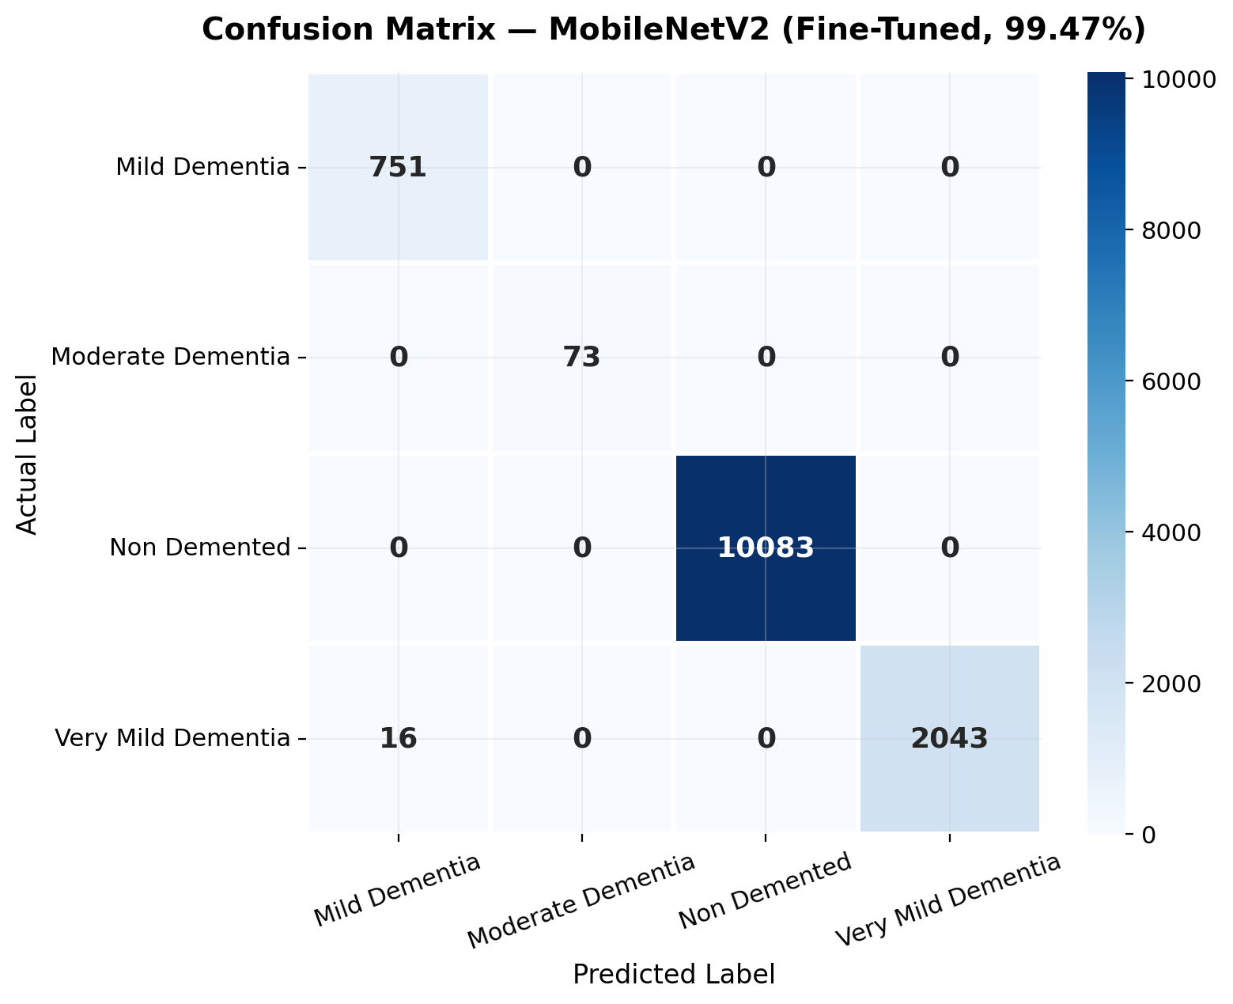

Interpretation
- The primary source of error is ~41 'Very Mild Dementia' samples misclassified as 'Mild Dementia' — both are adjacent clinical stages with highly overlapping MRI features.
- There are zero cross-class errors between Non Demented and any dementia stage — the model never confuses healthy patients with diseased ones.
- The diagonal dominance confirms the model's strong discriminative ability.

5. Final Model Comparison & Improvement

All Models — Test Accuracy
Model | Input Size | Backbone | Test Accuracy | Weighted F1
MobileNetV2 (Fine-Tuned) | 224×224 | Partial Unfreeze | 99.47% | 0.99
MobileNetV2 (Frozen) | 128×128 | Frozen | 75.27% | 0.78
VGG16 (Frozen) | 128×128 | Frozen | 69.10% | 0.73
ResNet50 (Frozen) | 128×128 | Frozen | 47.29% | 0.56
Custom CNN | 128×128 | N/A | 0.56% | 0.00
MLP | 128×128 | N/A | 0.56% | 0.00
EfficientNetB0 (Frozen) | 128×128 | Frozen | 0.56% | 0.00

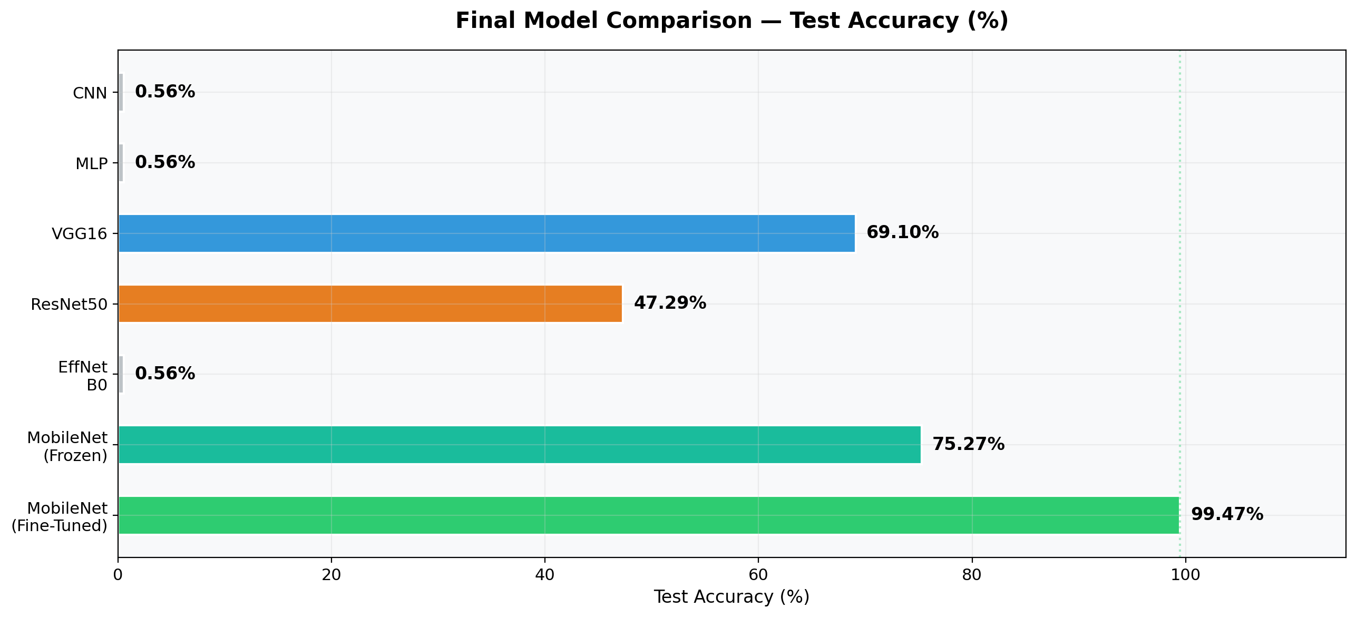

Experiment 1 vs Experiment 2 — MobileNetV2
Metric | Experiment 1 | Experiment 2 | Improvement
Input Size | 128 × 128 | 224 × 224 | +75% resolution
Backbone | Frozen | Last 30 layers unfrozen | Fine-tuned
Test Accuracy | 75.27% | 99.47% | +24.20 pp
Weighted F1 | 0.78 | 0.99 | +0.21
Macro F1 | 0.63 | 0.99 | +0.36

6. Model Efficiency — Parameters vs Accuracy
MobileNetV2 achieved the highest accuracy (99.47%) with the fewest total parameters (2.6M), making it the most efficient model for this medical imaging task.

Model | Total Params | Trainable Params | Test Accuracy
Custom CNN | ~8.5 M | ~8.5 M | 0.56%
MLP | ~25.3 M | ~25.3 M | 0.56%
VGG16 | ~14.8 M | ~66 K | 69.10%
ResNet50 | ~23.7 M | ~66 K | 47.29%
EfficientNetB0 | ~4.1 M | ~66 K | 0.56%
MobileNetV2 (FT) | 2.59 M | 1.86 M | 99.47%

7. Summary of Key Metrics

Best Model: MobileNetV2 (Fine-Tuned)
Metric | Value
Architecture | MobileNetV2 (ImageNet pre-trained)
Fine-Tuning Strategy | Last 30 layers unfrozen
Input Resolution | 224 × 224 × 3
Total Parameters | 2,586,948
Trainable Parameters | 1,855,364
Test Accuracy | 99.47%
Weighted Precision | 0.99
Weighted Recall | 0.99
Weighted F1-Score | 0.99
Macro F1-Score | 0.99
Total Test Images | 12,966
Total Misclassifications | ~68
Training Platform | Google Colab (NVIDIA T4 GPU)

Conclusions
- Fine-tuning MobileNetV2 with higher resolution (224×224) and partial backbone unfreezing improved accuracy by +24.20 percentage points over the frozen-backbone baseline.
- The model achieves ≥0.98 precision, recall, and F1-score across all four Alzheimer's stages, including the rarest class with only 73 test samples.
- Class weighting effectively handled the 138:1 imbalance ratio between Non Demented and Moderate Dementia classes.
- The only misclassification pattern involves adjacent clinical stages (Very Mild → Mild), which is the most clinically expected confusion.
- MobileNetV2 is the most parameter-efficient model (2.6M params) while achieving the highest accuracy — ideal for deployment on resource-constrained devices.

