Bioprinter Progress report – Month 2

Adrian Bowyer, Jean-Marc Giacalone and Sally Bowyer
RepRap Ltd and eMaker Ltd
6 July 2016

Summary
This report details work carried out by RepRap Ltd and eMaker Ltd on the Bioprinter design for Longer 3D for the month of June. Not all of that month was spent working on the design as one of us (AB) was on holiday and another (JMG) was in China.

Two different gel printing systems have been constructed and commissioned. Tests have started with them both. The first is a stepper/screw-drive syringe, and the second is a pneumatically driven syringe.

The pneumatic system seems to produce better results than the direct-drive system, but the direct drive system is simpler and lower-cost.

The design of the Cartesian robot is further considered and refined, with reasons for the decisions taken (such as the need for a tool changer) being given.

We have also nearly finished a digitally controlled pneumatic pressure regulator. This is also described.

Finally the work to be done next is described. In summary this will be detailed testing of the two rival extrusion systems leading to a choice of one of them, and the design of the tool changer part of the cartesian robot.

1. Gel Printing Systems
We have designed two separate gel printing systems and started tests with them both. Each has strengths and weaknesses, which are discussed below.

1.1 Stepper-syringe Gel Printing

This is a development from the paste extruder that we developed before the sale of RepRapPro Ltd.

1.1.1 Apparatus
Standard Ormerod 2 with paste extruder.
10ml syringe, 390mm bowden tube, 2mm ID.
Quick-set nozzle, 0.5mm diameter.
25G needle, 15mm long.

1.1.2 Description
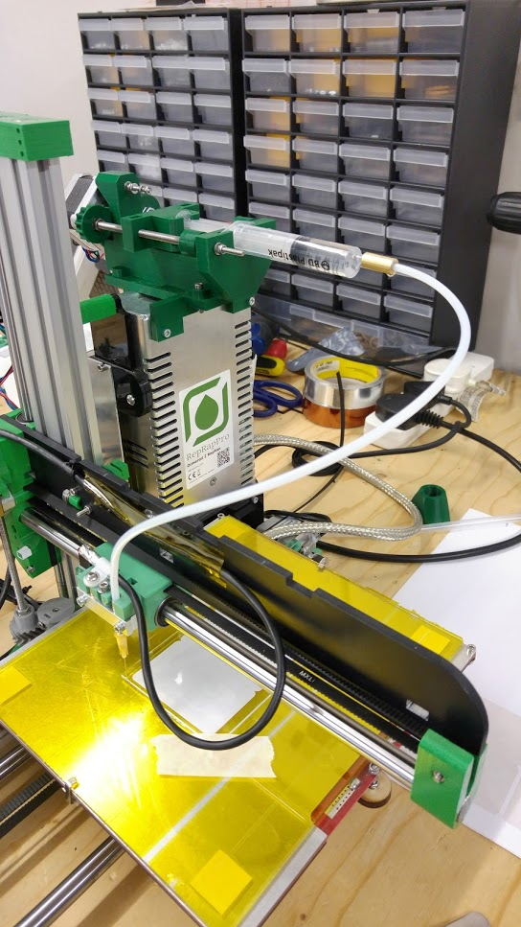
This is the device fitted to a RepRapPro Ormerod. At the top of the image in dark green is a stepper-driven screw drive that moves the piston in a 10ml syringe. A PTFE tube (identical to a standard RepRapPro Bowden tube) carries the contents of the syringe to a blunt hypodermic needle mounted in the X carriage of the Ormerod.

This system has the advantage of positive drive, which is to say that if the piston moves a known distance a precise known volume of syringe contents will be displaced. However a disadvantage is that the various components of the system are elastic. This can introduce delays, with the consequence that extrusion may start after the piston starts to move, and continue after it has stopped. Stiction in the piston’s movement can also be a problem, though this can be minimised with a small quantity of silicone grease on the piston.

1.1.3 Results
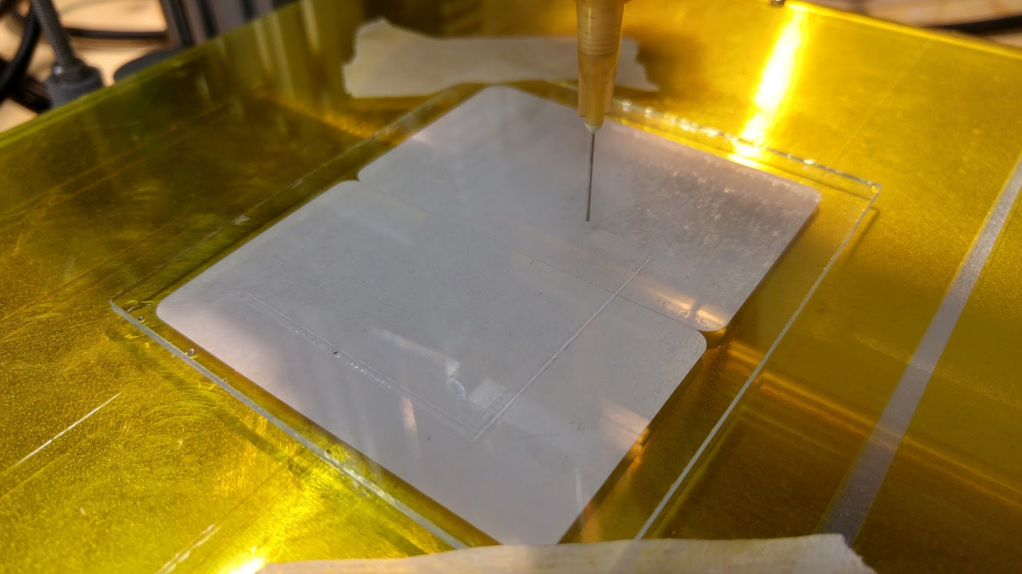
This picture shows a test print on a glass plate in progress (G codes in the Appendix below). The gel used was a 1:100 weight:weight solution of sodium alginate in de-ionised water.

As the gel is clear it is hard to see in the picture. It is a lot clearer in the video at: http://tinyurl.com/jy5raxl

As can be seen, the flow of gel is intermittent as a consequence of the disadvantage mentioned above.

1.2 Pneumatic Gel Printing

This is a system based (initially) on a commercial pneumatic glue deposition system.

1.2.1 Apparatus

Standard Ormerod 2 fitted with rocking head changer
DS 982-A pneumatic depositor from Taiwan Tech. and Material
Arduino Uno with pneumatic depositor controller shield
19G needle, cut short (3mm) using a Dremel cutting disc.

1.2.2 Description
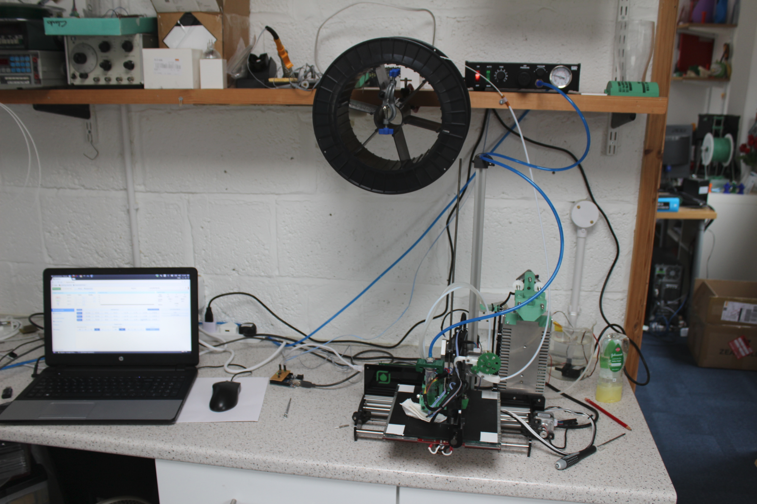
The picture shows the test layout. The deposition controller is on the shelf to the right of the filament reel.

The Ormerod controller ‘thinks’ that it is driving an ordinary stepper-powered extruder. But the stepper pulses are routed to the Arduino plus its shield (between the mouse and the Ormerod). These generate pulses of controllable length that are sent to the valve in the deposition controller. By changing the number of steps per millimetre of the imaginary extruder stepper motor the frequency of the pulses can also be controlled, and will match the acceleration and speed of the machine when it prints.

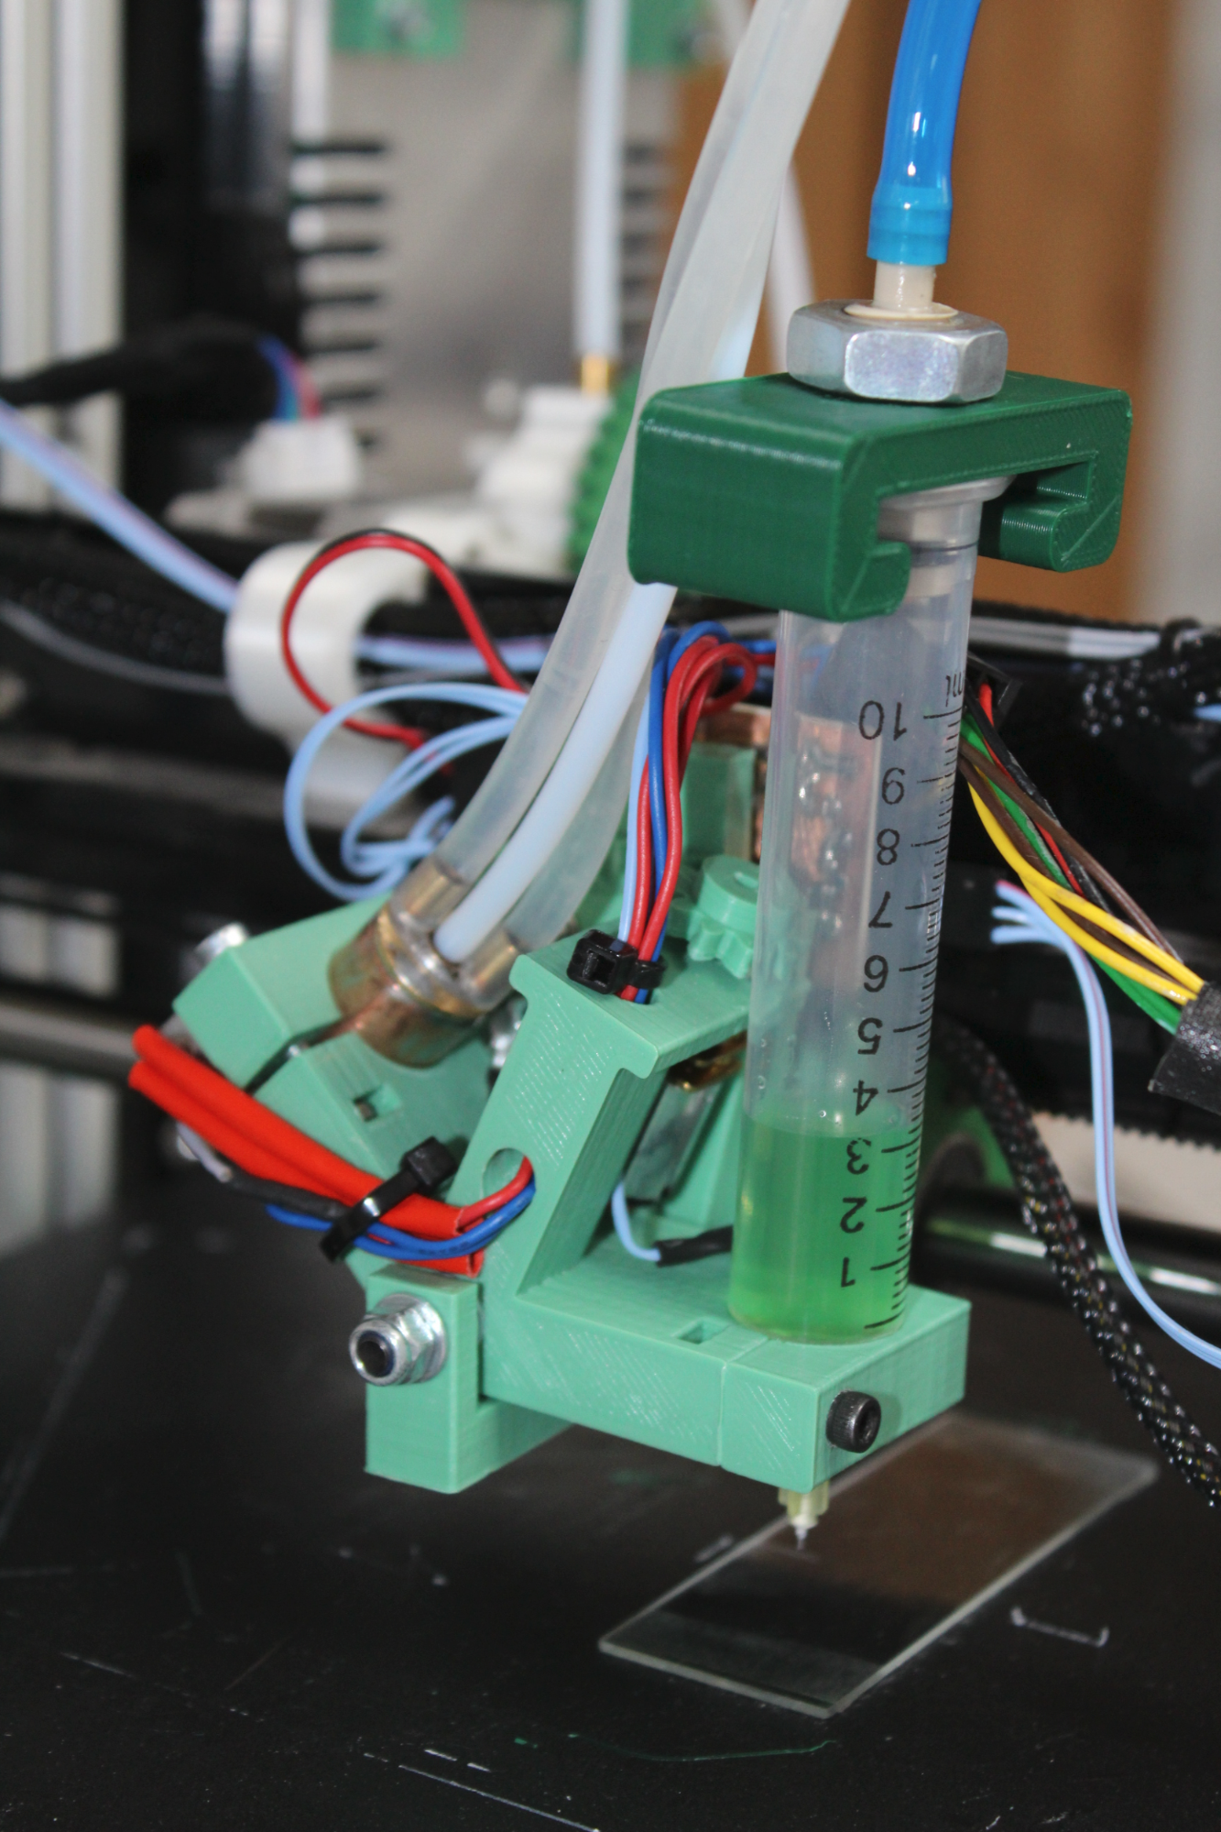
The deposition controller also has a venturi that generates a partial vacuum when the pressure pulses are not being applied. This can be adjusted to match the pull of gravity on the contents of the syringe (shown below). This counteracts the tendency of the syringe contents to ooze.

This system has the disadvantage of having many parameters to adjust to get the print characteristics desired.

1.2.3 Results

The video at http://tinyurl.com/jlap6ld shows three test prints with three different pulse lengths. The gel was a 50:1 weight:weight solution of sodium alginate in de-ionised water (so was rather more viscous than the gel used for the stepper-driven syringe above).

All the tests were done with a supply pressure of 2 bar. The first print is with a pulse length of 4.5 ms, the second (when no material is extruded) is with a pulse length of 4 ms, and the third is with a pulse length of 4.75 ms. The pulses on the soundtrack are the valve opening and closing.

As can be seen, the rate of extrusion can be changed dramatically by changing the pulse length. It will obviously also be dependent on the mechanical characteristics of the valve, the pressure, and the frequency of pulses. These last two can be controlled and varied automatically (see below). We are investigating the Festo MHJ9 high-speed jet valve for use in the final design.

One discovery made was that the pneumatic system works much better if the compressed air impinges directly on the syringe contents, as opposed to pushing a piston against those contents. Putting a piston in the syringe led to many problems with irregularity and stiction.

1.3 Comparison of the two systems

The pneumatic system seems to produce better results than the direct-drive system, but the direct drive system is simpler and lower-cost.

A feature of the hydrogel used became apparent with both systems and is visible in the movies. The water evaporates quickly, and a smooth uniform printed line can consequently become jagged and irregular with time. This will lead to problems in measuring the consistency and accuracy of the systems we are developing. As a consequence we have decided to change to oil-based gels for our tests. As oils have a much lower vapour pressure than water evaporation should not present these problems.

2. Other Developments

2.1 Design of the Cartesian Robot

We have decided that the final machine will need a tool changer, as opposed to having all four write-heads mounted at once. The reason for this is that sometimes printing will have to be carried out under water (or other liquids) held in a tank on the bed of the machine. A multi-head machine would suffer extremely restricted movement as unused heads approached the walls of the tank.

We have considered the option of making each of the four heads effectively have its own Z axis so that it could be moved vertically out of the way. These axes could either each be high precision and operate independently, or could be low precision but repeatable and further driven by a common final Z axis. This solution is interesting, but it seems to us to introduce a great deal of extra mechanical complexity.

We have a RepRap design for a head changer that was made a few years ago at Bath University. This uses three-point magnetic clamping, which gives reliable results.

With any head changer a tool probe will be needed as otherwise tool registration will not be exact. We have a sketch design for such a device (the principle is out of patent), or we could use a commercial one such as the Renishaw TS27R contact tool setting probe (repeatability 10⁻⁶m).

2.2 I2C Digitally-controlled Pressure Regulator
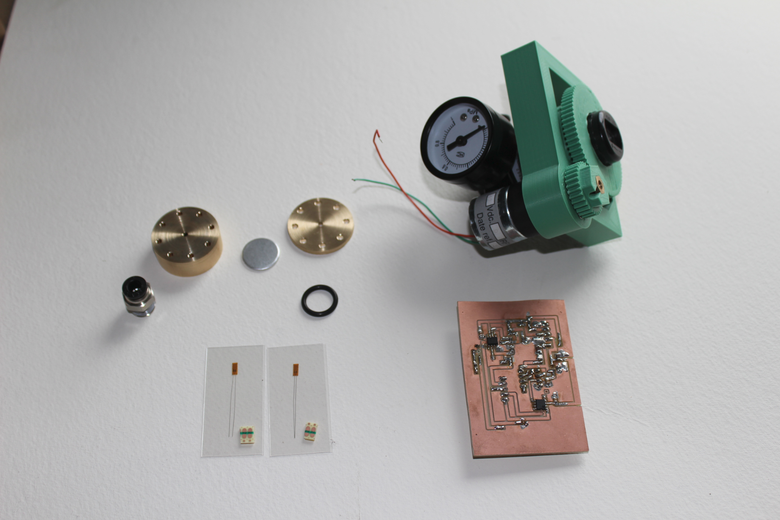
If the pneumatic solution is finally chosen, one item that will be needed is a pressure regulator that can be automatically controlled. We have been developing such a device for the Bioprinter. It is not yet finished, but its main components are shown above.

On the left are the parts of the pressure measuring device. This consists of an aluminium disc that deflects when pressure is applied. It will have strain gauges mounted on it to measure that deflection.

Bottom right is the control electronics. This has a gain-100 operational amplifier to amplify the output from the strain gauge bridge. This is fed into an ATTiny 8-pin microcontroller that measures the resulting voltage and uses it to drive an H-bridge motor controller.

Top right is a standard pressure regulator with an added geared DC motor drive.

The ATTiny will interface to the rest of the control system using the standard I2C bus. It will implement a PID control loop that will allow pressures to be set and reported back to the main controller.

The same device will work with a venturi partial vacuum, and so will allow that to be controlled as well.

Though this is intended for use with the pneumatic system described above, it has not escaped our attention that it might form a useful product for Longer 3D in its own right. It uses an industry-standard interface (I2C) and industry-standard pneumatic unions, so it would be easy to fit in a wide range of systems.

3. Work to be done next

Now that we have both rival gel-extrusion systems working we will standardise on a set of experimental conditions and compare their performance. As a result of that comparison we will decide the one to use in the final system.

The experimental standards will be the most extreme limits of the specification for the Bioprinter. That is to say that we will use gels of the highest and lowest viscosities required being deposited through the broadest and finest nozzles.

As mentioned above, we will use oil-based gels for the experiments. This will allow us to take micrographs of the resulting prints and from those gather measurement statistics on the smoothness, thickness and repeatability of the prints created.

We will also start work on the tool changer, as described above. We will build a system together with a tool probe and use the combination to check the accuracy and repeatability of the changer.

Appendix

G Codes for stepper syringe test

G90
M83
G92 X0 Y0 Z0.2
G1 E10 F200 ;flush nozzle
G1 E-10 F500 ;retract
G1 X10 Y10 F500 ;move to start
G1 E10 F500 ;un-retract
G1 X50 E0.3 F400 ;print square
G1 Y50 E0.3
G1 X10 E0.3
G1 Y10 E0.3
G1 E-10 F500 ;retract
G1 X0 Y0 F500 ;move clear

