Signature Forgery Verification

In this project we per your instructions we have employed CNN and HOG algorithm to extract features from signature images and then employ Decision tree to select relevant features from CNN extracted features and then employ SVM, KNN and LSTM algorithm on selected features to detect images as Original or Forge.

Each algorithm performance is evaluated in terms of accuracy, precision, recall and FSCORE. Among all algorithm LSTM is giving best accuracy.

To train algorithm we have downloaded forge signature image dataset from below KAGGLE URL

<https://www.kaggle.com/datasets/sohonjit/signature-dataset>

To implement this project we have designed following modules

1. Upload Signature Forgery Dataset: upload dataset to application and then read all images and extract HOG features from each image
2. Process Dataset: this module will shuffle, normalize and split dataset into train and test where application using 80% dataset for training and 20% for testing
3. CNN & HOG Based Features Extraction: employ CNN algorithm to extract features from HOG generated images data
4. Decision Tree Based Features Selection: apply decision tree to selected features from CNN extracted features
5. Run SVM Algorithm: 80% training with selected features will be input to SVM algorithm to train a model and this model will be applied on 20% test data to calculate prediction accuracy
6. Run KNN Algorithm: 80% training with selected features will be input to KNN algorithm to train a model and this model will be applied on 20% test data to calculate prediction accuracy
7. Run LSTM Algorithm: 80% training with selected features will be input to LSTM algorithm to train a model and this model will be applied on 20% test data to calculate prediction accuracy
8. Comparison Graph: will plot comparison graph between all algorithms
9. Forge Detection from Test Image: will upload test image and then application will apply trained model to classify that image as original or Forge signature

SCREEN SHOTS

To run project double click on run.bat file to get below screen

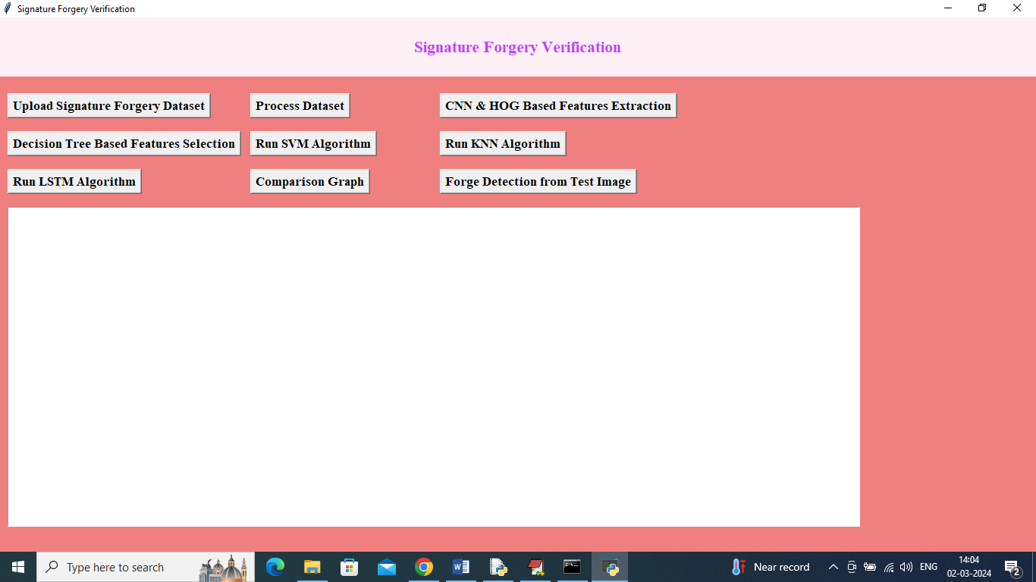

In above screen click on ‘Upload Signature Forgery Dataset’ button to upload dataset and get below page

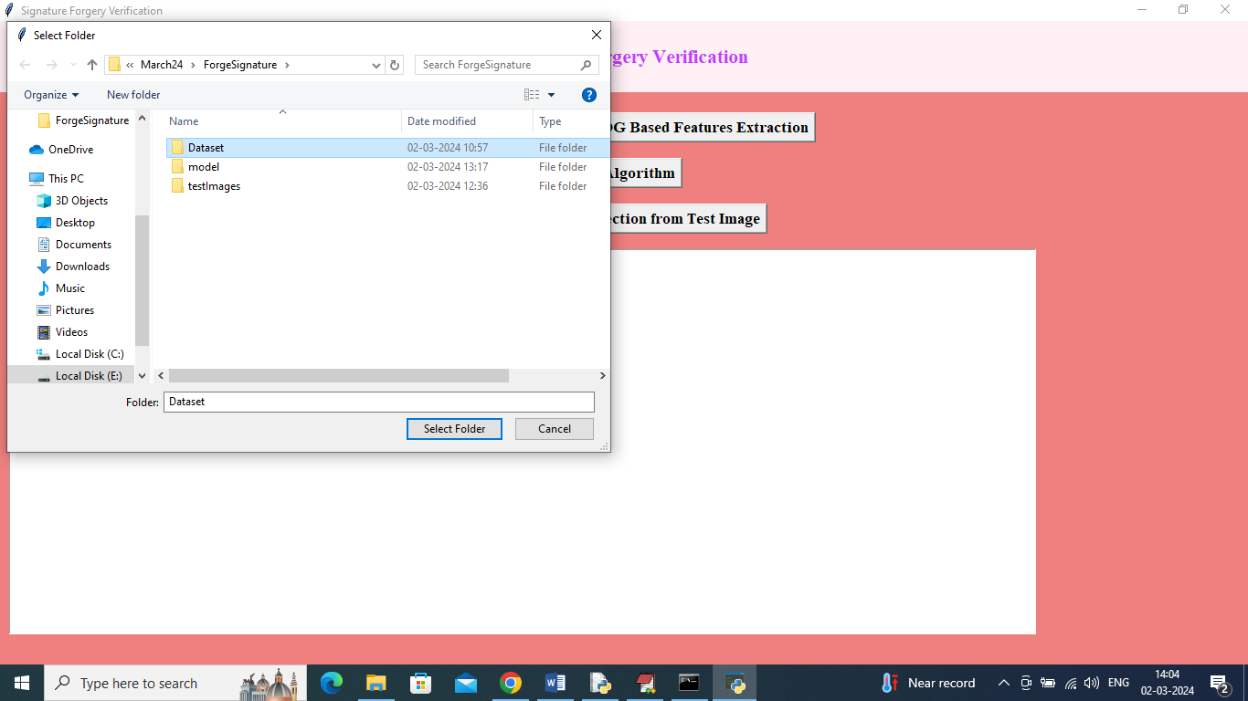

In above screen selecting and uploading Dataset and then click on ‘Select Folder’ button to load dataset and get below page

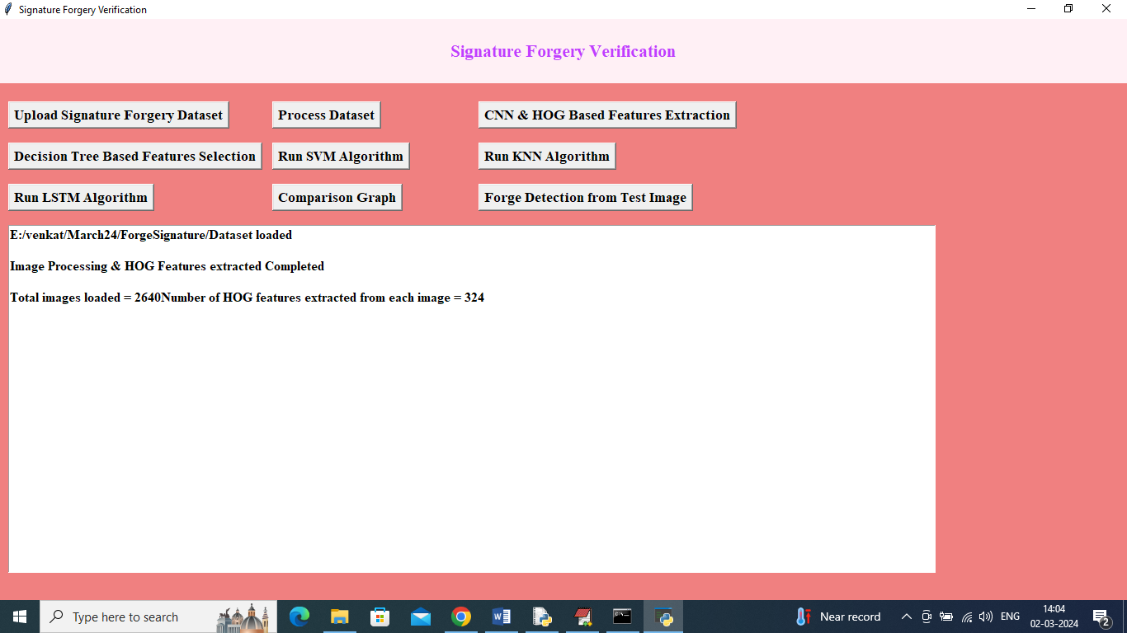

In above screen dataset loaded and can see total HOG features extracted from each image and now click on ‘Process Dataset’ button to shuffle and normalize HOG features

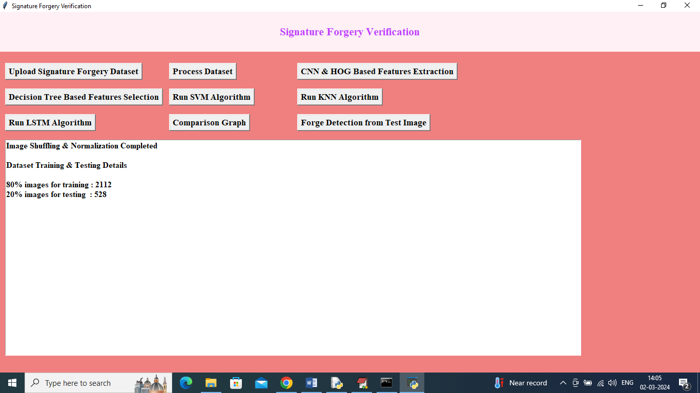

In above screen shuffling, normalizing and dataset splitting completed and can see train and test size and now click on ‘CNN & HOG Based Features Extraction’ button to train CNN on loaded dataset and then extract features

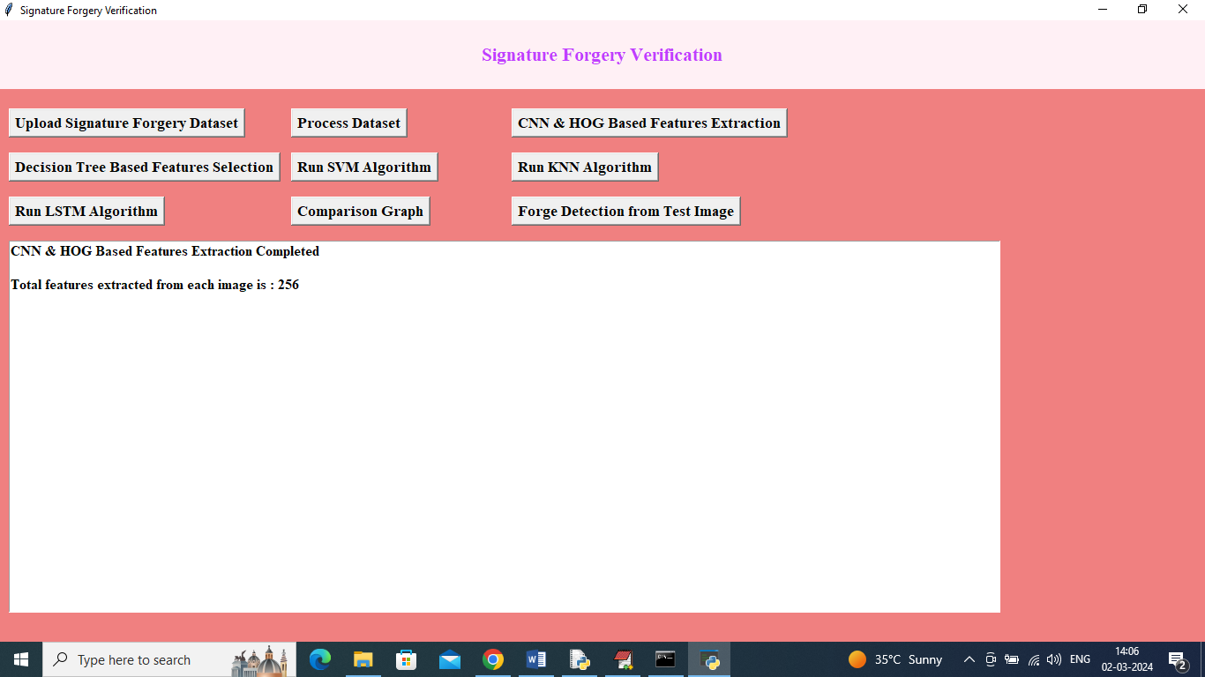

In above screen CNN extracted total 256 features from each image and now click on ‘Decision Tree Based Features Selection’ button to select relevant features from 256 cnn extracted features

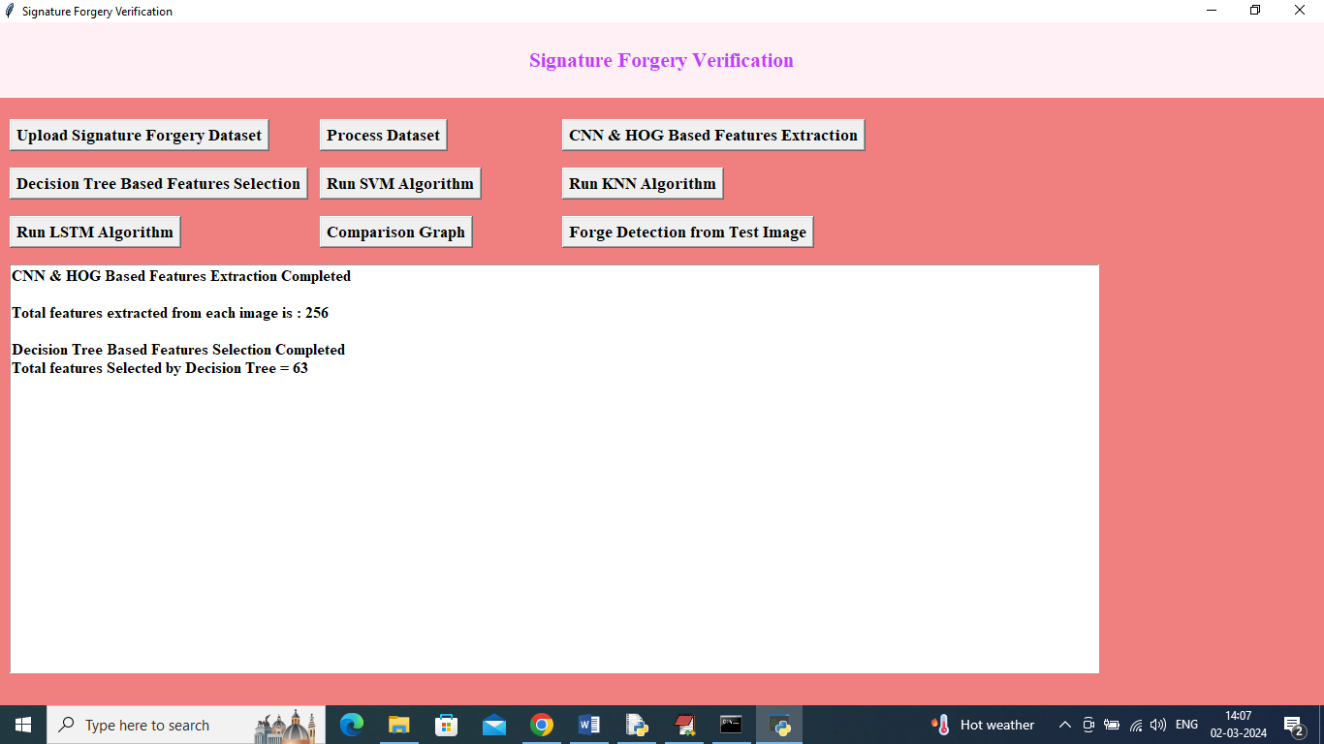

In above screen decision tree selected 63 features out of 256 and now click on ‘Run SVM Algorithm’ button to train SVM on selected features and get below output

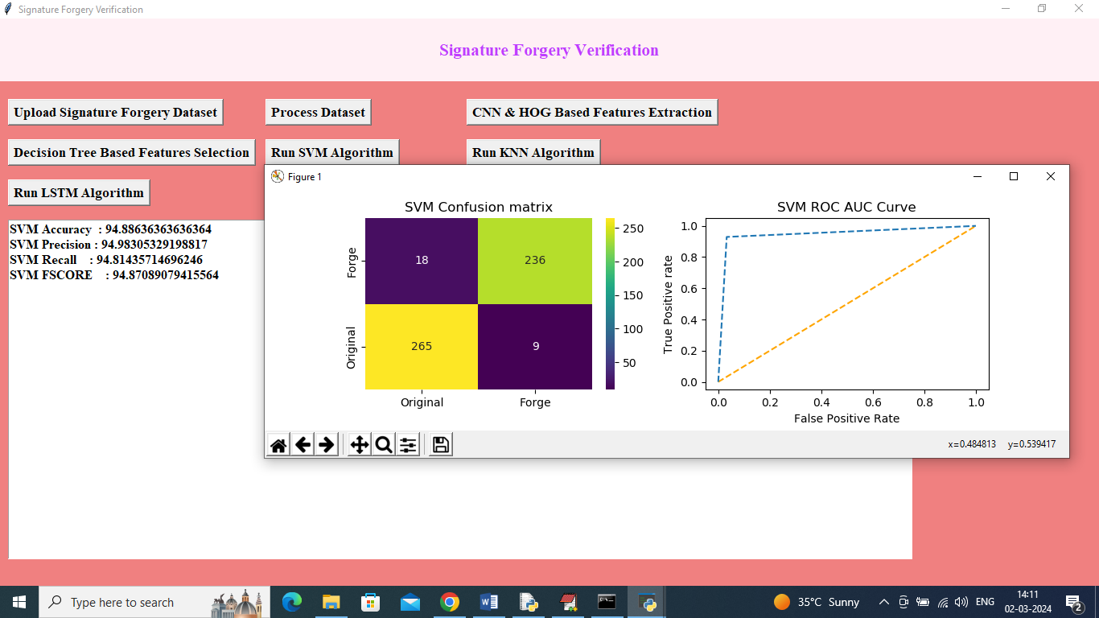

In above screen training SVM algorithm and then it got 94.88% accuracy and can see other metrics like precision, recall and etc. in confusion matrix graph x-axis represents Predicted Labels and y-axis represents True labels and then different color boxes like green and yellow represents correct prediction count and all blue boxes represents incorrect prediction count which are very few. In ROC graph x-axis represents False Positive Rate and y-axis represents True Positive Rate and if blue lines comes below orange line then all predictions are incorrect or false and if goes above orange line then all predictions are correct or true. Now click on ‘Run KNN Algorithm’ button to train KNN and get below page

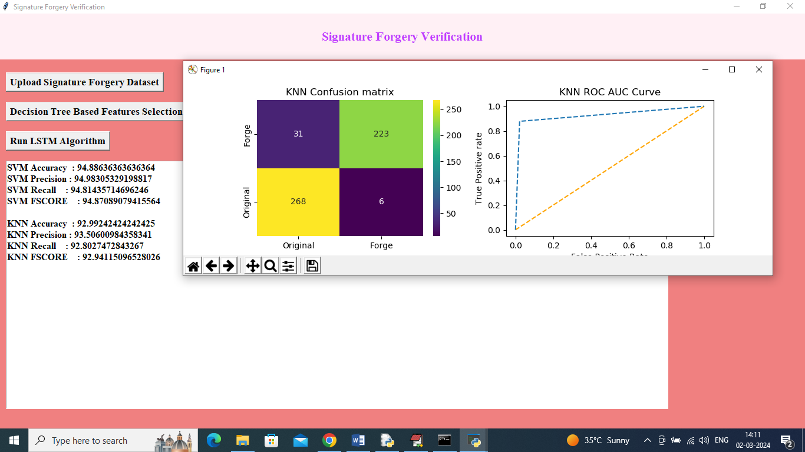

In above screen KNN got 92% accuracy and now click on ‘Run LSTM Algorithm’ button to get below output

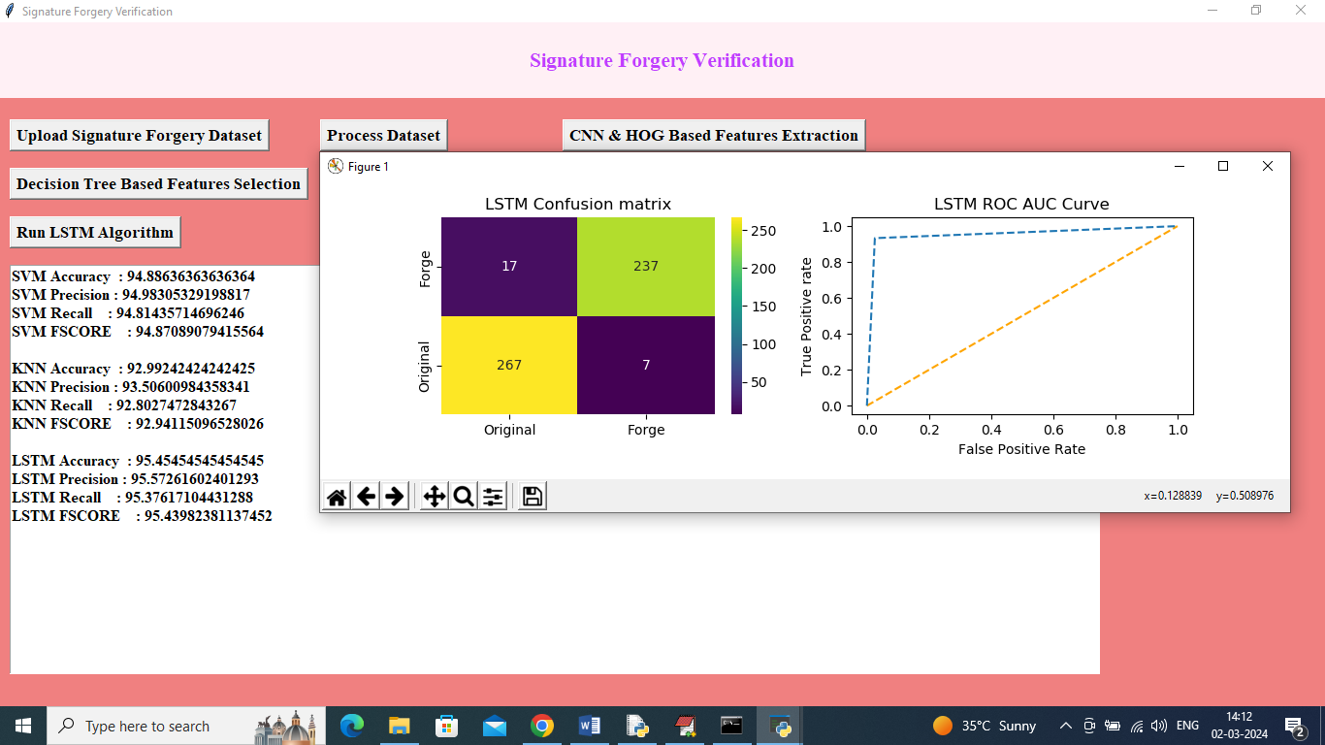

In above screen LSTM got 95% accuracy and can see other metrics output and now click on ‘Comparison Graph’ button to get below graph

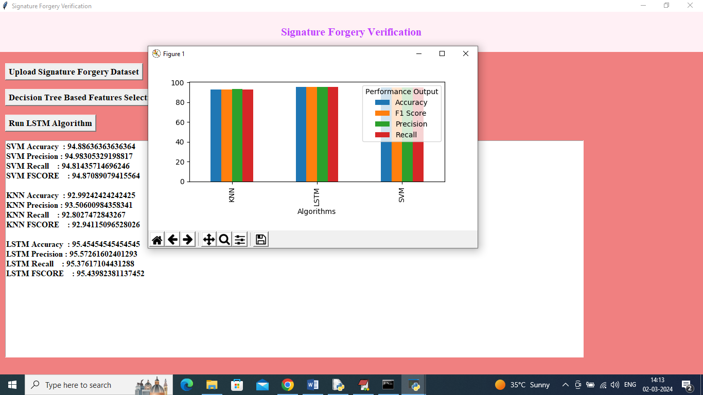

In above graph x-axis represents algorithm names and y-axis represents accuracy and other metrics in different color bars and in all algorithms LSTM got high performance and now click on ‘Forge Detection from Test Image’ button to upload test image and get below output

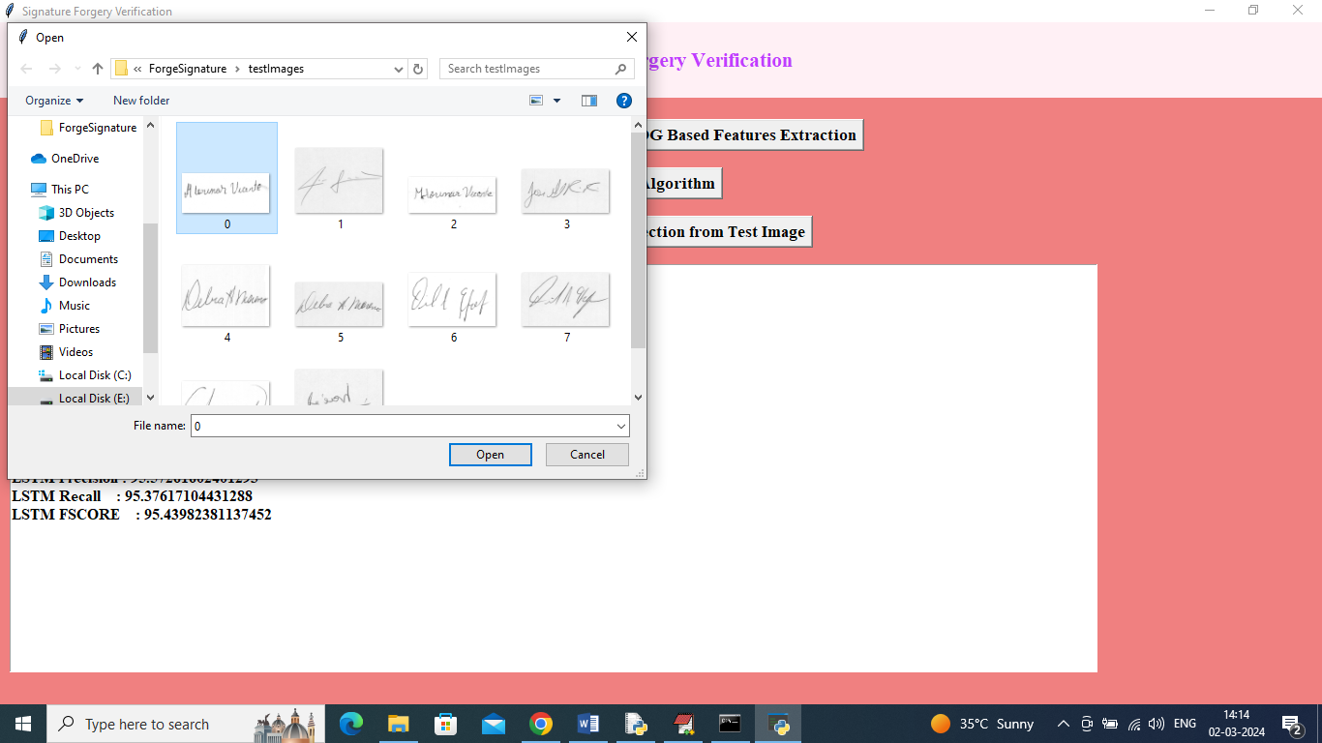

In above screen selecting and uploading test image and then click on ‘Open’ button to get below output

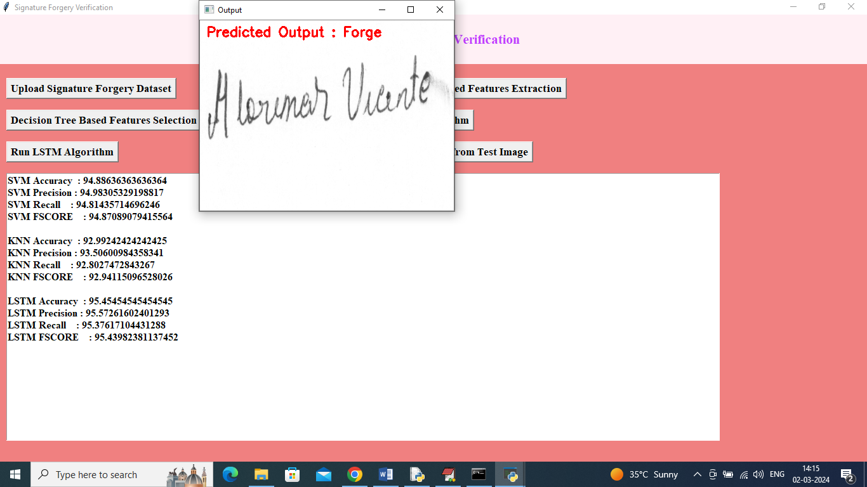

In above screen uploaded image detected as ‘Forge’ and similarly you can upload and test other images

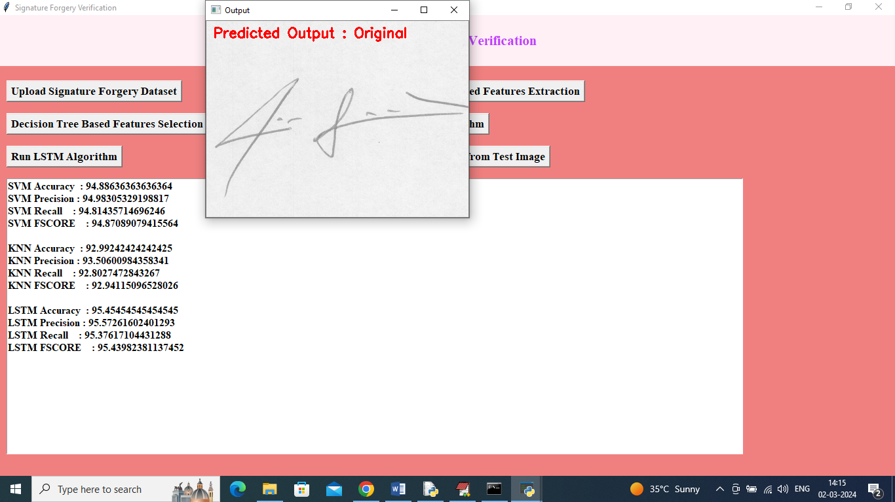

Above image detected as Original