Agent-based Model Microkernel Language
9/21/2007
Draft
By Michael. J. North
Meta-Level

- Define agents (i.e., a classes) 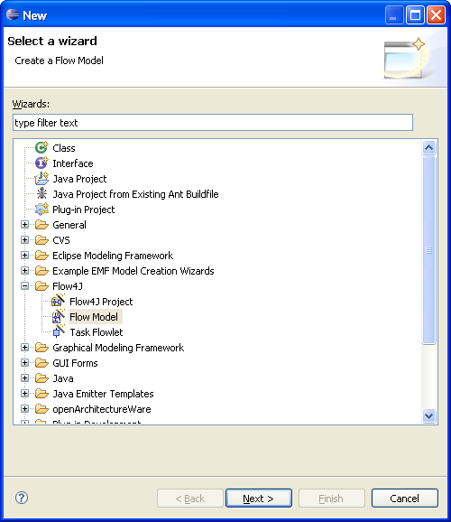
  - Define methods:
    - Method name
    - Parameter names
    - Scheduling info
    - Watching info
  - Define fields (field name only) 

Flow Control

- if (Boolean Expression) {…} else {…}
- while (Boolean Expression) {…} 
- scan (a query-generated list of agents) {} 
- return 

Operations 

- Create:
  - a context:
    - Parent context path
    - Name
  - a projection of a given type in a context:
    - Parent context path
    - Name
    - Type
    - Optional projection kind
    - Optional borders
    - Optional dimensions
  - an agent of a given type:
    - Type
    - Target reference variable
  - a Edge between given agents:
    - Context path and network projection
    - Agent reference variable 1
    - Agent reference variable 2
- Remove:
  - an agent of a given type from a given context:
    - Context path
    - Agent reference variable
  - a given agent from the model (i.e., kill the agent):
    - Agent reference variable
  - a given Edge between given agents:
    - Context path and network projection
    - Agent 1
    - Agent 2
  - a given sub-context from a given context:
    - Context path
  - a given projection from a given context:
    - Context path and projection
- Find:
  - a given context:
    - Context path
  - a given projection:
    - Context path and projection name
  - a given context or projection’s parent context:
    - Context path and optional projection name
  - a given edge:
    - Context path and network projection
    - Agent 1
    - Agent 2
  - a given edge weight:
    - Context path and network projection
    - Agent 1
    - Agent 2
  - a list of agents:
    - Query string
  - a list of edges:
    - Query string
  - a uniform random value versus a threshold
    - Threshold
- Add:
  - an existing agent to an existing context:
    - Context path
    - Agent reference variable
- Move:
  - a given agent in a given projection:
    - Context path and projection
    - Agent reference variable
- Assign (see the expression types listed below for the types of assignments):
  - a value to a given agent attribute:
    - Target field name
    - Expression
  - assign a value to a given temporary variable:
    - Target variable name (need to resolve new vs. existing variable)
    - Expression
  - assign a given edge weight:
    - Context path and network projection
    - Agent 1
    - Agent 2
    - new edge weight
- Tell a given agent to do something (i.e., execute a given method) now or later:
  - Agent reference variable
  - Method name
  - Method arguments
  - Scheduling info
- Cancel a scheduled action
- Execute a line of Groovy:
  - Line of Groovy
- Execute a line of MATLAB
  - Line of MATLAB
- Get scalar MATLAB value:
  - Scalar MATLAB value to return
- Reset the MATLAB interpreter
- To Do: Execute a line of Mathematica:
  - Line of Mathematica
- To Do: Reset the Mathematica interpreter
- Write an integration file
  - source object
  - integration XML file
  - target file path
- Read an integration file
  - target agent
  - integration XML file
  - source file path
- Run an external program (i.e., a legacy model)
  - full command line

Groovy

- To Do: Create an Expando with the model parameters

