UI Design

The game UI included four primary screens:
- Main Screen
- Gameplay screen
- Setting screen
- Upgrade screen
- Skill Store screen

Main Screen
The main menu included 4 sessions:
- Project description
- Levels display board
- Player achievement
- Game-related links

The main menu is given below:
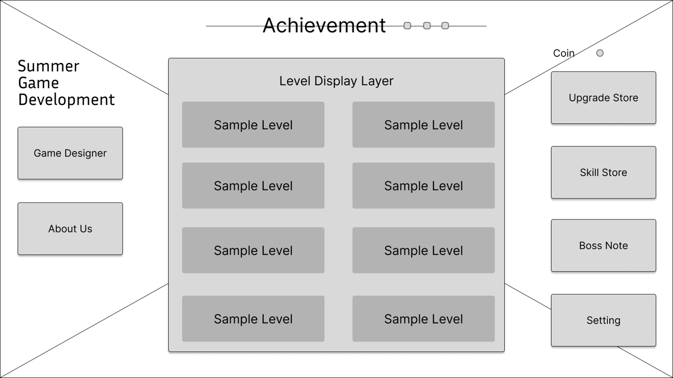

Achievement Session
This session functioned as visualizing the rewards.
For each completed level, an achievement diagram will be added. Besides, the level and coin of player will be located at this session. Animations will show when player level up and player earns coin after playing a game.

Level Display Session
This session displays all level included in the game.
For each level label, will display the level description and difficulty. Besides, a level opponent image will paste on the label to visualize the level design.
Game-Related Session
This session contains game machines for upgrading character, purchasing item and enemy notes.
The screen buttons are arranged in descending order of usage frequency. Thus, the higher the button’s located, the more important in gameplay experiences.
When there is an upgrade available, a red dot will pop out at “Upgrade button” to notice the user.

Following table show the linked screen at the “Main Screen”
Session | Pressed Button | Direct Toward Screen
Project Description | Game Designer | Game Designer screen
Project Description | About Us | About Us screen
Level Display | Sample Level | Gameplay screen
Game-related Link | Upgrade Store | Upgrade screen
Game-related Link | Skill Store | Skill Store screen
Game-related Link | Boss Note | Boss Note screen
Game-related Link | Setting | Setting screen

Gameplay Screen

The “Gameplay screen” contain four components:
- Boss Health Bar
- Player and Boss Character
- Player health bar and skill cooldown
- Player status

Gameplay Screen Figure:
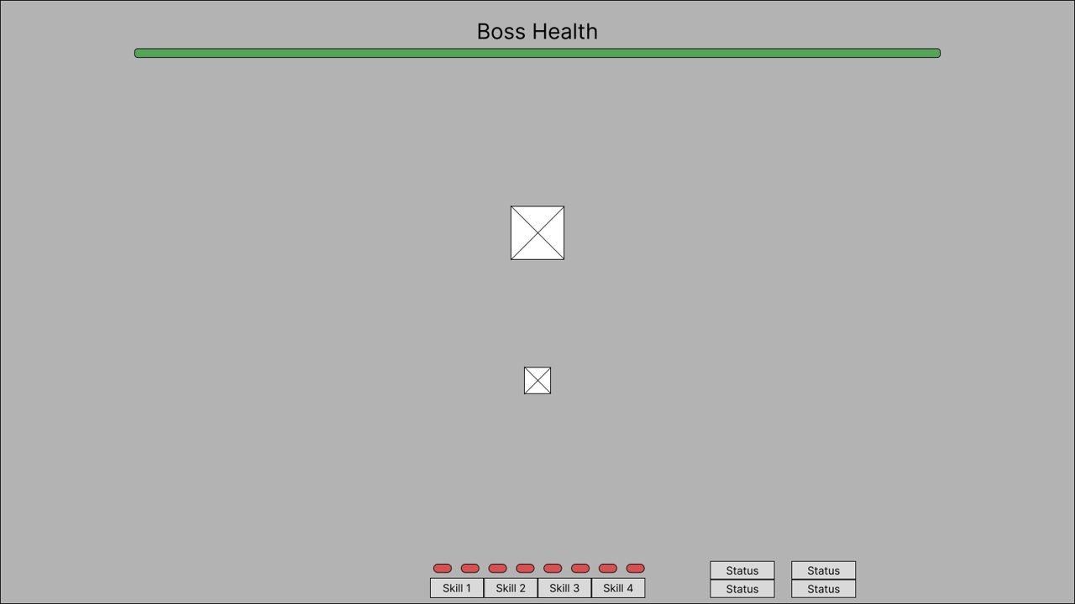

Before Game Start
Before the game start, the system will pop out a “Level Description window” to explain the level information. The game started after users clicked the confirmation button.
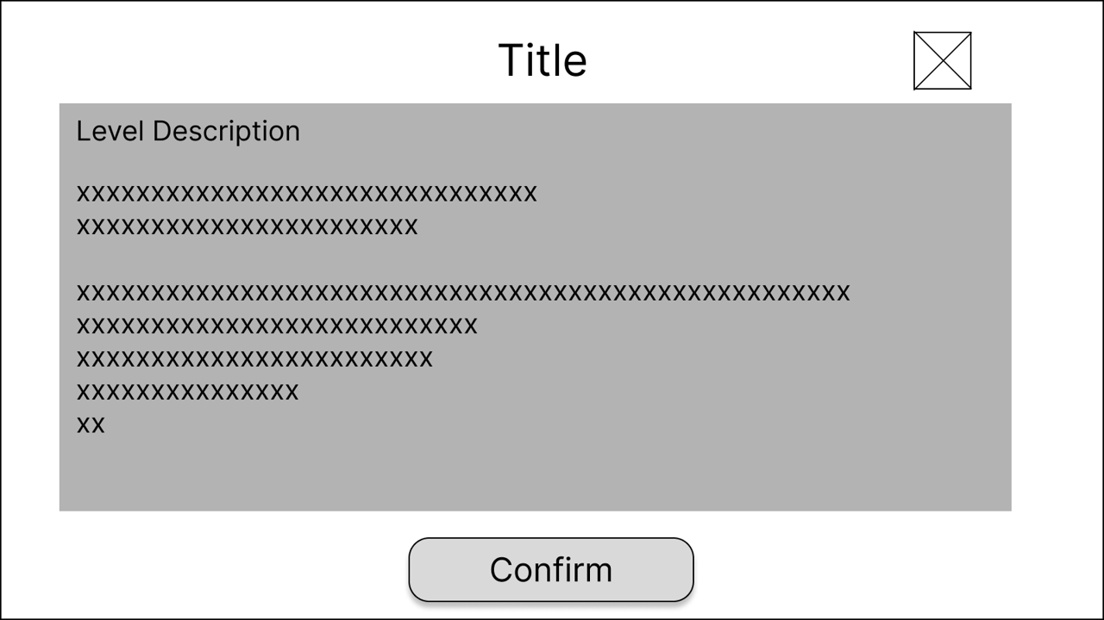
To Return Back to Main Menu
When users complete the game, a portal will be generated in the game center. Player can pass through the portal to direct back to “Main screen”.
When user loses the game, a window will pop out to notice user. After users confirmed the notification, users will be directed back to “Main screen”.

To Pause Game
During the gameplay, the player can press “ESC” button to pause the game.
In “Pause window”, some hints will be given in the description boxes. For action, users can continue the game, restart the game, or quit the game and return to “Main screen”.

Skill Store Screen
When user press “Skill Store” button in “Main screen”, user will be directed to “Skill Store screen”.
“Skil Store screen” contains four components:
- A “Back to Menu” button
- A scroll bar
- A coin label
- Skills label (Description, Purchase status, Equip status)

“Skill Store screen” design given below:
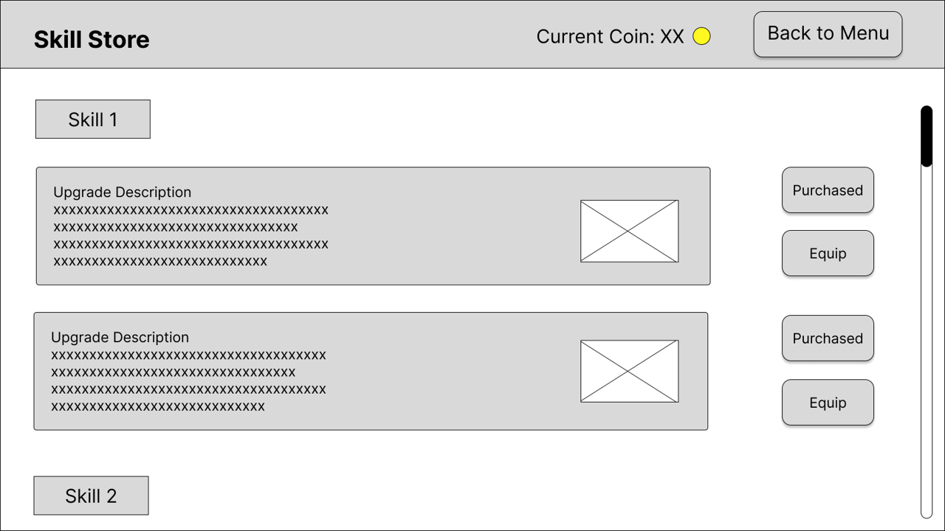

Purchase and Equip Skill
When skill been purchased or equipped, the related boxes will darken.
When users press an equipped skill box, the skill will be unequipped, and the equip box will be lighted up.

To Return Main Menu
When user press “Back to Main” button, user will be directed back to “Main screen”

