Level Design

The “Gameplay screen” as shown in below:
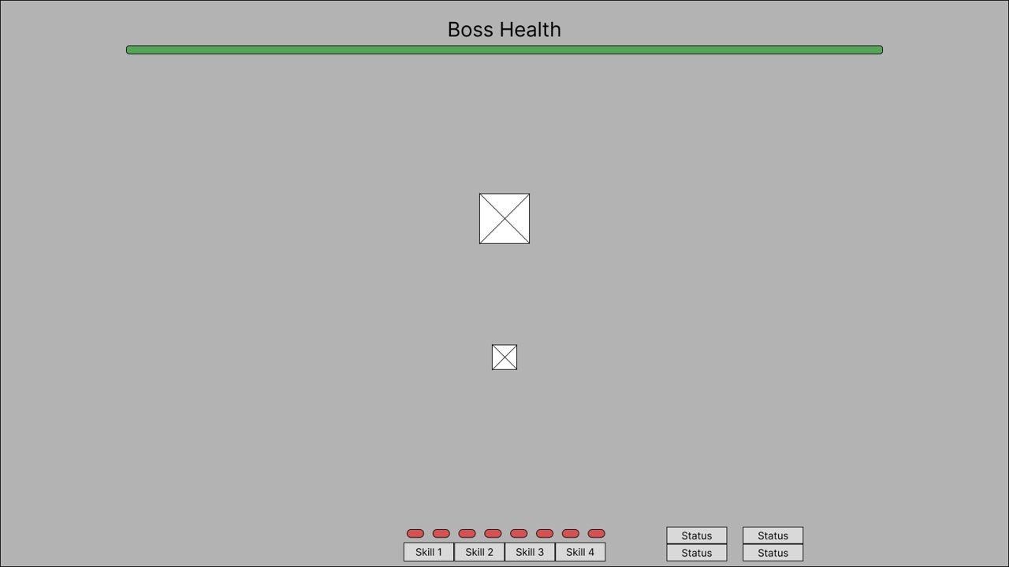

There is mechanic for player during gameplay:
- Basic movement
- Changing current skill abilities
- Apply skill

Basic Movement:
 | Pressed key | Movement
1. | “W” | Move up
2. | “A” | Move left
3. | “S” | Move down
4. | “D” | Move right
5. | NONE | Don’t move

When the movement destination is blocked (obstacle or map bound), the player won’t update their position.
Changing skill ability
When user scroll their mouse wheel, their skill ability will change.

