Tutorial – Level 1

The tutorial will start when a new player enters the game.

The first tutorial level will teach player how to attack, move, observe boss health, handle challenges, and gain rewards. To handle this, the level is divided into six sessions as given below:
- Attack trap to escape
- Move to observe surroundings
- Attack chest
- Chest drops item and level up
- Challenge higher level
- Reward new ability

- Player Attack Trap

The game initialize as below:
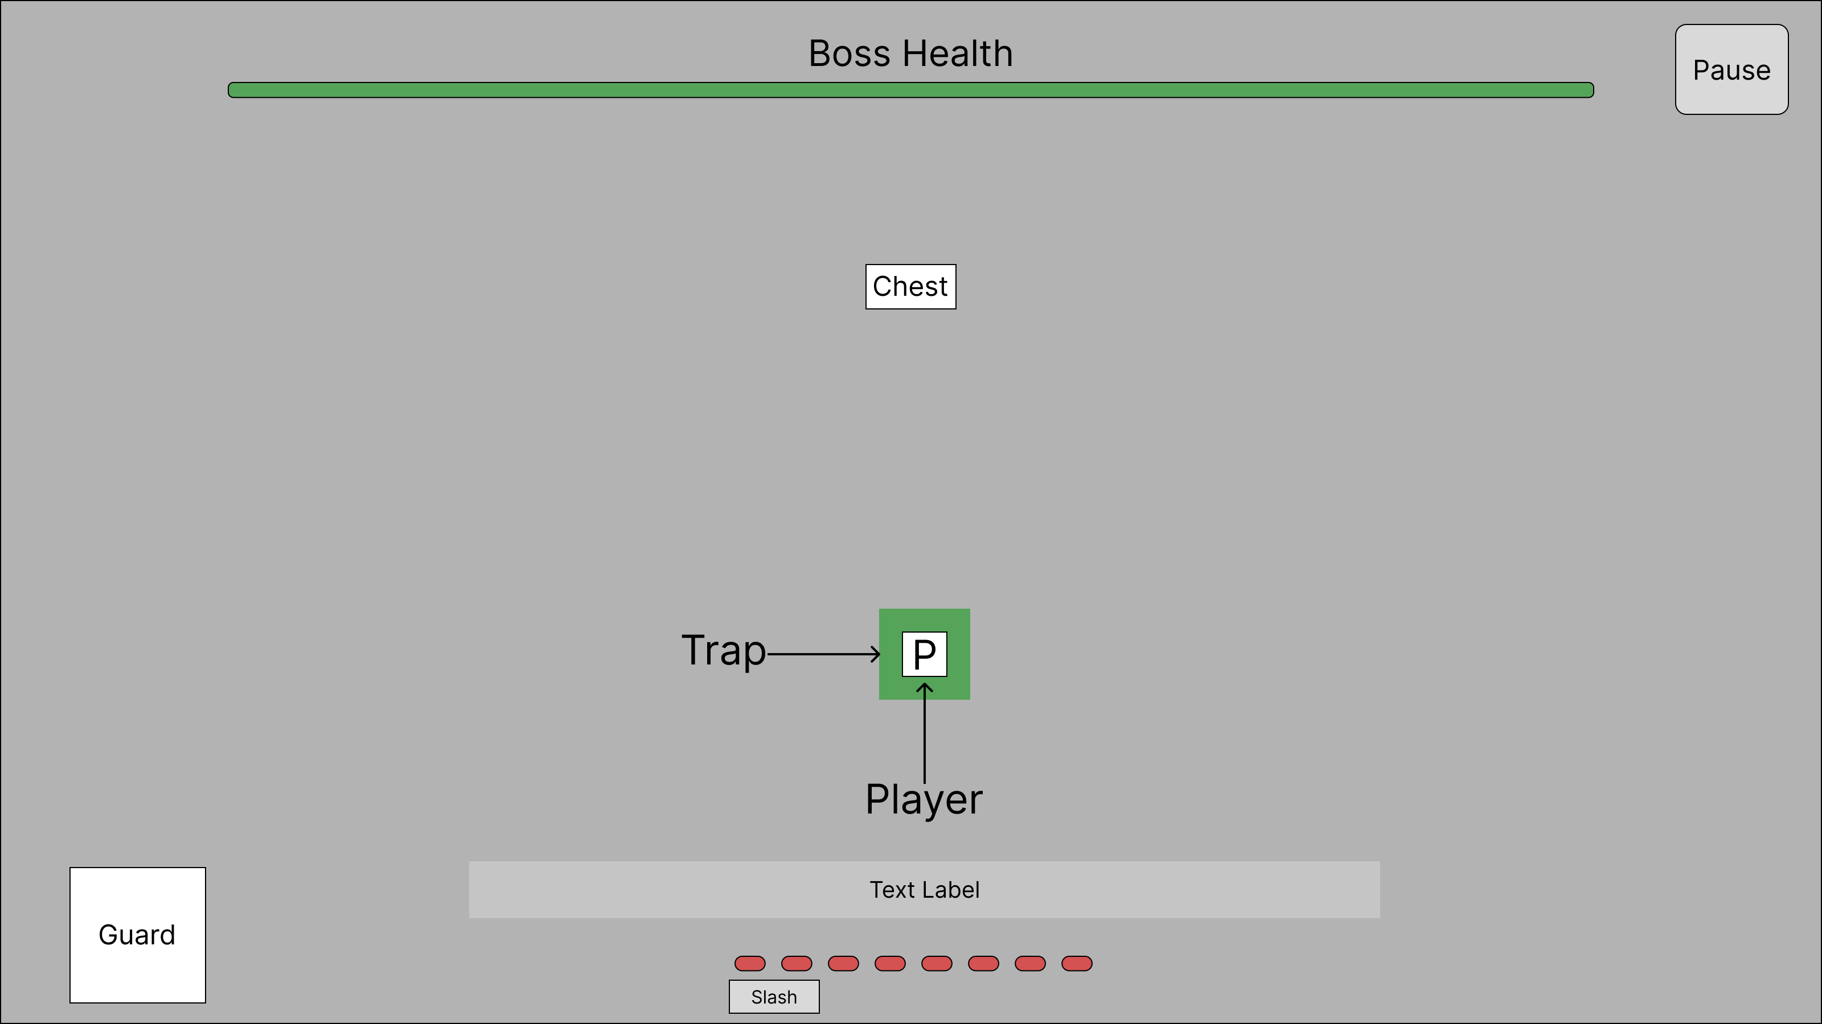

When the game starts, the player is unable to move using WASD. The player only allows to use “Slash” skill to attack the trap. When the trap been attacked, the trap will destroy and player able to move around with WASD.

This introduces the core mechanic – use attacks to interact.

- Player Move Toward Chest

After player been released, the chest health bar will pop out.
The player now can move freely to interact with object on the map. The game will direct player towards the chest in the map middle, so player can attack and interact with it.

This introduces movement mechanic – move near game object to interact (attack).

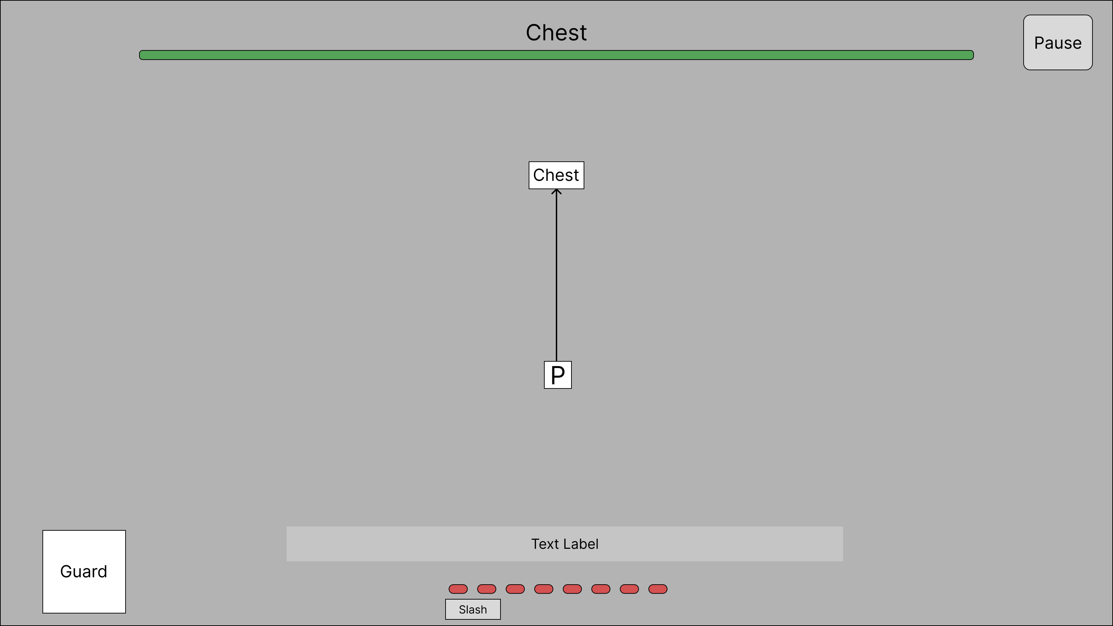

- Player Attack Chest

When chest is attacked, the chest health bar will reduce by 2/3. Then, the player ‘Slash’ skill will in a 3 second cooldown. After the cooldown is completed and player will attack it again. The chest health bar will be reduced to 0 and the challenge has ended. The rewards will pop out from the chest.

This introduces the boss’ health bar mechanic:
- Attack to reduce the boss’ health bar
- Attack have cooldown
- When boss’ health bar is empty, the challenge is complete

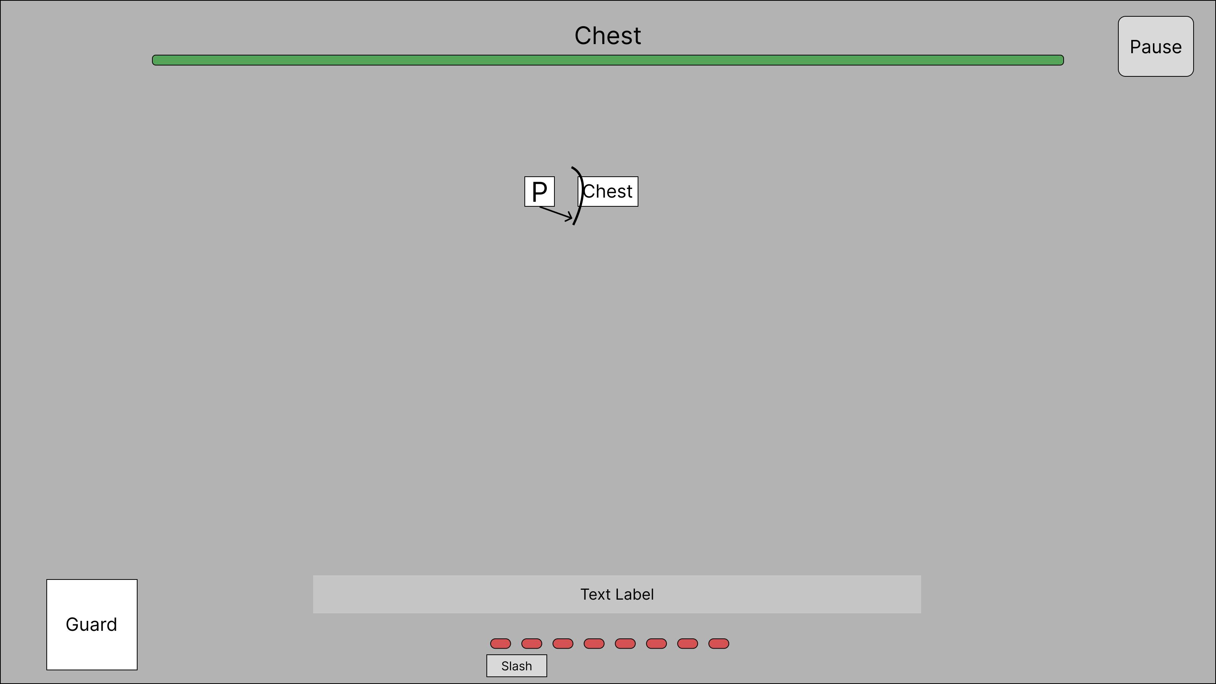

- Chest Drop Items and Level Up

When challenge complete, the chest opens. Coin and experiences will drop on the ground, then they will be picked by the player.
When player collect enough experiences, it will level up. The damage of “Slash” will be increased from 2 to 3.

This introduces the basic game flow: complete challenges and get reward.
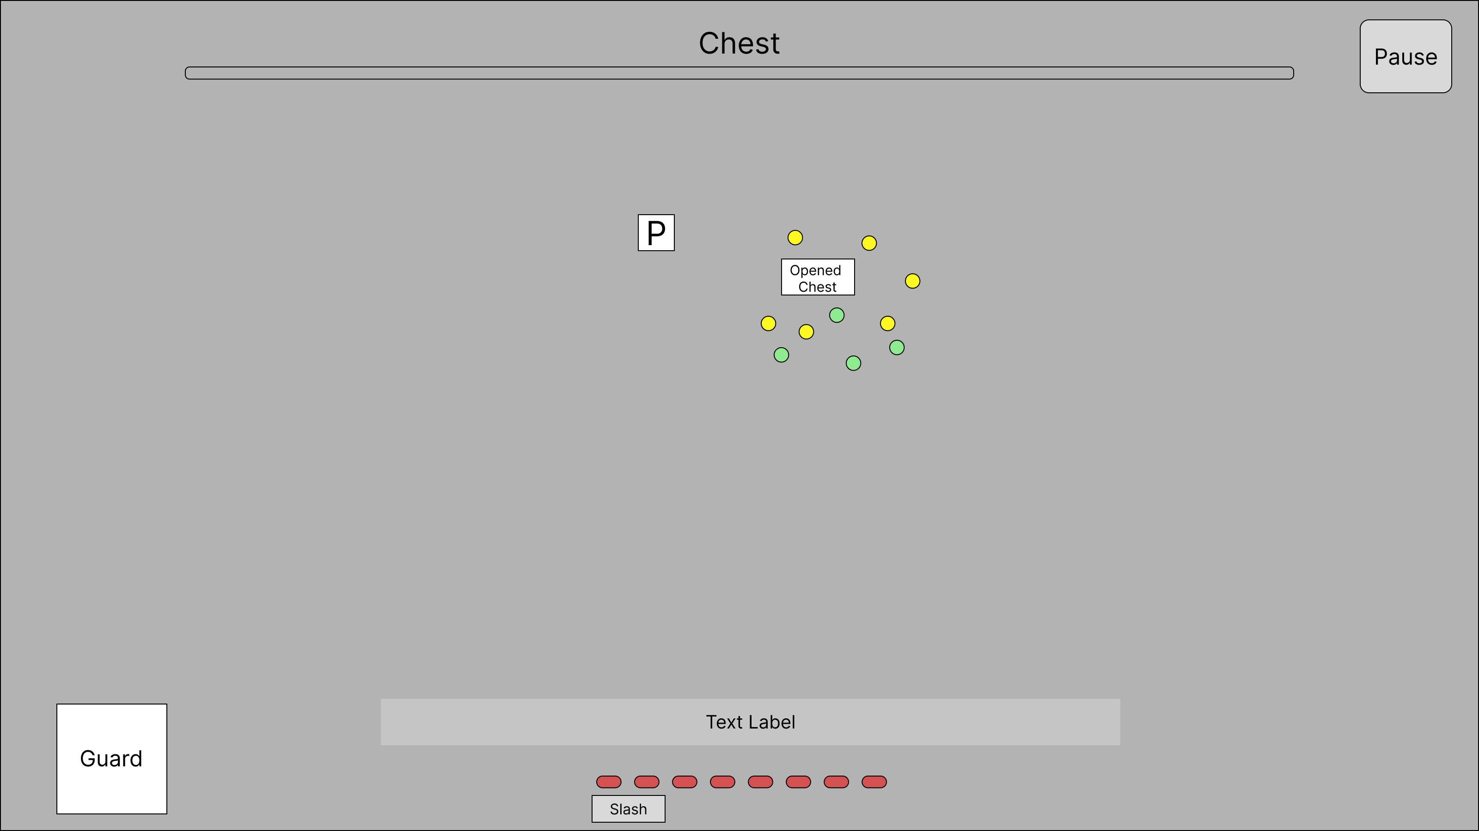

- Fight Boss

When the player collected all rewards, the “Guard” will wake up.
The guard will move towards the player at a faster speed. When the guard comes near to the player, the guard will attack will a long delay, so to give player an escape opportunity. After each attack, the guard will stun for a while without any movement. Now, player can attack the guard safely and reduce their health bar. After the player attack, the guard will enter rigid status then back to active.
This will repeat three time until the ‘Guard’ health bar empty. Then, a chest will be provided.

This introduces two mechanics:
- Player needs to attack boss when it’s stunned.
- Boss will get rigid after an attack, then back to active for next round. When boss rigid, the player is safe to escape away.

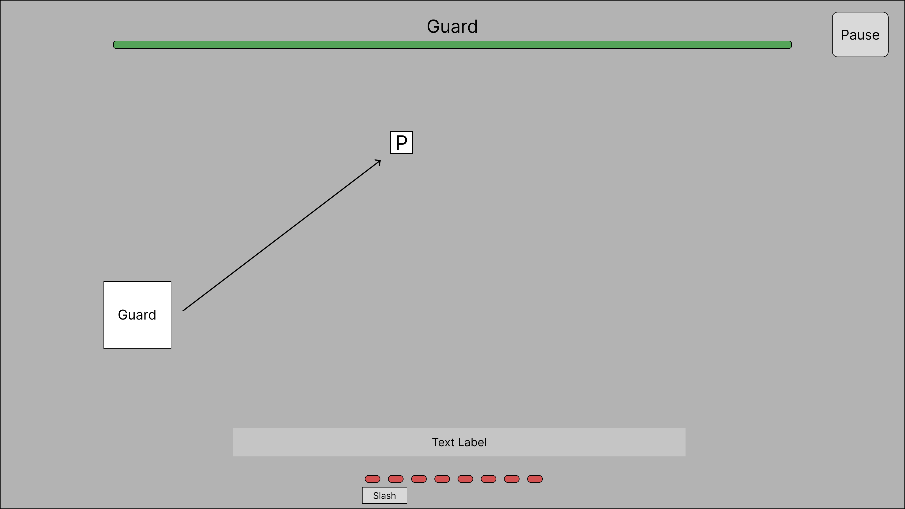

- New Ability Reward

When “Guard” be executed, a chest will drop down and a door. The chest will reward coin, experiences and the new ability for next tutorial level. A notification will pop pout when player gets the new ability. The door needs to be attacked by the player, so teleport player to the next level.

This introduces two mechanics:
- User can challenge harder level after receiving rewards.
- Harder level with better rewards.

