Insert sizes and distribution for paired-end sequencing
From: https://thesequencingcenter.com/knowledge-base/what-are-paired-end-reads/
Fig. 2 shows a typical insert size distribution for the Illumina Nextera XT DNA Library Preparation Kit. This is a probabilistic distribution and will vary somewhat for each DNA sample that is prepared with the XT kit. The distribution shows a peak insert size of around 300 bp. The distribution is somewhat leptokurtic and positively skewed with a minimum insert size around 40 bp and maximum insert size around 850 bp.
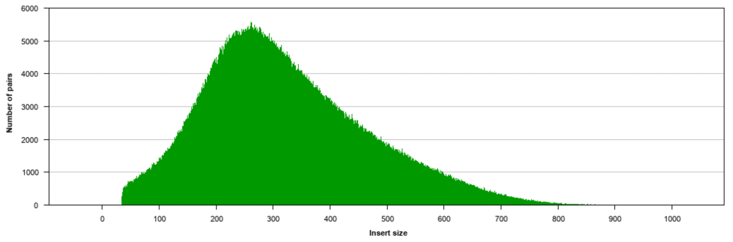
This document has an alternative
Figure 2 Analysis of sheared DNA using a DNA 1000 Bioanalyzer assay. The electropherogram shows a distribution with a peak size of 200 nucleotides
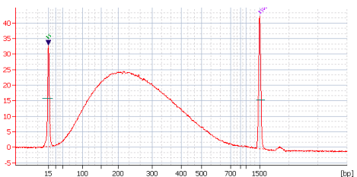

The Rayleigh probability density function (source Wikipedia) looks a good approximation to the second, less so for the first on the left-hand side of the curve
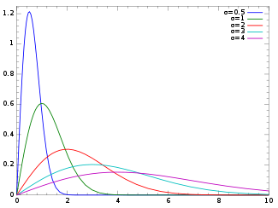

Using multiple calls to (Python library) numpy.random.rayleigh(scale=1.0, size=None), I can create a dataset which produces this graph, showing a peak at 300, after binning results in tens:

I can probably create a similar one showing a peak at 200.
The right-hand side, after the peak, gives me an approximation to the long right-hand tail in the first, although it could be skewed even further,
The left-hand side, before the peak, is skewed in the wrong direction: it is convex, where I need a concave-like curve
Questions:
a) Is there a different known density function that looks more like the first graph?
b) What method could I use to modify the curve for the section of data on the left of the peak, or am I just going to have to hand-manipulate this?
c) Are there any Python-available libraries that can help?
Thanks in anticipation.
Cary O’Donnell caryodonn@yahoo.com

