Data management and processing instructions
Important: set a value for $rootRG as described immediately below, in part a, before following any examples.

Commands shown in this document have been tested using MacOs zsh Examples use the double-quote symbol for decoding $ values eg: "$locus" and "$rootRG". Beware unintentional substitutions of this symbol for the double-quote symbols “ or ” which cause errors in sh interpretation.

Adding a new locus to the data management hierarchy
a) Locate and define a $rootRG directory.
The Github repository https://github.com/snowlizardz/rg_exploder_shared, has four directories at $rootRG level
caryodonnell@MacBook-Air Replicon % pwd
/Users/caryodonnell/Desktop/Replicon
caryodonnell@MacBook-Air Replicon % ls
data_sourcesexploder_pythonhelper_pythonhelper_scriptsmake_rootRG.sh
caryodonnell@MacBook-Air Replicon % export rootRG="`pwd`"
caryodonnell@MacBook-Air Replicon % echo $rootRG
/Users/caryodonnell/Desktop/Replicon
caryodonnell@MacBook-Air Replicon %
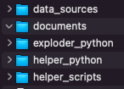
b) In "$rootRG"/data_sources these are the first-level data-source directories
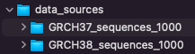
caryodonnell@MacBook-Air Replicon % ls "$rootRG"/data_sources
GRCH37_sequences_1000GRCH38_sequences_1000
...
GRCH37_sequences_1000: holds data files for build GRCH37
GRCH38_sequences_1000: holds data files for build GRCH38

c) Within each of these, there is one data directory for each locus:
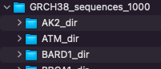
Eg: GRCH38_sequences_1000/AK2_dir holds downloaded AK2 data from Ensembl; initially as a file called ensembl.txt.gz, and later processed versions of these files (see ‘sequence file processing’ below)
c) To add a new "$locus" called AK22, create a new folder in the appropriate directory
GRCH38_sequences_1000/"$locus"_dir or GRCH37_sequences_1000/$"locus"_dir
> locus="AK22"
> mkdir "$rootRG"/data_sources/GRCH38_sequences_1000/"$locus"_dir

d) Follow “Downloading a sequence file ...” instructions below for the new "$locus"

e) Follow “Automated data processing…” instructions below for the new "$locus"
f) Also present in "$rootRG"/data_sources are the two main data-curation directories
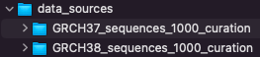
caryodonnell@MacBook-Air Replicon % ls "$rootRG"/data_sources
GRCH37_sequences_1000GRCH38_sequences_1000
GRCH37_sequences_1000_curationGRCH38_sequences_1000_curation
...
GRCH37_sequences_1000_curation: these hold curated files for build GRCH37
GRCH38_sequences_1000_curation: these hold curated files for build GRCH38
g) Within each of these, there is one data directory for each locus, eg:
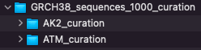
h) As with step c, add a new $locus folder in the appropriate curation directory eg:
GRCH38_sequences_1000_curation/"$locus"_curation
> locus="AK22"
> mkdir "$rootRG"/data_sources/GRCH38_sequences_1000_curation/"$locus"_dir

i) Follow “Maintaining the curation data” instructions below for the new "$locus"
j) Follow “Mashup time” instructions below to include the new "$locus" data in an updated version of the lookup file loci.json in

"$rootRG"/data_sources/exploder_input_38_1000/loci.json

k) Within "$rootRG"/data_sources are further directories to hold the input & output data when running the application. Create a directory for each locus in both the input and output directories:

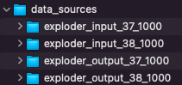
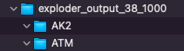
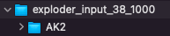
l) In "$rootRG"/data_sources/exploder_input_38_1000/"$locus" create soft links to files in the GRCH38_sequences_1000_curation/"$locus"_curation directory.

m) Locate "$rootRG"/data_sources/exploder_python
Create soft links to the desired input and output directories
caryodonnell@MacBook-Air exploder_python % pwd
/Users/caryodonnell/Desktop/Replicon/exploder_python
caryodonnell@MacBook-Air exploder_python % ls -l
…

input -> /Users/caryodonnell/Desktop/Replicon/data_sources/exploder_input_38_1000/
output -> /Users/caryodonnell/Desktop/Replicon/data_sources/exploder_output_38_1000/

Use "$rootRG"/data_sources/helper_scripts/switch_links.sh to flip quickly between
different sets; 37 and 38, for example

o) To create the lookup file "$rootRG"/data_sources/exploder_python/input/config.json
Run the python script RG_exploder_globals_make.py (check values in set_config_consts) in the exploder_python directory:

> cd "$rootRG"/exploder_python/
> python3 RG_exploder_globals_make.py

p) Finally, run the application "$rootRG"/data_sources/exploder_python/RG_exploder_gui.py

> cd "$rootRG"/exploder_python/
> python3 RG_exploder_gui.py

If the curation directory seems like overkill, it allows the maintenance of individual curated haplotype definitions, thereby separating the download-processed files from the input files. This is best illustrated by the EGFR set:

caryodonnell@MacBook-Air EGFR % pwd
/Users/caryodonnell/Desktop/Replicon/data_sources/exploder_input_38_1000/EGFR
caryodonnell@MacBook-Air EGFR % ls -l
total 0
EGFR_000000.gb -> EGFR_curation/EGFR_noseq.gb
EGFR_curation -> ../../GRCH38_sequences_1000_curation/EGFR_curation/
EGFR_locseq.gb -> EGFR_curation/EGFR_locseq.gb
EGFR_p1.gb -> EGFR_curation/EGFR_p1.gb
EGFR_p1som1.gb -> EGFR_curation/EGFR_p1som1.gb
EGFR_p1som15.gb -> EGFR_curation/EGFR_p1som15.gb
EGFR_p1som32.gb -> EGFR_curation/EGFR_p1som32.gb
EGFR_p2.gb -> EGFR_curation/EGFR_p2.gb
EGFR_p2som14.gb -> EGFR_curation/EGFR_p2som14.gb
EGFR_p2som16.gb -> EGFR_curation/EGFR_p2som16.gb
EGFR_p2som39.gb -> EGFR_curation/EGFR_p2som39.gb
EGFR_transcripts.json -> EGFR_curation/EGFR_transcripts.json

caryodonnell@MacBook-Air EGFR_curation % pwd
/Users/caryodonnell/Desktop/Replicon/data_sources/exploder_input_38_1000/EGFR/EGFR_curation
caryodonnell@MacBook-Air EGFR_curation % ls -l
total 80
EGFR_dir -> ../../GRCH38_sequences_1000/EGFR_dir/
EGFR_ensembl -> EGFR_dir/EGFR_ensembl
EGFR_locseq.gb -> EGFR_dir/EGFR_locseq.gb
EGFR_noseq.gb -> EGFR_dir/EGFR_noseq.gb
EGFR_p1.gb
EGFR_p1som1.gb
EGFR_p1som15.gb
EGFR_p1som32.gb
EGFR_p2.gb
EGFR_p2som14.gb
EGFR_p2som16.gb
EGFR_p2som39.gb
EGFR_transcripts.json

Downloading a sequence file for a locus from Ensembl
These instructions are suitable for downloading a new sequence, or when updating an existing one.
Starting at https://www.ensembl.org/Homo_sapiens/Info/Index:
- Find the gene of interest using Search & go to the Summary eg: ATM
  - Use the chosen gene name as locus below.
- Click on “export data” (LH menu)
- Select output: Flatfile/Genbank
- Select Forward Strand (preferred)
  - Alternatives are:
    - Feature Strand (This will be Forward or Reverse depending on the transcript)
    - Reverse Strand
- In “5' Flanking sequence (upstream)” and “3' Flanking sequence (downstream)”: enter 1000
  - A minimum value of 1000 is essential for supporting ‘paired end reads’
- In “Options for Genbank”:
  - Deselect all
  - Reselect: “variation features” and “gene information” (exon, mRNA & CDS definitions)
- Press “Next”

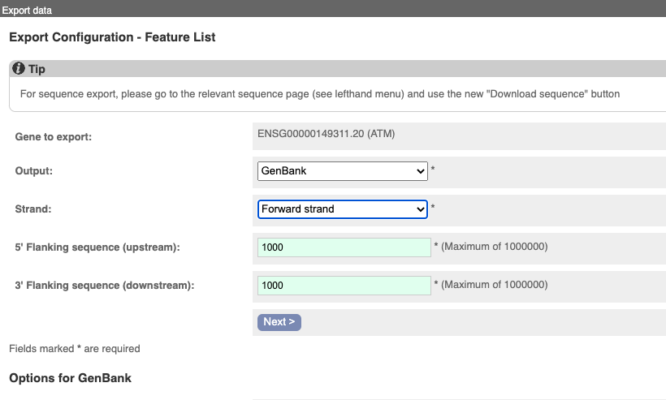
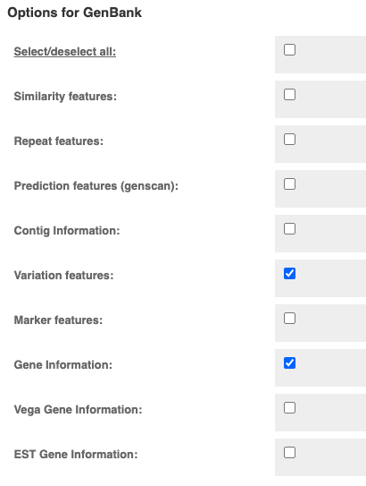
- In the new “Export data” window, click the “compressed text (gz)” link
- The downloaded file is named ensembl.txt.gz
  - Move this file, into a data directory called "$rootRG"/data_sources/"$locus"_dir eg: the GRCH38_sequences_1000/AK2_dir example above
  - Rename it to "$locus"_ensembl eg: AK2_ensembl
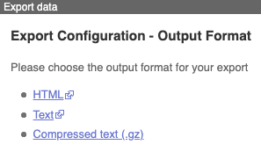

Downloading a sequence file for a locus from NCBI
These instructions are suitable for downloading a new sequence, or when updating an existing one
Starting at https://www.ncbi.nlm.nih.gov/
- Find the gene of interest using Search

- Click on the link in the gene card
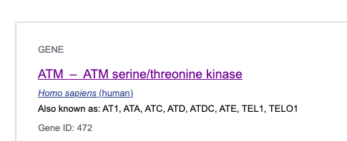
- Which shows the gene summary
- Click on "Genomic regions, transcripts, and products", then scroll down
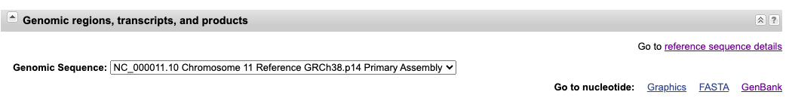
- Click on "Go to nucleotide ... Genbank" eg:
  - https://www.ncbi.nlm.nih.gov/nuccore/NC_000011.10?report=genbank&from=108223067&to=108369102

- Subtract 1000 from the start and add 1000 to the end:
  - https://www.ncbi.nlm.nih.gov/nuccore/NC_000011.10?report=genbank&from=108222067&to=108370102

- Top of page; modify "Customize view"; pulldown "Send to"; click "File" & "Create File"

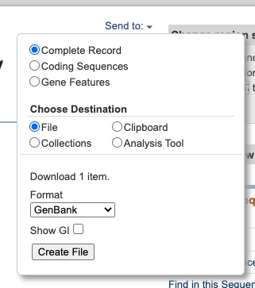
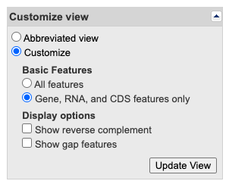

- The output is a file called sequence.db

Automated data processing for downloaded Ensembl data

Introduction to data processing
There are two main objectives:
a) Create a config.json file as a lookup list for the application.
b) Remove, from the downloaded ensembl.txt.gz, all the data unnecessary for this application.
Adding new data into the config.json file could be done manually by looking at the existing examples. The helper scripts automate the filtering, config.json generation, and other fiddly bits.

Using a feature-filter Python script
A Python script, "$rootRG"/helper_python/embl_feature_filter_revise.py should be used to process a "$locus"_ensembl file in either gz or uncompressed format eg:
> cd "$rootRG"/data_sources/GRCH38_sequences_1000/"$locus"_dir
> python3 "$rootRG"/helper_python/embl_feature_filter_revise.py -i "$locus"_ensembl -a
The output files used by the RG_exploder application, are:
"$locus"_locseq.gb: Contains a cleaned-up feature table: retaining only minimal db_xref identifiers; mRNA and CDS join data. Also holds the DNA sequence.
"$locus"_noseq.gb: Contains no DNA sequence and the bare minimum definition data. In the application it is used to define the "$locus"_000000 haplotype. This file is also used as a template for defining the variants in haplotypes, in the curation directory.
"$locus"_transcripts.json: Holds lookup data for the GUI part of the application.
Other output files, useful for curation and checking:
"$locus"_filtered.gb: The ‘original file’ with all the unwanted data taken out; same content as "$locus"_locseq.gb, but including all the variation features from the original source.
"$locus"_filtervar.gb: As for "$locus"_noseq.gb, but including all the variation features. These may be useful for extracting a subset of variation features to make haplotype definition files.
Parameters for embl_feature_filter_revise.py:
-i is the downloaded-from-Ensembl input file eg: ensembl.txt.gz,
-a is necessary to produce “all” output files (described below)
-j omits mRNA and CDS join data in "$locus"_transcripts.json
- -j may be used only for the Python GUI; the browser version requires the join data

An alternative feature-filter Python script
The Python script, "$rootRG"/helper_python/embl_feature_filter8.py does not use Biopython, using a line-by-line text elimination of 'dbxref= database' lines eg:unwanted=['xref="RefSeq_mRNA_predicted:', ... 'db_xref="RefSeq_ncRNA_predicted:']
Note that new, unnecessary data appears over time, so this list needs to be maintained. This is a harder script to maintain than embl_feature_filter_revise.py but was developed first. It may be useful to compare the output between these two.

Filtering multiple data sets at once
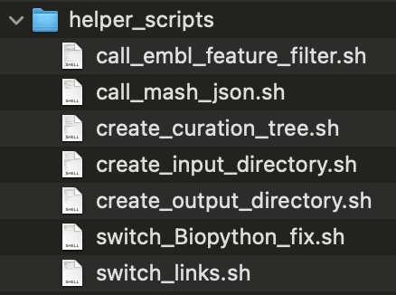
To automate this one step further, by (re-)processing multiple locus directories at once, using scripts in "$rootRG"/helper_scripts/

Automating feature-filter scripts
Use the script call_embl_feature_filter.sh to run a feature_filter script repeatedly for each subdirectory of downloaded data.

a) Go to the directory where
> cd "$rootRG"/data_sources/GRCH38_sequences_1000/
Or
> cd "$rootRG"/data_sources/GRCH37_sequences_1000/
caryodonnell@MacBook-Air AK2_dir % cd "$rootRG"/data_sources/GRCH38_sequences_1000/
caryodonnell@MacBook-Air GRCH38_sequences_1000 % ls -l
total 0
AK2_dir
ATM_dir
…
STK11_dir
TP53_dir
caryodonnell@MacBook-Air GRCH38_sequences_1000 %

Then:
> sh "$rootRG"/helper_scripts/call_embl_feature_filter.sh

As supplied the default is to use embl_feature_filter_revise.py
Within call_embl_feature_filter.sh you may change which of the feature-filter scripts is used

# There are two filter programs ...
python_filter1="$rootapplicationdir$filter8
# embl_feature_filter8.py is a difficult-to-follow line-by-line parsing of the input file
python_filter2="$rootapplicationdir$filter_revise

...
# ... Pick one:
# python_filter=$python_filter1
python_filter=$python_filter2

Amendments for attention in these python scripts prior to execution
When adding a new locus, corresponding identifiers need to be added to the two dictionary lists within embl_feature_filter_revise.py and embl_feature_filter8.py
- MANE_Select_dict and LRG_id_dict
  - Each item in MANE_Select_dict is the transcript identifier assigned MANE_Select status for each locus.
MANE_Select_dict={
"AK2":"672715",
"ATM":"675843",
…
"STK11":"326873",
"TP53":"269305"
}
  - Likewise items in LRG_id_dict are the LRG identifiers for each locus.
LRG_id_dict={
"AK2":"133",
"ATM":"135",
…
"STK11":"319",
"TP53":"321"
}
  - A link to LRG was an early user-requirement for a link from “Locus”, but LRG now appears to be being phased out. Links now go to the LRG page in Ensembl.
  - To include the correct date requires a code change in make_transcriptconstants(), eg: Release=”Ensembl Release 105 (Dec 2021)"

Data processing for downloaded NCBI data
Automated processing is currently not available for data downloaded directly from NCBI
There are significant differences between the content of Ensembl & Genbank downloads. Listing these, incompletely, here:
- There is no link between Transcript ID and CDS in Genbank output, unlike Ensembl
- The CDS in Genbank are clustered together in Genbank, and not interlaced with mRNA, as in Ensembl.
- There are far fewer tags that would need excluding
  - The major things to remove are:
    - Any information from genes not in the intended gene set (ie: overlaps or other-strand)
    - /translation="
- The terms for the transcript id and gene_id differ between Ensembl & Genbank eg:

Ensembl
gene 1001..147059
/gene=ENSG00000149311.20
/locus_tag="ATM"
/note="ATM serine/threonine kinase [Source:HGNC
Symbol;Acc:HGNC:795]"
mRNA ...
/gene="ENSG00000149311.20"
/ standard_name="ENST00000675843.1"

Genbank
gene 1001..147036
/gene="ATM"
/db_xref="GeneID:472"
/db_xref="HGNC:HGNC:795"
mRNA ...
/gene="ATM"
/transcript_id="XM_011542840.4"

Advantage:
a) Far less removal of unwanted content is required

Disadvantages:
a) Transcript ID tags are different
b) Cannot link a CDS to a given transcript with the information in this file, it would have to be inferred by order; a complication being the potential inclusion of non-coding mRNA

Automation of post-processing

Introduction to post-processing
Three more directories are required for data maintenance:
Curation: "$rootRG"/data_sources/GRCH38_sequences_1000_curation
Input: "$rootRG"/data_sources/exploder_input_38_1000
Output: "$rootRG"/data_sources/exploder_output_38_1000

The purpose of the curation directory is to maintain a working area where the variant haplotype data may be manipulated separately from the reference-data. The curation sub-directories for each locus initially holds soft links to the processed files in
"$rootRG"/data_sources/GRCH38_sequences_1000/ "$locus"_dir
Occasionally an edited copy of "$locus"_locseq.gb is used within the curation directory (eg: AK2 for GRCH37) instead of a soft-link.

The input directory is used by the application.
- The input directory requires the presence of a configuration file config.json.
- The input sub-directories for each locus hold soft links to files in the curation directories.
- The output directory requires empty folders for each locus present.

The output directory is also used by the application.
- The sub-directories have the same names present in the input directory.
- These are empty to receive the output from the Python GUI

Automated addition of multiple new curation folders
If you are starting from scratch and do not already have the directories
"$rootRG"/GRCH38_sequences_1000_curation,
or
"$rootRG"/GRCH37_sequences_1000_curation,

then:

a) Check, and amend where necessary, the path definitions at the head of
"$rootRG"/helper_scripts/create_curation_tree.sh

rootapplicationdir="$rootRG"/
rootdatadir=$rootapplicationdir"data_sources/"
targetdir37="GRCH37_sequences_1000"
targetdir38="GRCH38_sequences_1000"

b) Execute the script using 37 or 38 as a parameter eg:
> sh "$rootRG"/helper_scripts/create_curation_tree.sh 38

and it will build a set of directories in eg: where ?? is 37 or 38
"$rootRG"/GRC??_sequences_1000_curation, with the same starting names as in
"$rootRG"/GRCH??_sequences_1000
It also creates soft links from GRCH38_sequences_1000 as described previously

c) If you already have a curation directory, and execute the script anyway: you will get many error-reports about files that have been created previously, but these should be harmless.
You should find that any new locus directories will be created within the relevant curation directory.

Automated addition of multiple new input and output folders
If you are starting from scratch and do not already have the directories
"$rootRG"/exploder_input_??_1000 and "$rootRG"/exploder_output_??_1000 then
a) Check, and amend where necessary, the path definitions at the head of the two scripts
"$rootRG"/helper_scripts/create_input_directory.sh:
rootapplicationdir="$rootRG"/
rootdatadir=$rootapplicationdir"data_sources/"
targetdir37="GRCH37_sequences_1000"
input_seq37=$rootdatadir"exploder_input_37_1000"
targetdir38="GRCH38_sequences_1000"
input_seq38=$rootdatadir"exploder_input_38_1000"

"$rootRG"/helper_scripts/create_output_directory.sh:
rootapplicationdir="$rootRG"/
rootdatadir=$rootapplicationdir"data_sources/"
output_seq37=$rootdatadir"exploder_output_37_1000"
input_seq37=$rootdatadir"exploder_input_37_1000"
output_seq38=$rootdatadir"exploder_output_38_1000"
input_seq38=$rootdatadir"exploder_input_38_1000"

b) Execute the first script using 37 or 38 as a parameter
eg: > sh "$rootRG"/helper_scripts/create_input_directory.sh 38

and it will build a set of directories in eg:
"$rootRG"/exploder_input_38_1000
with the same names as in "$rootRG"/GRCH38_sequences_1000

It also creates soft links from GRCH38_sequences_1000_curation as described previously.

Plus it overwrites / creates a soft link
"$rootRG"/exploder_python/input
to
"$rootRG"/exploder_input_38_1000

c) Execute the second script using 37 or 38 as a parameter
eg: > sh "$rootRG"/helper_scripts/create_output_directory.sh 38
and it will build a set of empty directories, with the same names as in the output directory, in eg:
"$rootRG"/exploder_output_38_1000
Plus it deletes "$rootRG"/exploder_python/output

and makes this a soft link to

"$rootRG"/exploder_output_38_1000

d) If you already have an input and output directory, and execute the script anyway: you will get error-reports for files previously created.
You should find that any new locus directories originating from the curation directories will be created within the input and output directories. Just be aware of the possible errors arising from trying to create a soft link that already exists.

Mashup time
This file must exist for RG_exploder_globals_make.py to run:
"$rootRG"/data_sources/exploder_input_38_1000/loci.json

It is a concatenation of all the individual "$locus"_transcripts.json files in the input subdirectories eg:
caryodonnell@MacBook-Air data_sources % ls "$rootRG"/data_sources/exploder_input_38_1000/*/*.json
/Users/caryodonnell/Desktop/Replicon//data_sources/exploder_input_38_1000/AK2/AK2_transcripts.json
/Users/caryodonnell/Desktop/Replicon//data_sources/exploder_input_38_1000/ATM/ATM_transcripts.json
...
/Users/caryodonnell/Desktop/Replicon//data_sources/exploder_input_38_1000/STK11/STK11_transcripts.json
/Users/caryodonnell/Desktop/Replicon//data_sources/exploder_input_38_1000/TP53/TP53_transcripts.json

To create / renew this file with the latest data:
a) Check, and amend where necessary, the path definitions at the head of the script
"$rootRG"/helper_scripts/call_mash_json.sh

rootapplicationdir="$rootRG"/
rootdatadir=$rootapplicationdir"data_sources/"
input_seq37=$rootdatadir"exploder_input_37_1000"
input_seq38=$rootdatadir"exploder_input_38_1000"

Then execute:
> sh "$rootRG"/helper_scripts/call_mash_json.sh 38

Finally, as in the instructions at the start of this document:

o) To create the lookup file "$rootRG"/data_sources/exploder_python/input/config.json
Run the python script RG_exploder_globals_make.py (check values in set_config_consts) in the exploder_python directory:

> cd "$rootRG"/exploder_python/
> python3 RG_exploder_globals_make.py

Now the data should be ready for the application, test it out:

p) Finally, run the application "$rootRG"/data_sources/exploder_python/RG_exploder_gui.py

> cd "$rootRG"/exploder_python/
> python3 RG_exploder_gui.py

Manual maintenance of curation data
This section describes steps that the automated post-processing will do, along with manual maintenance to Variant Haplotype definition files. Managing special cases is also described.

Manual addition of a new curation folder
> mkdir "$rootRG"/data_sources/GRCH38_sequences_1000_curation/"$locus"_curation
> cd "$rootRG"/data_sources/GRCH38_sequences_1000_curation/"$locus"_curation
Simply soft link to the source data locus directory
> ln -s ../ ../GRCH38_sequences_1000/"$locus"_dir
Then soft link the following 2 files:
> ln -s "$locus"_dir/"$locus"_locseq.gb .
> ln -s "$locus"_dir/"$locus"_noseq.gb .
Then copy this one:
> cp -p "$locus"_dir/"$locus"_transcripts.json .
For a simple setup, such as for BARD1, which has no haplotype definitions apart from the reference, nothing more needs to be done.
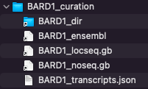
BARD1_dir -> ../../GRCH38_sequences_1000/BARD1_dir/
BARD1_ensembl -> BARD1_dir/BARD1_ensembl
BARD1_locseq.gb -> BARD1_dir/BARD1_locseq.gb
BARD1_noseq.gb -> BARD1_dir/BARD1_noseq.gb
BARD1_transcripts.json

A link to BARD1_ensembl is not required in this directory, but its presence can be useful.
Other loci are described below; chosen to demonstrate both the standard and less-obvious maintenance options available.
For AK2
> cd "$rootRG"/data_sources/GRCH38_sequences_1000_curation/AK2_curation
> ls -l
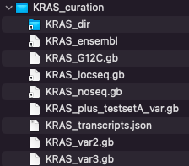
AK2_EB0001.gb
AK2_EB0002.gb
AK2_EB0003.gb
AK2_EB0004.gb
AK2_EB0005.gb
AK2_EB0006.gb
AK2_dir -> ../../GRCH38_sequences_1000/AK2_dir/
AK2_ensembl -> AK2_dir/AK2_ensembl
AK2_locseq.gb -> AK2_dir/AK2_locseq.gb
AK2_noseq.gb -> AK2_dir/AK2_noseq.gb
AK2_transcripts.json

Each of the haplotype definition files, in bold, contain these essential components:

A) The Header section, note the 0 bp definition, as there is no sequence in the file:
LOCUS 1 0 bp DNA HTG 19-AUG-2022
DEFINITION Homo sapiens chromosome 1 GRCh38 partial sequence 33006986..33081996
reannotated via EnsEMBL.

ACCESSION chromosome:GRCh38:1:33006986:33081996:1
VERSION chromosome:GRCh38:1:33006986:33081996:1
FEATURES Location/Qualifiers
source 1..75011
/organism="Homo sapiens"
/db_xref="taxon:9606"
gene complement(1001..74011)
/gene="ENSG00000004455.18"
/locus_tag="AK2"
/note="adenylate kinase 2 [Source:HGNC
Symbol;Acc:HGNC:362]"

This section should be the same as found in the file AK2_noseq.gb which can be used as a template for their creation.
B) A definition of the variation(s) in the Feature table, eg:
AK2_EB0001.gb has just one:
variation 7582..7583
/replace="GG/G"
AK2_EB0001.gb also has one:
variation 14469..14471
/replace="TCA/-"

C) To create a file defining a new variant, options include:

1) Use a SNP or other identifier and look in the file AK2_ensembl (the uncompressed, unfiltered source file) or in AK2_dir/AK2_filtervar.gb

eg: dbSNP:rs1553151177 (the AK2_EB0001 variant) can be found alongside other definitions

variation 7582..7582
/replace="G/T"
/db_xref="dbSNP:rs1241229733"
variation 7582..7582
/replace="HGMD_MUTATION"
/db_xref="HGMD-PUBLIC:CD090014"
variation 7582..7583
/replace="GG/G"
/db_xref="dbSNP:rs1553151177"

Edit the required lines into a copy of AK2_noseq.gb
Just be certain NOT to include overlapping definitions; the application does not recognise these overlaps and is likely to give incorrect output.

2) You may be able to edit a new definition from other markers you recognise, or using offsets. This manual method is very error-prone.

3) To create a validated position for a sequence-modification: first complete all the other “adding a new locus” steps; then run the GUI and use the “Create a new locus Haplotype Variant” feature, along with “Save Source Features”. That will generate an output file with a name you supply that can be copied straight back into this directory. Worked example for EGFR below.

For EGFR
> cd "$rootRG"/data_sources/GRCH38_sequences_1000_curation/EGFR_curation

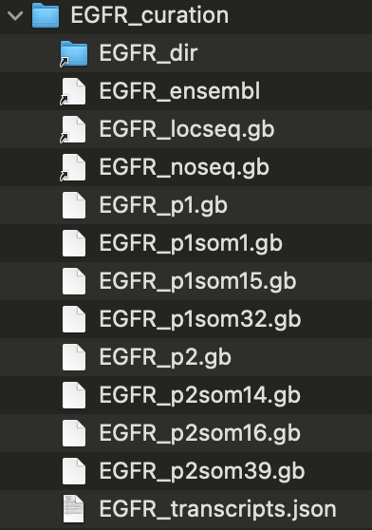
caryodonnell@MacBook-Air EGFR_curation % pwd
/Users/caryodonnell/Desktop/Replicon/data_sources/exploder_input_38_1000/EGFR/EGFR_curation
caryodonnell@MacBook-Air EGFR_curation % ls -l
total 80
EGFR_dir -> ../../GRCH38_sequences_1000/EGFR_dir/
EGFR_ensembl -> EGFR_dir/EGFR_ensembl
EGFR_locseq.gb -> EGFR_dir/EGFR_locseq.gb
EGFR_noseq.gb -> EGFR_dir/EGFR_noseq.gb
EGFR_p1.gb
EGFR_p1som1.gb
EGFR_p1som15.gb
EGFR_p1som32.gb
EGFR_p2.gb
EGFR_p2som14.gb
EGFR_p2som16.gb
EGFR_p2som39.gb
EGFR_transcripts.json
The variant definitions here are hierarchical, it uses two different haplotype definitions, each extracted originally from EGFR_ensembl, with extra commentary added from other sources:
EGFR_p1.gb (for “parent 1”)
variation 156018..156018
/replace="G/A"
/db_xref="dbSNP:rs55959834"
/consequence="dbSNP:synonymous_variant,genic_downstream_transcript_variant"
/consequence="dbSNP:coding_sequence_variant"
/comment=”ensembl:minor allele exon18, synonymous variant at v low freq 0.001”

variation 160511..160511
/replace="G/A"
/db_xref="dbSNP:rs62457092"
/consequence="dbSNP:genic_downstream_transcript_variant,intron_variant"
/comment=”ensembl:intron_variant 19_20 minor allele at 0.32”
EGFR_p2.gb (for “parent 2”)
variation 159798..159798
/replace="A/G"
/db_xref="dbSNP:rs845552"
/consequence="dbSNP:intron_variant,genic_downstream_transcript_variant"
/comment=”ensembl:intron_variant 19_20 minor allele at 0.45”

variation 163354..163354
/replace="G/A"
/db_xref="dbSNP:rs1050171"
/consequence="dbSNP:genic_downstream_transcript_variant,synonymous_variant"
/consequence="dbSNP:missense_variant,non_coding_transcript_variant"
/consequence="dbSNP:coding_sequence_variant"
/comment=”ensembl:minor allele exon 20, synonymous variant at 0.43”
The other files have further variants added onto these basic haplotypes
IMPORTANT:
The header sections of the ‘parent1’ files must agree with the source of the variant.
EGFR_p1.gb header:
LOCUS 7 0 bp DNA HTG 27-FEB-2022
DEFINITION Homo sapiens chromosome 7 GRCh38 partial sequence 55018017..55212628 reannotated
via EnsEMBL
ACCESSION chromosome:GRCh38:7:55018017:55212628:1
VERSION chromosome:GRCh38:7:55018017:55212628:1
COMMENT /consequence and /comment annotation by Replicon Genetics from public domain sources
FEATURES Location/Qualifiers
source 1..194612
/organism="Homo sapiens"
/db_xref="taxon:9606"
gene 1001..193612
/gene=ENSG00000146648.20
/locus_tag="EGFR"

EGFR_p1som1.gb: (som1 for “somatic 1”)
LOCUS 7 0 bp DNA HTG 27-FEB-2022
DEFINITION Homo sapiens chromosome 7 GRCh38 partial sequence 55018017..55212628 reannotated
via EnsEMBL
ACCESSION chromosome:GRCh38:7:55018017:55212628:1
VERSION chromosome:GRCh38:7:55018017:55212628:1
COMMENT /consequence and /comment annotation by Replicon Genetics from public domain sources
FEATURES Location/Qualifiers
source 1..194612
/organism="Homo sapiens"
/db_xref="taxon:9606"
gene 1001..193612
/gene=ENSG00000146648.20
/locus_tag="EGFR"

Intended capability not currently available here crossed out:
They DO NOT need to be exactly the same as the header in the reference-sequence file
EGFR_locseq.gb:
LOCUS 7 194612 bp DNA HTG 27-FEB-2022
DEFINITION Homo sapiens chromosome 7 GRCh38 partial sequence 55018017..55212628 reannotated
via EnsEMBL
ACCESSION chromosome:GRCh38:7:55018017:55212628:1
VERSION chromosome:GRCh38:7:55018017:55212628:1
FEATURES Location/Qualifiers
source 1..194612
/organism="Homo sapiens"
/db_xref="taxon:9606"
gene 1001..193612
/gene=ENSG00000146648.20 ← The difference is gene-id version is acceptable
/locus_tag="EGFR"

The range for the reference definition is GRCh38:7:55018017:55212628:1
The range for the variant definition is GRCh38:7:55018517:55212128:1
- Both the GRCh version and strand are the same: this is essential
- The sequence range of the variant is wholly contained within the reference range
  - If not, the application will generate a warning message and should ignore the haplotype completely.
  - The application detects the disparity and recalculates the offset
In this way, variant definition files do not need to be regenerated each time the source files are updated, and where only a small redefinition of the gene range takes place.
The inspiration, and naming, for this set of EGFR variants comes from table 2 of “Molecular characteristics and clinical outcomes of EGFR exon 19 indel subtypes to EGFR TKIs in NSCLC patients” by Su et al Oncotargetv.8(67); 2017 Dec 19
Subtypes are defined at CDS like this: Subtype 21 - c.2239_2247del9

Additional variants:
Here’s how to add two of the subtypes described using the application GUI rather than alternative, painstaking methods.

Subtype 21
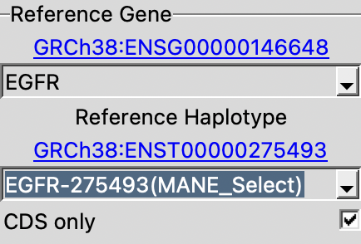
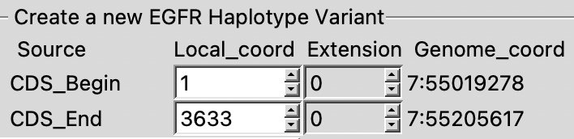
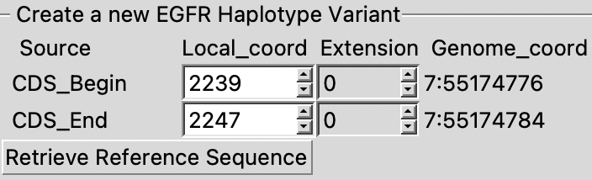
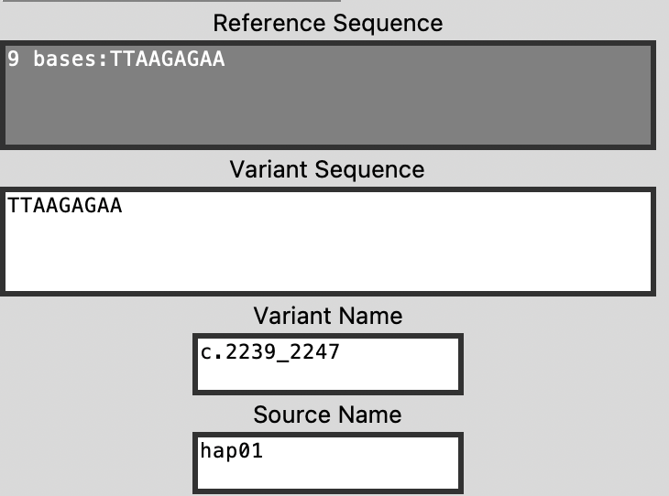

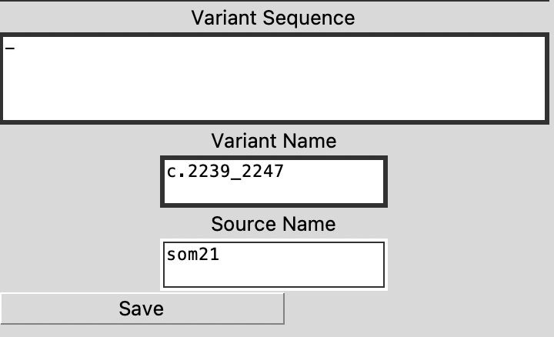
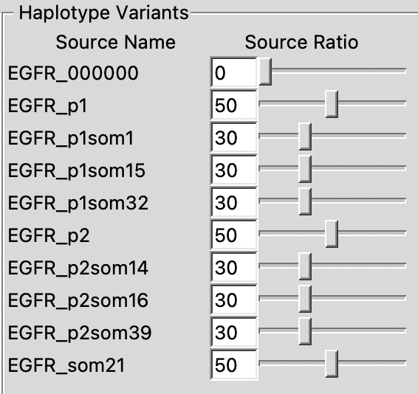
Set this before pressing “GO”

In the output will be a file name like EGFR-275493-CDS_paired_DNASeq_som21.gbout
LOCUS 7 0 bp DNA HTG 27-FEB-2022
DEFINITION Homo sapiens chromosome 7 GRCh38 partial sequence 55018017..55212628
reannotated via EnsEMBL.
ACCESSION chromosome:GRCh38:7:55018017:55212628:1
VERSION chromosome:GRCh38:7:55018017:55212628:1
KEYWORDS .
SOURCE .
ORGANISM .
.
FEATURES Location/Qualifiers
source 1..194612
/organism="Homo sapiens"
/db_xref="taxon:9606"
gene 1001..193612
/gene="ENSG00000146648.20"
/locus_tag="EGFR"
/note="epidermal growth factor receptor [Source:HGNC
Symbol;Acc:HGNC:3236]"
variation 156760..156768
/replace="TTAAGAGAA/-"
/db_xref="som21_1:c.2239_2247"
/global_range="GRCh38:7:55174776:55174784:1"
ORIGIN

Note that the location calculated by the application matches the assigned COSM6218 entry

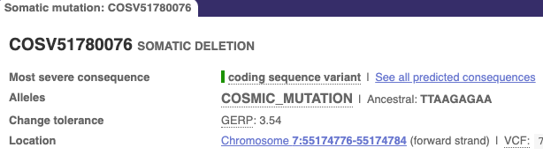

NB: The header matches that of the reference EGFR_locseq.gb

Subtype 24 - c.2239_2253>aat COSM51503
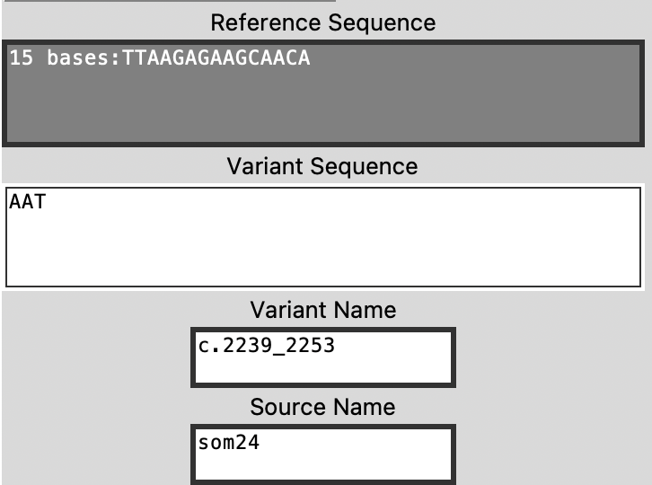
variation 156760..156774
/replace="TTAAGAGAAGCAACA/AAT"
/db_xref="som24_1:c.2239_2253"
/global_range="GRCh38:7:55174776:55174790:1"

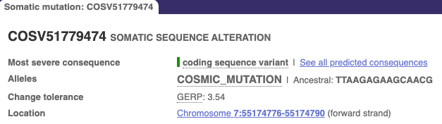

A preferable method would be to use VCF files, but the application is not currently set up for this.
For AK2 in GRCh37
The MANE_Select transcript for AK2 is not defined in GRCh37, but exists in GRCh38 with the identifier ENST00000672715
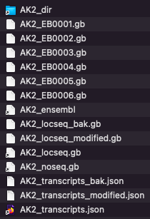
After manually identifying the differing offset-positions between GRCh37 and GRCh38 for exons shared with other transcripts, it was possible to create mRNA and CDS join features for the missing features in GRCh37. To verify this, the transcripts created from each version by the application were aligned. The sequence for this transcript differs by a single base substitution at one location between the two genome builds.
The new file is maintained as AK2_locseq_modified.gb with AK2_locseq.gb now a soft-link to it and the original saved as AK2_locseq_bak.gb
AK2_locseq.gb -> AK2_locseq_modified.gb
AK2_locseq_bak.gb
AK2_locseq_modified.gb
AK2_noseq.gb -> AK2_dir/AK2_noseq.gb
AK2_transcripts.json -> AK2_transcripts_modified.json
AK2_transcripts_bak.json
AK2_transcripts_modified.json

AK2_locseq_bak.gb is the original version of AK2_locseq.gb
Comparing the feature tables between the two builds:
AK2_locseq_modified.gb for GRCh37
Note the modified transcript identifier: from "ENST00000672715.1" to "ENST00000672715m.1"

The ‘m’ modifier is recognised in the GUI to generate a URL to link to Ensembl GRCh38 instead of GRCh37.

LOCUS 1 75013 bp DNA HTG 12-AUG-2022
DEFINITION Homo sapiens chromosome 1 GRCh37 partial sequence 33472585..33547597 reannotated
via EnsEMBL
ACCESSION chromosome:GRCh37:1:33472585:33547597:1
VERSION chromosome:GRCh37:1:33472585:33547597:1
FEATURES Location/Qualifiers
source 1..75013
/organism="Homo sapiens"
/db_xref="taxon:9606"
gene complement(1001..74013)
/gene=ENSG00000004455.12
/locus_tag="AK2"
/note="adenylate kinase 2 [Source:HGNC Symbol;Acc:362]"
mRNA join(complement(29753..29887),complement(17459..17584),
complement(14610..14720),complement(14384..14478),
complement(7539..7611),complement(1003..6419))
/gene="ENSG00000004455.12"
/standard_name="ENST00000672715m.1"
/comment="RG:copied from GRCH38 as not present in 37 download"
CDS join(complement(29753..29845),complement(17459..17584),
complement(14610..14720),complement(14384..14478),
complement(7539..7611),complement(6198..6419))
/gene="ENSG00000004455.12"
/protein_id="ENSP00000499935.1"
/note="transcript_id=ENST00000672715m.1"

AK2_locseq.gb for GRCh38:

LOCUS 1 75011 bp DNA HTG 19-AUG-2022
DEFINITION Homo sapiens chromosome 1 GRCh38 partial sequence 33006986..33081996 reannotated
via EnsEMBL
ACCESSION chromosome:GRCh38:1:33006986:33081996:1
VERSION chromosome:GRCh38:1:33006986:33081996:1
FEATURES Location/Qualifiers
source 1..75011
/organism="Homo sapiens"
/db_xref="taxon:9606"
gene complement(1001..74011)
/gene=ENSG00000004455.18
/locus_tag="AK2"
/note="adenylate kinase 2 [Source:HGNC
Symbol;Acc:HGNC:362]"
…
mRNA join(complement(29751..29898),complement(17457..17582),
complement(14608..14718),complement(14382..14476),
complement(7537..7609),complement(1001..6417))
/gene="ENSG00000004455.18"
/standard_name="ENST00000672715.1"
CDS join(complement(29751..29843),complement(17457..17582),
complement(14608..14718),complement(14382..14476),
complement(7537..7609),complement(6196..6417))
/gene="ENSG00000004455.18"
/protein_id="ENSP00000499935.1"
/note="transcript_id=ENST00000672715.1"

The file AK2_transcripts.json has been modified to incorporate the additional, modified transcript identifier. The original, modified and soft-linked files are managed in the same manner as for AK2_locseq.gb.

Directory management
A) Screen shots from MacOS Finder
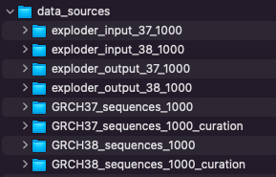
At the root level are these directories
GRCH38_sequences_1000/locus_dir initially hold the downloaded ensembl.txt.gz files of each locus
After automated processing of ensembl.txt.gz, these files remain in each locus_dir sub directory:
locus_ensembl – the original, now unzipped, downloaded file
locus_filtered.gb – same as locus_ensembl, minus unwanted annotation
locus_filtervar.gb – as above, but without mRNA & CDS features, without sequence ; just the variations
locus_locseq.gb – everything in locus_filtered.gb, without the variations; this is the Reference Source used in the application.
locus_noseq.gb – A no-sequence, no-features version. This is used as the input for locus_00000 haplotype in the application. It is a blank template for curating other haplotypes. Find known variants in locus_locseq.gb
locus_transcripts.json – lookup information for the application. These are later concatenated into config.json
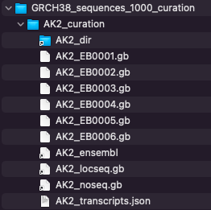
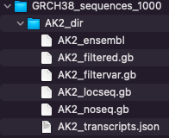
A curation directory is used to demarcate the automated-processed files from the hand-created haplotye definitions.
Here: AK2_EB0001.gb … AK2_EB0006.gb

Other files in this locus_curation directory are usually soft linked to the above. There may be exceptions to this, notably in GRCH37_sequences_1000_curation - the original AK2_locseq.gb and AK2_transcripts.json have been hand-edited to include the MANE_Select transcript that is absent in GRCH37, but is defined in GRCH37.

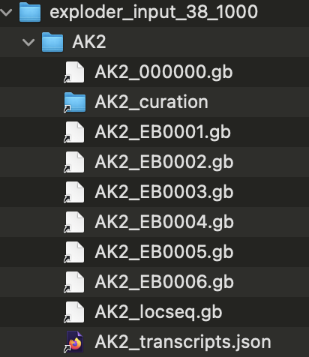
exploder-input_38_1000
The exploder_python/input directory is a soft link to here

Where all files in
exploder_input_38_1000/locus
are soft links to files in GRCH38_sequences_1000_curation/locus_curation
This allows for hand-culling or renaming of links in the input directory whilst retaining them in the curation directory or under a different name. Eg: compare the EGFR directories.

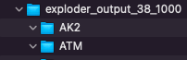
Finally – exploder-output_38_1000
Where the sub-directories for each locus are empty to receive the output from the application.
The exploder_python/output directory is a soft link to here

Recorded information on loci
NB: positions & annotation seems to change with Ensembl release versions. There may be inconsistency in the numbers stated within the URL (r=x:nnn-nnn) for the Ensembl ID and the genomic location this actually links to, but the URL seems to correct itself over time.
Note that it's normal for Ensembl and NCBI to show different position mappings; typically small numerical-differences at the start and end of a locus. All below are Ensembl mappings
Ensembl Release 96 Apr 2019, GRCh38.p12 – GENCODE release 30
OMIM | HGNC symbol report | Ensembl ID | Genomic Location  GRCh38.p12 | Publication | NIH genetics home reference
ATM | HGNC:795 | ENSG00000149311 | 11: 108,219,552-108,372,034 (+) |  | ATM serine/threonine kinase  ataxia telangiectasia
BARD1 | HGNC:952 | ENSG00000138376 | 2: 214,723,966-214,811,363 (-) |  | BRCA1 associated RING domain 1
BRCA1 | HGNC:1100 | ENSG00000012048 | 17: 43,041,776-43,172,764 (-) |  | DNA repair associated
BRCA2 | HGNC:1101 | ENSG00000139618 | 13: 32,313,779-32,401,961 (+) |  | DNA repair associated
BRIP1 | HGNC:20473 | ENSG00000136492 | 17: 61,677,621-61,867,166 (-) |  | BRCA1 interacting protein C-terminal helicase 1
CDH1 | HGNC:1748 | ENSG00000039068 | 16: 68,735,328-68,837,505 (+) |  | cadherin 1
CDK12 | HGNC:24224 | ENSG00000167258 | 17: 39,459,444-39,566,974 (+) |  | cyclin dependent kinase 12
CHEK1 | HGNC:1925 | ENSG00000149554 | 11: 125,624,114-125,677,277 (+) |  | checkpoint kinase 1
CHEK2 | HGNC:16627 | ENSG00000183765 | 22: 28,686,650-28,743,515 (-) | Breast Cancer (Dove Med Press). 2017; 9: 331–335. | checkpoint kinase 2
EPCAM | HGNC:11529 | ENSG00000119888 | 2: 58,157,601-58,243,014 (+) |  | epithelial cell adhesion molecule
FANCL | HGNC:20748 | ENSG00000115392 | 2: 58,159,243-58,241,372 (-) |  | FA complementation group L
KRAS | HGNC:6407 | ENSG00000133703 | 12: 25,203,867-25,251,858 (-) |  | KRAS proto-oncogene, GTPase
MLH1 | HGNC:7127 | ENSG00000076242 | 3: 36,992,181-37,052,069 (+) |  | mutL homolog 1  - DNA repair
MSH2 | HGNC:7325 | ENSG00000095002 | 2: 47,397,766-47,668,349 (+) |  | mutS homolog 2
MSH6 | HGNC:7329 | ENSG00000116062 | 2: 47,693,239-47,812,392 (+) |  | mutS homolog 6
NBN | HGNC:7652 | ENSG00000104320 | 8: 89,931,939-90,004,625 (-) |  | nibrin
NF1 | HGNC:7765 | ENSG00000196712 | 17: 31,089,184-31,387,859 (+) |  | Neurofibromin 1
PALB2 | HGNC:26144 | ENSG00000083093 | 16: 23,602,397-23,642,073 (-) |  | partner and localizer of BRCA2
PMS2 | HGNC:9122 | ENSG00000122512 | 7: 5,970,162-6,009,869 (-) |  | PMS1 homolog 2, mismatch repair system component
PPP2R2A | HGNC:9304 | ENSG00000221914 | 8: 26,289,885-26,374,303 (+) |  | protein phosphatase 2 regulatory subunit Balpha
PTEN | HGNC:9588 | ENSG00000171862 | 10: 87,861,459-87,974,096 (+) |  | phosphatase and tensin homolog
PTEN_a | HGNC:9588 | ENSG00000284792 | CHR_HG2334_PATCH: 87,861,382-87,968,399 (+) |  | phosphatase and tensin homolog  (alternative mapping)
RAD51B | HGNC:9822 | ENSG00000182185 | 14: 67,801,571-68,748,426(+) |  | RAD51 paralog B
RAD51C | HGNC:9820 | ENSG00000108384 | 17: 58,691,713-58,736,471 (+) |  | RAD51 paralog C
RAD51D | HGNC:9823 | ENSG00000185379 | 17: 35,091,622-35,122,108 (-) |  | RAD51 paralog D
RAD54L | HGNC:9826 | ENSG00000085999 | 1: 46,247,073-46,279,088 (+) |  | RAD54 like
STK11 | HGNC:11389 | ENSG00000118046 | 19: 1,176,541-1,229,452(+) |  | serine/threonine kinase 11
TP53 | HGNC:11998 | ENSG00000141510 | 17: 7,661,264-7,688,065 (-) |  | tumor protein p53
For clinical evidence on variations, from HGNC symbol report: click on Clinical Resources/Clinvar
For locations: Clinical Resources/Genetic Testing Registry

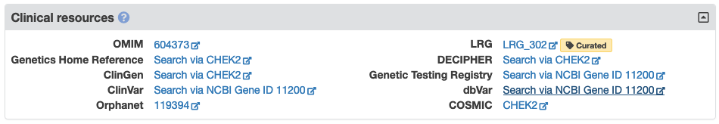
NB: Orphanet link has “diagnostic tests” link that lists laboratories testing for this gene.

Alternative possibilities:
a) Use Entrez API as an alternative to a manual selection: direct extraction of locus into application?
Entrez API requires a specific account, but is an obvious development

b) Ensembl Biomart
Do online search: tutorials etc, but beware broken links and not-working notices

Use Biomart to download only non-synonymous SNPs and indels?
Eg: for ATM

http://www.ensembl.org/biomart/martview/6f94c204c7331054b28277e0ed89d23c?VIRTUALSCHEMANAME=default&ATTRIBUTES=hsapiens_snp.default.snp.refsnp_id|hsapiens_snp.default.snp.refsnp_source|hsapiens_snp.default.snp.chr_name|hsapiens_snp.default.snp.chrom_start|hsapiens_snp.default.snp.chrom_end|hsapiens_snp.default.snp.consequence_type_tv|hsapiens_gene_ensembl.default.snp.ensembl_gene_id_version&FILTERS=hsapiens_snp.default.filters.chr_name."11"|hsapiens_snp.default.filters.so_mini_parent_name."nonsynonymous_variant"&VISIBLEPANEL=resultspanel

Your reference is martquery_0704132240_850.txt.gz.

Modifications log
Date | Section | Changes/reasons
13th February 2025 | Multiple sections | Updating screenshots and superseding script-usage instructions
7th February 2025 | “Automated data processing for downloaded Ensembl data” | Documenting additional processing Python script, which supersedes previous.
28th January 2025 |  | Corrections
27th January 2025 | New Sections: “Downloading a sequence file for a locus from NCBI”  “Data processing for downloaded NCBI data” | Section similar to that for existing Ensembl download, re-written for NCBI-derived datas
6th May 2023 | First version

