Data management and processing instructions

Adding a new locus to the data management hierarchy
a) Locate the $root directory.
The Github repository https://github.com/snowlizardz/rg_exploder_shared, has four directories at $root
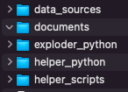
b) In $root/data_sources there are two main data-source directories
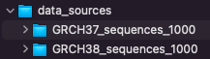
GRCH37_sequences_1000: hold data files for build GRCH37
GRCH38_sequences_1000: hold data files for build GRCH38

c) Within each of these, there is one data directory for each locus:
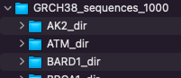
Eg: GRCH38_sequences_1000/AK2_dir holds downloaded AK2 data from Ensembl; initially as a file called ensembl.txt.gz, and later processed versions of these files (see ‘sequence file processing’ below)
c) To add a new $locus, create a new folder in the appropriate directory
GRCH38_sequences_1000/$locus_dir or GRCH37_sequences_1000/$locus_dir

d) Follow “Downloading a sequence file ...” instructions below for the new $locus

e) Follow “Automated data processing…” instructions below for the new $locus

f) Also in $root/data_sources are two main data-curation directories
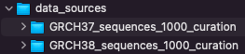
GRCH37_sequences_1000_curation: these hold curated files for build GRCH37
GRCH38_sequences_1000_curation: these hold curated files for build GRCH38
g) Within each of these, there is one data directory for each locus, eg:
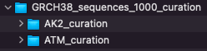
h) As with step c, add a new $locus folder in the appropriate curation directory eg:
GRCH38_sequences_1000_curation/$locus_curation

i) Follow “Maintaining the curation data” instructions below for the new $locus

j) In $root/data_sources are further directories to hold the input & output data when running the application.
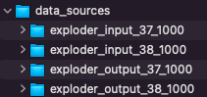

Downloading a sequence file for a locus from Ensembl
These instructions are suitable for downloading a new sequence, or when updating an existing one
Starting at https://www.ensembl.org/Homo_sapiens/Info/Index:
- Find the gene of interest using Search & go to the Summary eg: ATM
  - Use the chosen gene name as locus below.
- Click on “export data” (LH menu)
- Select output: Flatfile/Genbank
- Select Forward Strand (preferred)
  - Alternatives are:
    - Feature Strand (This will be Forward or Reverse depending on the transcript)
    - Reverse Strand
- In “5' Flanking sequence (upstream)” and “3' Flanking sequence (downstream)”: enter 1000
  - A minimum value of 1000 is essential for supporting ‘paired end reads’
- In “Options for Genbank”:
  - Deselect all
  - Reselect: “variation features” and “gene information” (exon, mRNA & CDS definitions)
- Press “Next”
- In the new “Export data” window, click the “compressed text (gz)” link
- The downloaded file is named ensembl.txt.gz
  - Move this file, into a data directory called $root/data_sources/$locus_dir eg: the GRCH38_sequences_1000/AK2_dir example above
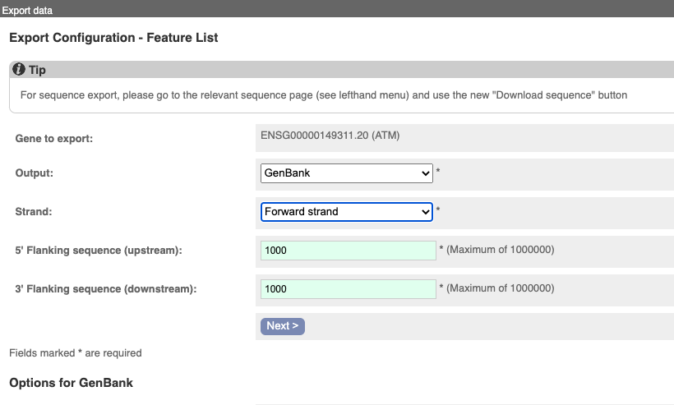
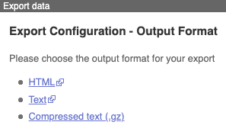
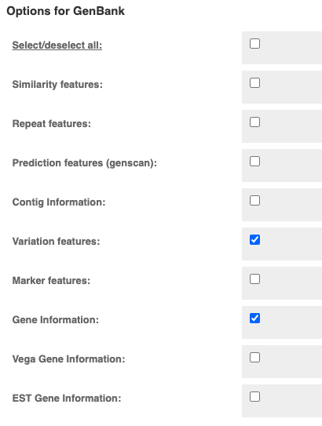
  - Rename it to $locus_ensembl eg: AK2_ensembl

Automated data processing using helper scripts

Introduction to data processing
There are two main objectives:
a) Create a config.json file as a lookup list for the application.
b) Remove, from ensembl.txt.gz, all the data unnecessary for this application.
As an example of doing this manually. (Don’t. It’s easier to use the automated scripts):
- Decompress ensembl.txt.gz and rename the output to $locus_ensembl
- Eliminate numerous 'dbxref= database' lines to get a filtered file eg:
sh noref.sh ATM_ensembl > ATM_filtered.gb
where noref.sh is:
grep -v 'xref="CCDS' $1| grep -v 'xref="RefSeq' | grep -v 'xref="Uni' | grep -v 'xref="UCSC' | grep -v 'xref="HPA' | grep -v 'db_xref="HGNC' |grep -v 'db_xref="EMBL' |grep -v 'xref="GO' |grep -v 'db_xref="protein' | grep -v 'xref="KEGG' |grep -v 'xref="ChEMBL' |grep -v 'xref="PDB' |grep -v 'xref="Reactome' |grep -v 'xref="Vega' |grep -v 'xref="goslim' |grep -v 'xref="OTTT'
- Note that new, unnecessary, data appears over time, so noref.sh needs to be maintained
- Optionally gzip the original: gzip ATM_Ensembl
Adding new data into the config.json file could be done manually by looking at the existing examples. The helper scripts automate the filtering, config.json generation, and other fiddly bits.

Using the feature-filter script
A Python script, $root/helper_python/embl_feature_filter7.py can be used to process the $locus_ensembl file in either gz or uncompressed format eg:
> cd $root/data_sources/GRCH38_sequences_1000/$locus_dir
> python3 $root/helper_python/embl_feature_filter7.py -i $locus_ensembl -a -g relnum
The output files, which are used by the application, are:
$locus_locseq.gb: Contains a cleaned-up feature table: retaining only minimal db_xref identifiers; mRNA and CDS join data. Also holds the DNA sequence.
$locus_noseq.gb: Contains no DNA sequence and the bare minimum definition data. T In the application it is used to define the $locus_00000 haplotype. It is also used as a template for defining the variants in haplotypes, in the curation directory.
$locus_transcripts.json: Holds lookup data for the GUI application.

Other output files, useful for curation and checking:
$locus_filtered.gb: The ‘original file’ with all the unwanted data taken out. Same content as $locus_locseq.gb, with the inclusion of all the variation features from the original source.
$locus_filtervar.gb: As for $locus_noseq.gb, but including the the variation features. These can be useful for extracting a subset to make haplotype definition files.
Parameters for embl_feature_filter7.py
-i is the downloaded-from-Ensembl input file eg: ensembl.txt.gz,
-a is necessary to produce “all” output files (described below)
-g relnum where relnum should be either “37” or “38”
- 37 has a ‘frozen’ release date which is coded into embl_feature_filter7.py
- 38 will need a release date re-coded, depending on when the data was downloaded. (see below)
-j adds mRNA and CDS join data to $locus_transcripts.json
- -j can be omitted when using the Python GUI; it is necessary when preparing for the browser version of the application.

Amendments required in embl_feature_filter7.py prior to execution
When adding a new locus, corresponding identifiers need to be added to two dictionary lists within embl_feature_filter7.py
- MANE_Select_dict and LRG_id_dict
  - Each item in MANE_Select_dict is the transcript identifier assigned MANE_Select status for each locus.
  - Likewise items in LRG_id_dict are the LRG identifiers for each locus.
  - A link to LRG was an early user-requirement for a link from “Locus”, but LRG now appears to be being phased out. Links now go to the LRG page in Ensembl.
  - To include the correct date requires a code change in make_transcriptconstants(), eg: Release=”Ensembl Release 105 (Dec 2021)"

Filtering multiple data sets at once
To automate this one step further, by (re-)processing multiple locus directories at once, using scripts in $root/helper_scripts/
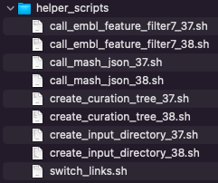
> cd $root/data_sources/GRCH38_sequences_1000/
> sh $root/helper_scripts/call_embl_feature_filter7_38.sh
Or
> cd $root/data_sources/GRCH37_sequences_1000/
> sh $root/helper_scripts/call_embl_feature_filter7_37.sh

Maintaining the curation data

Introduction to curation data
The purpose of the curation area is to maintain a working area where the variant haplotype data can be manipulated, separately from the preceding data processing step. The curation directory initially holds soft links to the processed files in the curation directories. Occasionally an edited copy, instead of soft-link is used instead (eg: AK2 for GRCH37).

Adding a new curation folder
> cd $root/data_sources/GRCH38_sequences_1000_curation/$locus_curation
Simply soft link to the source data locus directory
> ln -s ../ ../GRCH38_sequences_1000/$locus_dir .
Then soft link the following 2 files:
> ln -s $locus_dir/$locus_locseq.gb
> ln -s $locus_dir/$locus_noseq.gb
Then copy this one:
> cp -p $locus_dir/$locus_transcripts.json .
For a simple setup, such as for BARD1, which has no haplotype definitions apart from the reference, nothing more needs to be done.
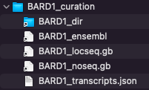
BARD1_dir -> ../../GRCH38_sequences_1000/BARD1_dir/
BARD1_ensembl -> BARD1_dir/BARD1_ensembl
BARD1_locseq.gb -> BARD1_dir/BARD1_locseq.gb
BARD1_noseq.gb -> BARD1_dir/BARD1_noseq.gb
BARD1_transcripts.json

A link to BARD1_ensembl is not required in this directory, but its presence can be useful.
Other loci are described below; chosen to demonstrate both the standard and less-obvious maintenance options available.
For AK2
> cd $root/data_sources/GRCH38_sequences_1000_curation/AK2_curation
> ls -l
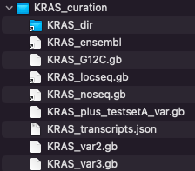
AK2_EB0001.gb
AK2_EB0002.gb
AK2_EB0003.gb
AK2_EB0004.gb
AK2_EB0005.gb
AK2_EB0006.gb
AK2_dir -> ../../GRCH38_sequences_1000/AK2_dir/
AK2_ensembl -> AK2_dir/AK2_ensembl
AK2_locseq.gb -> AK2_dir/AK2_locseq.gb
AK2_noseq.gb -> AK2_dir/AK2_noseq.gb
AK2_transcripts.json

Each of the haplotype definition files, in bold, contain these essential components:

A) The Header section, note the 0 bp definition, as there is no sequence in the file:
LOCUS 1 0 bp DNA HTG 19-AUG-2022
DEFINITION Homo sapiens chromosome 1 GRCh38 partial sequence 33006986..33081996
reannotated via EnsEMBL.

ACCESSION chromosome:GRCh38:1:33006986:33081996:1
VERSION chromosome:GRCh38:1:33006986:33081996:1
FEATURES Location/Qualifiers
source 1..75011
/organism="Homo sapiens"
/db_xref="taxon:9606"
gene complement(1001..74011)
/gene="ENSG00000004455.18"
/locus_tag="AK2"
/note="adenylate kinase 2 [Source:HGNC
Symbol;Acc:HGNC:362]"

This section should be the same as found in the file AK2_noseq.gb which can be used as a template for their creation.

B) A definition of the variation(s) in the Feature table, eg:
AK2_EB0001.gb has just one:
variation 7582..7583
/replace="GG/G"
AK2_EB0001.gb also has one:
variation 14469..14471
/replace="TCA/-"

C) To create a file defining a new variant, options include:

1) Use a SNP or other identifier and look in the file AK2_ensembl (the uncompressed, unfiltered source file) or in AK2_dir/AK2_filtervar.gb

eg: dbSNP:rs1553151177 (the AK2_EB0001 variant) can be found alongside other definitions

variation 7582..7582
/replace="G/T"
/db_xref="dbSNP:rs1241229733"
variation 7582..7582
/replace="HGMD_MUTATION"
/db_xref="HGMD-PUBLIC:CD090014"
variation 7582..7583
/replace="GG/G"
/db_xref="dbSNP:rs1553151177"

Edit the required lines into a copy of AK2_noseq.gb
Just be certain NOT to include overlapping definitions; the application cannot cope with that.

2) You may be able to edit a new definition from other markers you recognise, or using offsets. This manual method is very error-prone. The next option gives a way of creating a validated position and sequence-modification.

3) Leave it as a simple setup for now; complete the other “adding a new locus” steps; run the GUI and use the “Create a new Variations Source” feature. That will generate an output file with a name you supply that can be copied straight back into this directory. See “Additional variants” in EGFR.
For EGFR
> cd $root/data_sources/GRCH38_sequences_1000_curation/EGFR_curation
> ls -l
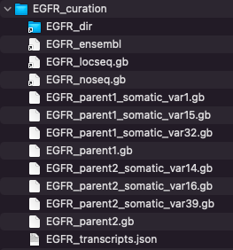
EGFR_dir -> ../../GRCH38_sequences_1000/EGFR_dir/
EGFR_ensembl -> EGFR_dir/EGFR_ensembl
EGFR_locseq.gb -> EGFR_dir/EGFR_locseq.gb
EGFR_noseq.gb -> EGFR_dir/EGFR_noseq.gb
EGFR_parent1.gb
EGFR_parent1_somatic_var1.gb
EGFR_parent1_somatic_var15.gb
EGFR_parent1_somatic_var32.gb
EGFR_parent2.gb
EGFR_parent2_somatic_var14.gb
EGFR_parent2_somatic_var16.gb
EGFR_parent2_somatic_var39.gb
EGFR_transcripts.json
The variant definitions here are hierarchical, it uses two different haplotype definitions, each extracted originally from *EGFR_ensembl, with extra commentary added from other sources:
EGFR_parent1.gb
variation 155518..155518
/replace="G/A"
/db_xref="dbSNP:rs55959834"
/consequence="dbSNP:synonymous_variant,genic_downstream_transcript_variant"
/consequence="dbSNP:coding_sequence_variant"
/comment=”ensembl:minor allele exon18, synonymous variant at v low freq 0.001”
variation 160011..160011
/replace="G/A"
/db_xref="dbSNP:rs62457092"
/consequence="dbSNP:genic_downstream_transcript_variant,intron_variant"
/comment=”ensembl:intron_variant 19_20 minor allele at 0.32”
EGFR_parent2.gb
variation 159298..159298
/replace="A/G"
/db_xref="dbSNP:rs845552"
/consequence="dbSNP:intron_variant,genic_downstream_transcript_variant"
/comment=”ensembl:intron_variant 19_20 minor allele at 0.45”
variation 162854..162854
/replace="G/A/"
/db_xref="dbSNP:rs1050171"
/consequence="dbSNP:genic_downstream_transcript_variant,synonymous_variant"
/consequence="dbSNP:missense_variant,non_coding_transcript_variant"
/consequence="dbSNP:coding_sequence_variant"
/comment=”ensembl:minor allele exon 20, synonymous variant at 0.43”
The other files have further variants added onto these basic haplotypes

*an older version of
IMPORTANT:
The header sections of the ‘parent1’ files must agree with the source of the variant.
EGFR_parent1.gb header:
LOCUS 7 0 bp DNA HTG 21-APR-2021
ACCESSION chromosome:GRCh38:7:55018517:55212128:1
VERSION chromosome:GRCh38:7:55018517:55212128:1
COMMENT /consequence and /comment annotation by Replicon Genetics from public domain sources
FEATURES Location/Qualifiers
source 1..193612
/organism="Homo sapiens"
/db_xref="taxon:9606"
gene 501..193112
/gene=ENSG00000146648.19
/locus_tag="EGFR"

EGFR_parent1_somatic_var1.gb:
LOCUS 7 0 bp DNA HTG 21-APR-2021
ACCESSION chromosome:GRCh38:7:55018517:55212128:1
VERSION chromosome:GRCh38:7:55018517:55212128:1
COMMENT /consequence and /comment annotation by Replicon Genetics from public domain sources
FEATURES Location/Qualifiers
source 1..193612
/organism="Homo sapiens"
/db_xref="taxon:9606"
gene 501..193112
/gene=ENSG00000146648.19
/locus_tag="EGFR"

They DO NOT need to be exactly the same as the header in the reference-sequence file
EGFR_locseq.gb:
LOCUS 7 194612 bp DNA HTG 27-FEB-2022
DEFINITION Homo sapiens chromosome 7 GRCh38 partial sequence 55018017..55212628 reannotated
via EnsEMBL
ACCESSION chromosome:GRCh38:7:55018017:55212628:1
VERSION chromosome:GRCh38:7:55018017:55212628:1
FEATURES Location/Qualifiers
source 1..194612
/organism="Homo sapiens"
/db_xref="taxon:9606"
gene 1001..193612
/gene=ENSG00000146648.20 ← The difference is gene-id version is acceptable
/locus_tag="EGFR"

The range for the reference definition is GRCh38:7:55018017:55212628:1
The range for the variant definition is GRCh38:7:55018517:55212128:1
- Both the GRCh version and strand are the same: this is essential
- The sequence range of the variant is wholly contained within the reference range
  - If not, the application will generate a warning message and should ignore the haplotype completely.
  - The application detects the disparity and recalculates the offset

In this way, variant definition files do not need to be regenerated each time the source files are updated, and where only a small redefinition of the gene range takes place.

The inspiration, and naming, for this set of EGFR variants comes from table 2 of “Molecular characteristics and clinical outcomes of EGFR exon 19 indel subtypes to EGFR TKIs in NSCLC patients” by Su et al Oncotargetv.8(67); 2017 Dec 19
Subtypes are defined at CDS like this: Subtype 21 - c.2239_2247del9

Additional variants:
Here’s how to add two of the subtypes described using the application GUI rather than alternative, painstaking methods.

Subtype 21
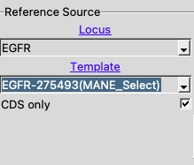
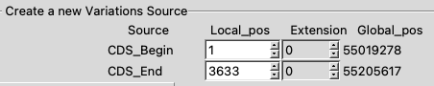
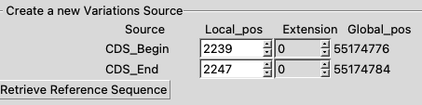

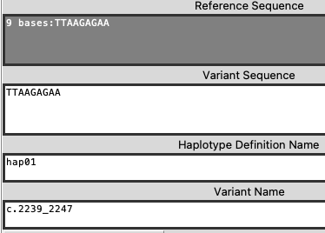
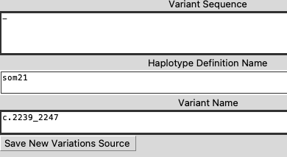
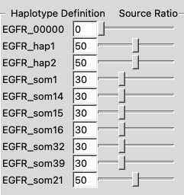
Set this before “GO”

In the output will be a file EGFR-locus_som21.gbout
LOCUS 7 0 bp DNA HTG 27-FEB-2022
DEFINITION Homo sapiens chromosome 7 GRCh38 partial sequence 55018017..55212628
reannotated via EnsEMBL.
ACCESSION chromosome:GRCh38:7:55018017:55212628:1
VERSION chromosome:GRCh38:7:55018017:55212628:1
KEYWORDS .
SOURCE .
ORGANISM .
.
FEATURES Location/Qualifiers
source 1..194612
/organism="Homo sapiens"
/db_xref="taxon:9606"
gene 1001..193612
/gene="ENSG00000146648.20"
/locus_tag="EGFR"
/note="epidermal growth factor receptor [Source:HGNC
Symbol;Acc:HGNC:3236]"
variation 156760..156768
/replace="TTAAGAGAA/-"
/db_xref="som21_1:c.2239_2247"
/global_range="GRCh38:7:55174776:55174784:1"
ORIGIN

Note that the location calculated by the application matches the assigned COSM6218 entry

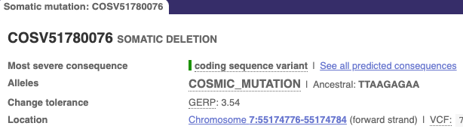

NB: The header is different from the existing curated variants, but matches that of the reference EGFR_locseq.gb

Subtype 24 - c.2239_2253>aat COSM51503
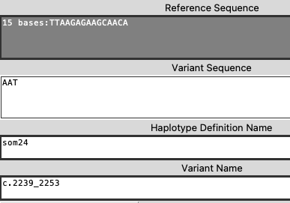
variation 156760..156774
/replace="TTAAGAGAAGCAACA/AAT"
/db_xref="som24_1:c.2239_2253"
/global_range="GRCh38:7:55174776:55174790:1"

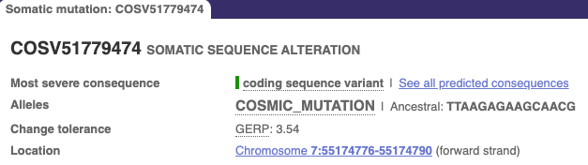

For AK2 in GRCh37
The MANE_Select transcript for AK2 is not defined in GRCh37, but exists in GRCh38 with the identifier ENST00000672715
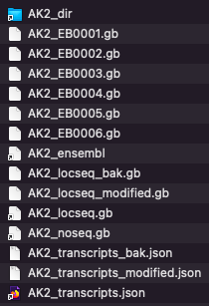
After manually identifying the differing offset-positions between GRCh37 and GRCh38 for exons shared with other transcripts, it was possible to create mRNA and CDS join features for the missing features in GRCh37. To verify this, the transcripts created from each version by the application were aligned. The sequence for this transcript differs by a single base substitution at one location between the two genome builds.
The new file is maintained as AK2_locseq_modified.gb with AK2_locseq.gb now a soft-link to it and the original saved as AK2_locseq_bak.gb
AK2_locseq.gb -> AK2_locseq_modified.gb
AK2_locseq_bak.gb
AK2_locseq_modified.gb
AK2_noseq.gb -> AK2_dir/AK2_noseq.gb
AK2_transcripts.json -> AK2_transcripts_modified.json
AK2_transcripts_bak.json
AK2_transcripts_modified.json

AK2_locseq_bak.gb is the original version of AK2_locseq_bak
Comparing the feature tables between the two builds:
AK2_locseq_modified.gb for GRCh37
Note the modified transcript identifier: from "ENST00000672715.1" to "ENST00000672715m.1"

The ‘m’ modifier is recognised in the GUI to generate a URL toi link to Ensembl GRCh38 instead of GRCh37.

LOCUS 1 75013 bp DNA HTG 12-AUG-2022
DEFINITION Homo sapiens chromosome 1 GRCh37 partial sequence 33472585..33547597 reannotated
via EnsEMBL
ACCESSION chromosome:GRCh37:1:33472585:33547597:1
VERSION chromosome:GRCh37:1:33472585:33547597:1
FEATURES Location/Qualifiers
source 1..75013
/organism="Homo sapiens"
/db_xref="taxon:9606"
gene complement(1001..74013)
/gene=ENSG00000004455.12
/locus_tag="AK2"
/note="adenylate kinase 2 [Source:HGNC Symbol;Acc:362]"
mRNA join(complement(29753..29887),complement(17459..17584),
complement(14610..14720),complement(14384..14478),
complement(7539..7611),complement(1003..6419))
/gene="ENSG00000004455.12"
/standard_name="ENST00000672715m.1"
/comment="RG:copied from GRCH38 as not present in 37 download"
CDS join(complement(29753..29845),complement(17459..17584),
complement(14610..14720),complement(14384..14478),
complement(7539..7611),complement(6198..6419))
/gene="ENSG00000004455.12"
/protein_id="ENSP00000499935.1"
/note="transcript_id=ENST00000672715m.1"

AK2_locseq.gb for GRCh38:

LOCUS 1 75011 bp DNA HTG 19-AUG-2022
DEFINITION Homo sapiens chromosome 1 GRCh38 partial sequence 33006986..33081996 reannotated
via EnsEMBL
ACCESSION chromosome:GRCh38:1:33006986:33081996:1
VERSION chromosome:GRCh38:1:33006986:33081996:1
FEATURES Location/Qualifiers
source 1..75011
/organism="Homo sapiens"
/db_xref="taxon:9606"
gene complement(1001..74011)
/gene=ENSG00000004455.18
/locus_tag="AK2"
/note="adenylate kinase 2 [Source:HGNC
Symbol;Acc:HGNC:362]"
…
mRNA join(complement(29751..29898),complement(17457..17582),
complement(14608..14718),complement(14382..14476),
complement(7537..7609),complement(1001..6417))
/gene="ENSG00000004455.18"
/standard_name="ENST00000672715.1"
CDS join(complement(29751..29843),complement(17457..17582),
complement(14608..14718),complement(14382..14476),
complement(7537..7609),complement(6196..6417))
/gene="ENSG00000004455.18"
/protein_id="ENSP00000499935.1"
/note="transcript_id=ENST00000672715.1"

The file AK2_transcripts.json has been modified to incorporate the additional, modified transcript identifier. The original, modified and soft-linked files are managed in the same manner as for AK2_locseq.gb.

Adding multiple new curation folders
If you are starting from scratch and do not already have the directory $root/GRCH38_sequences_1000_curation, then
a) Modify the path definition at the top of the script $root/helper_scripts/create_curation_tree_38.sh:
root="/Users/caryodonnell/Documents/repositories/rg_exploder_shared/data_sources/"
datadir="GRCH38_sequences_1000"

b) Execute this script and it will build a set of directories in $root/GRCH38_sequences_1000_curation, with the same names as in $root/GRCH38_sequences_1000
It also creates soft links from GRCH38_sequences_1000 as described previously
c) If you already have a curation directory, and execute the script anyway: you will get many error-reports about files already created.
You should find that any new locus directories in $datadir will be created within the curation directory.

Mashup time

a) In the helper-scripts directory

Step 3: directory management
A) Screen shots from MacOS Finder
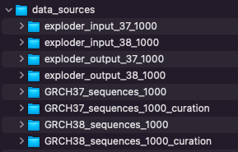
At the root level are these directories
GRCH38_sequences_1000/locus_dir initially hold the downloaded ensembl.txt.gz files of each locus
After automated processing of ensembl.txt.gz, these files remain in each locus_dir sub directory:
locus_ensembl – the original, now unzipped, downloaded file
locus_filtered.gb – same as locus_ensembl, minus unwanted annotation
locus_filtervar.gb – as above, but without mRNA & CDS features, without sequence ; just the variations
locus_locseq.gb – everything in locus_filtered.gb, without the variations; this is the Reference Source used in the application.
locus_noseq.gb – A no-sequence, no-features version. This is used as the input for locus_00000 haplotype in the application. It is a blank template for curating other haplotypes. Find known variants in locus_locseq.gb
locus_transcripts.json – lookup information for the application. These are later concatenated into config.json
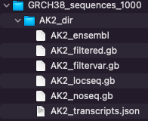

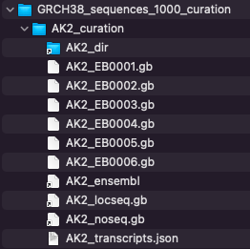
exploder-input_38_1000
Where all files in
exploder_input_38_1000/locus
are soft links to files in GRCH38_sequences_1000_curation/locus_curation
This allows for hand-culling or renaming of links in the input directory whilst retaining them in the curation directory or under a different name. Eg: compare the EGFR directories.
The exploder_python/input directory is a soft link to here
A curation directory is used to demarcate the automated-processed files from the hand-created haplotye definitions.
Here: AK2_EB0001.gb … AK2_EB0006.gb

Other files in this locus_curation directory are usually soft linked to the above. There may be exceptions to this, notably in GRCH37_sequences_1000_curation - the original AK2_locseq.gb and AK2_transcripts.json have been hand-edited to include the MANE_Select transcript that is absent in GRCH37, but is defined in GRCH37.

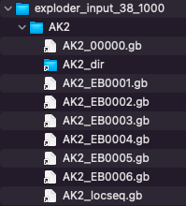
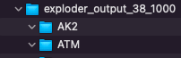
Finally – exploder-output_38_1000
Where the sub-directories for each locus are empty to receive the output from the application.
The exploder_python/output directory is a soft link to here

Recorded information on loci
NB: positions & annotation seems to change with Ensembl release versions. There may be inconsistency in the numbers stated within the URL (r=x:nnn-nnn) for the Ensembl ID and the genomic location this actually links to, but the URL seems to correct itself over time.
Note that it's normal for Ensembl and NCBI to show different position mappings. It's typically small numerical-differences at start and end. All below are Ensembl mappings
Ensembl Release 96 Apr 2019, GRCh38.p12 – GENCODE release 30
OMIM | HGNC symbol report | Ensembl ID | Genomic Location  GRCh38.p12 | Publication | NIH genetics home reference
ATM | HGNC:795 | ENSG00000149311 | 11: 108,219,552-108,372,034 (+) |  | ATM serine/threonine kinase  ataxia telangiectasia
BARD1 | HGNC:952 | ENSG00000138376 | 2: 214,723,966-214,811,363 (-) |  | BRCA1 associated RING domain 1
BRCA1 | HGNC:1100 | ENSG00000012048 | 17: 43,041,776-43,172,764 (-) |  | DNA repair associated
BRCA2 | HGNC:1101 | ENSG00000139618 | 13: 32,313,779-32,401,961 (+) |  | DNA repair associated
BRIP1 | HGNC:20473 | ENSG00000136492 | 17: 61,677,621-61,867,166 (-) |  | BRCA1 interacting protein C-terminal helicase 1
CDH1 | HGNC:1748 | ENSG00000039068 | 16: 68,735,328-68,837,505 (+) |  | cadherin 1
CDK12 | HGNC:24224 | ENSG00000167258 | 17: 39,459,444-39,566,974 (+) |  | cyclin dependent kinase 12
CHEK1 | HGNC:1925 | ENSG00000149554 | 11: 125,624,114-125,677,277 (+) |  | checkpoint kinase 1
CHEK2 | HGNC:16627 | ENSG00000183765 | 22: 28,686,650-28,743,515 (-) | Breast Cancer (Dove Med Press). 2017; 9: 331–335. | checkpoint kinase 2
EPCAM | HGNC:11529 | ENSG00000119888 | 2: 58,157,601-58,243,014 (+) |  | epithelial cell adhesion molecule
FANCL | HGNC:20748 | ENSG00000115392 | 2: 58,159,243-58,241,372 (-) |  | FA complementation group L
KRAS | HGNC:6407 | ENSG00000133703 | 12: 25,203,867-25,251,858 (-) |  | KRAS proto-oncogene, GTPase
MLH1 | HGNC:7127 | ENSG00000076242 | 3: 36,992,181-37,052,069 (+) |  | mutL homolog 1  - DNA repair
MSH2 | HGNC:7325 | ENSG00000095002 | 2: 47,397,766-47,668,349 (+) |  | mutS homolog 2
MSH6 | HGNC:7329 | ENSG00000116062 | 2: 47,693,239-47,812,392 (+) |  | mutS homolog 6
NBN | HGNC:7652 | ENSG00000104320 | 8: 89,931,939-90,004,625 (-) |  | nibrin
NF1 | HGNC:7765 | ENSG00000196712 | 17: 31,089,184-31,387,859 (+) |  | Neurofibromin 1
PALB2 | HGNC:26144 | ENSG00000083093 | 16: 23,602,397-23,642,073 (-) |  | partner and localizer of BRCA2
PMS2 | HGNC:9122 | ENSG00000122512 | 7: 5,970,162-6,009,869 (-) |  | PMS1 homolog 2, mismatch repair system component
PPP2R2A | HGNC:9304 | ENSG00000221914 | 8: 26,289,885-26,374,303 (+) |  | protein phosphatase 2 regulatory subunit Balpha
PTEN | HGNC:9588 | ENSG00000171862 | 10: 87,861,459-87,974,096 (+) |  | phosphatase and tensin homolog
PTEN_a | HGNC:9588 | ENSG00000284792 | CHR_HG2334_PATCH: 87,861,382-87,968,399 (+) |  | phosphatase and tensin homolog  (alternative mapping)
RAD51B | HGNC:9822 | ENSG00000182185 | 14: 67,801,571-68,748,426(+) |  | RAD51 paralog B
RAD51C | HGNC:9820 | ENSG00000108384 | 17: 58,691,713-58,736,471 (+) |  | RAD51 paralog C
RAD51D | HGNC:9823 | ENSG00000185379 | 17: 35,091,622-35,122,108 (-) |  | RAD51 paralog D
RAD54L | HGNC:9826 | ENSG00000085999 | 1: 46,247,073-46,279,088 (+) |  | RAD54 like
STK11 | HGNC:11389 | ENSG00000118046 | 19: 1,176,541-1,229,452(+) |  | serine/threonine kinase 11
TP53 | HGNC:11998 | ENSG00000141510 | 17: 7,661,264-7,688,065 (-) |  | tumor protein p53
For clinical evidence on variations, from HGNC symbol report: click on Clinical Resources/Clinvar
For locations: Clinical Resources/Genetic Testing Registry

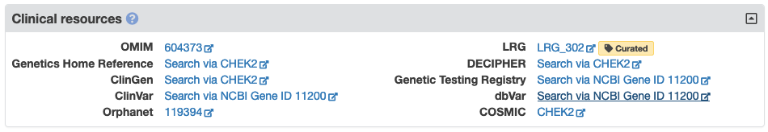
NB: Orphanet link has “diagnostic tests” link that lists laboratories testing for this gene.

Alternative possibilities:
Use Ensembl Biomart as an alternative to this manual selection?
Do online search: tutorials etc, but beware broken links and not-working notices

Use Biomart to download only non-synonymous SNPs and indels?
Eg: for ATM

http://www.ensembl.org/biomart/martview/6f94c204c7331054b28277e0ed89d23c?VIRTUALSCHEMANAME=default&ATTRIBUTES=hsapiens_snp.default.snp.refsnp_id|hsapiens_snp.default.snp.refsnp_source|hsapiens_snp.default.snp.chr_name|hsapiens_snp.default.snp.chrom_start|hsapiens_snp.default.snp.chrom_end|hsapiens_snp.default.snp.consequence_type_tv|hsapiens_gene_ensembl.default.snp.ensembl_gene_id_version&FILTERS=hsapiens_snp.default.filters.chr_name."11"|hsapiens_snp.default.filters.so_mini_parent_name."nonsynonymous_variant"&VISIBLEPANEL=resultspanel

Your reference is martquery_0704132240_850.txt.gz.

Last updated: 15th April 2023

