Rebuilding the Synthetic Reads Generator web application

Introduction
This is based on the document “Documentation RG exploder Web App.odt” which originates from the document first delivered in 2020.

Root directory for Python development:
pysourcedir="/Users/caryodonnell/Documents/repositories/snowlizardz/rg_exploder"

caryodonnell@ARWallace python % cd $pysourcedir
caryodonnell@ARWallace rg_exploder % ls -l
total 8
-rw-r--r-- 1 caryodonnell staff 931 18 Apr 2021 README.md
drwxr-xr-x 8 caryodonnell staff 256 10 May 2021 Website
drwxr-xr-x 6 caryodonnell staff 192 25 Mar 2021 __pycache__
drwxr-xr-x@ 20 caryodonnell staff 640 31 Mar 2022 builder_python
drwxr-xr-x@ 15 caryodonnell staff 480 23 Jul 2021 documents
drwxr-xr-x@ 15 caryodonnell staff 480 20 Nov 20:35 exploder_python
drwxr-xr-x@ 13 caryodonnell staff 416 21 Oct 15:02 helper_python
drwxr-xr-x 23 caryodonnell staff 736 20 Nov 11:55 helper_scripts
caryodonnell@ARWallace rg_exploder %

Ignore the crossed out ones.

Root directory for web application:
webroot="/Users/caryodonnell/Documents/repositories/mravn/rg_exploder"
caryodonnell@ARWallace ~ % cd $webroot

caryodonnell@ARWallace rg_exploder % ls -l
total 40
-rw-r--r--@ 1 caryodonnell staff 735 24 Mar 2022 README.md
-rw-r--r-- 1 caryodonnell staff 2191 18 Apr 2021 Replicon-GH-repository1 readme.rtf
-rw-r--r-- 1 caryodonnell staff 56 20 Nov 11:09 copy_files.sh
-rw-r--r--@ 1 caryodonnell staff 771 21 Nov 11:53 copy_input.sh
-rw-r--r-- 1 caryodonnell staff 346 20 Nov 11:09 copy_python.sh
drwxr-xr-x 3 caryodonnell staff 96 24 Nov 14:31 documents
drwxr-xr-x 2 caryodonnell staff 64 15 Feb 2022 keys
drwxr-xr-x 36 caryodonnell staff 1152 29 Mar 2022 pyodide
drwxr-xr-x 17 caryodonnell staff 544 21 Nov 12:16 python
drwxr-xr-x 34 caryodonnell staff 1088 1 Oct 14:18 webdist

Other presets
These softlinks are used in shell scripts in place of $webroot and $pysourcedir
lrwxr-xr-x 1 caryodonnell staff 40 7 May 2021 mravn_rg_exploder -> Documents/repositories/mravn/rg_exploder

lrwxr-xr-x 1 caryodonnell staff 62 22 Jul 2021 snowlizardz_rg_exploder -> Documents/repositories/snowlizardz/rg_exploder/exploder_python

Python source code updates
A) If there have been updates to the Python source code in $pysourcedir, they must first be copied to $webroot

cd $pysourcedir/helper_scripts
caryodonnell@ARWallace helper_scripts % sh copy_python_to_mravn.sh
caryodonnell@ARWallace helper_scripts % cat copy_python_to_mravn.sh

# Copy latest versions across to web prod area
target="/Users/caryodonnell/Documents/repositories/mravn/rg_exploder/python/."
source="/Users/caryodonnell/snowlizardz_rg_exploder"
cd $source
cp -p RG_exploder_globals.py $target
cp -p RG_exploder_globals_make.py $target
cp -p RG_exploder_gui.py $target
cp -p RG_exploder_io.py $target
cp -p RG_exploder_main.py $target
cp -p RG_exploder_process.py $target

B) Copy the needed python updates for the web build, by:
caryodonnell@ARWallace rg_exploder % cd $webroot
caryodonnell@ARWallace rg_exploder % sh copy_python.sh

caryodonnell@ARWallace rg_exploder % cat copy_python.sh
#!/usr/bin/env bash
cd ./python/
# copies these 3 python files, with these commands:
cp -p RG_exploder_main.py ../pyodide/packages/rg_exploder/rg_exploder/
cp -p RG_exploder_process.py ../pyodide/packages/rg_exploder/rg_exploder/
cp -p RG_exploder_globals.py ../pyodide/packages/rg_exploder/rg_exploder/
# DO NOT copy RG_exploder_io.py
cd ..

Data updates
C) If the data have been changed, copy the data set tested in $pysourcedir to $webroot/webdist/public/input by executing copy_input.sh.

Beware that this clears directories AND runs RG_exploder_globals_make.py

caryodonnell@ARWallace rg_exploder % cd $webroot
caryodonnell@ARWallace rg_exploder % sh copy_input.sh

caryodonnell@ARWallace rg_exploder % cat copy_input.sh
#!/usr/bin/env bash
rootdir="/Users/caryodonnell/mravn_rg_exploder"
sourcedatadir="/Users/caryodonnell/snowlizardz_rg_exploder/input"

cd $rootdir
PW='pwd'

cd $rootdir/python/input
rm -r *
cp -r $sourcedatadir/* .
mv loci.json_joins.json ../loci.json
/bin/rm loci.json*
/bin/rm config.json*

/bin/ls | while read dir; do
cd $dir
rm -r *_dir*
cd ..
done

cd $rootdir/python/
mv loci.json input/
# Now need to run RG_exploder_globals_make.py to replace config.json
# Just ensure the internal configs are correct
python3 RG_exploder_globals_make.py
# Next copy the input folder into the public folder under webdist
# Better to remove ../webdist/public/input/* first to avoid leaving any "old" files behind
rm -R ../webdist/public/input/*

Re-compiling pyodide
D) First go to the pyodide directory
caryodonnell@ARWallace rg_exploder % cd $webroot/pyodide
E) You must delete the old build in $webroot/pyodide/packages/rg_exploder/build/, this is done by executing delete_old_build.sh
caryodonnell@ARWallace pyodide % sh delete_old_build.sh
F) Execute run_docker from $webroot/pyodide
caryodonnell@ARWallace pyodide % ./run_docker
root@8ff43c0b21de:/src# make
… See full output from this below
root@8ff43c0b21de:/src# exit
exit
caryodonnell@ARWallace pyodide %
G) Now copy the generated build files into the $webroot/webdist folder, using copy_build_to_webdist.sh
caryodonnell@ARWallace pyodide % sh copy_build_to_webdist.sh
caryodonnell@ARWallace pyodide % cat copy_build_to_webdist.sh
cp -p build/pyodide.* ../webdist/public
cp -p build/numpy.* ../webdist/public
cp -p build/biopython.* ../webdist/public
cp -p build/rg_exploder.* ../webdist/public
cp -p build/packages.json ../webdist/public

H) Now test the build
caryodonnell@ARWallace pyodide % cd $webroot/webdist
First update browser list if haven't done it already that day
caryodonnell@ARWallace webdist % npx browserslist@latest --update-db
Changed to: npx update-browserslist-db@latest (16-June-2024)
15th June 2024:
No target browser changes
npm notice
npm notice New major version of npm available! 8.5.5 -> 10.8.1
npm notice Changelog: https://github.com/npm/cli/releases/tag/v10.8.1
npm notice Run npm install -g npm@10.8.1 to update!
npm notice

2nd Sep 2024:
Latest version: 1.0.30001655
Installed version: 1.0.30001621
Removing old caniuse-lite from lock file
Installing new caniuse-lite version
$ npm install caniuse-lite
Cleaning package.json dependencies from caniuse-lite
$ npm uninstall caniuse-lite
caniuse-lite has been successfully updated

No target browser changes

12th Sep 2024:
caryodonnell@ARWallace webdist % npx update-browserslist-db@latest
Latest version: 1.0.30001660
Installed version: 1.0.30001655
Removing old caniuse-lite from lock file
Installing new caniuse-lite version
$ npm install caniuse-lite
Cleaning package.json dependencies from caniuse-lite
$ npm uninstall caniuse-lite
caniuse-lite has been successfully updated

No target browser changes
caryodonnell@ARWallace webdist %

caryodonnell@ARWallace webdist % npm run serve
> rg_exploder@0.1.0 serve
> vue-cli-service serve
INFO Starting development server...
DONE Compiled successfully in 6748ms 16:44:06
App running at:
- Local: http://localhost:8080/
- Network: http://192.168.0.11:8080/

Note that the development build is not optimized.
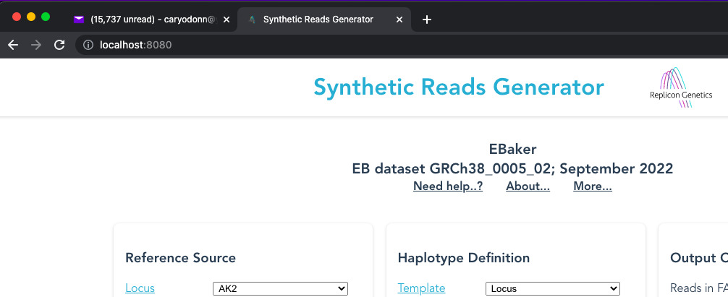

I) To create a set of files for AWS upload; a "production build"
npm run build
$webroot/webdist
But we need to delete superfluous .gb files created in the new or overwritten $webroot/webdist/dist
Use
cd $webroot/pyodide
sh tidy_dist.sh
caryodonnell@ARWallace pyodide % cat tidy_dist.sh
cd ../webdist/dist
/bin/rm *.gb

Selected output
run_docker output (24-Nov-2022)
root@8ff43c0b21de:/src# make
./tools/dependency-check.sh
npm i --no-save uglify-js lessc
npm WARN read-shrinkwrap This version of npm is compatible with lockfileVersion@1, but package-lock.json was generated for lockfileVersion@2. I'll try to do my best with it!
npm WARN src No repository field.
npm WARN src No license field.

+ uglify-js@3.17.4
+ lessc@1.0.2
updated 2 packages in 9.139s
found 0 vulnerabilities

date +"[%F %T] Building packages..."
[2022-11-24 15:56:42] Building packages...
make -C packages
make[1]: Entering directory '/src/packages'
mkdir -p /src/packages/.artifacts
PYTHONPATH=/src/packages/.artifacts/lib/python ../bin/pyodide buildall . ../build \
--target=/src/cpython/installs/python-3.8.2 --only --install-dir /src/packages/.artifacts
Starting thread 1
Thread 1 building libiconv
Starting thread 2
Thread 2 building zlib
Starting thread 3
Thread 3 building parso
Starting thread 4
Thread 4 building distlib
Thread 2 built zlib
Thread 2 building numpy
Thread 1 built libiconv
Thread 4 built distlib
Thread 1 building libxml
Thread 4 building six
Thread 3 built parso
Thread 3 building CLAPACK
Thread 1 built libxml
Thread 1 building micropip
Thread 3 built CLAPACK
Thread 3 building jedi
Thread 4 built six
Thread 4 building libxslt
Thread 1 built micropip
Thread 4 built libxslt
Thread 2 built numpy
Thread 1 building biopython
Thread 3 built jedi
Thread 1 built biopython
Thread 4 building rg_exploder
Thread 4 built rg_exploder
make[1]: Leaving directory '/src/packages'
date +"[%F %T] done building packages..."
[2022-11-24 15:57:41] done building packages...
echo -e "\nSUCCESS!"

SUCCESS!
root@8ff43c0b21de:/src#

caryodonnell@ARWallace webdist % npm run build

> rg_exploder@0.1.0 build
> vue-cli-service build

All browser targets in the browserslist configuration have supported ES module.
Therefore we don't build two separate bundles for differential loading.

⠙ Building for production...

WARNING Compiled with 3 warnings 12:56:03

warning

asset size limit: The following asset(s) exceed the recommended size limit (244 KiB).
This can impact web performance.
Assets:
300dd62983fd4392c10f690b66e477b7.gb (255 KiB)
2b197765490e06800fc16c913b557090.gb (250 KiB)
dd1a83e39042a3f03aeebed7904b7991.gb (332 KiB)
827c1fa6bf2219df45a62d48485e78db.gb (386 KiB)
b3d654e3e55ea56fc56955f168fc9ecf.gb (1.11 MiB)
js/app.086bf901.js (247 KiB)
biopython.data (4.44 MiB)
numpy.data (7.14 MiB)
pyodide.asm.data (5.12 MiB)
pyodide.asm.js (3.53 MiB)
pyodide.asm.wasm (10.9 MiB)
input/BRIP1/BRIP1_locseq.gb (255 KiB)
input/EGFR/EGFR_locseq.gb (250 KiB)
input/MSH2/MSH2_locseq.gb (332 KiB)
input/NF1/NF1_locseq.gb (386 KiB)
input/RAD51B/RAD51B_locseq.gb (1.11 MiB)

warning

24th November 2022;
Updated 25th March 2024 with section I and npm run build selected output

21st May 2024: Added the section "Expanding the UI" from original document

Expanding the UI
Root directory for web application:
webroot="/Users/caryodonnell/Documents/repositories/mravn/rg_exploder"

Short intro to the web code
The webpage is primarily coded in the file:

$webroot/webdist/src/App.vue

This file handles all the primary logic and data. It also defines most of the template (html) and style (CSS) files, along with the components at:

$webroot/webdist/src/components

Components are different pieces of code that might represent the header, a button, or any other component of the website. There are several predefined components useful for the project, described below.

For more information on web development, see:
Vue: https://v3.vuejs.org/guide/introduction.html
HTML: https://www.w3schools.com/html/html_intro.asp
CSS: https://www.w3schools.com/css/css_intro.asp

Adding/Deleting components
There are several different components that used in the website including:
- “BaseSelect”: Selector that handles selecting between an array of options.
- “BaseCheckbox”: Checkbox that handles switching a value on/off.
- “BaseNumberInput”: Input where a user can input numbers, between a min- and maxvalue.
- “BaseSlider”: Basic slider.
- “RunButton”: the button used to run the pyodide code.
- “Header”: the header section of the webpage
- “MessagePanel”: The message panel that appears when the code is running, showing messages from readme and journal

Example
Adding a BaseCheckbox component:
- Adding the component to the template (html):
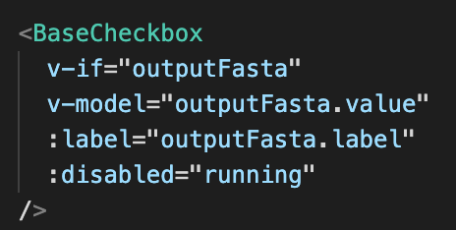
Where:
v-model=”outputFasta” is a two-way binding between passing on this data to the component for it to send back the updated values of the variable: “outputFasta” (which can be found under “data” in the script section, see image below).
v-if=”outputFasta” is a way of only showing the component if the value is not null in the config.json.
:label=”outputFasta.label” is the label for the components
:disabled=”running” disables the component when the “run” function is ongoing

- Adding the variable to “data”, in the script (JavaScript) section: It’s here all the variables that should be accessible for the template section, are stored.
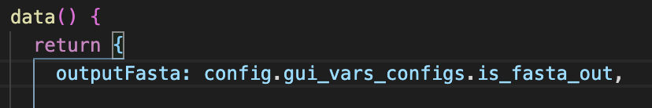
Here i have added the value of the outputFasta variable, so the component in the v-model field can use and update this value. The assignment, in this case, is using a default value from the config.json file.

- If the components variable should be sent to the pyodide code, you should pass the variable to pyodideWorker.postMessage({}) in the run function, under the “methods” section.
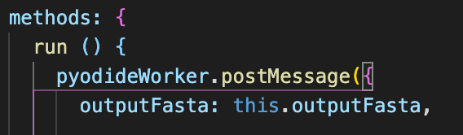
- The variable should then be further passed on in the WebWorker.js file under the public folder:

$webroot/webdist/public/WebWorker.js

Here the “onmessage” function should be edited to include the variable passed from the App.vue “run” function (described earlier). Here is an example of the variable: fragmentLength being passed on the python code:
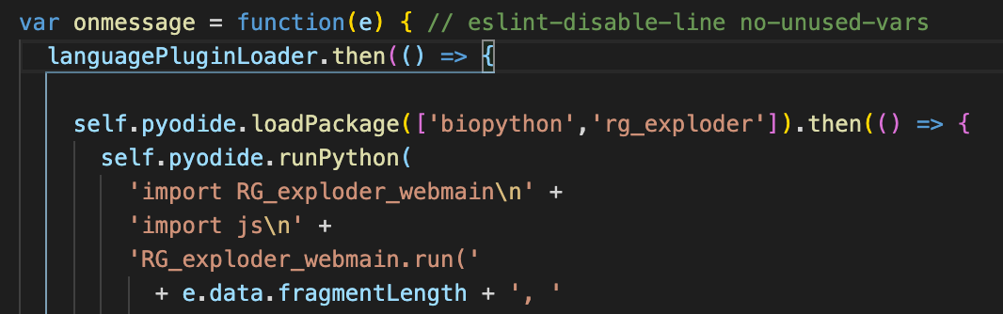
- Then in the file RG_exploder_webmain.py, under:

$webroot/pyodide/packages/rg_exploder/rg_exploder/

The run function should also be edited to use the variable passed, from the WebWorker.js (in this case fragment_length, which is then is used to set the global variable: “Fraglen”:
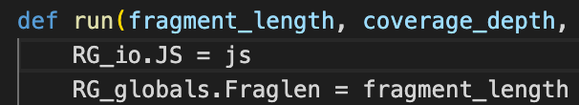

- Finally run the specified commands, from the section: “Subsequent builds” to apply these changes to the web interface.

The use case of the other components is very similar, with only a few changes.
This might be the use of min & max values for the: “BaseNumberInput” components.
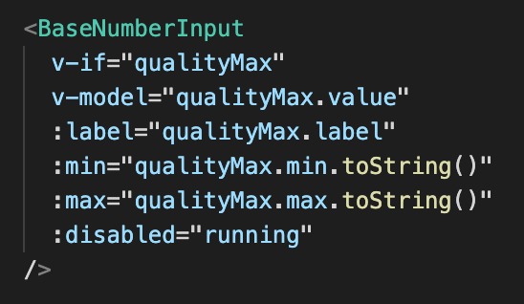

Notes:
- The colon before some of the properties in the photo above, indicates a one-way binding (can read but not write), whereas two-way binding, as with “v-model”, allows both read & write privileges.

Software used

Vue.js
The website was made using Vue.js version 3, an open source JavaScript framework:

https://vuejs.org/

Pyodide
Used to compile Python code into cpython, which can run natively in the browser as WebAssembly:

https://github.com/iodide-project/pyodide
Branch master, revision c01e741bbb5298dd76f0d53ddc60d9983d1d64

StreamSaver
Used to stream the files (generated by the cpython code), as they are generated, directly to the users computer:

https://github.com/jimmywarting/StreamSaver.js

Notes
Pyodide and StreamSaver.js have been modified lightly, as follows:
Our pyodide/ folder is what you get by downloading the pyodide GitHub project source code and removing some unneeded packages. Since we only need BioPython, we can delete all the packages in the pyodide/packages/ folder that are not used by Pyodide itself (CLAPACK, distlib, libiconv, libxslt, jedi, libxml, micropip, parso, six, zlib) or required by BioPython (numpy). Then add the package for rg_exploder.

The StreamSaver.js file needs to be patched to inform it that we are hosting mitm.html ourselves. Here is the diff:

31c31
<mitm: ‘https://jimmywarting.github.io/StreamSaver.js/mitm.html?version?2.0.0’
----
>mitm: ‘mitm.html’

These files must be placed in the $webroot/webdist/public folder.

