**Smart Automation System**

**----------------------------------------------------------------------------------------------------**

**Abstract**

*Due to the rapid growth of automation in the industry, the need for improved, smart, IT-enabled applications has increased in human life. Presently, automated systems are preferred over non-automated ones. With the rapid growth of internet users, the internet has become an integral part of life, leading to the emergence of IoT (Internet of Things) as the latest technology.*

**Introduction**

In this presentation, a prototype and implementation of Smart Automation with Wi-Fi technology is demonstrated. ESP32 is employed for its Wi-Fi. The proposed system consists of a hardware interface and software interface. In the hardware interface, the integration of ESP32 Wi-Fi technology for controlling home appliances and sensors is manifested, and an application is provided for controlling to multiple users of home, with smart phones, tablets. This application is used for controlling the home devices like lights, fans etc. so that energy consumption can be reduced. This system is also expandable for controlling various other electrical appliances used at home and for the security and safety purpose of the home through sensors as long as it exists on Wi-Fi network is available. Smart Automation system provides us with an easy, flexible interactive user interface.

**System Architecture**

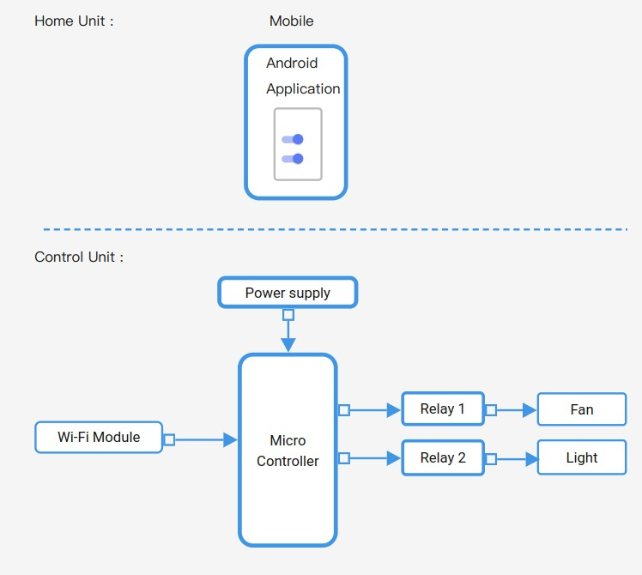

**Hardware Requirement**

We are using the ESP32 microcontroller for our hardware implementation. It has 34 digital input/output pins, with a bootloader preprogrammed to allow us to upload new code without using an external hardware programmer. The ESP32 Wi-Fi module is utilized for communication between the Android mobile app and the Arduino board. The Arduino then processes the received commands and controls the relay board. For electrical switches, we connected the relay board to the Arduino. In our system, two relays are involved.

**Software Requirement**

Clients typically communicate with servers using the TCP/IP protocol suite. TCP is a connection-oriented protocol, meaning a connection is established and maintained until the application programs at each end have finished exchanging messages.

We use an Android application developed in-house, to provide the owner with an override to the system. We can use buttons to turn the light and fan ON, OFF or AUTO. The system will not receive any instructions when they are OFF. The commands are sent through the web viewer object to the Wi-Fi module. The web viewer passes the commands with the address of the Wi-Fi Network.

**Future Scope**

Our system right now comes with restricted access to users i.e., limited to the same network, for the time being. In future, the system can be accessed remotely via internet.