INDEPENDENT STATE OF PAPUA NEW GUINEA
DEPARTMENT OF WORKS & HIGHWAYS
Central Materials Testing & Quality Assurance Division
MATERIALS TESTING LABORATORY MANAGEMENT SYSTEM (DOW MS)
USER ROLES, FUNCTIONAL ARCHITECTURE & PRODUCTIVITY REPORT
DOCUMENT REFERENCE: DOW-QA-SYS-2026-R01 | AUTHOR: Quality Assurance & Laboratory Operations | DATE: October 2026

1. Executive Summary
The Department of Works & Highways (PNG) Materials Testing Laboratory Management System (DOW MS) has been engineered to modernize civil engineering quality compliance, sample chain-of-custody tracking, and official testing certification. Historically, materials testing laboratories operate under intense operational friction caused by manual paper worksheets, repetitive mathematical calculations, scattered equipment calibration records, and multi-day signature routing bottlenecks. DOW MS eliminates these vulnerabilities through a purpose-built, dual-role operational architecture designed specifically for materials testing:
- Laboratory Managers & Senior Engineers: Executive oversight, real-time workload balancing, multi-stage compliance verification, and one-click cryptographic report certification.
- Laboratory Technicians & Shared Workstation Operators: Frictionless tablet/benchtop terminal execution, fast PIN-based technician identity switching, barcode/QR sample scanning, and real-time automated formula calculation.
★ EXECUTIVE PRODUCTIVITY IMPACT
Deploying DOW MS delivers an estimated 65% reduction in laboratory turnaround time (TAT), completely eliminates arithmetic calculation errors, and secures tamper-proof compliance across public road, airport, and bridge infrastructure projects.

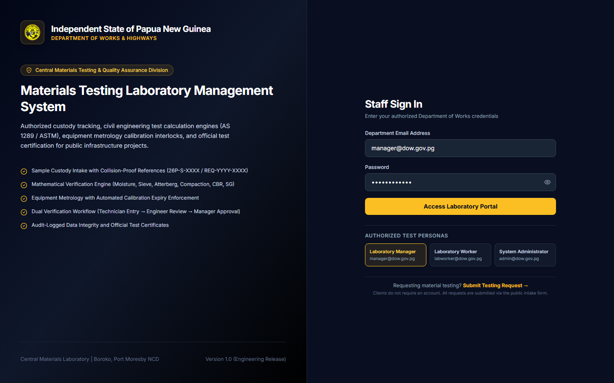
Figure: Official DOW Materials Testing Laboratory Secure Gateway & Multi-Role Entry Point
2. Laboratory Manager & Senior Materials Engineer Role
The Laboratory Manager holds statutory responsibility for test integrity, facility throughput, client relations, and official sign-off on engineering compliance reports. DOW MS provides the Lab Manager with comprehensive command-and-control capabilities without micromanaging physical testing benches.
2.1 Primary Functions & Capabilities
- Real-Time Operational Telemetry & KPI Monitoring: Live visibility into registered samples, tests in progress, pending technical reviews, overdue deadlines, and equipment utilization.
- Sample Intake & Chain-of-Custody Governance: Instant verification of incoming material batches from major national projects (e.g., Connect PNG, Highlands Highway, Enga Highway) with auto-generated collision-proof reference numbers (26P-S-XXXX).
- Workload Allocation & Queue Balancing: Assignment of specialized test procedures (Compaction MDD, CBR, Atterberg Limits, Sieve Analysis, Concrete Crushing) to certified technicians based on competency and availability.
- Multi-Stage Verification & Approval Gates: Technical review queue with side-by-side inspection of technician raw readings versus mathematical curves, with one-click approval or auditable reject-for-correction.
- Automated Report & Certificate Generation: Creation of official Department of Works & Highways materials testing certificates stamped with dynamic verification QR tokens and unique certificate numbers.
- Staff Competency & Metrology Surveillance: Tracking technician active workloads, total tests performed, and monitoring test apparatus calibration deadlines to maintain ISO/IEC 17025 readiness.
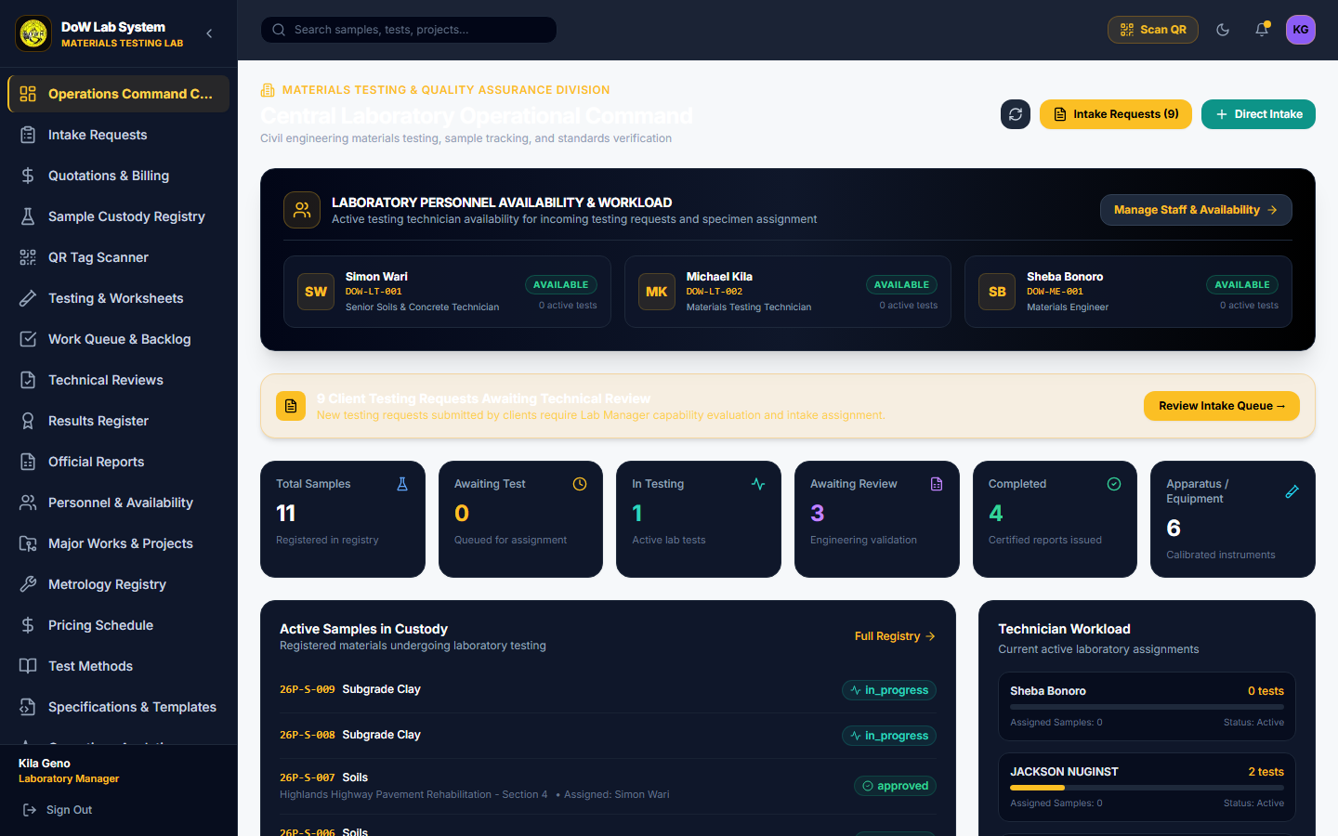
Figure: Laboratory Manager Operational Dashboard showing live KPIs, priority queues, and facility status
2.2 Why It Is Essential for Laboratory Operations
In traditional materials laboratories, managers spend over 40% of their working hours physically tracking paper test sheets, cross-checking technician arithmetic on calculators, and answering contractor telephone queries regarding sample status. The DOW MS Manager portal centralizes every sample lifecycle event in a single pane of glass. When a project engineer or external contractor inquires about test progress, the manager instantly views the sample's current state (Intake, In Testing, Review Pending, or Approved) along with the assigned technician and elapsed time.
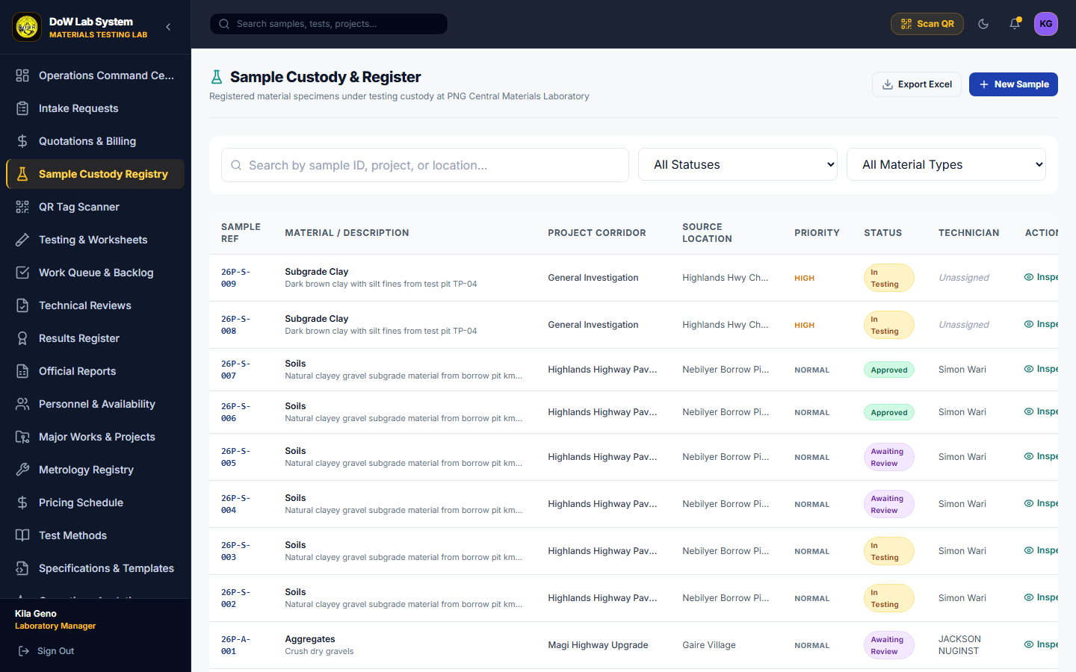
Figure: Central Sample Register with client references, priority filtering, and status badges
2.3 How It Boosts Laboratory Productivity
★ MANAGER PRODUCTIVITY MULTIPLIERS
• Turnaround Acceleration: Batch approvals allow approving dozens of verified tests in minutes rather than days.
• Elimination of Retesting Delays: Managers immediately spot abnormal moisture or density curves before technicians demold or discard test specimens.
• Seamless Audit Readiness: Full historical audit logs prove who received the sample, who performed each test, and who signed the report without searching paper binders.
• Zero Report Drafting Overhead: Reports are generated automatically from calculation records, saving hours of manual Excel formatting.

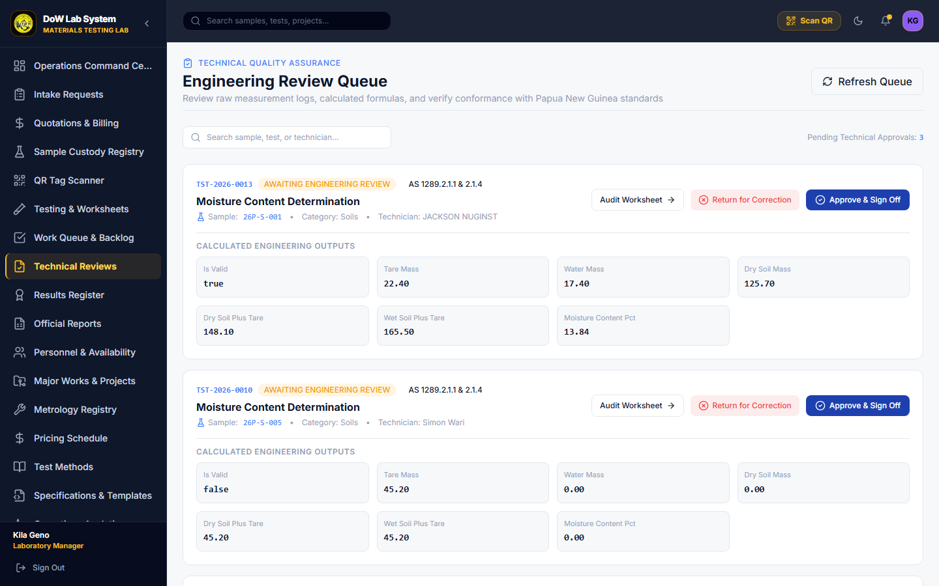
Figure: Technical Review Queue enabling side-by-side inspection and one-click quality sign-off
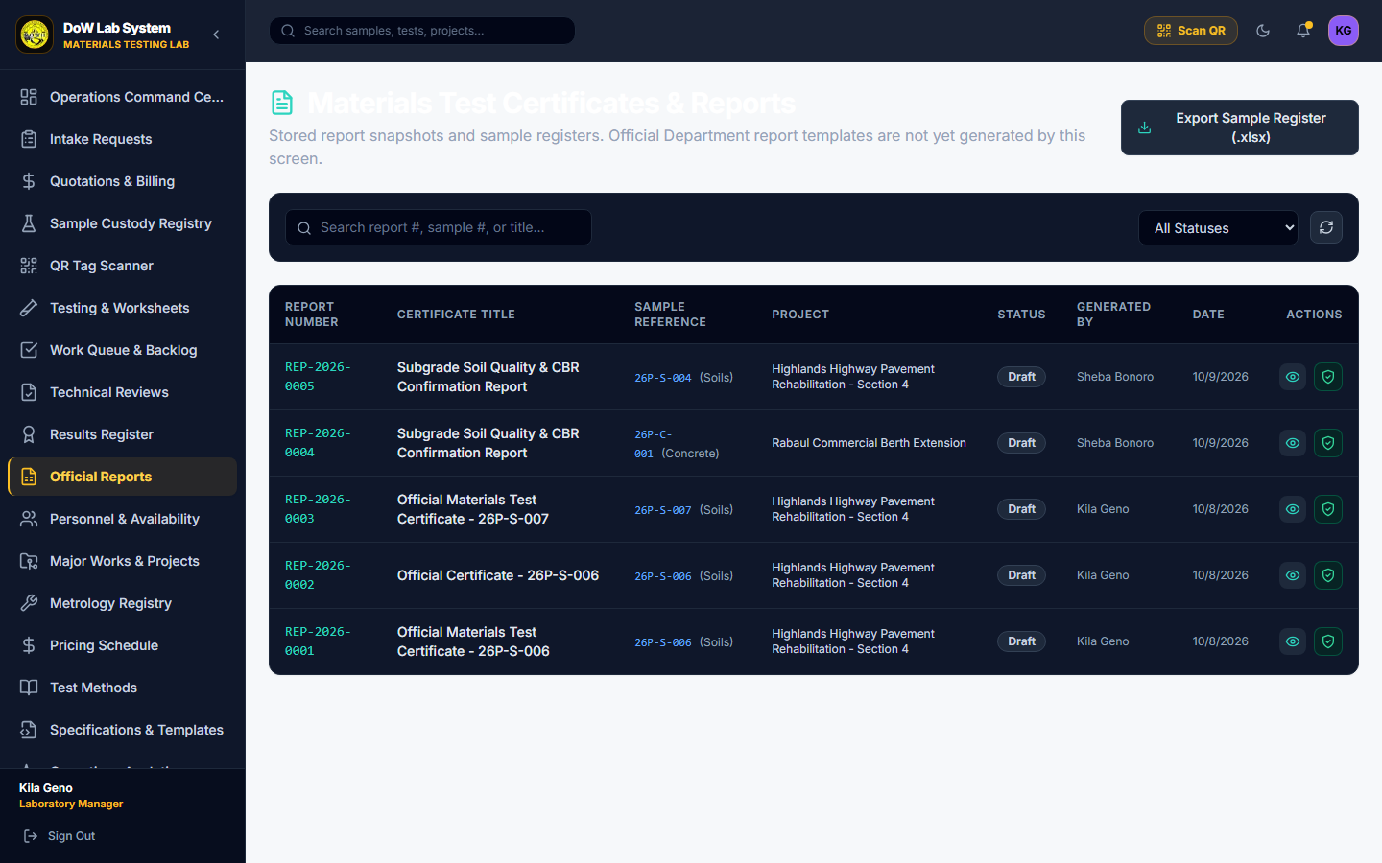
Figure: Official Report & Certificate Generator with digital sign-off and Excel register export
3. Laboratory Worker & Shared Workstation Role
Materials testing laboratories are industrial, physical environments where technicians work with soil compaction hammers, hydraulic concrete crushers, sieves, ovens, and wet slurry. Having every technician carry an individual laptop or log in and out with complex email/password credentials causes severe operational friction and leads to password sharing or untracked test entries. DOW MS solves this with the industry-first Shared Workstation Terminal architecture.
3.1 Primary Functions & Operational Architecture
- Permanent Benchtop Terminal Session: The laboratory workstation stays securely authenticated under the facility service identity (labworker@dow.gov.pg), eliminating repeated system lockouts during daily lab operations.
- Fast 4-Digit PIN Identity Switching: Technicians (e.g., Simon Wari, Michael Kila) select their visual personnel profile and unlock their session in seconds using a private 4-digit PIN.
- Barcode & QR Sample Intake Scanner: Camera and USB barcode scanner integration allows instant sample lookup by scanning physical sample tags attached to soil bags, aggregate sacks, or concrete cylinders.
- Dedicated Technician Work Queue: A personalized queue displaying exactly which tests are assigned to the active technician, prioritized by urgency and client delivery deadline.
- Automated Mathematical Worksheets (AS / ASTM): Technicians enter only primary observations (e.g., wet tare mass, dry tare mass, dial gauge readings, gauge proving ring values). The embedded engine automatically calculates moisture content, dry density, plasticity index, and California Bearing Ratio (CBR) curves in real time.
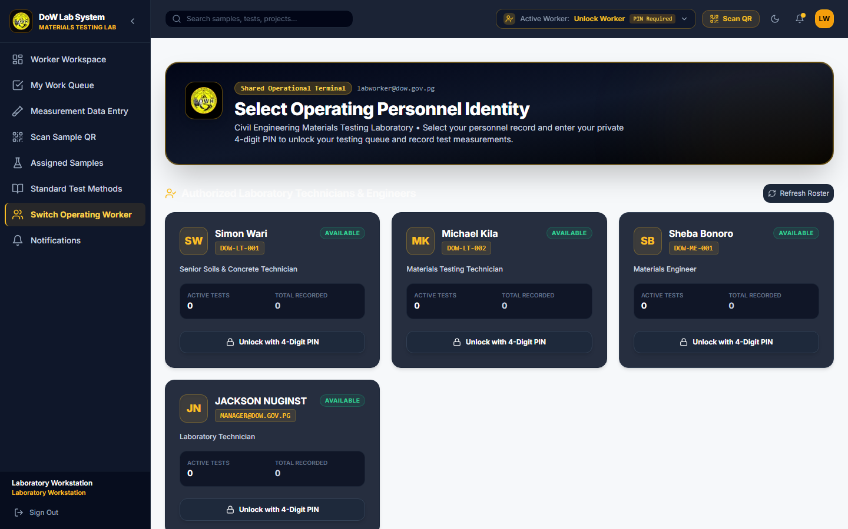
Figure: Shared Workstation Terminal: Visual roster of authorized technicians ready for fast PIN activation
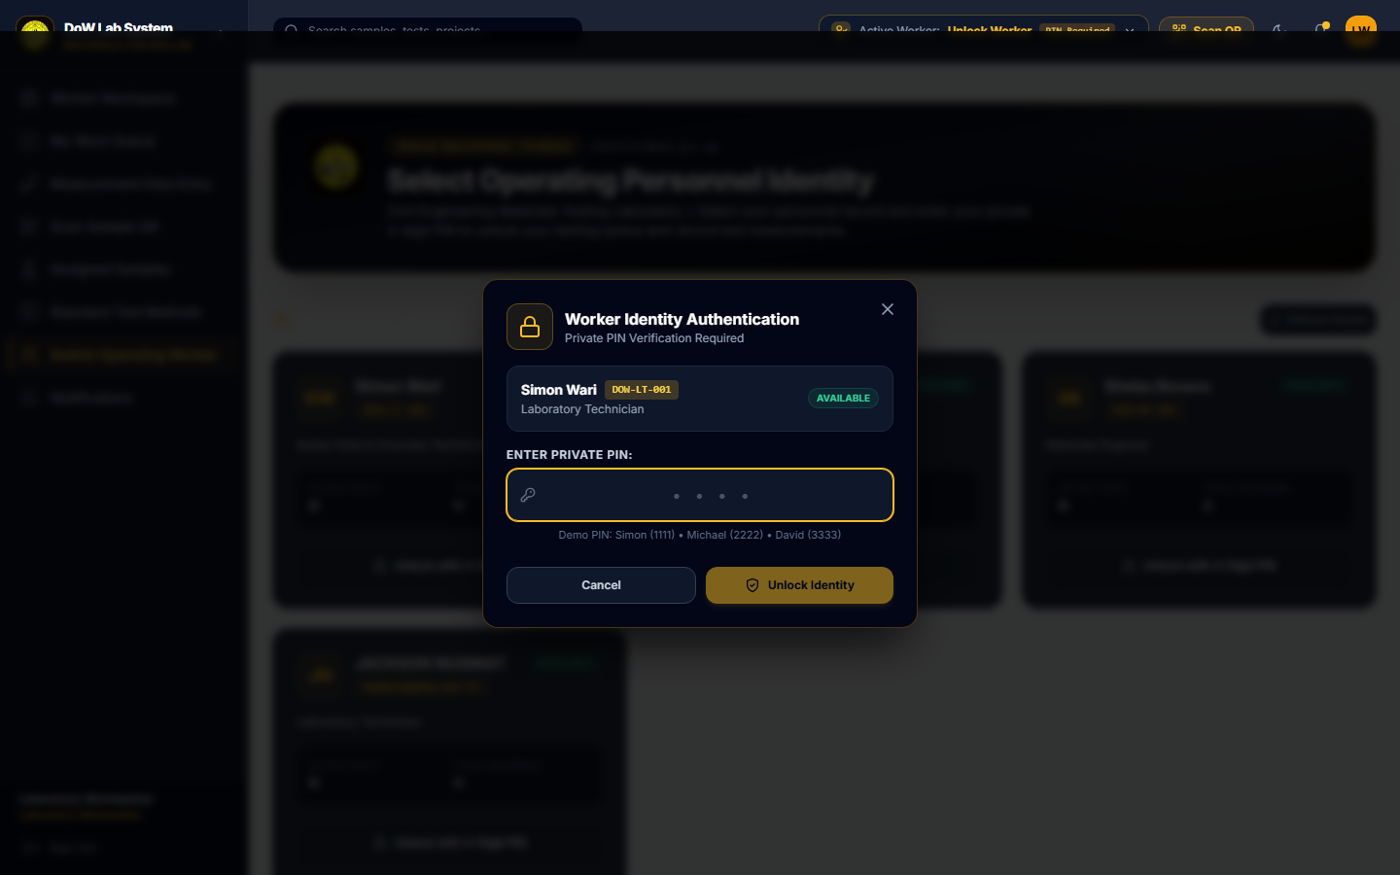
Figure: Secure 4-Digit PIN Authentication Modal ensuring individualized test attribution on shared hardware
3.2 Why It Is Useful on the Laboratory Floor
Testing technicians often wear gloves and move rapidly between drying ovens, balances, and testing frames. The terminal design provides large touch targets, high-contrast dark-mode styling, and clear operational states. Because technician identity switches take under three seconds, Simon Wari can enter a soil moisture reading, step aside, and Michael Kila can immediately enter a 28-day concrete compressive strength reading without restarting the browser or compromising accountability.
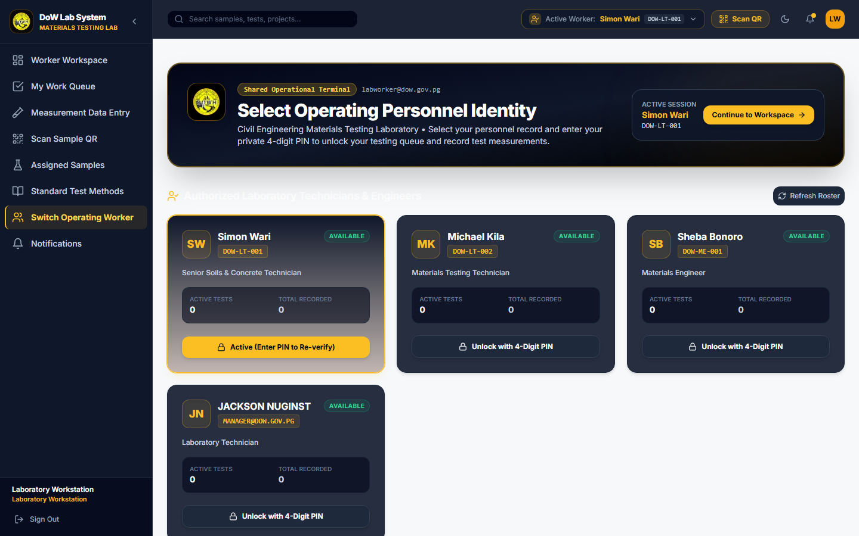
Figure: Active Technician Dashboard (Simon Wari) showing assigned tests and fast-action shortcuts
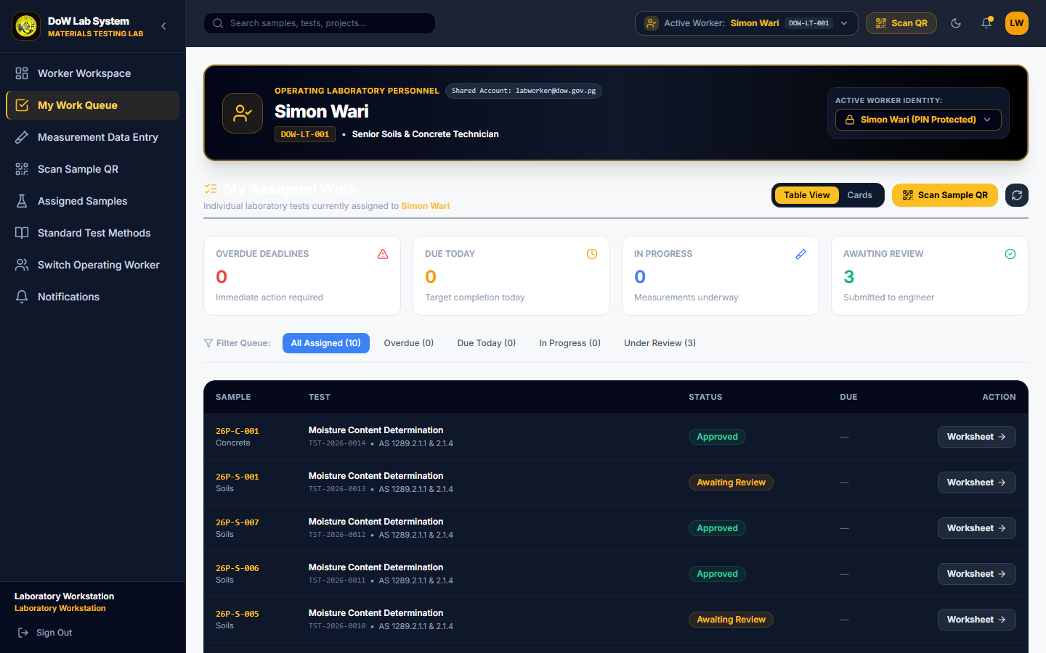
Figure: Technician Work Queue prioritized by testing urgency and material category
3.3 How It Boosts Laboratory Productivity
★ TECHNICIAN PRODUCTIVITY MULTIPLIERS
• 100% Elimination of Manual Calculation Time: Technicians save 20 to 45 minutes per test specimen by avoiding manual logarithmic graphing and spreadsheet data entry.
• Zero Lost Samples: Barcode scanning guarantees the right test is executed on the right sample bag every single time.
• Real-Time Data Entry: Measurements are entered directly at the balance, eliminating transcription errors from illegible handwritten bench notes.
• Maximum Hardware Utilization: 1 benchtop PC or ruggedized tablet serves the entire testing crew, minimizing IT hardware costs.

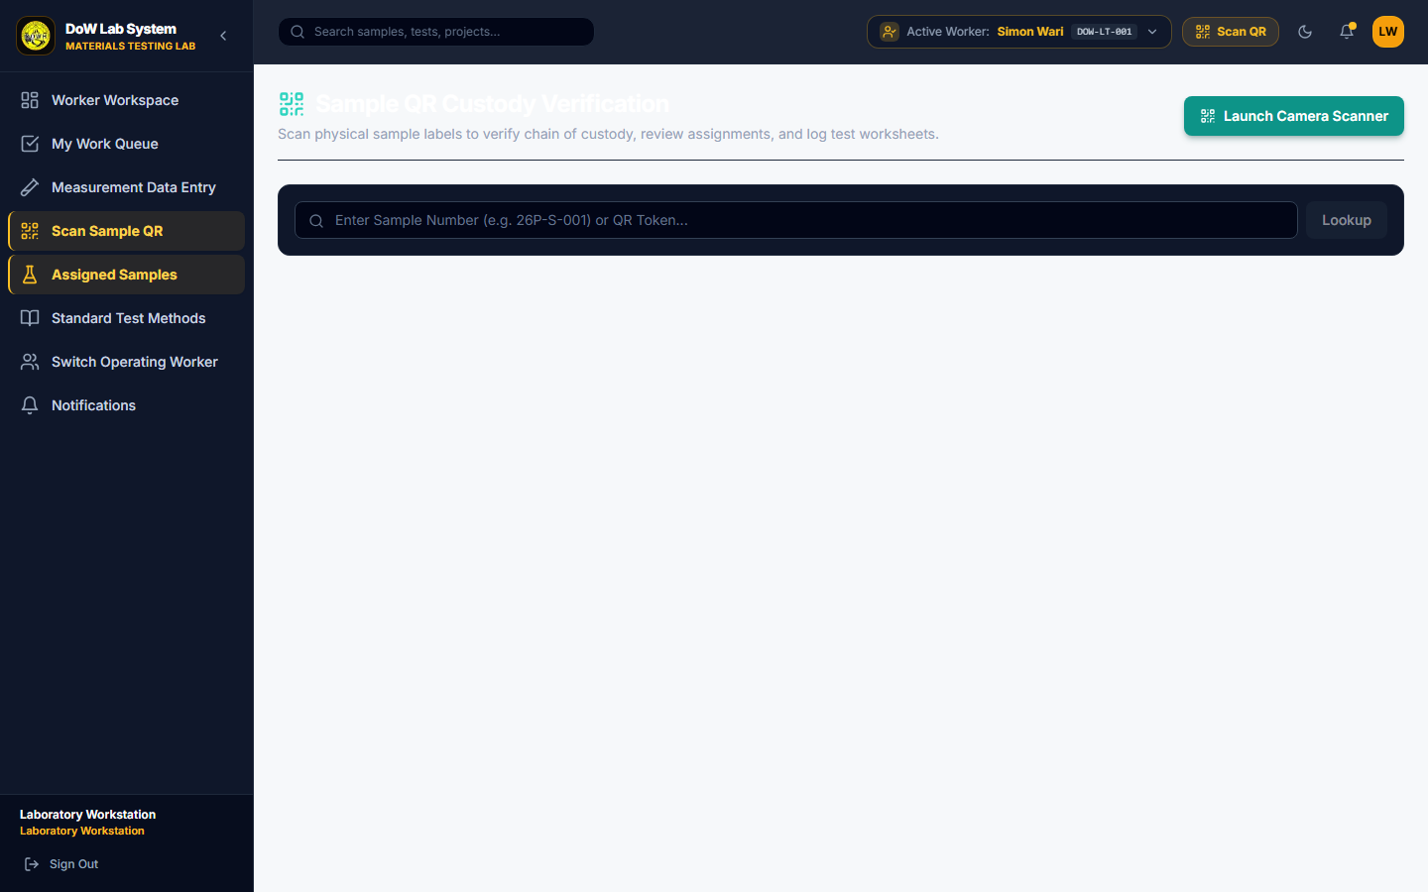
Figure: Instant Barcode & QR Code Sample Intake Scanner for fast benchtop lookup
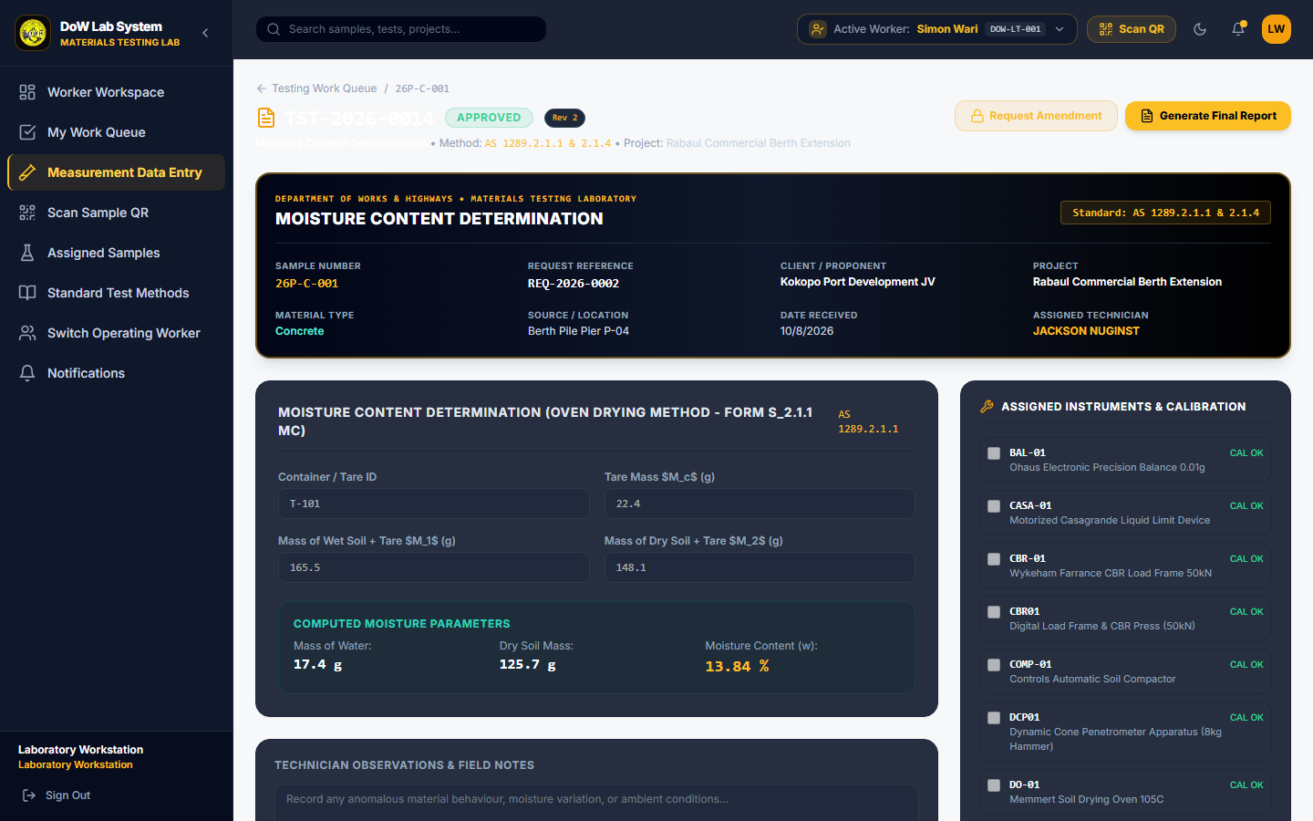
Figure: Interactive Standard Test Worksheet with automated calculation and specification limits
4. Role Functionality & Productivity Comparison
The following matrix summarizes the distinct functional division between Laboratory Managers and Laboratory Technicians, illustrating how their complementary workflows form an efficient quality loop.
Functional Dimension | Laboratory Manager | Laboratory Worker / Technician
Authentication & Access | Individual secure credential with multi-tenant facility scope | Shared workstation terminal with instant 4-digit PIN identity switching
Primary Workspace | Comprehensive KPI dashboard, sample registry, and review suite | Focused benchtop work queue, QR scanner, and interactive test worksheets
Key Daily Responsibilities | Workload distribution, reviewing test curves, approving certificates | Conducting physical tests, recording weights/readings, inspecting samples
Calculation Role | Inspects calculated parameters against PNG DoW specifications | Enters raw instrument readings; engine calculates equations in real time
Quality Gate Role | Final sign-off authority; generates official PDF certificates | Submits completed tests for technical review; addresses correction notes
Impact on Laboratory Productivity | Eliminates approval delays; provides immediate status to clients | Saves 30+ minutes per test; eliminates handwriting and math errors

5. Conclusion & Deployment Recommendations
The separation of roles in the Department of Works & Highways Materials Testing Laboratory Management System establishes an ideal balance between physical ease-of-use on the laboratory floor and rigorous quality compliance in the management office. By empowering technicians with rapid PIN switching and automated calculation worksheets while providing managers with real-time oversight and digital certificate generation, DOW MS transforms materials testing from a paper-bound bottleneck into a rapid, defensible quality assurance engine.
Key Deployment Recommendations:
- Deploy Dedicated Touch Tablets / Terminals in Soil, Concrete, and Asphalt Bays: Mount durable tablets at testing stations authenticated to the shared workstation profile so technicians can record readings directly at the scales.
- Enforce Individual Technician PIN Discipline: Ensure technicians maintain private 4-digit PINs to protect the integrity of the automated audit trail.
- Integrate Handheld Barcode / QR Scanners: Equip sample intake bays with 2D barcode scanners to accelerate sample reception from field couriers.
- Utilize Real-Time Review Cycles: Encourage managers to perform progressive reviews throughout the working day rather than end-of-week batching, unlocking immediate certificate availability for infrastructure contractors.
APPROVED FOR DISTRIBUTION:
Materials Testing & Quality Assurance Division
Department of Works & Highways, Port Moresby, Papua New Guinea
System Version: DOW MS 2026.1 (Production Standard)

