**Design Proposal**

**University Digital Bulletin Board System (DBBS)**

Prepared for:

Dr. Jackson Longwall, CEO

Engineering Innovations

4341 South Broadway Street

Denver, CO 84321

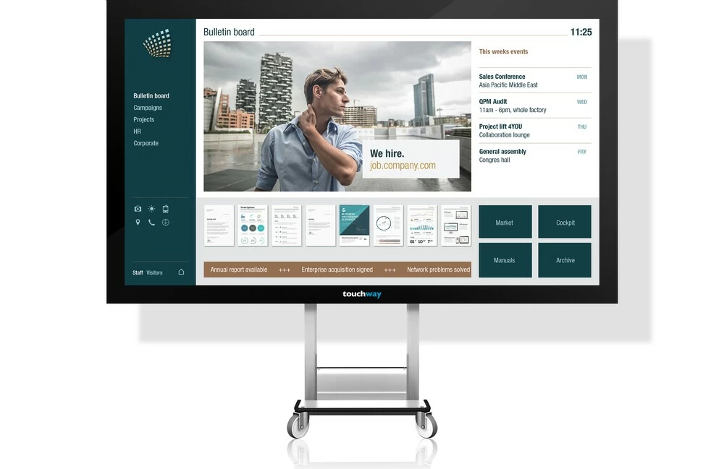

[1]

Prepared by:

Michael Harrop

Jake Pope

James Richardson

Mark Snyder

Utah State University

November 24, 2020

Communication between students is a key to success on a college campus. The purpose of this document is to propose a Digital Bulletin Board System (DBBS) for the campus of Utah State University. This document discusses the background of the technology, the method of work, the cost and schedule, and qualifications of the team members.

Executive Summary

The proposed solution is the installation of a Digital Bulletin Board System (DBBS) on the campus of Utah State University in Logan, Utah. The installation of a DBBS will provide the student community a community communication system. The system provides quick access to information and can be interacted with by the users. Because the information can be sent electronically, the information displayed can be updated quickly and always be current.

Current bulletin boards require new materials to use and update the board, communication is one-way, and information cannot be changed and can become outdated. Universities often have dozens of bulletin boards placed around their campus, meaning updates are a costly effort for both time and materials. While internet-based solutions could solve this problem, these solutions do have drawbacks which include privacy, miscommunication, off-topic discussion threads, and non-community member input.

To alleviate these problems, we propose a campus-wide installation of a DBBS. The projected total cost of the system is $57,024 and a completion of time frame of 6 months. The time frame includes five different phases which include: gathering resources, designing the system, developing the system, deploying the project, and maintenance.

The DBBS project for the campus of Utah State University is in accordance with Engineering Innovation’s Great Ideas Engineering Award requirements. The various experience among team members with networking, graphical user interfaces, and web development contribute to the team’s ability to complete the project. The team’s communication and technical skills ensure the smooth completion of this project.

**Table of Contents**

Executive Summary i

List of Figures and Tables iii

Introduction 1

Background Information 2

Current Implementation 2

Digital Implementation 2

College Campuses 3

Method of Work 4

Alternatives 6

Benefits 6

Challenges 6

Management Plan 7

Schedule 7

Personnel 8

Resources 9

Costs 9

References 12

Appendix – Team Resumes 13

List of Figures and Tables

**Figure 1.** The relationships between Server, Database, and Clients. 4

**Figure 2.** The relationship between the server and the Client (Kiosk). 5

**Figure 3.** The relationship between the server and the database. 5

**Figure 4.** The relationship between the server and clients. 6

**Figure 5.** Timeline for each phase of the project. 8

**Table 1.** Total expenses for the DBBS. 10

Introduction

This proposal is in response to the Great Ideas in Engineering RFP sponsored by Engineering Innovations. The purpose of this proposal is to recommend the installation of a Digital Bulletin Board System (DBBS) on the campus of Utah State University in Logan, Utah. The proposal provides a background information section, a method of work and benefits section, and a management plan section. These sections include instructions on the set up and the use of a DBBS and the benefits it would provide USU.

The Logan campus of Utah State University Logan campus was founded in 1888. Over the last 130 years, the campus has seen much construction, both the construction of new buildings and updating old buildings. However, while the buildings have been updated over the years, the campus communication system has not. The bigger buildings which have the most foot-traffic feature monitors around the building, but these only show university news and are not for student use.

The students at Utah State University form a community and a community is built on communication and awareness. “However, a community should not just be seen as a set of people who have something in common and who have the possibility to communicate, but as a set of people who are willing to help each other, who are collaborating to the advantage of all.” [2] Because of this, there must be something in place that allows community members to communicate and collaborate.

Current bulletin boards require new materials to use and update the board, communication is one-way, and information cannot be changed and becomes outdated. Universities often have dozens of bulletin boards placed around their campus, meaning, updates are a costly effort for both time and materials. While internet-based solutions could solve this problem, these solutions do have drawbacks which include privacy, miscommunication, off-topic discussion threads, and non-community member input.

A DBBS is an effective way to solve this communication problem between students at Utah State University. Built on a client/server model, information posted on one client would transfer to the server, then forwarded to all other clients. This allows up-to-date information to flow quickly between students with more efficiency than current bulletin boards. The DBBS also eliminates some of the internet solutions similar to off-topic discussions and miscommunication.

Background Information

Bulletin boards are useful tools for getting information to and interacting with a community. They often have announcements, flyers, event invitations, and advertisements [3]. Bulletin boards are used to great effect on college campuses but are limited by physical constraints. An interactive DBBS overcomes many of the problems and limitations of a traditional, physical bulletin board.

Current Implementation

There are limitations to traditional, physical bulletin boards. They require new materials to update and use the board, communication is one-way, usage statistics cannot be collected, and information cannot be changed and can become outdated. Installing a DBBS addresses these issues.

Physical bulletin boards require constant maintenance to stay updated. Campuses and companies often have dozens of bulletin boards. Making updates to the boards are a costly effort for both time and materials. Every update requires paper, printer ink, push pins, etc. [3]. On a large scale, these costs can add up quickly, which is why lots of bulletin boards are not updated [4]. These updates also require time spent in person for each individual board, whereas multiple digital boards can be updated instantly.

Traditional physical boards are inherently limited by one-way communication, a restriction digital boards do not have. A system that can both provide information and be interacted with is more valuable to the person viewing the board. With no meaningful way to interact with traditional boards, it is difficult to gauge the success of a board and determine if it is an efficient use of resources [3].

Digital Implementation

With the flaws discovered while during research on current physical bulletin boards, the DBBS requires three important features to be successful. The board needs to be simple and easy to use, have a consistent user interface (UI), and be remotely updatable across multiple boards.

The board and UI need to be simple and easy to use to be successful; this can be broken into four ideas: reduction, organization, integration, and prioritization. Reduction is removing all elements that are not essential to the purpose of the board. Organization means the design and layout of the board should be simple and easy to navigate. Integration means every piece of the board application serves to function as a greater whole, rather than be a standalone idea. Prioritization means focusing on the essential components and functions of the board [5].

Consistency is crucial to a good user experience. When the UI elements and overall design of an application are consistent, it becomes easier to learn and understand. If designed poorly, the user can become frustrated and abandon the board all together. A good UI is like a joke; if you must explain it, it is a bad one.

The DBBS uses a client/server model. This allows users to interact with one client, and have the new information forwarded through the server to all other clients. Because of this, all clients are displaying the same information at the same time. Administrative users can also add information they want displayed to the server, which is sent to all the clients. Any interactive elements on a board send the information back to the server [6].

College Campuses

College campuses are an ideal location for the digital notification board. Campuses often already utilize some form of bulletin boards, making them a natural fit. In addition, campuses are a controlled environment due to the consistent demographic. College campuses are a large market; if the project proves successful then it will be marketable. Campuses also have a high traffic density which results in more meaningful interactions.

Controlling as many variables as possible is crucial when testing ideas and products. College campuses naturally have a consistent demographic. The age of students is typically 18 – 24 years and they share common goals and academic needs [7, 8]. This consistency extends to different areas of a campus. Bulletin boards in general areas are frequented by all students, but boards in small, specific sections of campus can be used to test viability with a specific subpopulation of the student body [9].

The location of a bulletin board defines how successful it will be. Boards in high traffic areas are better suited to general purposes; whereas the aforementioned locations that target a specific subpopulation are better suited to specialized boards [9]. The goal of the DBBS is to accommodate the majority of the student body, so it should be in a high-density area.

College campuses are a good target audience to secure funding. Thousands of students will see and potentially interact with the bulletin board [7]. The DBBS also has internet connectivity, allowing students to interact with the bulletin service in meaningful ways after initial engagement.

Method of Work

The Digital Bulletin Board System (DBBS) is designed to display community information in a public place. The DDBS takes four actions to receive information and display it. Step 1, the client requests information from the server, or sends information to the server. Step 2, the server queries the database for relevant information. Step 3, the server returns the information to the client. Step 4, client updates display with the information received by the server. These relationships are depicted in Figure 1.

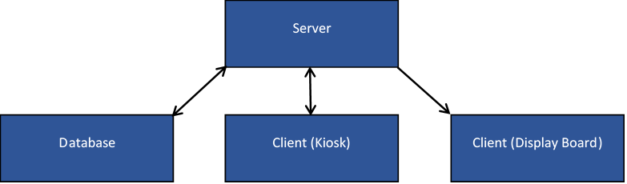

**Figure 1.** The relationships between Server, Database, and Clients.

In computing, a *client* is a piece of computer hardware or software, the kiosk or the display board, used to communicate information to a server on a computer network. In computing, a *server* is a piece of computer hardware or software that takes information from clients through the computer network and stores the information in an internal database. The server then resends the information to each client on the computer network.

**Step 1: Transfer of information.** The client requests information from the server or the server sends information to the client, which is depicted in Figure 2. One, the client can ask the server for information regarding the different ads in the database. Then the client takes the information and displays it to the user on the kiosk. Two, the user can create an event, or ad, and send the information to the server. Once the server has received the information from the client, the server queries the request for relevant information.

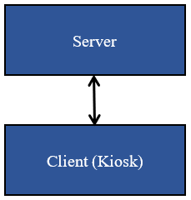

**Figure 2.** The relationship between the server and the Client (Kiosk).

In computing, a *query* is a request for information. This includes querying or scanning a request for relevant information. In computing, a *database* is a comprehensive collection of related data organized for convenient access, generally in a computer [10].

**Step 2: The server queries information**. Once the server has received the information from the client the server queries the database. The purpose of querying is to scan the database for the best place to put the information in the database, which is depicted in Figure 3. Once the server has added the information, it returns the new, updated information back to the clients.

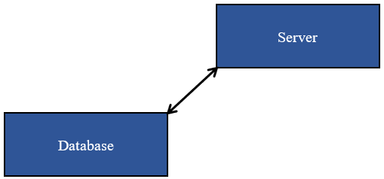

**Figure 3.** The relationship between the server and the database.

**Step 3: Server sends information**. The server sends the information to the different clients, which is depicted in Figure 4. There are two clients involved with the server: the kiosk and the bulletin display board. Each client takes the information sent from the server and processes the information in different ways.

**Step 4: Display information.** The kiosk displays the information as examples, and as an interactive bulletin. The TV or projector client displays the information received from the server. There is a one-way relationship in Figure 4 between the server and the display board client. The display board only receives information and cannot send information to the server.

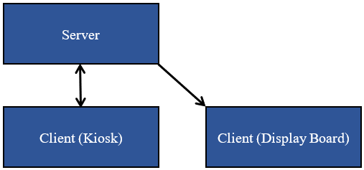

**Figure 4.** The relationship between the server and clients.

Alternatives

One option considered for the DBBS was to create the system completely electronically. The display where the notifications are would be a section of an application or website. To be able to add an event or an advertisement the user would visit a different section of the app or a different page on the website. This was not a valid option because it does not have a physical location where members of the community can gather to.

Benefits

Benefits of the DBBS include: a two-way communication and an easy way to update information. The two-way communication is where the DBBS can provide information and be interacted with by the user. Updating the information becomes easy as well, because the information can be sent electronically and update instantly.

Challenges

Some challenges of the DBBS are having the community start using it, having bugs in the code after deployment, and filtering out inappropriate content. Issue one, once the DBBS gets installed in the community, advertisement through word of mouth. Though getting the community to start using the DBBS would depend on how much the word spread.

In computing, *bugs* are issues in the code that make the program run incorrectly. Issue two, with bugs the code might seem to run perfectly, though upon deployment, when users interact with the DBBS they find bugs not previously noticed by the developers.

Management Plan

This section analyzes the schedule, personnel, resources, and costs required to complete the project. Each of the estimates provided in this section aim to be realistic, but they are expected to change as the project progresses. These differences may result from price changes in the market or changes in the amount of time needed to complete certain tasks.

Schedule

The project is separated into five different phases: gathering resources, designing the system, developing the system, deploying the project, and performing maintenance. The timeframe of the project last around 6 months. Each phase of the project has a projected length within the total timeframe of the project. Figure 5 shows the expected length of each design phase.

**Phase 1: Gathering resources.** The first phase of the project is gathering the necessary resources. The necessary resources include materials, services, and facilities. The gathering resources phase takes 4 weeks. Team members must analyze all resources and materials before making decisions.

**Phase 2: Designing the system.** The second phase of the project is designing the system. In this phase, the team designs the project, but no code is written. All aspects of the project are planned and designed before this phase ends. This phase has a projected length of about 5 weeks.

**Phase 3: Developing the system.** The third phase of the project is developing the system. This is the phase in which the project is coded and constructed. As the longest phase of the project, this section takes an estimated 2 months.

**Phase 4: Deploying the project.** The fourth phase of the project is deploying the project. In this phase, the project is hosted on any necessary servers, and the system is set up in the desired location. This phase is expected to take 3 weeks.

**Phase 5: Performing maintenance.** The fifth and final phase of the project is performing maintenance. This phase includes any necessary bug fixes or repairs on the system after deployment. New features are not added to the project after deployment, only necessary fixes. This phase is expected to last 1 month.

**Figure 5.** Timeline for each phase of the project.

Personnel

This section lists the skills and experiences for each of the members of the team. The team members each have the necessary skills to make necessary contributions to the project. These skills relate to the requirements of the project. The appendix contains the resumes of all team members.

**Michael Harrop.** Michael is a junior in the computer science program at USU. Michael has worked as a research assistant at USU and has experience in Java Networking and Event-Driven programming. He has taken courses that are helpful to this project such as Computer Networking and Algorithms and Data Structures.

**Jake Pope.** Jake is a junior in Utah State University’s Computer Science Program and a member of the University Honors Program. He has experience with web development, and he is proficient with the programming languages Java, Python, and JavaScript. Jake has taken courses for software development and web development. These experiences help contribute to this project.

**James Richardson.** James is a junior in Utah State University’s Computer Science Program. He has experience with web development, and he is proficient with programming languages such as Java, Python, HTML, CSS, and JavaScript. James has taken courses for software development and web development. James also works for Utah State University as a website technician.

**Mark Snyder.** Mark is a junior in Utah State University’s Computer Science Program. Mark has experience with front-end and back-end web development in addition to application programming and UI design. He is proficient with Java, C#, Python, HTML, CSS, JavaScript, and XSLT. Mark has years of experience on academic, professional, and personal projects. He currently works in web development as a CMS Programmer at Utah State University.

Resources

This section lists the materials and resources needed for the project. When applicable, the materials are purchased in the amounts specified below. Some resources for this project are services provided by other companies. The team has access to a computer laboratory with the necessary development software, but development is also possible using personal equipment. The necessary resources include:

Materials:

* Internet Enabled Tablet
* Tablet Mount
* 2 LED 43 in. Displays
* 2 Display Mounts
* Desktop Computer
* Display Cables

Facilities and Services:

* Computer Laboratory
* Web Servers

Costs

This section analyzes the projected expenses needed to design and manufacture a Digital Bulletin Board System (DBBS). For these projections, the team members are paid a wage of $20 per hour. The cost of materials is based on similar items listed on retail websites. Expenses for the DBBS are shown in Table 1.

The expenses for the project are divided into three sections: labor, materials, and facilities. The cost of labor is the largest at $53,600. The cost of materials is $1,274, and the cost of facilities is $2,150. These expenses add up to create a total cost of $57,024 for the project.

**Table 1.** Total expenses for the DBBS.

|  |  |  |
| --- | --- | --- |
| **Labor** | **Hours** | **Cost ($)** |
| Phase 1 | 320 | 6,400 |
| Phase 2 | 600 | 12,000 |
| Phase 3 | 1080 | 21,600 |
| Phase 4 | 360 | 7,200 |
| Phase 5 | 320 | 6,400 |
| Subtotal | 2680 | $53,600 |
|  |  |  |
| **Materials** |  |  |
| Internet Enabled Tablet | - | 380 |
| Tablet Mount | - | 84 |
| 2 LED 43" Displays | - | 320 |
| 2 Display Mounts | - | 70 |
| Desktop Computer | - | 400 |
| Display Cables | - | 20 |
| Subtotal | - | $1,274 |
|  |  |  |
| **Facilities** |  |  |
| Computer Laboratory | - | 2,000 |
| Web Hosting | - | 150 |
| Subtotal | - | 2,150 |
|  |  |  |
| **Total** |  | $57,024 |

**Conclusion**

Because of the limitations current bulletin boards need for communication in a community, there needs to be an improvement for the student community of Utah State University. This proposal discusses the implementation of a DBBS to solve this problem. The proposal provided a background information section, a method of work and benefits section, and a management plan section.

A DBBS is an effective way to solve this communication problem between students at Utah State University. Built on a client/server model, information posted on one client would transfer to the server, which would forward the information to all other clients. This allows up-to-date information to flow quickly between students with more efficiency than current bulletin boards. It also eliminates some of the internet solutions similar to off-topic discussions and miscommunication.

The project has five different phases which include: gathering resources, designing the system, developing the system, deploying the project, and maintenance. The project’s predicted completion timeframe is about 6 months. The projected total cost for necessary personnel and equipment is $57,024; this price can change however, based on the number of kiosks installed.

The various experience among team members with networking, graphical user interfaces, and web development contribute to the team’s ability to complete the project. The team’s communication and technical skills ensure the smooth completion of this project. While this project specifically mentions the campus of Utah State University, the DBBS could be implemented at other campuses and various locations. Because of this, it will result in a commercially viable product for Engineering Innovations.

References

[1] “Bulletin Board.” touchway. Available: <https://www.touchway.com/en/software/wall/974/Wall.htm>. [Accessed: 10-Nov-2020]

[2] Koch, Michael, "Supporting Community Awareness with Public Shared Displays" BLED 2005 Proceedings. 45. Dec. 2005. <http://aisel.aisnet.org/bled2005/45>

[3] Christopher Kullenberg et al., “What are analog bulletin boards used for today? Analysing media uses, intermediality and technology affordances in Swedish bulletin board messages using a citizen science approach,” PLOS One, Aug. 2018.

[4] K. Leggett, “Six KM best practices to enhance customer service,” KMWorld, 28-May-2011.

[5] J. Lee, D. Lee, J. Moon, and M.-C. Park, “Factors affecting the perceived usability of the mobile web portal services: comparing simplicity with consistency,” Inf. Technol. Manag., vol. 14, no. 1, pp. 43–57, 2013.

[6] S. Greenberg and M. Rounding, “The Notification Collage: Posting Information to Public and Personal Displays,” CHI 2001, vol. 3, no. 1, pp. 514-521, Mar. 2001.

[7] “Marketing to College Students,” business.com, Jun. 10, 2010.

[8] Slawsky, R. (2018). Beyond the Blackboard: Kiosks on Campus [PDF]. Kiosk Marketplace. https://engagis.com/wp-content/uploads/2019/01/White-paper-Kiosks-on-Campus.pdf

[9] Natapov, Asya, and Helena Grinshpun. “Hidden in the Most Visible Place: Measuring Visual Accessibility and Social Performance of Urban Kiosks.” Journal of Urban Design, vol. 25, no. 3, June 2020, pp. 412–432. EBSCOhost, doi:10.1080/13574809.2019.1592667.

[10] “database,” Dictionary.com. [Online]. Available: https://www.dictionary.com/browse/database?s=t. [Accessed: 15-Nov-2020].

Appendix – Team Resumes