Rachel Shaw

CSD-310

1.2 Assignment

**Link to GitHub repository:**

[ResCode75/csd-310: Assignments for CSD-310 "database development and use"](https://github.com/ResCode75/csd-310)

**Screenshot of repository:**

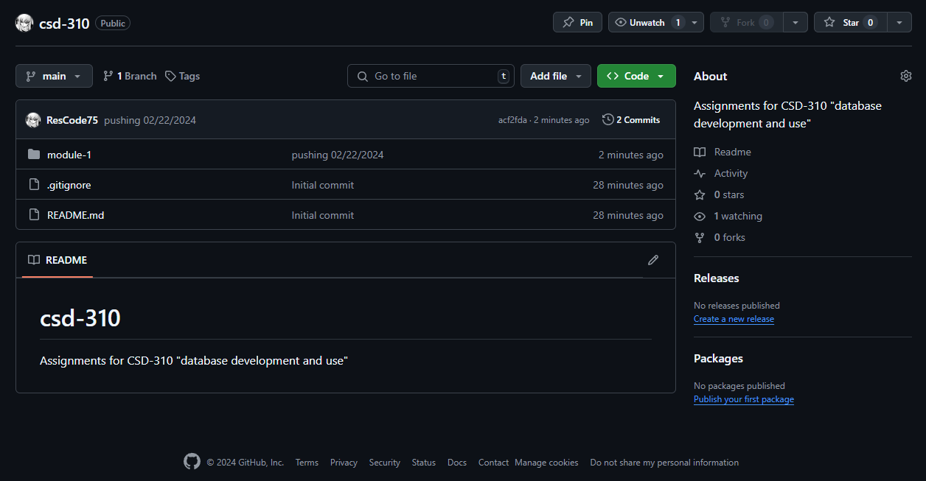

**Screenshot of local directory with csd directory and csd-310 repository inside:**

