Rachel Shaw

10.22.2024

CSD 325

Link to my CSD-325 Repository:

[ResCode75/csd-325: Assignments for CSD-325: "Advanced Python"](https://github.com/ResCode75/csd-325)

Screenshot of CSD-325 Repository:

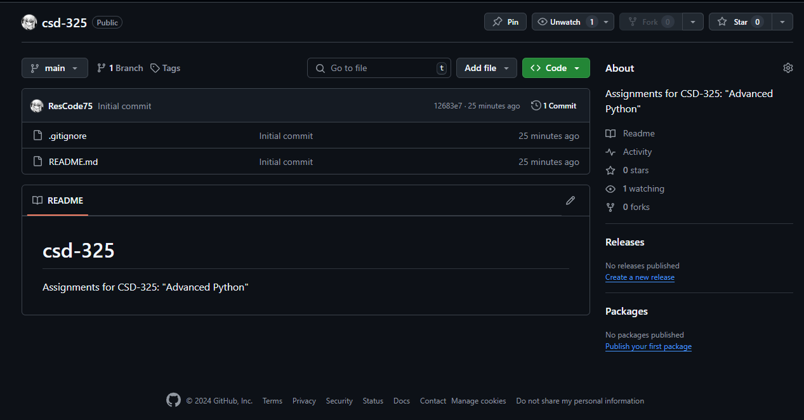

Screenshot of my local directory with my csd directory and a clone of my csd-325 repository inside it.

