Rachel Shaw

2.2 Debugging Assignment

10/24/2024

**Creating Breakpoints:**

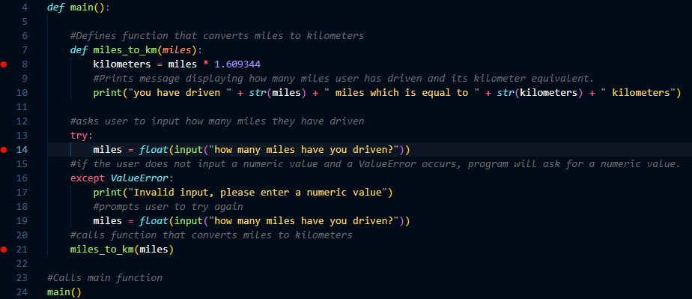

**Stepping into my miles_to_km function:**

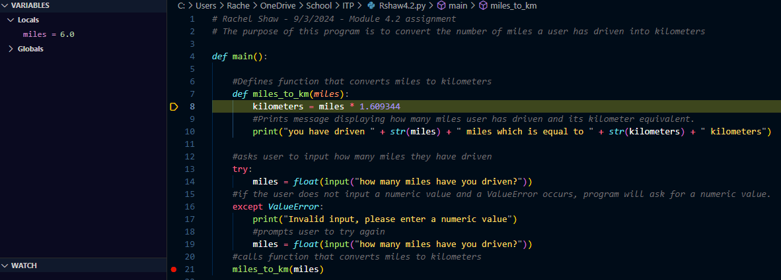

**Exploring my code by moving through the program:**

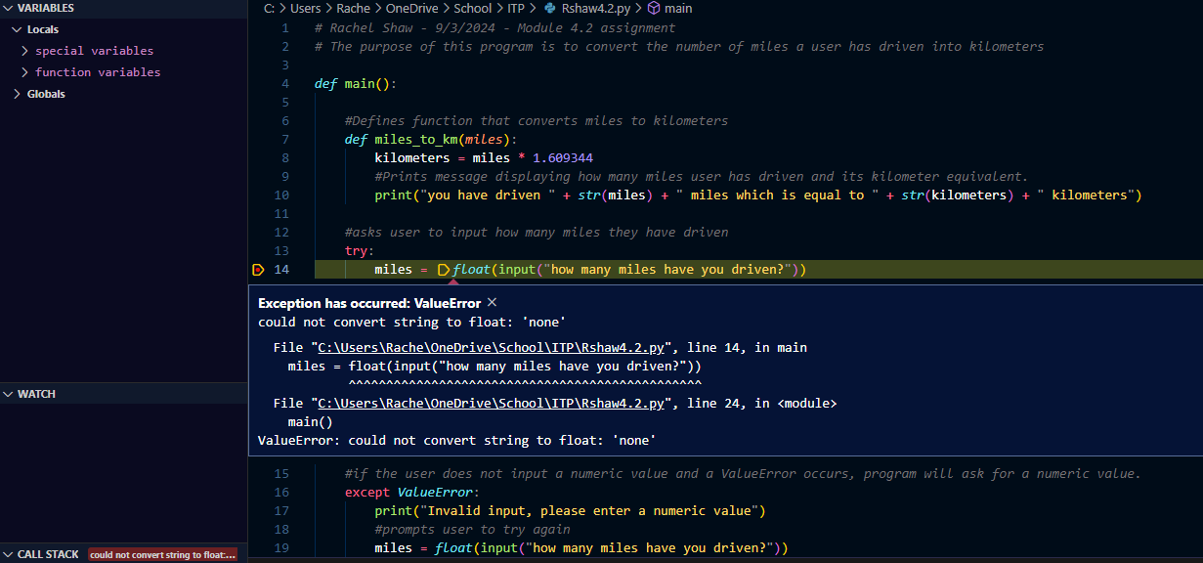*Stepped into the input function to see that the value error occurs here if the input wasn’t a numerical value*

**Watching when my variables change by moving through the program with step in and continue commands:**

