Contents

Application URL: 3

Home/Login Page 3

Home page 3

Upload Survey 3

Survey uploaded 4

Upload User data 5

Release Survey 5

Validate and Registration 7

Take Survey 9

Survey Q& A 9

Submit Survey 10

Survey result 11

Single user Graphs 12

Reports in Admin 14

Multiple users results 16

## Application URL:

<http://ec2-13-234-154-202.ap-south-1.compute.amazonaws.com:443/>

## Home/Login Page

Login details – Credentials: admin/admin to login as admin

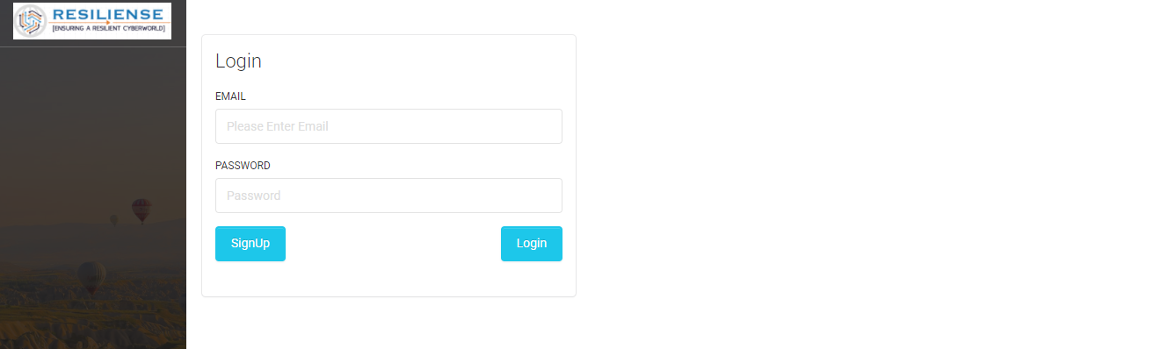

## Home page

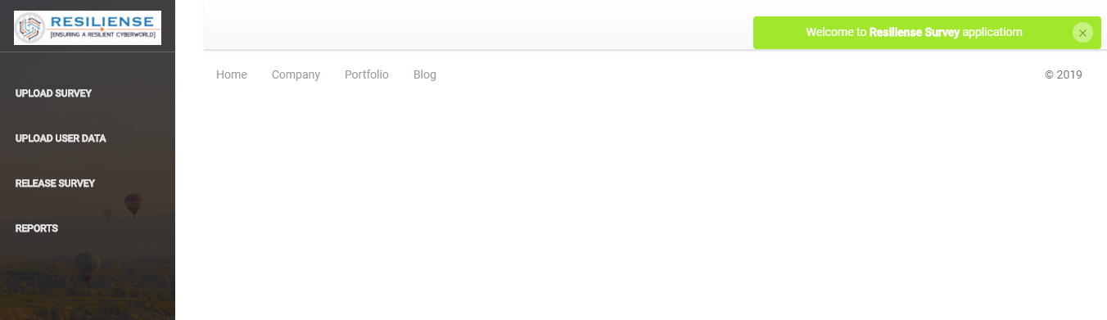

New Admin page

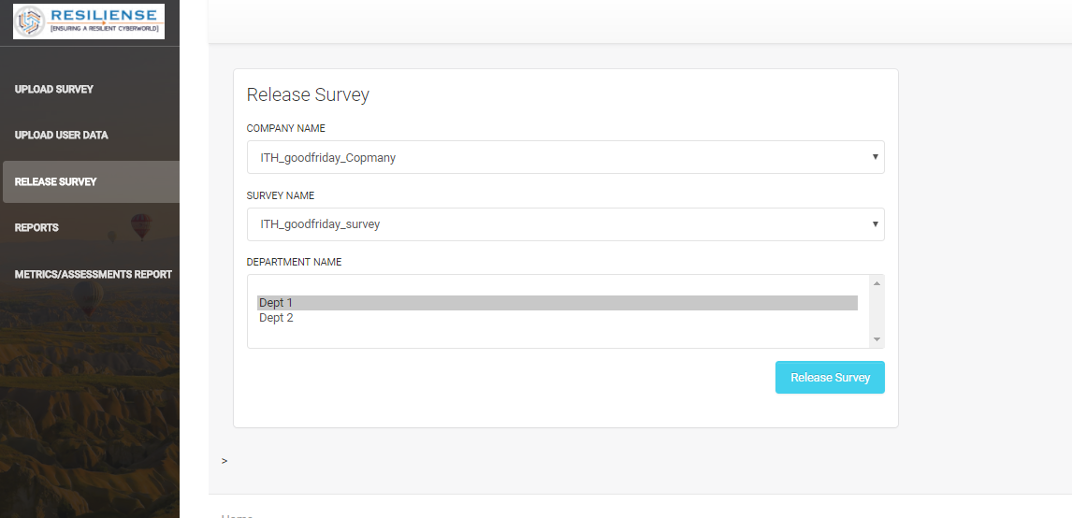

## Upload Survey

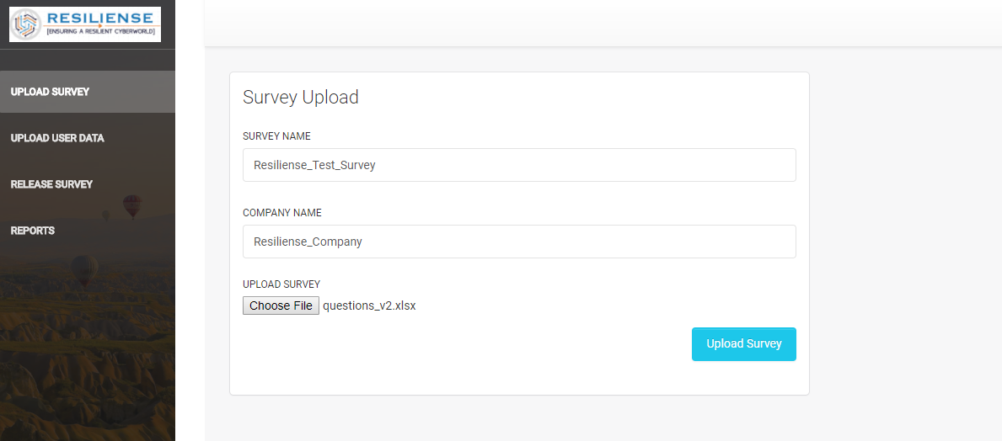

## Survey uploaded

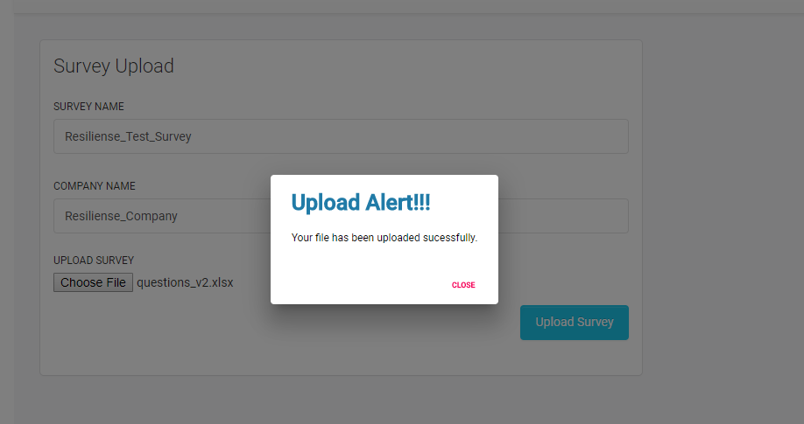

## Upload User data

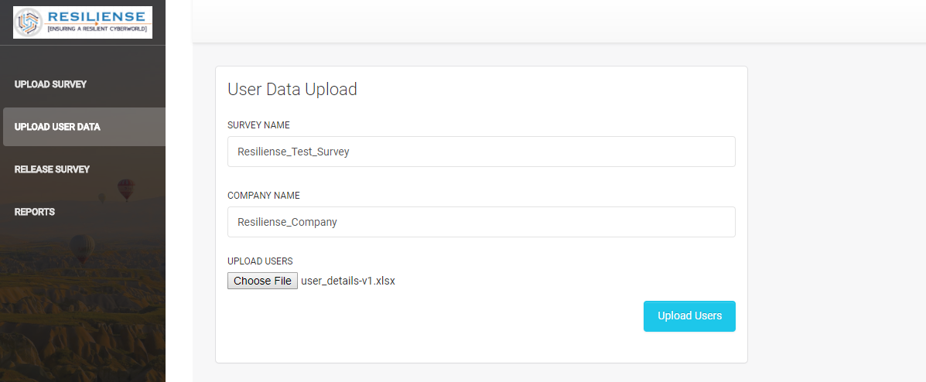

## Release Survey

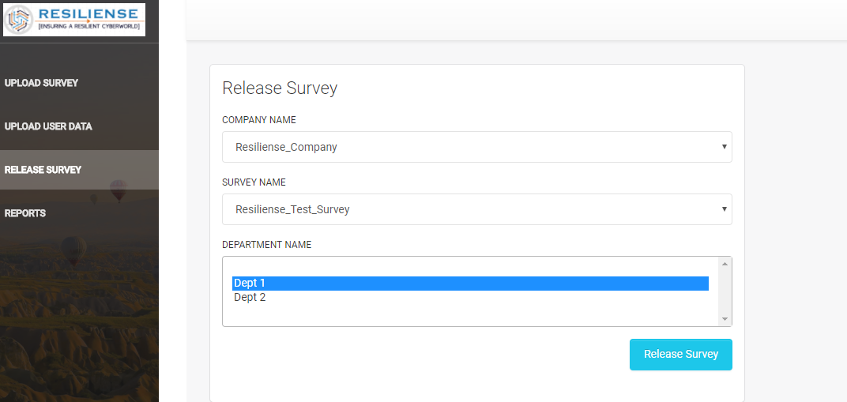

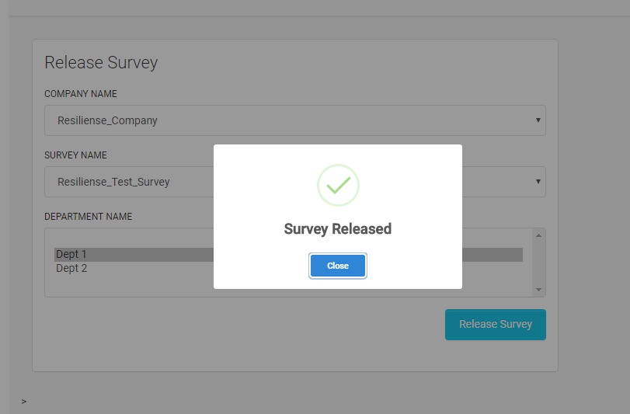

Mail will be sent to your registered mail

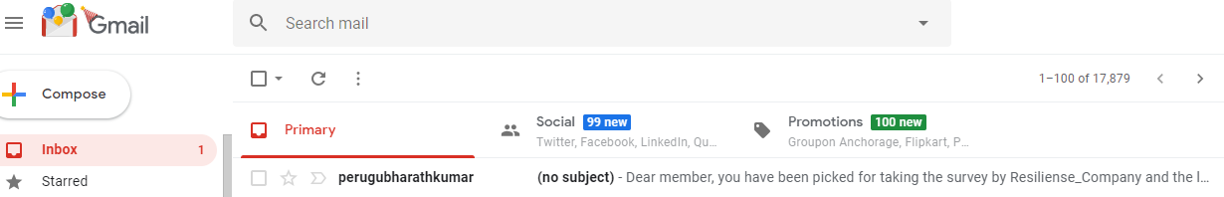

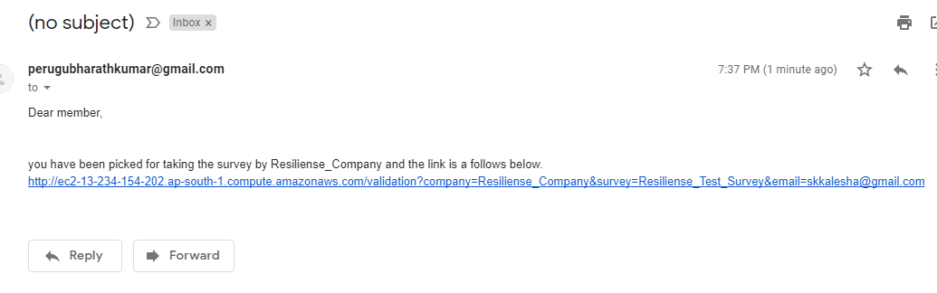

After clicking the URL

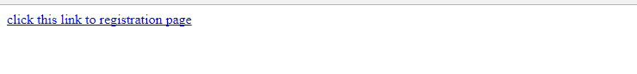

## Validate and Registration

You will be redirected to validate and registration page

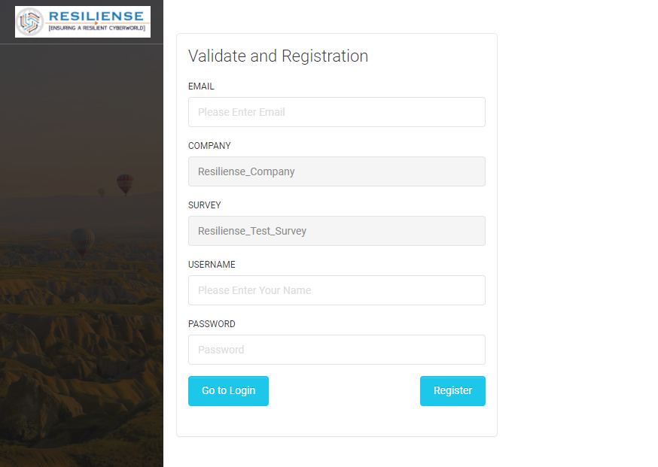

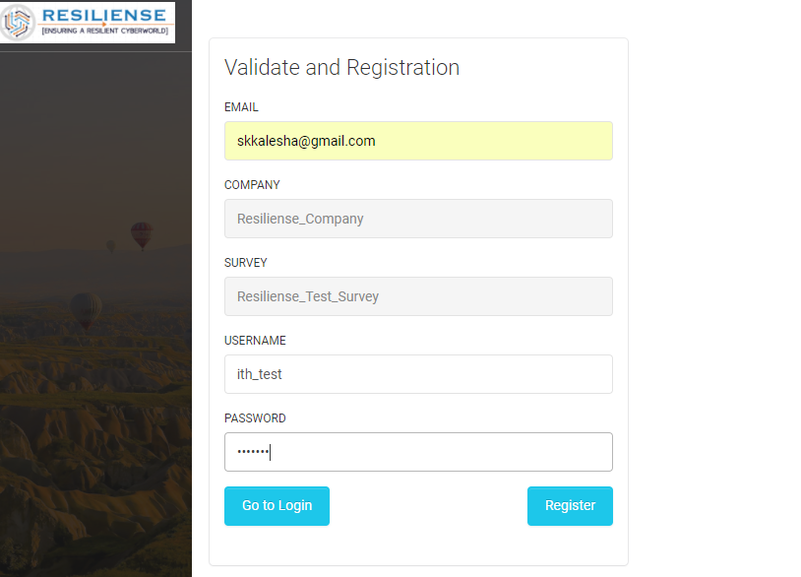

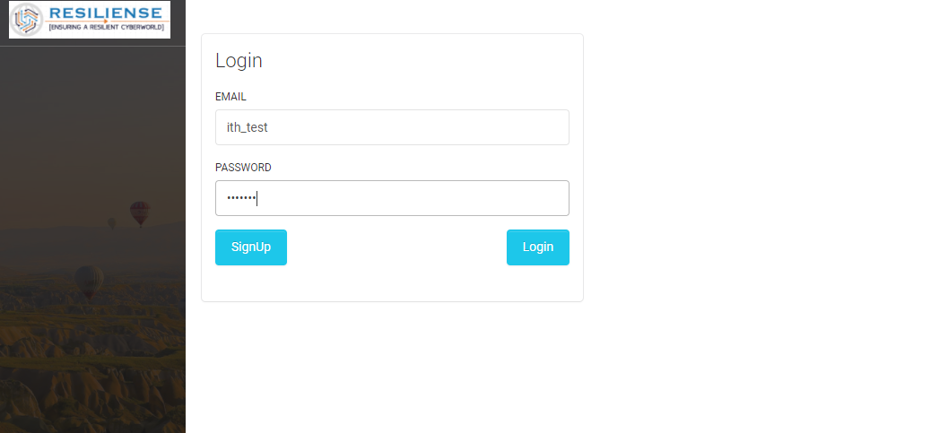

## Take Survey

Success login will take to you Take survey page

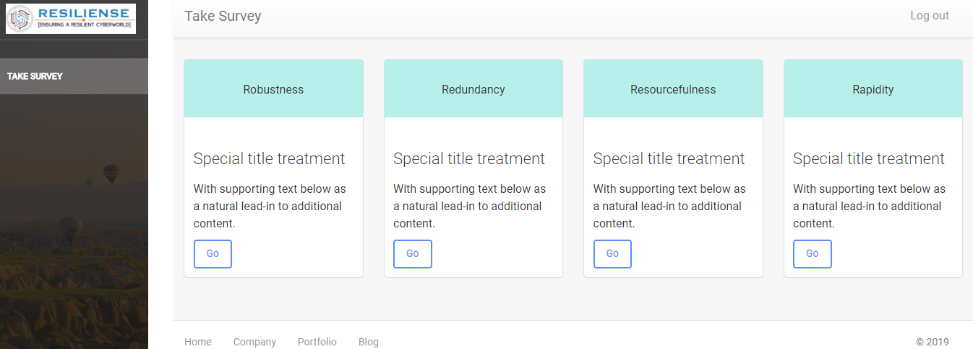

## Survey Q& A

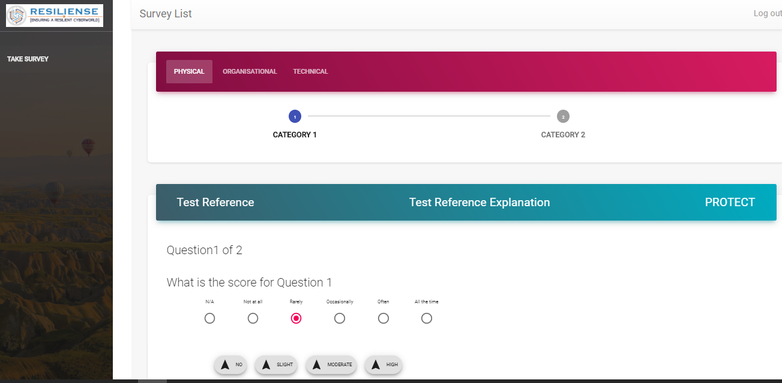

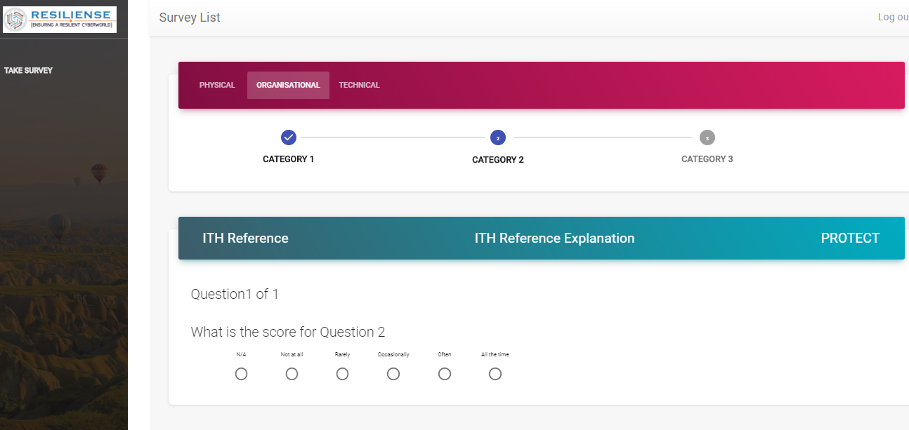

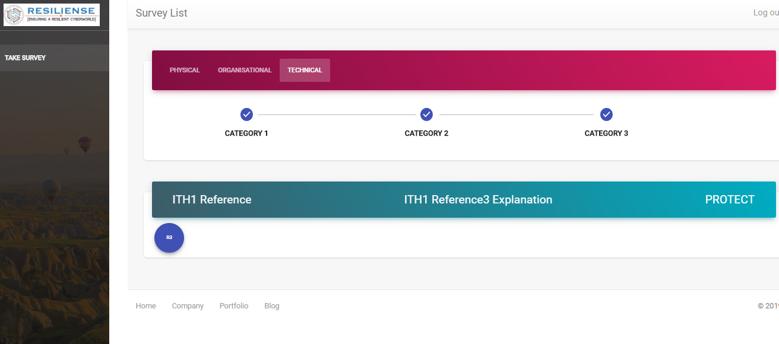

## Submit Survey

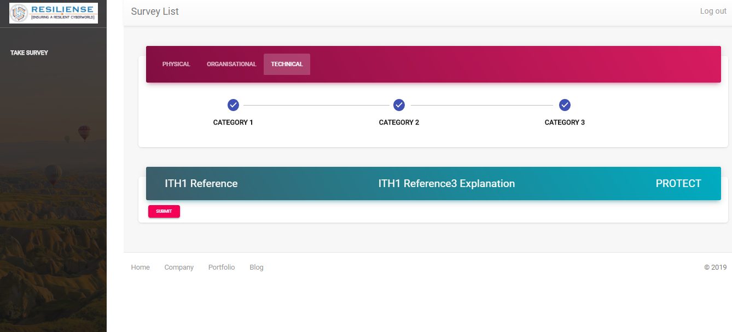

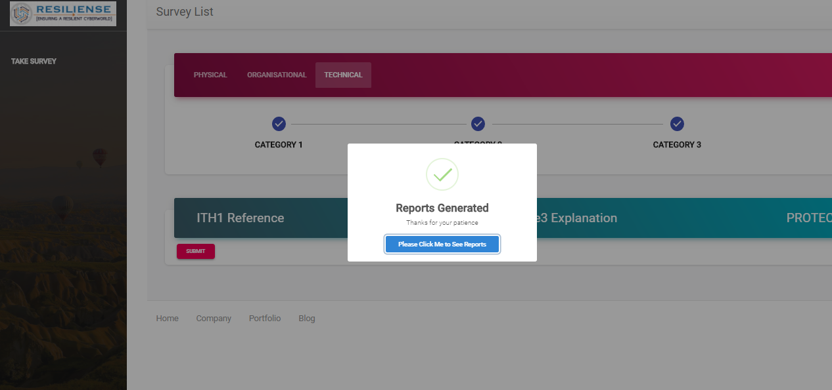

## Survey result

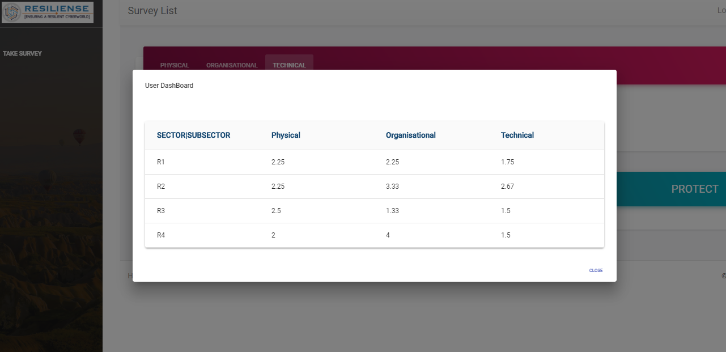

## Single user Graphs

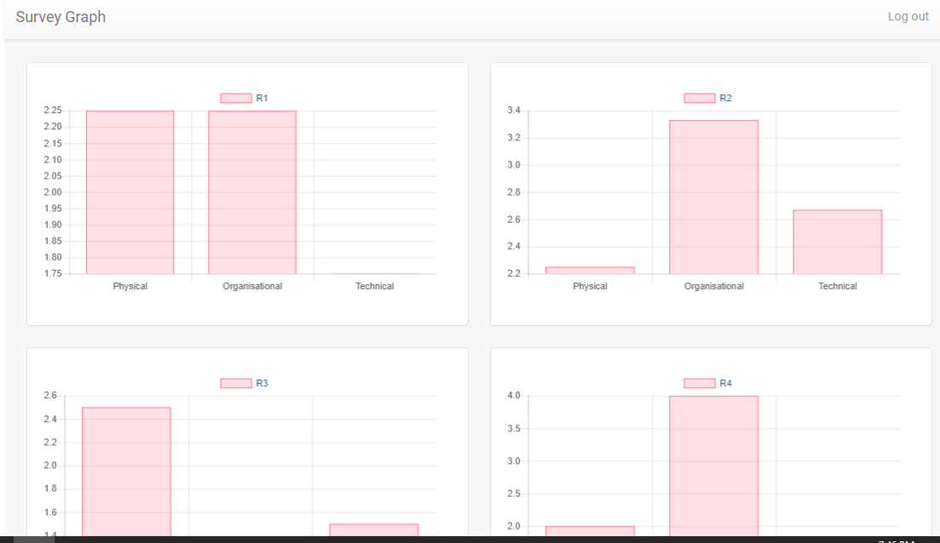

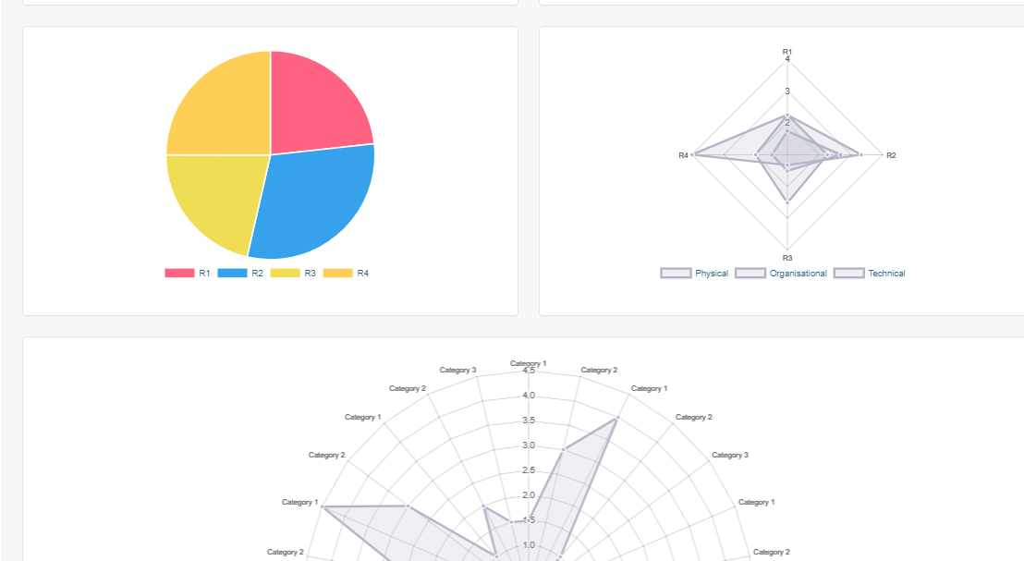

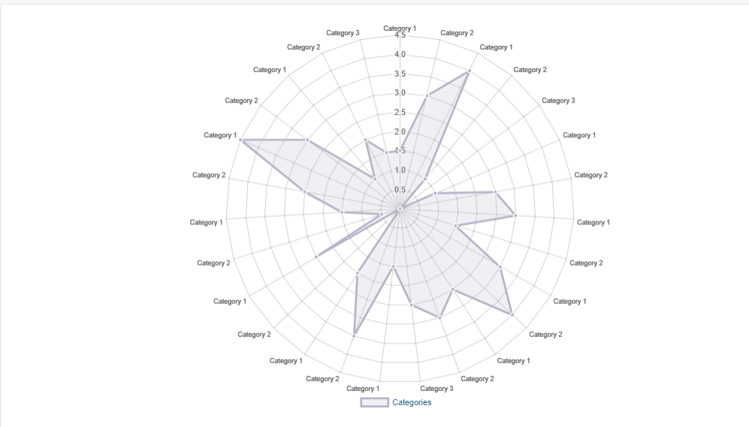

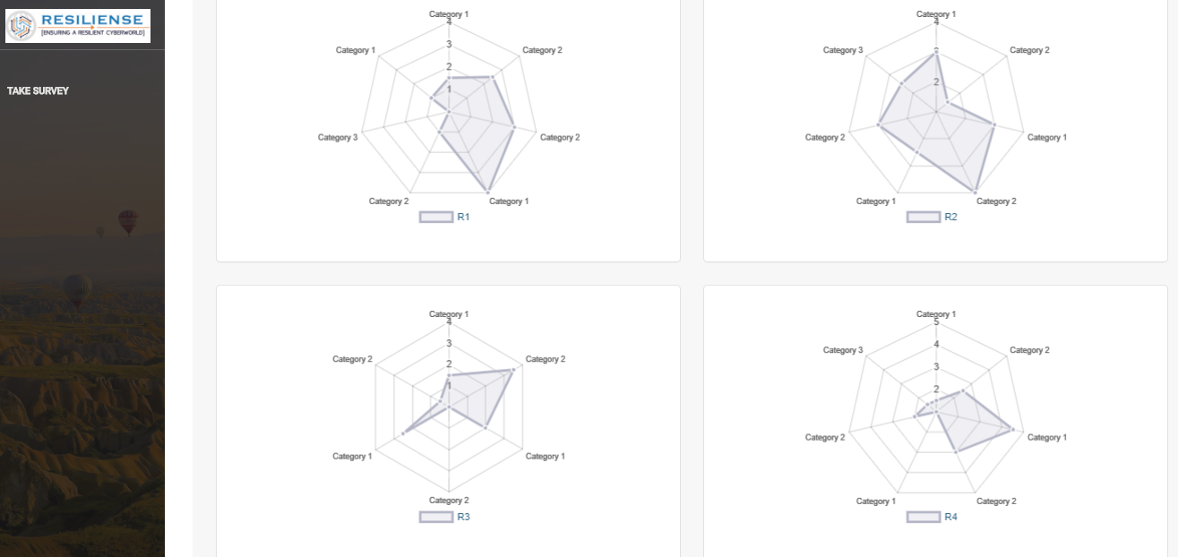

## Reports in Admin

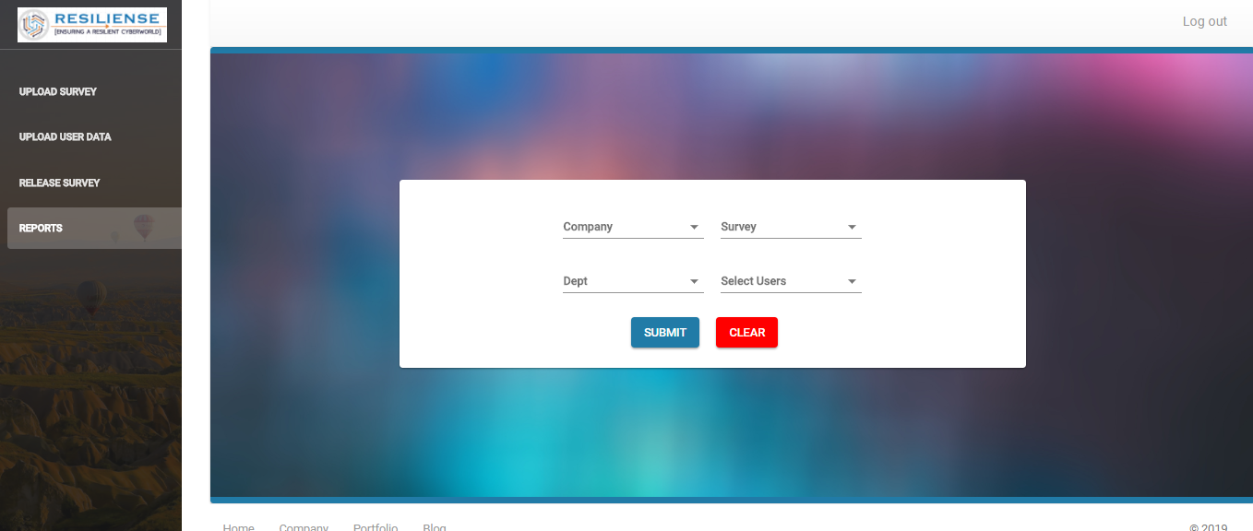

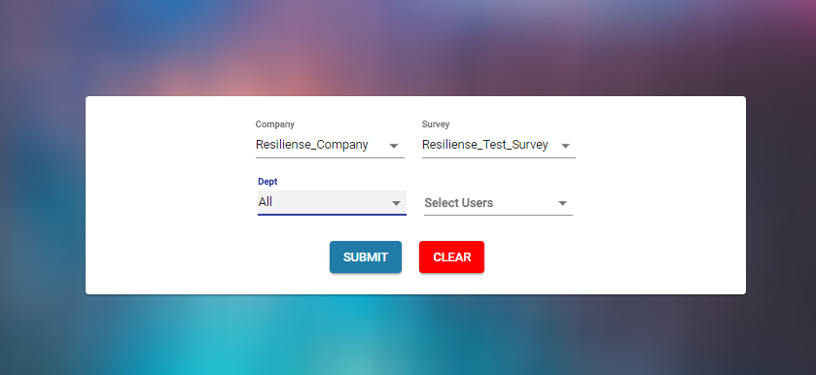

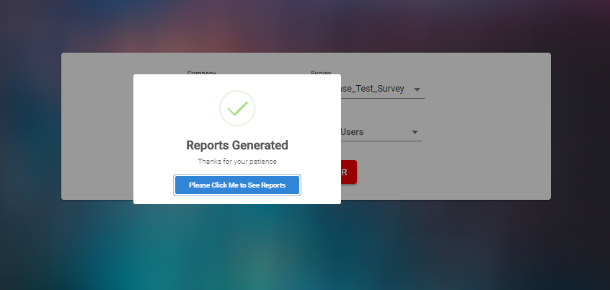

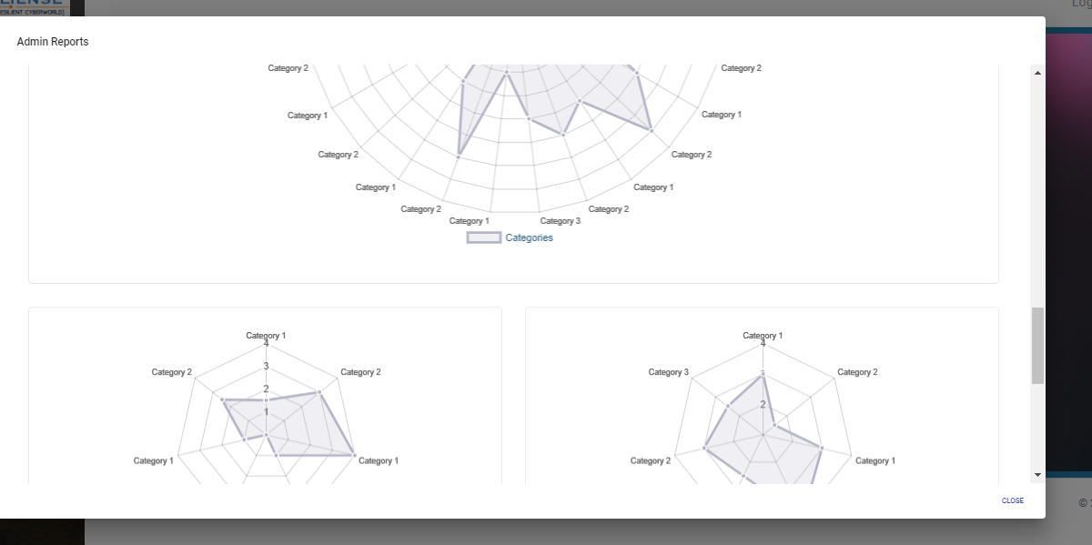

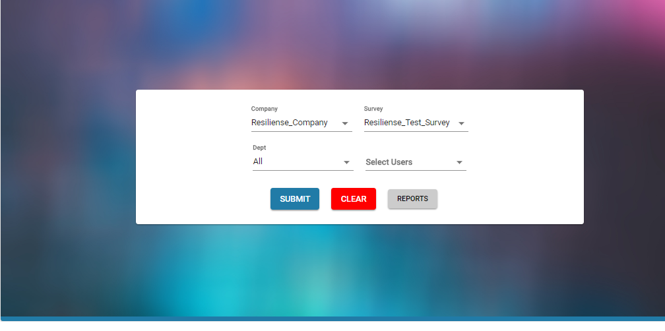

## Multiple users results

