The Electronic Gate — NPN Transistor
Electronics Lab | ISIS Proteus Simulation

1. Overview
In this project, we use the small output signal from an LDR (Light Dependent Resistor) voltage divider — built in Project 2.3 — to control a much larger current through a 2N2222 NPN transistor. This demonstrates one of the most fundamental concepts in electronics: current amplification.

2. Key Concept: Amplification
A transistor acts as an electronic gate or switch. In an NPN transistor, a small current injected at the Base (B) pin opens a path for a much larger current to flow from Collector (C) to Emitter (E). This is described by the current gain beta:
I_C = beta x I_B
For the 2N2222, beta is typically 100-300. A tiny base current of 0.1 mA can switch up to 30 mA at the collector — enough to drive an LED, relay, or small motor.

3. Circuit Description

3.1 LDR Voltage Divider (from Project 2.3)
The LDR and a 10 kO fixed resistor form a voltage divider between +5V and GND. The midpoint voltage (Node A) varies with light:
- In darkness: LDR resistance is high (~1 MO), Node A voltage is low.
- In bright light: LDR resistance drops (~1 kO), Node A voltage rises toward +5V.

3.2 Base Resistor (R_base = 1 kO)
Node A connects to the transistor Base through a 1 kO resistor. Without it, excessive current would overheat the transistor. Formula: I_B = (V_A - 0.7V) / R_base

3.3 Collector Circuit
The collector connects to +5V through a 470 O resistor and red LED in series. When the transistor turns ON, current flows: +5V -> R_col -> LED -> Collector -> Emitter -> GND, lighting the LED.

4. Circuit Diagram (Proteus Simulation)
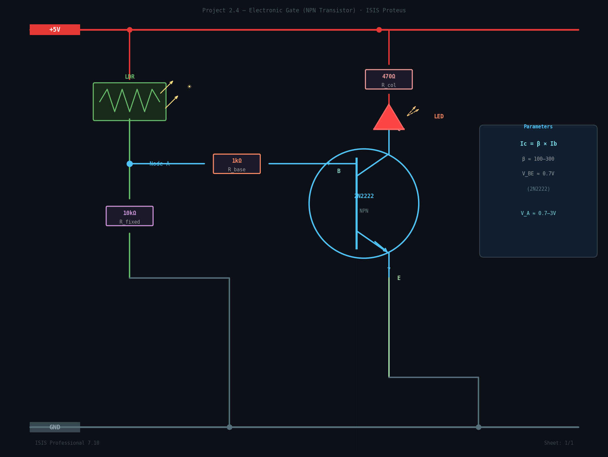
Figure 1: 2N2222 NPN Transistor with LDR Voltage Divider — Proteus ISIS

5. Component List
Component | Value / Model | Purpose

6. Key Calculations
Assuming bright light: V_A = 2.5 V
- Base current: I_B = (2.5 - 0.7) / 1000 = 1.8 mA
- Collector current: I_C = 200 x 1.8 mA = 360 mA (transistor saturates — LED fully ON)
- LED current (saturation): I_LED = (5 - 2.0 - 0.2) / 470 = 5.9 mA
- Power at transistor (saturation): P = V_CE x I_C = 0.2V x 5.9 mA = 1.2 mW

7. Simulation Steps in Proteus
- Open Proteus ISIS and create a new schematic project.
- Search and place components: 2N2222A, RES, LDR (TORCH), LED-RED.
- Connect the circuit as shown in Figure 1 above.
- Add a DC voltage source (VSOURCE) set to 5 V and label power rails.
- Place a VOLTAGE PROBE at Node A to monitor the midpoint voltage.
- Run simulation and adjust the LDR light level — observe LED switching behaviour.

8. Troubleshooting Guide
Problem | Likely Cause & Fix
Transistor gets hot | R_base is missing or too small. Add a 1 kO resistor between Node A and Base.
LED never turns ON | V_A is too low. Check LDR wiring and light level. Verify V_A >= 0.7V.
LED always ON (no control) | R_fixed too large or LDR disconnected. Recheck the voltage divider.
LED is very dim | R_col is too large. Try 220 O if your LED is rated for higher current.
No current anywhere | Check power supply and GND rail connections.

Project 2.4 | The Electronic Gate (NPN Transistor) | Electronics Lab

