Princess Nourah Bint Abdulrahman University
College of Computer & Information Science
Information Systems Department
Second Academic Semester 1447 – 2026
Business Intelligence – DS322



Gold & Oil Prices Dashboard with Power BI
ID | NAME | Section | Serial
445008617 | Resal Naif Alsantli | 61s | 1
445008565 | Lena Ahmad Aldokhayel | 61s | 2
445008578 | Norah Alotaibi | 61s | 3
445008571 | Fajr Khaled Alhajri | 61s | 4
444008716 | Sarah alfwzan | 61s | 5

Course: Business Intelligence
Course No: DS322
Section: 61s

Table of Contents
1. Introduction 3
2. Roles and contribution of team members 3
3 Problem description 4
4 Overview of solution 4
5. Dataset Description 5
6. Data Preparation 6
6.2. Loading Data from Web API 6
6.2. Data Transformation 6
6.3. Creating a Date Table 7
6.4. Establishing Relationships. 7
6.5. Sorting and Final Steps 7
7. Visual Model 8
8. Dashboard Design Overview 9
8.1 Dashboard Structure 9
8.2 Design and Aesthetic Choices 12
9. Implementation 13
9.1 Measures: 13
9.2 Dashboard Layout: 13
9.3 Visuals: 14
10. Power BI features used 18
11. Problems faced 19
12. Limitations 20
12. Future work 20
13. sustainable development goals 20
14. Conclusion 21

Table of Figures
Figure 1: Gold & Oil Prices Dashboard – Page 1 Overview 10
Figure 2 - Gold & Oil Prices Dashboard – Page 2 Detailed Analysis 12
Figure 3-Slicers 14
Figure 4-KPI Cards 15
Figure 5-Gauge Chart 15
Figure 6-Column charts 16
Figure 7-Clustered Column Chart 16
Figure 8-Stacked Area Chart 17
Figure 9-Dount Chart 17
Figure 10- Line Chart 18
Figure 11-Custom Calculations and KPIs 19
Figure 12-Slicers and Filters 19

Introduction

Gold and oil are among the most strategic commodities in the world. They directly affect global economies, inflation rates, and consumer purchasing power. Gold is often seen as a safe haven during economic crises, while oil is essential for transportation, industry, and daily life.
In this project, we analyze live and historical data of gold and oil prices using Power BI. Our goal is to understand the relationship between these two commodities and their impact on economic indicators such as inflation and economic growth. This analysis provides clear insights for investors, policymakers, and anyone interested in understanding global economic trends.

Roles and contribution of team members

ID | NAME | CONTRIBUTION
445008617 | Resal Naif Alsantli | Did Everything Together
445008565 | Lena Ahmad Aldokhayel | Did Everything Together
444008716 | Sarah alfwzan | Did Everything Together
445008571 | Fajr Khaled Alhajri | Did Everything Together
445008578 | Norah Alotaibi | Did Everything Together

Problem description
Gold and oil prices are sensitive economic variables that affect individuals, businesses, and governments. However, many people do not understand the relationship between these two commodities and how they influence inflation and purchasing power.
The main problem is the lack of simple, interactive tools that allow users to analyze this relationship in real-time. Without such tools, decision-makers may miss important patterns that could help in economic planning.
To solve this, we developed a live Power BI dashboard that displays gold and oil prices, analyzes their relationship, and provides actionable insights.

Overview of solution

We designed an interactive Power BI dashboard using:
- Live Data Source: Gold prices (daily) from – alphavantage
- Live Data Source: Oil prices (monthly) from – alphavantage
The dashboard provides:
Descriptive Analytics: Historical trends of gold and oil prices.
Diagnostic Analytics: Correlation between gold and oil.

5. Dataset Description
This project utilizes real-time and historical commodity price data retrieved from the Alpha Vantage API, covering two primary financial instruments:
1. Crude Oil Prices (WTI)
- Source: Alpha Vantage Commodity Data API
- Interval: Monthly
- Unit: US Dollars per Barrel
- Coverage: Multi-year historical records
- Fields: name, interval, unit, date, value
- Description: Contains monthly closing prices of West Texas Intermediate (WTI) crude oil, one of the world's primary oil price benchmarks, reflecting global supply and demand dynamics.
2. Gold Prices (XAU/USD)
- Source: Alpha Vantage Gold/Silver History API
- Endpoint: GOLD_SILVER_HISTORY with symbol GOLD
- Interval: Daily
- Unit: US Dollars per Troy Ounce
- Coverage: Up-to-date daily records
- Fields: date, price
- Description: Contains daily spot prices of gold in USD, serving as a key indicator of global economic stability, inflation hedging, and precious metals market trends.
Data Integration Both datasets are refreshed automatically via API calls in Power BI, enabling live data streaming and real-time dashboard updates. The data supports descriptive, predictive, and prescriptive analytics across multiple dashboard pages.

6. Data Preparation
We prepared the gold and oil price data using Power Query Editor in Power BI. Data was sourced live from the Alpha Vantage API via the Web connector using JSON format. The preparation process was applied separately to each table. Instead of merging the tables, we created a separate Date Table using DAX to serve as a central time dimension, following the star schema best practice in Power BI.

6.2. Loading Data from Web API
First, we loaded both datasets by clicking Get Data then Web API from the Home tab in Power BI Desktop. We entered the JSON URL for gold and clicked OK. The data loaded as a JSON document. We repeated the same process for oil using its dedicated API URL.

Data Transformation
We applied the following transformation steps to each table using Power Query Editor.
Gold table:
- We converted the JSON list to a table using Convert to Table.
- We clicked the Expand icon (the double arrow) on the data column to extract the nested records, which revealed the date and price columns.
- We renamed the date column to Gold.date and the price column to Gold.price.
- We changed the data type of Gold.date to Date and Gold.price to Decimal Number.
- Finally, we renamed the query to Gold.

Oil table:
- We converted the JSON list to a table using Convert to Table.
- We clicked the Expand icon (the double arrow) on the data column to extract the nested records, which revealed the date and pricecolumns.
- We removed unnecessary metadata columns such as name, interval, and unit.
- We renamed the date column to Oil.date and the value column to Oil.price.
- We changed the data type of Oil.date to Date and Oil.price to Decimal Number.
- Finally, we renamed the query to Oil.

Creating a Date Table
Instead of merging the Gold and Oil tables into a single table, we created a separate Date Table using DAX to serve as a central time dimension. This follows the star schema best practice in Power BI.
The Date Table was created using the following DAX code:
DateTable =
ADDCOLUMNS(
CALENDAR(MIN(Gold[Gold.date]), MAX(Gold[Gold.date])),
"Year", YEAR([Date]),
"MonthNum", MONTH([Date]),
"Month", FORMAT([Date], "MMMM"),
"MonthShort", FORMAT([Date], "MMM"),
"Quarter", "Q" & QUARTER([Date]),
"YearMonth", FORMAT([Date], "YYYY-MM"),
"YearQuarter", YEAR([Date]) & "Q" & QUARTER([Date])
)

Establishing Relationships.
After preparing the Gold table, Oil table, and Date Table, we established relationships between them:

- DateTable[Date] (One) → Gold[Gold.date] (Many)

- DateTable[Date] (One) → Oil[Oil.date] (Many)

This allows all time-based filters (Year, Month, Quarter) to control both Gold and Oil visuals simultaneously without needing a merged table.

Sorting and Final Steps
We sorted the Date Table by date in ascending order to ensure proper time series analysis.
After completing all transformations, we clicked Close & Apply to load the prepared data into the Power BI data model. The connection remains live, meaning any refresh will fetch the latest data from the Alpha Vantage API.

Visual Model
To ensure better organization and more efficient analysis in this project, we structured our data using a star schema with a central Date Table and separate tables.
Here is a simple explanation of our table structure:
1. Gold Table (Source Table)
- This table contains the original raw data for gold prices retrieved from the Alpha Vantage API.
- It includes columns: Gold.date and Gold.price.
- This table is connected to the Date Table.
2. Oil Table (Source Table)
- This table contains the original raw data for oil prices retrieved from the Alpha Vantage API.
- It includes columns: Oil.date and Oil.price.
- This table is connected to the Date Table.

3. Date Table (Dimension Table)
- This table was created using DAX to serve as a central time dimension.
- It contains: Date, Year, Month, MonthNum, Quarter, YearMonth, YearQuarter

By structuring the data this way, we made it easier to analyze the relationship between gold and oil prices, apply time intelligence functions, and create meaningful visualizations in Power BI.

8. Dashboard Design Overview
The dashboard was developed using Microsoft Power BI to deliver an interactive and visually engaging analysis of historical gold and oil prices. The design was organized into two dynamic pages to separate the real-time market snapshot and key indicators from the historical and comparative analysis, allowing users to smoothly transition between a general overview and deeper insights.

8.1 Dashboard Structure
The dashboard consists of two main pages, each containing a set of visual elements arranged in a logical layout to ensure easy readability and quick extraction of insights.
Page 1: Gold & Oil Prices Analyze (Overview Page)
The first page focuses on providing a quick and comprehensive snapshot of the current market situation, with the volatility indicator placed at the center as the focal point. It contains the following elements:
- Main Title: "GOLD & OIL PRICES ANALYZE" displayed in Times New Roman, size 28, bold, centered at the top of the page to clearly highlight the topic of analysis.
- Six KPI Cards (Side Panels): Distributed on both sides of the page for balanced visual symmetry. The left side displays gold-related indicators, and the right side displays oil-related indicators:
  - Last Gold Price – the most recent recorded gold price
  - Last Oil Price – the most recent recorded oil price
  - Max Gold Price – the highest gold price during the period
  - Min Gold Price – the lowest gold price during the period
  - Max Oil Price – the highest oil price during the period
  - Min Oil Price – the lowest oil price during the period

- Gauge – Gold Price Volatility (Center): Positioned at the top center of the page as the focal visual. It measures the volatility of gold prices against a maximum value and a target value, providing an immediate visual indication of market stability.
- Filter Panel (Slicer with Background Shape): A custom-designed filter panel placed in the lower-left corner. It includes a rounded rectangular background shape that groups the slicer visually and gives it a clean, professional appearance. The panel contains the Filter by Year–Month slicer that filters all visuals on the page interactively.
- Column Chart – Sum of Oil Price by Months: Located in the lower-middle area of the page, illustrating the monthly sum of oil prices to highlight seasonality and short-term trends.
- Column Chart – Sum of Gold Price by Months: Placed in the lower-right area next to the oil chart, enabling direct visual comparison between the two commodities across the same time periods.

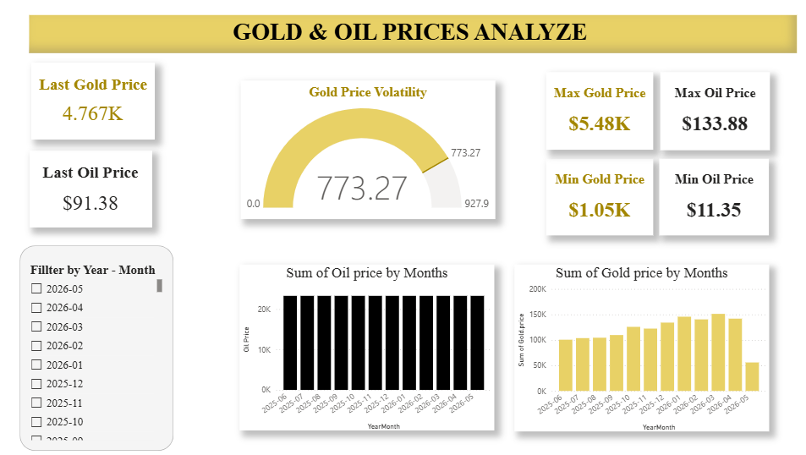
Figure 1: Gold & Oil Prices Dashboard – Page 1 Overview

Page 2: Detailed Analysis Page
The second page focuses on historical analysis and the relationship between the two commodities, and includes:
- Clustered Column Chart – Sum of Gold Price by Years: Displays the total gold prices distributed across years, highlighting long-term annual variation.
- Stacked Area Chart – Annual Gold Price Growth Rate: Visualizes the year-over-year growth rate of gold prices (Gold YoY %) across the years.
- Donut Chart – Avg Gold-Oil Ratio by Year: Shows the average gold-to-oil ratio annually, which is an important economic indicator reflecting the relative strength between the two commodities.
- Line Chart – Relationship Gold & Oil: Directly compares the sum of gold and oil prices across years to highlight the correlation between the movements of the two commodities.
- Advanced Slicer – Month: Allows users to filter data by month to focus on specific time periods.
- KPI Card – Total Records: Displays the total number of records in the dataset.
- KPI Card – Date Range: Displays the time period covered by the data (from date – to date), providing clear context for the analysis.
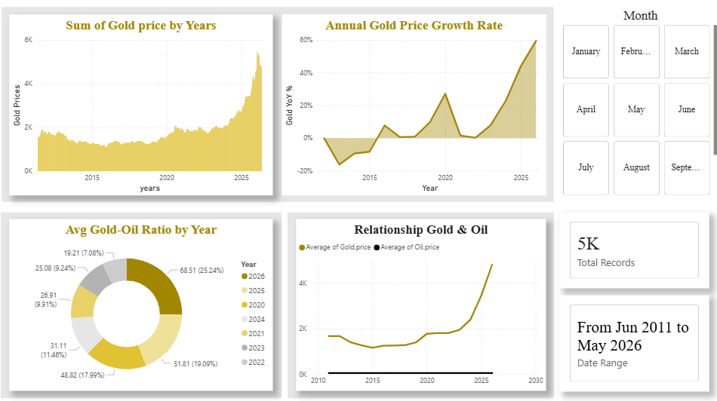

Figure 2 - Gold & Oil Prices Dashboard – Page 2 Detailed Analysis

8.2 Design and Aesthetic Choices
- Color Theme: A professional color palette combining golden yellow tones for gold and black/gray tones for oil was adopted. These colors reflect the nature of both commodities and make it easy for users to visually distinguish between them across all charts.
- Typography: Times New Roman font was used consistently across titles and labels to ensure professional and uniform readability, with emphasis on the main title at size 28 to make it stand out.
- Focal-Point Layout: Page 1 was deliberately designed with the Gold Price Volatility gauge at the visual center, while the KPI cards are arranged symmetrically on both sides. This creates a balanced composition that draws the user's attention to the most critical market indicator first.
- Custom Filter Panel: The slicer was placed inside a rounded rectangular background shape to give it a distinct, container-like appearance. This grouping technique improves visual hierarchy and signals to the user that the slicer is a separate interactive control rather than just another visual.
- Interactivity: The dashboard contains slicers (Year–Month on Page 1 and Month on Page 2) that allow users to filter data in real time. All charts are also interconnected through cross-filtering, so when a specific period is selected, all elements update automatically.
- Visual Consistency: The same labeling style, title placement, and numbering format are maintained across all charts to provide a unified and seamless experience.
- Ease of Use: The dashboard was designed to be understandable even for non-technical users, allowing anyone to read the main figures and trends without requiring technical expertise.

This dashboard empowers financial analysts, investors, and decision-makers to quickly and accurately understand the behavior of gold and oil prices, uncover relationships and trends hidden in the data, and make informed investment decisions.

9. Implementation

9.1 Measures:
- Latest Gold Price: A KPI measure created to display the latest available gold price from the dataset.
- Latest Oil Price: A KPI measure used to show the latest oil price value.
- Max Gold Price and Min Gold Price: Measures used to calculate the maximum and minimum gold prices during the selected period.
- Max Oil Price and Min Oil Price: Measures created to display the highest and lowest oil prices.
- Gold Volatility: A custom measure implemented to analyze fluctuations in gold prices and identify market volatility.
- Avg Gold-Oil Ratio: A calculated measure used to analyze the relationship between gold and oil prices.
- Gold YoY %: A custom calculation used to measure the yearly growth rate of gold prices.
- Total Records: A KPI card created to display the total number of records included in the dashboard.
- Date Range: A measure used to display the covered time period of the dataset.

9.2 Dashboard Layout:
The dashboard was designed using two interactive pages to provide an overview and detailed analysis of gold and oil prices. KPI cards were placed at the top for quick insights into the latest, maximum, and minimum prices, while the Gold Volatility gauge was positioned at the center to highlight market fluctuations. Interactive slicers allow users to filter the dashboard dynamically by Year-Month and Month, and the charts were organized clearly to support easy comparison between gold and oil trends

9.3 Visuals:

9.3.1 Slicer:
- Interactive slicers were implemented to allow users to filter the dashboard by Year-Month and Month.
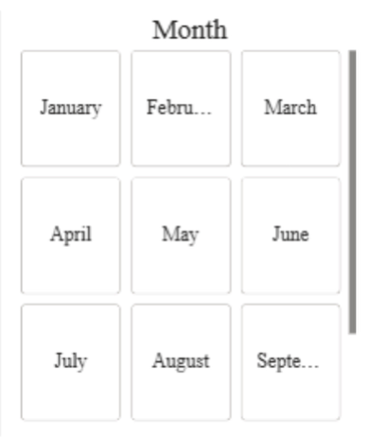
- These slicers help users focus on specific periods and explore trends interactively.
Figure 3-Slicers

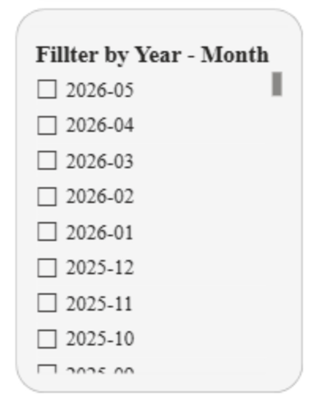
9.3.2 KPI Cards:
- KPI cards were used to display important indicators such as Latest Gold Price, Latest Oil Price, Max Gold Price, Min Gold Price, Max Oil Price, Min Oil Price, Total Records, and Date Range.
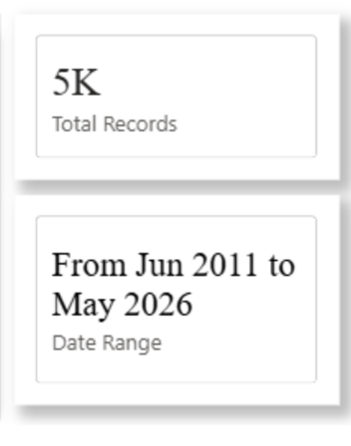
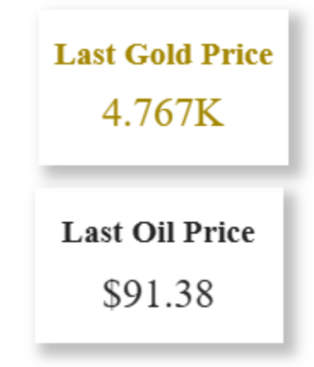
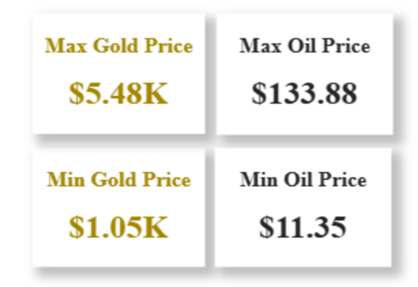
- These cards provide users with quick insights into the market performance without requiring detailed exploration.
Figure 4-KPI Cards

9.3.3 Gauge Chart:
- A gauge chart was used to represent Gold Volatility.
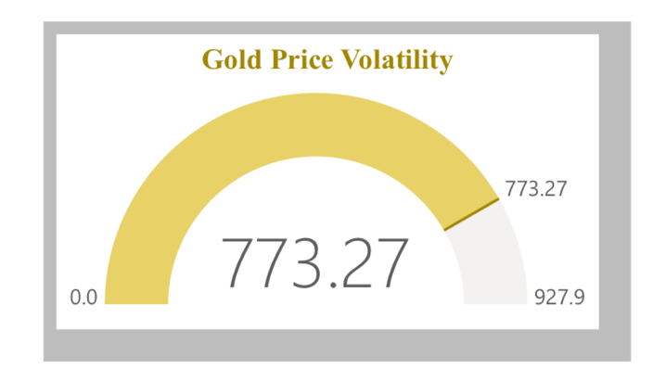
- The chart helps users understand the level of fluctuation in gold prices and monitor market stability visually.
Figure 5-Gauge Chart

9.3.4 Column Charts:
- Column charts were used to visualize the Sum of Gold Price by Months and Sum of Oil Price by Months.
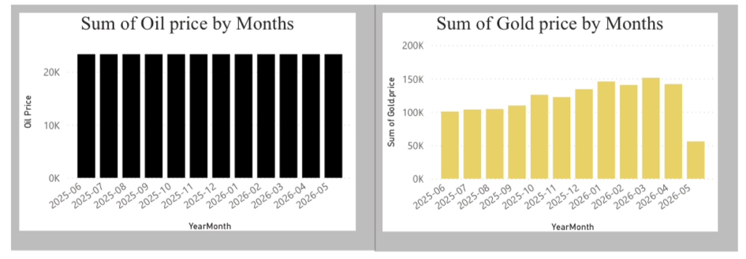
- These charts highlight monthly trends and allow comparison between the movements of both commodities.
Figure 6-Column charts

9.3.5 Clustered Column Chart:
- A clustered column chart was implemented to display the Sum of Gold Price by Years.
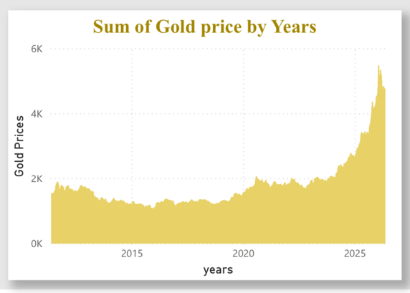
- The visualization shows annual variations in gold prices and highlights long-term growth patterns.
Figure 7-Clustered Column Chart

9.3.6 Stacked Area Chart:
- A stacked area chart was used to represent the Annual Gold Price Growth Rate (Gold YoY %).
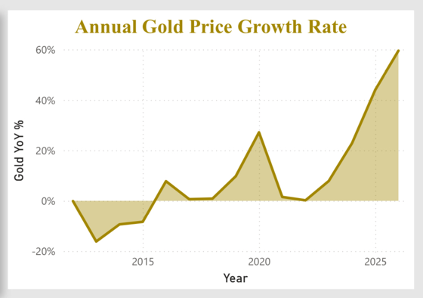
- The chart visualizes yearly growth fluctuations and helps identify periods of strong market increase or decline.

Figure 8-Stacked Area Chart

9.3.7 Donut Chart:
- A donut chart was created to display the Avg Gold-Oil Ratio by Year.
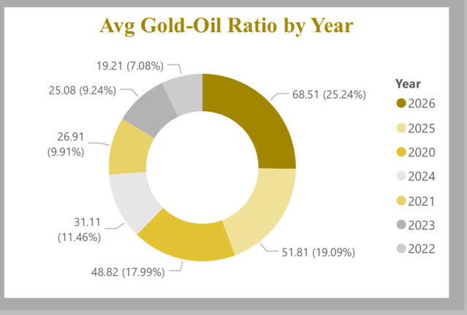
- This visualization simplifies comparison between yearly ratios and highlights the relationship between gold and oil prices.

Figure 9-Dount Chart

9.3.8 Line Chart:
- A line chart was used to analyze the Relationship between Gold & Oil prices across years.
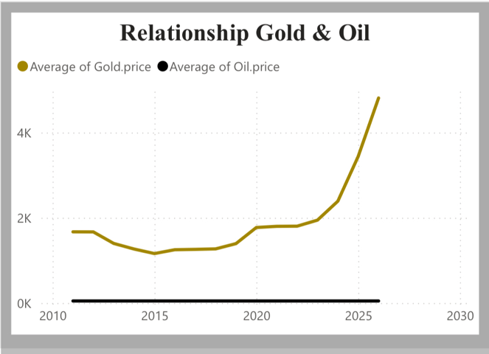
- The chart helps users identify correlations and similarities between price movements of the two commodities.

Figure 10- Line Chart

Power BI features used
- Visualizations:
Different visualizations such as KPI cards, gauge charts, line charts, column charts, stacked area charts, and donut charts were used to present the data clearly and provide meaningful insights.
- Interactive Dashboard:
The dashboard was designed to be user-friendly and interactive, allowing users to dynamically explore the data through filters and slicers.
- Custom Calculations and KPIs:
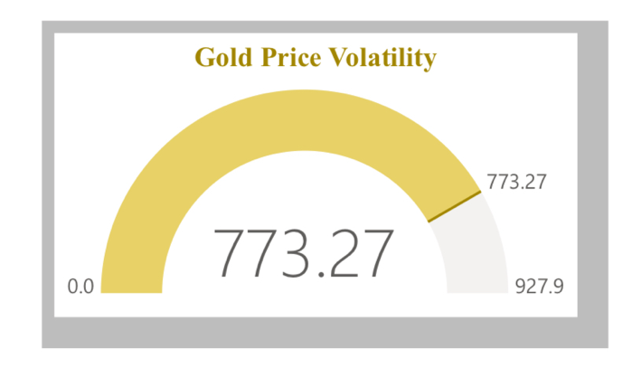
Several custom measures and KPIs were created using DAX, including Gold Volatility, Gold YoY %, Oil YoY %, Avg Gold Price, Avg Oil Price, and Avg Gold-Oil Ratio.

Figure 11-Custom Calculations and KPIs
- Slicers and Filters:
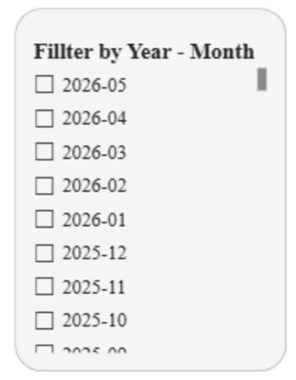
Interactive slicers were implemented to filter the dashboard by Year-Month and Month for customized analysis and easier navigation.
Figure 12-Slicers and Filters

- Power Query Editor:
Power Query Editor was used to clean, transform, and prepare the data before loading it into the Power BI model.
- Data Modeling:
Relationships between the Gold table, Oil table, and Date table were created to support integrated analysis and improve dashboard performance.
- Real-Time Data Integration:
The dashboard uses live API connections from Alpha Vantage, enabling automatic updates and real-time monitoring of gold and oil market prices.

Problems faced
- Difficulty in integrating multiple APIs together, especially since each API had different structures and response formats.
- API limitations such as request limits (rate limits), which sometimes affected data retrieval and testing.
- Challenges in creating new measures due to the limited number of available columns in the dataset.
- Some required calculations needed additional data processing before building the measures.

Limitations
- The project depended heavily on external APIs, so any API downtime or request limitation could affect the system performance.
- Limited dataset features and columns reduced the ability to create more advanced measures and deeper analysis.
- The accuracy and completeness of the analysis were dependent on the quality of the retrieved API data.
- Time constraints limited the ability to expand the dataset and add more analytical features.

Future work
For future improvements, the dashboard could include additional commodities such as silver, natural gas, and currencies to provide a broader economic analysis. Machine learning models may also be integrated to improve forecasting accuracy and detect unusual market changes automatically. In addition, a mobile-friendly version with real-time notifications could make the dashboard more practical for continuous monitoring.

sustainable development goals
This project supports Sustainable Development Goal 8: Decent Work and Economic Growth. By analyzing gold and oil price trends, the dashboard helps users better understand economic conditions and supports data-driven financial decision-making. The project also provides accessible insights that can assist investors, analysts, and decision-makers in monitoring market changes and economic performance.

Conclusion
In conclusion, this project successfully demonstrated the use of Microsoft Power BI in building an interactive dashboard for analyzing live and historical gold and oil prices. By integrating real-time data from the Alpha Vantage API, the dashboard provided meaningful insights into market trends, price fluctuations, and the relationship between the two commodities.The dashboard was designed with a clear and professional layout that allows users to easily monitor key indicators, compare historical trends, and explore the correlation between gold and oil prices through interactive visualizations and filters. The use of descriptive, diagnostic, predictive, and prescriptive analytics helped transform raw data into valuable economic insights.Despite challenges such as API limitations, data integration complexity, and limited dataset features, the project achieved its primary objective of creating an accessible analytical tool for financial and economic analysis. Overall, this project highlights the importance of business intelligence and data visualization in supporting informed decision-making for investors, analysts, and policymakers.

Appendices
Appendix A. Read me file-Report
Appendix B. Read me file-Dashboard

