实验3 数据库的查询和视图

1. **实验目的**
2. 掌握SELECT语句的基本语法。
3. 掌握子查询、连接查询的表示方法。
4. 掌握数据汇总的方法。
5. 掌握GROUP BY、ORDER BY子句的作用和使用方法。
6. 掌握视图的使用方法。
7. **实验内容和要求**
8. SELECT语句的基本使用
9. 子查询的使用
10. 连接查询的使用
11. 数据汇总
12. GROUP BY和ORDER BY子句的使用
13. 使用视图
14. **主要仪器设备**

**仪器：**计算机

**实验环境：** Windows 10 + Oracle DB 12c (Personal Version)

1. **实验步骤与调试**
2. 查询每个雇员的所有数据

指令SELECT * FROM Employees；

结果：

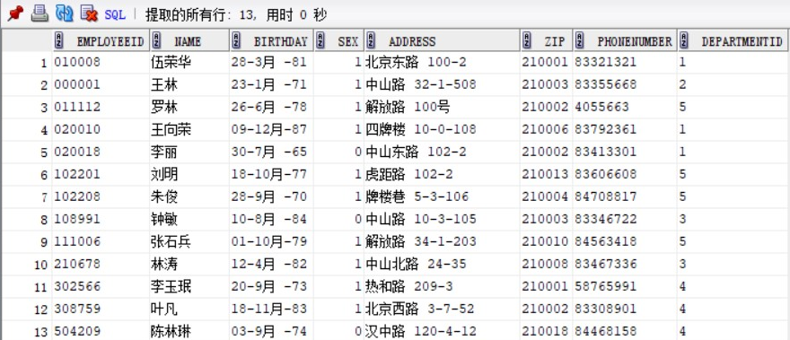

1. 查询每个雇员的地址和电话

SELECT Name,Address,PhoneNumber From Employees;

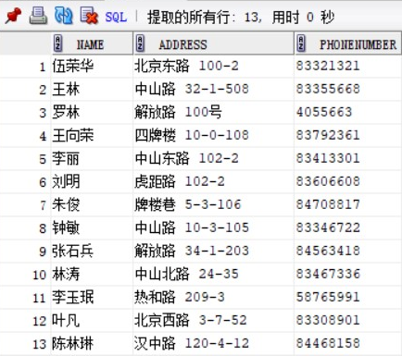

1. 查询EmployeeID为000001的雇员的地址和电话

SELECT Name,Address,PhoneNumber FROM Employees WHERE EmployeeID='000001';

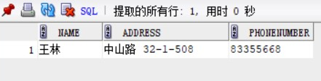

1. 查询Employees表中所有女雇员的地址和电话，使用AS子句将结果中各列的标题分别指定为电话和地址

SELECT Name AS 姓名,Address AS 地址,PhoneNumber AS电话 FROM Employees WHERE sex = 0;

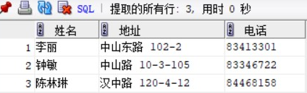

1. 计算每个雇员的实际收入

SELECT EmployeeID,InCome-OutCome AS 实际收入 FROM Salary;

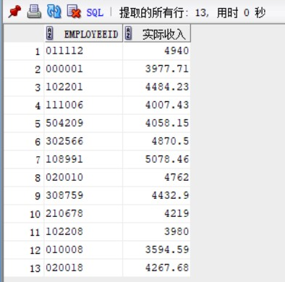

1. 找出所有姓王的雇员的部门号

SELECT DepartmentID FROM Employees WHERE name LIKE ‘王%’;

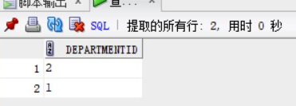

1. 找出所有收入在5000-6000元之间的雇员号码

SELECT EmployeeID FROM Salary WHERE InCome BETWEEN 5000 AND 6000;

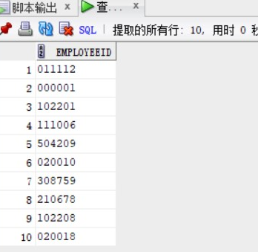

1. 查找在财务部工作的雇员的情况

SELECT * FROM Employees WHERE DepartmentID = (SELECT DepartmentID FROM Departments WHERE DepartmentName = ‘财务部’);

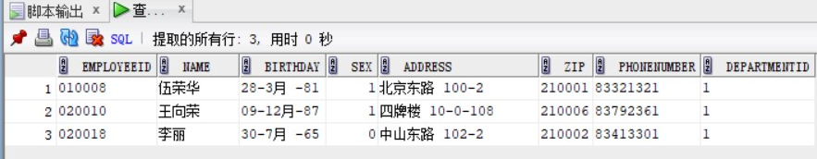

1. 查找财务部年龄不低于所有研发部雇员年龄的雇员的姓名

SELECT Name FROM Employees WHERE DepartmentID IN ( SELECT DepartmentID FROM Departments WHERE DepartmentName = ‘财务部’ ) AND Birthday <= ALL ( SELECT Birthday FROM Employees WHERE DepartmentID IN ( SELECT DepartmentID FROM Departments WHERE DepartmentName = ‘研发部’) );

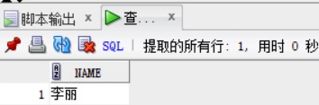

1. 查找比所有财务部的雇员收入都高的雇员的姓名

Select Name From Employees Where Employeeid In (Select Employeeid From Salary Where Income > All

( Select Income From Salary Where Employeeid In

(Select Employeeid From Employees WHERE Departmentid = (Select Departmentid FROM Departments WHERE DepartmentName = '财务部'))));

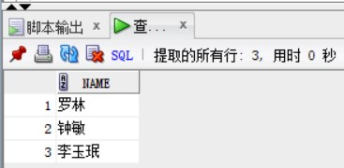

1. 查询每个雇员及其薪水情况

Select Employees.Name,Salary.Income

From Employees,Salary

Where Employees.Employeeid = Salary.Employeeid;

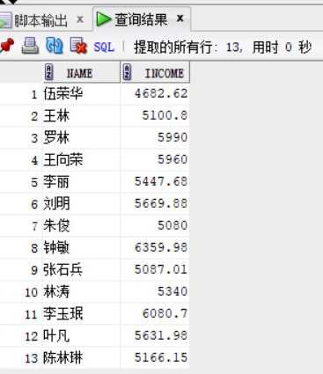

1. 查找财务部收入在5200元以上的雇员姓名及其薪水详情

Select Name,Income,Outcome

From Employees,Salary,Departments

Where Employees.Employeeid = Salary.Employeeid AND Employees.Departmentid = Departments.Departmentid AND DepartmentName = '财务部' AND InCome > 5200;

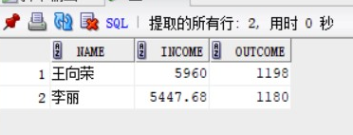

1. 求财务部雇员的平均收入

Select Avg(Income) As 财务部平均收入

From Salary

Where Employeeid In

(Select Employeeid

From Employees

Where Departmentid =

(Select Departmentid

From Departments

Where DepartmentName = '财务部'));

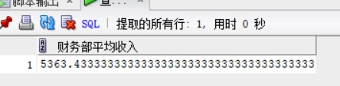

1. 求财务部雇员的平均实际收入

Select Avg(Income - Outcome) As 财务部平均实际收入

From Salary

Where Employeeid In

(Select Employeeid

From Employees

Where Departmentid =

(Select Departmentid

From Departments

Where DepartmentName = '财务部'));

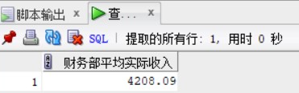

1. 求财务部雇员的总人数

Select Count(Employeeid)

From Employees

Where Departmentid =

(Select Departmentid

From Departments

Where DepartmentName = '财务部');

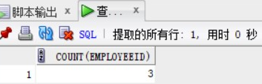

1. 求各部门的雇员数

Select Count(Employeeid)

From Employees

Group By DepartmentID;

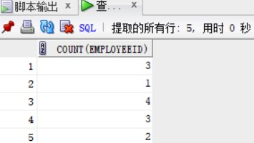

1. 将各雇员的情况按收入由低到高排列

Select Employees.* , Salary.*

From Employees,Salary

Where Employees.Employeeid = Salary.Employeeid

Order By InCome;

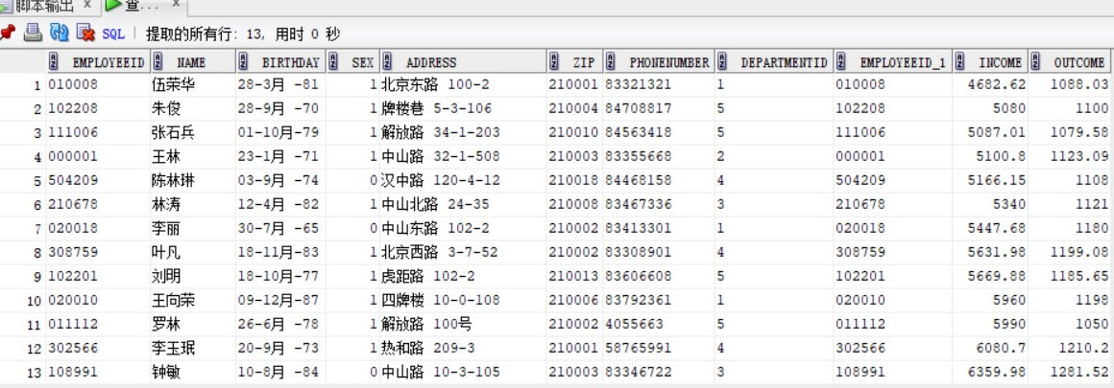

1. 创建视图 限制查看雇员的某些情况 限制各部门经理只能查找本部雇员的薪水情况

Create OR Replace View Cx_Employees

As Select Employeeid,Name,Birthday,Sex,Departmentid

From Employees;

Create Or Replace View Cx_Salary

As Select Name,Income,Outcome

From Employees,Salary,Departments

Where Employees.Employeeid = Salary.Employeeid And

Employees.Departmentid = Departments.Departmentid And

DepartmentName = '财务部';



1. 使用视图 只看雇员的编号、姓名、出生日期、性别和部门号信息 查询财务部雇员薪水的情况

Select * From Cx_Employees;

Select * From Cx_Salary;

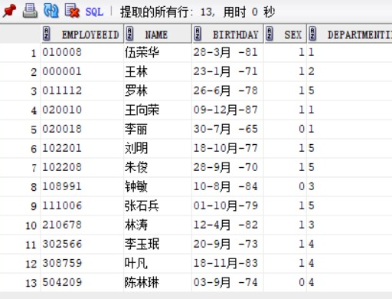

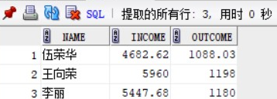

1. 向表Employees中插入一条记录

Insert Into Cx_Employees Values('510888','周何俊',To_Date('25-9月-83','dd-mon-yy'),1,'3');

1. 将周何俊从经理办公室转移到市场部 把周何俊从表Employees中删除

Update Cx_Employees Set Departmentid = '5'

Where name = '周何俊';



Delete From Cx_Employees Where Name = '周何俊';

