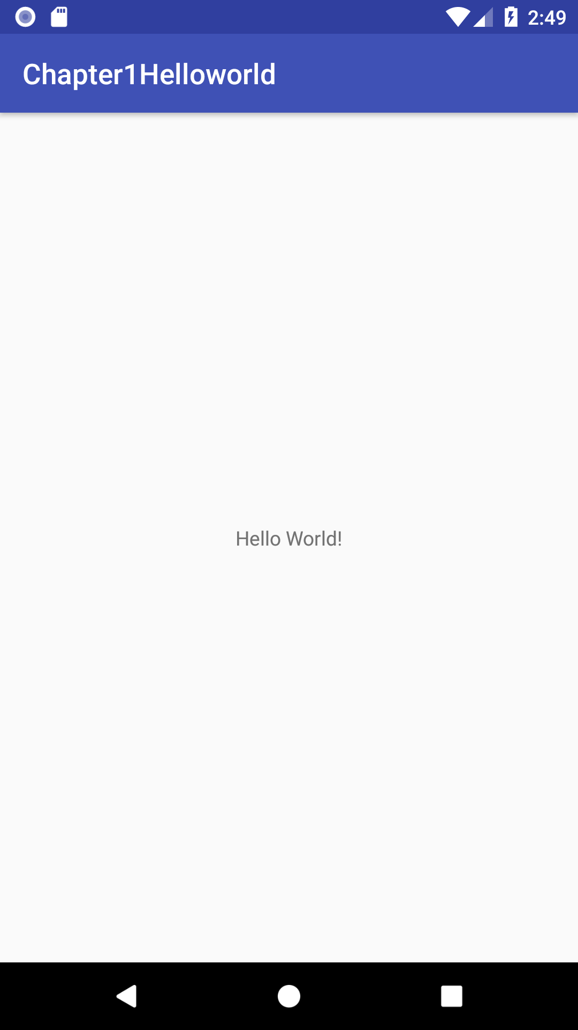Here is the completed assignment for Chapter 1. Please let me know if you have any questions or need further information.

Andrew Buskov