Names: Palesa Emily Thetele
Group: WG-3

Analyses of the visual chats from student interviews.

1.The Main Barrier Chat
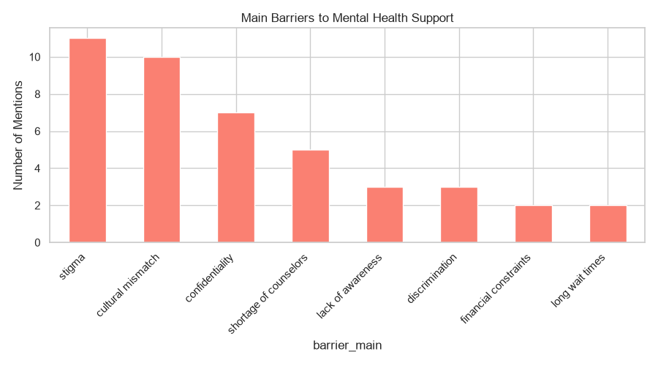
The chat shows why student tend not to get MHFA help. Showing that students are not avoiding getting help because they don’t need it. Rather they are avoiding it because they feel judged, misunderstood, and unsafe. The chat shows stigma, cultural mismatch and confidence being amongst the highest barriers.

2. Awareness Chart
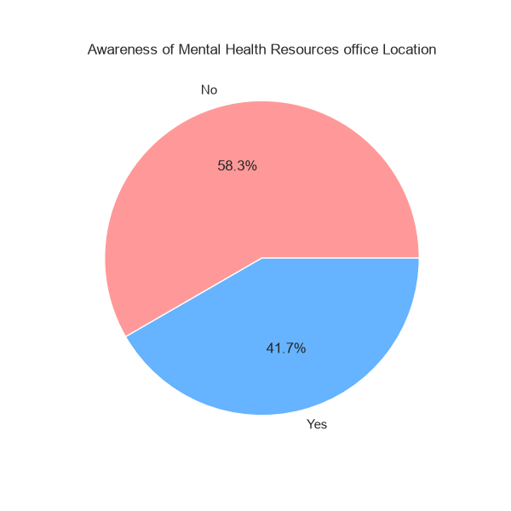
The chart indicates that students assume / are aware of the existing MHFA resources. However, 58.3% of them do not know the location of the offices on campus where to get these resources, while only 41.7% of the student know the location. This highlights a huge gap in awareness and accessibility of there resources.

3. Preferred Support Format Chart
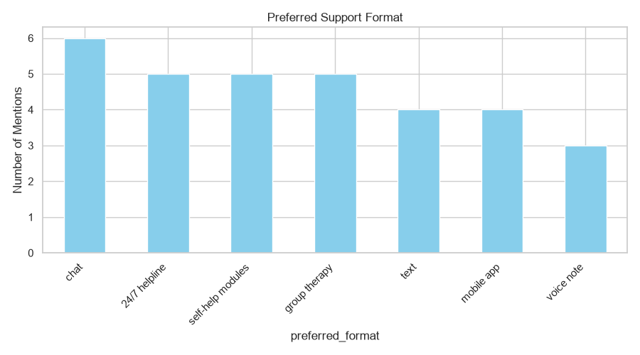
The chat highlights how student prefer to get MHFA assistance, with chat, 24/7 helpline, self-help modules and group therapy being amongst the most preferred. This shows that students don’t want to sit in an office. They want privacy, instant, digital support. They want to talk anytime, learn on their own, and not be seen.

3. Satisfaction Chart
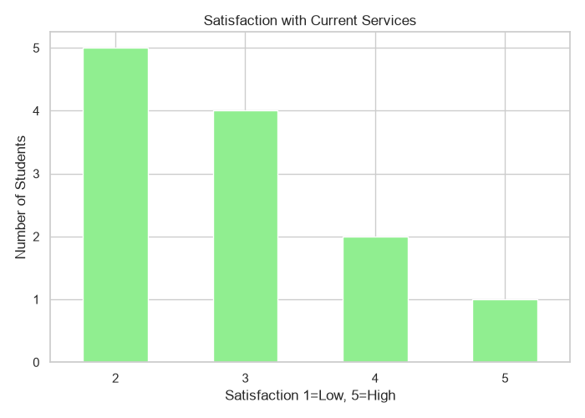
The chat indicates that most of the student find the current MHFA resources/services not to their satisfaction. As most of them rated them 2/5 or 3/5 almost no 4s and 5s. This also show that the few student who do access help are not happy with it. This hints that the current system is failing the people who needs it most.

5. Language Preference Chat

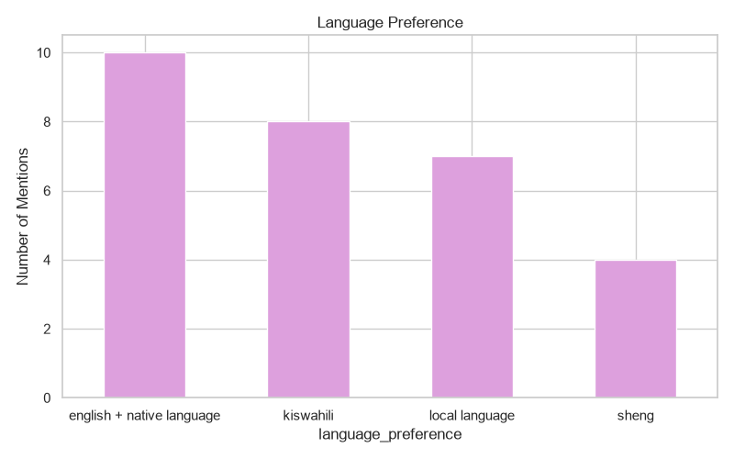

The chat shows that “English + Native language” is the highest followed by the others. This indicates that students are okay with English, but they don’t want English only. They need to express their feelings in Kiswahili, Sheng, or other local languages to feel understood.

Conclusion: The selected chats features indicate that our proposed WMW statements are valid, there is a need for an anonymous, 42/7, confidential, multilingual, culturally relevant digital MHFA platform build exactly how student want it.

