Swiss TPH Word report example
Sub-Title of Document Name of Project/Mandate, etc…
Jane Doe^{*,1,2,✉} and John Doe^{*,2}
2026-09-17
* These authors contributed equally to this work.
¹ Swiss Tropical and Public Health Institute, Basel, Switzerland
² University of Basel, Basel, Switzerland
✉ Correspondence: Jane Doe <jand.doe@swisstph.ch>

Executive summary
The European languages are members of the same family. Their separate existence is a myth. For science, music, sport, etc., Europe uses the same vocabulary. The languages only differ in their grammar, their pronunciation and their most common words. Everyone realises why a new common language would be desirable: one could refuse to pay expensive translators. To achieve this, it would be necessary to have uniform grammar, pronunciation and more common words. If several languages coalesce, the grammar of the resulting language is more simple and regular than that of the individual languages. The new common language will be more simple and regular than the existing European languages. It will be as simple as Occidental; in fact, it will be Occidental. To an English person, it will seem like simplified English, as a sceptical Cambridge friend of mine told me what Occidental is. The European languages are members of the same family. Their separate existence is a myth. For science, music, sport, etc., Europe uses the same vocabulary.
The languages only differ in their grammar, their pronunciation and their most common words. Everyone realises why a new common language would be desirable: one could refuse to pay expensive translators.

1. Example Heading 1
The European languages are members of the same family. Their separate existence is a myth. For science, music, sport, etc., Europe uses the same vocabulary. The languages only differ in their grammar, their pronunciation and their most common words.

1.1 Example Heading 2
The European languages are members of the same family. Their separate existence is a myth. For science, music, sport, etc., Europe uses the same vocabulary. The languages only differ in their grammar, their pronunciation and their most common words. Everyone realises why a new common language would be desirable: one could refuse to pay expensive translators. To achieve this, it would be necessary to have uniform grammar, pronunciation and more common words. If several languages coalesce, the grammar of the resulting language is simpler and more regular than that of the individual languages.

1.1.1 Example Heading 3
The European languages are members of the same family. Their separate existence is a myth. For science, music, sport, etc., Europe uses the same vocabulary. The languages only differ in their grammar, their pronunciation and their most common words. Everyone realises why a new common language would be desirable: one could refuse to pay expensive translators. To achieve this, it would be necessary to have uniform grammar, pronunciation and more common words. If several languages coalesce, the grammar of the resulting language is simpler and more regular than that of the individual languages.

1.1.1.1 Example Heading 4
The European languages are members of the same family. Their separate existence is a myth. For science, music, sport, etc., Europe uses the same vocabulary. The languages only differ in their grammar, their pronunciation.

2. Graphical chart colors
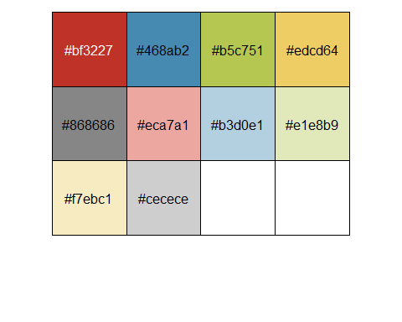

3. Table design
Sepal.Length | Sepal.Width | Petal.Length | Petal.Width | Species
5.1 | 3.5 | 1.4 | 0.2 | setosa
4.9 | 3.0 | 1.4 | 0.2 | setosa
4.7 | 3.2 | 1.3 | 0.2 | setosa
4.6 | 3.1 | 1.5 | 0.2 | setosa
5.0 | 3.6 | 1.4 | 0.2 | setosa
5.4 | 3.9 | 1.7 | 0.4 | setosa
4.6 | 3.4 | 1.4 | 0.3 | setosa
5.0 | 3.4 | 1.5 | 0.2 | setosa
4.4 | 2.9 | 1.4 | 0.2 | setosa
4.9 | 3.1 | 1.5 | 0.1 | setosa
