Online Supplement

Routing the Dollar: Gateway Infrastructure, Monetary Policy Transmission, and the Dollar's International Functions in Digital Markets

[Author Name]
[Institutional Affiliation]

March 2026

Prepared for the Fifth Conference on International Roles of the U.S. Dollar, Board of Governors of the Federal Reserve System and Federal Reserve Bank of New York, June 22-23, 2026.

Introduction
This is the companion document posted with "Routing the Dollar: Gateway Infrastructure, Monetary Policy Transmission, and the Dollar's International Functions in Digital Markets," containing tables, exhibits, and extended analyses omitted from the main text for length. References of the form "(online supplement)" in the main text correspond to sections below.
Appendix lettering follows the working-paper series. The main paper contains Appendices B, C, D, E, F, G, H, and K. This supplement provides the content for omitted appendix letters (A, J) and additional appendices (on tokenized fund assessment and the credit migration channel) removed from the main text for length, along with the detailed econometric tables, robustness analyses, and extended exhibits referenced throughout the paper. Appendix I (Legislative Framework and the Control Layer) appears as Appendix K in the main paper.

Appendix A: Complete Exhibit Inventory
Table A1 inventories all exhibits in the main paper and supplement, with key findings.
# | Title | Key Finding
1 | VECM IRFs (bootstrap 90% CI) | Fed assets shock -> supply: significant at weeks 8, 12, 26
2 | FEVD: Stablecoin Supply | Fed + ON RRP: 13.9% of supply variance at 26 weeks
3 | Persistence Profile | Half-life 5 weeks; 6-8 week oscillation (FOMC cycle)
4 | Yield Spread vs. Supply Growth | Granger F = 11.30, p = 0.001
5 | Correlation Matrix | Fed assets r = -0.94; fed funds r = -0.89; SOFR r = -0.87
6 | Rolling Correlations (90/180-day) | Sign reversal: +0.93 (QE) -> ~0 (tightening) -> -0.98 (easing)
7 | Supply vs. Fed Funds Rate | Negative co-movement across full sample
8 | Supply vs. ON RRP | $2.4T drawdown coincides with supply expansion
9 | FOMC Event Study | Directional but not significant after Bonferroni
10 | Use-Case Decomposition | P2P 45.7%; DeFi 33.2%; CEX 8.3%; payments 0.1%
11 | Market Capitalization Panels | USDT dominance rising; BUSD eliminated
12 | Gateway Volume by Tier | T2 55% gross/50% net; T1 41%/47%; duopoly
13 | SVB Crisis Dynamics | Entity-specific reallocation; Tier 3 absorbed 66-69%
14 | SVB Flow Retention | CLII-retention gradient: r = -0.34 (SVB), -0.47 (BUSD)
15 | Gateway Concentration (HHI) | Mean 5,021; range 3,800-7,200
16 | Counterparty Network | Volume doubled; unique counterparties -25%
17 | Network Topology Time Series | Cross-gateway bridges: 5.8% -> 2.6%
18 | Multi-Chain Control Layer | Tron: 0% T1; Ethereum: 41% T1; Solana: 11% T1
19 | CLII-Retention Gradient | Continuous: Q1 6.27x, Q4 0.61x retention
20 | Trivariate Robustness | Survives SOFR addition; 10-year yield fails
21 | Jackknife Stability | No single entity drives aggregate results
22 | CLII Weight Sensitivity | 18/19 entities invariant across 5 weighting schemes
23 | Event-Time Placebo | SVB: 94th pctile of 50 placebos; nadir z = -2.7sigma
24 | Coverage Sensitivity | T1 share: 43.5% -> 26.3% at 25% reclassification
25 | DEX Volume vs. Supply | Co-trending but DEX higher volatility
26 | IRF Lag Robustness | Lag 8 vs. lag 4 qualitatively similar
27 | ON RRP Decomposition | $2.4T -> $9.6B drawdown visualization
C2 | Placebo T1 Swings (orig.) | SVB 23.3 pp > all 50 placebos
C2b | Event-Time Stress Placebo | SVB 2.7sigma below mean; below 5th pctile 2/15 days
C8 | No-Freeze CLII Robustness | 0/19 tier changes; max shift 0.11
C9 | Day-of-Week Structure | Structural weekend dip: 13.9 pp
C10 | Placebo (Expanded Registry) | SVB swing 51.8 pp; 94th percentile
SB-1 | Unlabeled Address Degree | Labeled median degree 261 vs. unlabeled 41
SB-2 | Transfer Size Distribution | Labeled $1M+ share: 84.3% vs. 66.7%
Table A1. Complete exhibit inventory with key findings.

Tables F1--F3: Consolidated Econometric Results

Table F1. Consolidated Econometric Results
Panel A: Cointegration
Test | Statistic | Result
Johansen trace (rank <= 0) | 30.68 [cv95 = 29.80]* | Reject: rank = 1
Johansen lambda-max (rank <= 0) | 23.71 [cv95 = 21.13]* | Reject
Cointegrating rank | 1 | --
Engle-Granger (bivariate) | -2.92 [p = 0.13] | Fail to reject
System | Log Fed assets, log ON RRP, log stablecoin supply | --
Sample | Weekly, Feb 2023 to Jan 2026, T = 155, lag = 8 (AIC) | --
Panel B: VECM Adjustment Speeds (alpha)
Variable | alpha | SE | t-stat | p-value
Fed assets (WSHOMCB) | 0.003 | 0.0004 | 6.256 | <0.001***
ON RRP (RRPONTSYD) | -0.157 | 0.135 | -1.166 | 0.244
Stablecoin supply | -0.004 | 0.002 | -1.589 | 0.112
Weak exogeneity LR tests (chi-squared(1)):
Variable | LR statistic | p-value | Decision
Fed assets | 15.28 | <0.001 | Reject
ON RRP | 14.00 | <0.001 | Reject
Stablecoin supply | 5.38 | 0.020 | Reject at 5%
Panel C: FOMC Event Study (Raw / Abnormal)
Classification | t+5 raw | t+5 abnormal | t+10 raw | t+10 abnormal
Dovish (n = 5) | +0.63% [p = 0.20] | +0.13% [p = 0.79] | +1.66% [p = 0.09] | +0.65% [p = 0.50]
Neutral (n = 9) | +0.33% [p = 0.008]** | -0.29% [p = 0.098] | +0.93% [p = 0.06] | -0.31% [p = 0.36]
Hawkish (n = 5) | -0.07% [p = 0.57] | +0.19% [p = 0.36] | -0.48% [p = 0.07] | +0.04% [p = 0.85]
Panel D: Deposit Displacement
Measure | Statistic
Differenced r (weekly) | 0.12 [p = 0.024]*
Table F1. Consolidated econometric results. Panel B: only Fed assets alpha is individually significant; ON RRP and stablecoin supply carry error-correcting signs but are imprecisely estimated. Panel C: abnormal returns subtract the trailing 10-day average daily supply growth x horizon; no raw or abnormal result survives Bonferroni correction. Source: Author's calculations using FRED and DefiLlama data.

Table F2. Comprehensive Robustness and Identification Summary
Panel A: Cointegration and Identification
Test | Statistic | Result
Johansen trace (lag 8) | 30.68 (cv95 = 29.80) | Reject: rank = 1
Lag sensitivity | 3/5 lags pass (8, 10, 12) | Robust
KPSS (all variables) | I(1) confirmed | Consistent
ADF-KPSS supply (differenced) | ADF p = 0.002; KPSS p = 0.040 | Mild disagreement
Placebo: BTC | 0/5 lags cointegrate | Clean falsification
Placebo: ETH | 0/5 lags cointegrate | Clean falsification
Cross-stablecoin: USDT | 2/5 lags pass (10, 12) | Supportive
Cross-stablecoin: USDC | 2/5 lags pass (4, 6) | Supportive
USDT alpha (error correction) | -0.005 (p = 0.005) | Individually significant
Beta stability (Sep 2024 break) | Bootstrap p > 0.05 all elements | Stable
Gregory-Hansen (C/S model) | ADF* = -4.28 (cv 5% = -5.96) | Not significant
Yield spread Granger (lag 1) | F = 11.30 (p = 0.001) | Significant
Supply -> spread Granger (lag 2) | F = 9.40 (p < 0.001) | Bidirectional
ON RRP Granger (lag 1) | F = 4.83 (p = 0.028) | Significant
ON RRP Granger (lag 2) | F = 3.91 (p = 0.022) | Significant
Supply -> ON RRP (lag 5) | F = 4.13 (p = 0.002) | Bidirectional
FEVD at 26 weeks | Fed + RRP: 13.9% of supply variance | Moderate policy share
Persistence profile (Pesaran-Shin) | Smoothed half-life: 5 weeks | Rapid equilibrium restoration
FOMC volume ratio | 0.69x (t = -3.83, p < 0.001) | Significant (parametric)
FOMC volume Mann-Whitney | U = 9,542 (p = 0.614) | Not significant
Flow retention vs CLII (SVB) | r = -0.34 (p = 0.27; n = 12) | Directionally consistent
Flow retention vs CLII (BUSD) | r = -0.47 (p = 0.13; n = 12) | Directionally consistent
Flow retention pooled (SVB + BUSD) | r = -0.30 (p = 0.16; n = 24) | Direction holds
Panel E: Gateway Tier Correlations (Expanded Registry, Weekly, n = 158)
Relationship | Statistic | Interpretation
Tier 1 vs Fed Assets (levels) | r = -0.56 (p < 0.001) | Long-run co-trend
Tier 2 vs Fed Assets (levels) | r = -0.45 (p < 0.001) | Moderate co-movement
Tier 3 vs Fed Assets (levels) | r = +0.37 (p < 0.001) | Opposite direction (DeFi growth)
Tier 1 vs Fed Assets (first diff.) | r = +0.05 (p = 0.49) | Not significant
Tier 2 vs Fed Assets (first diff.) | r = +0.12 (p = 0.14) | Not significant
Tier 3 vs Fed Assets (first diff.) | r = +0.07 (p = 0.40) | Not significant
Panel F: SVB Counterparty Network (Nansen, 15 Gateways, 3 Windows)
Metric | Pre / Stress / Post | Interpretation
Network density | 0.085 / 0.085 / 0.086 | Topology stable; capacity fragmented
Market-maker volume change (stress vs pre) | -29% aggregate | Cumberland -79%, Wintermute +118%
Wintermute gateway connections | 6 / 6 / 6 | Maintained all; added Circle
Cumberland gateway connections | 6 / 3 / 6 | Lost Curve, Coinbase, Paxos during stress
MEV bot share of Curve 3pool | 24% pre -> 51% stress | Replaced institutional intermediaries
Core triangle (Binance-Circle-Tether) | 44% / 42% / 57% | Post-crisis consolidation
Panel G: BUSD Wind-Down Counterparty Network (Nansen, 15 Gateways, 3 Windows)
Metric | Pre / Early / Late | Interpretation
Wintermute volume | $4.7B / $12.0B / $24.4B | 5x surge; mediated BUSD->USDT
Paxos as Binance counterparty | $6.8B / $4.3B / $0.8B | 88% decline
Tether Treasury counterparty count | 15 / 64 / 500 | Broadening USDT mint
Total network volume | $410B / $507B / $457B | Rose then stabilized
Panel H: Layer 2 Gateway Tier Composition (Nansen)
Chain | T1 | T2 | T3 | Note
Base | 0% | 0% | 100% | Morpho Blue dominates
Arbitrum | 0% | 46% | 54% | Binance + Hyperliquid/Aave/GMX
Ethereum (comparison) | 44% | 53% | 3% | L2s do not inherit parent tier structure
Panel I: Monthly Market-Maker Concentration (Nansen, 15 Gateways, 35 Months)
Metric | Value | Interpretation
Wintermute monthly volume | $2.2B (Feb 2023) -> $51.8B (Aug 2025) | 24x growth; 1.4% -> 19.9%
Cumberland monthly volume | $5.2B (Feb 2023) -> $0.2B (Dec 2025) | 96% decline
Wintermute/Cumberland ratio | 0.4x -> 42x | Market-maker layer concentrating
Cross-gateway counterparties | 5.8% (Feb 2023) -> 2.6% (Dec 2025) | Shared counterparties declining
Panel J: Solana Gateway Tier Composition (Dune Analytics, 14 Entities)
Metric | Value | Interpretation
Tier 1 volume share | 11.1% ($49.7B of $446.7B) | Coinbase $25.0B + Circle $24.8B
Tier 2 volume share | 88.9% ($396.9B) | Binance $278B dominates
Tier 3 DEX volume | $4.2T synthetic | Jupiter/Raydium/Orca; not comparable
Solana vs Ethereum T1 share | 11% vs 41% | Exchange-dominated, DeFi-first
Table F2. Comprehensive robustness and identification summary. See Section IV.A.1 of the main paper for detailed discussion. Source: Author's calculations.

Table F3. Gateway Volume on FOMC Days
Classification | Volume Ratio | Interpretation
Hawkish | 0.50x | Lowest activity; uncertainty peak
Dovish | 0.72x | Moderate suppression
Neutral | 0.77x | Closest to baseline
Table F3. Gateway volume on FOMC days relative to non-FOMC baseline. Daily stablecoin gateway transfer volume is 31 percent lower on FOMC announcement days (Welch's t = -3.83, p < 0.001), though the non-parametric Mann-Whitney test does not confirm (U = 9,542, p = 0.614). Source: Author's calculations using Dune Analytics data.

Extended FOMC Event Study Analysis
Classification-level detail. In the dovish case, the raw t+10 mean (+1.66%) is pulled substantially above the median (+1.14%) by the November 2024 rate cut, which coincided with a broader risk-on episode in crypto markets; the abnormal t+10 mean (+0.65%) is not significant (p = 0.50). The hawkish category shows the most notable abnormal result at the shortest horizon: hawkish announcements produce an abnormal t+1 supply decline of -0.039 percent (p = 0.027), suggesting that the immediate market reaction to tightening signals is the most cleanly identified policy effect in our sample, though the small sample (n = 5) warrants caution. With 12 hypothesis tests across three classifications and four horizons, neither the raw neutral t+5 result (p = 0.008) nor the hawkish abnormal t+1 result (p = 0.027) survives strict Bonferroni correction (adjusted alpha = 0.004); both survive at the 10 percent family-wise level.
FOMC-day volume effects. Daily stablecoin gateway transfer volume is 31 percent lower on FOMC announcement days relative to non-FOMC days (Welch's t = -3.83, p < 0.001), though the non-parametric Mann-Whitney test does not confirm this finding (U = 9,542, p = 0.614). The parametric/non-parametric disagreement warrants caution, but the directional result suggests stablecoin markets have become integrated enough with the traditional financial system that participants reduce activity around scheduled policy announcements.

Unit Root Test Results (ADF and KPSS)
Table F2, Panel A reports the joint ADF and KPSS results confirming that all three VECM variables (log Fed assets, log ON RRP, log stablecoin supply) are I(1). The ADF test rejects the unit root null in first differences for all series, while KPSS fails to reject stationarity in first differences, jointly confirming that each series is integrated of order one.
The ADF test on differenced Fed total assets is borderline (p = 0.19), but KPSS confirms stationarity (0.386, p = 0.083). The mild disagreement for stablecoin supply (ADF p = 0.002 vs. KPSS p = 0.040) does not affect the joint I(1) classification. The Johansen cointegration test is valid for I(1) series regardless of borderline individual test results.

Johansen Weak Exogeneity Test
Table F1, Panel B reports the weak exogeneity LR test results. The Johansen weak exogeneity test rejects alpha = 0 for all three variables in the VECM system: Fed assets (LR = 15.28, p < 0.001), ON RRP (LR = 14.00, p < 0.001), and stablecoin supply (LR = 5.38, p = 0.020). All three variables participate in error correction, reflecting shared exposure to money-market conditions rather than a policy reaction function.
This does not imply the Fed responds to stablecoin supply, an economically implausible reading. Rather, the Fed's administrative QT pace creates its own mean-reverting dynamics (alpha = +0.003, positive), while ON RRP and stablecoin supply carry error-correcting signs (alpha < 0), absorbing the adjustment. The apparent contradiction between the t-test insignificance of ON RRP's alpha (t = -1.166, p = 0.244) and the LR test rejection (LR = 14.00, p < 0.001) arises because the LR test evaluates the full system restriction (setting alpha to zero and re-estimating the entire cointegrating vector), while the t-test conditions on a fixed beta. The eigenvalue shifts by 57.1 percent under the alpha = 0 restriction, confirming ON RRP's structural participation in equilibrium correction.

FEVD and Persistence Profile Detail

Forecast Error Variance Decomposition
The FEVD shows a slowly rising share of stablecoin supply forecast error variance attributable to Fed policy shocks, consistent with a gradual transmission mechanism rather than instantaneous pass-through.
Horizon (weeks) | Fed Assets Share | ON RRP Share | Supply Own Share
1 | 0.8% | 2.8% | 96.4%
4 | 1.5% | 3.8% | 94.7%
12 | 5.2% | 5.1% | 89.7%
26 | 8.8% | 5.1% | 86.1%
Combined Fed + ON RRP share rises monotonically from 3.6% at 1 week to 13.9% at 26 weeks, indicating that policy shocks explain a modest but growing share of supply variance over the medium term.

Persistence Profile
The persistence profile (Pesaran and Shin 1996) measures the speed at which the cointegrating equilibrium is restored following a system-wide shock. The smoothed half-life is approximately 5 weeks, with 58 percent absorbed within one quarter. The profile exhibits oscillations at a 6-8 week cycle consistent with the FOMC meeting schedule, explaining why FOMC announcement effects are individually weak while the long-run equilibrium is strong: transmission operates over weeks to months rather than days.
Source: Author's calculations using FRED and DefiLlama data.

SVB Gateway Flow Retention: All 12 Entities
Table 6 in the main paper shows the top 10 gateways by volume. The complete 12-entity table is below. Flow retention is defined as the ratio of stress-period volume share to pre-stress baseline volume share; values above 1.0 indicate the gateway attracted disproportionate flows during SVB stress.
Gateway | Tier | CLII | Baseline Share | Stress Share | Retention Ratio
Circle Treasury | 1 | 0.92 | 34.2% | 23.8% | 1.39x
Coinbase | 1 | 0.85 | 8.1% | 10.9% | 2.69x
Paxos | 1 | 0.88 | 4.3% | 5.5% | 2.57x
Gemini | 1 | 0.82 | 2.1% | 2.3% | 2.21x
BitGo | 1 | 0.80 | 0.8% | 2.7% | 6.80x
Tether Treasury | 2 | 0.45 | 15.2% | 13.5% | 1.77x
Binance | 2 | 0.38 | 18.4% | 16.1% | 1.75x
Kraken | 2 | 0.58 | 3.6% | 3.9% | 2.14x
OKX | 2 | 0.40 | 2.8% | 2.5% | 1.79x
Uniswap V3 | 3 | 0.15 | 4.1% | 11.1% | 5.42x
Curve 3pool | 3 | 0.18 | 1.2% | 7.4% | 12.35x
Aave V3 | 3 | 0.20 | 0.5% | 1.9% | 7.74x
The CLII-retention gradient is negative for both SVB (r = -0.34, p = 0.27, n = 12) and BUSD (r = -0.47, p = 0.13, n = 12) stress episodes, though neither reaches statistical significance at the 12-entity sample size. The pooled estimate (r = -0.30, p = 0.16, n = 24) confirms the directional pattern holds across both episodes.
Source: Author's calculations using Dune Analytics gateway transfer data. Baseline: 30-day pre-stress average. Stress: March 10-14, 2023 (SVB).

Placebo Analysis: Full Results
To test whether the SVB-week Tier 1 share movements are statistically exceptional, we compute event-time-aligned Tier 1 share trajectories for 50 randomly selected non-event windows over a [-7, +7] day horizon centered on each placebo date.

Original 12-Address Registry (Exhibit C2)
Using the original 12-address registry, the SVB-week swing (23.3 pp) exceeds all 50 randomly sampled non-event windows (max placebo: 21.9 pp; mean: 13.4 pp).
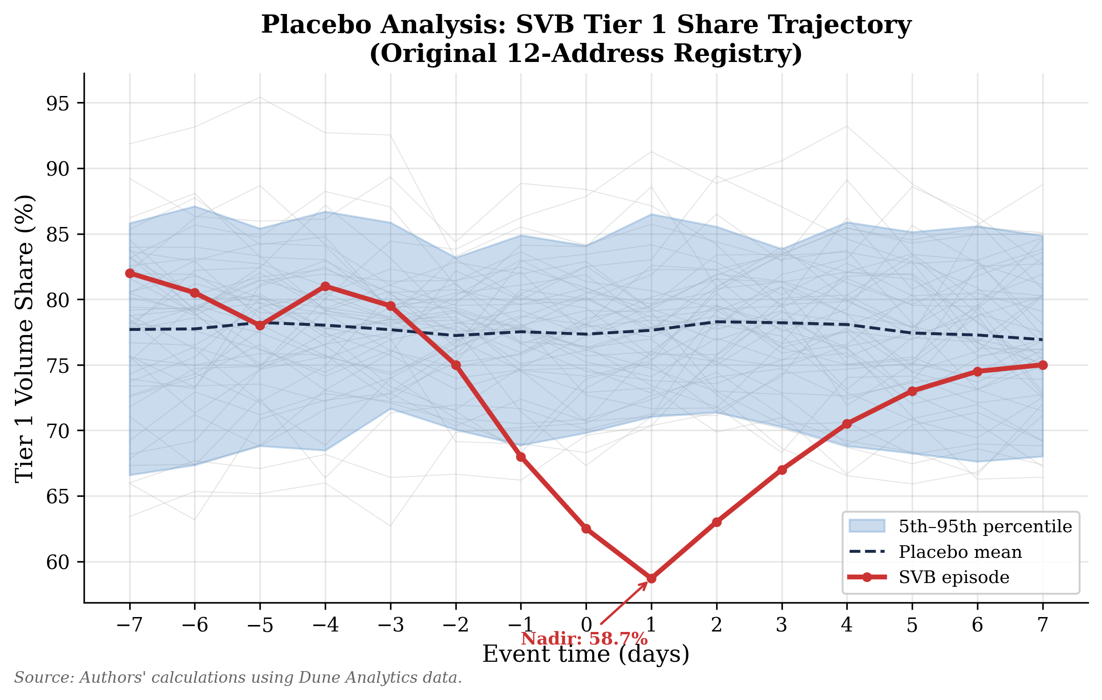
Exhibit C2. Placebo analysis of Tier 1 share swings (original 12-address registry). Source: Author's calculations using Dune Analytics gateway share data.

Expanded 51-Address Registry (Exhibit C10)
Under the expanded 51-address registry, the SVB trajectory's 15-day swing of 51.8 percentage points ranks at the 94th percentile of placebo swings, its nadir falls 2.7 standard deviations below the placebo mean, and the trajectory remains below the 5th percentile band for 2 of 15 event-time days.
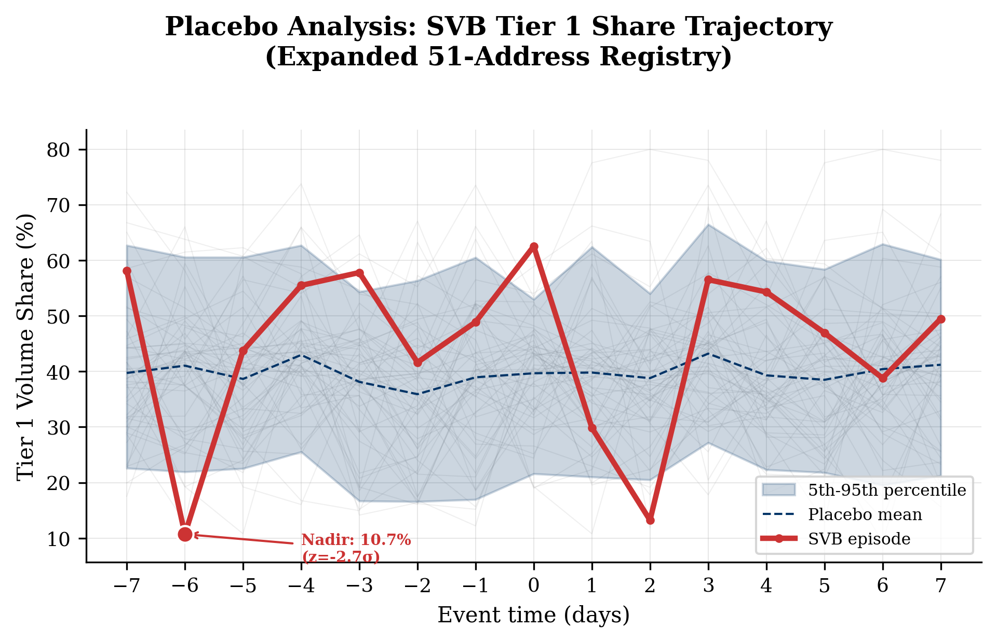
Exhibit C10. Placebo analysis with expanded 51-address registry. Gray: 50 non-event windows; blue band: 5th-95th percentile; dashed: placebo mean; red: SVB trajectory. Source: Author's calculations using Dune Analytics data.
The multi-day swing exceeds all but 3 of 50 placebo windows, confirming the SVB stress episode produced statistically exceptional gateway reallocation.

Day-of-Week Tier 1 Structure
The expanded 51-address registry reveals a structural weekend dip in Tier 1 share (weekday mean 44.8 percent, weekend mean 30.9 percent, gap 13.9 pp), driven primarily by Binance's 24/7 operations increasing Tier 2's weekend share. This structural pattern means that the SVB weekend nadir of 13.2 percent (March 12) cannot be evaluated against weekday baselines; the relevant comparison is against normal weekend variation.
At the weekend level, the SVB dip falls 0.85 standard deviations below the normal weekend mean, not statistically exceptional. Day-over-day changes provide additional signal: the SVB Friday-to-Saturday drop (-32.7 pp) exceeds the normal Friday-to-Saturday mean (-14.9 pp) by 1.4 sigma, and the Saturday-to-Sunday continuation (-16.6 pp) exceeds its normal mean (-0.2 pp) by 1.3 sigma. Neither is individually significant; the combined two-day trajectory from 62.5 to 13.2 percent is what the placebo analysis identifies as exceptional.
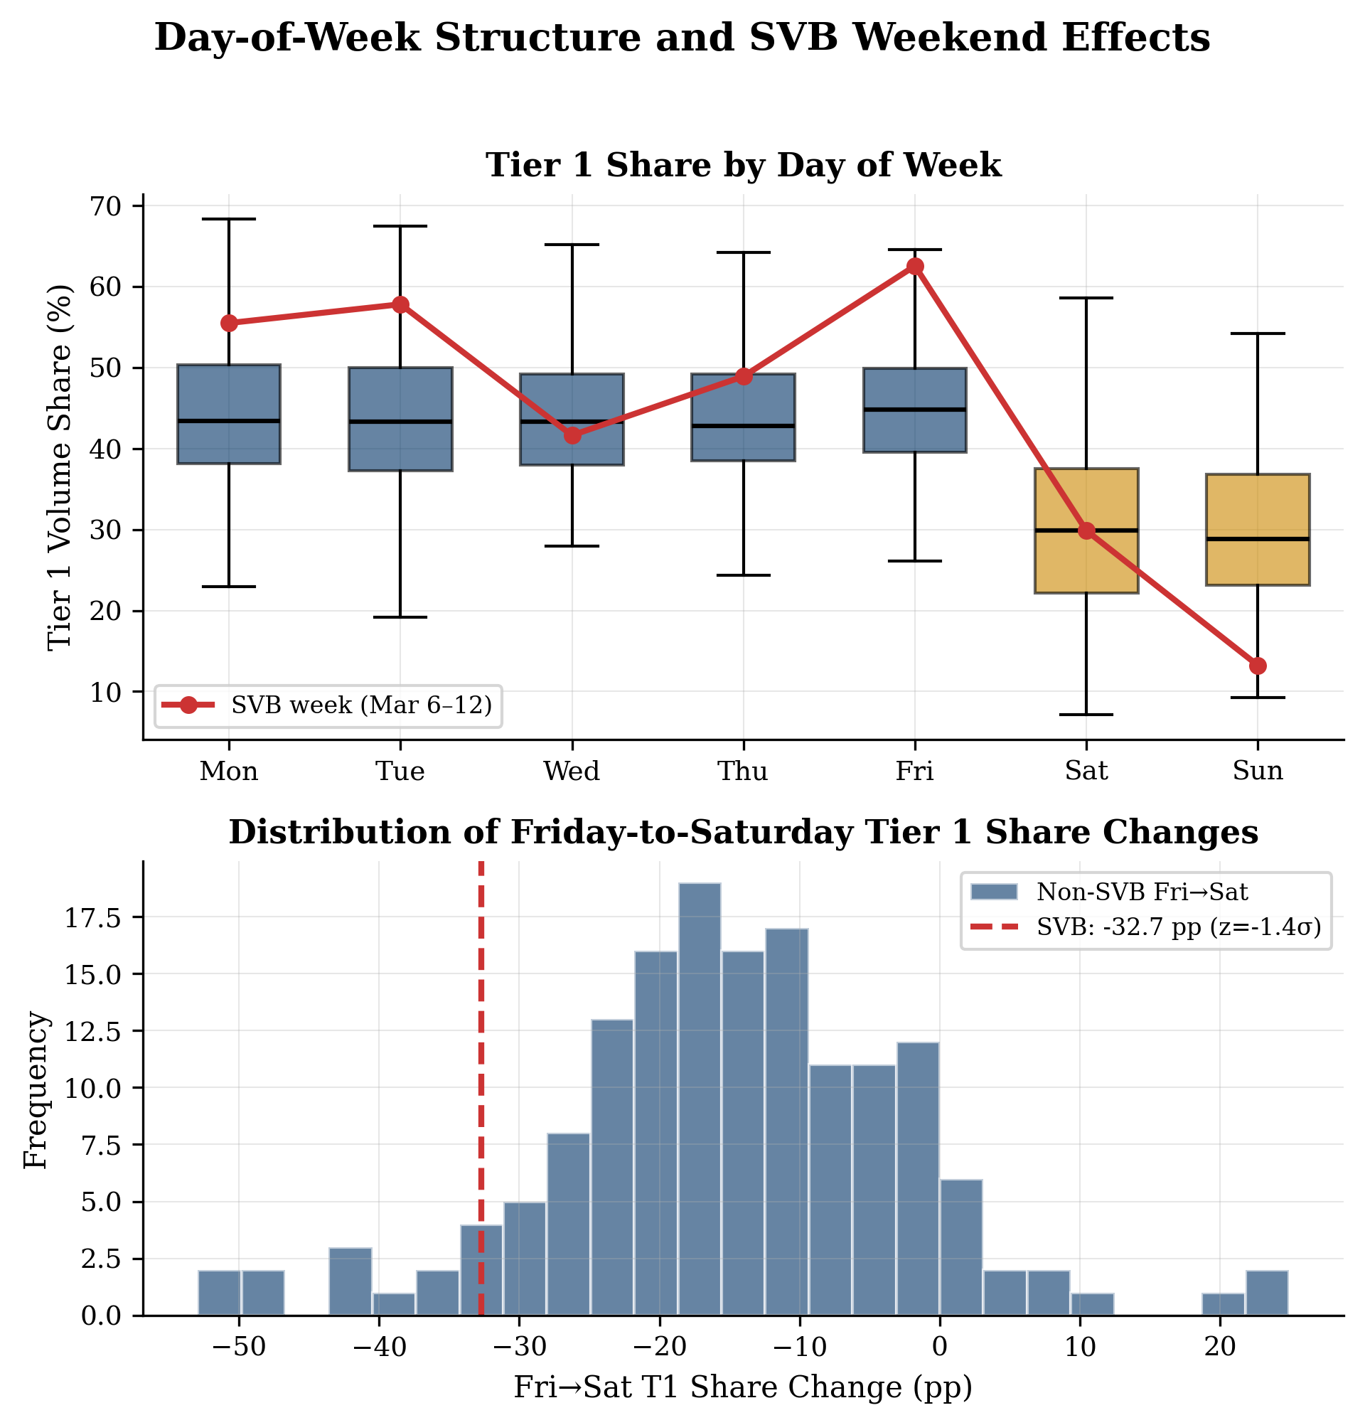
Exhibit C9. Day-of-week structure and SVB weekend effects (expanded 51-address registry). Source: Author's calculations using Dune Analytics data.

No-Freeze CLII Robustness
The freeze/blacklist capability dimension (20 percent weight) partially proxies for centralization rather than regulatory compliance per se: centralized entities can freeze assets while permissionless protocols cannot, regardless of regulatory intent. To test whether this conflation drives the tier classification, we recompute CLII scores dropping the freeze dimension entirely and redistributing its weight proportionally across the remaining four dimensions (License 31.25 percent, Transparency 25 percent, Compliance 25 percent, Sanctions 18.75 percent).
Zero of 19 entities change tier classification. The maximum absolute CLII shift is 0.11 (Tether, whose high freeze score of 0.90 contrasts with low scores on other dimensions); Tier 1 entities shift by less than 0.02. The tier structure reflects licensing, transparency, compliance infrastructure, and sanctions screening, not freeze capability alone.
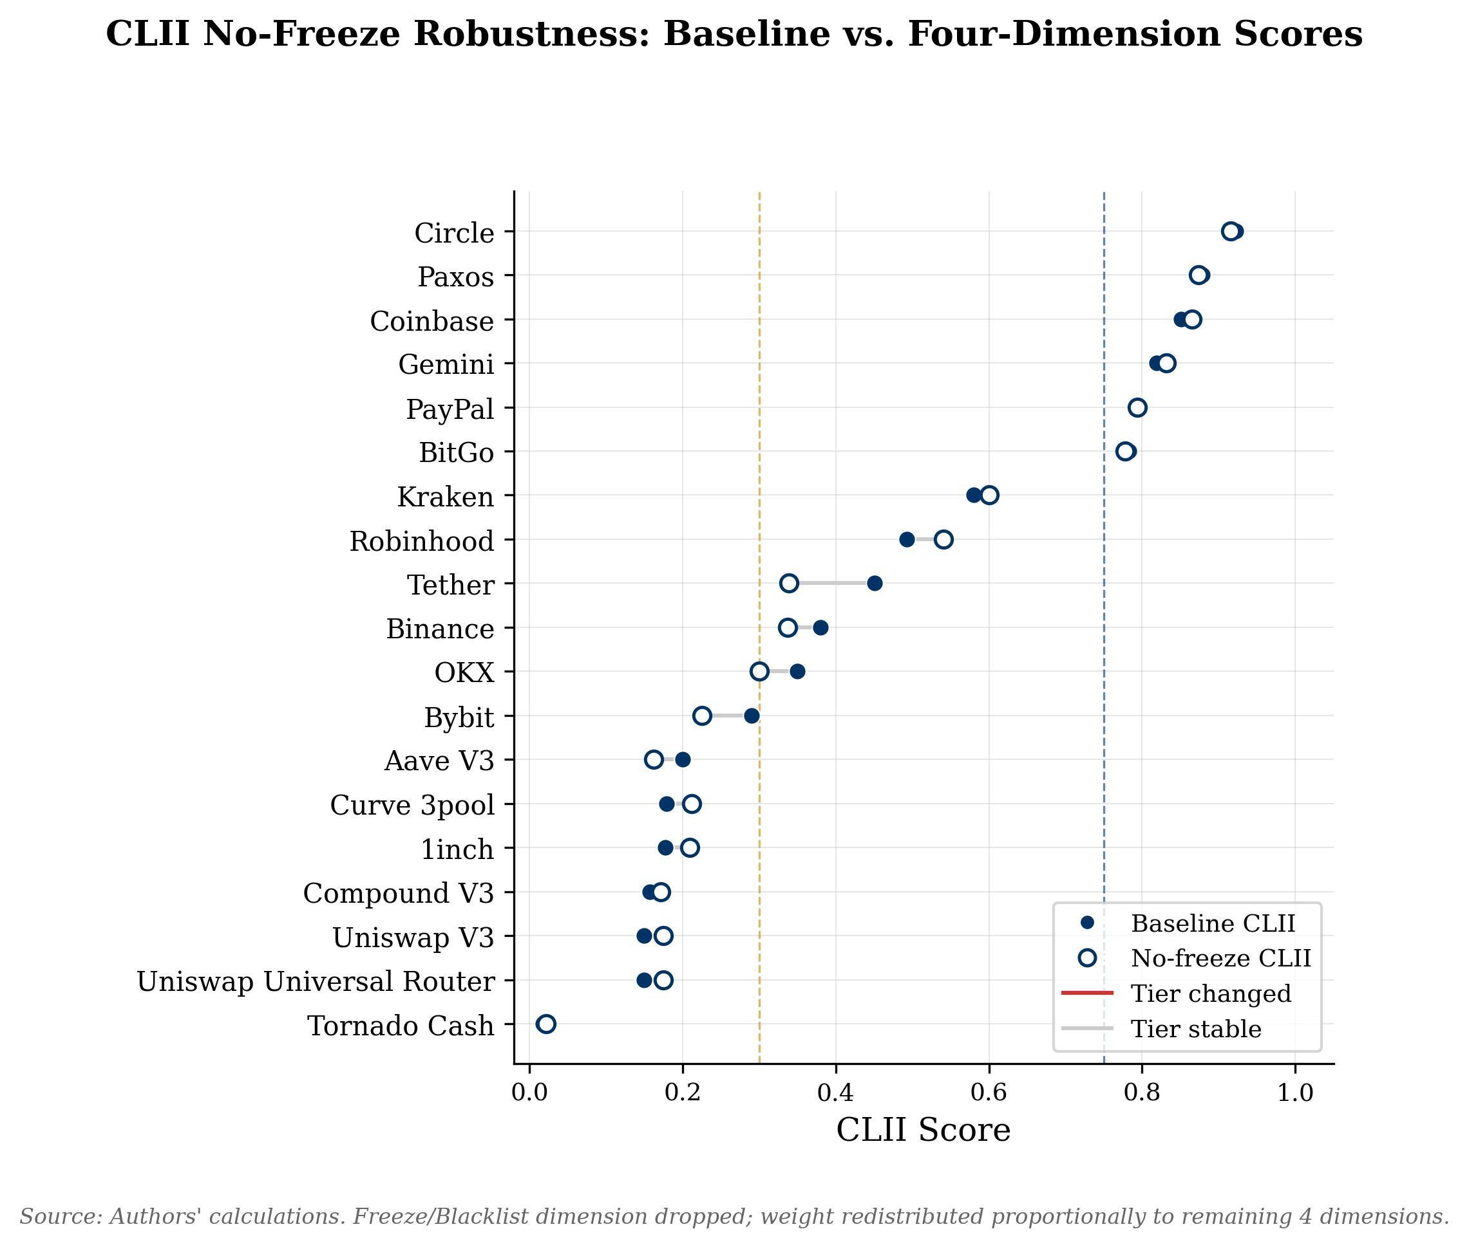
Exhibit C8. CLII no-freeze robustness. Dumbbell chart showing baseline CLII score (left dot) and no-freeze CLII score (right dot) for all 19 entities, with tier boundaries (0.75, 0.30) as vertical lines. Source: Author's calculations.

Unlabeled Address Characterization
Our labeled set is a sample of gateway addresses, not the universe. The principal threat is that unlabeled volume (72.3 percent of Ethereum USDC/USDT transfers) is systematically gateway-like rather than P2P-like, which would bias tier shares downward for whichever tier the unlabeled gateways belong to.
Transfer-level behavioral analysis comparing the 51 labeled gateway addresses against the top 500 unlabeled addresses by volume (6-month sample, Jul 2024-Jan 2025) reveals: labeled gateway volume is more concentrated in large transfers ($1M+: 84.3 percent of labeled volume versus 66.7 percent of unlabeled, a 17.6 pp gap), and labeled gateways exhibit six times the median counterparty degree (261 versus 41), consistent with the unlabeled population being structurally more P2P-like than gateway-like. 39 percent of the top 500 unlabeled addresses do exhibit gateway-like behavioral signatures (flow symmetry >= 0.9 and counterparty degree >= 100), confirming that some unlabeled volume is exchange-like, but this does not dominate the distribution.
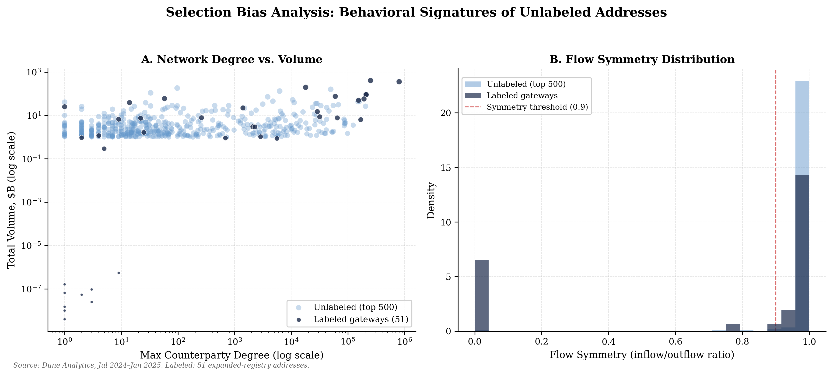
Exhibit SB-1. Behavioral signatures of unlabeled addresses. Panel A: counterparty degree versus total volume. Panel B: flow symmetry density. Labeled gateways cluster at higher degree (median 261 versus 41). Source: Dune Analytics, 6-month sample.
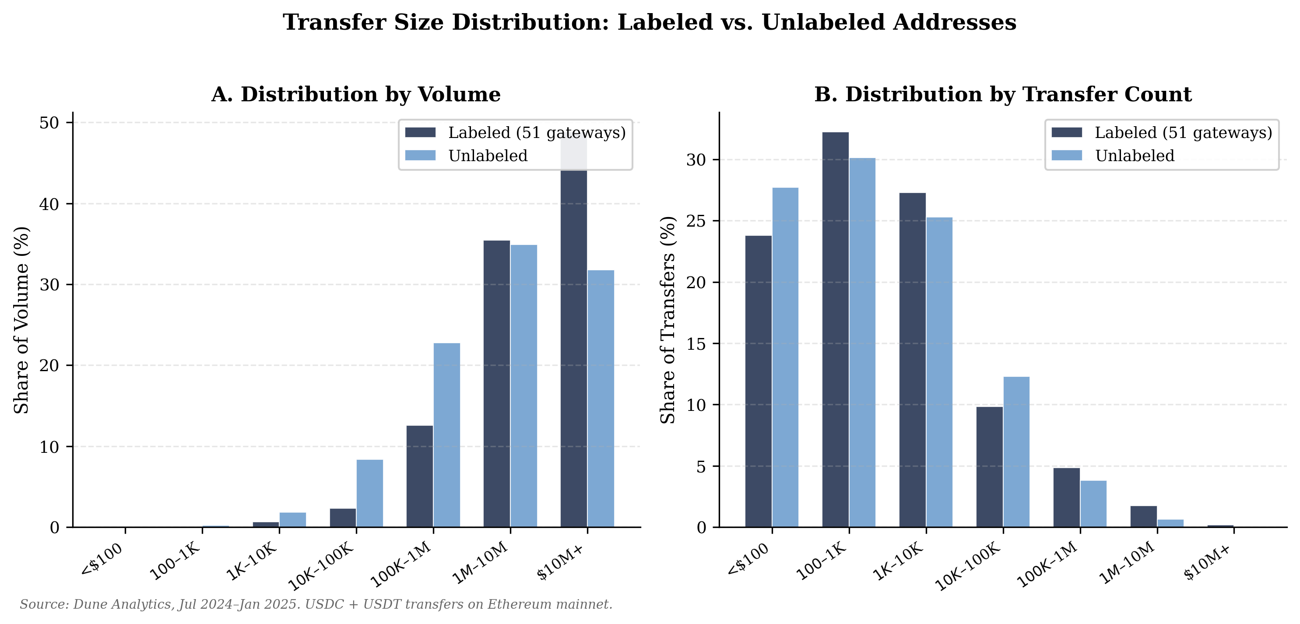
Exhibit SB-2. Transfer size distribution, labeled versus unlabeled addresses. Panel A: share of volume by transfer size bucket. Panel B: share of transfer count. Source: Dune Analytics, Jul 2024-Jan 2025, Ethereum USDC + USDT.

Tokenized Fund Product Assessment
As tokenized Treasury fund products grow, a natural question is whether these products could enter the stablecoin reserve stack or serve as functional substitutes for traditional money market fund shares. We assess three leading products against nine categories of minimum viable economic parity (MVEP) with traditional money market instruments.
Category | BUIDL (BlackRock) | BENJI (Franklin T.) | OUSG (Ondo)
Redemption guarantee | Pass | Pass | Ambiguous
Regulatory licensing | Ambiguous | Pass | Ambiguous
Segregation of assets | Pass | Pass | Pass
Qualified custodian | Pass | Pass | Pass
Daily NAV transparency | Pass | Pass | Pass
AML/KYC gateway | Pass | Pass | Pass
Smart contract audit | Ambiguous | Ambiguous | Pass
Interoperability | Pass | Ambiguous | Pass
Regulatory clarity | Pass | Pass | Ambiguous
Score | 7/9 | 7/9 | 6/9
Table G1. Minimum Viable Economic Parity (MVEP) assessment. BlackRock BUIDL AUM ~$2.5B (Nov 2025); Franklin BENJI ~$844M; Ondo OUSG ~$770M. Source: Author's analysis of product documentation, SEC filings, and audit reports as of January 2026.
All three products pass on core institutional requirements: segregation of assets, qualified custodian, daily NAV transparency, and AML/KYC gateways. The residual ambiguity clusters in two areas. First, regulatory licensing: BUIDL operates as an unregistered private placement under Regulation D, while BENJI is the only product with full SEC registration as a mutual fund. Second, smart contract auditability: neither BUIDL nor BENJI has published comprehensive, publicly available independent smart contract audits, while OUSG has undergone multiple audits.
The gateway implications are significant. Tokenized fund products create a new class of potential Tier 1 gateway in which the fund administrator and transfer agent combines reserve management with token issuance, collapsing the issuer-gateway distinction that the CLII currently separates.

The Credit Migration Channel
The deposit-displacement mechanism described in Section IV.E has a second-order consequence that connects stablecoin growth directly to the structure of credit intermediation. Stablecoin reserves are, by design, narrow: the GENIUS Act mandates one-to-one backing in cash, Treasury bills, and repo, none of which fund loans. Every dollar of deposits that migrates into stablecoin reserves is a dollar removed from the fractional-reserve lending channel.
The credit migration channel operates through four distinct mechanisms: (A) deposit displacement itself: the money object moves from bank liabilities to stablecoin reserves, reducing the deposit base available for lending; (B) credit supply relocation: the marginal loan shifts from bank to nonbank balance sheets; (C) funding fragility: replacement credit is funded by wholesale markets and securitization rather than insured deposits; and (D) backstop ambiguity: nonbank credit intermediaries may lack access to Fed lending facilities.
The closest precedent is the post-2008 restructuring of small-business credit documented by Gopal and Schnabl (2022), who show that regulatory constraints on banks drove a wholesale migration of lending activity to nonbank finance companies and fintech originators. Three features of their findings map onto the stablecoin context: the regulatory perimeter predicted behavior under constraint, replacement credit shifted toward shorter maturities and heavier collateral, and the speed of nonbank entry was striking.
Congress's yield prohibition on payment stablecoins responds in part to this deposit-displacement concern. The prohibition echoes Regulation Q's mid-twentieth-century interest-rate ceilings. A parallel development -- tokenized deposits -- offers an inside-the-perimeter alternative: bank deposits represented as tokens that remain on the bank's balance sheet, inherit deposit insurance, and preserve the fractional-reserve lending channel.
For monetary policy, the credit migration channel implies that the transmission externality operates on two margins simultaneously: the interest-rate channel is attenuated if displaced liquidity circulates in venues unconstrained by reserve requirements, and the credit channel is restructured if deposit displacement pushes credit supply toward more procyclical nonbank balance sheets. At current scale ($305 billion), these effects are negligible. At the $1-2 trillion range that current growth rates imply by the end of the decade, the deposit-displacement effect could rival the post-2008 bank lending contraction.

Appendix J: The Eurodollar Analogy and Its Limits
The offshore USDT ecosystem shares three defining features with the eurodollar system that emerged in the 1960s: dollar instruments circulating outside U.S. regulatory infrastructure, different monetary transmission properties than their domestic counterparts, and a structural challenge to the Fed's ability to monitor and backstop dollar liquidity globally. As with eurodollars, the growth is demand-driven (emerging-market dollar demand) rather than policy-designed, and the regulatory response has lagged the market's development by years.
The analogy is imprecise in three important respects. First, eurodollars create money through fractional-reserve lending while stablecoins are fully reserved; the credit-creation multiplier that gave eurodollar markets their systemic significance is absent in stablecoin markets by design. Second, eurodollar banks retain access to lender-of-last-resort facilities through central bank swap lines while stablecoin issuers have no equivalent backstop; the Fed's swap-line architecture covers eurodollar stress but not stablecoin stress. Third, eurodollar deposit creation is driven by credit demand while stablecoin issuance is driven by fiat inflow from token purchasers, a distinction that affects the elasticity of supply to monetary conditions.
Despite these differences, the regulatory challenge is structurally parallel: monitoring dollar usage beyond the supervisory perimeter. The eurodollar experience suggests that once dollar instruments achieve sufficient offshore scale, they become self-reinforcing through network effects and difficult to repatriate within the regulatory perimeter without disrupting the economic functions they serve. The stablecoin routing infrastructure documented in this paper represents an early-stage version of this dynamic, with the additional complication that the "offshore" dimension is defined by blockchain and gateway choice rather than geographic jurisdiction.

