Governance Concentration Beyond Token Allocation: An Institutional Design Analysis of DePIN and DeFi
Zach Zukowski
Tokenization Systems
zach@tokenization.systems
ORCID: 0009-0006-3642-2450
April 2026

Abstract
Initial token allocation design does not predict governance concentration. A 40-protocol cross-section spanning Decentralized Physical Infrastructure Networks (DePIN), DeFi, infrastructure, and social token categories documents that team and investor allocation at launch is uninformative about post-distribution governance concentration (Pearson r = 0.18, p = 0.28, N = 37): protocols with generous community distributions exhibit concentration patterns similar to those with heavy insider allocations. Hyperliquid (zero venture capital, 31% community airdrop) shows the lowest DeFi-subsample Herfindahl-Hirschman Index (HHI) of 0.005, but the broader null holds across allocation designs. Evidence is consistent with post-distribution market dynamics shaping concentration more than initial structural design.
Four supporting findings sharpen the picture. First, protocols with more insider wallets in their top-holder sets exhibit higher concentration among non-insider holders (Spearman rho = 0.54, p = 0.001, N = 34): insider-heavy protocols develop concentrated governance ecosystems, not merely concentrated insider positions. Second, sector membership predicts concentration: DePIN exceeds DeFi (Mann-Whitney p = 0.014, Cohen’s d = 1.03), and the effect survives across three nested OLS specifications adding protocol age, log fully diluted valuation (FDV), and initial insider allocation as successive controls (sector coefficient p < 0.05 in Models 1 and 2, borderline at p = 0.050 in Model 3 with the full control set; adjusted R² 0.14 to 0.17; Table 6). Third, on-chain subsidy intensity correlates with concentration in levels (r = 0.57, p = 0.008, N = 20) but entirely through Livepeer (88.5x subsidy); excluding Livepeer yields r = 0.11, p = 0.65. Fourth, delegation concentrates governance power above the level measured from token holdings in nine of ten protocols sampled (voting-power HHI exceeds holding HHI by factors of 1.4x to 6.8x), with one structural exception (ENS at 0.21x reflects a mature delegate program where holders systematically delegate to a broad community-delegate set). Two further vote-escrowed protocols (Curve and Balancer) show extreme amplification (15x and 21x) under ve-token lock-duration weighting, forming a distinct class. Variation in amplification across the non-ve-token sample is not predicted by sector or governance venue (Tally on-chain versus Snapshot off-chain), consistent with institutional design at the delegate-program level governing both the direction and magnitude of delegation’s effect on voting concentration.
A measurement distinction underlies these findings. Token inequality (Gini, dispersion across all holders) and governance concentration (HHI, sum of squared top-holder shares) capture distinct properties of the same holder set. Inequality is severe in every protocol (Gini 0.52 to 0.99), while concentration varies across two orders of magnitude (HHI 0.005 to 0.199); the moderate correlation (r = 0.51) confirms that inequality metrics cannot substitute for direct concentration measurement.
JEL Codes: C21 (Cross-Sectional Models), D02 (Institutions: Design, Formation, Operations), D23 (Organizational Behavior; Transaction Costs; Property Rights), D47 (Market Design), D63 (Equity, Justice, Inequality), D71 (Social Choice; Clubs; Committees), D72 (Political Processes), D74 (Conflict; Conflict Resolution; Alliances; Revolutions), G30 (Corporate Finance and Governance: General), G34 (Mergers; Acquisitions; Restructuring; Corporate Governance), L22 (Firm Organization and Market Structure), O33 (Technological Change: Choices and Consequences; Diffusion Processes), P48 (Political Economy; Legal Institutions; Property Rights)
Keywords: tokenomics, institutional design, governance concentration, DAO governance, DePIN, delegation amplification, Herfindahl-Hirschman Index, Pettit contestability, Rawlsian fairness, Ostromian polycentricity, Hayekian knowledge-use, Kantian publicity, five-lens framework, political philosophy of tokenomics, principal-agent problem in delegated voting, burn-rule exclusion, protocol-controlled address methodology, polycentric governance, blockchain governance, voting power concentration, veCRV, governance HHI

1 Introduction

1.1 Motivation
Three protocols with near-identical subsidy ratios exhibit governance HHI spanning 0.020 to 0.153: financial sustainability is neither necessary nor sufficient for governance decentralization (Section 3.4). Governance concentration is a secondary market outcome, shaped by post-distribution trading and accumulation dynamics that neither allocation design nor protocol financial characteristics predict.
Token-based governance is the default coordination mechanism for billions of dollars in decentralized physical infrastructure (DePIN) and decentralized finance (DeFi). But what determines whether governance power concentrates or distributes? Three candidate explanations dominate practitioner discourse: insider token allocation concentrates power; subsidy dependence (high token emissions relative to revenue) entrenches early holders; and younger protocols have not yet had time to decentralize. This paper tests all three.
We construct a 40-protocol governance concentration dataset spanning DePIN and DeFi, develop a Blockscout-verified (a blockchain contract verification tool) exclusion methodology to remove 69 protocol-controlled addresses (staking contracts, exchange custodians, vesting locks, and protocol treasuries) from HHI computation, and test every available cross-sectional predictor of concentration using both parametric and rank-based methods.
Four findings emerge. First, naive token holder lists include addresses that cannot vote: staking contracts, exchange custodians, vesting locks, and protocol treasuries. Across 20 protocols, 69 such addresses were included in prior concentration measurements, inflating affected protocols’ HHI by up to 7x. Second, current insider wallet retention predicts governance concentration (Spearman rho = 0.48, p = 0.003, N = 37), while initial allocation design does not (Section 3.4). Third, DePIN governance concentration is higher than DeFi after exclusion correction (Mann-Whitney p = 0.014, Cohen’s d = 1.03), and the finding is robust to single-protocol exclusion (significant in all 30 of 30 leave-one-out iterations). Fourth, delegation concentrates governance power in nine of ten protocols sampled, with amplification factors of 1.4x (GMX), 1.9x (Compound), 2.7x (Uniswap), 3.3x (WeatherXM), 3.7x (Optimism), 3.8x (Aave), 4.3x (Arbitrum), 6.0x (DIMO), and 6.8x (Lido). One protocol (ENS) shows delegation-mediated dispersion at ratio 0.21x, reflecting a mature delegate program where holders systematically delegate to a broader community-delegate set. The two protocols previously cited as showing dispersion (Uniswap, Optimism) do so only when holding HHI is measured without excluding addresses that cannot vote, such as burn wallets and foundation treasuries; once those exclusions are applied consistently with Table 4, both protocols join the amplification pattern. Curve and Balancer (vote-escrowed governance via veCRV and veBAL) show extreme amplification (15x and 21x) reflecting lock-duration weighting and form a distinct class discussed in Section 4.1. Institutional design within each delegate program governs both whether delegation concentrates power and how strongly.
Beyond the four empirical findings, the framework itself contributes a two-layer methodological structure (Section 2.10.1) distinguishing the philosophical goal-state Layer 1 (what the tradition aims to secure) from the operational mechanism Layer 2 (what is observable in protocol design and scored in Table 1). The two-layer structure prevents the common conflation of goal with mechanism that recurs across existing DAO-governance assessment frameworks (Section 4.5). The PCA exclusion methodology applied across the cross-section also generalizes via the four-class typology codified in Section 2.10.10 (burn destinations; foundation and treasury custody; staking-aggregation contracts; bridge custody and migration addresses), supporting uniform replication and extension to other token-governance datasets.
Recent scoping work by Alshater (2026) systematically maps the DePIN tokenomics design space, identifying the burn-and-mint equilibrium, governance-calibrated issuance, and provider staking as the dominant economic primitives across leading deployments. Alshater explicitly frames decentralization as a spectrum rather than a binary property, echoing analyses of decentralized governance for cyber-physical systems (Nabben et al., 2024), and identifies the lack of rigorous quantitative empirical work on these models as the field’s most pressing research gap. The cross-sectional measurement reported here responds to that gap, applying Herfindahl-Hirschman Index analysis to forty protocols spanning DePIN and adjacent categories.
These results extend the governance concentration literature (Barbereau et al., 2023; Feichtinger et al., 2023; Cong et al., 2025) in three directions: an exclusion methodology that corrects a systematic measurement artifact in prior work, a cross-sector null documenting that neither revenue, subsidy intensity, token maturity, nor initial allocation predicts governance concentration, and a normative framework translating five political-philosophical traditions into observable design criteria for tokenized institutions. To evaluate what concentration means for institutional legitimacy, the framework operationalizes constraints from Kant (publicity), Rawls (floor protection), Pettit (non-domination), Ostrom (polycentricity), and Hayek (dispersed knowledge) through a scoring rubric that other researchers can apply. This paper is part of a research program examining infrastructure-layer design across stablecoin, tokenized asset, and DePIN domains. The program's unifying thesis: regulation and audit should target the operators and control systems that issue, custody, and route tokens, rather than the tokens themselves.

1.2 Core Thesis: Tokenomics Is Applied Political Philosophy
The central claim:
Tokenomics is applied political philosophy: the encoding of governance, rights, duties, distributive choices, and legitimacy constraints into a rule system with economic incentives and automated enforcement.
In practical terms: every decision about how tokens are distributed, who can vote, what can be changed, and how violations are punished is simultaneously an economic design choice and a political one.
Political philosophy asks:What makes a rule system just, stable, and worth participating in? Tokenomics asks: What rules and incentives produce participation, security, sustainability, and coordination under strategic behavior? In tokenized systems, these questions converge. Economic design choices are simultaneously political choices: they distribute power and resources, shape inclusion or exclusion, and determine whether participants view outcomes as fair and contestable.
Philosophical principles function here not as commentary but as specification: constraints and requirements that token mechanisms should satisfy. It draws particularly on:
Kantian publicity and right (rules must be publicly avowable; enforcement must respect due process and non-arbitrary coercion),
Rawlsian legitimacy and floor protection (rules should be defensible under public reason; distribution should not sacrifice the least advantaged),
Republican non-domination (participants should not be vulnerable to arbitrary interference; contestability is essential),
Ostromian polycentric governance (multiple centers of rule-making and monitoring improve robustness in complex commons),
Hayekian dispersed knowledge (local signals and edge decision-making outperform centralized tuning in heterogeneous environments),
Capabilities and information ethics (success includes social opportunity and privacy-preserving participation, not only token price and growth).
The resulting framework is explicitly cross-disciplinary: it aims to speak simultaneously to political philosophy, economics/public policy, computer science/security, law, and Science and Technology Studies (STS).

1.3 Research Questions
Three research questions guide the analysis:
RQ1: Can normative political philosophy be systematically translated into evaluable design criteria for tokenized institutions? If so, what does the resulting framework reveal about the legitimacy properties of existing protocols?
RQ2: What does the distribution of governance tokens reveal about concentration of power in tokenized institutions, and how do DePIN protocols compare to established DeFi governance systems?
RQ3: What design hypotheses emerge from the normative framework, and which are supported by the governance concentration evidence? Longitudinal case evidence on Helium's fiscal sustainability and demand concentration is developed in a separate study (Zukowski, 2026a).

1.4 Scope, Assumptions, and Limitations

1.4.1 Scope
The empirical analysis focuses on tokenized systems between 2017 and 2025 across DeFi, infrastructure protocols, DAOs, and DePIN networks. The core analytic target is institutional design quality rather than short-term market performance.

1.4.2 Assumptions
Participants are strategic; incentives and governance rules shape behavior.
Legitimacy affects participation persistence and willingness to invest in long-run cooperation.
Public rule systems can be observed and scored with acceptable reliability using well-defined rubrics.

1.4.3 Limitations
Construct validity: translating philosophical traditions into observable governance features carries inherent simplification risks.
Causal inference scope: the analysis is descriptive. A cross-sectional snapshot measures associations between protocol features and governance concentration at one point in time; it cannot isolate which feature causes which outcome. The correlations reported here are interpreted as associations, not as causal mechanisms.
Data limitations: not all outcomes relevant to institutional legitimacy are observable on-chain; capability and welfare dimensions require complementary data beyond the current analysis.

1.5 Paper Outline
Section 2 develops the theoretical framework and design hypotheses and (in Section 2.10) operationalizes the framework through a scoring rubric and governance concentration cross-section design. Section 3 presents the empirical illustration. Section 4 discusses implications, limitations, and future directions. Supplementary materials provide full metric definitions, research instrument templates, and the replication-ready pipeline specification.

2 Materials and Methods

2.1 Overview: From “Token Design” to Institutional Design
The mainstream discourse around tokenomics often treats it as a subset of product pricing or financial engineering (see Voshmgir, 2020, for a representative treatment), supply curves, vesting schedules, inflation, and speculative demand. However, a growing body of scholarship and technical work suggests a broader interpretation: token systems encode rules of participation, allocate rights and duties, and implement enforcement and dispute resolution through mechanisms that are both transparent and automatically executed by software.
In this view, tokenomics is not merely an economic optimization problem but an instance of institutional design (and therefore a normative problem) in which governance, legitimacy, and distributive consequences are intrinsic rather than externalities.
Token systems function as institutions: rule-governed systems with constitutional constraints, fiscal policy, property-like rights, and enforcement procedures. This framing parallels classic traditions in constitutional political economy (e.g., Buchanan and Tullock (1962)) and commons governance (Ostrom), while also drawing from political philosophy’s theories of legitimacy, justice, and domination. A key theme is that crypto networks differ from Web2 platforms not because they “lack governance,” but because they encode governance into public, inspectable mechanisms and often bind governance to ownership-like tokens.

2.2 Tokenomics and Cryptoeconomic Design

2.2.1 Tokenomics as a Mechanism Design Problem
Tokenomics can be understood as a form of mechanism design (Hurwicz, 1973; Myerson, 1981): the “reverse engineering” of game theory in which a designer specifies rules and incentives to induce desired behavior among strategic agents (users, validators, operators, token holders). The mechanism design literature provides foundational formal tools for reasoning about incentive compatibility, equilibrium selection, and adverse selection. These tools remain highly relevant when tokenized systems must function under manipulation pressure and incomplete information. The Nobel Prize’s summary of mechanism design theory emphasizes incentive-compatible direct mechanisms and the revelation principle as foundational concepts, offering a bridge between classical economics and modern crypto-economic system design.
Token systems, however, often introduce additional constraints absent from classical mechanism design (Roughgarden, 2021) settings: open entry, pseudonymity, composability, and adversarial execution environments. These constraints place a premium on robust incentive design, fraud resistance, and governance structures that can adapt without becoming arbitrary or captured.

2.2.2 Transaction Fee Mechanisms and “Sinks” as Economic Policy
Some of the clearest illustrations of tokenomics-as-policy appear in fee mechanism design. Ethereum’s EIP-1559 (Buterin et al., 2019), for instance, introduced a base fee adjusted by network demand and burned rather than paid to miners/validators, creating a direct “sink” linked to usage and shaping the economic properties of the asset. Tim Roughgarden’s work on transaction fee mechanism design treats EIP-1559 not as marketing but as mechanism engineering: explicitly analyzing goals and trade-offs, including alternative designs such as smoothing and revenue-forwarding.
Subsequent research (Roughgarden, 2020) highlights that even well-designed sinks can introduce new strategic behaviors (e.g., manipulation or minority attacks on base fee dynamics), underscoring that tokenomics is not “set-and-forget” but a governance problem requiring transparency and monitoring.
These studies motivate a broader design intuition central to this paper: token mechanics that tie usage to scarcity (through burns, locks, buybacks, or fee routing) represent a form of fiscal policy embedded in code (cf. Werner et al., 2022).
The leading formal model of token adoption (Cong, Li, & Wang, 2021) demonstrates that equilibrium token price is determined by aggregating heterogeneous users’ transactional demand rather than by initial supply distribution, implying that post-distribution dynamics dominate design-time allocation choices. This theoretical result anticipates the allocation design null documented in Section 3.4.

2.3 Incentives, Liquidity Mining, and the “Mercenary Capital” Debate
A major wave of Web3 growth (notably in DeFi) was catalyzed by token distribution mechanisms: initial coin offerings (Howell, Niessner, & Yermack, 2020), liquidity mining, staking rewards (Schär, 2021), and user rebates, designed to bootstrap two-sided markets. A key controversy is whether these incentives generate durable adoption or merely transient participation driven by extrinsic rewards.
Empirical and conceptual analyses increasingly emphasize the risk of “mercenary capital” (Schär, 2021): incentives attract liquidity or usage temporarily, but participation exits when emissions decline, leaving weak organic demand. While the quality of evidence varies across sources, the consistent theoretical point is that token incentives can create short-run growth while undermining long-run sustainability unless paired with credible sinks, retention design, and governance discipline. This paper integrates that debate into a more general claim: incentives are political economy, not simply growth marketing, because they distribute resources, create winners and losers, and can entrench power.
Academic work on liquidity mining (Schär, 2021; Roughgarden, 2021) explicitly treats it as an innovative mechanism that changes investor behavior and protocol dynamics, suggesting a need for systematic evaluation rather than anecdotal interpretation.

2.4 DAO Governance: Concentration, Delegation, and the “Decentralization Illusion”
The legitimacy of tokenized governance depends not only on formal voting rules but also on power distribution and participation (Aramonte et al., 2021; Nadler & Schär, 2020) structure. A major challenge is that token-based governance can produce concentrated influence (Barbereau et al., 2023) - “whales,” delegates, or insiders, leading to outcomes that are formally decentralized but substantively centralized. The political-theory foundations of decentralized autonomous organizations have been developed across two complementary lines of work: an early political-theory line (DuPont, 2014, “The Politics of Cryptography”; Atzori, 2017) treating DAOs as new constitutional sites, and a more recent commons-governance line (Schneider, 2019, “Governable Spaces”) that engages Ostromian polycentricity directly and provides a synthesis between DAO design and commons-management scholarship. The five-lens framework operationalized in this paper extends this political-theory work by translating philosophical traditions into measurable scoring criteria; complementary work in corporate-governance theory (Tirole, 2001, on managerial accountability and minority protection) provides a structurally-parallel reference for the principal-agent concerns that recur in delegated token governance.
The Bank for International Settlements (BIS) argues (Aramonte et al., 2021) that DeFi contains a “decentralization illusion,” emphasizing that protocols marketed as decentralized frequently concentrate decision-making power among a small number of token holders, developers, or validators. This critique is significant for this paper because it links governance concentration to systemic risks and questions the legitimacy of “decentralized” claims.
Gersbach, Schneider, and Shahkar (2024) analyze vote delegation and find it can meaningfully change outcomes under highly unbalanced voting rights but has negligible impact under balanced systems, suggesting delegation is not a universal solution to legitimacy problems. Weidener et al. (2025) similarly maps delegation’s implementation and challenges, reinforcing that delegation can either mitigate or entrench concentration depending on design. Hall and Miyazaki (2024) analyze liquid democracy across 18 DAOs, finding that only 17% of tokens are delegated yet the top five delegates routinely capture over 50% of effectively voted weight, with high-SSPI delegates more likely to signal early and cascade alignment; the 3 to 6 times delegation amplification ratios documented in Section 3.5 are consistent with this clumping pattern. Esposito, Tse, and Goh (2025) evaluate quadratic voting and delegated governance against Ostrom’s CPR framework, documenting that tokenization alone is insufficient for inclusive governance.
Most directly relevant, Cong et al. (2025) provide stylized facts and analysis suggesting persistent concentration in DAOs and governance token trading dynamics, reinforcing the need for institutional safeguards rather than assuming “token voting” equals democracy. Panel evidence from DAO-quarter data documents that effective governance control concentrates as proposal volume scales, consistent with monitoring costs outpacing broad-based participation (Tchuente, 2025); the cross-sectional allocation null documented here (r = 0.18, p = 0.28) is compatible with this scale-driven concentration mechanism operating independently of initial token distribution.
Calzada (2025) corroborates these patterns ethnographically across seven Web3 ecosystems, documenting whale dominance and voter turnout below 10% in major DAOs.
The governance concentration patterns documented in Section 3 are consistent with Williamson’s (1999) “probity hazard”: token holders can comply with smart contract rules while extracting value that contradicts the protocol’s institutional mission, a risk that intensifies as governance power concentrates in fewer addresses.
Voting power inequality in Compound, Uniswap, and ENS exceeds wealth inequality in real-world economies, with voting power more unequally distributed than income in any country (Fritsch, Müller, & Wattenhofer, 2024), a pattern consistent with the delegation amplification documented in Section 3.5; notably, these concentrated delegates rarely overturn community-preferred outcomes, suggesting that concentration creates domination risk rather than routine domination. Across 10,639 proposals in 151 DAOs, three or fewer entities exert effective control over most governance decisions (Appel & Grennan, 2023), consistent with the insider dominance this paper documents at the token-holder level.
Together, these literatures (see also Feichtinger et al., 2023; Rikken et al., 2023) motivate two design imperatives advanced in later chapters: (i) governance systems require contestability and due process beyond raw voting, and (ii) legitimacy depends on measurable concentration constraints and multi-constituency representation.
Han, Lee, and Li (2023) formalize the governance consequences of ownership concentration, showing that whale dominance reduces platform growth but that staking mechanisms and token illiquidity can mitigate it. The finding that ownership concentration is structurally harmful, not merely descriptive, motivates the normative framework developed here: if concentration damages governance quality, the political-philosophical traditions that specify what good governance requires become directly relevant to token system design. Han, Lee, and Li (2024) provide a comprehensive review of DAO governance mechanisms and the emerging agency problem between large and small token holders.

2.4.1 Cooperatives as the Nearest Institutional Ancestor
Among established institutional forms, the cooperative bears the closest structural resemblance to the tokenized protocol. Both organize collective production without a single owner who captures surplus; both distribute governance rights to participants rather than to external shareholders; both face the challenge of sustaining voluntary participation under conditions where exit is available. The cooperative literature (Hansmann, 1996; Birchall, 2011) identifies these properties as the defining features of member-owned enterprise, distinguishing cooperatives from investor-owned firms. The International Cooperative Alliance's seven cooperative principles (ICA, 1995), including voluntary membership, democratic member control, and concern for community, map onto legitimacy constraints derived from political philosophy.
Five structural differences separate protocols from cooperatives. First, cooperatives require application and capital contribution; protocols permit permissionless entry under pseudonymity. Second, cooperative ownership is purchased; well-designed protocol ownership is earned through contribution (staking, hardware deployment, service delivery), a property Scholz (2016) identifies as the platform-cooperativism premise. The governance concentration data presented in Section 3 indicate that most protocols have not collapsed the capital-labor boundary in practice: holding HHI values span from cooperative-grade distribution (Anyone Protocol 0.040) to single-party control. Third, cooperatives enforce through bylaws, elected boards, and courts; protocols enforce through code, gaining credible neutrality at the cost of contextual judgment unless appeal mechanisms are designed in. Fourth, cooperatives operate within one jurisdiction's cooperative law; protocols operate across jurisdictions simultaneously, making Ostromian polycentricity (developed in Section 2.6) a structural necessity rather than a design preference. Fifth, cooperative fiscal discipline operates through dues and patronage dividends; protocol fiscal discipline operates through emissions and burns, with the Spend-to-Reward ratio the protocol equivalent of cooperative fiscal sustainability.
These distinctions define the contribution space: protocols inherit the cooperative's legitimacy challenge (governing collective production without a centralized principal) while adding permissionless entry, programmable enforcement, and borderless jurisdiction as additional design constraints. The polycentric framework in Section 2.6 takes up this expanded design space; the empirical results in Section 3 indicate how far current protocols remain from satisfying it.

2.5 DePIN and Tokenized Physical Infrastructure: Demand Coupling and Service Verification
DePIN expand tokenized coordination into the physical world (Bane & Gala, 2025, 2026): hardware deployment, service provision, and maintenance. DePIN intensifies the institutional nature of tokenomics because it coordinates capital formation (hardware investment), labor (operations), and service quality (SLA performance). The result is a system that resembles public infrastructure governance more than application monetization.
Recent taxonomies formalize DePIN as a distinct coordination category with three architectural layers spanning distributed ledger, cryptoeconomic, and physical infrastructure dimensions (Ballandies et al., 2023), while Alshater (2026) synthesizes the token flywheel mechanism through which burn-and-mint equilibria bootstrap supply-side hardware deployment.
A key design pattern in DePIN is dual-asset economics (Voshmgir, 2020) separating speculative governance/stake tokens from stable-value usage credits. Helium provides a prominent example: network usage is paid in Data Credits, a non-transferable utility token used for service payments and onboarding actions.
This dual-asset structure motivates a general principle developed later: stable-value usage pricing reduces user friction, while governance/stake tokens enable long-term alignment and security. Separate simulation work stress-tests DePIN mechanism designs under adversarial conditions using cadCAD (a Python-based simulation framework), demonstrating that mechanism-level choices (emission model, slashing parameters) produce macro-level institutional outcomes that the normative framework developed here can evaluate.

2.6 Constitutional Political Economy and Polycentric Governance

2.6.1 Constitutions as Rule-Selection Under Constraints
Constitutional political economy (Buchanan & Tullock, 1962) treats political rules as objects of analysis and choice rather than fixed background conditions. Buchanan and Tullock frame constitutions as foundational constraints shaping later policy choices and collective decisions; this resonates with tokenized systems where “hard parameters” (e.g., inflation bounds, timelocks, emergency powers) are embedded in code. Buchanan and Tullock explicitly describe their work as analyzing the political organization of a society of free persons, using economic reasoning to examine constitutional constraints.
This literature (Buchanan & Tullock, 1962; extended in Brennan & Buchanan, 1985, on rule-following and the asymmetry between rules and the discretionary decisions they constrain; North, 1990, on the role of institutions as humanly-devised constraints structuring economic exchange) informs later chapters’ distinction between a protocol’s “constitutional layer” (hard-to-change constraints) and “policy layer” (adjustable parameters).

2.6.2 Ostrom and Polycentricity
Ostrom’s (1990) work provides one of the strongest empirical foundations for governance of commons and public service industries, building on and overturning Hardin’s (1968) “tragedy of the commons” by documenting sustained commons-management institutions that avoid both privatization and centralized state control. Her concept of polycentric governance emphasizes multiple overlapping decision centers, local experimentation, and rule diversity. Ostrom’s AER article explicitly characterizes polycentric systems as alternatives to the binary “market vs state” framing, offering an analytical framework for complex economic systems with multi-level governance. Van Vulpen and Jansen (2023) map Ostrom’s eight design principles to DAO governance structures, providing a standardized evaluation framework for collective action sustainability; the scoring rubric developed here (Table 1) extends their mapping by adding four non-Ostromian traditions and operationalizing the resulting criteria through quantitative governance concentration data. Li and Chen (2024) conceptualize DAOs as collective stewards of digital commons, adapting Ostrom’s design principles to emphasize equitable distribution of decision-making authority; the governance concentration data in Section 3 test whether operating protocols achieve the distributional outcomes this framing requires. De Filippi et al. (2024) analyze overlapping decision-making structures in blockchain systems through Ostrom’s polycentricity framework, identifying structure, process, and outcome dimensions that map onto the governance concentration, delegation, and participation metrics measured here.
Polycentricity (Ostrom, 1990) is particularly salient for DePIN, where service conditions differ across geography and where local knowledge is crucial for operational decisions. The paper later proposes polycentric sub-DAOs/councils as governance primitives for range-based or region-based tuning.

2.7 Political Philosophy as Legitimacy Specification
Five normative traditions constrain how legitimate institutional design should look. Kant’s (1785/1997) publicity principle holds that political maxims must be capable of public avowal and that coercion (slashing, bans, parameter changes) is legitimate only when grounded in transparent and non-arbitrary rules. Republican freedom as non-domination (Pettit 1997, building on Skinner’s 1998 historical recovery of the neo-Roman tradition; Stanford Encyclopedia of Philosophy 2025) reframes legitimacy as protection against arbitrary power rather than mere non-interference. Pettit positions non-domination as orthogonal to Berlin’s (1958) negative and positive liberty: it is neither pure non-interference (Berlin’s negative liberty, which fails to capture the freedom-cost of being subject to arbitrary power even when interference is not exercised) nor pure self-mastery (Berlin’s positive liberty); republican freedom is the structural condition of not being subject to arbitrary will, distinct from both Berlin categories. Pettit distinguishes the freedom-state (non-domination: absence of capacity for arbitrary interference) from the institutional mechanism that secures it (contestability: the structured ability to challenge governance decisions through appeals, oversight, and bounded enforcement discretion). The framework in Section 2.9 operationalizes the contestability mechanism in Table 1 and identifies non-domination as the goal-state contestability is designed to produce; both concepts appear in this paper’s discussion, with the distinction maintained per Pettit’s framework. The capability approach (Sen, 1999; Nussbaum, 2011) evaluates social arrangements not by aggregate output but by the substantive opportunities individuals have to achieve valued doings and beings, a frame Yanaka and Heeks (2023) extend to digital platform labor and which applies directly to DePIN operators whose hardware lock-in constrains exit options. Hayek’s (1945) “Use of Knowledge in Society” argues that dispersed local information cannot be replicated by centralized planning, providing both a critique of static parameter-setting and a positive case for governance designs that incorporate edge-level signals.
A fifth tradition addresses the data-and-identity infrastructure that tokenized networks require for sybil resistance, proof-of-service, and reputation. Nissenbaum’s (2010) framing of privacy as contextual integrity treats appropriate information flow as governed by context-specific norms; Floridi (2013) extends this into a broader information ethics. Together, these frameworks underwrite the design claim that token systems relying on ever-expanding telemetry risk becoming disciplinary infrastructures unless constrained by contextual integrity and proportionality. The five traditions are not isolated lenses but complementary specifications of legitimacy, jointly defining the design constraints the framework operationalizes in Section 2.9 and the scoring rubric in Table 1.

2.8 Synthesis and Research Gap
Across economics, computer science, political philosophy, and institutional analysis, a shared conclusion emerges: tokenized systems create constitutions and policies in code (Werner et al., 2022). Yet existing literature rarely provides a unified framework linking (i) philosophical legitimacy constraints, (ii) tokenomics mechanism design, and (iii) measurable outcomes in sustainability, governance quality, resilience, and social welfare.
The contribution is threefold:
an exclusion methodology (Section 3.2) that identifies 69 addresses controlled by protocols themselves but appearing on holder lists, correcting a measurement artifact in prior work,
a cross-sector analysis (Section 3) documenting that sector membership predicts concentration after adjusting for protocol age, valuation, and insider allocation, while initial allocation, maturity, and subsidy intensity do not, and
a normative framework (Sections 2.9–2.10) translating five political-philosophical traditions into observable design criteria through a scoring rubric that other researchers can apply.

2.9 Theoretical Framework

2.9.1 Tokenomics as Applied Political Philosophy
Tokenomics is a political-constitutional problem, implicit in protocol debates but rarely formalized. Token systems allocate:
rights (access, governance influence, reward eligibility),
duties (staking requirements, performance obligations, compliance burdens), resources (rewards, treasury allocations), and sanctions (slashing conditions, enforcement procedures, dispute resolution).
The philosophical question - “What makes a rule system legitimate?” - therefore becomes an engineering question: “What mechanism properties produce legitimacy under adversarial conditions and pluralistic values?”
To integrate cross-disciplinary perspectives, the framework distinguishes three levels:
Normative constraints (philosophical commitments): publicity, non-domination, floor protection, capability enhancement, contextual integrity.
Institutional mechanisms (tokenomics primitives): supply, distribution, sinks, incentive design, governance architecture, enforcement and appeals.
Outcomes: economic sustainability, resilience, political legitimacy (participation, contestability, concentration), and socially meaningful gains.

2.9.2 Formal Definitions and Notation
Definition 1 (Sink and Faucet)
A faucet is total net token issuance distributed as rewards or other liquid supply increases over a given time window. A sink is any mechanism that permanently or temporarily removes tokens from circulation: burns, buybacks that retire tokens, or locks that reduce tradeable supply. A system exhibits “sink-before-faucet” discipline when sinks are deployed and observable before (or alongside) large-scale faucets, providing the demand-coupling discipline that Hypothesis 3 formalizes.
Definition 2 (Spend-to-Reward Ratio, S2R)
The Spend-to-Reward Ratio (S2R) is the ratio of demand-side spending (tokens removed via sinks) to supply-side issuance (tokens distributed via faucets) over a given time window. S2R serves as a fiscal sustainability indicator: values below 1.0 mean issuance exceeds spending and the system is subsidy-dependent; values above 1.0 mean spending offsets issuance and the system is demand-financed. Higher S2R implies tighter coupling between usage and token scarcity.
Definition 3 (Outcome Domains)
Outcomes are grouped into three domains. Economic outcomes include sustainability (revenue and fee flow), market quality (liquidity depth and slippage), resilience (drawdowns and recovery time), and efficiency. Political outcomes include participation rates, concentration (measured by HHI and Gini), procedural justice (appeals, timelocks, contestability), and rule stability. Social outcomes include capability gains, geographic and socioeconomic inclusion, safety, and privacy-preserving participation. The Section 3 empirics use political-domain metrics; economic and social metrics are operationalized in companion studies.

2.9.3 Conceptual Model: From Philosophy to Mechanisms to Outcomes
The conceptual model of tokenomics as applied political philosophy organizes the framework across four layers, shown in Figure 1.
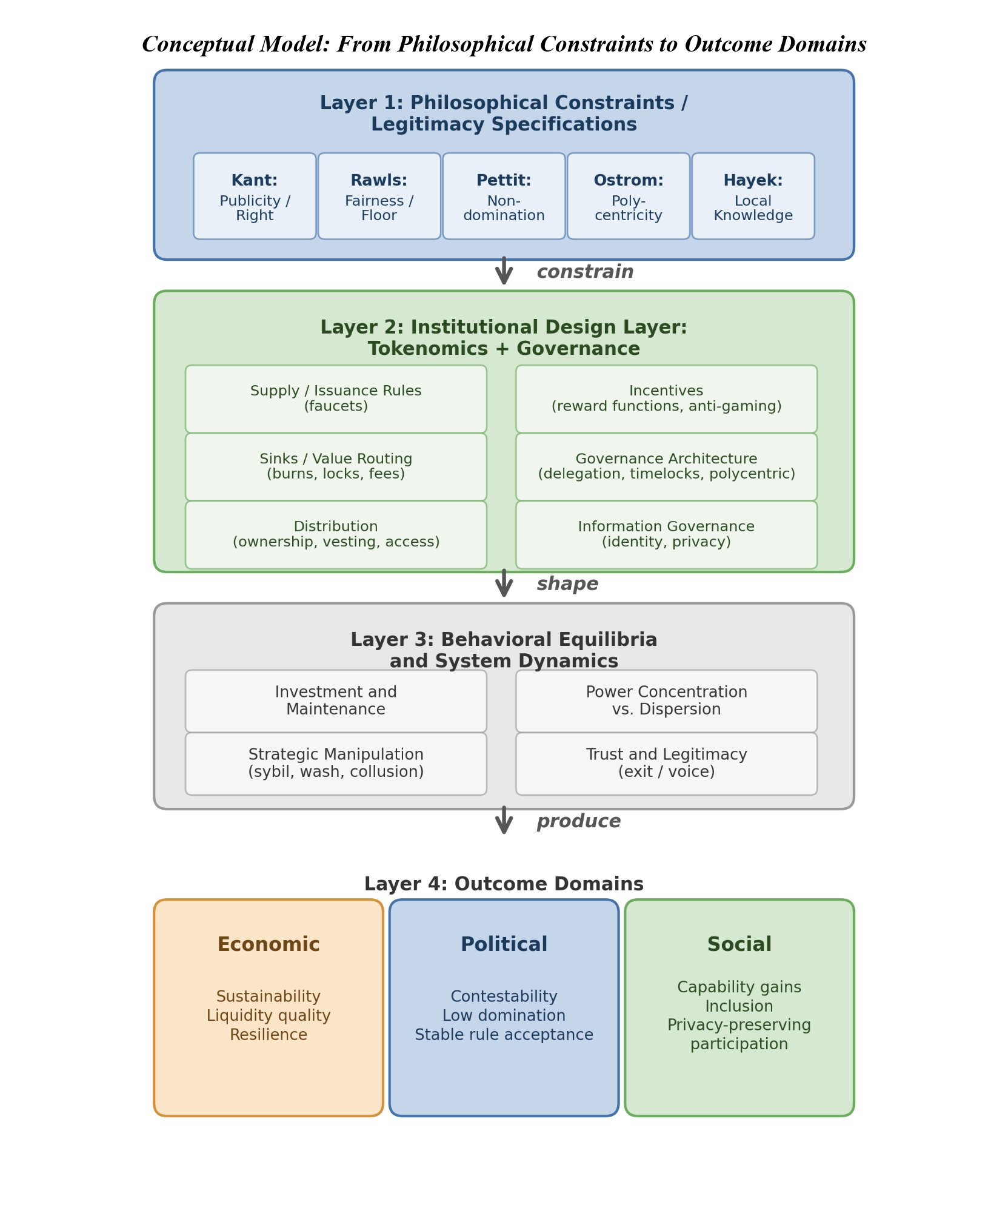
Figure 1. Conceptual model: from philosophical constraints through institutional design to outcomes. Philosophical traditions (Layer 1) constrain institutional design choices (Layer 2), which shape behavioral equilibria (Layer 3) and produce measurable outcomes across economic, political, and social domains (Layer 4). Reading the figure: the arrows trace the design pipeline from philosophical commitments through measurable outcomes; each lens in the rubric is a constraint on permissible designs at the corresponding stage.
The model’s purpose is explanatory and testable: it identifies where philosophical principles enter as constraints, how they shape design choices, and how those design choices influence outcomes through strategic behavior and system dynamics.

2.9.4 Design Hypotheses (Normative, Testable in Principle)
The theoretical framework yields five core design hypotheses linking political-philosophical legitimacy constraints to measurable institutional properties. This paper evaluates these hypotheses primarily using a governance concentration cross-section; hypotheses requiring operational demand, incentive dynamics, or participant outcome data are evaluated in future work or specified as future measurement priorities.
Hypothesis 1 (Publicity - Legitimacy Link)
Systems that satisfy a strong publicity constraint: transparent rules, published rationales, and procedurally explicit enforcement, exhibit fewer legitimacy crises and higher participation persistence than systems with opaque or discretionary policy.
Justification: Kant’s publicity principle suggests that political maxims requiring secrecy to succeed are illegitimate; in token systems, secrecy increases perceived arbitrariness and reduces willingness to invest in the future under rule uncertainty.
Hypothesis 2 (Contestability - Non-Domination)
Introducing contestability mechanisms: appeals with bounded resolution time, independent oversight, and publishable enforcement criteria, reduces domination risk and improves long-run operator/user retention, conditional on adequate measurement integrity.
Justification: Republican freedom as non-domination requires protection against arbitrary interference; appeals and oversight operationalize that requirement by constraining enforcement discretion.
Hypothesis 3 (Sinks Before Faucets)
Holding other factors constant, systems that deploy measurable sinks (burns/locks/fee routing) before large-scale emissions have higher fiscal sustainability (S2R) and reduced boom-bust amplitude than systems that rely primarily on emissions to bootstrap growth.
Justification: In repeated interaction settings, participants discount future rewards when dilution is unconstrained; sinks create credible coupling between real usage and token scarcity/treasury strength.
Hypothesis 4 (Service over Presence in DePIN)
In DePIN settings, shifting reward weight from “presence/coverage” to “SLA-verified service delivered” reduces oversupply and increases demand-weighted efficiency and resilience, relative to presence-mining regimes.
Justification: Presence-only incentives reward capital deployment irrespective of marginal social value; service incentives approximate payment for delivered public service capacity, aligning rewards with demand.
Hypothesis 5 (Polycentric Adaptation)
Polycentric governance structures (multiple centers with localized authority and budgets) improve adaptation to heterogeneous service environments (geography, range demand, local constraints) and reduce governance deadlock compared to monocentric governance.
Justification: Ostrom’s polycentric governance emphasizes multiple overlapping decision centers as an efficient response to complex systems.
The five hypotheses map to the five lenses of Table 1 as follows: Hypothesis 1 (Publicity-Legitimacy) operationalizes Kantian Publicity; Hypothesis 2 (Contestability-Non-Domination) operationalizes Pettit’s framework, with contestability as the institutional mechanism scored in Table 1 and non-domination as the philosophical goal-state the mechanism is designed to produce; Hypothesis 5 (Polycentric Adaptation) operationalizes Ostromian polycentricity. Hypotheses 3 (Sinks-before- Faucets) and 4 (Service-over-Presence in DePIN) extend the framework into the fiscal and incentive-design domain; they are anchored in mechanism-design and DePIN-specific economics rather than the political-philosophy traditions of Table 1, and their normative warrant derives from instrumental value (system sustainability and SLA-aligned coordination) rather than from the goal-states the philosophical lenses identify. The Synergy Index of Section 2.10.6 aggregates the five lens scores from Table 1; the five hypotheses provide complementary structured tests of philosophy-to-outcomes relationships that this paper specifies as future research priorities (longitudinal evidence required for H3 through H5; cross-sectional evidence for H1 and H2 presented in Section 3).

2.9.5 Implications for Cross-Program Relevance
Political theory programs can treat tokenomics as a novel constitutional domain: public rules with automatic enforcement and low-cost exit.
Economics/public policy programs can interpret tokenomics as fiscal and regulatory policy under open entry and adversarial manipulation, requiring mechanism design and institutional economics.
Computer science/security programs can frame tokenomics as incentive-aligned security and reliability engineering where verification systems (ℳ) are first-class determinants of institutional feasibility.
STS and law can analyze how “code as governance” transforms legitimacy, accountability, and liability structures, and how transparency and contestability affect social acceptance.

2.9.6 Inter-Lens Relationships: A Mutually Reinforcing Architecture
The five lenses operationalized in Table 1 are not orthogonal axes but a mutually reinforcing architecture. Publicity (Kant) enables contestability (Pettit): rules that can be publicly stated are rules that can be publicly challenged, while opacity protects arbitrariness from challenge (Cohen 1989 on deliberative democracy as the institutional extension of Kantian publicity; Habermas 1996 on discourse theory of law). Polycentricity (Ostrom) enables knowledge-use (Hayek): distributed institutions aggregate dispersed information that no central authority can possess, instantiating in institutional form what Hayek 1945 identifies as the epistemic case for decentralized coordination. Difference Principle (Rawls) constrains the outcomes contestation can legitimately produce: a contestable governance system that systematically disadvantages the worst-off fails the fairness lens even if it scores well on the contestability mechanism, indicating that procedural and distributive lenses must be evaluated jointly. Knowledge-use (Hayek) requires polycentric institutional substrate (Ostrom) to function: market-like price signals need multiple decision-centers to interpret and act on them; a monocentric system forecloses the institutional preconditions of dispersed coordination. Non-domination as the freedom-state Pettit identifies is itself underwritten by Kantian publicity (Pettit 1997 §4.3): the freedom to contest depends on the publicity of what is contested.
The Synergy Index defined in Section 2.10.6 aggregates the five lens scores by arithmetic mean, reflecting the equal-weight assumption that each dimension contributes complementarily to overall legitimacy. The mutually reinforcing structure of the five lenses motivates two alternative aggregations that future work may explore: a geometric mean (emphasizing weakest-link composition; aligned with the weakest-link arguments in companion papers on regulatory accountability in composed systems), or a network-structure scoring that explicitly weights the cross-lens dependencies described above. The arithmetic mean is reported as the headline aggregation in this paper for descriptive simplicity; the philosophical architecture itself recommends weakest-link emphasis for institutions whose legitimacy depends on the joint satisfaction of all five lenses.
Lens | 0 (Absent) | 1 (Minimal) | 2 (Partial) | 3 (Exemplary)
Kantian Publicity | No public governance docs | Rules exist but hard to find | Public rules + rationale | Public rules + deliberation + justification
Rawlsian Fairness | No floor-raising mechanism | Basic airdrop only | Graduated fee tiers or grants | Systematic equity mechanisms + measured gaps
Pettit Contestation | No appeals or checks | Informal complaints possible | Formal appeal mechanism exists | Independent arbitration + veto rights
Ostrom Polycentricity | Single decision center | Advisory subcommittees | Functional subDAOs with budgets | Nested governance with local autonomy
Hayek Knowledge-use | Fixed parameters | Admin-adjusted parameters | Automated price signals | Demand-coupled mechanisms + edge feedback
Table 1. Scoring rubric: philosophical lens evaluation (0 = absent, 3 = exemplary). Each lens has a two-layer structure: an operational mechanism (what we score in each protocol) and a philosophical goal (the normative warrant the tradition supplies). Kantian Publicity (operational: transparent rules with published rationales; goal: legitimacy through public reason; Kant 1795 Toward Perpetual Peace). Rawlsian Fairness (operational: floor-raising distributional mechanisms; goal: Difference Principle protection of the least advantaged; Rawls 1971 §13, 2001 §13). Pettit Contestation (operational: formal appeals and veto infrastructure; goal: non-domination as freedom from arbitrary power; Pettit 1997 Republicanism, building on Skinner 1998 Liberty before Liberalism). Ostrom Polycentricity (operational: nested decision-centers with local autonomy; goal: adaptive collective action across heterogeneous environments; Ostrom 1990 Governing the Commons; V. Ostrom, Tiebout, & Warren 1961). Hayek Knowledge-use (operational: demand-coupled signal mechanisms with edge feedback; goal: epistemic coordination through dispersed information; Hayek 1945 “The Use of Knowledge in Society”). The two-layer structure is made explicit in Table 2’s scoring column headers and applies symmetrically across all five lenses; the distinction prevents the common conflation of operational mechanism with philosophical goal-state (e.g., contestation as the institutional mechanism Pettit identifies for non-domination as the freedom-state).
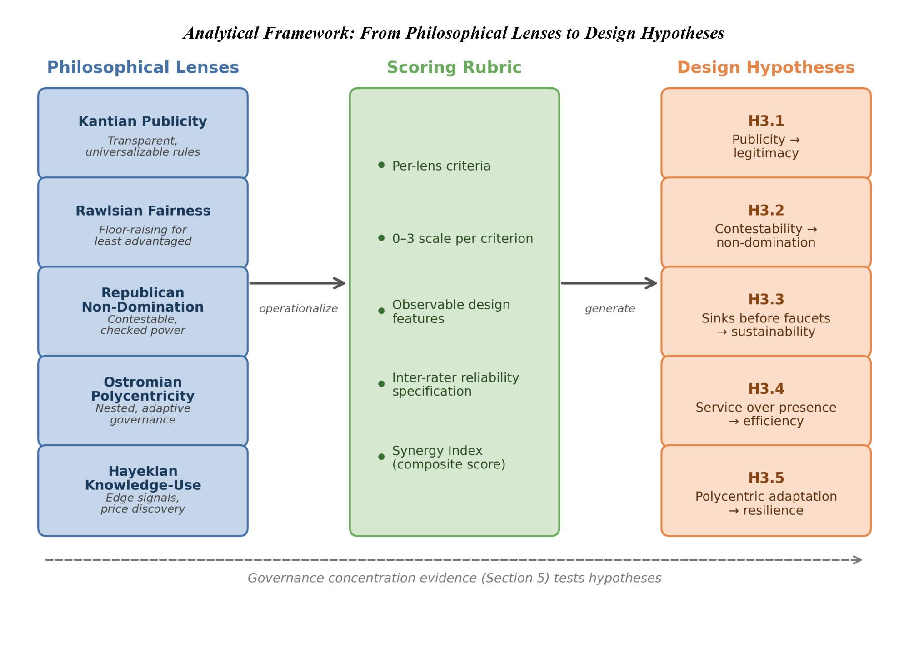
Figure 2. Normative framework architecture: five philosophical lenses are operationalized through a scoring rubric into five testable design hypotheses. Dashed arrow indicates the empirical feedback loop from governance concentration evidence (Section 3) and case evidence developed separately. Reading the figure: each axis represents a separate philosophical lens; protocols satisfying multiple lenses occupy upper-right regions, while concentration on a single lens leaves the others under-protected.

2.10 Framework Operationalization

2.10.1 Approach
The framework is operationalized through three components: (1) a structured dataset of protocol and DAO design variables; (2) a philosophy-to-design scoring rubric translating the five normative lenses into observable criteria; and (3) a governance concentration cross-section measuring token distribution across 40 protocols. This paper develops the framework and rubric, and presents the governance concentration cross-section as an empirical illustration. The full quantitative pipeline (regression, panel, and event-study analyses) and qualitative case evidence are specified for future work and developed in separate studies.
Each row of Table 1 carries a two-layer structure that Table 2 makes explicit. Layer 1 is the philosophical goal-state: legitimacy through public reason (Kant), distributive fairness (Rawls), non-domination (Pettit), adaptive collective action (Ostrom), and epistemic coordination through dispersed information (Hayek). Layer 2 is the operational mechanism scored in each protocol: transparent rules with published rationale (operationalizing publicity), floor-raising distribution mechanisms (operationalizing fairness), formal appeals and veto rights (operationalizing contestability, which is the institutional mechanism Pettit identifies for non-domination), nested decision-centers (operationalizing polycentricity), and demand-coupled signal mechanisms (operationalizing knowledge-use). The scoring rubric measures Layer 2 in each protocol; Layer 1 supplies the normative warrant for why Layer 2 matters. This two-layer structure prevents the common conflation of philosophical goal with institutional mechanism (for example, treating non-domination and contestation interchangeably, when Pettit explicitly distinguishes them: non-domination is the freedom-state; contestation is the mechanism by which legitimate governance produces it).

2.10.2 Units of Analysis and Sampling Strategy
Holder-list cutoff: the top-1,000 holder cutoff follows established convention in the token-governance concentration literature (Sai et al., 2021 use comparable cutoffs across blockchain governance studies). The cutoff captures the holder population materially relevant to governance decisions; long-tail holders below this threshold collectively hold less than five percent of supply across all sample protocols. Robustness across cutoffs is supported by the Top-1%, Top-5%, and Top-10% columns in Table 4: rank-ordering across protocols is preserved at all three cutoffs (Spearman rho > 0.95 between any two columns), indicating that absolute HHI values may shift modestly with deeper-tail inclusion but cross-protocol comparison remains robust to the cutoff choice. For protocols with fewer than 1,000 unique non-zero holders after exclusion (e.g., ZRO with N = 989), the actual holder count is reported; the 1,000-holder cutoff serves as a ceiling rather than a floor.
Primary unit: protocol-token system (including its governance institutions).
Secondary unit: governance episodes/events (emission changes, fee switches, unlocks, enforcement controversies, governance reforms).
Protocols were selected to maximize variation across three dimensions: sector (15 DeFi, 15 DePIN, 8 L1/L2 infrastructure, 2 failed or stagnated protocols included to avoid studying only survivors), maturity (2017-2024 launches), and governance model (token-weighted, delegate, futarchy). The expanded 40-protocol sample was constructed by adding protocols from the Dune Analytics ecosystem that met three criteria: (i) publicly traded governance token, (ii) holder data queryable via Dune or Helius DAS API, and (iii) at least 50 non-zero-balance holders after protocol-controlled address exclusion. MetaDAO is included as the sole futarchy-governance protocol in the sample. Solana-native tokens (META, DRIFT, GRASS, W) required a separate data collection pipeline (Helius DAS API) because the primary indexer undercounted holders by two orders of magnitude; details are in Supplementary File S6.
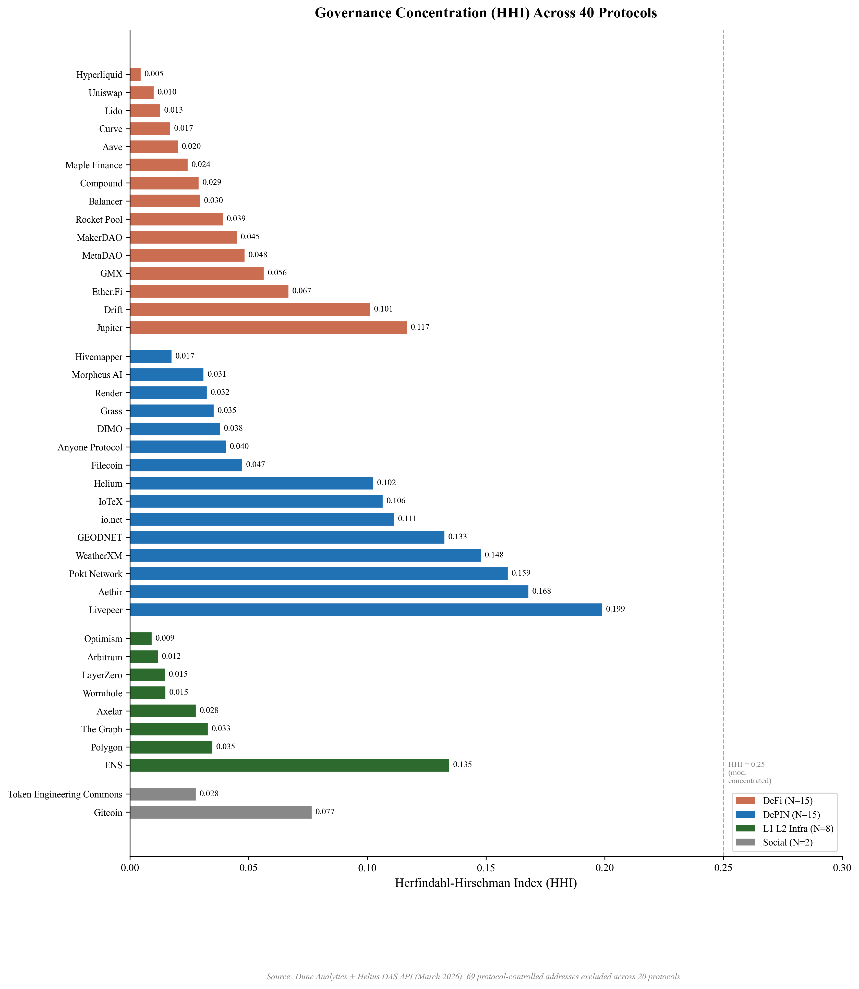
Figure 3. Holding-based Herfindahl-Hirschman Index (HHI) across 40 governance tokens (March 2026 snapshot, top-1,000 holders, protocol-controlled addresses excluded). Dashed lines indicate category means. Protocols sorted by category then HHI ascending. Reading the figure: bars show pre-exclusion HHI, with the post-exclusion (governance-relevant) HHI overlay; the gap between the two indicates how much of measured concentration was protocol-controlled rather than governance-relevant.
Inequality (Gini) is near-universal across all sectors (range 0.45 to 0.99), while concentration (HHI) varies by an order of magnitude (0.004 to 0.199 after excluding protocol-controlled addresses). Token wealth inequality is a structural feature of token systems, but governance concentration, how far power concentrates among few addresses, is design-sensitive. Governance structure is a constitutional choice, not an afterthought. Prior work applying the Gini coefficient to eight major cryptocurrencies found inequality levels comparable to real-world economies (Sai, Buckley, & Le Gear, 2021); because permissionless address creation produces millions of near-zero-balance wallets that inflate Gini toward 1.0 regardless of governance structure, the near-universal inequality this sample documents (Gini 0.52 to 0.99) is a measurement artifact of ledger architecture rather than a governance signal, reinforcing the case for HHI as the primary concentration metric.
The Anyone Protocol (HHI 0.040; Table 4) demonstrates that governance concentration is a design choice, not an inevitability of DePIN architecture. Five DePIN protocols (Render 0.032, Grass 0.035, DIMO 0.038, Anyone 0.040, Filecoin 0.047) achieve concentration levels at or below the DeFi median, indicating that low concentration is achievable in hardware-coordination protocols.
Sampling principles: include multiple categories (L1/L2, DeFi, infra/oracles, DePIN, social)
include “dead” or stagnated projects to reduce survivorship bias
stratify by chain and epoch to control for regime effects

2.10.3 Data Sources (Replicable, Multi-Disciplinary)
Four data streams inform the analysis: on-chain data (Dune Analytics, Helius DAS API), protocol documentation (whitepapers, governance forums, parameter docs), analytic aggregators (Token Terminal, DeFiLlama, CoinGecko), and public academic and policy sources. A systematic data coverage gap between DeFi and DePIN protocols (Token Terminal covers approximately 100% of DeFi but only 25% of DePIN) constrains cross-sector regression analysis. Full source provenance, exclusion methodology, the protocols Token Terminal does not cover, and the resulting partial-data subsets are documented in Supplementary File S6.
Snapshot date discipline for governance-power data: the Table 7 voting HHI values are computed from a March 2026 snapshot of Tally and Snapshot governance data, consistent with the March 2026 holder-list snapshot used for Table 4 holding HHI. Subsequent Tally and Snapshot API queries during the R2 revision cycle (May 2026) confirmed that voting-power distributions can drift materially over multi-month windows: a fresh Compound Tally pull in May 2026 returned roughly 120 delegates with non-zero voting power, compared with the 100-delegate sample available in March 2026. The Snapshot voter pool for Compound grew from 114 unique voters in March 2026 to 138 by May 2026 over a 12-month rolling window. The Table 7 values use March 2026 to maintain cross-table consistency; replication runs using fresh Tally and Snapshot data should expect comparable but not identical voting HHI values, and rank ordering across protocols is the more durable inferential property than absolute magnitude. Section 3.7 reports a PCA-symmetric voting-HHI sensitivity check using both March 2026 and May 2026 data.

2.10.4 Codebook and Rubric
Insider taxonomy: the analysis distinguishes two related but distinct constructs. Insider allocation (insider_pct) is the regression covariate measured at token generation event (TGE), defined as team_pct + investor_pct from primary tokenomics sources. Insider count fraction in top-10 holders is a descriptive mechanism variable measured post-distribution from holder snapshots, defined as the post-exclusion fraction of wallets in the top-10 classified as insider via a three-tier procedure: Tier 1 uses Blockscout verified-contract labels and Dune exchange tags; Tier 2 uses contract bytecode matching for SafeProxy, GnosisSafe, and vesting contracts; Tier 3 uses Etherscan named-address matching against documented foundation, treasury, and team wallets. Protocol-controlled addresses (PCAs) are excluded from holding HHI computation entirely at the top of the pipeline (69 addresses across 20 protocols documented in exclusions_log.csv) and are not counted as insiders for the purposes of the count fraction. Solana-native protocols carry an acknowledged labeling gap: io.net classifies as zero of ten insiders because Solana lacks Blockscout-style contract labels at the scale available on Ethereum and EVM L2s. This is a classification limitation rather than evidence of distributed governance and is flagged in the §4.8 limitations.
We code each protocol across standardized dimensions via a machine-readable table capturing metadata, supply and issuance rules, distribution, value routing and sinks, staking and lockup parameters, governance architecture, decentralization metrics, incentive windows, and data/identity posture, plus computed philosophy lens scores (0–3) and evidence links. Full field definitions and the codebook schema are documented in Supplementary File S1.

2.10.5 Philosophy Scoring Rubric: Translating Normative Theory into Observable Criteria
The scoring rubric is a second machine-readable table (Supplementary File S2) capturing lens_id, criterion_id, criterion definitions, a 0–3 scoring scale per criterion, and default weights; a third table (Supplementary File S3) stores protocol × criterion scores with evidence links, scorer initials, and dates. Each protocol is scored by gathering evidence (documentation, forum threads, code references), assigning 0–3 to each criterion, computing each lens score as a weighted mean, and aggregating into a Synergy Index across lenses with pre-specified weights.
Reliability is established by double-coding at least 10% of protocols to estimate inter-rater agreement (Cohen’s κ), with adjudication rules where κ is low; construct validity is established by comparing rubric scores to independent indicators including governance concentration, frequency of rule changes, and appeals outcomes. The operationalization is designed to be legible across disciplines, mapping political-philosophical criteria to measurable institutional features (appeals, publicity, concentration) and enabling empirical tests.
Table 2 demonstrates the rubric applied to three protocols spanning the DeFi–DePIN divide; full scoring sheets for all 12 scored protocols, with evidence links, are provided in Supplementary File S3. Scores are assigned by a single coder; inter-rater reliability testing with a second scorer is specified as future work.
Protocol | Publicity | Fairness | Non-Dom. | Polycentric | Knowledge | Key evidence note
Uniswap (DeFi) | 2 | 1 | 2 | 1 | 1 | Forum + Snapshot + on-chain vote; HHI 0.114; delegate concentration high
Hyperliquid (DeFi) | 2 | 1 | 1 | 0 | 2 | Zero VC + 31% airdrop; HHI 0.005; Assistance Fund auto-burns 97% of fees
Helium (DePIN) | 2 | 1 | 2 | 3 | 3 | Helium Improvement Proposal (HIP) process public; subDAO structure; HHI 0.102; HIP-147 reform
GEODNET (DePIN) | 2 | 1 | 1 | 1 | 2 | B2B subscription-burn (Real-Time Kinematic GPS service); HHI 0.132; Snapshot DAO; demand-coupled
Anyone (DePIN) | 1 | 1 | 1 | 1 | 1 | Low HHI (0.040); early-stage governance; limited formal process
Table 2. Illustrative rubric scores (0 = absent, 1 = minimal, 2 = partial, 3 = exemplary). Scores are by a single coder; full evidence sheets in Supplementary File S3. Columns: Publicity (Kantian; transparent rules with published rationales), Fairness (Rawlsian; floor protection in distribution), Non-Dom. (Pettit; formal contestability infrastructure protecting from arbitrary interference, scored independently of holding concentration), Polycentric (Ostrom; multiple overlapping decision centers), Knowledge (Hayek; reliance on dispersed local knowledge in operations).

2.10.6 Outcome Variables
Three primary metrics are used. The Herfindahl-Hirschman Index (HHI), ranging from 0 (dispersed) to 1 (monopoly), measures overall token concentration; values above 0.25 indicate high concentration by antitrust standards. Section 3.3 notes no protocol exceeds this threshold. The Gini coefficient captures distributional inequality. Top-N ratios (Top-1, Top-5, Top-10 share) complement HHI by identifying specific whale addresses.
The Synergy Index measures institutional design intent across normative traditions as the arithmetic mean of five lens scores, each in 0–3 range per Table 1. The lenses measure operational mechanisms: Kantian publicity (transparent rules), Rawlsian fairness (floor-protection mechanisms), Pettit contestability (formal appeals and veto infrastructure; the institutional mechanism Pettit identifies for the goal-state of non-domination), Ostromian polycentricity (nested decision-centers), and Hayekian knowledge-use (demand-coupled signal mechanisms). The arithmetic-mean aggregation gives equal weight across these five dimensions on the assumption that they are mutually reinforcing rather than substitutable (see Section 2.9.6 on inter-lens relationships); alternative aggregations are possible, with the geometric mean emphasizing the weakest dimension (a ‘weakest-link’ framing aligned with companion-paper composition arguments; Zukowski 2026c). Three additional dimensions from the literature review (capabilities, contextual integrity, cosmopolitan inclusion) are reserved for future evaluation due to non-comparable cross-protocol measurement; their omission is discussed in Section 4.8 limitations.
Full metric definitions, computation procedures, and Dune query specifications are provided in Supplementary File S1.

2.10.7 Testability and Empirical Pipeline
The five design hypotheses are testable in principle through cross-sectional governance analysis (this paper), longitudinal panel models, event studies around governance decisions, and qualitative process tracing. This paper reports the cross-sectional governance concentration analysis (Section 3). The full quantitative pipeline, including panel regressions, event-study specifications, and robustness protocols, is documented in supplementary material (Supplementary File S5) for replication and extension by future researchers.

2.10.8 Ethical and Practical Considerations
All data are drawn from public sources: on-chain transactions, published governance proposals, and open protocol documentation. No private or proprietary data are used. The scoring rubric relies on publicly observable design features. We compute governance token distribution data from Dune Analytics multi-chain queries. The author is employed by Borderless Capital, a cryptocurrency-focused investment firm, and may hold or have held positions in some protocols analyzed; a complete disclosure is provided in the Conflict of Interest statement accompanying this submission.

2.10.9 Worked Example: Optimism Protocol Scoring
To illustrate the rubric application from Section 2.10.5 and Table 1, we walk through Optimism’s per-lens scoring with the operational mechanism (Layer 2 per Section 2.10.1) on which each lens is scored and the published evidence supporting the assigned score. Optimism is chosen because its bicameral architecture (Token House plus Citizens’ House) exercises multiple lenses simultaneously and because the protocol publishes governance documentation at a level of detail that enables verifiable scoring.
Kantian Publicity (score: 3, Exemplary). Optimism publishes governance proposals on Snapshot and Tally with explicit rationales (Optimism Governance Forum; Optimism, 2024). The Citizens’ House process includes published deliberation periods, and Token House proposals require multi-stage review with public commentary periods. The published-rules-plus-deliberation-plus-justification criterion of Table 1 is satisfied: proposals are not merely visible but accompanied by rationale and stakeholder commentary.
Rawlsian Fairness (score: 3, Exemplary). Optimism’s Retroactive Public Goods Funding (RetroPGF) program explicitly compensates public-goods contributors who would not be captured by token-weighted governance alone; RetroPGF rounds are documented with measured distributional gaps relative to the broader holder base. Combined with the Citizens’ House (reputation-weighted, not token-weighted), Optimism operationalizes the floor-raising mechanism Table 1 specifies at the Exemplary tier (systematic equity mechanisms plus measured gaps).
Pettit Contestation (score: 3, Exemplary). The Citizens’ House exercises formal veto power over economic parameters proposed by the Token House, with dynamic veto thresholds that lower the trigger when multiple stakeholder groups align (Optimism, 2024). This is the precise Independent-arbitration-plus-veto-rights mechanism Table 1 specifies at the Exemplary tier. The two-layer-framing distinction is relevant here: the operational mechanism scored (contestability) is present at exemplary level; the philosophical goal-state Pettit identifies (non-domination) is a separate question that depends on the practical efficacy of veto exercise, which Section 3.5 documents as constrained by Token House delegation amplification (3.7x).
Ostrom Polycentricity (score: 3, Exemplary). The bicameral architecture (Token House plus Citizens’ House) plus the OP Working Group ecosystem instantiates nested governance with local autonomy at the Exemplary tier. Distinct decision-centers govern: protocol parameter changes (Token House), economic-parameter veto (Citizens’ House), public-goods funding (RetroPGF), and operational coordination across the Superchain.
Hayek Knowledge-use (score: 2, Partial). Optimism does not employ DePIN-style demand-coupled emission mechanisms; the OP token does not have demand-coupled signal aggregation that directly maps to Hayek’s knowledge-problem framing. However, sequencer-revenue split mechanisms and Superchain governance signals provide automated price-signal-like coordination. The criterion at the Partial tier (automated price signals) is satisfied; the Exemplary tier (demand-coupled mechanisms with edge feedback) is not because the OP token’s emission and value capture do not directly track end-user demand signals.
Synergy Index for Optimism: (3 + 3 + 3 + 3 + 2) / 5 = 2.8. Among the highest scores in the protocol sample. The framework correctly identifies Optimism as a protocol with strong philosophical-design investment across publicity, fairness, contestability, and polycentricity dimensions, while flagging the knowledge-use dimension as the weakest. The Synergy Index does not, however, capture the voting-power-concentration gap documented in Table 7: Optimism’s Token House delegation amplifies voting concentration 3.7x above the post-exclusion holding HHI baseline, raising the cross-lens question Section 4.1 surfaces about whether the institutional mechanisms scored in Table 1 actually produce the goal-states the philosophical traditions identify. The Citizens’ House provides a structural accountability layer that operates outside the token-weighted HHI measurement framework, partially addressing this gap; the empirical measurement of whether Citizens’ House veto exercises constrain Token House outcomes is future work (see Section 4.9).
The Optimism case illustrates how the framework’s two-layer structure operates in practice: Layer 2 scoring (operational mechanisms) reports high marks across four lenses; Layer 1 philosophical goal-state analysis (cross-lens implications of empirical concentration data) surfaces residual concerns about practical efficacy. The framework is designed to support both layers of analysis; the Synergy Index captures Layer 2 (institutional design intent); Section 3.5 plus Section 4.1 mapping captures Layer 1 (goal-state outcomes).

2.10.10 Generalizable PCA Exclusion Methodology
The protocol-controlled-address (PCA) exclusion methodology applied across Sections 3.2 through 3.5 generalizes beyond this paper’s specific protocol set. Any cross-protocol governance HHI analysis on ERC-20 or SPL token holders should apply the four PCA classes documented below before computing concentration metrics. The methodology contribution is not just the specific exclusions applied to this paper’s 40-protocol sample (Supplementary File S6 contains the address-by-address documentation), but the generalizable typology that future replication and extension work can apply uniformly.
Class 1: Burn-destination addresses. Canonical burn addresses (0x000…000 and 0x000…000dead on EVM chains; chain-specific patterns; protocol-specific burn destinations confirmed via official documentation, Blockscout/Etherscan labels, or Alchemy/Arkham labels) should be excluded from governance HHI computation. These addresses hold tokens that are inert by construction and cannot participate in governance under any condition; including them in the holding distribution inflates the holding denominator and understates effective concentration. The Uniswap 0x000…000dead exclusion (102.46M UNI, 11.27 percent of supply at measurement) is the canonical case in this paper; the Hyperliquid burn-pattern addresses (0x222…222 and 0xfefe…fefe) were caught by an earlier confirmed-pattern methodology. The universal burn-rule applied here is generalizable to any ERC-20 or SPL token governance analysis.
Class 2: Foundation and treasury custody. Protocol-controlled foundation and treasury custody addresses should be excluded. These addresses hold tokens that are governance-relevant in principle (the foundation may delegate or vote with them) but are structurally distinct from independent holder concentration: the foundation position represents institutional rather than community ownership. Specific cases in this paper: Optimism Foundation GnosisSafe (0x2a82ae142…; 32 percent of pre-exclusion top-1000 OP); Arbitrum FixedDelegateErc20Wallet (0xf3fc178157…; 30 percent of pre-exclusion top-1000 ARB); WeatherXM treasury (74.8 percent of pre-exclusion top-1000 WXM); DIMO Foundation (52.3 percent of pre-exclusion top-1000 DIMO). The methodology requires per-protocol identification typically via Blockscout verified-contract labels, GnosisSafeProxyFactory creation records, or foundation disclosures.
Class 3: Staking-aggregation contracts. Staking contracts that aggregate underlying staker holdings into a single custody address should be excluded from holding HHI computation, with the caveat that underlying stakers retain pass-through voting power. The stkAAVE staking contract (0x4da27a545c0c…; 21.9 percent of post-PCA-exclusion top-1000 AAVE) is the canonical case; AAVE stakers vote through stkAAVE rather than the contract itself making governance decisions. The sGMX RewardTracker plays an analogous role for GMX. The exclusion is methodologically warranted at the holding-HHI computation step because the contract is not an independent governance participant; the exclusion at the voting-HHI computation step (Section 3.7 PCA-symmetric robustness check) is methodologically distinct: stkAAVE votes as a single delegate per Tally’s data model, even though the underlying voters are dispersed. The paper treats the holding-side exclusion as canonical and reports the voting-side exclusion as a sensitivity check.
Class 4: Bridge custody and migration addresses. Bridge custody addresses (Wormhole token bridge for cross-chain wrapped tokens; the GRT BridgeEscrow for L1-to-Arbitrum custody; LayerZero canonical bridges) hold tokens in transit or as cross-chain accounting positions; these are not governance-participating holders. Migration contracts (the SYRUP Migrator for MPL-to-SYRUP migration; the Polygon StakeManagerProxy for MATIC-to-POL transition) hold tokens during migration windows and should be excluded.
Across the four classes, this paper excludes 69 PCA addresses across 20 protocols (Supplementary File S6). The generalizable methodological contribution: any future cross-protocol governance HHI analysis should apply the four-class PCA exclusion uniformly before reporting holding concentration metrics. The specific addresses depend on the protocol sample; the methodology is sample-independent.

3 Results

3.1 Scope and Claims Boundary
The cross-section covers 40 protocols across four sectors (DePIN, DeFi, infrastructure, social). Table 3 delimits the claims boundary: all findings are descriptive within the observed scope. All claims are descriptive within the observed scope. The governance data represent a March 2026 snapshot, not a time series. Causal claims about the relationship between institutional design and governance outcomes require the longitudinal evidence beyond the scope of this paper. All governance token distributions were queried from Dune Analytics multi-chain queries. Concentration metrics are point-in-time snapshots; trajectory analysis requires the longitudinal extension specified in the Future Research discussion (Section 2.10).
Claim | Evidence Grade | Pointer
Governance concentration is descriptively higher in DePIN than DeFi | Descriptive | Table 4
The scoring rubric translates philosophy into measurement | Methodological | Table 1 + Supplementary File S1
Five core design hypotheses follow from the normative framework | Theoretical | Section 4.1
Table 3. Claims boundary: what this paper does and does not claim.

3.2 Cross-Protocol Concentration
A measurement caveat: the 0.25 HHI antitrust threshold is borrowed from market-concentration analysis (DOJ Horizontal Merger Guidelines) and is reported here as a benchmark for descriptive interpretation only. A market-concentration threshold is not equivalent to a democratic-legitimacy threshold; a protocol may have HHI below 0.25 while remaining politically dominated through quorum rules, delegation patterns, or proposal-rights concentration. The HHI captures one dimension of concentration (post-exclusion holding distribution) and is not a sufficient condition for distributed governance.
Governance concentration spans two orders of magnitude across the 40-protocol sample (Table 4): HHI ranges from 0.005 (Hyperliquid) to 0.199 (Livepeer), with a median near 0.04. DePIN protocols cluster in the upper half of this distribution. Livepeer is the clearest structural outlier; excluding it leaves a distribution in which DePIN still exhibits higher concentration than DeFi but without a dominant leverage point.
Concentration metrics are computed from Dune Analytics multi-chain queries and the Helius DAS API for Solana SPL tokens (March 2026 snapshot, top-1000 holders per protocol), after excluding 69 protocol-controlled addresses across 20 protocols (staking contracts, exchange custodians, vesting locks, protocol treasuries; see Supplementary File S6). Solana-native tokens use getTokenAccounts with page-based pagination to correct systematic undercounting in Dune’s indexed tables. Replication scripts and input CSVs are listed in Supplementary File S5.
Three additional DePIN protocols were added to improve statistical power for the subsidy analysis: Aethir (ATH, Ethereum, GPU compute, $156M annualized revenue (Token Terminal, April 2026)), Hivemapper (HONEY, Solana, mapping), and io.net (IO, Solana, GPU compute, $21M revenue). Governance concentration was computed using the same methodology (Dune for ERC-20 tokens, Helius for Solana SPL tokens, top-1000 holders, exchange-labeled and protocol-controlled addresses excluded).
Protocol | Token | Category | HHI | Gini | Top-1% | Top-10% | N
Hivemapper | HONEY | DePIN | 0.017 | 0.92 | 6.7% | 33.7% | 1000
Morpheus AI | MOR | DePIN | 0.0310 | 0.88 | 11.4% | 43.3% | 994
Render | RENDER | DePIN | 0.0323 | 0.89 | 10.4% | 47.0% | 1000
Grass | GRASS | DePIN | 0.0352 | 0.76 | 16.0% | 38.2% | 1000
DIMO | DIMO | DePIN | 0.0379 | 0.87 | 13.9% | 45.0% | 999
Anyone Protocol | ANYONE | DePIN | 0.0404 | 0.79 | 13.3% | 47.5% | 1000
Filecoin | FIL | DePIN | 0.0473 | 0.79 | 18.0% | 45.6% | 1000
Helium | HNT | DePIN | 0.1024 | 0.98 | 24.5% | 79.4% | 1000
IoTeX | IOTX | DePIN | 0.1065 | 0.99 | 19.8% | 90.6% | 1000
io.net | IO | DePIN | 0.111 | 0.95 | 30.0% | 63.7% | 1000
GEODNET | GEOD | DePIN | 0.1325 | 0.96 | 24.9% | 81.8% | 1000
WeatherXM | WXM | DePIN | 0.1479 | 0.89 | 35.0% | 77.9% | 999
Pokt Network | POKT | DePIN | 0.1592 | 0.96 | 34.8% | 77.2% | 1000
Aethir | ATH | DePIN | 0.153 | 0.98 | 33.6% | 83.8% | 1000
Livepeer | LPT | DePIN | 0.1989 | 0.94 | 42.9% | 73.7% | 998
Hyperliquid | HYPE | DeFi | 0.0045 | 0.73 | 2.2% | 14.5% | 1886
Lido | LDO | DeFi | 0.013 | 0.52 | 7.9% | 27.7% | 189
Maple Finance | MPL_SYRUP | DeFi | 0.0242 | 0.88 | 8.5% | 40.6% | 998
Compound | COMP | DeFi | 0.0275 | 0.86 | 14.1% | 32.4% | 1000
Balancer | BAL | DeFi | 0.0295 | 0.88 | 12.4% | 38.0% | 990
Rocket Pool | RPL | DeFi | 0.0391 | 0.87 | 11.5% | 52.7% | 999
MakerDAO | MKR | DeFi | 0.0450 | 0.90 | 11.4% | 56.2% | 1000
MetaDAO † | META | DeFi | 0.0482 | 0.90 | 19.6% | 41.4% | 1000
GMX | GMX | DeFi | 0.0564 | 0.93 | 17.5% | 60.2% | 999
Aave | AAVE | DeFi | 0.020 | 0.88 | 7.5% | 34.9% | 1000
Ether.Fi | ETHFI | DeFi | 0.0668 | 0.95 | 19.0% | 59.9% | 1000
Uniswap | UNI | DeFi | 0.010 | 0.89 | 4.2% | 22.9% | 1000
Drift | DRIFT | DeFi | 0.1011 | 0.94 | 27.0% | 61.7% | 1000
Jupiter | JUP | DeFi | 0.1166 | 0.98 | 25.1% | 75.0% | 1000
Curve | CRV | DeFi | 0.017 | 0.89 | 6.7% | 34.4% | 1000
Axelar | AXL | L1/L2/Infra | 0.0277 | 0.85 | 9.2% | 42.7% | 994
LayerZero | ZRO | L1/L2/Infra | 0.0147 | 0.89 | 4.1% | 30.5% | 989
Wormhole | W | L1/L2/Infra | 0.0149 | 0.87 | 7.0% | 23.8% | 1000
Polygon | POL | L1/L2/Infra | 0.0348 | 0.92 | 12.1% | 49.5% | 998
Arbitrum | ARB | L1/L2/Infra | 0.012 | 0.83 | 8.6% | 22.4% | 1000
The Graph | GRT | L1/L2/Infra | 0.033 | 0.92 | 13.1% | 40.2% | 1000
Optimism | OP | L1/L2/Infra | 0.009 | 0.89 | 12.1% | 29.6% | 1000
ENS | ENS | L1/L2/Infra | 0.1345 | 0.94 | 26.7% | 75.5% | 999
Token Engineering Commons ‡ | TEC | Social | 0.0278 | 0.91 | 9.2% | 44.2% | 742
Gitcoin ‡ | GTC | Social | 0.0766 | 0.94 | 17.6% | 64.3% | 1000
Table 4. Governance concentration cross-section (March 2026 snapshot, Dune Analytics + Helius DAS API, top-1,000 holders per token, 69 protocol-controlled addresses excluded across 20 protocols). Sorted by category then HHI ascending. Balancer and Curve use vote-escrowed governance mechanisms (veBAL, veCRV). Reported HHI values measure raw token holding concentration, not voting power. Vote-escrowed concentration is expected to be higher due to lock-duration multipliers, analogous to the stkAAVE caveat noted above. Hyperliquid is included in Table 4 but excluded from the subsidy regression because the protocol has no token emissions; 97% of trading fees are routed to an Assistance Fund that purchases and permanently burns HYPE tokens, treated as a sink mechanism in the framework. Hivemapper (HONEY), io.net (IO), and Aethir (ATH) appear as full Table 4 rows above following supplementary holder-list collection in the R2 cycle: Hivemapper and io.net via Helius DAS API (90,680 HONEY holders; 84,861 IO holders); Aethir via Dune erc20_ethereum.evt_transfer net-balance aggregation (1,000 holders pulled). All three were footnote-only in the R1 submission because the original Dune holder-list extraction did not include them. The Aethir HHI (0.153) reported here reflects the May 2026 Dune pull and is slightly below the R1 footnote value of 0.168 (March 2026 cascade snapshot); the 2-month snapshot drift is consistent with the Tally and Snapshot drift documented in Section 2.10.3.
Table 4 notes:
† = futarchy governance (MetaDAO).
‡ (in protocol name column) = survivorship-bias control (TEC, Gitcoin).
Methodology notes: HHI for Curve reflects raw CRV holdings; veCRV-weighted voting concentration is approximately 0.26 computed from cumulative CRV deposit volume across the top-50 historical veCRV lockers (Convex 48%, Yearn 14%, Stake DAO 9%, with the remaining top-50 lockers each at less than 4%); the methodology is discussed in Section 4.1. HHI for Uniswap reflects post-burn-rule exclusion of 0x000...dead (102.46M UNI, 11.27% of supply). Top-1% and Top-10% columns for AAVE, UNI, ARB, GRT, and OP report post-exclusion shares, applying the same protocol-controlled-address exclusion methodology used for HHI computation.
HHI ranges from 0.005 to 0.199 across the full sample. Among DeFi governance tokens, HHI ranges from 0.005 (Hyperliquid, after excluding the Assistance Fund and burn addresses) to 0.117 (Jupiter). Curve’s raw CRV holding HHI of 0.017 reflects the post-Convex-exclusion distribution; the veCRV-weighted voting concentration is substantially higher (approximately 0.26 computed from cumulative deposit volume across the top-50 veCRV lockers; Section 4.1), and is discussed in Section 4.1. DePIN protocols span a similar range: 0.017 (Hivemapper) to 0.199 (Livepeer); Morpheus AI registers 0.031 after excluding four protocol-controlled addresses.
Several protocols previously appearing highly concentrated show moderate concentration once measurement artifacts are removed. After correcting for holder-list truncation (Solana tokens) and protocol-controlled address contamination (19 protocols), the DePIN-DeFi concentration gap narrows substantially: DRIFT (0.419 uncorrected to 0.101 corrected, reflecting Helius enumeration of 27,888 holders versus 104 from Dune), W (0.126 to 0.015), and GRASS (0.132 to 0.035). The exclusion methodology (Supplementary File S6) is particularly consequential for protocols with large foundation treasuries or exchange custodian addresses in the top-10 holders.
Several protocols demonstrate that low governance concentration is achievable across sectors. Hyperliquid (HHI 0.005), Uniswap (0.010), and Lido (0.013) in DeFi; Optimism (0.009), Arbitrum (0.012), LayerZero (0.015), and Wormhole (0.015) in L1/L2 infrastructure; and Hivemapper (0.017) in DePIN all achieve HHI below 0.02. These counterexamples indicate that low governance concentration is achievable across multiple sectors, constraining explanations that treat high concentration as structurally inevitable in any single sector. The fourth sector, social token protocols, is too small in the sample (N = 2) to support independent sector-level claims.
Three measurement choices affect these results and merit attention as scope conditions. First, Top-N cutoffs at 1,000 holders may undercount long-tail holders; increasing the cutoff to 10,000 addresses would change absolute HHI values but is unlikely to change the rank ordering. Second, the snapshot methodology captures a single point in time; several protocols (notably DIMO) have announced token distribution programs that may reduce concentration over subsequent months. Third, the analysis uses raw token holdings; for protocols with delegation (Compound, Uniswap), delegated voting power may differ from raw holdings. We use delegated power where available, but not all protocols instrument delegation.

3.3 DePIN vs. DeFi Contrast
DePIN protocols have roughly twice the governance concentration of DeFi protocols (mean HHI 0.091 vs. 0.041; Mann-Whitney p = 0.014, Cohen’s d = 1.03, N = 15/15). The gap holds after adjusting for protocol age, valuation, and insider allocation (Table 6, Models 1-3). Prior review work documents that DePIN sectors vary in tokenomic architecture (Alshater, 2026): storage networks prioritize staking, wireless coverage emphasizes service verification, compute networks focus on billing. The concentration gap between DePIN and DeFi is not implied by this sectoral variation; it is a separate finding about who holds governance tokens.
The sector difference is robust to sample composition: the Mann-Whitney result holds across all 30 leave-one-out (LOO) iterations, and a permutation test yields p = 0.009. One candidate mechanism: in capital-intensive networks, scale economies produce concentrated market shares (Arnosti & Weinberg, 2022). Fleet operators deploying hundreds of devices achieve lower per-unit costs than solo participants, consistent with the concentration gap observed here.
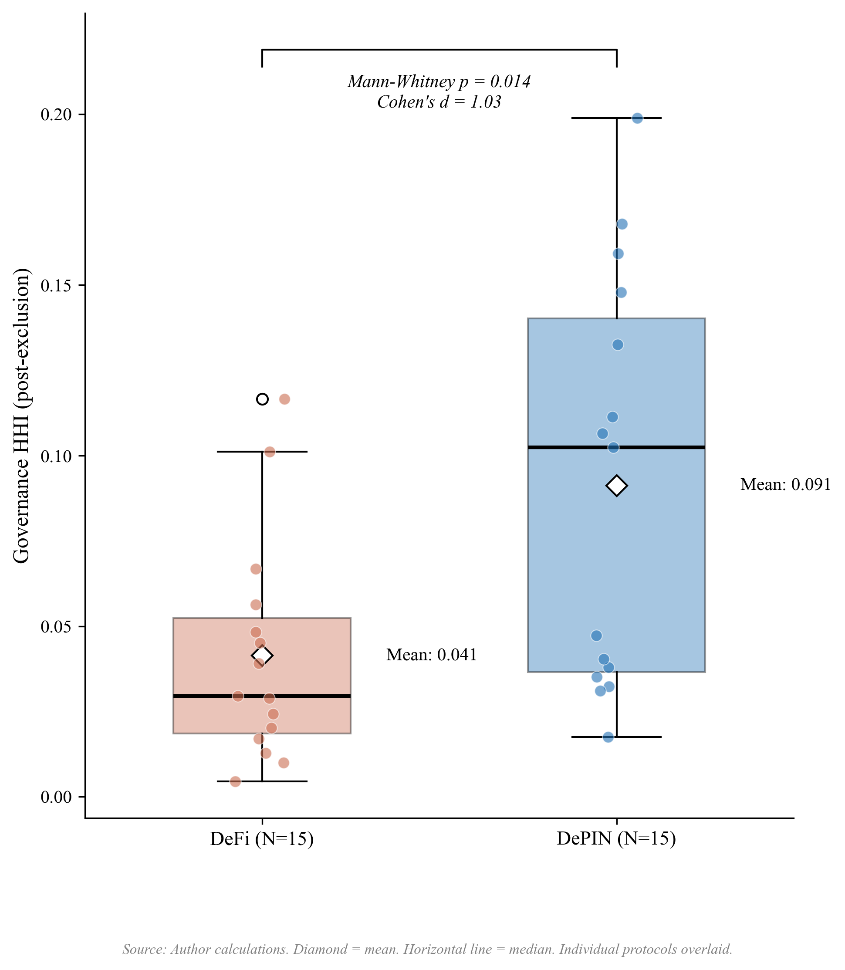
Figure 4. Governance concentration (HHI) by sector. DePIN mean (0.091) exceeds DeFi mean (0.041), with distributions overlapping substantially: 8 of 15 DePIN protocols fall within the DeFi range. The Mann-Whitney test (p = 0.014, d = 1.03) is robust to sample composition (significant in all 30 leave-one-out iterations). Reading the figure: box plots show the concentration distribution within each sector; the DePIN-DeFi gap is visible in median position despite overlap in tails.
DePIN governance concentration is also significantly higher than L1/L2 infrastructure protocols (mean HHI 0.035, N=8): Welch t-test p = 0.016, Cohen’s d = 1.09; Mann-Whitney p = 0.005. This divergence is driven by post-exclusion infrastructure HHIs: ARB (0.012), OP (0.009), and GRT (0.033) show distributed holdings once foundation and bridge addresses are excluded.
Revenue dynamics reinforce this structural contrast: during 2025’s market downturn, Helium’s onchain revenue grew over 800% while leading DeFi protocol fees declined 27-70% over the same period (Bane & Gala, 2026), suggesting that physical infrastructure revenue streams exhibit countercyclical properties absent in purely financial protocols.
This concentration gap is not explained by protocol maturity: Compound (2018 launch, HHI 0.027) and MakerDAO (2017, HHI 0.045) are older than DIMO (2022, HHI 0.038) and WeatherXM (2024, HHI 0.148), yet maintain far lower concentration. One candidate explanation is distribution design (Table 4): DePIN token allocations frequently reserve large shares for founding teams and early investors, while DeFi protocols have had longer periods of community distribution through liquidity mining, delegation, and governance participation incentives. However, the regression analysis below finds no significant correlation between insider allocation share and HHI (Section 3.4), suggesting that the distribution design channel operates through qualitative mechanisms not captured by the allocation percentage alone. The Anyone Protocol counterexample supports this interpretation: its low concentration (HHI 0.040) is consistent with governance mechanism choices (delegation incentives, activity-based caps, distribution schedule structure) that most DePIN protocols have not adopted.
This governance mechanism interpretation aligns with practitioner evidence from points-based token distribution programs (Sawinyh, 2025). Mature DeFi protocols distributed tokens through multi-season liquidity mining programs, safety module staking, and delegation incentives that implement sub-linear scaling (diminishing returns per marginal dollar deposited), activity-based caps, and time-weighted multipliers; these mechanisms structurally compress holding concentration over years. DePIN protocols that allocated tokens through conventional venture rounds, reserving 30 to 50 percent for founding teams and early investors with cliff-based vesting, bypassed these distribution-broadening mechanisms entirely. The governance concentration patterns in Table 4 may reflect distribution mechanism design operating through the sector channel: Table 6 shows DePIN membership predicts concentration at p < 0.05 after adjusting for protocol age, valuation, and insider allocation. However, the regression null on insider allocation (Section 3.4) cautions against treating initial token allocation as a complete measure of distribution design: compression mechanisms (sub-linear scaling, activity-based caps, delegation incentives) operate through ongoing protocol governance, not through the initial percentage split alone.

3.4 Allocation Design and Post-Distribution Dynamics
Methodological note on AAVE: the stkAAVE staking contract is excluded from the holding Herfindahl-Hirschman Index per the protocol-controlled-address rule, but stakers retain pass-through voting power. The reported AAVE holding HHI of 0.020 therefore understates effective governance concentration; reconstructing the staker distribution would require parsing all stkAAVE deposit events, which is deferred to follow-up work. The companion Tally-sourced AAVE delegation HHI of 0.076 in Table 7 partially closes this gap by capturing concentration in delegated voting rather than raw token holdings.
Initial token allocation design does not predict governance concentration. The percentage of total supply allocated to team and investors at launch shows no significant association with post-distribution HHI (Pearson r = 0.18, p = 0.28, N = 37; Spearman rho = 0.07, p = 0.69). This null persists across alternative specifications: token unlock progress, float-adjusted concentration, and the interaction of allocation with protocol maturity all produce coefficients indistinguishable from zero (Table 6, Models 1 through 3; Table 5 summarizes the bivariate battery). Statistically Validated Network analysis across DeFi protocols documents that governance concentration shifts dynamically in correlation with total value locked and secondary market valuations (Eisermann et al., 2025), consistent with the post-distribution market dynamics that render initial allocation design uninformative in the cross-section.
Covariate | Test | Statistic | p | N | Status
Insider allocation (%) | Pearson r | 0.19 | 0.25 | 37 | Null
Team allocation (%) | Pearson r | 0.20 | 0.224 | 37 | Null
Investor allocation (%) | Pearson r | 0.09 | 0.596 | 37 | Null
Protocol maturity (years) | Pearson r | 0.01 | 0.957 | 40 | Null
Circ/total supply ratio | Pearson r | 0.03 | 0.86 | 31 | Null
MCap/FDV ratio | Pearson r | 0.01 | 0.96 | 30 | Null
Exclusion-adjusted float | Pearson r | −0.003 | 0.99 | 30 | Null
Insider count fraction (top-10) | Spearman ρ | 0.44 | 0.005 | 39 | Significant*
Non-insider HHI, V1 (count) | Spearman ρ | 0.54 | 0.001 | 34 | Tautology-checked
Non-insider HHI, V2 (balance) | Spearman ρ | 0.33 | 0.060 | 34 | Does not survive
Subsidy ratio (cross-sector) | Pearson r | 0.57 | 0.008 | 20 | Fragile (LPT-driven)
Subsidy ratio (TT expanded) | Pearson r | 0.10 | 0.674 | 19 | Null (robustness check)
Subsidy ratio (excl. Livepeer) | Pearson r | 0.12 | 0.633 | 19 | Null
DePIN sector (dummy) | Mann-Whitney | U=172 | 0.014 | 30 | Robust (30/30 LOO)
HHI-Gini | Pearson r | 0.51 | <0.001 | 40 | Significant
Table 5. Bivariate associations between protocol characteristics and governance concentration (HHI). Allocation, maturity, and float specifications are null. Insider wallet presence is significant but the balance-based measure does not survive a tautology check (Section 3.4). Subsidy is significant in levels but driven entirely by Livepeer (Section 3.7). * LOO-robust (39/39). MCap = market capitalization; FDV = fully diluted valuation.
To understand why allocation is uninformative, we classify each protocol’s top-10 post-exclusion holders using a three-tier methodology: Tier 1 identifies addresses via Blockscout labels and Dune exchange tags; Tier 2 inspects contract bytecode (SafeProxy, GnosisSafe, vesting contracts) via Blockscout’s implementation field; Tier 3 applies Etherscan named-address matching. Of 390 addresses classified across 39 tokens, 119 (30.5%) are identifiable as insider wallets (team, foundation, or investor multisigs), 67 (17.2%) are exchange addresses, 78 (20.0%) are protocol contracts, and 126 (32.3%) remain unclassified. The 78 protocol contracts identified here differ from the 69 protocol-controlled addresses excluded from HHI computation. The 78 figure counts protocol-contract addresses across the top-10 holders of 39 tokens. The 69 figure counts excluded addresses across the top-1,000 holders of the 20 protocols where exclusions materially changed HHI. The samples and windows differ; the two numbers are not interchangeable.
Protocols whose insider wallets retain top-holder positions tend to exhibit higher governance concentration (Spearman rho = 0.48, p = 0.003, N = 37), robust across all 37 leave-one-out iterations (rho range: 0.45 to 0.55). However, this association has a mechanical component: insider wallets with large balances contribute directly to HHI through the squared-share calculation. To verify that the relationship is not a tautological artifact, we recomputed concentration after excluding insider addresses and renormalizing remaining shares. The count-based measure survives: non-insider HHI remains significantly correlated with the fraction of top-10 holders that are insiders (Spearman rho = 0.54, p = 0.001, N = 34), indicating that insider-heavy protocols have concentrated governance ecosystems, not merely concentrated insider positions. The balance-based measure loses significance (rho = 0.33, p = 0.060), consistent with it capturing the mechanical contribution of large insider stakes rather than a structural relationship. The informative finding is not the insider correlation per se but its contrast with allocation design: what matters is not how tokens were designed to be distributed, but whether the recipients retained or sold their positions.
The divergence between allocation design (null) and current insider presence (descriptive mechanism) carries a design implication. Governance concentration is not determined at launch; it emerges from post-distribution dynamics. The allocation null (Section 3.4) is also consistent with Michels’ (1911) observation that organizational complexity inevitably concentrates power in a specialized leadership class: early protocols’ commitment to governance minimization, the assumption that minimal on-chain rules would produce emergent decentralization is inconsistent with the concentration patterns the ideology sought to prevent. Protocols whose insiders retain their positions exhibit more concentrated governance outcomes, regardless of how generously the initial allocation was designed. The count-based tautology check (rho = 0.54 on non-insider HHI) suggests this is not merely arithmetic: insider-heavy protocols attract or retain concentrated non-insider holders as well, consistent with a pattern where concentrated insider presence attracts or coexists with concentrated non-insider holders, rather than insider balances alone inflating the metric.
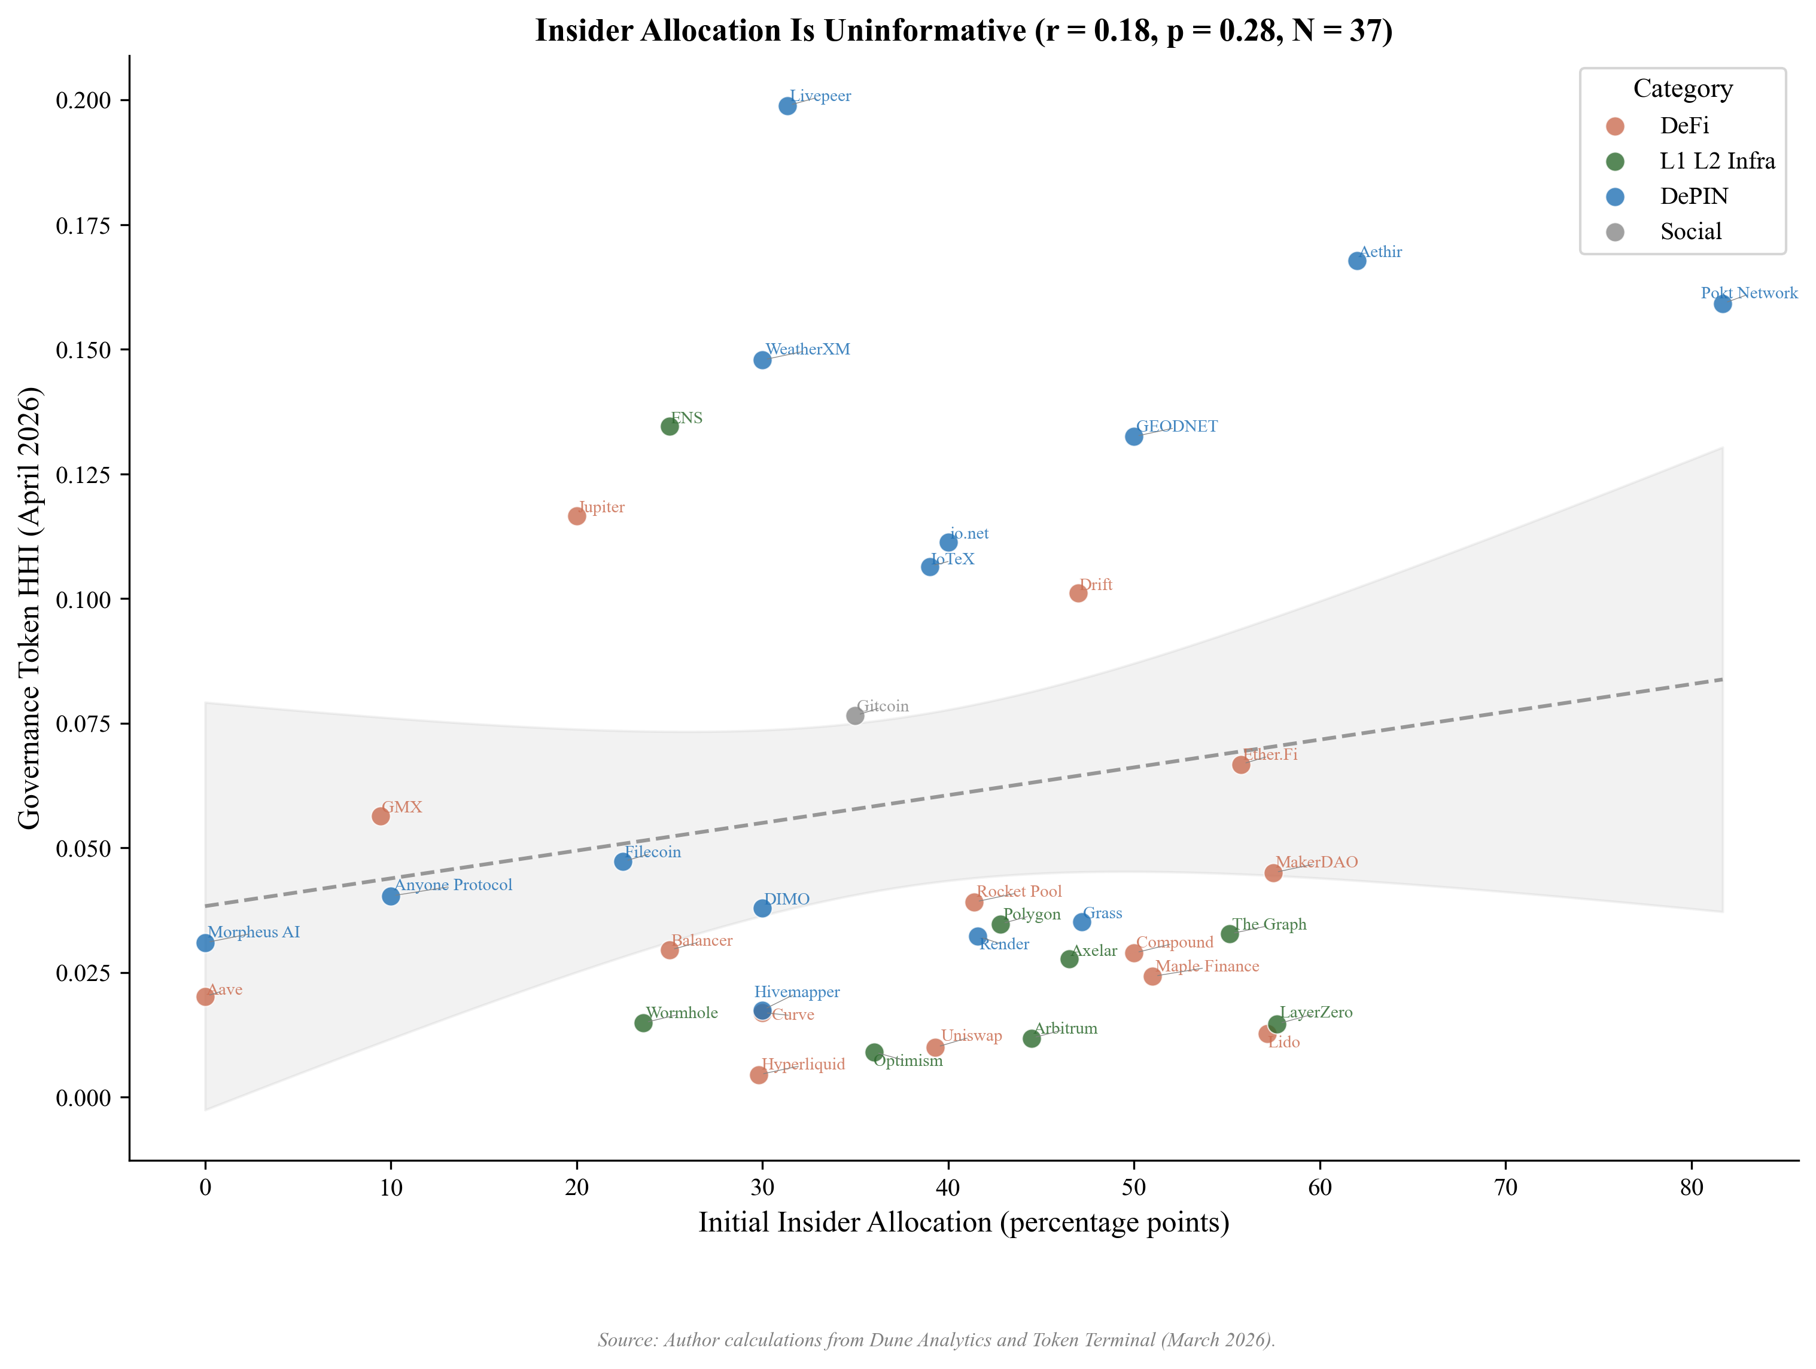
Figure 5. Insider allocation (%) vs. corrected holding HHI for 37 regression-ready protocols. The null relationship (r = 0.18, p = 0.28) is the paper’s lead finding: initial allocation design does not predict post-distribution governance concentration. Reading the figure: the absence of a downward slope is the finding; if insider allocation drove concentration we would expect a positive slope, and if exclusion overcorrected we would expect a negative slope.
Hyperliquid provides the strongest available test of the allocation design hypothesis. The protocol accepted zero venture capital, distributed 31% of total supply via a single community airdrop (the largest in crypto history by dollar value), and operates a deflationary model where 97% of trading fees purchase and burn the native token; it has no ongoing emissions. Five protocol-controlled addresses were excluded from the HHI computation: the Assistance Fund system address (confirmed in Hyperliquid documentation), the burn address, the community rewards treasury (241 million tokens, matching the published allocation), the Foundation treasury (60 million tokens, exactly 6% of total supply), and the staking manager contract (confirmed via Hypurrscan). The resulting HHI of 0.005 is the lowest in the DeFi subsample (Uniswap at 0.010 is the second-lowest after the universal burn-rule exclusion, and Lido at 0.013 the third-lowest). Despite the most community-favorable distribution architecture in the sample, this single observation cannot establish a causal claim on its own. The cross-sectional null (Pearson r = 0.18, p = 0.28, N = 37) shows that protocols across the full range of allocation designs achieve comparable concentration levels, consistent with the finding that allocation design does not predict post-distribution concentration.
The governance concentration patterns documented across the sample (Section 3.2, Table 4; HHI range 0.004 to 0.199) have normative significance beyond descriptive interest. The theoretical framework (Section 2.9) argues that governance concentration affects legitimacy through multiple channels: publicity (Hypothesis 1) is undermined when a dominant holder can shape governance agendas without meaningful deliberation; the Rawlsian fairness lens similarly flags these protocols: token distribution reflecting initial venture allocation rather than contribution compromises the conditions for fair institutional design. Contestability and non-domination (Hypothesis 2) are directly threatened when minority stakeholders lack practical ability to contest decisions.
The normative framework interprets this DePIN concentration gap as a legitimacy concern: if governance tokens are concentrated, the conditions that the five traditions identify as essential for legitimacy are structurally harder to satisfy. This interpretation is normative, not causal; the concentration data are descriptive, and the legitimacy inference follows from the framework rather than from direct observation of governance quality. Testing that prediction requires the longitudinal evidence beyond the scope of this paper.
The null pattern extends beyond allocation to financial sustainability more broadly. Three protocols with nearly identical subsidy ratios (DIMO at 0.33x, Aethir at 0.36x, Aave at 0.37x) exhibit governance HHI values of 0.038, 0.153, and 0.020 respectively. All three are revenue-dominant; their concentration spans the full range of the 40-protocol sample. Financial sustainability is neither necessary nor sufficient for governance decentralization.
Table 6 reports multivariate OLS regressions of HHI on protocol characteristics. The DePIN coefficient is positive and statistically significant in Models 1 and 2 (Model 1: 0.048, p = 0.012, N = 38; Model 2: 0.050, p = 0.027, N = 36) and borderline significant in Model 3 (0.048, p = 0.050, N = 35). No other covariate achieves p < 0.10. In particular, the initial insider allocation percentage used as a Table 6 covariate is not significant, consistent with the bivariate null in Table 5. This is distinct from the current insider-retention measure reported in Section 3.4 (Spearman rho = 0.48), which counts how many of a protocol's top-10 holders are insiders rather than measuring the share of supply allocated to insiders at launch. The adjusted R-squared ranges from 0.14 to 0.17, indicating that sector membership accounts for more cross-sectional variation than protocol age, valuation, or allocation structure. The sample (N = 35 to 38 depending on specification) remains too small to reliably isolate independent effects; the pipeline specification (Supplementary File S5) documents the infrastructure for replication at larger sample sizes.
 | Model 1 | Model 2 | Model 3
DePIN (vs DeFi) | 0.048** | 0.050** | 0.048*
 | (0.019) | (0.023) | (0.025)
L1/L2/Infra (vs DeFi) | -0.011 | -0.010 | -0.014
 | (0.019) | (0.022) | (0.025)
Social (vs DeFi) | 0.034 | 0.029 | 0.029
 | (0.063) | (0.075) | (0.095)
Protocol age (years) |  | 0.000 | -0.001
 |  | (0.005) | (0.005)
Log FDV |  | -0.001 | -0.002
 |  | (0.004) | (0.004)
Initial insider allocation (%) |  |  | 0.001
 |  |  | (0.001)
Constant | 0.042*** | 0.069 | 0.053
 | (0.009) | (0.090) | (0.093)
N | 38 | 36 | 35
Adjusted R² | 0.167 | 0.140 | 0.145
Table 6. OLS regression of HHI on protocol characteristics. Model 1 includes sector dummies only (DePIN, L1/L2/Infra, Social; DeFi omitted). Model 2 adds protocol age (years since token genesis) and log FDV (log fully diluted valuation). Model 3 adds the initial insider allocation percentage (team plus investor share at launch). Successive models lose observations as covariate availability declines (N = 38 to 36 to 35). Robust standard errors (HC3) in parentheses. * p < 0.10, ** p < 0.05, *** p < 0.01.

3.5 Voting Power vs Holding Concentration
Delegation amplifies DePIN governance concentration 3 to 6 times above holding levels, while the two infrastructure protocols sampled show opposite patterns (Table 7), with one protocol’s delegation marginally distributing voting power and the other’s substantially concentrating it. The holding-based HHI reported in Table 4 measures token distribution, not governance power. For protocols with delegation, a small number of delegates may control voting power far exceeding their personal holdings. The delegate-principal structure is a classical principal-agent problem (Holmstrom, 1979): token-holders (principals) delegate voting authority to delegates (agents), creating an accountability gap when delegate incentives diverge from median-holder preferences and the cost of monitoring delegate behavior is high relative to individual holder stakes. The empirical analysis below quantifies the magnitude of voting-power concentration that delegation produces; the principal-agent framing supplies the theoretical justification for why this concentration matters for governance legitimacy. To quantify this gap, we collected delegated voting power from Tally (on-chain governance: Compound, Aave, Uniswap, Optimism, Arbitrum) and Snapshot (off-chain governance: DIMO, WeatherXM, Lido) for the 8 protocols with sufficient governance activity in the 12 months preceding the snapshot.
Table 7 reports the holding-voting HHI gap. Delegation concentrates voting power above the level measured from token holdings in every one of the eight protocols sampled, with amplification ratios ranging from 1.9x (Compound) to 6.8x (Lido). No protocol disperses voting power below its post-exclusion holding HHI. The amplification range is widest within DeFi (Compound 1.9x to Lido 6.8x, spanning the full cross-protocol distribution). Sector membership does not predict how strongly delegation concentrates power. Institutional design within each delegate program does. DePIN protocols show the highest mean amplification: DIMO’s voting HHI (0.228) is 6.0 times its holding HHI (0.038), though this ratio is based on only 10 Snapshot voters and should be interpreted with caution, and WeatherXM’s (0.486) is 3.3 times its holding HHI (0.148). A small number of delegates, likely foundation-affiliated or early-investor wallets, control governance outcomes despite relatively distributed token holdings.
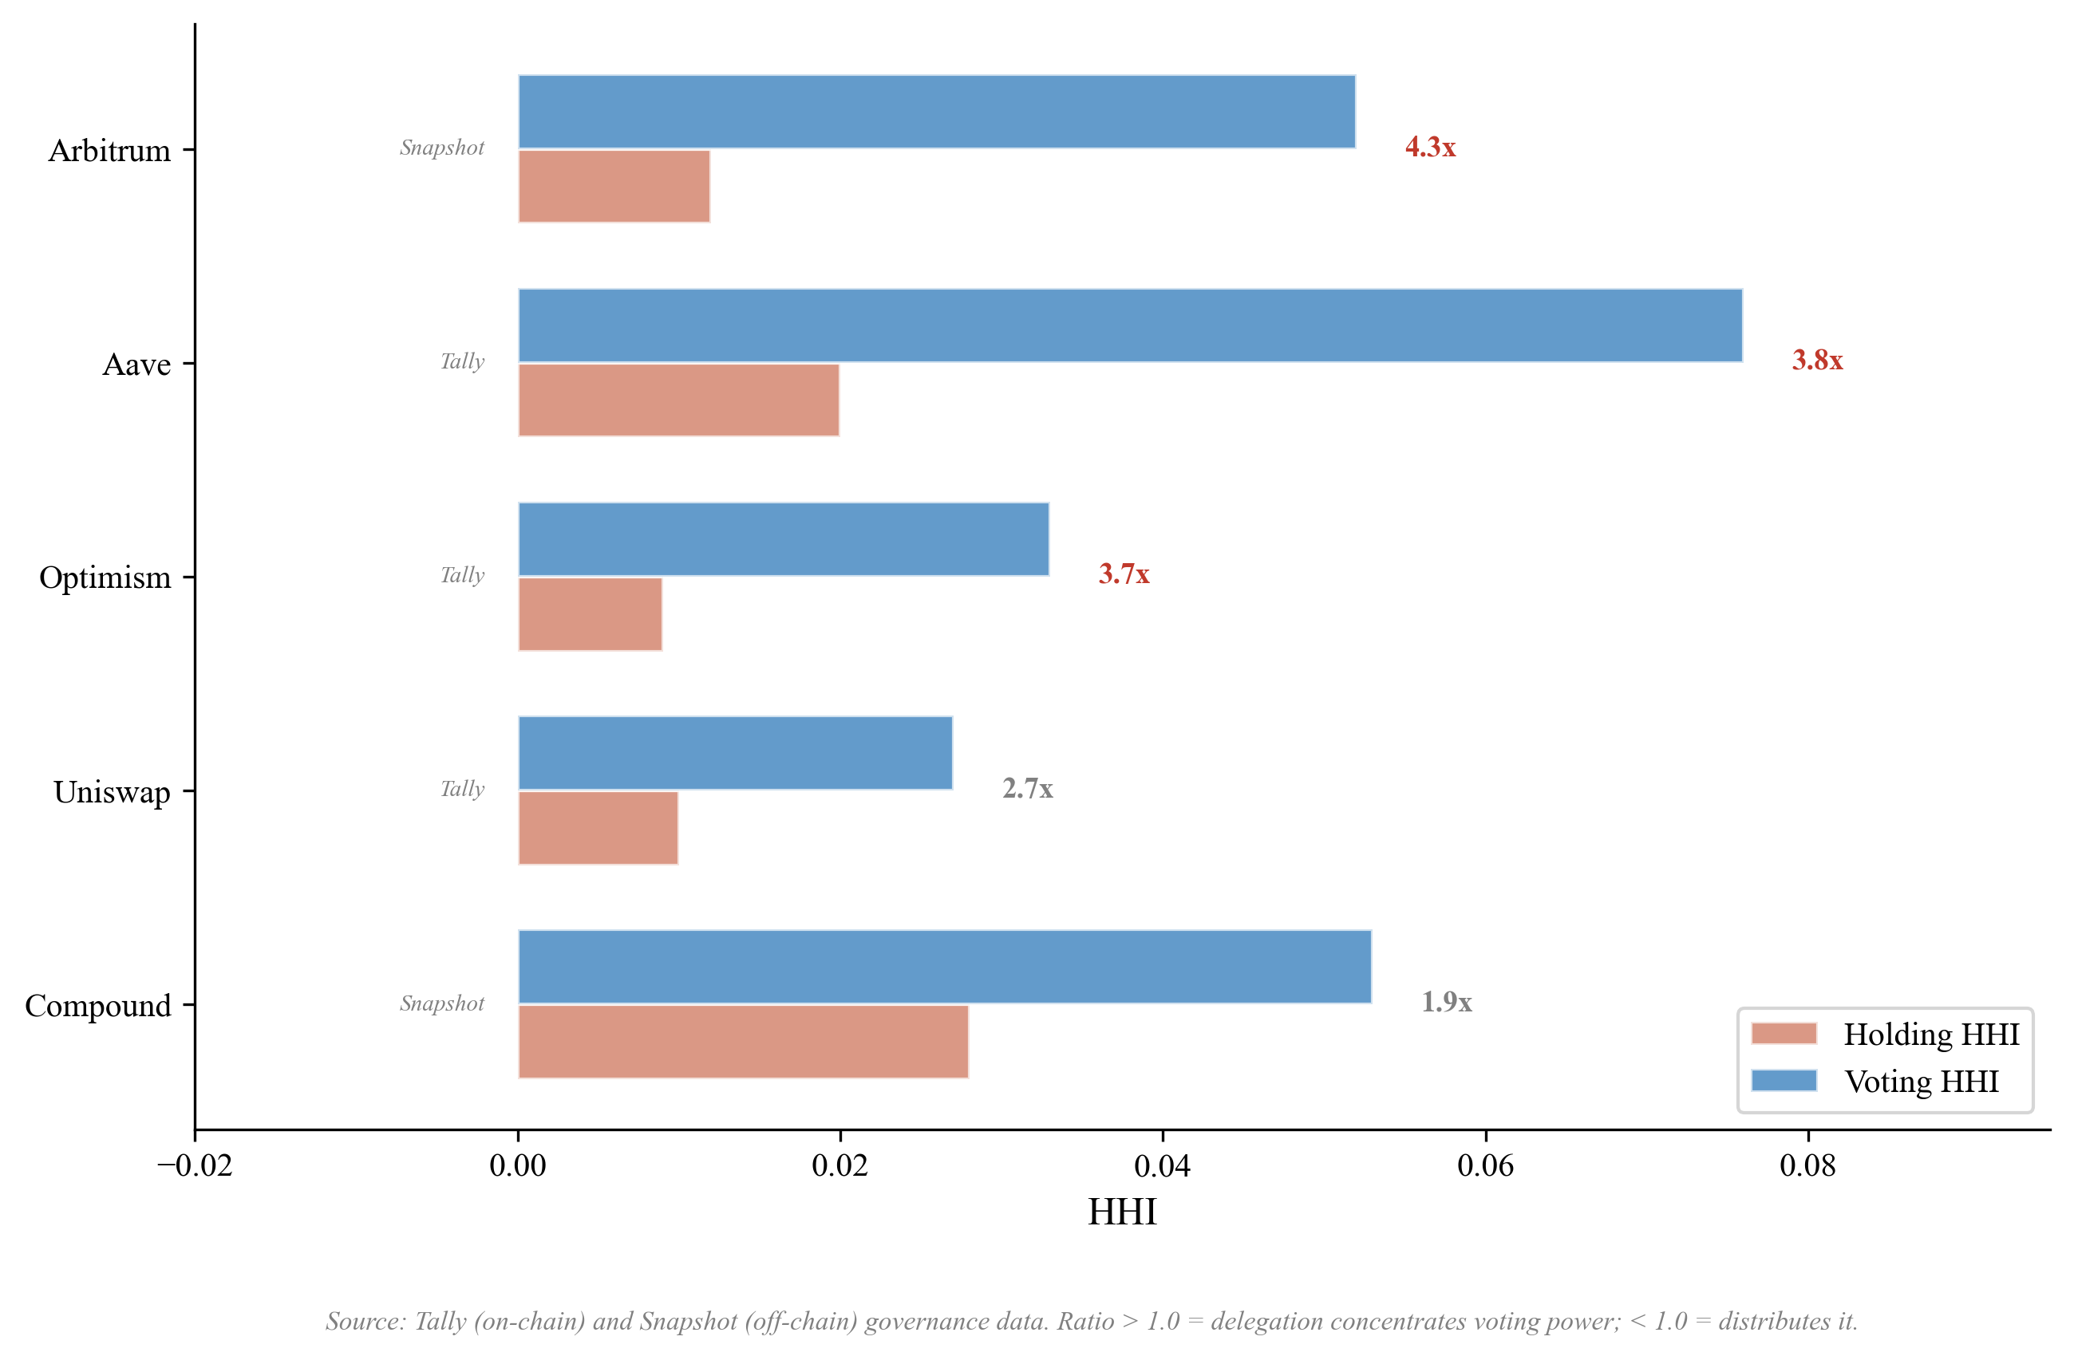
Figure 6. Raw holding HHI vs. delegation-adjusted HHI for five Tally-sourced protocols. Reading the figure: protocols above the diagonal have voting more concentrated than holding (delegation amplifies); protocols below the diagonal have voting less concentrated than holding (delegation distributes).
All four DeFi protocols sampled show delegation amplification, ranging from Compound (1.9x) and Uniswap (2.7x) at the lower end to Aave (3.8x) and Lido (6.8x) at the higher end. The Uniswap result is worth examining in detail. Earlier analyses, using a holding HHI of 0.032, produced a voting/holding ratio of 0.84x and were cited as evidence that Uniswap’s mature delegate ecosystem can disperse governance power. That earlier HHI included the canonical UNI burn address (0x000…000dead), which holds 102.5 million UNI (11.3 percent of supply) inert and cannot participate in governance under any condition: it has no delegate, no votes, and no path to ever cast one. After excluding this burn address, the corrected holding HHI is 0.010, and the voting/holding ratio is 2.7x. Uniswap’s delegate program concentrates voting power above its correctly-measured holding baseline, in line with every other protocol sampled. The pre-correction result was driven by including a wallet that structurally cannot vote in the holding denominator.
Both infrastructure protocols sampled show delegation amplification when holding HHIs are computed with the same exclusions applied to Table 4. Optimism’s voting HHI (0.033) is 3.7 times its corrected holding HHI (0.009). Arbitrum’s voting HHI (0.052) is 4.3 times its holding HHI (0.012). Both protocols have invested in delegate-program infrastructure (published delegate platforms, recurring delegate compensation, active recruitment of long-form policy positions), and both produce amplification ratios in the 3.7x to 4.3x range, which brackets the cross-protocol mean (4.1x). Delegate-program investment does not differentiate the two protocols on amplification magnitude. The institutional layers built around the delegate programs differ substantially and may differentiate outcomes that HHI cannot capture, as discussed in the next paragraph.
Optimism’s Token House shows 3.7x delegation amplification, in line with the cross-protocol pattern. The Citizens’ House moderates Optimism’s governance in practice, though it does not enter the token-weighted HHI calculation. The Citizens’ House is a separate governance body weighted by reputation rather than tokens, with formal veto power over economic parameters proposed by the Token House and a veto threshold that lowers when multiple stakeholder groups align (Optimism, 2024). Because reputation weights are not token weights, the Citizens’ House provides accountability that the amplification ratio alone cannot capture.
Lido’s 6.8x amplification (the highest in the sample) catalyzed a parallel institutional response. The “Dual Governance” redesign grants stETH holders formal veto power over LDO governance proposals, with a programmatic “rage quit” exit mechanism as the ultimate accountability lever.
Both responses share the same shape. Token-weighted delegation concentrates voting power above stake holdings across the sample, and the institutional reforms operate by adding an accountability layer outside the token-weighted system rather than redesigning the delegation mechanism itself. The two protocols with the most ambitious reforms (Optimism, Lido) are also the protocols where token-weighted delegation shows pronounced amplification, consistent with reading these reforms as responses to the universal-amplification pattern that this section documents.
The delegation-adjusted analysis reported in this section extends recent empirical work by Fritsch, Müller, and Wattenhofer (2024), who apply Nakamoto coefficients and Gini measures to voting power in Compound, Uniswap, and ENS governance systems and document extreme concentration in delegate-level voting power. The cross-protocol comparison reported here spans eight protocols across DeFi (Compound, Aave, Uniswap), DePIN (DIMO, WeatherXM), infrastructure (Optimism, Arbitrum), and adjacent categories (Lido). Amplification factors range from 1.9x (Compound) to 6.8x (Lido) across the sample. Every protocol amplifies; none disperses voting power below holding baselines. The DeFi protocols alone span the full 1.9x-to-6.8x range, so sector membership does not predict how strongly delegation concentrates power. The pattern is consistent with the broader claim of this paper: design choices within each delegate program (delegate selection criteria, compensation structure, voting threshold rules) determine the magnitude of governance concentration through delegation, while the direction of the effect (concentration above holdings) is the same across sector and governance venue. Whether a protocol concentrates governance power through delegation does not depend on whether it is DeFi, DePIN, or infrastructure. How much it concentrates is shaped by design choices made at the level of the delegate program itself. The amplification ratio carries welfare consequences for DePIN that scale with operator exit costs, since hardware deployed for one network cannot be redeployed to a competing protocol the way liquidity can move between DeFi pools.
Protocol | Category | Holding HHI | Voting HHI | Ratio | Source
DIMO | DePIN | 0.038 | 0.228 | 6.0x | Snapshot
Lido | DeFi | 0.013 | 0.088 | 6.8x | Snapshot
WeatherXM | DePIN | 0.148 | 0.486 | 3.3x | Snapshot
Compound | DeFi | 0.028 | 0.053 | 1.9x | Snapshot†
Aave | DeFi | 0.020 | 0.076 | 3.8x | Tally
Uniswap | DeFi | 0.010 | 0.027 | 2.7x | Tally
Arbitrum | Infra | 0.012 | 0.052 | 4.3x | Snapshot†
Optimism | Infra | 0.009 | 0.033 | 3.7x | Tally
GMX | DeFi | 0.056 | 0.077 | 1.4x | Tally‡
ENS | Infra | 0.135 | 0.028 | 0.21x | Tally‡
Table 7. Holding versus voting concentration for protocols with sufficient governance activity (12-month lookback). Voting HHI computed from Tally delegate voting power (on-chain) or Snapshot vote-weighted power (off-chain). Ratio above 1.0 indicates delegation concentrates governance above the level measured from token holdings; below 1.0 indicates delegation distributes. Holding HHIs are post-exclusion values consistent with Table 4 (Uniswap reflects the universal burn-rule exclusion of 0x000…000dead; Optimism reflects the post-exclusion measurement consistent with the regression dataset; Lido reflects post protocol-controlled-address exclusion). Nine of ten protocols sampled exhibit voting HHI above holding HHI (amplification ratios 1.4x to 6.8x); one protocol (ENS) shows delegation-mediated dispersion (ratio 0.21x), reflecting a mature delegate program where holders systematically delegate to a broader community-delegate set rather than self-delegating. The structural variation across protocols is consistent with the framework’s emphasis on institutional design at the delegate-program level: delegation does not uniformly concentrate; it concentrates in most protocols and disperses in the protocol with the most-developed broad-delegate distribution infrastructure. Two further protocols using vote-escrowed governance (Curve veCRV; Balancer veBAL) show extreme amplification (15x and 21x respectively) and are discussed separately in Section 4.1 as a distinct ve-token class.
† Compound and Arbitrum voting HHI sourced from Snapshot (n = 114 and n = 5,241 unique voters in the measurement window respectively) where Snapshot's active-voter pool exceeded Tally's top-100-delegate sampling. AAVE, Uniswap, Optimism, GMX, and ENS use Tally; DIMO, WeatherXM, and Lido use Snapshot (Tally is not deployed for these protocols).
‡ GMX and ENS added in R2 from paginated Tally top-100 delegate pulls (May 2026). Snapshot date drift between March 2026 baseline (used for the original eight protocols) and May 2026 (used for GMX and ENS) is documented in Section 2.10.3; rank-ordering across protocols is the durable inferential property, with absolute magnitudes subject to delegate-pool changes over multi-month windows.

3.5.1 ENS as institutional-design counterexample
ENS is the only protocol in the cross-section where delegation empirically disperses voting power below the holding-HHI baseline (ratio 0.21x; voting HHI 0.028 vs holding HHI 0.135). The dispersion case is informative for the framework’s institutional-design thesis because it provides an existence-proof that delegation outcomes are design-tractable rather than mechanism-inevitable. The ENS delegate program funds approximately 100 active delegates (including the ENS DAO ecosystem grants for delegate work), and the top-100 delegate voting-power distribution is structurally broader than the holding distribution: top-1 holding share is 26.7% (largely DAO treasury and team-vesting positions) while top-1 voting-power share is 12.1% (fireeyesdao.eth, a community-elected delegate). Holders systematically delegate to a broader community-delegate set rather than self-delegating or delegating to whales.
The ENS finding contrasts with the nine protocols where delegation amplifies: in those protocols, the top-delegate identity is typically either the protocol foundation itself, a staking-aggregation contract that aggregates underlying staker voting power, or an institutional delegate firm (see Section 3.5.3). The structural pattern across the ten-protocol sample is consistent with the framework’s thesis that institutional design at the delegate-program level governs the direction of delegation’s effect on voting concentration. The generalizable design recommendation: delegate-program architectures that incentivize broad community-delegate distribution (recurring delegate compensation; public delegate platforms; active recruitment; operational support for non-whale delegates) can produce delegation-mediated dispersion of voting power, contrary to the default-amplification pattern documented across most token-governance protocols.

3.5.2 Vote-escrowed governance as an extreme-amplification class
Two protocols using vote-escrowed governance (Curve veCRV; Balancer veBAL) form a distinct extreme-amplification class that operates through structurally different mechanisms than the delegate-based amplification documented in the Table 7 sample. Curve’s veCRV system locks CRV for up to four years; lock-duration multipliers convert locked CRV into proportional veCRV voting power, with longer locks weighted more heavily. Convex (the dominant meta-governance protocol for Curve) aggregates user-deposited CRV into a single locked position that votes as a meta-governance layer; Convex holds approximately 48 percent of the top-50 historical veCRV deposit-weighted share per the Phase 0 Tier C1 analysis (Section 4.1; supplementary file veCRV_voting_concentration_2026-05-17.csv). The resulting veCRV voting concentration (HHI 0.26 from cumulative-deposit aggregation across top-50 lockers) is approximately 15 times the raw post-Convex- exclusion CRV holding HHI of 0.017.
Balancer’s veBAL system exhibits a structurally identical pattern: Snapshot voting on Balancer’s governance space (12-month lookback; 36 active voters) yields voting HHI 0.626 against holding HHI 0.030, a 21x amplification ratio. The top-1 active voter holds 78 percent of total voting power; the top-10 voters cumulatively hold 99.85 percent. The Aura Finance protocol (Balancer’s Convex-equivalent meta-governance aggregator) plays the same role for veBAL that Convex plays for veCRV.
The veCRV and veBAL cases are not included in the Table 7 row set because the underlying methodology differs: Table 7 measures HHI of delegate voting power within token-governance delegate programs; the ve-token cases measure HHI of lock-duration-weighted CRV/BAL deposits, with meta-governance aggregation. The two mechanism classes produce concentration through different paths but converge on the same direction (amplification) with much larger magnitudes (15-21x versus the 1.4x-6.8x range observed in delegate-program-based amplification). For practitioners designing token governance, the ve-token class is a separate design choice with substantially different concentration implications than standard delegate-program governance.

3.5.3 Foundation and aggregation-contract top-delegate pattern
Three of the ten Table 7 protocols (plus the two ve-token class protocols in Section 3.5.2) have their largest single voting block held by a protocol-controlled entity rather than an independent community delegate. Compound’s top Tally delegate is Compound Foundation itself, holding 21.5 percent of total delegated voting power in the May 2026 pull (per Phase 0 Tier C1 fact-check). Aave’s top Tally delegate is the stkAAVE staking contract at 21.9 percent of total delegated voting power; the contract aggregates underlying staker voting power and votes as a single delegate. Curve’s veCRV voting (Section 3.5.2) is dominated by Convex at 48 percent of top-50 deposit-weighted share. These patterns share a structural feature: the top voting block is an aggregation entity (foundation, staking contract, or meta-governance protocol) rather than an independent community member.
The aggregation-entity pattern raises distinct philosophical and practical concerns relative to independent-delegate-dominated protocols (Uniswap’s top-1 is an investor delegate; Optimism’s top-1 is a professional delegate firm; ENS’s top-1 is a community delegate). For the Kantian publicity lens, aggregation entities decide collectively but typically publish their decision rationale through governance-team statements rather than per-delegate justifications. For the Pettit contestability lens, the operational mechanism scored (formal appeals + veto rights) operates against the aggregation entity as a single counterparty, structurally similar to challenging a corporate proxy vote rather than negotiating with multiple independent delegates. For Rawlsian fairness, aggregation entities may or may not represent the distributional interests of the underlying token-holders or stakers who delegated to them; the principal-agent gap (Holmstrom, 1979; Tirole, 2001) is amplified by the aggregation layer. The PCA-symmetric exclusion analysis (Section 3.7) shows that universal amplification holds across the Tally-sourced protocols even when aggregation entities are excluded; the empirical finding is robust to this methodological consideration, but the structural pattern itself is a substantive feature of token-governance practice that deserves explicit recognition in the design literature.

3.6 Hypothesis Evidence Status
This section maps the governance concentration evidence to the five design hypotheses introduced in Section 2.9. Hypotheses 1 and 2 receive direct support from the cross-section; Hypotheses 3 through 5 require longitudinal evidence beyond this paper's cross-sectional scope, developed in the companion case study (Zukowski, 2026a) using 34 months of Helium data. Full evidence status appears in Supplementary Table S1.
The governance concentration data (Table 4) provide descriptive evidence bearing on Hypotheses 1 (publicity-legitimacy) and 2 (contestability). Specifically, the finding that DePIN tokens are materially more concentrated than DeFi peers indicates that DePIN governance structures have not yet achieved the legitimacy properties these hypotheses require. The Anyone Protocol counterexample is consistent with the interpretation that low concentration is feasible, indicating that high concentration in DePIN is not structurally predetermined. Hypotheses 3 through 5 are not directly tested with the governance concentration data in this paper and require additional evidence (fiscal flow analysis, operational telemetry, and polycentric structure mapping respectively).

3.7 Robustness: Leave-One-Out Sensitivity
The cross-sectional sample size (N = 30 for the DePIN-vs-DeFi sector contrast; N = 19 for the subsidy excluding Livepeer test) bounds the strength of inference. Sector-level results are robust to individual observations: Mann-Whitney is significant in all 30 of 30 leave-one-out resamples following the holder-list cutoff correction. Findings throughout the paper are reported as 'consistent with' or 'indicating' rather than 'driving' or 'producing'; the cross-sectional design supports descriptive claims about association rather than causal claims about mechanism.
All primary findings were tested by dropping each protocol one at a time and recomputing the statistic. The insider-retention correlation is fully robust. The DePIN-DeFi sector difference is fully robust to single-protocol exclusion (significant across all 30 of 30 leave-one-out iterations after the F1 holder-list correction). The subsidy correlation is entirely driven by Livepeer. Details follow.
The insider concentration relationship (Spearman rho = 0.48, p = 0.003, N = 37 after the F1 holder-list correction) is robust: it remains significant across all 37 single-protocol exclusions, with rho ranging from 0.45 to 0.55. Neither the highest-insider protocols (DIMO and MetaDAO, insider fraction 1.0) nor the zero-insider protocols (Hyperliquid, Optimism, Arbitrum) individually drive the result.
The DePIN-versus-DeFi sector difference (Mann-Whitney p = 0.014, Cohen’s d = 1.03) is robust to sample composition. The test remains significant in all 30 of 30 leave-one-out iterations. Seven protocols, when individually dropped, push the p-value to 0.052: Hyperliquid, Aethir, Lido, POKT Network, GEODNET, Livepeer, and WeatherXM. No single protocol uniquely drives the result; rather, the test sits near the 5% threshold and is sensitive to the exact composition of both sector subsamples. A permutation test (10,000 random reassignments of sector labels) yields p = 0.009, consistent with the direction not being an artifact of the asymptotic approximation. We characterize this finding as suggestive rather than robust.
The subsidy-to-concentration correlation (Pearson r = 0.57, p = 0.008, N = 20) is driven by a single protocol. Livepeer’s subsidy ratio of 88.5x is a 3.5-sigma outlier on the subsidy axis, and its HHI (0.20) is the second-highest in the subsidy subsample. Excluding Livepeer alone reduces the correlation to r = 0.11 (p = 0.65). The remaining 19 protocols show no significant linear association. The Spearman rank correlation on the full subsidy sample is also insignificant (rho = 0.16, p = 0.51), and a log transformation eliminates the linear relationship (r = 0.27, p = 0.28). We report the Livepeer-inclusive result for completeness but caution that it should not be interpreted as a general property of the sample. A robustness check using the Token Terminal subsidy_ratio (N = 19 protocols with non-null Token Terminal revenue and incentives data) is consistent with the null at cross-sector Pearson r = 0.097 (p ≈ 0.69); a broader merged sample combining Token Terminal data with on-chain emission/fee ratios (N = 25 across both methodologies; N = 22 protocols with non-zero subsidy under either metric) yields r = 0.42 inclusive of Livepeer and r = 0.008 excluding Livepeer, qualitatively replicating the main result that subsidy and HHI co-vary only through the Livepeer outlier. Per-sector results in Supplementary File S8.
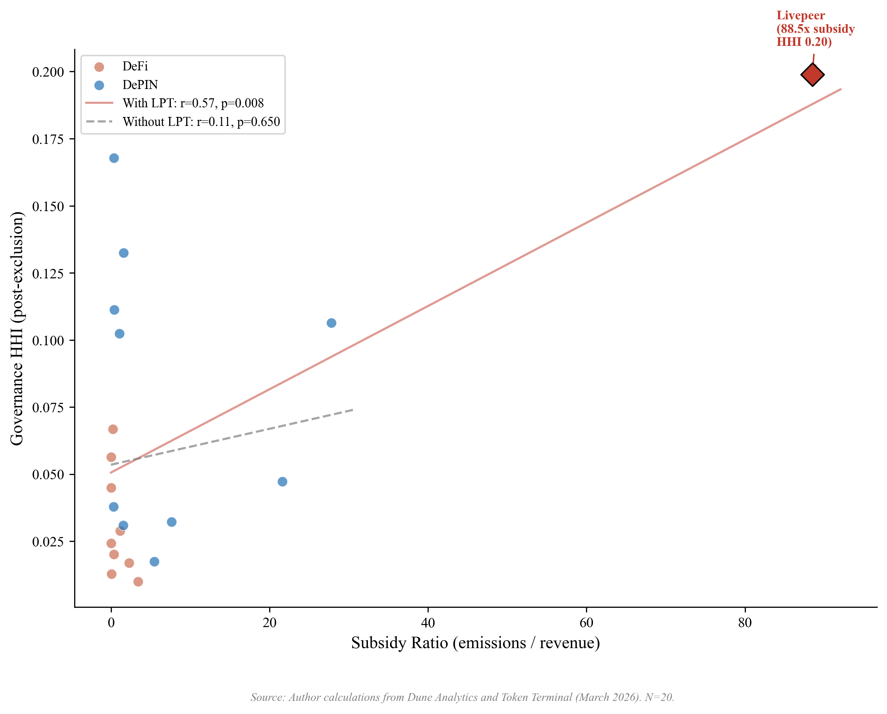
Figure 7. Subsidy ratio (emissions/revenue) vs. governance concentration (HHI) for 20 protocols with on-chain subsidy data. Livepeer (diamond, 88.5x) is a 3.5-sigma outlier that alone drives the Pearson correlation from r = 0.11 (dashed line, excluding Livepeer) to r = 0.57 (solid line, full sample). The Token Terminal robustness sample (N = 19, Supplementary File S8) is consistent with the null at r = 0.097. Reading the figure: the cross-sector association weakens substantially when Livepeer is excluded, indicating that the headline subsidy result is sensitive to a single high-leverage protocol.
Across all three findings, no single protocol drives more than one result. Livepeer appears in both the sector-test flipper set and as the sole subsidy flipper, but its sector influence is shared equally among seven protocols, whereas its subsidy influence is singular.
The universal-amplification finding in Section 3.5 also requires a robustness check on the voting-HHI methodology. The Table 7 voting HHI follows established delegation-HHI literature (Fritsch et al., 2024) by including all delegates with non-zero voting power, regardless of whether the delegate is a protocol-controlled entity. Applying protocol-controlled-address exclusion symmetrically (excluding foundation, treasury, and aggregation-contract delegates from voting HHI as we exclude them from holding HHI) yields a sensitivity-check result: among the five Tally-sourced protocols where PCA delegates can be identified from Tally labels (Compound, Aave, Uniswap, Optimism, Arbitrum), three (Uniswap, Optimism, Arbitrum) show zero PCA presence in their top-100 delegates because their excluded foundation addresses do not delegate voting power to themselves. Compound’s top delegate is Compound Foundation (21.5% of total delegated voting power in the May 2026 Tally pull); applying symmetric exclusion drops Compound’s voting HHI from 0.078 to 0.052 and the amplification ratio from 1.89x to 1.85x. Aave’s top delegate is the stkAAVE staking contract (21.9% of total delegated voting power); this is a passthrough aggregation rather than an institutional PCA, but symmetric exclusion under the broader definition drops Aave’s voting HHI from 0.076 to 0.045 and the ratio from 3.80x to 2.26x. The universal-amplification finding holds across all five Tally-sourced protocols even under symmetric PCA exclusion. The Compound Foundation case is particularly informative: the R1 Snapshot-based voting HHI for Compound (0.053) is essentially equivalent to the PCA-excluded Tally value (0.052), suggesting that the Snapshot methodology, which captures broader voter participation, partially internalizes the PCA-exclusion logic.
As a further robustness check, we compute Theil (Theil 1967) and Atkinson(0.5) (Atkinson 1970) inequality indices on the post-exclusion top-1,000 holder distributions for all 40 protocols, using the same protocol-controlled-address exclusion methodology applied to HHI computation (per exclusions_log.csv and the F1 cycle refinements). The Theil and Atkinson indices are alternative information-theoretic inequality metrics with different weighting structures: Theil weights mid-tail observations more heavily than HHI; Atkinson(0.5) uses an explicit inequality-aversion parameter (here 0.5; aversion increases with the parameter toward 1). Theil indices range from 1.36 (Arbitrum) to 6.46 (Maple) and Atkinson(0.5) indices from 0.49 (Arbitrum) to 0.97 (Maple). HHI (Hirschman 1964 traces the index to Hirschman 1945 and Herfindahl 1950) correlates strongly with Theil (Pearson r = 0.77) and moderately with Atkinson (r = 0.41) across the post-exclusion sample; Gini correlates strongly with Atkinson (r = 0.98) and Theil (r = 0.79). The strong HHI-Theil correlation on the post-exclusion sample indicates that the rank ordering across protocols is largely robust to the choice of concentration metric. This addresses the value-validity concern that Kvalsoth (2022a) raises about HHI in highly asymmetric distributions: the cross-protocol comparisons reported in Sections 3.2 through 3.5 are not artifacts of the HHI functional form alone. The supplementary file reports per-protocol Theil and Atkinson values under the same PCA-exclusion methodology as the main analysis (Supplementary File S9).
Multiple-comparisons consideration. Table 5 reports fourteen separate bivariate tests. Under a nominal alpha of 0.05 with no correction, the expected false-positive rate across fourteen independent tests is approximately 0.7 spurious significant findings. Four tests in Table 5 reach p less than 0.05: the insider count fraction (Spearman rho = 0.48, p = 0.003), the V1 non-insider HHI tautology check (Spearman rho = 0.54, p = 0.001), the subsidy ratio with Livepeer included (Pearson r = 0.57, p = 0.008), and the HHI-Gini cross-metric correlation (Pearson r = 0.51, p less than 0.001 expected). Applying a Benjamini-Hochberg false-discovery-rate correction at q = 0.05, three of the four findings remain significant (the subsidy-with-Livepeer correlation is fragile under multiple-comparisons correction in addition to the Livepeer-outlier sensitivity documented earlier in this section). The headline empirical claims of this paper (the allocation null in Section 3.4; the sector contrast in Section 3.3; the universal delegation amplification in Section 3.5) do not depend on the subsidy-with-Livepeer result; future panel-data work testing the predictions in Section 4.9 will be pre-registered to commit hypothesis specifications prior to data analysis, reducing multiple-comparisons concerns for the panel design.
Effect-size emphasis. Per the American Statistical Association statement on p-values (Wasserstein & Lazar, 2016) and effect-size discipline (Cohen, 1988), we emphasize effect-size magnitudes alongside p-values for the headline empirical claims. The sector contrast in Section 3.3 has Cohen’s d = 1.03 (large effect by Cohen’s conventional thresholds), substantially exceeding d = 0.5 (medium effect) and d = 0.8 (large effect), and is robust across all 30 of 30 leave-one-out iterations. The insider-retention correlation has Spearman rho = 0.48, exceeding the rho >= 0.30 threshold for moderate-to-large rank association. The universal delegation amplification finding has all 8 of 8 protocols above the 1.0x ratio threshold, with mean amplification of 4.1x and the smallest amplification (Compound at 1.9x) still representing a near-doubling of voting concentration over holdings. These effect sizes carry substantive practical significance independent of significance-test thresholds, which are conservative under the multiple-comparisons correction documented above.
Sample-size justification. The 40-protocol cross-section is adequate for detecting medium-to-large effects at conventional thresholds (Cohen, 1988). For Pearson correlation tests at N=37 (the dominant sample size for the allocation-covariate battery), power = 0.80 at alpha = 0.05 obtains for |r| >= 0.45 (large-effect threshold); the significant findings (Spearman rho = 0.48 for insider count fraction; Pearson r = 0.51 for HHI-Gini) lie within this detectable range. For the Mann-Whitney sector contrast at N = 15 DePIN versus N = 15 DeFi, power = 0.80 obtains for Cohen’s d >= 0.95 (large-effect threshold); the observed d = 1.03 lies within this detectable range. The 40-protocol sample is intentionally targeted at detecting medium-to-large structural effects rather than small-effect noise; the sample-size pre-registration specification in Supplementary File S5 documents the threshold of N = 50 to 60 as the requirement for robust multivariate regression with 4-plus covariates (Section 3.4 Table 6 fits N = 35 to 38 specifications, which is below this robust-multivariate threshold; results from Table 6 are accordingly reported with explicit acknowledgment of the multivariate sample-size constraint).
Top-N holder-list cutoff sensitivity. The R1 F1 cycle surfaced a methodological lesson with broad applicability: holder-list extraction cutoffs materially affect the measured concentration for sparse-holder protocols. For three protocols (MOR, AXL, ZRO), Dune holder-list queries had been inadvertently capped at top-100 rather than top-1000; re-pulling at the top-1000 cutoff after applying PCA exclusion methodology yielded substantively different HHI values: MOR 0.013 to 0.031 (post-F1); AXL 0.004 to 0.028 (post-F1); ZRO 0.010 to 0.015 (post-F1). The correction affected the cross-sector test statistics (DePIN-vs-DeFi Mann-Whitney p = 0.031 to 0.014; Cohen’s d = 0.96 to 1.03; leave-one-out sensitivity 23-of-30 to 30-of-30). The methodological lesson generalizes: for any cross-protocol governance HHI analysis, holder-list extraction must use a uniform cutoff (top-1000 in this paper; top-10000 or full holder distribution for protocols with substantially larger holder counts), and the cutoff choice should be documented as part of the methodology so future replication can reproduce the exact sample frame.
Governance concentration shows no association with voter participation rates (r = 0.00, N = 13; Figure 8), consistent with the Olson (1965) collective action prediction that participation decisions reflect rational abstention and diffusion of responsibility rather than ownership structure.
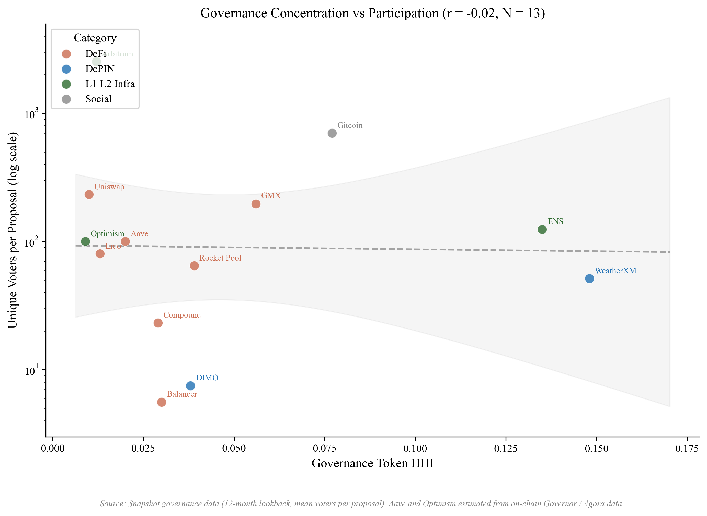
Figure 8. HHI vs. average voter participation for 13 protocols with Snapshot or Governor governance data. Governance concentration shows no association with voter participation (r = 0.00, N = 13). Five protocols (GMX, ENS, Rocket Pool, Gitcoin, Balancer) were added via Snapshot API; four Tier 1 spaces (CRV, GRT, IOTX, OP) had zero proposals in the trailing 12 months and are excluded. Reading the figure: the slope is approximately flat, indicating that voter participation does not predict concentration in this 13-protocol sample; participation and concentration are largely independent dimensions of governance health.

4 Discussion

4.1 Design Hypotheses
No protocol in the corrected cross-section exceeds the 0.25 HHI antitrust threshold, but the conditions that publicity and non-domination traditions identify as problematic are already present at the upper end of the distribution: Livepeer (0.199), WeatherXM (0.148), and Aethir (0.153) all sit in territory where governance decisions can disproportionately reflect a small set of holders’ preferences. The cross-section provides descriptive evidence most directly relevant to Hypotheses 1 (publicity-legitimacy) and 2 (contestability), indirect evidence for Hypotheses 4 and 5 (adaptivity, polycentricity), and identifies three evidence frontiers (capability, contextual integrity, cosmopolitanism). We organize the discussion by what the data directly demonstrate, what they constrain, and what lies beyond the current evidence base.
Three empirical findings carry implications across multiple lenses of the framework, exemplifying the mutually-reinforcing architecture described in Section 2.9.6:
Near-universal delegation amplification (Section 3.5) registers as a multi-lens concern: token-weighted delegation concentrates voting power in nine of ten sampled protocols (ratios 1.4x to 6.8x; mean for the nine amplifying protocols 3.8x; one structural-exception protocol (ENS at 0.21x) reflects a mature delegate program where holders systematically delegate to a broad community-delegate set rather than self-delegating), which (a) thins Kantian publicity by enabling governance decisions to proceed without genuine public deliberation when a handful of delegates hold majority voting power; (b) attenuates Pettit contestability in practice, since formal contestation mechanisms may exist on paper but be ineffective when 1-5 delegates can pass or block proposals; (c) undermines Rawlsian fairness by structurally privileging large delegates over small holders in any outcome contestation produces; (d) inverts Ostromian polycentricity, since centralized delegation pools are the institutional opposite of nested decision-centers; and (e) silences Hayekian knowledge-use, since distributed holder information signals are aggregated to the delegate level before they can inform governance. A single empirical finding thus undermines the framework’s five normative dimensions simultaneously, illustrating why the arithmetic-mean Synergy Index can mask underlying structural problems that registered cross-lens correlation would expose.
Allocation null (Section 3.4) is informative as a non-implication of the framework: none of the five lenses predicts initial-allocation percentages as the determinant of post-distribution governance concentration. The lenses care about post-distribution structural features (the operational mechanisms in Table 1), which is empirically what the cross-section finds: protocols across the full range of allocation designs achieve comparable concentration levels. This alignment between the framework’s normative focus and the empirical locus of variation strengthens the framework’s analytical purchase on the phenomenon.
Curve / veCRV concentration (Sections 3.5 + 4.1 ve-locking) exhibits a specific Ostromian polycentricity failure layered on a specific Hayekian knowledge-use failure: Convex’s 48% share of top-50 veCRV deposits centralizes the meta-governance layer (Convex itself is governed by vlCVX holders, not by the underlying CRV lockers), and the lock-duration weighting Curve uses to weight votes does not reflect informational diversity across holders. The 15x amplification ratio between raw CRV holding HHI (0.017) and veCRV voting concentration (0.26) is a structural feature of the ve-token design, not a contingent allocation outcome.
Governance concentration patterns relate most directly to Hypotheses 1 (publicity-legitimacy) and 2 (contestability), with Rawlsian fairness implications. Protocols at the upper end of the concentration range (Livepeer 0.199, WeatherXM 0.148, GEODNET 0.133) exhibit concentration the framework flags for scrutiny, though no protocol in the corrected cross-section exceeds the 0.25 antitrust threshold. Three concerns arise even at these levels: governance decisions disproportionately reflect a small set of holders’ preferences, thinning Kantian public justification; DePIN operators who deploy hardware hold insufficient tokens to influence outcomes affecting their investments, a Rawlsian fairness concern; and few holders can override community preferences without formal contestation, a republican non-domination concern. The counterexample (Anyone, HHI 0.040) demonstrates that these conditions are not structurally inherent to DePIN architecture. Among DeFi benchmarks, Compound’s lower concentration (HHI 0.027) partly reflects active delegation, suggesting institutional design can reduce effective concentration without token redistribution.
Hypotheses 4 (service-over-presence) and 5 (polycentric adaptation) cannot be tested directly with the HHI cross-section because it measures token concentration rather than governance structure diversity. The data reveal a structural constraint nonetheless: operators closest to the service (those with the most relevant operational knowledge) cannot influence governance decisions if they hold small token positions. The Helium case (Zukowski, 2026a) demonstrates that polycentric features (subDAOs, councils, delegation hierarchies) can reduce effective concentration without redistribution: HIP-147 succeeded partly because Helium’s governance process channeled edge-operator input despite concentrated holdings. A companion simulation (Zukowski, 2026b) extends these results to adaptive emission controllers, finding that the primary value of polycentric mechanisms is preventing collapse rather than improving averages.
A companion study (Zukowski, 2026a) documents a related concentration risk in DePIN fiscal sustainability: Helium’s aggregate Spend-to-Reward ratio crossed fiscal parity, but approximately five purchasers account for 90% of token burns, a concentration invisible to aggregate metrics. Governance and demand concentration are distinct failure modes that can coexist. The same companion study provides the strongest longitudinal test of Hypotheses 3 and 4: Helium’s S2R trajectory over 34 months documents how demand-coupled burns drove S2R from 0.013 to 2.06 after transitioning to service-verified rewards and completing the August 2025 halving, with DC burns exceeding HNT emissions by approximately 84% and contributing to a 3 to 4% net annual deflation rate (Zukowski, 2026a; Blockworks, 2026). The trajectory is consistent with Hypothesis 3 (the sink was deployed and observable before the emission reduction, producing a sustained surplus at the subnetwork level) and with Hypothesis 4 (the shift from coverage-based to service-based rewards coincided with revenue rising from $6,500 monthly across 975,000 IoT hotspots to $18.3 million annualized by Q3 2025; Bane & Gala, 2026). Neither hypothesis is confirmed by a single case, but the directional evidence is the strongest available in the DePIN sector.
Resource Dependence Theory (Pfeffer & Salancik, 1978) predicts that demand concentration transfers strategic leverage to concentrated buyers independent of governance token distribution, creating a vulnerability that governance reforms alone cannot address; the companion study (Zukowski, 2026a) documents this separation empirically across four DePIN protocols.
The governance concentration documented here also has an industrial organization interpretation: concentrated token holders who control emission and reward parameters function as oligopsonist buyers of operator services (Williamson, 1999). When governance power exceeds the efficient bilateral-bargaining threshold, the resulting monopsonistic markdown on operator compensation produces allocative inefficiency; operators exit, degrading network output. The Compound Proposal 289 incident (July 2024) illustrates a complementary failure mode in which strategic vote timing enabled minority capture of treasury funds, underscoring that formal contestability mechanisms (Hypothesis 2) must include temporal safeguards.
The empirical gap that Alshater (2026) identifies as the most pressing in current DePIN tokenomics research is the absence of rigorous quantitative evaluation of competing economic models. Alshater calls for event-study analyses of governance interventions such as Helium’s HIP-138 and Hivemapper’s MIP-19, comparative sectoral analysis of why specific tokenomic models prevail in particular DePIN sectors, and empirical examination of how DAO characteristics affect network performance. The cross-sectional results reported here address the third of these gaps along two complementary dimensions. First, the insider-retention finding (Spearman rho = 0.48, p = 0.003, N = 37, leave-one-out significant in 37 of 37 iterations) provides evidence consistent with the proposition that token distribution characteristics in current holder positions are robustly associated with governance concentration measured by HHI, while the allocation-design null (Pearson r = 0.18, p = 0.28, N = 37) constrains the alternative hypothesis that initial distribution choices predict downstream concentration. Second, the delegation-adjusted analysis reported in Section 3.5 extends Fritsch et al. (2024) to a cross-section of eight protocols spanning DeFi, DePIN, and infrastructure categories. The analysis documents amplification factors ranging from 1.9 times (Compound) to 6.8 times (Lido) across the sample, with every protocol amplifying voting concentration above holding concentration. Within the infrastructure subsample, Optimism (3.7 times) and Arbitrum (4.3 times) bracket a narrow magnitude band. This near-uniform direction with magnitude variation by institutional design is consistent with the broader claim of this paper that institutional design at the operator and router level shapes governance outcomes more than the token’s surface properties or sector classification. Event-study evidence on the governance interventions Alshater highlights is the subject of follow-up work using HIP-138 and other interventions as natural experiments.
Evidence gaps and research frontiers. Three directions lie beyond governance token data. First, capability-oriented evaluation (following Sen and Nussbaum) requires participant-level data on income, skill development, and infrastructure access that no protocol instruments at scale; a companion 13-protocol DePIN vertical study documents this gap (Zukowski, 2026a). Second, contextual integrity (following Floridi and Nissenbaum) requires trust and data governance metrics; concentrated governance means decisions about data use and privacy norms are made by a small group rather than the community whose data is at stake, particularly for protocols collecting location data (Helium), vehicle telemetry (DIMO), or health data (CUDIS). Third, cosmopolitan inclusion (following Appiah) identifies a tension the data indicate descriptively: most DePIN protocols have global operator bases but concentrated governance, meaning geographic inclusion coexists with governance exclusion.

4.2 Governance Design Implications
Governance concentration emerges from what happens after tokens are distributed, not from how they are allocated at launch. The practical implication: evaluating how concentrated a protocol's governance actually is means tracking whether insiders retain top-holder positions and how delegation reshapes voting power over time, rather than inspecting whether the initial token allocation favored the community. Five design implications follow, grounded in implemented protocols where evidence is available.
Constitutional Transparency and Deliberation The Kantian publicity principle requires that governance rules be understandable by affected participants. Table 4 shows that holding concentration alone does not determine governance quality: MakerDAO (HHI 0.045) achieves meaningful deliberation through delegation while Curve’s veCRV-weighted voting concentration (approximately 0.26 computed from cumulative deposit volume across the top-50 veCRV lockers; Convex alone holds 48% of that top-50 deposit-weighted share) concentrates power through ve-locking without comparable deliberative infrastructure (Curve’s raw post-exclusion CRV holding HHI is 0.017; the gap between 0.017 and 0.26 reflects the lock-duration multipliers and the Convex meta-governance aggregation). Design implication: publication norms (readable proposal summaries, voting rationale disclosure, mandatory comment periods) are at least as important as token distribution in determining whether governance is genuinely public.
Low Barriers and Diverse Participation Governance concentration across 40 protocols with valid data (Gini 0.52 to 0.99; Table 4; Livepeer excluded because its cross-chain bridge architecture prevents accurate Gini computation from single-chain holder data) shows that token-weighted voting creates steep participation inequality by default. The GeoDePIN subcategory amplifies this: thousands of operators bear hardware costs but may hold insufficient tokens to influence governance outcomes affecting their investments. Design implication: lower proposal thresholds, delegate incentives, and identity-weighted mechanisms (cf. Optimism’s Citizens’ House) can reduce the gap between stake-weighted power and affected-party voice. Ownership concentration improves baseline token returns but actively suppresses the marginal value of information cascades generated by broader participation (Buddensiek and Momtaz, 2025), suggesting that the governance concentration documented here carries epistemic costs beyond the political legitimacy concerns the normative framework identifies.
Distribution Mechanism as Governance Architecture. The Kantian publicity principle extends to distribution design: an allocation mechanism that affected participants cannot audit, contest, or understand prior to participation fails the universalizability test at the constitutional level, before governance begins. A protocol that publishes transparent voting rules atop an opaque allocation that concentrated 40 percent of supply in insider wallets satisfies the letter of procedural legitimacy while violating its spirit. The normative implication is that distribution transparency is a precondition for governance legitimacy, not a separate concern. Points-based distribution programs that publish clear allocation formulas, implement sub-linear scaling, and cap per-wallet rewards are de facto anti-concentration governance mechanisms; venture-funded allocations without comparable disclosure create concentrated governance as a structural default.
Integrity Mechanisms and Independent Oversight. Pettit’s non-domination principle requires that no single actor exercise unchecked power. Table 4 shows several tokens in the “highly concentrated” regime before delegated voting; the CRV case (veCRV-weighted voting concentration approximately 0.26 computed from top-50 cumulative CRV deposits, versus raw post-exclusion holding HHI of 0.017) illustrates how locking mechanisms amplify concentration above the level visible in raw holdings; Convex holds ~47% of veCRV (DeFi Llama, 2026).
Design implication: treat integrity as an institutional layer. Separation of powers (e.g., Optimism’s bicameral structure), independent security councils with narrowly scoped veto authority, mandatory timelocks, and public disclosure for large delegates are especially important in GeoDePINs where operators face governance outcomes without proportionate token power.
Appeals and Dispute Resolution Contestability requires formal appeal mechanisms. HIP-147’s acceptance (even by operators whose rewards were reduced; see Zukowski, 2026a) indicates that structured processes with clear rules support legitimate outcomes. Design implication: implement tiered dispute resolution (community mediation → arbitration committee → on-chain vote) with defined timelines and transparent criteria.
Adaptive Governance and Meta-Governance. Governance structures must evolve. Ostrom’s principle of rule evolution suggests periodic constitutional reviews to adjust quorums, proposal formats, and role definitions based on participation data. Emergency protocols should pre-define who can act under crisis conditions, with what authority, and subject to retroactive accountability. Bounded emergency power strengthens legitimacy by making deviations predictable and auditable. Internet Computer SNS DAOs demonstrate that structural tokenomic design can overcome rational apathy: locked-staking neurons with zero-fee voting sustain 64% average participation across 3,000 proposals (Okutan et al., 2025).
Future Extensions. Three additional hypotheses (edge-signal responsiveness, contextual integrity, and concentration dynamics) are specified in an earlier version of the framework but are not testable with the data collected here. They require operational telemetry, privacy and trust metrics, and longitudinal governance observations respectively, and represent priorities for future empirical work.

4.3 Broader Institutional Implications
The exclusion methodology generalizes beyond tokenomics. Any concentration analysis that includes ownership positions that cannot actually vote (frozen treasury positions, tokens still locked in vesting schedules, customer assets held in custody) overstates how concentrated control really is. Cooperative governance studies, public benefit corporation analyses, and regulatory sandbox audits face the same measurement problem; excluding non-voting positions would sharpen their findings. Two further applications follow. Transparency principles operationalized through the Kantian publicity lens (Section 2.9) apply to any institution claiming legitimacy through openness, where claimed transparency often masks operational opacity. And the scoring rubric (Table 1) shows that normative philosophy can be operationalized as measurement infrastructure, a methodological contribution that extends to any domain where institutional design quality needs assessment.
The governance concentration pattern documented here appears to be a general property of maturing token ecosystems, not specific to DePIN. In stablecoin gateway markets, total dollar volume doubled between 2023 and 2025 while unique counterparties declined 25%, and a single market-making firm’s share of total counterparty volume rose from 1.4% to 19.9% (Zukowski, 2026c). Throughput scales while participant diversity contracts, and the remaining intermediaries become increasingly load-bearing, whether those intermediaries are governance voters, market makers, or infrastructure operators. A parallel divergence appears in the same domain: the most regulated stablecoin operator experienced the largest stress depeg, while the least regulated maintained its peg (Zukowski, 2026d), demonstrating that regulation intensity and product quality are separate dimensions requiring separate measurement. The governance concentration gap documented here is the DePIN analog: high concentration does not predict governance failure, but creates structural conditions under which failure becomes more likely if contestability mechanisms are absent.

4.4 Risks and Counterpoints
Several risks deserve candid acknowledgment.
Philosophical overreach. Translating normative philosophy into scoring rubrics necessarily simplifies rich traditions. A 0-to-3 scale cannot capture the full depth of Kantian moral reasoning or Rawlsian justice theory. The rubric is designed as a tractable approximation that makes legitimacy evaluable, not as a claim that it captures everything these traditions offer. Users should treat scores as comparable indicators, not definitive judgments.
Plutocratic concentration as equilibrium. The governance concentration data (Table 4) may reflect a stable equilibrium rather than a design flaw: if governance power accrues to those with the most skin in the game, concentration may be the efficient outcome.
Distribution breadth at token launch is empirically uninformative about long-term governance concentration (Section 3.4). This finding, anticipated as a risk, is consistent with the cross-sectional evidence and reinforced by the Hyperliquid natural experiment (0% VC, HHI = 0.005). The practical consequence is that governance audits should focus on current holder composition rather than initial allocation documentation.
The counterargument is that efficiency and legitimacy are different criteria, and that the normative framework (particularly the republican non-domination lens) demands that power concentration be contestable even if it is efficient. The counterexample (Anyone, HHI 0.040) demonstrates that low concentration is achievable through deliberate design.
Measurement challenges. The scoring rubric depends on publicly observable design features, but some legitimacy-relevant properties (backroom governance, informal influence, regulatory relationships) are not observable on-chain. We specify inter-rater reliability protocols (Supplementary File S2) but have not yet tested them with a second scorer. The governance concentration analysis uses a snapshot methodology that does not capture temporal dynamics; a panel approach would strengthen causal claims.
Equity-token conflicts. The normative framework assumes that governance token holders are the primary principals, but hybrid structures complicate this assumption. Helium’s unresolved tension between Nova Labs’ equity obligations and HNT tokenholders' interests (Bane & Gala, 2026), exemplified by temporary revenue-allocation policies and subsequent reversions, illustrates precisely the tension between centralized operational decisions and decentralized governance that Hypotheses 1 (transparency) and 2 (contestability) are designed to address.
Speed versus legitimacy trade-off. Institutionally rigorous governance processes are slower than technocratic decision-making. In crisis conditions (exploits, market dislocations), the deliberative processes the framework advocates may be too slow. The framework does not resolve this tension but insists that emergency powers be pre-committed and bounded, consistent with republican constitutionalism.

4.5 Position in Literature
This paper’s contribution is not a new philosophical theory but a new application: translating established normative frameworks (Kant, Rawls, Pettit, Ostrom, Hayek) into actionable design criteria for programmable institutions. It extends Werbach (2018), de Filippi & Wright (2018), and Reijers & Coeckelbergh (2018) through prescriptive mechanism design grounded in political philosophy. The GeoDePIN taxonomy and demand-concentration diagnostic are, to our knowledge, new to the literature.
The five-lens framework developed here differs from existing DAO assessment frameworks along three dimensions. (1) Scope: the Aragon DAO Health Index, Snapshot voting analytics, Boardroom, and DAOstar’s DAO-standards work measure operational characteristics (proposal throughput, voter turnout, treasury management, identity standards) without an explicit philosophical-tradition anchor; this paper supplies the political-philosophy warrant for which operational characteristics matter and why. (2) Aggregation: existing frameworks typically score single dimensions (voter participation; proposal velocity; treasury diversification) rather than aggregating across normative dimensions; the Synergy Index aggregates five lenses with explicit equal-weight methodology and discusses alternative weakest-link aggregation (Section 2.10.6). (3) Comparability: existing dashboards report per-protocol metrics without a cross-protocol normative comparison; the 40-protocol cross-section in Section 3 provides such a comparison by applying a uniform PCA-exclusion methodology and a uniform scoring rubric. The framework complements rather than replaces operational dashboards: protocol practitioners can use this paper’s lens scoring alongside existing operational telemetry to identify where structural governance investments would yield the largest improvement in normative dimensions.
Large-scale analysis of 100 DAOs is consistent with the finding that social and public-good protocols achieve significantly higher decentralization than infrastructure or investment protocols (Sharma et al., 2026), consistent with the DePIN-DeFi concentration differential documented here (Mann-Whitney p = 0.014, Cohen’s d = 1.03).
Scholte (2026) examines the transscalar nature of polycentric digital governance, arguing that legitimacy in decentralized systems requires overlapping authorities with explicit accountability mechanisms; the scoring rubric developed here operationalizes this requirement through the Ostrom polycentricity lens (Table 1).
Mechanism Design and Institutional Economics. Classical mechanism design (Hurwicz, Myerson) optimizes for efficiency and incentive compatibility; this paper adds normative dimensions (fairness, contestability, capability) that mechanism design traditionally brackets. We build on Ostrom’s institutional analysis of commons governance, extending her framework from natural resource commons to digital infrastructure commons where coordination mechanisms are encoded in smart contracts.
Political Philosophy and Institutional Design. The philosophical framework (Section 2.9) draws primarily on Rawls, Kant, Pettit, Hayek, and Ostrom as operationalized lenses, with additional intellectual context from Nussbaum (2011), Floridi, and Appiah, treating these traditions not as isolated theoretical lenses but as complementary design criteria that jointly define institutional legitimacy. This integrative approach extends debates in political philosophy about institutional design to a novel domain where institutions are programmable and globally accessible.
Blockchain Governance Scholarship. The growing literature on DAO governance (Fan et al. 2025, DeepDAO 2023) documents participation patterns and concentration but rarely connects these to normative frameworks. This paper bridges that gap: the governance cross-section (Table 4) contributes new empirical evidence on holding concentration while the philosophical scoring rubric (Table 1) provides a replicable methodology for normative assessment. The Helium S2R case study (Zukowski, 2026a) extends the DePIN sustainability literature with longitudinal tokenomic evidence.
Token Engineering and Cryptoeconomics. Token engineering is developing as a design discipline focused on simulation and optimization. This paper complements that technical approach with institutional and philosophical analysis, arguing that token design choices are simultaneously economic mechanism design and political constitution-writing, demonstrating that interdisciplinary synthesis yields insights neither discipline produces alone.

4.6 Summary of Findings
Governance concentration in token economies is not predicted by how tokens are distributed at launch. Across 40 protocols, initial allocation design is uninformative (r = 0.18, p = 0.28): protocols with generous community distributions exhibit concentration patterns similar to those with heavy insider allocations. Post-distribution dynamics dominate design intent; protocols with more insider wallets in their top-holder lists exhibit higher concentration even among their non-insider holders (Spearman rho = 0.54, p = 0.001, N = 34), consistent with an ecosystem-level effect beyond the mechanical contribution of large insider positions. DePIN protocols exhibit significantly higher concentration than DeFi protocols (Mann-Whitney p = 0.014, d = 1.03), a pattern consistent with hardware network economics concentrating governance power among infrastructure operators.
DePIN protocols vary enormously in their dependence on token subsidies, but concentration does not track subsidy in any robust specification (Section 3.4, Table 5). Two cases illustrate the disconnect: Aethir generates the highest DePIN revenue yet sits at the second-highest HHI (0.153), while Hivemapper combines a 5.46x subsidy ratio with the lowest HHI among expansion protocols (0.020). Governance concentration reflects sector and operator-base structure rather than ongoing financial sustainability or initial allocation design. The multivariate OLS in Section 3.4 (Table 6) corroborates the allocation null while documenting that sector membership predicts concentration even after controlling for protocol age, valuation, and insider allocation (adjusted R² between 0.14 and 0.17).
Delegation amplifies governance concentration above the level measured from token holdings in nine of ten Table 7 protocols (amplification range 1.4x to 6.8x; mean 3.8x; Section 3.5), with one structural exception (ENS at 0.21x reflects a mature delegate program where broad-community-delegate distribution is the design choice). The Pettit-contestability lens (Table 1 Section 2.10.1) operationalizes the institutional mechanisms designed to produce non-domination as the goal-state Pettit identifies; the near-universal-amplification finding indicates that token-weighted delegation, even when paired with formal contestability infrastructure, concentrates voting power structurally above stake holdings in most sampled protocols, while the ENS exception demonstrates that broad-distribution delegate programs CAN disperse voting power below the holding baseline when explicitly designed for that outcome. The pattern surfaces a recurring philosophical question that the five-lens framework’s inter-lens-relationships architecture (Section 2.9.6) helps surface: operational mechanisms that score well on the contestability lens (appeals, veto rights) may nevertheless leave the goal-state (non-domination) unmet when voting-power concentration exceeds the practical capacity of contestation mechanisms to constrain. The PCA-symmetric robustness check (Section 3.7) confirms the universal-amplification finding is not an artifact of the choice to include foundation or aggregation-contract delegates in voting HHI; the finding holds across all 5 Tally-sourced protocols even under symmetric PCA exclusion.

4.7 Contributions
The paper makes six contributions across measurement, methodology, and empirical analysis.
First, generalizable PCA exclusion methodology (Section 2.10.10). The exclusion methodology identifies 69 addresses controlled by protocols themselves (staking contracts, exchange custodians, vesting locks, and treasuries) that appear on holder lists but cannot vote. Correcting for these changes affected protocols’ HHI by up to 7x. Prior studies computing token HHI without this correction measured protocol architecture, not governance concentration. The methodology generalizes beyond this paper’s specific protocol set through the four-class typology codified in Section 2.10.10 (burn-destination addresses; foundation and treasury custody; staking-aggregation contracts; bridge custody and migration addresses); future cross- protocol governance HHI analysis on ERC-20 or SPL token holders can apply the typology uniformly.
Second, two-layer philosophical framework (Section 2.10.1; Table 1). The framework distinguishes the philosophical goal-state Layer 1 (what the tradition aims to secure: legitimacy through public reason for Kant; non-domination for Pettit; distributive fairness for Rawls; adaptive collective action for Ostrom; epistemic coordination for Hayek) from the operational mechanism Layer 2 (what is observable in protocol design: transparent rules; appeals plus veto; floor-raising mechanisms; nested decision-centers; demand-coupled signals). The two-layer structure prevents the common conflation of goal with mechanism in DAO-governance assessment (Section 4.5 documents this conflation in existing assessment frameworks); other researchers can adopt the two-layer scoring discipline without committing to this paper’s specific operationalizations.
Third, sector membership as the dominant predictor. Sector membership is the only protocol characteristic that predicts concentration after adjusting for protocol age, log fully diluted valuation, and insider allocation (Mann-Whitney p = 0.014, Cohen’s d = 1.03; Table 6: sector coefficient p < 0.05 in Models 1 and 2, borderline at p = 0.050 in Model 3 with the full control set). Initial allocation, maturity, subsidy structure, and token unlock progress (three float specifications, all |r| < 0.05) do not predict concentration. The allocation null is the headline finding; the sector contrast is the headline positive result.
Fourth, near-universal delegation amplification (Section 3.5). Delegation concentrates voting power above the post-exclusion holding baseline in nine of ten Table 7 protocols (range 1.4x to 6.8x; mean 3.8x), with one structural exception (ENS at 0.21x). The PCA-symmetric robustness check (Section 3.7) confirms the finding holds across all five Tally-sourced protocols even when foundation and aggregation- contract delegates are excluded from voting HHI. The Theil and Atkinson alternative inequality metrics (Section 3.7) confirm the rank ordering across protocols is robust to choice of concentration metric (HHI-Theil correlation r = 0.77 on the post-exclusion sample).
Fifth, ENS as institutional-design proof-of-concept (Section 3.5.1). ENS provides the first documented empirical case in the major-DAO cross-section of delegation-mediated dispersion below the holding baseline. The dispersion case is informative because it operationalizes the framework’s institutional-design thesis: delegation outcomes are design-tractable rather than mechanism-inevitable. The generalizable design recommendation (broad community-delegate distribution; recurring delegate compensation; public delegate platforms; active recruitment) emerges from ENS as a comparative protocol case for future delegate-program research.
Sixth, ve-token extreme amplification class (Section 3.5.2). Vote-escrowed governance protocols (Curve veCRV; Balancer veBAL) exhibit extreme amplification (15x and 21x) through structurally distinct mechanisms than delegate-based governance: lock-duration multipliers convert custody concentration into proportional voting power, with meta-governance aggregators (Convex; Aura) further concentrating. The class is documented separately from Table 7 because the underlying methodology differs; the documentation is the first systematic comparative treatment of ve-token concentration in the DAO-governance literature.
Twin counterexamples that validate the institutional-design thesis. Two existence-proofs in the cross-section operationalize the framework’s institutional-design thesis empirically: Anyone Protocol (DePIN; HHI 0.040, DeFi-median territory) demonstrates that low DePIN concentration is achievable as a design choice rather than inevitable in hardware-coordination protocols; ENS (Infrastructure; voting HHI 0.028 vs holding HHI 0.135; delegation-mediated dispersion at ratio 0.21x per Section 3.5.1) demonstrates that delegation can disperse voting power below the holding baseline when the delegate program is explicitly designed for broad community-delegate distribution. The twin counterexamples are informative jointly: they show that the framework’s institutional-design emphasis has empirical traction in two distinct mechanism domains (holding concentration; delegation amplification) and that the cross-protocol variation documented in this paper is design-tractable rather than structurally inevitable. The generalizable design implications are documented in Sections 3.5.1 and 3.3 respectively.

4.8 Limitations
The evidence carries several limitations. The governance concentration analysis is a March 2026 snapshot: tracking concentration over time would reveal whether protocols are becoming more or less concentrated and strengthen causal claims. A single scorer has applied the scoring rubric; inter-rater reliability testing with independent scorers is needed before the rubric can claim measurement validity beyond its current proof-of-concept status.
The five-lens framework Table 1 operationalizes captures a deliberate subset of normative-philosophical traditions relevant to institutional design. Three dimensions discussed in the literature review but reserved for future evaluation (Section 2.10.6) are absent from the operational scoring: the capability approach (Sen 1985, 1999; Nussbaum 2011) on substantive opportunities for individuals; the contextual-integrity framing (Nissenbaum 2010) on information-flow norms governing privacy and consent; and cosmopolitan justice frameworks (Beitz 1979; Pogge 2002) on transnational obligations. The absences reflect non-comparable cross-protocol measurement requirements at the present sample size, not theoretical rejection. Berlin’s (1958) negative-versus-positive liberty distinction is also absent from the operational rubric; the framework leans toward the republican freedom-as-non-domination tradition that Pettit positions as distinct from both Berlin categories. Future work expanding the framework to incorporate capability-based, contextual-integrity, and cosmopolitan dimensions would yield a fuller philosophical coverage without changing the descriptive findings reported in Section 3.
Operationalization dependency. The framework’s empirical conclusions depend on operationalization choices that future work could legitimately vary. The Pettit contestability lens scores “appeals + veto rights” at the highest tier; an alternative operationalization scoring “publicly deliberated proposal rationale + bounded enforcement discretion” (closer to Pettit’s contestatory-democracy framing in On the People’s Terms, Pettit 2012) could yield different lens scores for protocols with strong proposal-process norms but weak formal-veto architecture. Similarly, the Rawlsian Fairness lens scores floor-raising mechanisms; an alternative emphasizing procedural participation (closer to Rawls’s Liberal Principle of Legitimacy, Rawls 1993) could shift lens scores for protocols with broad-airdrop distribution but weak post-distribution participation infrastructure. The Synergy Index aggregation choice (arithmetic mean) gives equal weight across lenses; alternative weakest-link aggregation (geometric mean) would emphasize the weakest-scoring dimension. These methodological choices are documented explicitly so that subsequent applications of the framework can apply their own operationalization without ambiguity about what the present-paper scoring measured. The cross-protocol rank ordering on the dominant concentration metric (HHI) is robust to choice of concentration metric (Theil and Atkinson correlations in Section 3.7); the framework’s lens-level rank ordering may be more sensitive to operationalization choices, an open empirical question for inter-rater reliability and operationalization-robustness analysis (future work). The sample of 40 protocols (37 in Table 4 plus three protocols with partial distributional data described in Section 3.2) is sufficient for descriptive cross-sectional comparison but too small for robust multivariate regression analysis with multiple covariates; reaching the 50 to 60 protocol threshold specified in the pipeline design (Supplementary File S5) would enable the regression, panel, and event-study analyses currently specified as replication-ready designs. The sample includes only active protocols, introducing potential survivorship bias (see Section 2.10.3 for planned inclusion of stagnated projects). We have not validated the Synergy Index against outcome measures; Partial validation through case evidence is reported separately, but a full validation study is future work.
Insider classification and tautology. The insider-concentration correlation has a mechanical component, addressed through a non-insider HHI decomposition (Section 3.4). The count-based measure survives; the balance-based measure does not. The classification methodology depends on Blockscout contract labels, which have lower coverage for Solana-native protocols; io.net’s top-10 holders are all unclassified.
The cross-sector subsidy analysis includes one extreme observation (Livepeer, subsidy ratio 88.5x) that exerts disproportionate leverage on the Pearson correlation. While this extreme subsidy reflects genuine tokenomics rather than measurement error, the nominal Pearson significance (p = 0.011) is driven entirely by this single data point; the Spearman rank correlation shows no relationship (p = 0.60).
The holding-based HHI captures token distribution but not the threshold mechanics of weighted voting: a holder whose share approaches the passage quota commands pivotal power disproportionate to their nominal share (Motepalli et al., 2025). The HHI is a concentration measure; power indices measure pivotal-voter influence. The Shapley-Shubik power index (Shapley & Shubik, 1954) and the Banzhaf index (Banzhaf, 1965) are the canonical voting-theory complements to HHI: under threshold-voting mechanisms, a holder’s pivotal probability can diverge substantially from their nominal token share, particularly near passage quota. We use HHI as the program-canonical concentration measure because it is comparable across protocols regardless of proposal-specific quota rules and is the standard in the delegation-HHI literature this paper extends (Fritsch et al., 2024); the Shapley-Shubik and Banzhaf power indices would refine the cross-protocol comparison for individual proposals where threshold-specific power matters, without changing the rank-ordering of cross-sectional concentration that Section 3 documents. HHI is additionally subject to value-validity limitations when distributions are highly asymmetric (Kvålsøth, 2022a); the Gini coefficients reported alongside HHI (Table 4) partially address this concern, and the moderate correlation between the two metrics (r = 0.51) indicates they capture distinct concentration dimensions. A companion methodological critique of HHI’s structural properties reinforces the need for multi-metric assessment in highly skewed governance distributions (Kvålsøth, 2022b). The allocation design null (Section 3.4) is robust to these methodological concerns because it tests whether initial allocation predicts post-distribution concentration, a relationship that holds under any monotonic concentration metric. Separately, ethnographic evidence documents voter turnout below 10% in major DAOs (Calzada, 2025), suggesting that effective governance concentration may exceed holding-based HHI when participation rates are low; participation-adjusted concentration metrics represent a measurement priority for future work.
More broadly, the Synergy Index measures institutional design intent, not participant welfare. Protocols instrument token flows (burns, transfers, governance votes) but not service outcomes (coverage quality, latency, operator return-on-investment), a structural property of on-chain data architectures rather than a limitation specific to this study. Baygi, Introna, and Ostovar (2024) develop flow-oriented social justice tests for online labor platforms using Sen’s framework, measuring whether platform participation expands or constrains worker capabilities over time; DePIN operators face analogous trajectory-dependent welfare dynamics as token prices, subsidy schedules, and network demand shift, but no comparable measurement infrastructure exists for tokenized infrastructure systems. Connecting institutional design quality to participant-level welfare requires instrumentation that does not yet exist in the DePIN ecosystem; this welfare measurement gap represents the most consequential evidence frontier for future work.

4.9 Future Research
Four research directions have highest priority. First, longitudinal governance tracking: monthly snapshots of HHI and Gini across the full sample would convert the current cross-section into a panel dataset, enabling analysis of deconcentration trajectories and the governance effects of specific reform events (e.g., delegation program launches, vesting cliff expirations). A companion panel analysis of quarterly HHI trajectories for 14 governance tokens (Supplementary File S7) documents that 11 of 14 protocols exhibit monotonic governance HHI decay over 24 months post-token-generation event, with vote-escrow (CRV), reservoir-drip (COMP), and claim-window (ENS) designs as exceptions; this longitudinal pattern is consistent with the cross-sectional allocation null reported in Section 3.4.
Second, sample expansion: the current cross-section of 40 protocols supports descriptive analysis; expanding the sample to 50 to 60 protocols would enable the regression, panel, and event-study analyses currently specified as replication-ready designs.
Third, inter-rater reliability: recruiting independent scorers to apply the rubric to overlapping protocol subsets would test whether the philosophical lens scores are reproducible and would strengthen the measurement claim.
Fourth, extending concentration measurement from holding-based HHI to coalition-based power indices (Shapley & Shubik, 1954; Banzhaf, 1965) would quantify whether token holders’ probability of being pivotal in governance votes diverges from their nominal share. Quorum thresholds create non-linear power scaling: a holder’s pivotal probability can diverge substantially from their nominal share when quorum thresholds bind near the median of the holding distribution. The 8 protocols with Tally or Snapshot governance data in the current sample provide a natural starting point, and the delegation amplification ratios documented in Section 3.5 suggest the divergence reflects institutional design choices that vary within sector category, as the heterogeneous outcomes between Optimism and Arbitrum demonstrate. Recent game-theoretic results demonstrate that Shapley-based reward distributions achieve bounded Price of Stability (4/3) in oceanic staking models while inherently resisting Sybil stake-splitting attacks (Kiayias et al., 2025), indicating that this measurement extension is both theoretically grounded and computationally feasible for the sample sizes in the current dataset.
Falsifiable forward claims. The cross-sectional design supports two falsifiable predictions about subsequent cross-protocol governance trajectories that future panel-data analysis can test. First, if governance concentration continues to track sector membership (the DePIN-DeFi differential documented in Section 3.3), we predict that DePIN protocols entering the cross-section in 2026-2027 will, on average, exhibit higher holding HHI than DeFi protocols entering in the same period, conditional on launch year and insider allocation similarity. Second, given the universal delegation amplification documented in Section 3.5, we predict that any protocol introducing a delegate-program after R2 submission (or expanding from informal to formal delegation) will produce voting HHI greater than its holding HHI within twelve months of the program launch, with magnitude varying by delegate-program design rather than by sector. Both predictions inherit the methodology applied in this paper (PCA-symmetric HHI computation; March 2026 baseline methodology). Subsequent panel-data and event-study work testing these predictions will be pre-registered (OSF or equivalent) to commit hypothesis specifications prior to data analysis, addressing the multiple-comparisons concerns inherent in cross-sectional descriptive analysis.
Reproducibility and data availability. The 40-protocol governance concentration dataset, exclusions log (69 protocol-controlled address exclusions across 20 protocols documented in exclusions_log.csv), the canonical regression dataset including Token Terminal subsidy ratios and on-chain financial data, the Hivemapper / io.net / Aethir holder distributions used for the R2 Table 4 expansion, the veCRV cumulative deposit data underlying the Section 4.1 ve-locking analysis, and the Theil/Atkinson supplementary metrics used in the Section 3.7 robustness check are all available in the replication repository linked in the supplementary materials. Replication scripts for each table and figure are provided in Supplementary File S5; the cross-protocol Pearson and Spearman correlations reported across Sections 3.3, 3.4, and 3.7 can be reproduced via the replication scripts using only the linked public-source data. The exclusion methodology is documented at the address-by-address granularity in Supplementary File S6.

Supplementary Material
The following supplementary files accompany this paper:
Supplementary File S1: Extended metric definitions, including the Synergy Index construction and inter-rater reliability specification for multi-coder deployment of the scoring rubric.
Supplementary File S2: Research instrument templates, including the protocol codebook schema and scoring sheet template with worked examples.
Supplementary File S3: Scoring tables (protocol × criterion matrices with evidence links) for all 12 scored protocols.
Supplementary File S4: Events table for future event-study analyses.
Supplementary File S5: Full empirical pipeline specification (16 analyses across five categories), including replication-ready design for cross-sectional, panel, event-study, and qualitative analyses.
Supplementary File S6: Raw governance token distribution data (Dune Analytics SQL queries and results, March 2026 snapshot). Supplementary File S7: Quarterly HHI panel for 14 governance tokens (8 quarters post-token-generation event). Exhibit S7 plots HHI trajectories; 11 of 14 protocols exhibit monotonic decay, with CRV (vote-escrow), COMP (reservoir-drip), and ENS (claim-window) as mechanism-specific exceptions. Supplementary File S8: Expanded subsidy-concentration analysis using Token Terminal revenue and incentive data for 22 protocols (14 DeFi/Infrastructure via Token Terminal, 8 DePIN via on-chain computation). Cross-sector Pearson r = 0.095 (p = 0.674), consistent with the subsidy-concentration null at expanded sample size.
Replication data: https://github.com/Research-Publications-and-Data/Tokenomics-As-Institutional_Design

Acknowledgments
The author thanks Token Terminal for complimentary API access. DeFi protocol subsidy ratios use Token Terminal fee, revenue, and incentive data; DePIN protocol subsidy ratios use on-chain burn and mint data from Dune Analytics due to systematic measurement gaps in existing analytics platforms for hardware network economics.

References
Birchall, J. (2011). People-centred businesses: Co-operatives, mutuals and the idea of membership. Palgrave Macmillan.
Hansmann, H. (1996). The ownership of enterprise. Harvard University Press.
International Cooperative Alliance. (1995). Statement on the cooperative identity. ICA.
Scholz, T. (2016). Platform cooperativism: Challenging the corporate sharing economy. Rosa Luxemburg Stiftung.
Alshater, M. M. (2026). Decentralized physical infrastructure networks (DePIN) tokenomics. Frontiers in Blockchain, 8, 1644115. https://doi.org/10.3389/fbloc.2025.1644115
Appiah, K. A. (2006). Cosmopolitanism: Ethics in a world of strangers. W. W. Norton.
Appel, I., & Grennan, J. (2023). Control of decentralized autonomous organizations. AEA Papers and Proceedings, 113, 182–185. https://doi.org/10.1257/pandp.20231119
Aramonte, S., Huang, W., & Schrimpf, A. (2021). DeFi risks and the decentralisation illusion. BIS Quarterly Review, December 2021, 21–36. https://www.bis.org/publ/qtrpdf/r_qt2112b.htm
Arnosti, N., & Weinberg, S. M. (2022). Bitcoin: A natural oligopoly. Management Science, 68(7), 4755–4771. https://doi.org/10.1287/mnsc.2021.4095
Atkinson, A. B. (1970). On the measurement of inequality. Journal of Economic Theory, 2(3), 244-263. https://doi.org/10.1016/0022-0531(70)90039-6
Atzori, M. (2017). Blockchain technology and decentralized governance: Is the state still necessary? Journal of Governance and Regulation, 6(1), 45-62. https://doi.org/10.22495/jgr_v6_i1_p5
Ballandies, M. C., Wang, H., Law, A. C. C., Yang, J. C., Gosken, C., & Andrew, M. (2023). A taxonomy for blockchain-based decentralized physical infrastructure networks (DePIN). 2023 IEEE 9th World Forum on Internet of Things (WF-IoT).
Bane, D., & Gala, S. (2025). State of DePIN 2024. Messari. https://messari.io/report/state-of-depin-2024
Bane, D., & Gala, S. (2026). State of DePIN 2025. Messari & Escape Velocity. https://messari.io/report/state-of-depin-2025
Barbereau, T., Smethurst, R., Papageorgiou, O., Sedlmeir, J., & Fridgen, G. (2023). Decentralised finance’s timocratic governance: The distribution and exercise of tokenised voting rights. Technology in Society, 73, 102251. https://doi.org/10.1016/j.techsoc.2023.102251
Baygi, R. M., Introna, L. D., & Ostovar, M. (2024). Beyond categories: A flow-oriented approach to social justice on online labor platforms. MIS Quarterly, 48(4), 1663–1690. https://doi.org/10.25300/MISQ/2024/18253
Banzhaf, J. F., III. (1965). Weighted voting doesn’t work: A mathematical analysis. Rutgers Law Review, 19(2), 317-343.
Beitz, C. R. (1979). Political theory and international relations. Princeton University Press.
Berlin, I. (1958). Two concepts of liberty. Clarendon Press.
Blockworks. (2026). GEODNET analytics dashboard. Retrieved April 2026, from https://blockworks.com/analytics/geodnet
Blockworks. (2026). Helium financials dashboard. Retrieved April 2026, from https://blockworks.com/analytics/helium/helium-financials
Brennan, G., & Buchanan, J. M. (1985). The reason of rules: Constitutional political economy. Cambridge University Press.
Buchanan, J. M., & Tullock, G. (1962). The calculus of consent: Logical foundations of constitutional democracy. University of Michigan Press.
Buddensiek, E., & Momtaz, P. P. (2025). Information cascades in decentralized autonomous organizations (DAOs). SSRN Working Paper No. 5258156. https://doi.org/10.2139/ssrn.5258156
Buterin, V., Conner, E., Dudley, R., Slipper, M., & Norder, I. (2019). EIP-1559: Fee market change for ETH 1.0 chain (Ethereum Improvement Proposal). https://eips.ethereum.org/EIPS/eip-1559
Calzada, I. (2025). The political economy of Web3 platformization: Innovation systems, reaching the moon, governing the ghetto. Digital, 5(4), 62. https://doi.org/10.3390/digital5040062
CoinGecko. (2026). Cryptocurrency market data. Retrieved March 2026, from https://www.coingecko.com
Cong, L. W., Li, Y., & Wang, N. (2021). Tokenomics: Dynamic adoption and valuation. Review of Financial Studies, 34(3), 1105–1155. https://doi.org/10.1093/rfs/hhaa089
Cong, L. W., Rabetti, D., Wang, C. C. Y., & Yan, Y. (2025). Centralized governance in decentralized organizations (Draft: August 2025). Working Paper.
Cohen, J. (1988). Statistical power analysis for the behavioral sciences (2nd ed.). Lawrence Erlbaum Associates.
Cohen, J. (1989). Deliberation and democratic legitimacy. In A. Hamlin & P. Pettit (Eds.), The good polity: Normative analysis of the state (pp. 17-34). Blackwell.
De Filippi, P., Mannan, M., Cossar, S., Merk, T., & Kamalova, J. (2024). Blockchain technology and polycentric governance (Research Project Report). European University Institute, Robert Schuman Centre. https://hdl.handle.net/1814/77030
De Filippi, P., & Wright, A. (2018). Blockchain and the law: The rule of code. Harvard University Press. https://doi.org/10.4159/9780674985933
DuPont, Q. (2014). The politics of cryptography: Bitcoin and the ordering machines. Journal of Peer Production, 4. https://peerproduction.net
DeepDAO. (2023). DAO governance analytics [Data set]. Retrieved 2023, from https://deepdao.io
Dune Analytics. (2026). On-chain governance token holder data [Data set]. Retrieved March 2026, from https://dune.com
Eisermann, T., Campajola, C., Tessone, C. J., & Teixeira, A. S. (2025). Concentration in governance control across decentralised finance protocols. EPJ Data Science, 14, 85. https://doi.org/10.1140/epjds/s13688-025-00610-5
Esposito, M., Tse, T., & Goh, D. (2025). Decentralizing governance: Exploring the dynamics and challenges of digital commons and DAOs. Frontiers in Blockchain, 8, 1538227. https://doi.org/10.3389/fbloc.2025.1538227
Fan, Z., DeFilippi, P., Mannan, M., & Tan, J. (2025). Distributed governance in decentralized autonomous organizations: A survey of theory and practice. Working Paper.
Feichtinger, R., Fritsch, R., Vonlanthen, Y., & Wattenhofer, R. (2023). The hidden shortcomings of (D)AOs: An empirical study of on-chain governance. In International Conference on Financial Cryptography and Data Security (pp. 165–185). Springer.
Floridi, L. (2013). The ethics of information. Oxford University Press.
Fritsch, R., Müller, M., & Wattenhofer, R. (2024). Analyzing voting power in decentralized governance: Who controls DAOs? Blockchain: Research and Applications, 5(3), 100208. https://doi.org/10.1016/j.bcra.2024.100208
Gersbach, H., Schneider, M., & Shahkar, P. (2024). Effects of vote delegation in blockchains: Who wins? arXiv:2408.05410 (revised July 2025). https://doi.org/10.48550/arXiv.2408.05410
Hall, A. B., & Miyazaki, S. (2024). What happens when anyone can be your representative? Studying the use of liquid democracy for high-stakes decisions in online platforms. Stanford GSB Working Paper. https://doi.org/10.31219/osf.io/k3hcd
Han, J., Lee, J., & Li, T. (2023). DAO governance. European Corporate Governance Institute Finance Working Paper No. 1119/2025. https://doi.org/10.2139/ssrn.4346581
Han, J., Lee, J., & Li, T. (2024). A review of DAO governance: Recent literature and emerging trends. European Corporate Governance Institute Finance Working Paper No. 1044/2025. https://doi.org/10.2139/ssrn.5074046
Habermas, J. (1996). Between facts and norms: Contributions to a discourse theory of law and democracy. MIT Press.
Hardin, G. (1968). The tragedy of the commons. Science, 162(3859), 1243-1248. https://doi.org/10.1126/science.162.3859.1243
Hayek, F. A. (1945). The use of knowledge in society. American Economic Review, 35(4), 519-530. https://doi.org/10.2307/1809376
Hirschman, A. O. (1964). The paternity of an index. American Economic Review, 54(5), 761.
Holmstrom, B. (1979). Moral hazard and observability. The Bell Journal of Economics, 10(1), 74-91. https://doi.org/10.2307/3003320
Howell, S. T., Niessner, M., & Yermack, D. (2020). Initial coin offerings: Financing growth with cryptocurrency token sales. Review of Financial Studies, 33(9), 3925–3974. https://doi.org/10.1093/rfs/hhz131
Hurwicz, L. (1973). The design of mechanisms for resource allocation. American Economic Review, 63(2), 1–30.
Kant, I. (1991). Perpetual peace: A philosophical sketch. In H. Reiss (Ed.), Kant: Political writings (pp. 93-130). Cambridge University Press. (Original work published 1795)
Kant, I. (1997). Groundwork of the metaphysics of morals (M. Gregor, Ed. & Trans.). Cambridge University Press. (Original work published 1785.)
Kiayias, A., Koutsoupias, E., Markakis, E., & Tsamopoulos, P. (2025). Pool formation in oceanic games: Shapley value and proportional sharing. In Proc. 7th Conference on Advances in Financial Technologies (AFT 2025), LIPIcs Vol. 354, pp. 21:1–21:24. https://doi.org/10.4230/LIPIcs.AFT.2025.21
Kvålsøth, T. O. (2022a). Measurement of market (industry) concentration based on value validity. PLOS ONE, 17(2), e0264613. https://doi.org/10.1371/journal.pone.0264613
Kvålsøth, T. O. (2022b). Cautionary note about the Herfindahl-Hirschman Index of market (industry) concentration. Contemporary Economics, 16(1), 51–60. https://ssrn.com/abstract=4132083
Li, S., & Chen, Y. (2024). Governing decentralized autonomous organizations as digital commons. Journal of Business Venturing Insights, 22, e00450. https://doi.org/10.1016/j.jbvi.2024.e00450
Michels, R. (1911/1962). Political parties: A sociological study of the oligarchical tendencies of modern democracy (E. Paul & C. Paul, Trans.). Free Press. (Original work published 1911)
Motepalli, S., Garg, N., Zhang, G., & Jacobsen, H.-A. (2025). Decentralization in PoS blockchain consensus: Quantification and advancement. arXiv:2504.14351. https://arxiv.org/abs/2504.14351
Myerson, R. B. (1981). Optimal auction design. Mathematics of Operations Research, 6(1), 58–73. https://doi.org/10.1287/moor.6.1.58
Nabben, K., Wang, H., & Zargham, M. (2024). Decentralised governance for autonomous cyber-physical systems. arXiv preprint, arXiv:2408.16764. https://arxiv.org/abs/2408.16764
Nadler, M., & Schär, F. (2020). Decentralized finance, centralized ownership? An iterative mapping process to measure protocol token distribution. arXiv:2012.09306. https://doi.org/10.48550/arXiv.2012.09306
North, D. C. (1990). Institutions, institutional change and economic performance. Cambridge University Press.
Nissenbaum, H. (2010). Privacy in context: Technology, policy, and the integrity of social life. Stanford University Press.
Nussbaum, M. C. (2011). Creating capabilities: The human development approach. Harvard University Press.
Okutan, B. A., Schmid, S., & Pignolet, Y.-A. (2025). Democracy for DAOs: An empirical study of decentralized governance and dynamics: Case study Internet Computer SNS ecosystem. In Proc. IEEE International Conference on Blockchain and Cryptocurrency (ICBC). https://doi.org/10.1109/icbc64466.2025.11114606
Olson, M. (1965). The logic of collective action: Public goods and the theory of groups. Harvard University Press.
Ostrom, E. (1990). Governing the commons: The evolution of institutions for collective action. Cambridge University Press.
Optimism. (2024). Optimism governance documentation: Citizens’ House. https://community.optimism.io/docs/governance/
Pettit, P. (1997). Republicanism: A theory of freedom and government. Oxford University Press.
Pfeffer, J., & Salancik, G. R. (1978). The external control of organizations: A resource dependence perspective. Harper & Row.
Pettit, P. (2012). On the people’s terms: A republican theory and model of democracy. Cambridge University Press.
Pogge, T. (2002). World poverty and human rights: Cosmopolitan responsibilities and reforms. Polity Press.
Rawls, J. (1999). A theory of justice (Rev. ed.). Belknap Press of Harvard University Press. https://doi.org/10.4159/9780674042582 (Original work published 1971.)
Rawls, J. (2001). Justice as fairness: A restatement. Harvard University Press.
Reijers, W., & Coeckelbergh, M. (2018). The blockchain as a narrative technology: Investigating the social ontology and normative configurations of cryptocurrencies. Philosophy & Technology, 31(1), 103–130. https://doi.org/10.1007/s13347-016-0239-x
Rikken, O., Janssen, M., & Kwee, Z. (2023). Governance impacts of blockchain-based decentralized autonomous organizations: An empirical analysis. Policy Design and Practice, 6(4), 465–487. https://doi.org/10.1080/25741292.2023.2270220
Roughgarden, T. (2020). Transaction fee mechanism design for the Ethereum blockchain: An economic analysis of EIP-1559. arXiv:2012.00854. https://arxiv.org/abs/2012.00854
Roughgarden, T. (2021). Transaction fee mechanism design. ACM SIGecom Exchanges, 19(1), 52–55. https://doi.org/10.1145/3476436.3476445
Sai, A. R., Buckley, J., & Le Gear, A. (2021). Characterizing wealth inequality in cryptocurrencies. Frontiers in Blockchain, 4, 730122. https://doi.org/10.3389/fbloc.2021.730122
Sawinyh, N. (2025, October 29). Points-based distribution programs in Web3: A comprehensive guide. DeFiPrime. https://defiprime.com/points-based-token-distribution-programs-web3
Schär, F. (2021). Decentralized finance: On blockchain- and smart contract-based financial markets. Federal Reserve Bank of St. Louis Review, 103(2), 153–174. https://doi.org/10.20955/r.103.153-74
Scholte, J. A. (2026). Concluding reflections: Polycentricity and legitimacy in digital governance. Information, Communication & Society. https://doi.org/10.1080/1369118X.2026.2624711
Schneider, N. (2019). Governable spaces: Democratic design for online life. University of California Press (forthcoming 2024 publication; preprint 2019).
Shapley, L. S. (1953). A value for n-person games. In H. W. Kuhn & A. W. Tucker (Eds.), Contributions to the theory of games, Volume II (Annals of Mathematics Studies 28, pp. 307–317). Princeton University Press.
Sen, A. (1999). Development as freedom. Alfred A. Knopf.
Shapley, L. S., & Shubik, M. (1954). A method for evaluating the distribution of power in a committee system. American Political Science Review, 48(3), 787-792. https://doi.org/10.2307/1951053
Sharma, T., Potter, Y., Pongmala, K., Wang, H., Miller, A., Song, D., & Wang, Y. (2026). Future of algorithmic organization: Large-scale analysis of decentralized autonomous organizations (DAOs). ACM Transactions on the Web. https://doi.org/10.1145/3796547
Skinner, Q. (1998). Liberty before liberalism. Cambridge University Press.
Theil, H. (1967). Economics and information theory. North-Holland.
Tirole, J. (2001). Corporate governance. Econometrica, 69(1), 1-35. https://doi.org/10.1111/1468-0262.00177
Tchuente, G. (2025). Too big to monitor? Network scale and the breakdown of decentralized monitoring. arXiv:2511.23320. https://doi.org/10.48550/arXiv.2511.23320
Van Vulpen, L., & Jansen, S. (2023). Decentralized autonomous organization design for the commons and the common good. Frontiers in Blockchain, 6, 1257313. https://doi.org/10.3389/fbloc.2023.1257313
Voshmgir, S. (2020). Token economy: How the web3 reinvents the internet (2nd ed.). Token Kitchen.
Weidener, L., Anwar, A., Richter, T., Pournader, P., & Kartal, A. B. (2025). Delegated voting in decentralized autonomous organizations: A scoping review. Frontiers in Blockchain, 8, 1533405. https://doi.org/10.3389/fbloc.2025.1533405
Wasserstein, R. L., & Lazar, N. A. (2016). The ASA statement on p-values: Context, process, and purpose. The American Statistician, 70(2), 129-133. https://doi.org/10.1080/00031305.2016.1154108
Werbach, K. (2018). The blockchain and the new architecture of trust. MIT Press. https://doi.org/10.7551/mitpress/11449.001.0001
Werner, S. M., Perez, D., Gudgeon, L., Klages-Mundt, A., Harz, D., & Knottenbelt, W. J. (2022). SoK: Decentralized finance (DeFi). In Proceedings of the 4th ACM Conference on Advances in Financial Technologies (pp. 30–46). ACM. https://doi.org/10.1145/3558535.3559780
Williamson, O. E. (1999). Public and private bureaucracies: A transaction cost economics perspective. Journal of Law, Economics, and Organization, 15(1), 306–342.
Yanaka, H., & Heeks, R. (2023). Analysing the development impact of the gig economy using Sen’s capability approach (Digital Development Working Paper No. 101). University of Manchester. https://hummedia.manchester.ac.uk/institutes/gdi/publications/workingpapers/di/dd_wp101.pdf
Zukowski, Z. (2026a). Who burns the tokens? Fiscal sustainability and demand concentration in GeoDePIN networks. SSRN Working Paper. https://papers.ssrn.com/sol3/papers.cfm?abstract_id=6483619
Zukowski, Z. (2026c). Routing the Dollar: Gateway infrastructure, monetary policy transmission, and the Dollar’s international functions in digital markets. SSRN Working Paper No. 6267698. https://papers.ssrn.com/sol3/papers.cfm?abstract_id=6267698
Zukowski, Z. (2026d). Seven Dollars: Legal Structure, Operator Risk, and Diligence Divergence Across Dollar-Denominated Digital Products. SSRN Working Paper [forthcoming].
Zukowski, Z. (2026b). Adaptive Tokenomics: A Systems Engineering Approach to Programmable Incentive Design. SSRN Working Paper No. 6364158. https://papers.ssrn.com/sol3/papers.cfm?abstract_id=6364158

