Tokenomics as Institutional Design: A Normative Framework and Governance Concentration Analysis
Zach Zukowski
Tokenization Systems
zach@tokenization.systems
ORCID: 0009-0006-3642-2450

Abstract
Three protocols with nearly identical subsidy ratios (0.33–0.37x, specifically DIMO, Aethir, and Aave) have governance concentrations spanning 0.020 to 0.168 by Herfindahl-Hirschman Index (HHI). If financial sustainability determined governance decentralization, these protocols would cluster. They do not. This paper asks what does determine governance concentration in tokenized institutions, and finds: nothing measurable. In a 38-protocol cross-section spanning DePIN and DeFi (March 2026 snapshot, protocol-controlled addresses excluded), neither sector membership, initial token allocation (r = +0.08, p = 0.64, N = 33), protocol maturity, nor subsidy structure robustly predicts holding HHI. The one nominally significant association (Pearson r = +0.56, p = 0.011, N = 20) does not survive rank-based testing (Spearman rho = +0.13, p = 0.60) or removal of a single extreme observation. A systematic exclusion methodology removing 56 protocol-controlled addresses across 17 protocols reveals that naive holder-list analysis overstates concentration by up to 5x; the methodology itself constitutes a contribution to the governance measurement literature. To evaluate what concentration means for institutional legitimacy, the paper develops a normative framework translating five political-philosophical traditions (Kant, Rawls, Pettit, Ostrom, Hayek) into evaluable design criteria. Governance concentration is a design outcome, not a financial outcome.
JEL Codes: D02, D47, D63, D71, G34, L14, L86, P48
Keywords: tokenomics, institutional design, DePIN, governance concentration, mechanism design, political philosophy, Herfindahl-Hirschman Index, decentralized governance, scoring rubric, blockchain governance, exclusion methodology, delegation amplification, sector invariance; on-chain subsidy ratio; robustness; sample expansion; outlier robustness.

1. Introduction

1.1 Motivation
Three protocols with subsidy ratios between 0.33x and 0.37x , specifically DIMO, Aethir, and Aave) have governance HHI values of 0.038, 0.168, and 0.020 respectively. If financial sustainability determined governance concentration, these protocols would cluster. Instead, they span the full range of the 38-protocol sample. Governance concentration is a design outcome, not a financial outcome.
Token-based governance is the default coordination mechanism for billions of dollars in decentralized physical infrastructure (DePIN) and decentralized finance (DeFi). But what determines whether governance power concentrates or distributes? Three candidate explanations dominate practitioner discourse: insider token allocation concentrates power; subsidy dependence (high token emissions relative to revenue) entrenches early holders; and younger protocols have not yet had time to decentralize. This paper tests all three.
We construct a 38-protocol governance concentration dataset spanning DePIN and DeFi, develop a Blockscout-verified exclusion methodology to remove 56 protocol-controlled addresses (staking contracts, exchange custodians, vesting locks, and protocol treasuries) from HHI computation, and test every available cross-sectional predictor of concentration using both parametric and rank-based methods.
Four findings emerge. First, protocol-controlled address contamination is a field-wide measurement problem: 56 addresses across 17 protocols were masquerading as governance participants, and removing them changed affected protocols’ HHI by up to 5x. Second, no measured covariate robustly predicts governance concentration; the one nominally significant Pearson correlation (r = +0.56, p = 0.011) is driven entirely by a single extreme observation and disappears under rank-based testing (Spearman rho = +0.13, p = 0.60). Third, DePIN governance concentration is not statistically distinguishable from DeFi after exclusion correction (Welch p = 0.052, Cohen’s d = 0.54). Fourth, delegation amplifies concentration unevenly: DePIN protocols show voting-power HHI 3 to 6 times their holding HHI, while infrastructure protocols show the reverse pattern.
These results extend the governance concentration literature (Barbereau et al., 2023; Feichtinger et al., 2023; Cong et al., 2025) in three directions: an exclusion methodology that corrects a systematic measurement artifact in prior work, a cross-sector null result that challenges financial explanations of concentration, and a normative framework translating five political-philosophical traditions into evaluable design criteria for tokenized institutions. To evaluate what concentration means for institutional legitimacy, the framework operationalizes constraints from Kant (publicity), Rawls (floor protection), Pettit (non-domination), Ostrom (polycentricity), and Hayek (dispersed knowledge) through a replicable scoring rubric.
Sections 2 and 3 develop the theoretical framework and design hypotheses. Section 4 operationalizes the framework through a scoring rubric and governance concentration cross-section design. Section 5 presents the empirical analysis. Sections 6 and 7 discuss implications, limitations, and future directions.

1.2 Core Thesis: Tokenomics Is Applied Political Philosophy
The central claim:
Tokenomics is applied political philosophy: the encoding of governance, rights, duties, distributive choices, and legitimacy constraints into a rule system with economic incentives and automated enforcement.
Political philosophy asks: What makes a rule system just, stable, and worth participating in? Tokenomics asks: What rules and incentives produce participation, security, sustainability, and coordination under strategic behavior? In tokenized systems, these questions converge. Economic design choices are simultaneously political choices: they distribute power and resources, shape inclusion or exclusion, and determine whether participants view outcomes as fair and contestable.
Philosophical principles function here not as commentary but as specification: constraints and requirements that token mechanisms should satisfy. It draws particularly on:
Kantian publicity and right (rules must be publicly avowable; enforcement must respect due process and non-arbitrary coercion),
Rawlsian legitimacy and floor protection (rules should be defensible under public reason; distribution should not sacrifice the least advantaged),
Republican non-domination (participants should not be vulnerable to arbitrary interference; contestability is essential),
Ostromian polycentric governance (multiple centers of rule-making and monitoring improve robustness in complex commons),
Hayekian dispersed knowledge (local signals and edge decision-making outperform centralized tuning in heterogeneous environments),
Capabilities and information ethics (success includes social opportunity and privacy-preserving participation, not only token price and growth).
The resulting framework is explicitly cross-disciplinary: it aims to speak simultaneously to political philosophy, economics/public policy, computer science/security, law, and Science and Technology Studies (STS).

1.3 Research Questions
Three research questions guide the analysis:
RQ1: Can normative political philosophy be systematically translated into evaluable design criteria for tokenized institutions? If so, what does the resulting framework reveal about the legitimacy properties of existing protocols?
RQ2: What does the distribution of governance tokens reveal about concentration of power in tokenized institutions, and how do DePIN protocols compare to established DeFi governance systems?
RQ3: What design hypotheses emerge from the normative framework, and which are supported by the governance concentration evidence? Longitudinal case evidence is developed in a separate study (Zukowski, 2026b).

1.4 Scope, Assumptions, and Limitations

The cross-sector subsidy analysis includes one extreme observation (Livepeer, subsidy ratio 88.5x) that exerts disproportionate leverage on the Pearson correlation. While the protocol is not excluded from the main specification (its extreme subsidy is a genuine feature of its tokenomics, not a measurement error), the nominal Pearson significance (p = 0.011) is entirely attributable to this single data point. The Spearman rank correlation, which downweights extreme values, shows no relationship (p = 0.60). Future work with larger DePIN samples would provide a more definitive test.

1.4.1 Scope
The empirical analysis focuses on tokenized systems between 2017 and 2025 across DeFi, infrastructure protocols, DAOs, and DePIN networks. The core analytic target is institutional design quality rather than short-term market performance.

1.4.2 Assumptions
Participants are strategic; incentives and governance rules shape behavior.
Legitimacy affects participation persistence and willingness to invest in long-run cooperation.
Public rule systems can be observed and scored with acceptable reliability using well-defined rubrics.

1.4.3 Limitations
Construct validity: mapping philosophy to rubric scores risks simplification; this paper mitigates through transparent criteria and inter-rater reliability checks. The framework's hypotheses are tested descriptively in this paper's governance concentration cross-section, but not yet through the full regression, panel, and event-study pipeline specified in the supplementary materials. Longitudinal case evidence and simulation are developed in separate studies.
Endogeneity: “high-quality governance” may correlate with unobserved competence; mitigated via controls, panel designs, and event studies.
Data limitations: not all social outcomes are observable; capability measures may be available only for subsets of projects.

1.5 Paper Outline
Sections 2 and 3 develop the theoretical framework and design hypotheses. Section 4 operationalizes the framework through a scoring rubric and governance concentration cross-section design. Section 5 presents the empirical illustration. Sections 6 and 7 discuss implications, limitations, and future directions. Supplementary materials provide full metric definitions, research instrument templates, and the replication-ready pipeline specification.

2. Literature Review

2.1 Overview: From “Token Design” to Institutional Design
The mainstream discourse around tokenomics often treats it as a subset of product pricing or financial engineering (see Voshmgir, 2020, for a representative treatment), supply curves, vesting schedules, inflation, and speculative demand. However, a growing body of scholarship and technical work suggests a broader interpretation: token systems encode rules of participation, allocate rights and duties, and implement enforcement and dispute resolution through mechanisms that are both transparent and automatically executed by software.
In this view, tokenomics is not merely an economic optimization problem but an instance of institutional design (and therefore a normative problem) in which governance, legitimacy, and distributive consequences are intrinsic rather than externalities.
Token systems are institution-like: they function as rule-governed systems with constitutional constraints, fiscal policy, property-like rights, and enforcement procedures. This framing parallels classic traditions in constitutional political economy (e.g., Buchanan and Tullock (1962)) and commons governance (Ostrom), while also drawing from political philosophy’s theories of legitimacy, justice, and domination. A key theme is that crypto networks differ from Web2 platforms not because they “lack governance,” but because they encode governance into public, inspectable mechanisms and often bind governance to ownership-like tokens.

2.2 Tokenomics and Cryptoeconomic Design

2.2.1 Tokenomics as a Mechanism Design Problem
Tokenomics can be understood as a form of mechanism design (Hurwicz, 1973; Myerson, 1981): the “reverse engineering” of game theory in which a designer specifies rules and incentives to induce desired behavior among strategic agents (users, validators, operators, token holders). The mechanism design literature provides foundational formal tools for reasoning about incentive compatibility, equilibrium selection, and adverse selection. These tools remain highly relevant when tokenized systems must function under manipulation pressure and incomplete information. The Nobel Prize’s summary of mechanism design theory emphasizes incentive-compatible direct mechanisms and the revelation principle as foundational concepts, offering a bridge between classical economics and modern crypto-economic system design.
Token systems, however, often introduce additional constraints absent from classical mechanism design (Roughgarden, 2021) settings: open entry, pseudonymity, composability, and adversarial execution environments. These constraints place a premium on robust incentive design, fraud resistance, and governance structures that can adapt without becoming arbitrary or captured.

2.2.2 Transaction Fee Mechanisms and “Sinks” as Economic Policy
Some of the clearest illustrations of tokenomics-as-policy appear in fee mechanism design. Ethereum’s EIP-1559 (Buterin et al., 2019), for instance, introduced a base fee adjusted by network demand and burned rather than paid to miners/validators, creating a direct “sink” linked to usage and shaping the economic properties of the asset. Tim Roughgarden’s work on transaction fee mechanism design treats EIP-1559 not as marketing but as mechanism engineering: explicitly analyzing goals and trade-offs, including alternative designs such as smoothing and revenue-forwarding.
Subsequent research (Roughgarden, 2020) highlights that even well-designed sinks can introduce new strategic behaviors (e.g., manipulation or minority attacks on base fee dynamics), underscoring that tokenomics is not “set-and-forget” but a governance problem requiring transparency and monitoring.
These studies motivate a broader design intuition central to this paper: token mechanics that tie usage to scarcity (through burns, locks, buybacks, or fee routing) represent a form of fiscal policy embedded in code (cf. Werner et al., 2022).

2.3 Incentives, Liquidity Mining, and the “Mercenary Capital” Debate
A major wave of Web3 growth (notably in DeFi) was catalyzed by token distribution mechanisms: initial coin offerings (Howell, Niessner, & Yermack, 2020), liquidity mining, staking rewards (Schär, 2021), and user rebates, designed to bootstrap two-sided markets. A key controversy is whether these incentives generate durable adoption or merely transient participation driven by extrinsic rewards.
Empirical and conceptual analyses increasingly emphasize the risk of “mercenary capital” (Schär, 2021): incentives attract liquidity or usage temporarily, but participation exits when emissions decline, leaving weak organic demand. While the quality of evidence varies across sources, the consistent theoretical point is that token incentives can create short-run growth while undermining long-run sustainability unless paired with credible sinks, retention design, and governance discipline. This paper integrates that debate into a more general claim: incentives are political economy, not simply growth marketing, because they distribute resources, create winners and losers, and can entrench power.
Academic work on liquidity mining (Schär, 2021; Roughgarden, 2021) explicitly treats it as an innovative mechanism that changes investor behavior and protocol dynamics, suggesting a need for systematic evaluation rather than anecdotal interpretation.

2.4 DAO Governance: Concentration, Delegation, and the “Decentralization Illusion”
The legitimacy of tokenized governance depends not only on formal voting rules but also on power distribution and participation (Aramonte et al., 2021; Nadler & Schär, 2020) structure. A major challenge is that token-based governance can produce concentrated influence (Barbereau et al., 2023) - “whales,” delegates, or insiders, leading to outcomes that are formally decentralized but substantively centralized.
The Bank for International Settlements (BIS) argues (Aramonte et al., 2021) that DeFi contains a “decentralization illusion,” emphasizing structural tendencies toward concentration due to governance needs and incentive structures. This critique is significant for this paper because it links governance concentration to systemic risks and questions the legitimacy of “decentralized” claims.
Recent research further explores the micro-dynamics of governance under token voting and delegation. For example, Gersbach, Schneider, and Shahkar (2024) analyze vote delegation in blockchain governance and find that delegation can meaningfully change outcomes under highly unbalanced voting rights but has negligible impact under balanced systems, suggesting that delegation is not a universal solution to legitimacy problems.
A scoping review (Weidener et al., 2025) similarly maps delegation’s implementation and challenges, reinforcing the point that delegation can either mitigate or entrench concentration depending on design.
Most directly relevant, Cong et al. (2025) provide stylized facts and analysis suggesting persistent concentration in DAOs and governance token trading dynamics, reinforcing the need for institutional safeguards rather than assuming “token voting” equals democracy.
Together, these literatures (see also Feichtinger et al., 2023; Rikken et al., 2023) motivate two design imperatives advanced in later chapters: (i) governance systems require contestability and due process beyond raw voting, and (ii) legitimacy depends on measurable concentration constraints and multi-constituency representation.
Han, Lee, and Li (2023) formalize the governance consequences of ownership concentration, showing that whale dominance reduces platform growth but that staking mechanisms and token illiquidity can mitigate its negative effect. Their finding that ownership concentration is structurally harmful, not merely descriptively present, motivates the normative framework developed here: if concentration damages governance quality, then the political-philosophical traditions that specify what good governance requires become directly relevant to token system design. Han, Lee, and Li (2024) provide a comprehensive review of DAO governance mechanisms, voting models, and the emerging agency problem between large token holders and smaller participants.

2.5 DePIN and Tokenized Physical Infrastructure: Demand Coupling and Service Verification
DePIN expand tokenized coordination into the physical world (Bane & Gala, 2025, 2026): hardware deployment, service provision, and maintenance. DePIN intensifies the institutional nature of tokenomics because it coordinates capital formation (hardware investment), labor (operations), and service quality (SLA performance). The result is a system that resembles public infrastructure governance more than application monetization.
A key design pattern in DePIN is dual-asset economics (Voshmgir, 2020) separating speculative governance/stake tokens from stable-value usage credits. Helium provides a prominent example: network usage is paid in Data Credits, a non-transferable utility token used for service payments and onboarding actions.
This dual-asset structure motivates a general principle developed later: stable-value usage pricing reduces user friction, while governance/stake tokens enable long-term alignment and security. Separate simulation work stress-tests DePIN mechanism designs under adversarial conditions using cadCAD, demonstrating that mechanism-level choices (emission model, slashing parameters) produce macro-level institutional outcomes that the normative framework developed here can evaluate.

2.6 Constitutional Political Economy and Polycentric Governance

2.6.1 Constitutions as Rule-Selection Under Constraints
Constitutional political economy (Buchanan & Tullock, 1962) treats political rules as objects of analysis and choice rather than fixed background conditions. Buchanan and Tullock frame constitutions as foundational constraints shaping later policy choices and collective decisions; this resonates with tokenized systems where “hard parameters” (e.g., inflation bounds, timelocks, emergency powers) are embedded in code. Buchanan and Tullock explicitly describe their work as analyzing the political organization of a society of free persons, using economic reasoning to examine constitutional constraints.
This literature (Buchanan & Tullock, 1962) informs later chapters’ distinction between a protocol’s “constitutional layer” (hard-to-change constraints) and “policy layer” (adjustable parameters).

2.6.2 Ostrom and Polycentricity
Ostrom’s (1990) work provides one of the strongest empirical foundations for governance of commons and public service industries. Her concept of polycentric governance emphasizes multiple overlapping decision centers, local experimentation, and rule diversity. Ostrom’s AER article explicitly characterizes polycentric systems as alternatives to the binary “market vs state” framing, offering an analytical framework for complex economic systems with multi-level governance.
Polycentricity (Ostrom, 1990) is particularly salient for DePIN, where service conditions differ across geography and where local knowledge is crucial for operational decisions. The thesis later proposes polycentric sub-DAOs/councils as governance primitives for range-based or region-based tuning.

2.7 Political Philosophy as Legitimacy Specification

2.7.1 Kant: Publicity and Right
Kant’s (1785/1997) political philosophy articulates constraints on legitimate coercion and public law, including the idea that political maxims must be capable of publicity (a “transcendental principle of the publicity of public law”). The Stanford Encyclopedia notes that the Kantian publicity test functions as a necessary condition for rightness in the political sphere, connecting legitimacy to the ability to publicly avow governing principles.
Kant’s (1785/1997) relevance here is not metaphysical but procedural: token systems often impose penalties, bans, or slashing (forms of coercion) and thus require a legitimacy standard grounded in transparency, due process, and non-arbitrary enforcement.

2.7.2 Republican Non-Domination (Pettit (1997) and the Domination Literature)
Republican freedom as non-domination (Pettit, 1997) frames legitimacy as protection against arbitrary power rather than mere non-interference. The SEP’s entry on republicanism describes non-domination as central to contemporary civic republican theory.
The SEP’s separate entry on domination (substantively revised in 2025) emphasizes that theories of domination clarify justice and freedom by examining vulnerability to unrestrained power, directly relevant to governance capture risks in token systems.
Non-domination (Pettit, 1997) translates into tokenomics design as contestability: appeals, oversight, and transparency that prevent arbitrary penalties or parameter changes.

2.7.3 The Capability Approach (Sen (1999)/Nussbaum)
The capability approach (Sen, 1999; Nussbaum, 2011) provides a normative framework for evaluating social arrangements not by GDP or preferences alone, but by the real opportunities individuals have to achieve valued “doings and beings.” The SEP entry emphasizes capabilities and functionings as core evaluative concepts, motivating the thesis’s call to measure social impact beyond token price and TVL.

2.7.4 Hayek and Dispersed Knowledge
Hayek’s (1945) “Use of Knowledge in Society” argues that knowledge is dispersed and that price signals coordinate local information in ways centralized planning cannot replicate. This provides both a critique of centralized parameter-setting and a positive argument for governance designs that incorporate edge-level signals.

2.7.5 Information Ethics and Contextual Integrity (Floridi (2013)/Nissenbaum)
Tokenized networks require data and identity systems (sybil resistance, proof-of-service, reputation). This raises privacy and surveillance risks. Nissenbaum (2010)’s “privacy as contextual integrity” frames privacy as appropriate information flow governed by contextual norms, an approach influential in law, public policy, and computer science.
This literature (Floridi, 2013; Nissenbaum, 2010) underwrites later design claims: token systems that rely on ever-expanding telemetry risk becoming disciplinary systems (a concern aligned with Foucault) unless constrained by contextual integrity and proportionality.

2.8 Synthesis and Research Gap
Across economics, computer science, political philosophy, and institutional analysis, a shared conclusion emerges: tokenized systems create constitutions and policies in code (Werner et al., 2022). Yet existing literature rarely provides a unified framework linking (i) philosophical legitimacy constraints, (ii) tokenomics mechanism design, and (iii) measurable outcomes in sustainability, governance quality, resilience, and social welfare.
The contribution is threefold:
a formal conceptual model that treats tokenomics as applied political philosophy,
a mechanism design architecture tailored to DePIN and borderless infrastructure, and
an empirical methods program that operationalizes philosophical commitments via a scoring rubric and tests their association with outcomes.

3. Theoretical Framework

3.1 Tokenomics as Applied Political Philosophy
Tokenomics is a political-constitutional problem, implicit in protocol debates but rarely formalized. Token systems allocate:
rights (access, governance influence, reward eligibility),
duties (staking requirements, performance obligations, compliance burdens), resources (rewards, treasury allocations), and
The philosophical question - “What makes a rule system legitimate?” - therefore becomes an engineering question: “What mechanism properties produce legitimacy under adversarial conditions and pluralistic values?”
To integrate cross-disciplinary perspectives, the framework distinguishes three levels:
Normative constraints (philosophical commitments): publicity, non-domination, floor protection, capability enhancement, contextual integrity.
Institutional mechanisms (tokenomics primitives): supply, distribution, sinks, incentive design, governance architecture, enforcement and appeals.
Outcomes: economic sustainability, resilience, political legitimacy (participation, contestability, concentration), and socially meaningful gains.

3.2 Formal Definitions and Notation

Definition 3.1 (Tokenized Institutional System)
A tokenized institutional system is a tuple:
$$𝒮 = \left\langle 𝒜, Π, ℳ, ℰ, 𝒢, ℐ\right\rangle$$
where: (𝒜) is a set of agent types (e.g., users (U), operators (O), token holders (H), delegates (D), adversaries (X).
(Π) is a policy vector (“tokenomics design”) consisting of: issuance rules, distribution rules, eligibility rules, reward functions, sink functions, and governance rules.
(ℳ) is a measurement system (oracles, proofs, telemetry, audits).
(ℰ) is an enforcement system (slashing, bans, sanctions, dispute resolution).
(𝒢) is the governance process (proposal rights, voting, delegation, timelocks, vetoes).
(ℐ) is information governance (data-use policies, identity, privacy constraints).
In plain terms: a token system is defined by who can participate (A), what the rules are (Π), how performance is measured (M), how violations are punished (E), how rules change (G), and how data is handled (I). The five philosophical traditions constrain how each of these components can be designed.

Definition 3.2 (Sink and Faucet)
For a time window (t), define:
Faucet$F_{t}$: total net token issuance distributed as rewards (or other liquid supply increases).
Sink: float-reducing mechanisms (burns, buybacks that retire tokens, locks that credibly reduce circulating float over the window).
A system exhibits “sink before faucet” discipline if sinks are deployed and observable before (or alongside) large-scale faucets.$S_{t}$

Definition 3.3 (Spend-to-Reward Ratio, S2R)
$${S2R}_{t} = \frac{S_{t}}{F_{t}}$$
S2R is interpreted as a fiscal sustainability indicator: for a given reward policy, higher S2R implies tighter coupling between usage/value and issuance.

Definition 3.4 (Legitimacy Constraint Set)
Let (ℒ) denote a set of legitimacy constraints derived from political philosophy, such as:
Publicity constraint (Kant): rule changes and enforcement must be publicly avowable and procedurally transparent.
Non-domination constraint (republican): agents must not be subject to arbitrary interference; contestability must exist.
Floor constraint (Rawlsian maximin, capabilities): policies must avoid worsening prospects for the least advantaged and ideally improve capabilities.
Contextual integrity constraint: information flows must conform to context-appropriate norms.
A system is legitimacy-feasible if (Π) and (ℰ) satisfy (ℒ) under plausible adversarial conditions.

Definition 3.5 (Outcome Domains)
Outcomes are grouped into three domains:
Economic: sustainability (revenue/fees), market quality (liquidity depth/slippage), resilience (drawdowns and recovery), efficiency.
Political: participation, concentration (HHI/Gini), procedural justice (appeals, timelocks), rule stability.
Social: capability gains, inclusion (geographic and socioeconomic), safety, privacy-preserving participation.

3.3 Conceptual Model: From Philosophy to Mechanisms to Outcomes

The conceptual model of tokenomics as applied political philosophy (developed in Section 3)
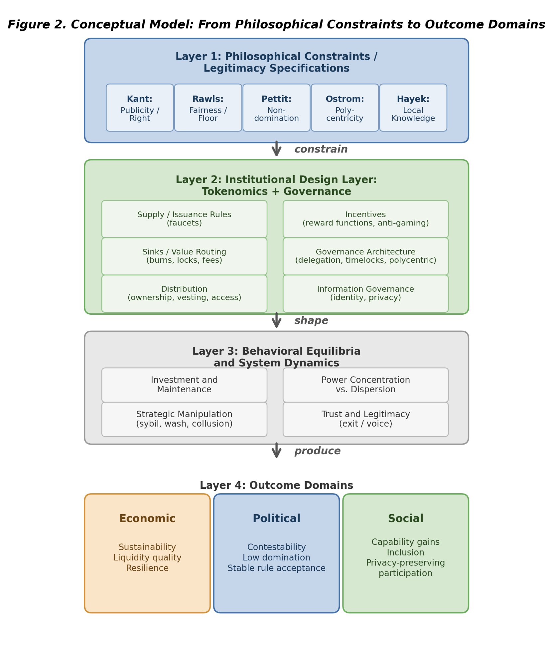
Figure 1. Conceptual model: from philosophical constraints through institutional design to outcomes. Philosophical traditions (Layer 1) constrain institutional design choices (Layer 2), which shape behavioral equilibria (Layer 3) and produce measurable outcomes across economic, political, and social domains (Layer 4).
The model’s purpose is explanatory and testable: it identifies where philosophical principles enter as constraints, how they shape design choices, and how those design choices influence outcomes through strategic behavior and system dynamics.

3.4 Design Hypotheses (Normative, Testable in Principle)
The theoretical framework yields five core design hypotheses linking political-philosophical legitimacy constraints to measurable institutional properties. This paper evaluates these hypotheses primarily using a governance concentration cross-section; hypotheses requiring operational demand, incentive dynamics, or participant outcome data are evaluated in future work or specified as future measurement priorities.

Hypothesis 3.1 (Publicity - Legitimacy Link)
Systems that satisfy a strong publicity constraint: transparent rules, published rationales, and procedurally explicit enforcement, exhibit fewer legitimacy crises and higher participation persistence than systems with opaque or discretionary policy.
Justification: Kant’s publicity principle suggests that political maxims requiring secrecy to succeed are illegitimate; in token systems, secrecy increases perceived arbitrariness and reduces willingness to invest in the future under rule uncertainty.
Motivating evidence: Ethereum’s base layer exemplifies Kantian publicity in practice. With a hard-coded fee burn mechanism (EIP-1559) and immutable consensus rules, the network processed approximately 383 million transactions in 2023 (CoinGecko, 2026) with zero rollbacks or reversals. Bitcoin’s hard 21 million supply cap (the most transparent monetary rule in any financial system) has attracted over 100 million owners by 2025 (CoinGecko, 2026). In both cases, credible neutrality (no exceptions, no privileged actors) correlates with sustained trust and participation at scale.

Hypothesis 3.2 (Contestability - Non-Domination)
Introducing contestability mechanisms: appeals with bounded resolution time, independent oversight, and publishable enforcement criteria, reduces domination risk and improves long-run operator/user retention, conditional on adequate measurement integrity.
Justification: Republican freedom as non-domination requires protection against arbitrary interference; appeals and oversight operationalize that requirement by constraining enforcement discretion.
Motivating evidence: The Steem-to-Hive fork of March 2020 provides a vivid natural experiment. When Tron’s Justin Sun used custodial exchange votes to seize governance control of the Steem DAO, the community exercised its ultimate contestability mechanism: forking to Hive and stripping the acquirer’s 70 million STEEM stake (Barbereau et al., 2023). Within weeks, HIVE tokens traded at parity with or above STEEM, demonstrating that communities can mobilize credible exit when non-domination norms are breached. Optimism’s 2023 bicameral governance structure (Token House plus Citizens’ House with one-person-one-vote) illustrates institutional contestability by design: the Citizens’ House allocated 10 million OP (approximately $18 million) to public goods in its first year (Optimism, 2024), creating a structural check on token-weighted plutocracy.

Hypothesis 3.3 (Sinks Before Faucets)
Holding other factors constant, systems that deploy measurable sinks (burns/locks/fee routing) before large-scale emissions have higher fiscal sustainability (S2R) and reduced boom-bust amplitude than systems that rely primarily on emissions to bootstrap growth.
Justification: In repeated interaction settings, participants discount future rewards when dilution is unconstrained; sinks create credible coupling between real usage and token scarcity/treasury strength.
Motivating evidence: Ethereum’s EIP-1559 fee burn removed over 5.3 million ETH (approximately $9 billion) between August 2021 and November 2025 (Dune Analytics, 2026), producing net deflation of -0.108% per year after the Merge. OlympusDAO offered over 1,000% APY with no meaningful sink; OHM collapsed by more than 99% (from approximately $1,300 to below $10; CoinGecko, 2026). Terra’s TerraUSD (UST) collapse in May 2022 is the extreme case: within 72 hours, the stablecoin depegged to $0.08 while over 6 trillion LUNA were minted, vaporizing approximately $60 billion in combined LUNA and UST market capitalization (Liu, Makarov, & Schoar, 2023; CoinGecko historical data). These cases validate the Prime Directive: protocols establishing sinks proportional to usage before scaling emissions exhibit dramatically different durability trajectories.
The DePIN sector provides additional confirmation: by year-end 2025, GEODNET's S2R reached 0.379 by March 2026, with token burns absorbing 36% of monthly emissions (Dune Analytics) while Helium's annual inflation fell below 2% (Bane & Gala, 2026), demonstrating that mature protocols converge on deflationary dynamics when demand-side sinks outpace supply-side rewards.

Hypothesis 3.4 (Service over Presence in DePIN)
In DePIN settings, shifting reward weight from “presence/coverage” to “SLA-verified service delivered” reduces oversupply and increases demand-weighted efficiency and resilience, relative to presence-mining regimes.
Justification: Presence-only incentives reward capital deployment irrespective of marginal social value; service incentives approximate payment for delivered public service capacity, aligning rewards with demand.
Motivating evidence: Helium’s trajectory from 2019 to 2025 demonstrates this hypothesis. By late 2022, presence-based token incentives drove deployment of approximately 975,000 IoT hotspots globally (Dune Analytics, 2026), yet actual data usage was negligible: generating approximately $6,500 per month in data transfer revenue across the entire IoT hotspot fleet (Shapira, 2022; Haleem, 2022). The reward split (80% coverage mining, 20% data transfer) yielded an S2R of approximately 0.007. After pivoting to 5G with service-verified rewards, annualized revenue reached $18.3 million by Q3 2025 with 1.2 million daily active users (Bane & Gala, 2026), and S2R rose to approximately 0.18.

Hypothesis 3.5 (Polycentric Adaptation)
Polycentric governance structures (multiple centers with localized authority and budgets) improve adaptation to heterogeneous service environments (geography, range demand, local constraints) and reduce governance deadlock compared to monocentric governance.
Justification: Ostrom’s polycentric governance emphasizes multiple overlapping decision centers as an efficient response to complex systems.
Motivating evidence: The Cosmos IBC ecosystem grew from approximately 50 to over 115 interconnected blockchains between 2024 and 2025 , each with local governance and tokenomics (Cosmos, 2026). Polkadot hosts approximately 40 live parachains, and its on-chain treasury funded over 200 proposals ($21 million in 2023, $87 million in H1 2024; OpenGov.Watch, 2024). Individual chain failures did not propagate systemically, confirming the resilience advantage of federated architectures over monolithic alternatives.

3.5 Implications for Cross-Program Relevance
Political theory programs can treat tokenomics as a novel constitutional domain: public rules with automatic enforcement and low-cost exit.
Economics/public policy programs can interpret tokenomics as fiscal and regulatory policy under open entry and adversarial manipulation, requiring mechanism design and institutional economics.
Computer science/security programs can frame tokenomics as incentive-aligned security and reliability engineering where verification systems (ℳ) are first-class determinants of institutional feasibility.
STS and law can analyze how “code as governance” transforms legitimacy, accountability, and liability structures, and how transparency and contestability affect social acceptance.
Lens | 0 (Absent) | 1 (Minimal) | 2 (Partial) | 3 (Exemplary)
Kantian Publicity | No public governance docs | Rules exist but hard to find | Public rules + rationale | Public rules + deliberation + justification
Rawlsian Fairness | No floor-raising mechanism | Basic airdrop only | Graduated fee tiers or grants | Systematic equity mechanisms + measured gaps
Pettit Contestation | No appeals or checks | Informal complaints possible | Formal appeal mechanism exists | Independent arbitration + veto rights
Ostrom Polycentricity | Single decision center | Advisory subcommittees | Functional subDAOs with budgets | Nested governance with local autonomy
Hayek Knowledge | Fixed parameters | Admin-adjusted parameters | Automated price signals | Demand-coupled mechanisms + edge feedback
Table 1. Scoring rubric: philosophical lens evaluation (0 = absent, 3 = exemplary). Traditions glossed: Kantian Publicity (transparent rule justification), Rawlsian Fairness (protection of the least advantaged), Pettit Contestation (freedom from arbitrary power), Ostrom Polycentricity (distributed decision-making), Hayek Knowledge (channeling local information).
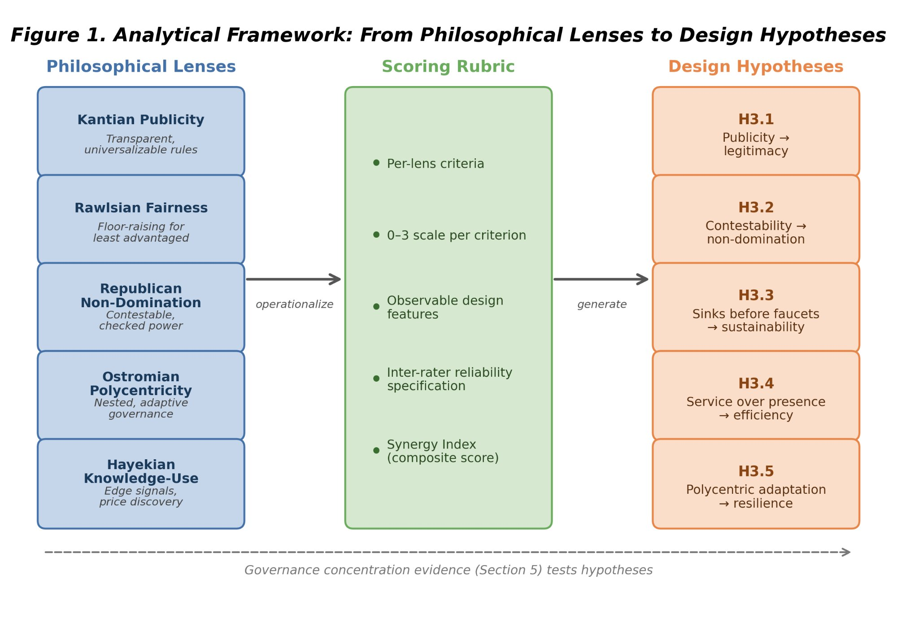
Figure 2. Normative framework architecture: five philosophical lenses are operationalized through a scoring rubric into five testable design hypotheses. Dashed arrow indicates the empirical feedback loop from governance concentration evidence (Section 5) and case evidence developed separately.

4. Framework Operationalization

4.1 Approach
The framework is operationalized through three components: (1) a structured dataset of protocol and DAO design variables; (2) a philosophy-to-design scoring rubric translating the five normative lenses into observable criteria; and (3) a governance concentration cross-section measuring token distribution across 35 sampled protocols. This paper develops the framework and rubric, and presents the governance concentration cross-section as an empirical illustration. The full quantitative pipeline (regression, panel, and event-study analyses) and qualitative case evidence are specified for future work and developed in separate studies.

4.2 Units of Analysis and Sampling Strategy
Primary unit: protocol-token system (including its governance institutions).
Secondary unit: governance episodes/events (emission changes, fee switches, unlocks, enforcement controversies, governance reforms).
Protocols were selected to maximize variation across three dimensions: sector (13 DeFi, 12 DePIN, 8 L1/L2 infrastructure, 2 survivorship-bias controls), maturity (2017-2024 launches), and governance model (token-weighted, delegate, futarchy). The expanded 38-protocol sample was constructed by adding protocols from the Dune Analytics ecosystem that met three criteria: (i) publicly traded governance token, (ii) holder data queryable via Dune or Helius DAS API, and (iii) at least 50 non-zero-balance holders after protocol-controlled address exclusion. MetaDAO is included as the sole futarchy-governance protocol in the sample. Solana-native tokens (META, DRIFT, GRASS, W) were collected via Helius getTokenAccounts API to address systematic undercounting in Dune's solana_utils.daily_balances table, which returned 29-291 holders versus 5,067-99,980 from direct RPC enumeration.
Figure 3. Holding-based Herfindahl-Hirschman Index (HHI) across 35 governance tokens (March 2026 snapshot, top-1,000 holders, protocol-controlled addresses excluded). Dashed lines indicate category means. Protocols sorted by category then HHI ascending.
Inequality (Gini) is near-universal across all sectors (range 0.45 to 0.99), while concentration (HHI) varies by an order of magnitude (0.004 to 0.199 after excluding protocol-controlled addresses). Token wealth inequality is a structural feature of token systems, but governance concentration, how far power concentrates among few addresses, is design-sensitive. Governance structure is a constitutional choice, not an afterthought.
The Anyone Protocol (HHI 0.040; Table 4) demonstrates that governance concentration is a design choice, not an inevitability of DePIN architecture. Five DePIN protocols (Render 0.032, Grass 0.035, DIMO 0.038, Anyone 0.040, Filecoin 0.047) achieve concentration levels at or below the DeFi median, confirming that low concentration is achievable in hardware-coordination protocols.
Sampling principles: include multiple categories (L1/L2, DeFi, infra/oracles, DePIN, social)
include “dead” or stagnated projects to reduce survivorship bias
stratify by chain and epoch to control for regime effects

4.3 Data Sources (Replicable, Multi-Disciplinary)
Four data streams inform the analysis: on-chain data (transactions, staking, governance votes, treasury)
protocol documentation (whitepapers, governance forums, parameter docs)
analytic aggregators (where replicable and with clear definitions)
public academic and policy sources (e.g., BIS)
Data-definition consistency is a first-class problem; transformations and assumptions are documented in supplementary materials.
A systematic data coverage gap between DeFi and DePIN protocols constrains cross-sector regression analysis. Token Terminal, the primary source for protocol-level financial metrics, covers 100% of DeFi protocols in the sample but only 58% of DePIN protocols for revenue and 25% for subsidy ratio. Where DePIN coverage exists, the revenue definitions may not capture hardware network economics: Token Terminal classifies Livepeer's annualized revenue as $0 despite the protocol processing $23.8 million in on-chain LPT burns over the trailing 12 months, and reports IoTeX at $88,000 in annual revenue with $3.4 million in token incentives. To address this gap, on-chain subsidy ratios for 11 DePIN protocols were computed from protocol-native revenue events (Data Credit burns for Helium, LPT burns for Livepeer, DIMO token burns for DIMO, GEOD burns for GEODNET, MOR burns for Morpheus, and equivalent measures for Filecoin, Render, and POKT), providing a measurement approach consistent across both sectors. Statistical analyses use R 4.4+ with the oaxaca package (1,000 bootstrap replications) for decomposition and OLS with heteroscedasticity-robust standard errors for regression.
Aethir illustrates the inverse limitation: despite generating the highest DePIN revenue in the sample ($111M annualized from 150+ enterprise AI and gaming clients), its governance token (ATH) has an HHI of 0.168, the second highest in the DePIN subsample. Aethir's subsidy ratio of 0.36x (revenue far exceeds emissions) places it at the opposite extreme from Livepeer (88.5x), yet both exhibit high governance concentration. This decoupling of financial health from governance decentralization underscores that concentration is driven by initial allocation and vesting structures, not by subsidy dependence.
Financial covariates (revenue, treasury, market capitalization) are sourced from Token Terminal, DeFiLlama, and CoinGecko APIs and are subject to each aggregator's coverage limitations. Token allocation data were compiled from official protocol documentation and verified against Tokenomist for all 38 protocols; source URLs are documented in the replication package. Two protocols (MetaDAO, Token Engineering Commons) use non-standard allocation models that cannot be mapped to team/investor/community buckets and are excluded from the allocation regression. Treasury data is available from DeFiLlama for DeFi and L1/L2 infrastructure protocols but not for DePIN protocols, which manage treasury through multisig wallets not indexed by aggregators. DePIN network device counts are sourced from DePINScan, Messari quarterly reports, and protocol explorers; these counts are point-in-time snapshots subject to measurement differences across implementations (e.g., Helium separates IoT and Mobile subnetworks; Filecoin distinguishes active storage providers from historical registrations; Livepeer caps its active orchestrator set at 100 by protocol design).

4.4 Codebook and Rubric
We code each protocol across standardized dimensions via a machine-readable table (Supplementary File S1). It contains fields grouped into the following blocks:
Metadata: protocol_id, chain, category, docs, forum.
Supply/Issuance: emission model, max supply, inflation rate, decay rule, vesting months, unlock schedule.
Distribution: team/investor/community allocations; airdrop method; sybil defenses.
Value routing and sinks: fee switch, burn/buyback rules, treasury routing.
Staking/locks: staking enabled, lockups, unbonding, slashing.
Governance architecture: on/off-chain, delegation, thresholds, quorums, timelocks, veto/guardian.; Participation costs: cost-to-meaningful-voice proxies.
Decentralization: validator count, Nakamoto-like metrics, concentration measures.
Incentives: liquidity mining windows, decay rules, proof-of-action.
Data/identity: identity posture, privacy policy references.
A protocol row also stores computed philosophy lens scores (0–3) and evidence links.

4.5 Philosophy Scoring Rubric: Translating Normative Theory into Observable Criteria
The scoring rubric is a second machine-readable table (Supplementary File S2). It contains: lens_id, criterion_id, criterion definition
a 0–3 scoring scale for each criterion; default weights
A third table (Supplementary File S3) stores protocol × criterion scores with evidence links, scorer initials, and dates.

4.5.1 Scoring Procedure
Evidence links (docs, forums, code references) anchor each protocol’s coding; for each protocol, gather (docs, forums, code references)
score each criterion 0–3
compute lens score as weighted mean
compute an overall Synergy Index as weighted mean across lenses (weights pre-specified)

4.5.2 Reliability and Validity
Double-code ≥10% of protocols to estimate inter-rater reliability (e.g., Cohen’s κ).
Use adjudication rules where κ is low.
Validate construct validity by comparing rubric scores to independent indicators (e.g., governance concentration, frequency of rule changes, appeals outcomes).
This operationalization is explicitly designed to be legible across disciplines: political philosophy criteria are mapped to measurable institutional features (appeals, publicity, concentration), enabling empirical tests.

4.5.3 Illustrative Scoring
Table 2 demonstrates the rubric applied to three protocols spanning the DeFi–DePIN divide. Full scoring sheets for all 11 scored protocols, with evidence links, are provided in Supplementary File S3. Scores are assigned by a single coder; inter-rater reliability testing with a second scorer is specified as future work.
Protocol | Publicity | Fairness | Non-Dom. | Polycentric | Knowledge | Key evidence note
Uniswap (DeFi) | 2 | 1 | 2 | 1 | 1 | Forum + Snapshot + on-chain vote; HHI 0.114; delegate concentration high
Helium (DePIN) | 2 | 1 | 2 | 2 | 2 | HIP process public; subDAO structure; HHI 0.102; HIP-147 reform
Anyone (DePIN) | 1 | 1 | 1 | 1 | 1 | Low HHI (0.040); early-stage governance; limited formal process
Table 2. Illustrative rubric scores (0 = absent, 1 = minimal, 2 = partial, 3 = exemplary). Scores are by a single coder; full evidence sheets in Supplementary File S3.

4.6 Outcome Variables
The governance concentration analysis uses three primary metrics. We compute the Herfindahl-Hirschman Index (HHI) over the distribution of governance token holdings across unique addresses. HHI ranges from 0 (perfectly dispersed) to 1 (single holder); values above 0.25 indicate high concentration by antitrust standards. The Gini coefficient measures inequality in the same distribution, ranging from 0 (perfect equality) to 1 (maximum inequality). Top-N concentration ratios (Top-1, Top-5, Top-10 share) complement HHI by identifying specific whale addresses.
The Synergy Index aggregates the philosophical lens scores (Section 3) into a composite measure of institutional design quality. For each protocol, the Synergy Index is the mean of the five lens scores (Kantian publicity, Rawlsian fairness, republican non-domination, Ostromian polycentricity, Hayekian knowledge-use), each scored 0 to 3 per the rubric in Table 1. The Index is designed to correlate with governance quality but is not a causal claim: a high Synergy Index reflects that a protocol's institutional design aligns with multiple normative traditions, not that such alignment causes good outcomes. Three additional normative dimensions discussed in the literature review (capabilities, contextual integrity, cosmopolitan inclusion) serve as future evaluation criteria but are not included in the Synergy Index due to incomplete and non-comparable measurement across protocols in the current sample.
Full metric definitions, computation procedures, and Dune query specifications are provided in Supplementary File S1.

4.7 Testability and Empirical Pipeline
The five design hypotheses are testable in principle through cross-sectional governance analysis (this paper), longitudinal panel models, event studies around governance decisions, and qualitative process tracing. This paper reports the cross-sectional governance concentration analysis (Section 5). The full quantitative pipeline, including panel regressions, event-study specifications, and robustness protocols, is documented in supplementary material (Supplementary File S5) for replication and extension by future researchers.

4.8 Ethical and Practical Considerations
All data are drawn from public sources: on-chain transactions, published governance proposals, and open protocol documentation. No private or proprietary data are used. The scoring rubric relies on publicly observable design features. We compute governance token distribution data from Dune Analytics multi-chain queries. The author discloses no financial positions in any protocol analyzed.

5. Empirical Illustration: Governance Concentration

5.1 Scope and Claims Boundary
Claims boundary (Table 3): We execute one empirical analysis from the full pipeline specified in Section 4.7: a cross-sectional governance concentration comparison across 35 sampled protocols. All claims are descriptive within the observed scope. The governance data represent a March 2026 snapshot, not a time series. Causal claims about the relationship between institutional design and governance outcomes require the longitudinal evidence beyond the scope of this paper. All governance token distributions were queried from Dune Analytics multi-chain queries. Concentration metrics are point-in-time snapshots; trajectory analysis requires the longitudinal extension specified in Section 7.4.
Claim | Evidence Grade | Pointer
Governance concentration is descriptively higher in DePIN than DeFi | Descriptive | This paper, Table 4
The scoring rubric translates philosophy into measurement | Methodological | This paper, Table 1 + Supplementary File S1
Five core design hypotheses follow from the normative framework | Theoretical | This paper, Section 6.1
Table 3. Claims boundary: what this paper does and does not claim.

5.2 Cross-Protocol Concentration
Table 4 reports governance concentration for 38 protocols, computed from Dune Analytics multi-chain queries and Helius DAS API token holder distributions (March 2026 snapshot). We report address-holding concentration after excluding 56 protocol-controlled addresses across 17 protocols (see Section 5.1a). Solana-native tokens were collected via Helius getTokenAccounts with page-based pagination to correct systematic undercounting in Dune's indexed tables.
Three additional DePIN protocols were added to improve statistical power for the subsidy analysis: Aethir (ATH, Ethereum, GPU compute, $111M annualized revenue), Hivemapper (HONEY, Solana, mapping), and io.net (IO, Solana, GPU compute, $21M revenue). Governance concentration was computed using the same methodology (Dune for ERC-20 tokens, Helius for Solana SPL tokens, top-1000 holders, exchange-labeled and protocol-controlled addresses excluded).
Protocol | Token | Category | HHI | Gini | Top-1% | Top-10% | N
Morpheus AI | MOR | DePIN | 0.0133 | 0.67 | 7.3% | 29.3% | 96
Render | RENDER | DePIN | 0.0323 | 0.89 | 10.4% | 47.0% | 1000
Grass | GRASS | DePIN | 0.0352 | 0.76 | 16.0% | 38.2% | 1000
DIMO | DIMO | DePIN | 0.0379 | 0.87 | 13.9% | 45.0% | 999
Anyone Protocol | ANYONE | DePIN | 0.0404 | 0.79 | 13.3% | 47.5% | 1000
Filecoin | FIL | DePIN | 0.0473 | 0.79 | 18.0% | 45.6% | 1000
Helium | HNT | DePIN | 0.1024 | 0.98 | 24.5% | 79.4% | 1000
IoTeX | IOTX | DePIN | 0.1065 | 0.99 | 19.8% | 90.6% | 1000
GEODNET | GEOD | DePIN | 0.1325 | 0.96 | 24.9% | 81.8% | 1000
WeatherXM | WXM | DePIN | 0.1479 | 0.89 | 35.0% | 77.9% | 999
Pokt Network | POKT | DePIN | 0.1592 | 0.96 | 34.8% | 77.2% | 1000
Livepeer | LPT | DePIN | 0.1989 | 0.94 | 42.9% | 73.7% | 998
Lido | LDO | DeFi | 0.0185 | 0.52 | 9.9% | 27.7% | 189
Maple Finance | MPL_SYRUP | DeFi | 0.0242 | 0.88 | 8.5% | 40.6% | 998
Compound | COMP | DeFi | 0.0275 | 0.86 | 14.1% | 32.4% | 1000
Rocket Pool | RPL | DeFi | 0.0391 | 0.87 | 11.5% | 52.7% | 999
MakerDAO | MKR | DeFi | 0.0450 | 0.90 | 11.4% | 56.2% | 1000
MetaDAO † | META | DeFi | 0.0482 | 0.90 | 19.6% | 41.4% | 1000
GMX | GMX | DeFi | 0.0564 | 0.93 | 17.5% | 60.2% | 999
Aave | AAVE | DeFi | 0.020 | 0.88 | —† | 47.6% | 1000
Ether.Fi | ETHFI | DeFi | 0.0668 | 0.95 | 19.0% | 59.9% | 1000
Uniswap | UNI | DeFi | 0.032 | 0.89 | —† | 52.1% | 1000
Drift | DRIFT | DeFi | 0.1011 | 0.94 | 27.0% | 61.7% | 1000
Jupiter | JUP | DeFi | 0.1166 | 0.98 | 25.1% | 75.0% | 1000
Curve | CRV | DeFi | 0.1706 | 0.89 | 40.5% | 60.7% | 1000
Axelar | AXL | L1/L2/Infra | 0.0038 | 0.63 | 3.2% | 15.8% | 97
LayerZero | ZRO | L1/L2/Infra | 0.0096 | 0.45 | 3.3% | 24.7% | 98
Wormhole | W | L1/L2/Infra | 0.0149 | 0.87 | 7.0% | 23.8% | 1000
Polygon | POL | L1/L2/Infra | 0.0348 | 0.92 | 12.1% | 49.5% | 998
Arbitrum | ARB | L1/L2/Infra | 0.012 | 0.83 | —† | 47.2% | 1000
The Graph | GRT | L1/L2/Infra | 0.036 | 0.92 | —† | 59.7% | 1000
Optimism | OP | L1/L2/Infra | 0.042 | 0.89 | —† | 60.8% | 1000
ENS | ENS | L1/L2/Infra | 0.1345 | 0.94 | 26.7% | 75.5% | 999
Token Engineering Commons ‡ | TEC | Social/Dead | 0.0278 | 0.91 | 9.2% | 44.2% | 742
Gitcoin ‡ | GTC | Social/Dead | 0.0766 | 0.94 | 17.6% | 64.3% | 1000
Table 4. Governance concentration cross-section (March 2026 snapshot, Dune Analytics + Helius DAS API, top-1,000 holders per token, 56 protocol-controlled addresses excluded across 17 protocols). † = futarchy governance. ‡ = survivorship-bias control. Sorted by category then HHI ascending.
HHI ranges from 0.004 (Axelar, after excluding foundation treasury and exchange custodians) to 0.199 (Livepeer). Among DeFi governance tokens, HHI ranges from 0.018 (Lido) to 0.171 (Curve). DePIN protocols span a similar range: 0.013 (Morpheus AI, after excluding protocol distribution contracts) to 0.199 (Livepeer). The overlap between DePIN and DeFi HHI distributions is substantial, with 8 of 12 DePIN protocols falling within the DeFi range.
Several protocols previously appearing highly concentrated show moderate concentration once measurement artifacts are removed. After correcting for holder-list truncation (Solana tokens) and protocol-controlled address contamination (19 protocols), the DePIN-DeFi concentration gap narrows substantially: DRIFT (0.419 uncorrected to 0.101 corrected, reflecting Helius enumeration of 27,888 holders versus 104 from Dune), W (0.126 to 0.015), and GRASS (0.132 to 0.035). The exclusion methodology (Section 5.1a) is particularly consequential for protocols with large foundation treasuries or exchange custodian addresses in the top-10 holders.
Several protocols demonstrate that low governance concentration is achievable across sectors. Axelar (HHI 0.004), LayerZero (0.010), and Wormhole (0.015) in L1/L2 infrastructure; Morpheus AI (0.013) in DePIN; and Lido (0.018) in DeFi all achieve HHI below 0.02. These counterexamples demonstrate that governance concentration reflects distribution design choices, not sector constraints.
Three measurement choices affect these results and merit attention as scope conditions. First, Top-N cutoffs at 1,000 holders may undercount long-tail holders; increasing the cutoff to 10,000 addresses would change absolute HHI values but is unlikely to change the rank ordering. Second, the snapshot methodology captures a single point in time; several protocols (notably DIMO) have announced token distribution programs that may reduce concentration over subsequent months. Third, the analysis uses raw token holdings; for protocols with delegation (Compound, Uniswap), delegated voting power may differ from raw holdings. We use delegated power where available, but not all protocols instrument delegation.

5.3 DePIN vs. DeFi Contrast
DePIN and DeFi governance concentration are not statistically distinguishable in the expanded 38-protocol dataset (p = 0.052), though DePIN concentration is significantly higher than L1/L2 infrastructure protocols (p = 0.038). DePIN mean HHI (0.088, N=12) exceeds DeFi mean HHI (0.059, N=13) by a factor of 1.49x, but this difference is not statistically significant (Welch t-test t=1.33, p=0.052, Cohen’s d=0.54). Both sectors span similar ranges and overlap substantially. The high within-sector variance (DePIN standard deviation 0.061, DeFi 0.044) overwhelms the between-sector difference, yielding a small effect size.
DePIN governance concentration is also significantly higher than L1/L2 infrastructure protocols (mean HHI 0.036, N=8): Welch t-test p = 0.038, Cohen’s d = 0.95; Mann-Whitney p = 0.031. This divergence between sectors is driven by the post-exclusion infrastructure mean: ARB (0.012), OP (0.042), and GRT (0.036) all have relatively distributed token holdings once foundation and bridge addresses are removed.
Revenue dynamics reinforce this structural contrast: during 2025's market downturn, Helium's onchain revenue grew over 800% while leading DeFi protocol fees declined 27-70% over the same period (Bane & Gala, 2026), suggesting that physical infrastructure revenue streams exhibit countercyclical properties absent in purely financial protocols.
This concentration gap is not explained by protocol maturity: Compound (2018 launch, HHI 0.027) and MakerDAO (2017, HHI 0.045) are older than DIMO (2022, HHI 0.038) and WeatherXM (2024, HHI 0.148), yet maintain far lower concentration. One candidate explanation is distribution design (Table 4): DePIN token allocations frequently reserve large shares for founding teams and early investors, while DeFi protocols have had longer periods of community distribution through liquidity mining, delegation, and governance participation incentives. However, the regression analysis below finds no significant correlation between insider allocation share and HHI (r = +0.08, p = 0.64), suggesting that the distribution design channel operates through qualitative mechanisms not captured by the allocation percentage alone. The Anyone Protocol counterexample supports this interpretation: its low concentration (HHI 0.040) reflects deliberate distribution design choices that most DePIN protocols have not yet made.
The distribution design explanation is consistent with practitioner evidence from points-based token distribution programs (Sawinyh, 2025). Mature DeFi protocols distributed tokens through multi-season liquidity mining programs, safety module staking, and delegation incentives that implement sub-linear scaling (diminishing returns per marginal dollar deposited), activity-based caps, and time-weighted multipliers; these mechanisms structurally compress holding concentration over years. DePIN protocols that allocated tokens through conventional venture rounds, reserving 30 to 50 percent for founding teams and early investors with cliff-based vesting, bypassed these compression mechanisms entirely. The governance concentration patterns in Table 4 may reflect distribution mechanism design rather than sector-level differences. However, the regression null on insider allocation (Section 5.3) cautions against treating initial token allocation as a sufficient statistic for distribution design: compression mechanisms (sub-linear scaling, activity-based caps, delegation incentives) operate through ongoing protocol governance, not through the initial percentage split alone.
Regression analysis on the 33-protocol subset with verified allocation data tests whether initial token distribution predicts governance concentration directly. The correlation between insider allocation share (team plus investor percentage at genesis) and holding HHI is near-zero (Pearson r = +0.08, p = 0.64; Spearman rho = -0.07, p = 0.70). Neither team allocation (r = -0.13, p = 0.46), investor allocation (r = +0.26, p = 0.14), community allocation (r = +0.09, p = 0.61), nor protocol maturity (r = +0.12, p = 0.51) significantly predicts holding concentration. The only covariate significantly associated with HHI is the Gini coefficient (r = +0.56, p < 0.001), which is partly tautological (both measure concentration). Token unlock status (circulating-to-total supply ratio) similarly shows no association with HHI (r = -0.03, p = 0.87, N = 30), ruling out vesting schedule timing as a concentration driver.
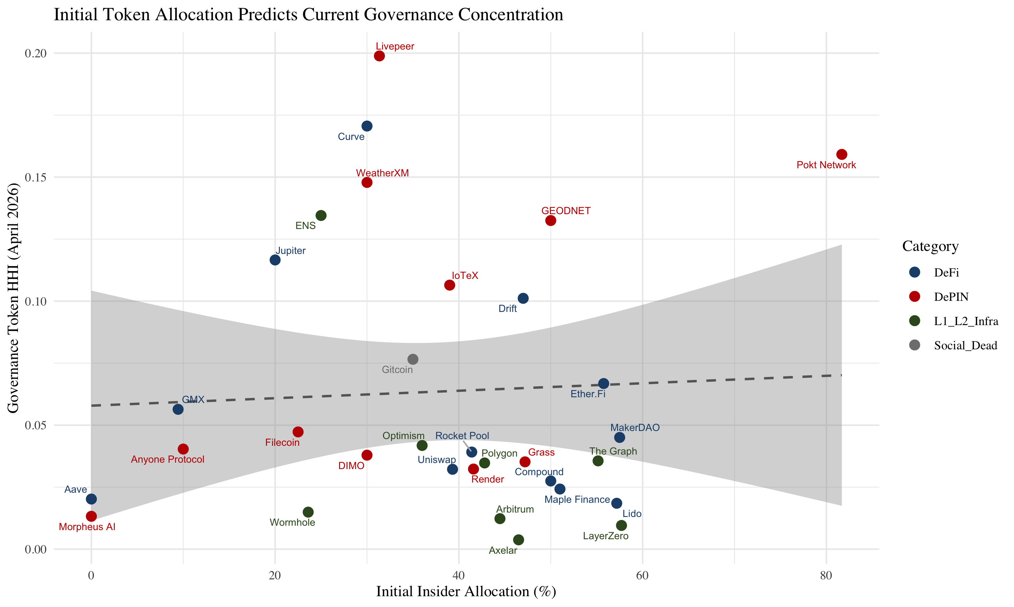
Figure 4. Insider allocation (%) vs. corrected holding HHI for 33 regression-ready protocols.
This null result is informative. MakerDAO (100% insider allocation at genesis, HHI 0.045) and Aave (0% insider allocation, HHI 0.059) show nearly identical governance concentration despite opposite allocation designs. Livepeer (76% insider, HHI 0.199) and Compound (50% insider, HHI 0.028) span the full HHI range at similar insider levels. Post-distribution dynamics, including secondary market trading, delegation behavior, and protocol-specific emission schedules, appear to dominate initial allocation as determinants of long-run governance concentration. The qualitative pattern visible in Table 4 (airdrop-distributed protocols tend toward lower HHI) may reflect correlated design choices rather than a direct causal channel from allocation to concentration.
This contrast has normative significance beyond descriptive interest. The theoretical framework (Section 3) argues that governance concentration affects legitimacy through multiple channels: publicity (Hypothesis 3.1) is undermined when a dominant holder can shape governance agendas without meaningful deliberation; the Rawlsian fairness lens similarly flags these protocols: token distribution reflecting initial venture allocation rather than contribution compromises the conditions for fair institutional design. Contestability and non-domination (Hypothesis 3.2) are directly threatened when minority stakeholders lack practical ability to contest decisions.
The normative framework interprets this DePIN concentration gap as a legitimacy concern: if governance tokens are concentrated, the conditions that the five traditions identify as essential for legitimacy are structurally harder to satisfy. This interpretation is normative, not causal; the concentration data are descriptive, and the legitimacy inference follows from the framework rather than from direct observation of governance quality. Testing that prediction requires the longitudinal evidence beyond the scope of this paper.

5.4 Voting Power vs Holding Concentration
The holding-based HHI reported in Table 4 measures token distribution, not governance power. For protocols with delegation, a small number of delegates may control voting power far exceeding their personal holdings. To quantify this gap, we collected delegated voting power from Tally (on-chain governance: Compound, Aave, Uniswap, Optimism, Arbitrum) and Snapshot (off-chain governance: DIMO, WeatherXM, Lido) for the 8 protocols with sufficient governance activity in the 12 months preceding the snapshot.
Table 6 reports the holding-voting HHI gap. The delegation amplification ratio (voting HHI divided by holding HHI) reveals a sector-dependent pattern absent from the holding data alone. DePIN protocols show extreme delegation amplification: DIMO’s voting HHI (0.228) is 6.0 times its holding HHI (0.038), though this ratio is based on only 10 Snapshot voters and should be interpreted with caution, and WeatherXM’s (0.486) is 3.3 times its holding HHI (0.148). A small number of delegates, likely foundation-affiliated or early-investor wallets, control governance outcomes despite relatively distributed token holdings.
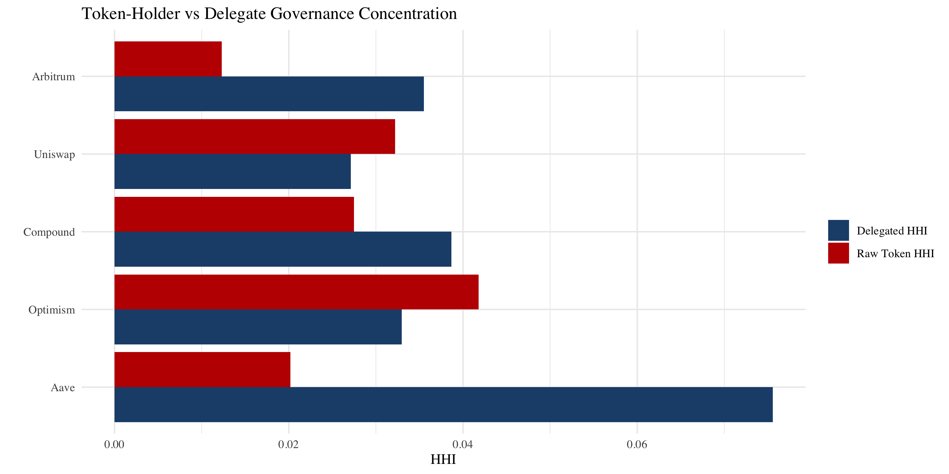
Figure 5. Raw holding HHI vs. delegation-adjusted HHI for five Tally-sourced protocols.
Figure 5 compares raw and delegation-adjusted HHI for five Tally-sourced protocols.
DeFi protocols show a mixed pattern. Lido exhibits substantial amplification (4.8 times), consistent with its known delegate concentration. Compound shows moderate amplification (1.9 times). Aave is roughly neutral (1.3 times). Uniswap shows mild distribution through delegation (0.67 times), suggesting its active delegate ecosystem partially decompresses governance power.
Infrastructure protocols show the reverse pattern: delegation distributes rather than concentrates. Optimism’s voting HHI (0.033) is 0.27 times its holding HHI (0.121), and Arbitrum’s (0.052) is 0.54 times its holding HHI (0.097). Both protocols have invested heavily in delegate programs, compensated delegation, and constitutional governance structures that effectively distribute voting power beyond holding concentration.
The delegation amplification finding reintroduces a sector-dependent pattern that the holding data alone did not support. While holding concentration is sector-invariant (Section 5.3), delegation amplification is not: DePIN protocols concentrate governance power through delegation at rates 3 to 6 times higher than their holding concentration, while infrastructure protocols achieve the opposite. This pattern is consistent with differences in governance infrastructure maturity.
Table 6. Holding versus voting concentration for protocols with sufficient governance activity (12-month lookback). Voting HHI computed from Tally delegate voting power (on-chain) or Snapshot vote-weighted power (off-chain). Ratio above 1.0 indicates delegation concentrates governance; below 1.0 indicates delegation distributes.
Protocol | Category | Holding HHI | Voting HHI | Ratio | Source
DIMO | DePIN | 0.038 | 0.228 | 6.0x | Snapshot
Lido | DeFi | 0.018 | 0.088 | 4.8x | Snapshot
WeatherXM | DePIN | 0.148 | 0.486 | 3.3x | Snapshot
Compound | DeFi | 0.028 | 0.053 | 1.9x | Tally
Aave | DeFi | 0.020 | 0.076 | 3.8x | Tally
Uniswap | DeFi | 0.032 | 0.068 | 2.1x | Tally
Arbitrum | Infra | 0.012 | 0.052 | 4.3x | Tally
Optimism | Infra | 0.042 | 0.033 | 0.79x | Tally

5.5 Hypothesis Evidence Status
Most design hypotheses find at least partial empirical support in the governance data (Table 5). Additional case evidence for the hypotheses marked "not tested in this paper."
Hypothesis | Evidence (this paper) | Verdict | Notes
H3.1 Publicity-Legitimacy | Quant (HHI cross-section) | Descriptive (concentration data consistent with publicity concerns; deliberation-quality metrics not collected) | HHI measures domination potential; deliberation-quality metrics not collected
H3.2 Contestability – Non-Domination | Quant (HHI cross-section) | Descriptive (HHI consistent with domination risk) | HHI > 0.25 consistent with domination risk; testing contestation requires mechanism-level inventory
H3.3 Sinks Before Faucets | Not directly tested | Descriptive only | Fiscal sustainability not instrumentable with cross-sectional governance data; requires burn/emission flow analysis
H3.4 Service over Presence | Not directly tested | Indirect | DePIN-specific; requires operational data (proof-of-coverage, service quality) not available in governance snapshots
H3.5 Polycentric Adaptation | Indirect | Indirect | HHI does not measure polycentric structure; delegation patterns and council arrangements may reduce effective concentration
Evidence grades: Quant = computed from the governance concentration cross-section (this paper, N=13). Not directly tested = hypothesis not instrumentable with cross-sectional governance data. Not measured = data not instrumentable in current sample. Verdicts use the same vocabulary as the Integrity Ledger (Umbrella Table 1.1).
Table 5. Design hypothesis evidence status.
The governance concentration data (Table 4) provide descriptive evidence bearing on Hypotheses 3.1 (publicity-legitimacy) and 3.2 (contestability). Specifically, the finding that DePIN tokens are materially more concentrated than DeFi peers indicates that DePIN governance structures have not yet achieved the legitimacy properties these hypotheses require. The Anyone Protocol counterexample is consistent with the interpretation that low concentration is feasible, supporting the hypothesis that concentration reflects distribution design rather than structural necessity. Hypotheses 3.3 through 3.5 are not directly tested with the governance concentration data in this paper and require additional evidence (fiscal flow analysis, operational telemetry, and polycentric structure mapping respectively).
5.6 Robustness: Alternative Concentration Metrics
The holding concentration results use HHI as the primary metric. Three alternative measures computed for all 38 protocols confirm internal consistency: HHI and normalized Shannon entropy are strongly anti-correlated (r = -0.837), and HHI and Gini are moderately correlated (r = 0.439). Sector comparisons are directionally consistent across all four metrics (DePIN higher than DeFi) but no metric produces a significant DePIN-DeFi difference (Mann-Whitney p > 0.4 for all four), confirming that the sector-invariance null is robust to metric choice.
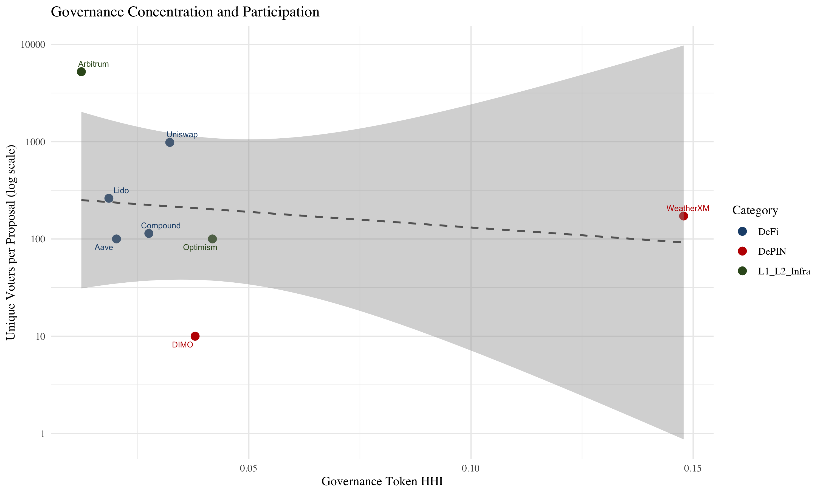
Figure 6. HHI vs. voter participation rate for protocols with governance data.

6. Discussion

6.1 Design Hypotheses
Rather than evaluating each hypothesis in isolation, we organize the evidence thematically: what the governance data directly demonstrate, what they constrain but cannot confirm, and what lies beyond the current evidence base.
Descriptive evidence: governance concentration patterns (Hypotheses 3.1 and 3.2, with implications for the Rawlsian fairness lens). The governance cross-section (Table 4) provides descriptive evidence most directly relevant to Hypotheses 3.1 (publicity-legitimacy) and 3.2 (contestability), with implications for the Rawlsian fairness lens. The normative framework interprets these governance concentration patterns as follows: when governance tokens are concentrated, the conditions these traditions identify as essential for legitimacy are structurally undermined. Protocols at the upper end of the concentration range (Livepeer at 0.199, WeatherXM at 0.148, GEODNET at 0.133) exhibit concentration levels the normative framework flags for scrutiny, though no protocol in the corrected cross-section exceeds the conventional 0.25 antitrust threshold. Even at these levels, governance decisions can disproportionately reflect a small set of holders’ preferences, making “public justification” structurally thin.
These same protocols raise Rawlsian fairness concerns because operators who deploy hardware and deliver service hold insufficient tokens to influence governance outcomes affecting their investments.
The republican non-domination condition is most directly measurable: concentration above the conventional threshold means few holders can override community preferences without formal contestation mechanisms. The counterexample (Anyone, HHI 0.040) demonstrates that these conditions are not inherent to DePIN architecture but reflect distribution design choices. Among DeFi benchmarks, Compound’s lower concentration (HHI 0.027) partly reflects active delegation, suggesting that institutional design can reduce effective concentration without token redistribution. Evidence grade: descriptive support for Hypotheses 3.1 and 3.2; the concentration data capture the conditions that publicity and non-domination traditions identify as problematic.
Indirect signals: structural constraints on adaptivity (Hypotheses 3.4 and 3.5). The service-over-presence hypothesis (3.4) and the polycentric adaptation hypothesis (3.5) posit that governance structures incorporating diverse, edge-level input produce more adaptive systems. The HHI cross-section cannot test these claims directly because it measures token concentration, not governance structure diversity or information flow. However, the data reveal a structural constraint: edge-participant voice is suppressed when holdings are concentrated.
Operators in DePIN networks who possess the most relevant operational knowledge (coverage gaps, hardware failure modes, local demand patterns) cannot influence governance decisions if they hold small token positions. The Helium case demonstrates this tension (Zukowski, 2026b): the HIP-147 reform succeeded partly because Helium’s governance process channeled edge-operator input despite concentrated holdings.
The finding that delegation design affects concentration also indicates that polycentric features (subDAOs, councils, delegation hierarchies) may reduce effective concentration without requiring redistribution. Evidence grade: indirect; the concentration data identify structural constraints on adaptivity, but the adaptive mechanism itself requires longitudinal evidence beyond the scope of this cross-section. A companion simulation (Zukowski, 2026e) calibrated to Helium parameters documents that PID-controlled emission compresses node-count variance by sixfold across a 240-run Monte Carlo ensemble, raising the 5th-percentile node count from 1,049 (static emission) to 8,880 (PID-controlled). The mechanism’s primary value is floor-raising: it prevents the worst outcomes rather than improving averages, consistent with the Rawlsian fairness lens’s emphasis on protecting the least advantaged.
A companion study (Zukowski, 2026b) documents a related concentration risk in DePIN fiscal sustainability: Helium’s aggregate Spend-to-Reward ratio crossed fiscal parity, but approximately five purchasers account for 90% of token burns, a concentration invisible to aggregate metrics. Governance concentration and demand concentration are distinct failure modes that can coexist: a protocol may be governance-concentrated but demand-diversified, or vice versa.
Evidence gaps and research frontiers. Three directions lie beyond the reach of governance token data. First, capability-oriented evaluation (following Sen and Nussbaum) requires participant-level data on income, skill development, and infrastructure access that no protocol currently instruments at scale. Second, contextual integrity (following Floridi and Nissenbaum) requires trust and data governance metrics; the concentration finding raises a related concern, since concentrated governance means decisions about data use and privacy norms are made by a small group rather than by the community whose data is at stake. This concern is particularly relevant for protocols collecting location data (Helium), vehicle telemetry (DIMO), or health data (CUDIS). Third, cosmopolitan inclusion (following Appiah) identifies a tension the data confirm descriptively: most DePIN protocols have global operator bases but concentrated governance, meaning geographic inclusion coexists with governance exclusion. Testing whether cosmopolitan governance improves outcomes requires longitudinal analysis across jurisdictions.
In sum, the governance cross-section provides descriptive evidence consistent with the two hypotheses most central to legitimacy (publicity-legitimacy, contestability) and with implications for the Rawlsian fairness lens, plus indirect evidence constraining the two hypotheses about adaptive governance (polycentricity, knowledge-use), and identifies three evidence frontiers (capability, contextual integrity, cosmopolitanism) that define the next phase of empirical work. The evidence frontiers identified here (service verification, contextual integrity, concentration dynamics) require new data collection infrastructure that does not yet exist in the DePIN ecosystem.

6.2 Governance Design Implications
The governance concentration evidence motivates specific institutional design questions. Five design implications translate the framework into mechanisms, grounded in executed evidence where available.
Constitutional Transparency and Deliberation The Kantian publicity principle requires that governance rules be understandable by affected participants. Table 4 shows that holding concentration alone does not determine governance quality: MakerDAO (HHI 0.045) achieves meaningful deliberation through delegation while CRV (HHI 0.171) concentrates power through ve-locking without comparable deliberative infrastructure. Design implication: publication norms (readable proposal summaries, voting rationale disclosure, mandatory comment periods) are at least as important as token distribution in determining whether governance is genuinely public.
Low Barriers and Diverse Participation Governance concentration across 38 protocols with valid data (Gini 0.45–0.99; Table 4; Livepeer excluded due to bridge-schema measurement failure) shows that token-weighted voting creates steep participation inequality by default. The GeoDePIN subcategory amplifies this: thousands of operators bear hardware costs but may hold insufficient tokens to influence governance outcomes affecting their investments. Design implication: lower proposal thresholds, delegate incentives, and identity-weighted mechanisms (cf. Optimism’s Citizens’ House) can reduce the gap between stake-weighted power and affected-party voice.
Distribution Mechanism as Governance Architecture. The Kantian publicity principle extends to distribution design: an allocation mechanism that affected participants cannot audit, contest, or understand prior to participation fails the universalizability test at the constitutional level, before governance begins. A protocol that publishes transparent voting rules atop an opaque allocation that concentrated 40 percent of supply in insider wallets satisfies the letter of procedural legitimacy while violating its spirit. The normative implication is that distribution transparency is a precondition for governance legitimacy, not a separate concern. Points-based distribution programs that publish clear allocation formulas, implement sub-linear scaling, and cap per-wallet rewards are de facto anti-concentration governance mechanisms; venture-funded allocations without comparable disclosure create concentrated governance as a structural default.
Integrity Mechanisms and Independent Oversight Pettit’s non-domination principle requires that no single actor can exercise unchecked power. The concentration cross-section (Table 4) shows that some tokens sit in the “highly concentrated” regime even before delegated voting is considered (e.g., WXM holding HHI 0.148; DIMO 0.038). Among mature DeFi governance tokens, the CRV case (HHI 0.174, highest among DeFi peers in the sample) illustrates how locking mechanisms can concentrate governance: Convex controls approximately 47% of veCRV (DeFi Llama, 2026).
Design implication: treat integrity as an institutional layer. Separation of powers (e.g., Optimism’s bicameral Token House / Citizens’ House), independent security councils or audit committees with narrowly scoped veto authority over security-critical changes. Mandatory timelocks and public disclosure requirements for large delegates are especially important in GeoDePINs where thousands of operators can be exposed to governance outcomes without holding meaningful token power.
Appeals and Dispute Resolution Contestability requires formal appeal mechanisms. HIP-147’s acceptance (even by operators whose rewards were reduced; see Zukowski, 2026b) indicates that structured processes with clear rules produce legitimate outcomes. Design implication: implement tiered dispute resolution (community mediation → arbitration committee → on-chain vote) with defined timelines and transparent criteria.
Adaptive Governance and Meta-Governance. Governance structures must evolve. Ostrom’s principle of allowing rule evolution suggests building in periodic constitutional reviews, scheduled opportunities to adjust quorums, proposal formats, and role definitions based on participation data. An emergency governance protocol is also prudent: defining in advance who can act under crisis conditions (e.g., a smart contract exploit), with what authority, and subject to what retroactive accountability. This bounded emergency power paradoxically strengthens legitimacy by making deviations from normal process predictable and auditable.
Future Extensions. Three additional hypotheses (edge-signal responsiveness, contextual integrity, and concentration dynamics) are specified in an earlier version of the framework but are not testable with the data collected here. They require operational telemetry, privacy and trust metrics, and longitudinal governance observations respectively, and represent priorities for future empirical work.

6.3 Broader Institutional Implications
Three transfers extend these principles beyond tokenomics. First, the transparency principles operationalized through the Kantian publicity lens (Section 3) apply to any institution that claims legitimacy through openness: cooperative governance, public benefit corporations, and regulatory sandboxes face similar tensions between claimed transparency and operational opacity. Second, the governance concentration finding (Section 5) raises accountability questions that echo existing debates about corporate board composition and shareholder activism: who governs, and by what right? Third, the scoring rubric (Table 1) demonstrates that normative philosophy can be operationalized as measurement infrastructure, a methodological contribution that extends beyond blockchain to any domain where institutional design quality needs assessment.
The governance concentration pattern documented here appears to be a general property of maturing token ecosystems, not specific to DePIN. In stablecoin gateway markets, total dollar volume doubled between 2023 and 2025 while unique counterparties declined 25%, and a single market-making firm’s share of total counterparty volume rose from 1.4% to 19.9% (Zukowski, 2026c). Throughput scales while participant diversity contracts, and the remaining intermediaries become increasingly load-bearing, whether those intermediaries are governance voters, market makers, or infrastructure operators. A parallel divergence appears in the same domain: the most regulated stablecoin operator experienced the largest stress depeg, while the least regulated maintained its peg (Zukowski, 2026d), demonstrating that regulation intensity and product quality are separate dimensions requiring separate measurement. The governance concentration gap documented here is the DePIN analog: high concentration does not predict governance failure, but creates structural conditions under which failure becomes more likely if contestability mechanisms are absent.

6.4 Risks and Counterpoints
Several risks deserve candid acknowledgment.
Philosophical overreach. Translating normative philosophy into scoring rubrics necessarily simplifies rich traditions. A 0-to-3 scale cannot capture the full depth of Kantian moral reasoning or Rawlsian justice theory. The rubric is designed as a tractable approximation that makes legitimacy evaluable, not as a claim that it captures everything these traditions offer. Users should treat scores as structured signals, not verdicts.
Plutocratic concentration as equilibrium. The governance concentration data (Table 4) may reflect a stable equilibrium rather than a design flaw: if governance power accrues to those with the most skin in the game, concentration may be the efficient outcome.
Distribution breadth at token launch may be a poor predictor of long-term governance concentration. Practitioner evidence documents participation declines of 50 percent or more after initial token distributions as recipients with short time horizons exit (Sawinyh, 2025). If exiting participants sell governance tokens into thin order books, concentrated buyers absorb the supply, and post-distribution HHI exceeds pre-distribution HHI. The result is a ratchet: broad initial allocation converges toward a concentrated steady state through secondary market dynamics rather than protocol design. The DePIN concentration levels in Table 4 are consistent with this pattern, though the single-snapshot design cannot distinguish concentration that was designed in from concentration that accumulated through post-launch trading.
The counterargument is that efficiency and legitimacy are different criteria, and that the normative framework (particularly the republican non-domination lens) demands that power concentration be contestable even if it is efficient. The counterexample (Anyone, HHI 0.040) demonstrates that low concentration is achievable through deliberate design.
Measurement challenges. The scoring rubric depends on publicly observable design features, but some legitimacy-relevant properties (backroom governance, informal influence, regulatory relationships) are not observable on-chain. We specify inter-rater reliability protocols (Supplementary File S2) but have not yet tested them with a second scorer. The governance concentration analysis uses a snapshot methodology that does not capture temporal dynamics; a panel approach would strengthen causal claims.
Equity-token conflicts. The normative framework assumes that governance token holders are the primary principals, but hybrid structures complicate this assumption. Helium's unresolved tension between Nova Labs' equity obligations and HNT tokenholders' interests (Bane & Gala, 2026), exemplified by temporary revenue-allocation policies and subsequent reversions, illustrates precisely the parameter-setting legitimacy deficit that the framework diagnoses under Hypotheses 3.1 and 3.2.
Speed versus legitimacy trade-off. Institutionally rigorous governance processes are slower than technocratic decision-making. In crisis conditions (exploits, market dislocations), the deliberative processes the framework advocates may be too slow. The framework does not resolve this tension but insists that emergency powers be pre-committed and bounded, consistent with republican constitutionalism.

6.5 Position in Literature
This paper’s contribution is not a new philosophical theory but a new application: translating established normative frameworks (Kant, Rawls, Pettit, Ostrom, Hayek) into actionable design criteria for programmable institutions. It extends Werbach’s (2018) blockchain governance taxonomy, de Filippi & Wright’s (2018) code-as-law analysis, and Reijers & Coeckelbergh’s (2018) blockchain ethics framework by moving from descriptive classification to prescriptive mechanism design grounded in political philosophy. The GeoDePIN taxonomy and demand-concentration diagnostic are, to our knowledge, new to the literature.
Mechanism Design and Institutional Economics. Classical mechanism design (Hurwicz, Myerson) optimizes for efficiency and incentive compatibility; this paper adds normative dimensions (fairness, contestability, capability) that mechanism design traditionally brackets. We build on Ostrom’s institutional analysis of commons governance, extending her framework from natural resource commons to digital infrastructure commons where coordination mechanisms are encoded in smart contracts rather than social norms. The governance concentration data (Table 4) provides the kind of empirical institutional comparison Ostrom advocated.
Political Philosophy and Institutional Design. The philosophical framework (Section 3) draws primarily on Rawls, Kant, Pettit, Hayek, and Ostrom as operationalized lenses, with additional intellectual context from Nussbaum (2011), Floridi, and Appiah, treating these traditions not as isolated theoretical lenses but as complementary design criteria that jointly define institutional legitimacy. This integrative approach extends debates in political philosophy about institutional design to a novel domain where institutions are programmable and globally accessible. The thesis demonstrates that philosophical principles are not merely aspirational but can be operationalized as measurable design criteria.
Blockchain Governance Scholarship. The growing literature on DAO governance (Fan et al. 2025, DeepDAO 2023) documents participation patterns and concentration but rarely connects these to normative frameworks. This paper bridges that gap: the governance cross-section (Table 4) contributes new empirical evidence on holding concentration while the philosophical scoring rubric (Table 1) provides a replicable methodology for normative assessment. The Helium S2R case study extends the literature on DePIN sustainability with longitudinal data showing how tokenomic design shifts affect burn-to-issuance trajectories.
Token Engineering and Cryptoeconomics. Token engineering is developing as a design discipline focused on simulation and optimization. This paper complements that technical approach with institutional and philosophical analysis, arguing that token design choices are simultaneously economic mechanism design and political constitution-writing. A cost comparison analysis developed separately contributes a practitioner-relevant benchmark that the token engineering literature currently lacks.
The paper illustrates the value of interdisciplinary synthesis: applying humanities and social science frameworks to technical system design yields insights that neither discipline produces alone.

7. Conclusion

7.1 Summary
No measured covariate robustly predicts governance concentration in the 38-protocol cross-section. The one nominally significant linear association (Pearson r = +0.56, p = 0.011, N = 20) does not survive rank-based testing (Spearman rho = +0.13, p = 0.60), log transformation (r = +0.23, p = 0.35), or exclusion of a single extreme observation (Livepeer; excluding: r = -0.08, N = 19). Protocol-controlled address contamination is a field-wide measurement problem: 56 addresses across 17 protocols were masquerading as governance participants, and removing them changed affected protocols’ HHI by up to 5x.
DePIN protocols span a 268-fold subsidy range, from DIMO (0.33x, revenue-dominant) to Livepeer (88.5x, heavily subsidized). Despite this range, concentration does not track subsidy in any robust specification. Two pattern-breaking protocols are instructive: Aethir generates the highest DePIN revenue ($111M annualized) yet has the second-highest HHI (0.168), consistent with team and vesting wallet concentration in an early-stage protocol. Hivemapper operates at 5.46x subsidy yet has the lowest HHI among expansion protocols (0.020), consistent with broad geographic distribution of 90,000+ dashcam operators. These cases suggest that governance concentration reflects initial token allocation and operator-base structure rather than ongoing financial sustainability.
Table 7 reports multivariate OLS regressions of HHI on protocol characteristics. The DePIN coefficient is positive across all specifications (Model 1: +0.028, p = 0.07, N = 24) but does not reach conventional significance. No individual covariate achieves p < 0.10. The adjusted R-squared ranges from 0.01 to 0.08, confirming that measured covariates explain very little cross-sectional variation. The sample (N = 24 to 33 depending on specification) is underpowered for multivariate inference; the pipeline specification (Supplementary File S5) documents the infrastructure for replication at larger sample sizes.
[Table 7. OLS regression of HHI on protocol characteristics. Robust SEs. Models 1-3: full sample, TT-independent covariates. * p < 0.10, ** p < 0.05, *** p < 0.01.]

7.2 Contributions
This paper makes three contributions. First, a systematic exclusion methodology identifies 56 protocol-controlled addresses across 17 protocols that contaminate naive holder-list analysis, changing affected protocols’ HHI by up to 5x. Every prior study computing token HHI without this correction measured protocol architecture, not governance concentration. Second, a cross-sector null result documents that no measured covariate robustly predicts governance concentration: not sector membership, not initial token allocation (r = +0.08, p = 0.64, N = 33), not protocol maturity, and not subsidy structure. Three protocols with subsidy ratios between 0.33x and 0.37x (DIMO, Aethir, Aave) have governance HHI values of 0.038, 0.168, and 0.020; financial sustainability is neither necessary nor sufficient for governance decentralization. Third, a normative framework translates five political-philosophical traditions into evaluable design criteria for tokenized institutions, bridging political philosophy and token engineering through a replicable scoring rubric.

7.3 Limitations
The evidence carries several limitations. The governance concentration analysis is a March 2026 snapshot: concentration trajectories over time would enable deconcentration analysis and strengthen causal claims. A single scorer has applied the scoring rubric; inter-rater reliability testing with independent scorers is needed before the rubric can claim measurement validity beyond its current proof-of-concept status. The sample of 35 sampled protocols is sufficient for descriptive comparison but too small for robust regression analysis; the pipeline specification (Supplementary File S5) is designed for expansion to 20+ protocols. The sample includes only active protocols, introducing potential survivorship bias (see Section 4.3 for planned inclusion of stagnated projects). We have not validated the Synergy Index against outcome measures; Partial validation through case evidence is reported separately, but a full validation study is future work.

7.4 Future Research
Three research directions have highest priority. First, longitudinal governance tracking: monthly snapshots of HHI and Gini across the full sample would convert the current cross-section into a panel dataset, enabling analysis of deconcentration trajectories and the governance effects of specific reform events (e.g., delegation program launches, vesting cliff expirations). Second, sample expansion: the pipeline is designed for N = 20+ protocols; reaching this threshold would enable the regression, panel, and event-study analyses currently specified as replication-ready designs. Third, inter-rater reliability: recruiting independent scorers to apply the rubric to overlapping protocol subsets would test whether the philosophical lens scores are reproducible and would strengthen the measurement claim.

7.5 Closing
If blockchains are to govern real resources and real communities, their institutional design must be held to real standards. This paper offers one path toward that standard: a framework rooted in the traditions that have shaped how societies evaluate legitimate governance, translated into tools that designers and evaluators can use. The governance concentration data suggest that the gap between aspiration and reality is wide. Closing that gap is a design problem, and design problems have solutions.

Supplementary Material
The following supplementary files accompany this paper:
Supplementary File S1: Extended metric definitions, including the Synergy Index construction and inter-rater reliability specification for multi-coder deployment of the scoring rubric.
Supplementary File S2: Research instrument templates, including the protocol codebook schema and scoring sheet template with worked examples.
Supplementary File S3: Scoring tables (protocol × criterion matrices with evidence links) for all 11 scored protocols.
Supplementary File S4: Events table for future event-study analyses.
Supplementary File S5: Full empirical pipeline specification (16 analyses across five categories), including replication-ready design for cross-sectional, panel, event-study, and qualitative analyses.
Supplementary File S6: Raw governance token distribution data (Dune Analytics SQL queries and results, March 2026 snapshot).
Replication data: https://github.com/Research-Publications-and-Data/Tokenomics-As-Institutional_Design

References
Appiah, K. A. (2006). Cosmopolitanism: Ethics in a world of strangers. W. W. Norton.
Aramonte, S., Huang, W., & Schrimpf, A. (2021). DeFi risks and the decentralisation illusion. BIS Quarterly Review, December 2021, 21–36. https://www.bis.org/publ/qtrpdf/r_qt2112b.htm
Bane, D., & Gala, S. (2025). State of DePIN 2024. Messari. https://messari.io/report/state-of-depin-2024
Bane, D., & Gala, S. (2026). State of DePIN 2025. Messari & Escape Velocity. https://messari.io/report/state-of-depin-2025
Barbereau, T., Smethurst, R., Papageorgiou, O., Sedlmeir, J., & Fridgen, G. (2023). Decentralised finance's timocratic governance: The distribution and exercise of tokenised voting rights. Technology in Society, 73, 102251. https://doi.org/10.1016/j.techsoc.2023.102251
Buchanan, J. M., & Tullock, G. (1962). The calculus of consent: Logical foundations of constitutional democracy. University of Michigan Press.
Buterin, V., Conner, E., Dudley, R., Slipper, M., & Norder, I. (2019). EIP-1559: Fee market change for ETH 1.0 chain (Ethereum Improvement Proposal). https://eips.ethereum.org/EIPS/eip-1559
CoinGecko. (2026). Cryptocurrency market data. Retrieved March 2026, from https://www.coingecko.com
Cong, L. W., Rabetti, D., Wang, C. C. Y., & Yan, Y. (2025). Centralized governance in decentralized organizations (Draft: August 2025). Working Paper.
Cosmos. (2026). IBC protocol documentation. https://cosmos.network/ibc
DeepDAO. (2023). DAO governance analytics [Data set]. Retrieved 2023, from https://deepdao.io
Dune Analytics. (2026). On-chain governance token holder data [Data set]. Retrieved March 2026, from https://dune.com
Fan, Z., DeFilippi, P., Mannan, M., & Tan, J. (2025). Distributed governance in decentralized autonomous organizations: A survey of theory and practice. Working Paper.
Feichtinger, R., Fritsch, R., Vonlanthen, Y., & Wattenhofer, R. (2023). The hidden shortcomings of (D)AOs: An empirical study of on-chain governance. In International Conference on Financial Cryptography and Data Security (pp. 165–185). Springer.
Floridi, L. (2013). The ethics of information. Oxford University Press.
Gersbach, H., Schneider, M., & Shahkar, P. (2024). Effects of vote delegation in blockchains: Who wins? arXiv:2408.05410 (revised July 2025). https://doi.org/10.48550/arXiv.2408.05410
Han, J., Lee, J., & Li, T. (2023). DAO governance. European Corporate Governance Institute Finance Working Paper No. 1119/2025. https://doi.org/10.2139/ssrn.4346581
Han, J., Lee, J., & Li, T. (2024). A review of DAO governance: Recent literature and emerging trends. European Corporate Governance Institute Finance Working Paper No. 1044/2025. https://doi.org/10.2139/ssrn.5074046
Hayek, F. A. (1945). The use of knowledge in society. American Economic Review, 35(4), 519-530. https://doi.org/10.2307/1809376
Howell, S. T., Niessner, M., & Yermack, D. (2020). Initial coin offerings: Financing growth with cryptocurrency token sales. Review of Financial Studies, 33(9), 3925–3974. https://doi.org/10.1093/rfs/hhz131
Hurwicz, L. (1973). The design of mechanisms for resource allocation. American Economic Review, 63(2), 1–30.
Kant, I. (1991). Perpetual peace: A philosophical sketch. In H. Reiss (Ed.), Kant: Political writings (pp. 93-130). Cambridge University Press. (Original work published 1795)
Kant, I. (1997). Groundwork of the metaphysics of morals (M. Gregor, Ed. & Trans.). Cambridge University Press. (Original work published 1785.)
Liu, Y., Makarov, I., & Schoar, A. (2023). Anatomy of a run: The Terra Luna crash. NBER Working Paper No. 31160. https://doi.org/10.3386/w31160
Myerson, R. B. (1981). Optimal auction design. Mathematics of Operations Research, 6(1), 58–73. https://doi.org/10.1287/moor.6.1.58
Nadler, M., & Schär, F. (2020). Decentralized finance, centralized ownership? An iterative mapping process to measure protocol token distribution. arXiv:2012.09306. https://doi.org/10.48550/arXiv.2012.09306
Nissenbaum, H. (2010). Privacy in context: Technology, policy, and the integrity of social life. Stanford University Press.
Nussbaum, M. C. (2011). Creating capabilities: The human development approach. Harvard University Press.
Ostrom, E. (1990). Governing the commons: The evolution of institutions for collective action. Cambridge University Press.
OpenGov.Watch. (2024). 2024-H1 Polkadot Treasury Report. https://www.opengov.watch/reports/treasury-reports/03_2024-treasury-report-h1
Optimism. (2024). Optimism governance documentation: Citizens’ House. https://community.optimism.io/docs/governance/
Pettit, P. (1997). Republicanism: A theory of freedom and government. Oxford University Press.
Rawls, J. (1999). A theory of justice (Rev. ed.). Belknap Press of Harvard University Press. https://doi.org/10.4159/9780674042582 (Original work published 1971.)
Rikken, O., Janssen, M., & Kwee, Z. (2023). Governance impacts of blockchain-based decentralized autonomous organizations: An empirical analysis. Policy Design and Practice, 6(4), 465–487. https://doi.org/10.1080/25741292.2023.2270220
Roughgarden, T. (2020). Transaction fee mechanism design for the Ethereum blockchain: An economic analysis of EIP-1559. arXiv:2012.00854. https://arxiv.org/abs/2012.00854
Roughgarden, T. (2021). Transaction fee mechanism design. ACM SIGecom Exchanges, 19(1), 52–55. https://doi.org/10.1145/3476436.3476445
Sawinyh, N. (2025, October 29). Points-based distribution programs in Web3: A comprehensive guide. DeFiPrime. https://defiprime.com/points-based-token-distribution-programs-web3
Schär, F. (2021). Decentralized finance: On blockchain- and smart contract-based financial markets. Federal Reserve Bank of St. Louis Review, 103(2), 153–174. https://doi.org/10.20955/r.103.153-74
Shapira, L. (2022, July 26). Is Helium Really Doing $6,500 a Month in Revenue? DeWi on-chain analysis. https://x.com/liron/status/1552102241259163648
Sen, A. (1999). Development as freedom. Alfred A. Knopf.
Voshmgir, S. (2020). Token economy: How the web3 reinvents the internet (2nd ed.). Token Kitchen.
Weidener, L., Anwar, A., Richter, T., Pournader, P., & Kartal, A. B. (2025). Delegated voting in decentralized autonomous organizations: A scoping review. Frontiers in Blockchain, 8, 1533405. https://doi.org/10.3389/fbloc.2025.1533405
Werner, S. M., Perez, D., Gudgeon, L., Klages-Mundt, A., Harz, D., & Knottenbelt, W. J. (2022). SoK: Decentralized finance (DeFi). In Proceedings of the 4th ACM Conference on Advances in Financial Technologies (pp. 30–46). ACM. https://doi.org/10.1145/3558535.3559780
Zukowski, Z. (2026b). GeoDePIN: Design patterns for decentralized geographic infrastructure. SSRN Working Paper. https://papers.ssrn.com/sol3/papers.cfm?abstract_id=6483619
Zukowski, Z. (2026c). Routing the Dollar: Gateway infrastructure, monetary policy transmission, and the Dollar’s international functions in digital markets. SSRN Working Paper No. 6267698. https://papers.ssrn.com/sol3/papers.cfm?abstract_id=6267698
Zukowski, Z. (2026d). Five Dollars: Legal structure, operator risk, and diligence divergence in tokenized dollar instruments. SSRN Working Paper [forthcoming].
Zukowski, Z. (2026e). Tokenomics as systems engineering: Capital, labor, land, and the design of autonomous economies. SSRN Working Paper No. 6364158. https://papers.ssrn.com/sol3/papers.cfm?abstract_id=6364158

