Getting Reddit Credentials for Use in the Reddit Scraping Tool

In order to use the Reddit Scraping Tool 4 pieces of information are required, collectively called the Reddit Credentials. These are:

1. Username
2. Password
3. Client ID
4. Secret Key

This information in gathered in two steps. First signing up for a reddit account, and second registering an App. The following document details how to complete both these components.

Before signing up and using the Reddit Scraper be sure to read the Data API terms of service:

https://www.redditinc.com/policies/data-api-terms

Signing up for a Reddit Account

First you must sign up for a Reddit account. Follow the instructions at the following link:

https://www.reddit.com/account/register/

First enter a valid email address, then select a username and password. (These are part of the credentials you will need to use the Reddit Scraper.)

After signing up and before registering for an API key you must verify your e-mail address. Shortly after sign-up a verification e-mail will be sent. Follow these verification steps.

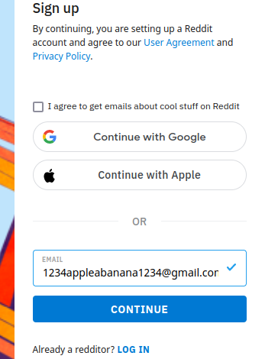 | 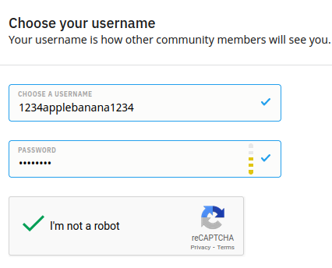

Registering an App

Second, click the following link to register an App and get access to the API:

https://www.reddit.com/prefs/apps

Start by clicking the “are you a developer? Create an app...” button in the top left of the screen.
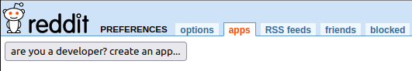

This will being you to the application creation screen. There you will need to fill in the “name” and “redirect uri” fields, as well as selecting the “script” radio button. The “name” field can be anything, however the “redirect uri” must be http://localhost:8080 in order for the app to be accepted. Then complete the CAPTCHA, and click the “create app” button.

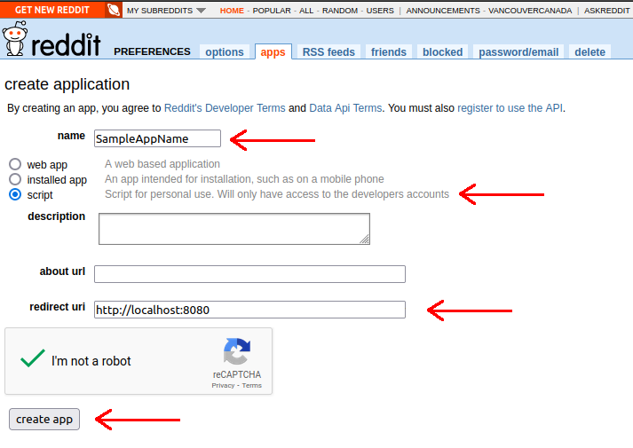

This will complete the application creation process and the “Client ID” and “Secret Key” will be displayed as shown in the image below. The “Client ID” is a string of 22 character located in the first redacted box, and the “Secret Key” is a string of 30 characters in the second.
