Structural Robustness and Reconfiguration of Global Crude Oil Trade in 2017, 2019, and 2020
Mehrdad Maghsoudi; Mehrdad Agha Mohammad Ali Kermani*; Armin Pourhossein Parizad; Hossein Shayesteh
Shahid Beheshti University, Tehran, Iran; Iran University of Science and Technology, Tehran, Iran. *Corresponding author: m_kermani@iust.ac.ir

Abstract
International crude petroleum trade was examined as a directed, dollar-weighted network at three annual observations surrounding the 2018 reimposition of United States sanctions on Iran and the 2020 COVID-19 pandemic. Bilateral links extracted for HS 2709 were evaluated for 2017, 2019, and 2020 using directional degree and strength, harmonic centrality, HITS scores, weighted community detection, and simulated node removal. After documented name harmonization, the networks contained 172, 170, and 170 nodes and 1,482, 1,316, and 1,259 directed edges. Density decreased from 0.0504 to 0.0458 and 0.0438. Directed global efficiency decreased from 0.2486 in 2017 to 0.2184 in 2019 but recovered to 0.2274 in 2020. Under degree-targeted deletion of 30% of nodes, the largest weakly connected component retained 28.3%, 10.1%, and 16.0% of surviving nodes, respectively. Monetary rankings differed from partner-count rankings. The three snapshots document structural differences and vulnerability to stylized disruptions; they do not identify causal effects of sanctions or the pandemic or measure actual supply recovery. The policy discussion distinguishes trade-system robustness from decarbonization outcomes.
Keywords: crude petroleum trade; directed weighted networks; structural robustness; sanctions; COVID-19

1. Introduction
Crude petroleum flows create an asymmetric system of international relationships. A country can purchase from many suppliers while exporting little, or sell substantial volumes to a few destinations. A binary measure of whether two partners trade therefore answers a different question from the monetary value flowing between them. The distinction becomes central when bilateral links contract and the remaining connections are concentrated around a limited number of countries. Studies of import- and export-side oil-network stability have shown that the two sides can have different exposure patterns (Shahnazi et al., 2023), while targeted node failures can affect international oil trade differently from random failures (Wei et al., 2022).
The United States announced its withdrawal from the Joint Comprehensive Plan of Action (JCPOA) on 8 May 2018; United States sanctions previously lifted or waived under that agreement were fully reimposed on 5 November 2018 (Office of Foreign Assets Control, 2018). The World Health Organization characterized COVID-19 as a pandemic on 11 March 2020 (World Health Organization, 2020). These dates supply the historical context for three snapshots selected by the authors: 2017 before the withdrawal, 2019 after reimposition but before the pandemic year, and 2020 during the pandemic. Their sequence does not provide a counterfactual for either event. Oil prices, production decisions, reporting practices, and other changes occurred over the same interval.
Published research has examined international oil trade with centrality, dependence, and robustness models. A 2024 study of monthly energy-trade records documented changes during the period of the COVID-19 outbreak (Liu et al., 2024). More recent work models adaptive trade rewiring following shocks (Chen et al., 2025) or represents shipping links and trade relations as interdependent systems (Zhang et al., 2026). Those approaches make the scope of the present study clear. The available observations support a comparison of recorded country-to-country dollar-valued trade and controlled network deletion experiments; neither physical shipping routes nor realized adaptation following an interruption can be reconstructed from the supplied data.
The original manuscript reported density, aggregate degree, clustering, closeness, betweenness, and community labels, but left edge direction and the treatment of weights insufficiently specified. Because a directed trade graph can contain a single weakly connected component yet many strongly connected components, ordinary closeness scores can be misleading. In addition, a decline in network density need not imply a proportional decline in robustness. Both issues require explicit measurement definitions and sensitivity analysis.
The present study asks how recorded trade connections, dollar-weighted positions, and community partitions differ among the three annual snapshots; how sensitive those descriptions are to edge-value thresholds and country selection; and how the same observed networks respond to stylized removal of random or high-degree nodes. Network analysis is used to describe connectivity and simulated structural robustness. The findings are subsequently considered for energy-security planning and sustainable transitions, without treating progress on the Sustainable Development Goals as a measured outcome.
The contribution lies in reconstructing the three networks as directed graphs, distinguishing trade breadth from dollar-value prominence, replacing problematic closeness comparisons with an explicit harmonic measure, and reporting removal and sensitivity tests on the original observation years. The accompanying reproducibility archive records all label changes and the limitations of reconciling independently downloaded OEC trade files.

2. Related work and analytical framework
International oil trade can be modeled at different analytical levels. A country trade network records aggregate bilateral relationships; a maritime network represents ports and physical routes; an interdependent model links both layers. These models assign different meanings to network paths. For example, a sequence from country A to B to C in the country graph is a mathematical reachability path, not necessarily a shipment that travels through B. The distinction matters when betweenness is interpreted economically. Models based on port connectivity or actual shipping data contain information that the country-value network does not (Si et al., 2025) (Zhang et al., 2026).
Research has also used different definitions of resilience. Shahnazi and colleagues analyzed the stability of export and import exposures (Shahnazi et al., 2023). Wei and colleagues evaluated the consequences of targeted attacks on country nodes (Wei et al., 2022). Chen and colleagues studied adaptation through edge rewiring (Chen et al., 2025). A related 2026 analysis considers risk propagation across oil-product trade networks (Chen et al., 2026). Such designs should not be treated as interchangeable: node deletion measures the connectivity remaining after a hypothetical disruption, whereas flow redistribution, demand adjustment, and recovery require additional economic information.
The methodological separation in this paper is between structural description, stress testing, and policy interpretation. Structural description uses directed degrees, strengths, centralities, and communities. Stress testing measures connectivity after removal of observed nodes. The policy interpretation is conditional because the data contain neither oil inventories nor refinery capacities, physical shipping costs, emissions, or recovery time.
Table 1. Studies used to delimit the structural and functional meanings of oil-trade resilience.
Study | System | Analytical approach | Relevance to this paper
Wei et al. (2022) | International oil trade | Targeted node attacks | Topology-based vulnerability; direct comparison for removal tests
Shahnazi et al. (2023) | Global oil trade | Import/export resilience | Separates exposure on the two sides of trade
Liu et al. (2024) | Multi-fuel energy trade | Monthly network comparison | COVID-period contextual evidence; different time resolution
Si et al. (2025) | Crude oil maritime transport | Directed shipping network and motifs | Physical routing is outside country-edge data
Chen et al. (2025) | Global oil trade | Adaptive edge rewiring | Adaptation requires modeling beyond fixed graph deletion
Zhang et al. (2026) | Crude oil shipping and trade | Multiscale network robustness | Shipping–trade interdependence extends the present model
Chen et al. (2026) | Oil industry chain | Risk propagation and dimensional resilience | Economic and functional effects require extra data
The comparison in Table 1 separates what is actually observed in the supplied HS 2709 records from mechanisms assessed in other work. The analytical distinction is also represented schematically in Figure 1.
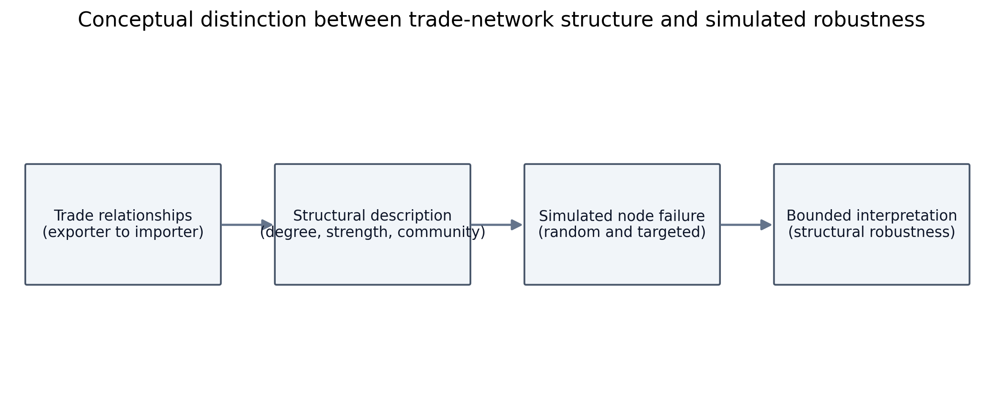
Figure 1. Analytical distinction among observed trade structure, simulated node failure, and policy interpretation.
Community detection complements these measures by grouping nodes with relatively strong internal connections. Modularity is an optimization criterion, not evidence of an economic bloc or a formal agreement. The Louvain procedure is a heuristic and may yield different partitions when initialization changes (Blondel et al., 2008); the modularity objective itself compares observed internal connectivity with a network-specific benchmark (Newman, 2006). For that reason, this paper reports the algorithm, weights, resolution, and repeat-seed variation.
An additional distinction concerns value-weighted prominence. HITS hub and authority scores are computed using the directed trade-value adjacency matrix, following the logic of mutually reinforcing incoming and outgoing positions (Kleinberg, 1999). Because their values depend on all links in the matrix, these scores are reported alongside degree and strength instead of being labeled general economic or political influence.

3. Data and methodology

3.1. Source data, period selection and provenance
The authors collected annual country-partner crude petroleum trade observations from the Observatory of Economic Complexity (OEC) for Harmonized System heading 2709, petroleum oils and oils obtained from bituminous minerals, crude (Observatory of Economic Complexity, 2024). The original extraction was reported as occurring on 21 January 2024. According to the data-collection description supplied by the authors, each country was examined separately for bilateral import and export relationships and the observations were consolidated into one Excel file per year. The final consolidated files contain source, target, and a positive numeric weight; the unit is the United States dollar, not million dollars. Each year was treated as a separate network.
The consolidated edge lists provide the primary inputs for all three-year comparisons. The newly supplied 2019 archive contains 97 Excel workbooks, of which 96 have country-specific importer-list names and one contains an aggregate exporter table. The 96 country-specific files represent 94 distinct reporter labels because some are duplicate copies. Their monetary entries cannot be substituted for the consolidated 2019 matrix without a reconciliation rule. Matching the reporter and partner labels in the recorded direction produced 1,268 comparable pairs out of 1,343 archive entries; 261 pairs had an exact dollar match and 372 differed by no more than 1% in relative value. The archive also contained 75 pairs absent from the consolidated network. These checks establish incomplete agreement between the two supplied representations. The analyses therefore retain the authors’ consolidated inputs, and the full audit is supplied separately.
Potential reasons for the differences include extraction version, reporting basis, or manual aggregation, but the available material does not identify which explanation is correct. An archive entry and a consolidated edge should not be averaged or summed without identifying whether they are a mirror report or independent transaction. This unresolved provenance issue affects the interpretation of monetary strengths and warrants explicit disclosure. The country- and pair-level comparison is retained in the audit archive.
Table 2. Audit of the supplementary 2019 OEC extraction archive.
Audit item | Result | Interpretation
2019 country-specific workbooks | 96; 94 distinct labels | Not a complete worldwide exporter panel
Country-partner entries | 1,343 | Recorded values in the supplied archive
Pairs matched to directed 2019 network | 1,268 | Same named origin–destination pair
Exact value matches | 261 | Dollar values identical
Within ±1% of archive value | 372 | Includes exact matches
Archive pairs absent from network | 75 | Not imputed into primary graph
Note. The comparisons are descriptive; the exchange does not establish a consistent rule for resolving mismatches.
The validation counts in Table 2 are documented in the downloadable source-to-network crosswalk. The main network values are reproducible from the three author-provided consolidated sheets, but their historical construction from the separate reporter pages cannot yet be reconstructed exactly.

3.2. Network definition and data treatment
For observation year t, let a directed vertex correspond to the named reporting jurisdiction and an ordered edge (i,j) represent a recorded export relationship from source i to destination j. The nonnegative annual monetary value is wᵢⱼ(t) in US dollars. A binary indicator is equal to one for a strictly positive valid weight and zero otherwise. Directed edges i→j and j→i are distinct. The observed vertex set is the union of all sources and destinations in a given consolidated file; the data do not supply an independently verified registry of zero-trade jurisdictions.
$$Aᵢⱼ(t) = 𝟙[wᵢⱼ(t) > 0], wᵢⱼ(t) ∈ ℝ≥0, Aᵢᵢ(t) = 0$$
Rows with missing or nonnumeric weights, nonpositive values, or self-links are excluded; equal ordered source–destination pairs are summed after deterministic name harmonization. Original labels are retained in an audit file. The corrections include an encoding variant of Curaçao in 2017, an apostrophe/letter substitution in Côte d’Ivoire and an encoding issue in Saint Barthélemy in 2019, and the spelling Hungray for Hungary in 2020. These changes merge demonstrably equivalent labels but do not resolve the 2019 source label Chinese, for which the supplied records do not establish a unique jurisdiction. It remains a separate, flagged node to avoid inventing an identity.
The resulting node counts are 172 in 2017 and 170 in each later year, one lower than the originally reported counts for each observation. Link totals remain 1,482, 1,316, and 1,259. Since weighted metrics can change if ambiguously named countries or values are later corrected, the published calculations should be rerun if the underlying source labels are authoritatively reconciled.
Trade direction is preserved for the primary graph. Directed density is m/[n(n−1)]. In-degree and out-degree count incoming and outgoing partners; their monetary counterparts, in-strength and out-strength, sum incoming and outgoing edge values. The reported mean directional degree is m/n, not the total directed degree 2m/n. Raw trade values are not interpreted as physical volumes because no quantity harmonization or oil-price adjustment was supplied.
$$kᵢᶦⁿ = ∑ⱼ Aⱼᵢ, kᵢᵒᵘᵗ = ∑ⱼ Aᵢⱼ, sᵢᵒᵘᵗ = ∑ⱼ wᵢⱼ$$

3.3. Centrality, components and communities
Directed betweenness is calculated from unweighted shortest paths so that each recorded relationship has unit topological length. It measures the share of shortest routes through a node among reachable source–destination pairs; it does not establish that physical crude oil transits through that jurisdiction. To avoid unstable closeness values in disconnected directed graphs, outward harmonic centrality sums the reciprocals of finite directed distances from a country to other countries and assigns zero to unreachable destinations. For compatibility with directed graph software implementations, outward scores are computed by reversing the graph before calling an inward harmonic-centrality routine.
$$Hᵢᵒᵘᵗ = (1/(n−1)) ∑ⱼ≠ᵢ, d(i,j)<∞ 1/d(i,j)$$
Directed global efficiency is the mean reciprocal shortest-path distance across ordered pairs, with an unreachable pair contributing zero. Strongly connected components use mutual directed reachability; weakly connected components ignore direction. The latter are used for the removal experiments because they characterize whether the remaining graph retains a single undirected skeleton, even if not every country can reach every other country as an exporter.
$$E(G) = [1/(n(n−1))] ∑ᵢ≠ⱼ 1/d(i,j), 1/∞ = 0$$
HITS hub and authority scores use edge weights in dollars, while degree and betweenness use the binary directed adjacency matrix. For community analysis only, reciprocal directed values are combined into one undirected edge whose weight is their sum. Louvain optimization is applied to this projection with a resolution parameter of 1 and seed 46 for the displayed partition. Twenty additional seed runs assess partition-level variation. Group identifiers are numerical and have no presumed geopolitical meaning.

3.4. Structural robustness, sensitivity and inference limits
Structural robustness is operationalized as retained connectivity under stylized node deletion, not recovery of oil supply. The primary experiment removes nodes in descending order of original total directed degree, keeping the initial ranking fixed. A comparator averages 70 seeded random deletion orders in each year. At removal fractions of 0%, 10%, …, 100%, the largest weak component is divided by the number of nodes still present. The denominator is the surviving-node count; values therefore measure conditional connectivity, and the final 100% deletion state is defined as zero.
Further checks compare graphs retaining only ties worth at least US$1,000, US$1 million, and US$10 million, while keeping the original vertex sets to distinguish exclusion of weak ties from exclusion of countries. Spearman correlations compare country rankings on the intersection of the vertex sets for pairs of years. For the unweighted undirected skeleton, 25 degree-preserving rewired networks provide exploratory reference distributions for clustering. Positive in- and out-degree values are compared with geometric and Zipf models using one-parameter likelihood fits and the Akaike information criterion. Such fits do not prove a power law, nor do these finite network references establish the significance of historical treatment effects.
Because the three years are fixed purposive observations and no independent untreated group exists, all cross-year comparisons are descriptive. Neither the deletion simulations nor associations among the observed network indicators identify the effect of sanctions or the pandemic. Code parameters, the input checksums, seeded experiments, and full country-level results accompany the reproducibility package.
The construction and validation sequence is summarized in Figure 2.
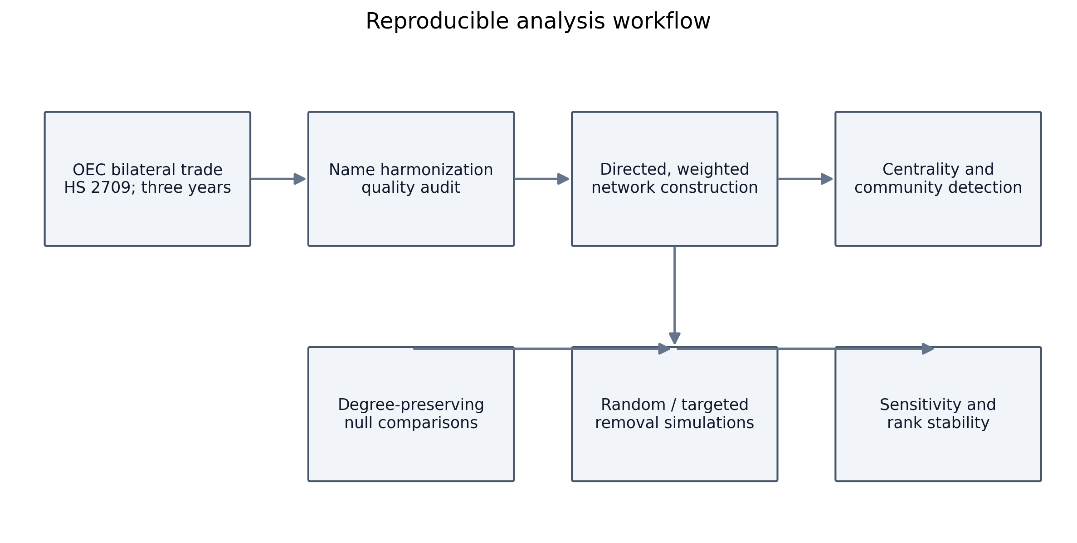
Figure 2. Source consolidation, graph construction, harmonization, structural measurement, and sensitivity testing.

4. Results

4.1. Size, direction and global connectivity
Table 3. Directed graph statistics after documented label harmonization.
Year | Nodes | Directed edges | Density | Mean in/out degree | Weak CC | Strong CC | Efficiency
2017 | 172 | 1482 | 0.0504 | 8.62 | 1 | 88 | 0.2486
2019 | 170 | 1316 | 0.0458 | 7.74 | 1 | 100 | 0.2184
2020 | 170 | 1259 | 0.0438 | 7.41 | 1 | 93 | 0.2274
Note. Mean in-degree equals mean out-degree; connected-component counts and efficiency use directed definitions where appropriate.
The consolidated networks contain 1,482 edges in 2017, 1,316 in 2019, and 1,259 in 2020. Density declines from 0.0504 to 0.0458 and 0.0438; mean in-degree and mean out-degree decline from 8.62 to 7.74 and 7.41. Each graph has one weakly connected component, but its number of strongly connected components is large, rising from 88 in 2017 to 100 in 2019 and falling to 93 in 2020. These figures, reported in Table 3, indicate different connectivity conclusions depending on whether the direction of trade is respected.
Directed global efficiency falls by 0.0303 between the first two snapshots, then increases by 0.0091 in 2020. A claim of an uninterrupted decline in every structural indicator would therefore misrepresent the data. The network diagrams in Figure 3 use a common layout so that differences in the positions of nodes reflect changes in recorded graph structure rather than an independently optimized drawing for each year.
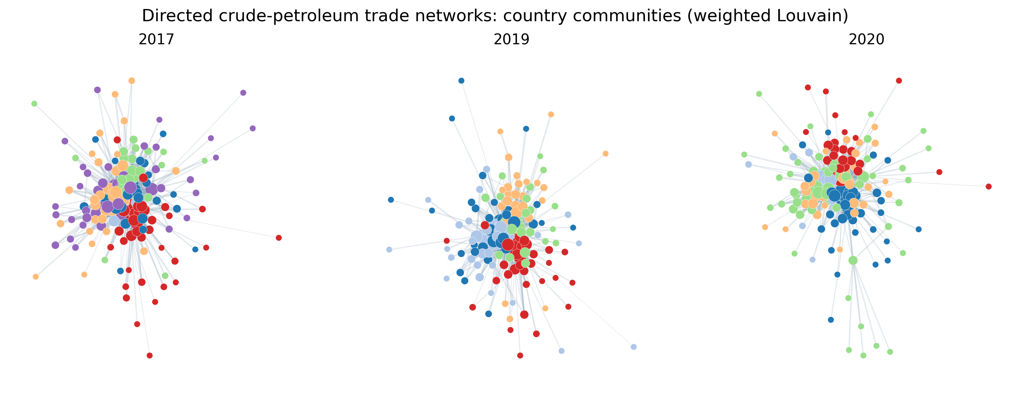
Figure 3. Country networks in 2017, 2019, and 2020 using common coordinates; color denotes a weighted computational community.
The three trajectories of density, average undirected clustering and directed efficiency are compared in Figure 4. Average undirected clustering declines from 0.5575 to 0.4910 and 0.4651. This undirected projection measure is deliberately different from the original article’s reported Gephi clustering values and should not be mixed with them.
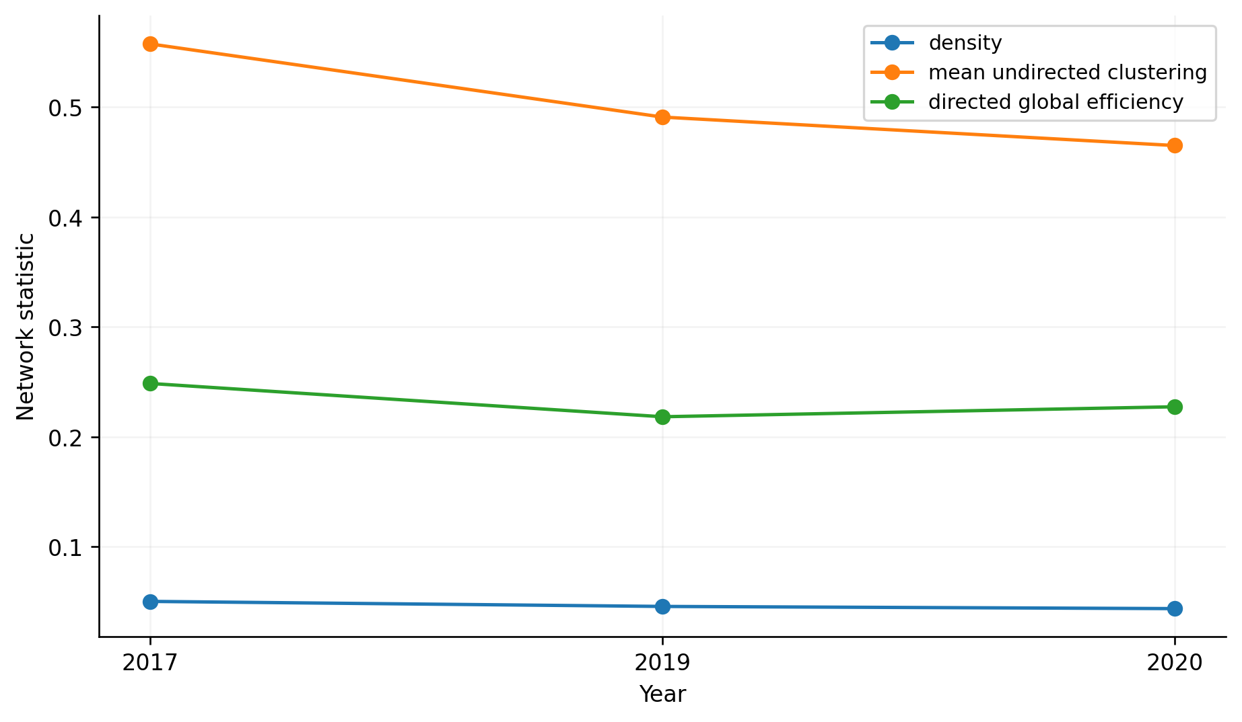
Figure 4. Directed density, undirected mean local clustering, and directed global efficiency.

4.2. Exporter and importer positions
Table 4. Highest-ranked jurisdictions by the reported directional metrics.
Year | Most outgoing partners | Most incoming partners | Largest export-value strength | Largest import-value strength | Top HITS hub | Top HITS authority
2017 | United States | United States | Saudi Arabia | China | Canada | United States
2019 | United States | Netherlands | Saudi Arabia | China | Saudi Arabia | China
2020 | United States | Netherlands | Saudi Arabia | China | Saudi Arabia | China
The United States has the highest out-degree in each observation, but Saudi Arabia has the greatest out-strength in dollars. China is highest in in-strength. The divergence in Table 4 reflects the distinction between how many partners a jurisdiction has and the total dollar value of the relationships. A high HITS score describes a position in the weighted adjacency system; it does not directly measure bargaining power, the physical passage of oil, or diplomatic influence.
Table 5. Iran’s recorded role in the reconstructed directed networks.
Year | In-degree | Out-degree | Out-strength (US$ bn) | Outward harmonic | Directed betweenness
2017 | 4 | 20 | 56.62 | 0.4815 | 0.00313
2019 | 0 | 7 | 12.40 | 0.4103 | 0.00000
2020 | 0 | 2 | 1.18 | 0.3457 | 0.00000
In the supplied data, Iran has 20 outgoing partners in 2017, seven in 2019 and two in 2020. Its out-strength is US$56.62 billion, US$12.40 billion and US$1.18 billion, respectively. Directed betweenness decreases to zero in the two later snapshots, as listed in Table 5. This is a statement about shortest paths in the observed formal network. It does not establish the cessation of unreported trade, indirect delivery arrangements, or Iran’s broader commercial intermediary activity.
The country-level degree distributions are asymmetric: many nodes have few recorded partners and relatively few have large partner sets. The positive in-degree and out-degree frequency distributions are plotted separately in Figure 5, rather than relying on mean degree as the sole summary.
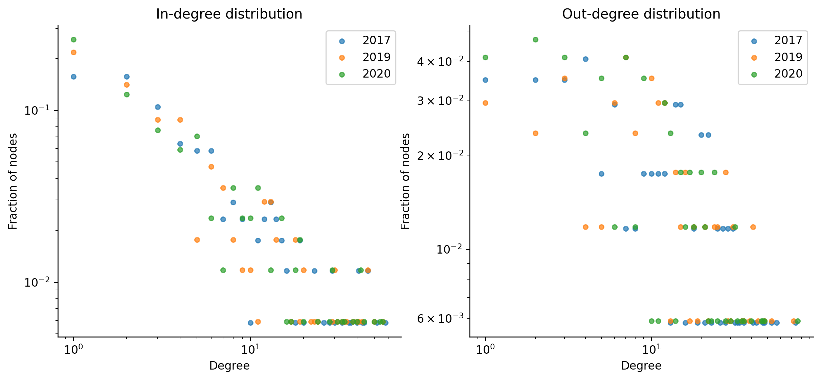
Figure 5. Observed positive in- and out-degree frequencies by year, displayed on logarithmic axes.
Table 6. Exploratory geometric and Zipf fits to positive partner counts.
Year | Side | Lower-AIC candidate | AIC | AIC advantage | Positive-degree nodes
2017 | in | geometric | 1024.8 | 50.0 | 162
2017 | out | geometric | 707.8 | 114.7 | 95
2019 | in | geometric | 952.0 | 5.4 | 154
2019 | out | geometric | 642.8 | 115.1 | 87
2020 | in | zipf | 932.8 | 8.6 | 155
2020 | out | geometric | 670.6 | 101.1 | 94
Note. Model comparison uses the same positive-degree observations per year and side; the candidate families are not exhaustive.
The relative fit comparison in Table 6 is conditional on the two candidate families and the exclusion of zero-degree observations. The fitted models are descriptive representations of each sample distribution, not evidence that a particular generative law governs world petroleum trade. The full degree-frequency and fitted-parameter tables are supplied with the code.
Monetary prominence is shown independently in Figure 6. The differences between the exported dollar values and partner counts should prevent descriptions of network leadership based solely on degree.
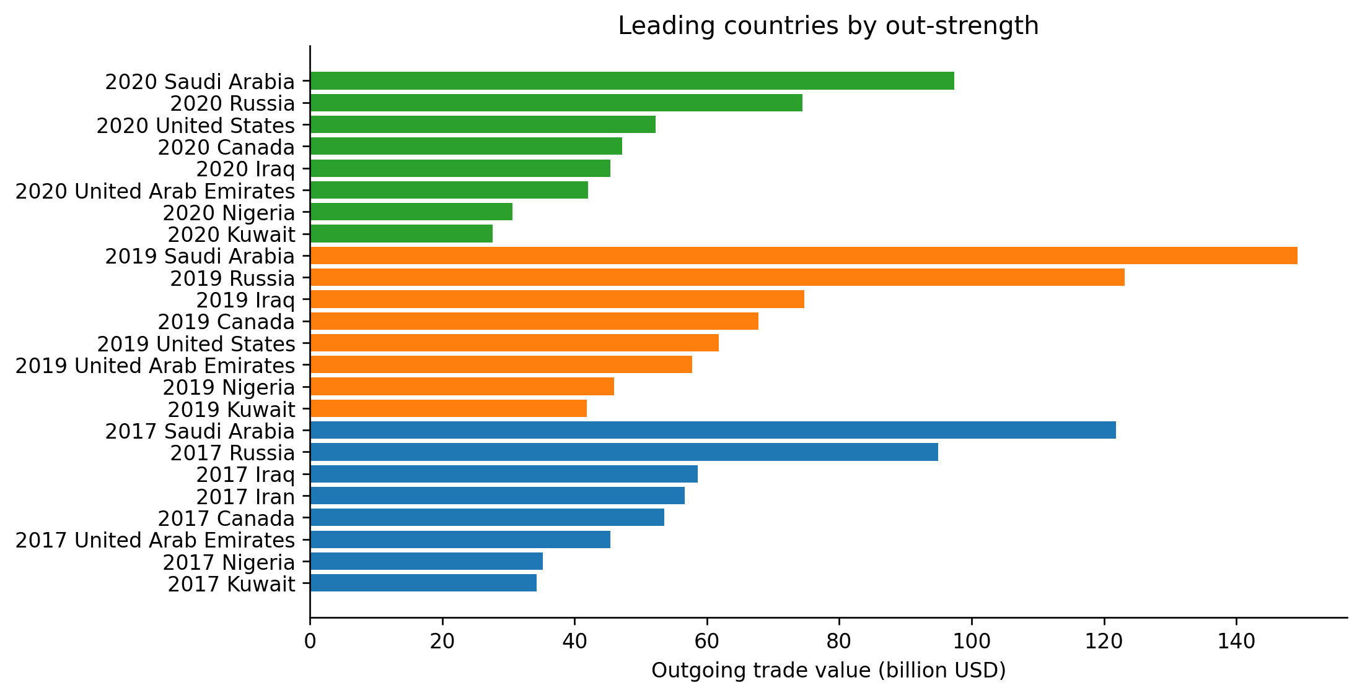
Figure 6. Country out-strength rankings measured in recorded US dollars across the three network snapshots.

4.3. Communities and persistence of country roles
Table 7. Weighted Louvain communities and partition sensitivity.
Year | Displayed groups | Weighted modularity | Range over 20 seeds | Groups across seeds
2017 | 6 | 0.3992 | 0.3992–0.4008 | 6, 7
2019 | 5 | 0.3771 | 0.3614–0.3788 | 4, 5
2020 | 5 | 0.3549 | 0.3491–0.3661 | 5
Note. Reciprocal edge values are summed in the undirected projection; resolution is 1. The displayed partition uses seed 46.
The selected weighted modularity values are 0.3992, 0.3771, and 0.3549, with six, five, and five displayed communities. The random-seed ranges in Table 7 show that the 2019 and 2020 group counts can vary under repeated optimization. A change in the number of detected communities therefore does not, on its own, establish increased regional integration or consolidation. Geographic and political labels are not assigned to the computational partitions.
Table 8. Rank stability based on the countries present in both annual networks.
Paired years | Statistic | Shared jurisdictions | Spearman ρ
2017–2019 | in degree | 155 | 0.807
2017–2019 | out degree | 155 | 0.908
2017–2019 | out strength usd | 155 | 0.935
2017–2019 | harmonic out | 155 | 0.899
2019–2020 | in degree | 151 | 0.909
2019–2020 | out degree | 151 | 0.834
2019–2020 | out strength usd | 151 | 0.900
2019–2020 | harmonic out | 151 | 0.828
2017–2020 | in degree | 156 | 0.817
2017–2020 | out degree | 156 | 0.847
2017–2020 | out strength usd | 156 | 0.867
2017–2020 | harmonic out | 156 | 0.846
Rank correlations in Table 8 are calculated only on the intersection of country labels for each year pair. They quantify relative stability in observed positions, not stability of trade quantities or causal effects. Differences between the complete annual node sets and common-country comparisons are recorded in the supplementary files.

4.4. Simulated robustness and threshold tests
Table 9. Largest weak-component share after removal of 30% of observed nodes.
Year | Removal rule | Remaining LCC/survivors at 30% | Implementation
2017 | random | 0.951 | 70 permutations
2017 | targeted | 0.283 | Fixed baseline degree
2019 | random | 0.931 | 70 permutations
2019 | targeted | 0.101 | Fixed baseline degree
2020 | random | 0.922 | 70 permutations
2020 | targeted | 0.160 | Fixed baseline degree
Note. The fraction is conditional on surviving nodes; targeted removal uses a fixed initial degree ranking.
The contrast between deletion strategies is substantial. At 30% removal, the surviving-node shares in the largest weak component are 0.283, 0.101 and 0.160 in the targeted experiment, compared with 0.951, 0.931 and 0.922 under averaged random deletion for 2017, 2019 and 2020. The point comparisons are in Table 9, while the full removal curves appear in Figure 7. The 2019 graph appears most vulnerable at this fixed intervention level, but that ordering need not hold for all fractions removed or alternative targeting definitions.
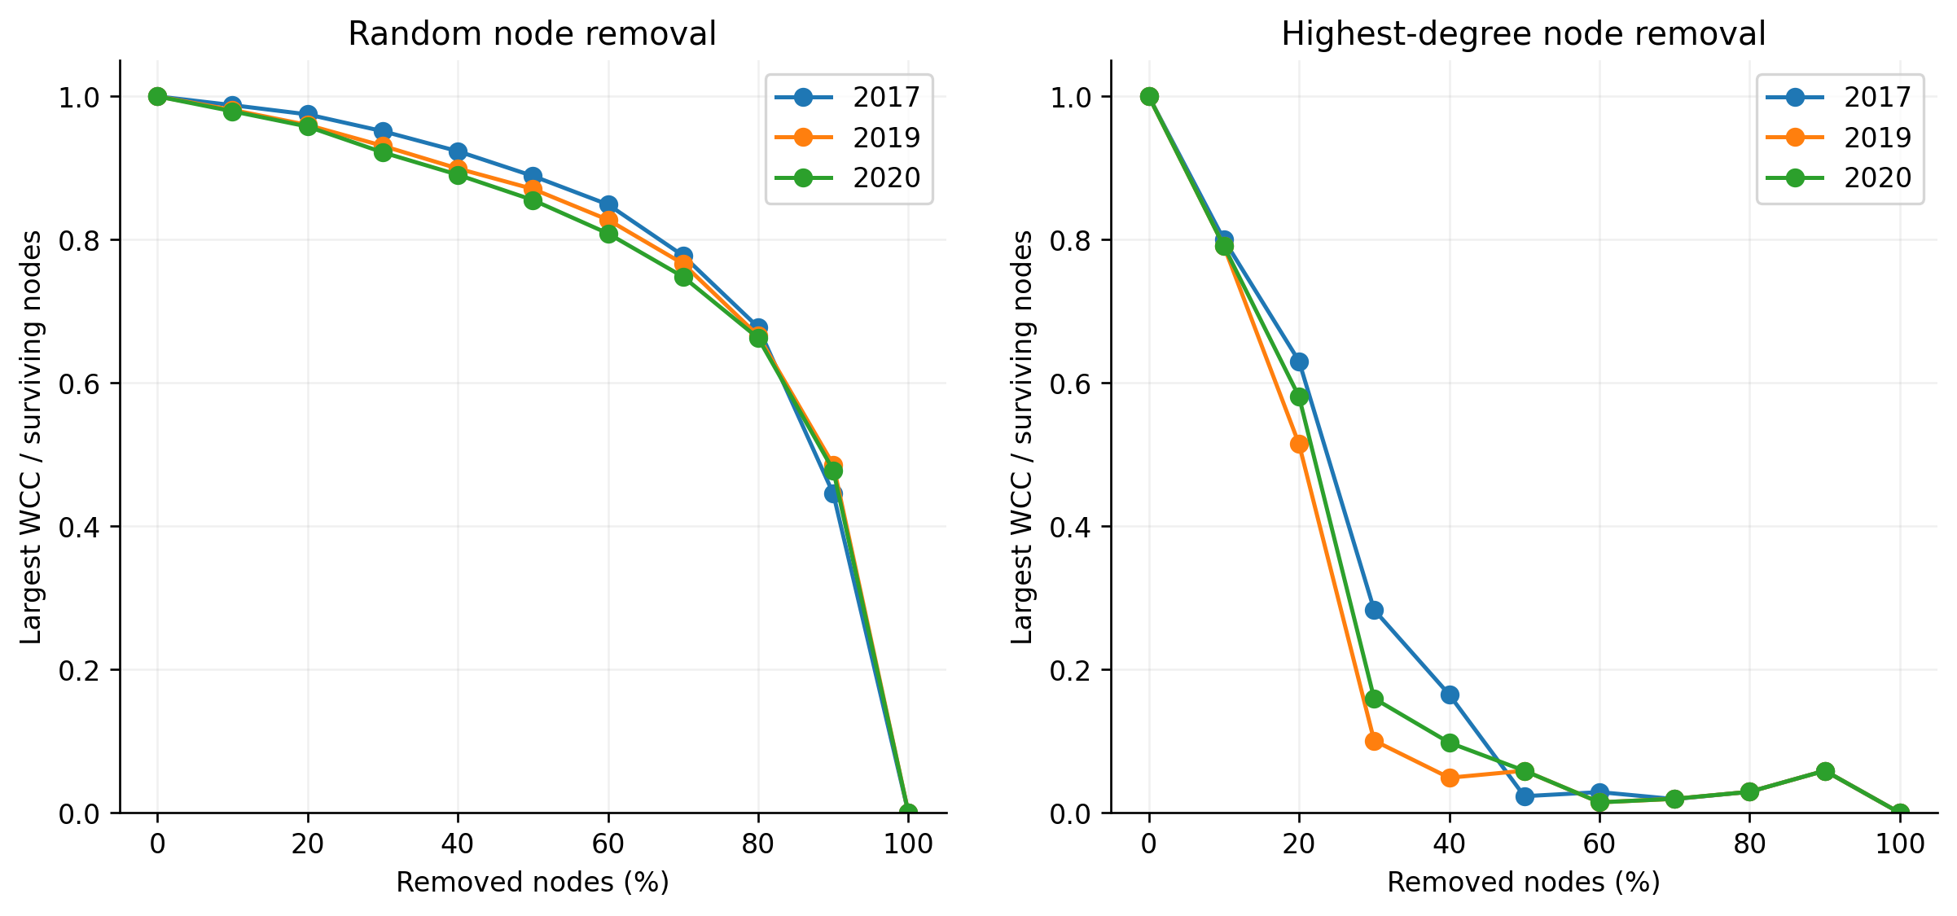
Figure 7. Conditional largest-component connectivity under seeded random deletion and original-degree-targeted deletion.
Table 10. Sensitivity to minimum observed dollar values for retained edges.
Year | Minimum edge value (US$) | Edges retained | Weak components | Largest weak component
2017 | 0 | 1482 | 1 | 172
2017 | 1,000 | 1191 | 11 | 162
2017 | 1,000,000 | 945 | 42 | 131
2017 | 10,000,000 | 867 | 49 | 124
2019 | 0 | 1316 | 1 | 170
2019 | 1,000 | 1047 | 14 | 157
2019 | 1,000,000 | 832 | 45 | 126
2019 | 10,000,000 | 789 | 50 | 121
2020 | 0 | 1259 | 1 | 170
2020 | 1,000 | 1040 | 12 | 159
2020 | 1,000,000 | 863 | 48 | 123
2020 | 10,000,000 | 801 | 54 | 117
Note. The same node set is held for all cutoffs within a year.
Removing low-dollar relationships increases the number of weakly connected components. For example, at a US$1 million minimum, the 2017 graph retains 945 edges and its largest weak component includes 131 nodes, compared with 1,482 edges and 172 nodes at the zero cutoff. The complete comparison in Table 10 and Figure 8 shows that the appearance of complete weak connectivity in the baseline network depends in part on small-value relationships.
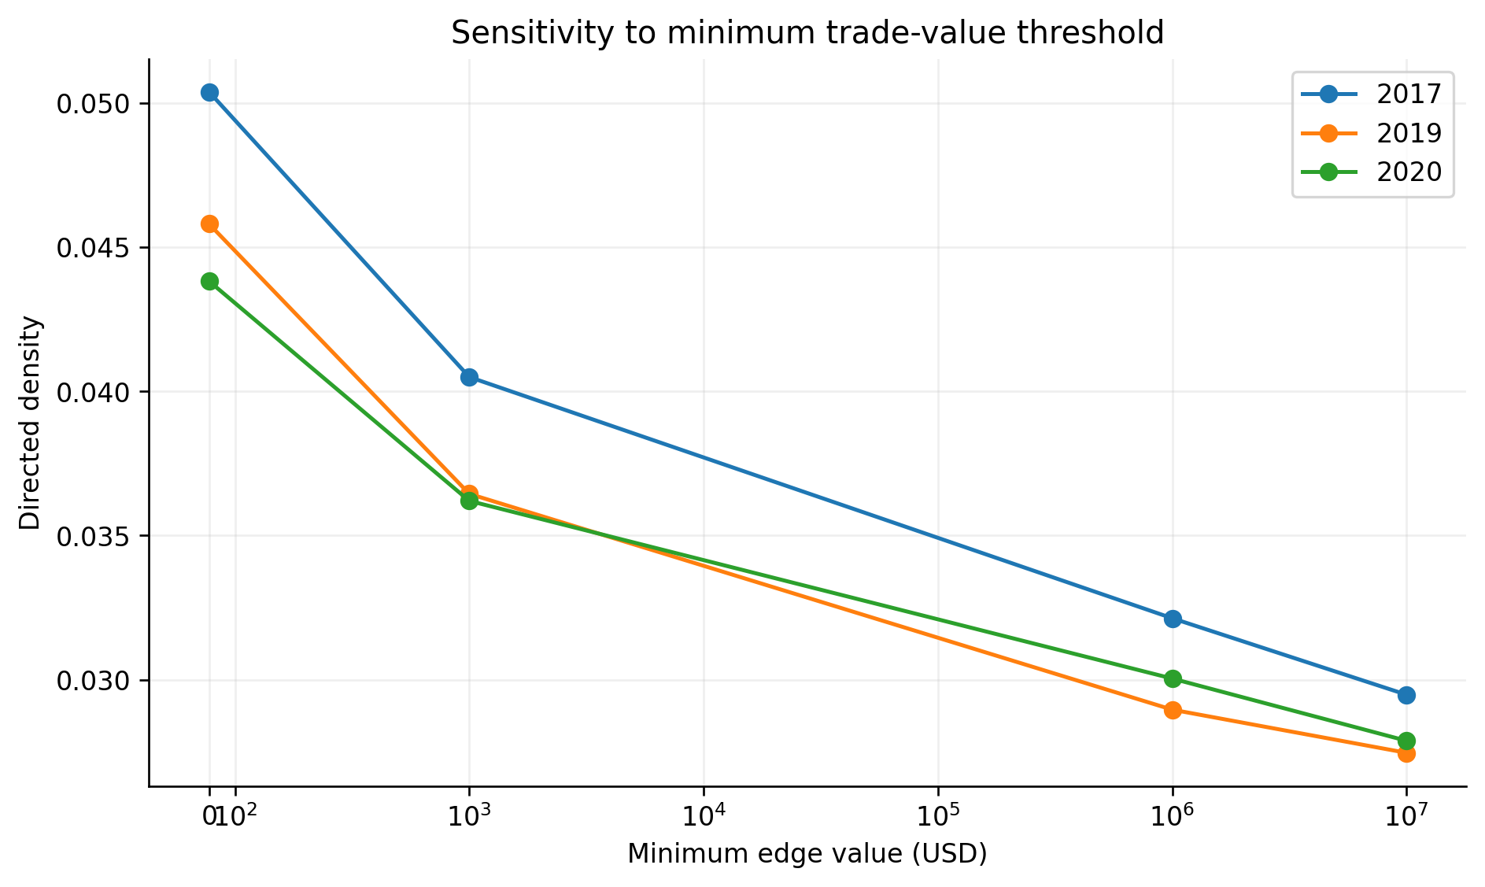
Figure 8. Sensitivity of graph connectivity to minimum reported bilateral trade value.
Table 11. Exploratory degree-preserving rewiring benchmark.
Year | Observed clustering | Null mean | Null range | Upper-tail empirical p
2017 | 0.5575 | 0.4889 | 0.4316–0.5232 | 0.038
2019 | 0.4910 | 0.4552 | 0.4238–0.4779 | 0.038
2020 | 0.4651 | 0.4331 | 0.4015–0.4594 | 0.038
Note. Twenty-five undirected double-edge-swap realizations per year; p=(1+number of null values at least observed)/(26).
Observed clustering exceeds the mean of the 25 degree-preserving reference graphs in each snapshot, as reported in Table 11. The finite empirical p-values represent the resolution of these exploratory comparisons and should not be read as a statistical test of the pandemic or sanctions. The sensitivity and null-network experiments check network-construction dependence, not a causal treatment effect.

5. Discussion

5.1. What structural changes can be inferred?
The three annual comparisons reveal fewer reported links and lower density in 2019 and 2020 than in 2017. That observation is compatible with several changes in the oil-trade environment, including sanctions policy and the demand shock of the pandemic, but the analysis does not isolate the contribution of either event. As the higher 2020 global-efficiency value demonstrates, the direction of a change depends on the chosen connectivity metric. Treating all declines in degree or density as the same phenomenon would obscure the role of reachability and the remaining placement of links.
The distinction between export value and export breadth is equally consequential. Saudi Arabia appears at the top of reported out-strength while the United States has the most outgoing partners in all three snapshots. The economic meaning is limited to the two measured dimensions: dollar-valued bilateral exports and number of counterparties. The data cannot establish a country’s capacity to supply replacement barrels after a disruption. Similarly, large values of directed betweenness imply prominence on topological shortest paths, not a verified ability to mediate physical shipments.
The decline in Iran’s recorded partner count and dollar-valued out-strength is unusually pronounced. The chronology of sanctions creates an obvious contextual connection, but the observed difference is not a causal estimate. The sample excludes informal, concealed, or unreported arrangements; the zero betweenness observed for Iran in the 2019 and 2020 binary graphs is not evidence that Iran ceased to participate in all intermediary trade. This interpretation addresses a measurement gap that cannot be solved by extrapolating from public reporting.

5.2. Stress-test interpretation and data limitations
The deletion curves give a direct operational meaning to structural robustness: the share of surviving jurisdictions that remain in the largest weakly connected portion of the network after a specified removal rule. The sharp targeted-removal declines relative to random-removal curves indicate concentration around a limited number of highly connected vertices. Related studies have reached vulnerability findings using targeted attacks, although their country sets and removal definitions differ (Wei et al., 2022) (Liu et al., 2025). The present results concern fixed, static observed graphs. They neither allow remaining importers to switch suppliers nor estimate the capacity, cost or timing of rerouted oil flows.
Weighted community detection and its seed variation also constrain the interpretation of regionalization. The displayed partitions are an optimization output on a particular undirected transformation of a monetary graph. The values can change when a resolution parameter, random initialization, or small edge threshold is changed. Claims that a named regional alliance emerged or disappeared would require direct country-group analysis and evidence of trade institutions beyond the algorithmic communities.
A larger interpretive uncertainty concerns the provenance of the 2019 weights. The new source archive provides useful reporter-level evidence but does not reproduce the consolidated dollar figures exactly for many matched pairs. In consequence, the principal results are auditable transformations of the three consolidated author-supplied datasets. They should not be presented as a fully independently reproduced extraction from OEC. This boundary is also relevant to the figures for national in-strength and out-strength, which depend on monetary reporting values.

5.3. Energy security and sustainable development
The structural results may inform how alternative suppliers and counterparties are considered in energy-security planning. High concentration of network ties and the strong impact of targeted node removal justify examining redundancy around large exporters, importers and commercial hubs. They do not by themselves identify spare production capacity, operating pipeline routes, refining compatibility or the contractual ability to substitute suppliers. Studies that model adaptive trade rewiring or the interaction of shipping and trade records use precisely the additional information needed to approach those operational questions (Chen et al., 2025) (Zhang et al., 2026).
The Sustainable Development Goals provide a policy context, not outcome variables in the estimated model. SDG 7 concerns access to affordable and reliable energy; SDG 9 concerns infrastructure and industrial systems. Trade connectivity can affect exposure during energy transitions, but preserving every crude-oil linkage is not an SDG target. SDG 13 requires emissions reductions, which are not measured by the present edge list. SDG 17 concerns partnerships and cooperation, which might support responses to concentrated supply exposures but cannot be measured from network modularity alone. Resilience of an existing oil trade network and progress toward decarbonization must be treated as analytically distinct issues.

6. Study limitations
The study uses three selected years and does not estimate an event-study, difference-in-differences model, structural supply-demand system, or any other design that identifies the counterfactual impact of sanctions or COVID-19. No consecutive-year series was supplied, and no additional years have been invented. Nominal dollar values vary with prices as well as quantities; therefore, a decline in trade value cannot be interpreted as a proportional fall in physical barrels or earnings without additional data.
The original record-cleaning protocol lacked a verifiable mirror-statistics reconciliation rule. Although country-specific 2019 downloads are now available, their overlap with the consolidated graph contains substantial mismatches. A small number of node names also require authoritative confirmation, particularly Chinese in the 2019 consolidated dataset. Code and all recorded corrections are supplied; none of the unresolved records has been assigned a speculative country identity.
The node-deletion experiment removes countries without allowing exchange-rate adjustment, price changes, physical oil substitution, spare capacity, route substitution, or network recovery. Conditional weak-component connectivity is a topological measure. Weighted HITS and value-based community partitions describe the observed monetary adjacency matrix but depend on the specific weight definition and may be sensitive to reporting versions. The degree-preserving null samples are limited to 25 rewires per year and should not be interpreted as precise population-level significance estimates.

7. Conclusion
The reconstructed 2017, 2019 and 2020 crude petroleum trade networks differ in directed link density, dollar-weighted country prominence, shortest-path reachability and community partitions. The three snapshots show declining density, but directed global efficiency rises between 2019 and 2020. Exporter rankings also depend on whether prominence is defined by partner count or recorded dollar value. Replacing conventional closeness with outward harmonic centrality resolves an interpretive problem caused by the large number of strongly disconnected directed components.
The deletion experiments indicate that removing high-degree countries can disrupt the weak network skeleton more severely than random country removal. These results justify a qualified claim of simulated structural robustness within the supplied data and assumptions. The study cannot attribute the differences to the two historical disruptions, assess recovery of physical supply or infer progress toward climate goals. Its reproducible outputs provide a basis for verifying those bounded structural statements and for revisiting monetary discrepancies once the original trade reports are reconciled.

Declarations

Ethical approval
Not applicable. The analysis concerns aggregated country-level trade records and does not involve human participants or animal subjects.

Consent to participate
Not applicable. No human participants were recruited.

Consent to publish
Not applicable to participant consent because no identifying participant material is reported.

Funding
The source manuscript states that the research received no specific grant from public, commercial or not-for-profit funding agencies. Authors should confirm that this statement remains accurate.

Competing interests
The source manuscript declares no competing interests. All authors should confirm this declaration before submission.

Data and code availability
Reproducibility materials have been prepared for public deposition under the ResearchRepro GitHub organization at https://github.com/ResearchRepro/crude-oil-trade-network-resilience. This repository address is a planned destination; the files have not been published there at manuscript preparation. The authors will activate the repository and verify third-party data redistribution permissions before asserting public access. Derived edge lists, analysis scripts, graphs, audit reports and figure files are supplied with the revision materials. The source OEC profile is https://oec.world/en/profile/hs/crude-petroleum.

Author contributions
[AUTHOR TO CONFIRM] The roles of individual authors in data extraction, conceptualization, methodology, software, validation, writing and supervision were not established by the supplied materials.

AI-assisted preparation
OpenAI ChatGPT was used to support drafting, language revision, code development and analytical-document preparation. All numerical outputs were generated from supplied datasets using documented scripts. The human authors remain responsible for validating the code, source interpretation, references and final claims. The authors should confirm that this disclosure accurately captures the tools used during manuscript preparation.

References
Blondel, Vincent D.; Guillaume, Jean-Loup; Lambiotte, Renaud; Lefebvre, Etienne (2008). Fast unfolding of communities in large networks. Journal of Statistical Mechanics: Theory and Experiment, 2008(10), P10008. https://doi.org/10.1088/1742-5468/2008/10/P10008
Chen, Sai; Ji, Gaojian; Tian, Kailan; Ding, Yueting (2025). Adaptive strategies to enhance resilience in the global oil trade network. Energy Strategy Reviews, 62, 101921. https://doi.org/10.1016/j.esr.2025.101921
Chen, Sai; Sun, Xinran; Tian, Yuxi; Zhang, Tairui; Xue, Guiqin (2026). Resilience of oil product trade networks along the global oil industry chain: A risk propagation approach. Energy Strategy Reviews, 66, 102331. https://doi.org/10.1016/j.esr.2026.102331
Kleinberg, Jon M. (1999). Authoritative sources in a hyperlinked environment. Journal of the ACM, 46(5), 604–632. https://doi.org/10.1145/324133.324140
Liu, Jingye; Guo, Fengqi; Shi, Ying; Ding, Rijia (2025). Study on the evolutionary characteristics and robustness of the global refined oil trade network. Energy, 331, 137032. https://doi.org/10.1016/j.energy.2025.137032
Liu, Yu-Qi; Wen, Shou-Xun; Li, Jun; Yang, Jun; Cheng, Xi; Feng, Chao; Guo, Li-Yang (2024). Revealing the evolution of global energy trade patterns amidst the COVID-19 epicenter storm. Energy Strategy Reviews, 53, 101367. https://doi.org/10.1016/j.esr.2024.101367
Newman, M. E. J. (2006). Modularity and community structure in networks. Proceedings of the National Academy of Sciences, 103(23), 8577–8582. https://doi.org/10.1073/pnas.0601602103
Observatory of Economic Complexity (2024). Crude petroleum (HS 2709): trade profile. https://oec.world/en/profile/hs/crude-petroleum
Office of Foreign Assets Control (2018). Re-imposition of the sanctions on Iran that had been lifted or waived under the JCPOA. https://ofac.treasury.gov/sanctions-programs-and-country-information/iran-sanctions/re-imposition-of-the-sanctions-on-iran-that-had-been-lifted-or-waived-under-the-jcpoa
Shahnazi, R.; Sajedianfard, N.; Melatos, M. (2023). Import and export resilience of the global oil trade network. Energy Reports, 10, 2017–2035. https://doi.org/10.1016/j.egyr.2023.08.065
Si, Ruibin; Jia, Peng; Li, Haijiang; Zhao, Xueting (2025). Assessing the structural resilience of the global crude oil maritime transportation network: A motif-based approach from network to ports. Journal of Transport Geography, 123, 104123. https://doi.org/10.1016/j.jtrangeo.2025.104123
Wei, Na; Xie, Wen-Jie; Zhou, Wei-Xing (2022). Robustness of the international oil trade network under targeted attacks to economies. Energy, 251, 123939. https://doi.org/10.1016/j.energy.2022.123939
World Health Organization (2020). Listings of WHO’s response to COVID-19. https://www.who.int/news/item/29-06-2020-COVIDtimeline
Zhang, Lingye; Su, Wan; Liao, Shiguan; Wang, Shuang (2026). Enhancing energy security through multi-scale network analysis: robustness in global crude oil shipping–trade networks. Reliability Engineering & System Safety, 265, 111525. https://doi.org/10.1016/j.ress.2025.111525

