**What is LIDAR?**

LIDAR (an acronym for Light Detection and Ranging) is used for creating 2D/3D maps of surrounding environment. It is an essential component of autonomous/smart cars [1] as it enables cars to solve Simultaneous Localization and Mapping (SLAM) problem and enables creating dynamic model of the environment in which it is currently operating in. It is also used to map vegetation and wide ground area with the help of aerial vehicles such as airplanes, helicopters, and drones. When it is used in aerial vehicles, it is often necessary to fuse with Inertial Measurement Unit (IMU), GPS, and LIDAR data in order to map the environment.

**How does LIDAR work?**

LIDAR sensor sends a light beam and measures the time it takes to return to its source (Fig. 1) [2,3].

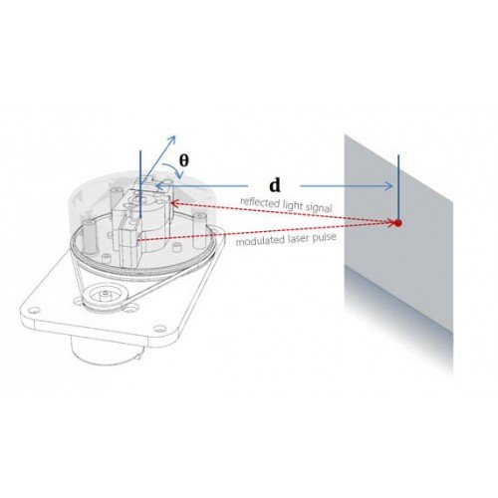

Fig. 1, how LIDAR measures the distance

The calculation is actually quite simple:

**Distance = (Speed of Light x Time of Flight) / 2**

Though it is quite simple to do the calculation, LIDAR sensors fires rapid pulses of laser light at a rate ranging from 1000 per second to 150.000 per second depending on the application requirements. Since LIDAR has its own source of light (laser), it can also operate in dark environments.[2] Knowing accurate distance between the object and the sensor, combined with orientation data of LIDAR, allows computer to build 2D/3D model of environment.

**There are four main components of LIDAR systems:**

1. Lasers
2. Photodetector and receiver
3. Navigation and positioning systems
4. Scanners and optics

***Lasers***

Lasers are used to fire pulses of light at objects. Wavelength of 600-1000nm lasers are generally used for non-scientific purposes and can be sense by eye. Wavelength of 1550nm lasers are more commonly used. 1550nm allows longer range at the expense of lower accuracy [4] (Accuracy for LIDAR refers to how much measurement can deviate from actual distance between LIDAR and object) compared to 600-1000nm wavelength and is more suitable for military applications as 1550nm lasers are not seen in night vision googles. The reason 1550nm wavelength allows longer range is, most applications are required to be eye-safe and unlike 600-1000nm wavelength, 1550nm wavelength laser is not focused by eye so it allows operating laser at much higher powers.

***Photodetector and receiver***

This part record signals that are being returned to the LIDAR system. Solid state detectors and photomultipliers are two commonly used photodetector and receiver types.

***Navigation and positioning systems***

LIDAR system can be put with tripod on the ground (Fig. 2) [5] (to reduce the motion) for the mapping of the environment, and repeat the process with same LIDAR at different parts of the site for capturing the whole area. It can also be mobile and integrated with satellites, airplanes, and automobiles (Fig. 3) [6]. When LIDAR system is mobilized, it is necessary to determine the absolute position and orientation of the sensor.

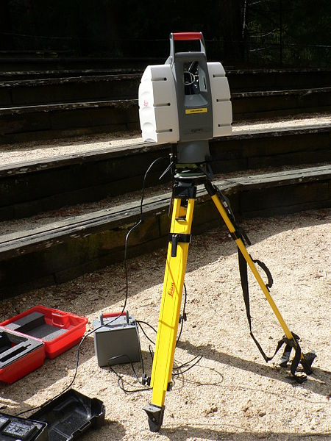

Fig. 2, Ground LIDAR

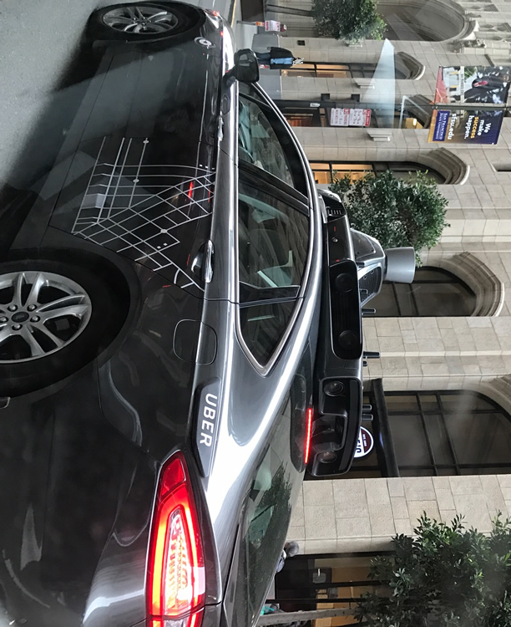

Fig. 3, Autonomous Car Mounted LIDAR

***Scanners and optics***

Those parts are used to deflect laser beams in different directions in order to capture complete image of the environment. LIDAR systems can be both scanning and flash. Scanning type LIDAR systems are not effective for relatively dynamic environments as the sensor capture rate bounded by how fast could LIDAR can rotate per second whereas for flash type LIDAR systems only constraint is how fast can it flash laser beam and readout the pixels. [2]

For scanning type LIDAR systems, there are various methods for scanning azimuth and elevation such as dual oscillating plane mirrors, dual axis scanner and polygonal mirrors. Those different scanning methods affects angular resolution and range of the system as they utilize different mechanical parts and mirrors in order to fire laser beam for scanning process.

In **LIDAR Security and Resiliency for Smart Cars** project we will be using **RPLIDAR 360 A1** module as LIDAR sensor.

**LIDAR Sensor Examples**

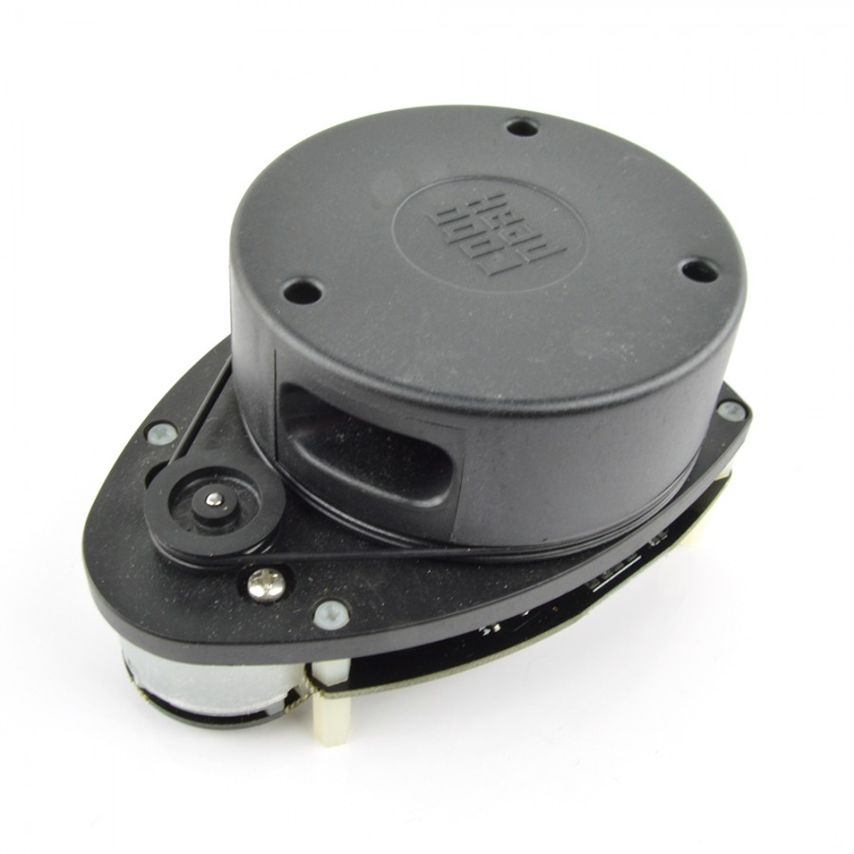

Fig. 4, RPLIDAR 360 A1

RPLIDAR 360 A1 (Fig 4) [7] is a low cost 2D LIDAR sensor that can operate in environments without direct sunlight exposure. It has a range of 6-8 meters, it collects 2000 samples per second at 5.5Hz rate and it is capable of 360 degrees scanning. An example of 360 scan data visualization captured by rplidar can be seen in figure 5. The module is Robot Operating System (ROS) ready, meaning that it can be easily integrated with systems that are using ROS framework. It also has SDK (Fig. 6) for developing application using C++ programming language. [8]

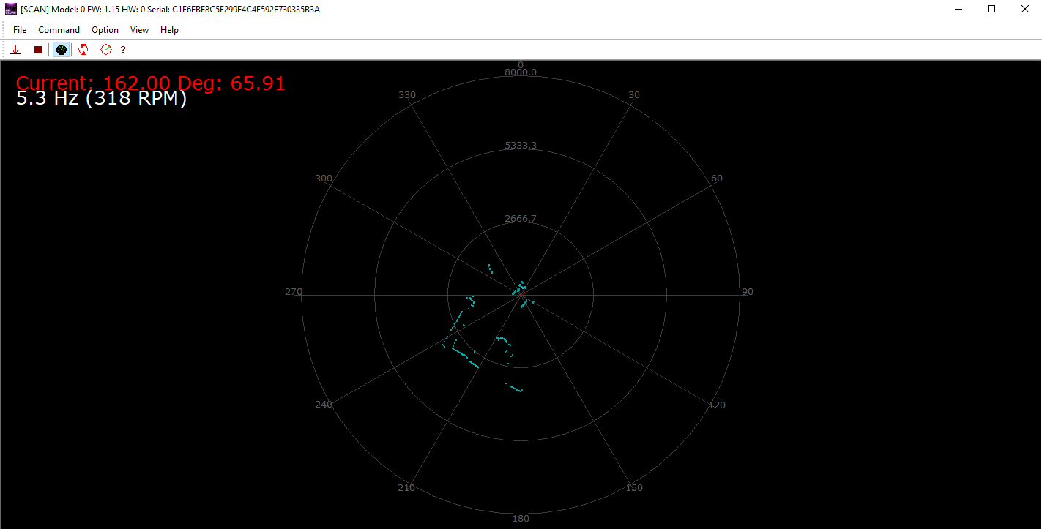

Fig. 5, 360 Degree Scan by RPLIDAR 360

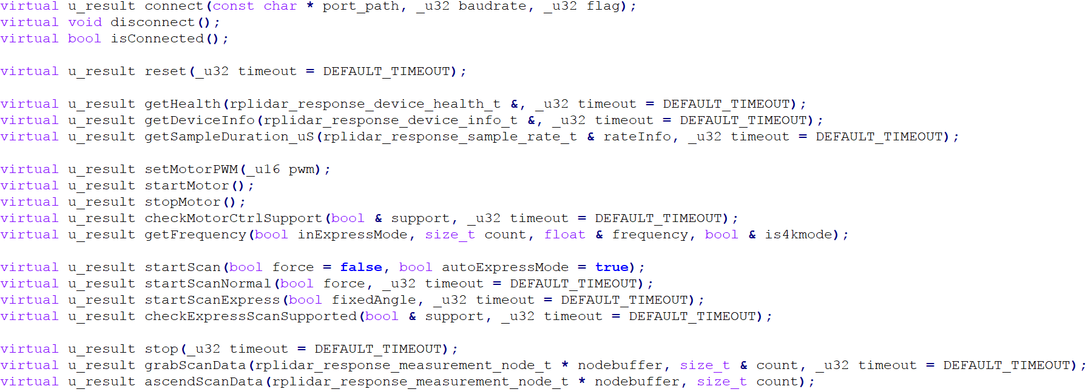Fig. 6, C++ SDK for RPLIDAR 360 A1

Alternatives to RPLIDAR 360 A1 is like the following:

RPLIDAR 360 A2

This module has almost double range compared to RPLIDAR 360 A1, it can collect up to 4000 samples per second, it is capable of 360 degrees scanning, and it can rotate at 5-15Hz. It is also ROS ready and has C++ SDK. This module is also capable of operating at outdoor environments.

SCANSE

Though creators of this module claimed that this module has 40 meters range, various people experimenting with the product mentioned that it has only range of 12 meters indoors and 4-5m outdoors. [9]

There are also industrial 2D and 3D LIDAR modules available in the market; however, those module prices are starting from thousands of dollars, so we will focus on low cost 2D LIDAR sensors for this project. Even though there are more advanced 2D LIDAR modules, we have chosen RPLIDAR 360 A1 module because it is currently most accessible 2D LIDAR module in Turkey.

**References**

[1] Pereira, M., Silva, D., Santos, V. and Dias, P., 2016. Self calibration of multiple LIDARs and cameras on autonomous vehicles. Robotics and Autonomous Systems, 83, pp.326-337.

[2] Williams, G., 2017. Optimization of eyesafe avalanche photodiode lidar for automobile safety and autonomous navigation systems. Optical Engineering, 56(3), pp.031224-1, 031224-3, 031224-4.

[3] robopeak, 2017. robopeak sensor distance measurement image, [Online]. Available: http://www.robotshop.com/media/files/images2/robopeak-sensor.jpg [Accessed: Nov 2017]

[4] [Online] Available: <http://bucket.download.slamtec.com/e9e096e9d9f30205d665260abe2cfb0c2dd62efa/LD108_SLAMTEC_rplidar_datasheet_A1M8_v1.0_en.pdf> [Accessed Nov 2017]

[5] wikipedia, 2017. ground LIDAR, [Online]. Available: https://en.wikipedia.org/wiki/Lidar#/media/File:Lidar_P1270901.jpg [Accessed: Nov 2017]

[6] wikipedia, 2017. Uber car with LIDAR, [Online]. Available: https://upload.wikimedia.org/wikipedia/en/5/57/Uber_car_with_lidar.jpg [Accessed: Nov 2017]

[7] robopeak, 2017. RPLIDAR 360 A1, [Online]. Available: http://www.robotshop.com/media/catalog/product/cache/1/image/900x900/9df78eab33525d08d6e5fb8d27136e95/r/p/rplidar-360-laser-scanner-4_1.jpg [Accessed: Nov 2017]

[8] Avadhanulu, M., 2010. An introduction to lasers, New Delhi: S. Chand & Company.

[9] [Online] Available: <https://diyrobocars.com/2017/05/28/comparing-low-cost-2d-scanning-lidars/> [Accessed Nov 2017]