

Acknowledgement

The present Project was developed under the supervision of Teacher Maira Beltrán and Lic. Felix Sinto, to express our gratitude for bring us the opportunity to work under their supervision on our project. Thanks for all the support, suggestions, and dedications it could be possible the early termination of this project. Definitely also be our guides of high school, they are wonderful humans that deserved all our respect and sincerity in all moment.

Thanks to God and our parents to give us an opportunity of study in a prestigious school. For the confidence that deposited in us and for unconditional love.

Our heartfelt thanks to all people that help one way or another in our academic education.

# Introduction

In this manual we pretend to guide in the use of the platform AeroControl. In it contain we will see the aspects more essentials to use in an easy way the platform. AeroControl is an application that was design with the objective to innovate the form of many airlines work in just one platform. AeroControl, is an application Web also offers the function of buy tickets, and also allow print the list of all registers in the platform and consult the different ways.

# Presentation

The manual of the platform AeroControl was developed by students of Colegio Santa Cecilia, it’s about the first platform that combines many Airlines in just one platform.

The manual introduce the use and the develop of the platform detailed how it can be a model on function that the client and the airline have a better experience on buy flights and the airlines given their services.

Modules

**Administrator:** This type of module have all the actions inside the platform, it can inter flights, sign up Airlines, users. Clients, etc. This manage all the system from its own platform.



**User Client:** This type of module only have the option to buy flights and see the different destinations.



**Airline:** The Airlines have the option to post their flights, and post the promotions that have inside the platform.

# Glossary

Airline: An organization that provides air transportation for passengers and freight.

Airplane: Any of various winged vehicles capable of flight, generally heavier than air and driven by jet engines or propellers.

Airports: a tract of land or water with facilities for the landing, takeoff, shelter, supply, and repair of aircraft, especially one used for receiving or discharging passengers and cargo at regularly scheduled times.

Staff: a group of persons, as employees, charged with carrying out the work of an establishment or executing some undertaking.

Flight: The motion of an object in or through a medium, especially through the earth's atmosphere or through space.

Destinations: the place to which a person or thing travels or is sent.

Tickets: a slip, usually of pap.er or cardboard, serving as evidence that the holder has paid a fare or admission or is entitled to some service, right, or the like.

Client: A customer or patron.

Calendar: a table or register with the days of each month and week in a year.

Administrator: One who administers, especially one who works as a manager in a business, government agency, or school.

Stewardess: A woman flight attendant.

Passport: An official document issued by a government identifying a citizen, certifying his or her nationality, and formally requesting admittance and safe passage from foreign countries.

Seats: something designed to support a person in a sitting position, as a chair, bench, or pew; a place on or in which one sits.

Zip: to travel with a sharp hissing or humming sound.

Runways: A strip of level, usually paved ground on which aircraft take off and land.

Location: a place of settlement, activity, or residence.

Aircraft: is a machine that is able to fly by gaining support from the air, or, in general, the atmosphere of a planet.

Cost: An amount paid or required in payment for a purchase; a price.

State: The supreme public power within a sovereign political entity.

Database: is an organized collection of data.

PHP : is a script language and interpreter that is freely available

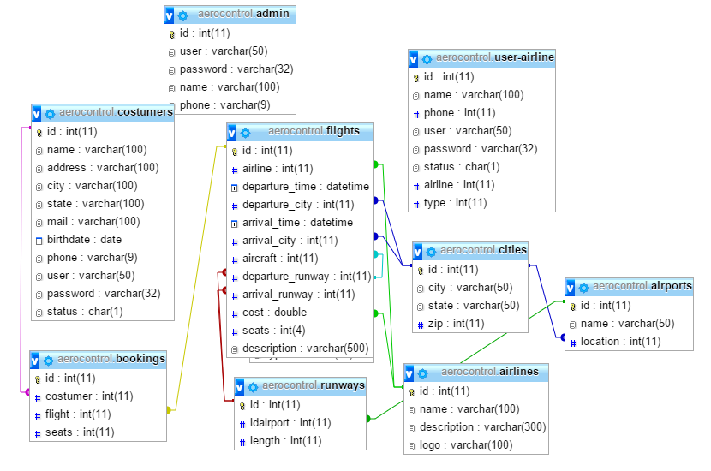

Software recommendations

It suggest to use in all moment a computer connected with interne, because is need to refresh the web platform, without connection it’s impossible to do it. And for Web browser it’s recommended to use Google Chrome

# Platform administrator (Screenshots)

* First we sign in the principal page of AeroControl

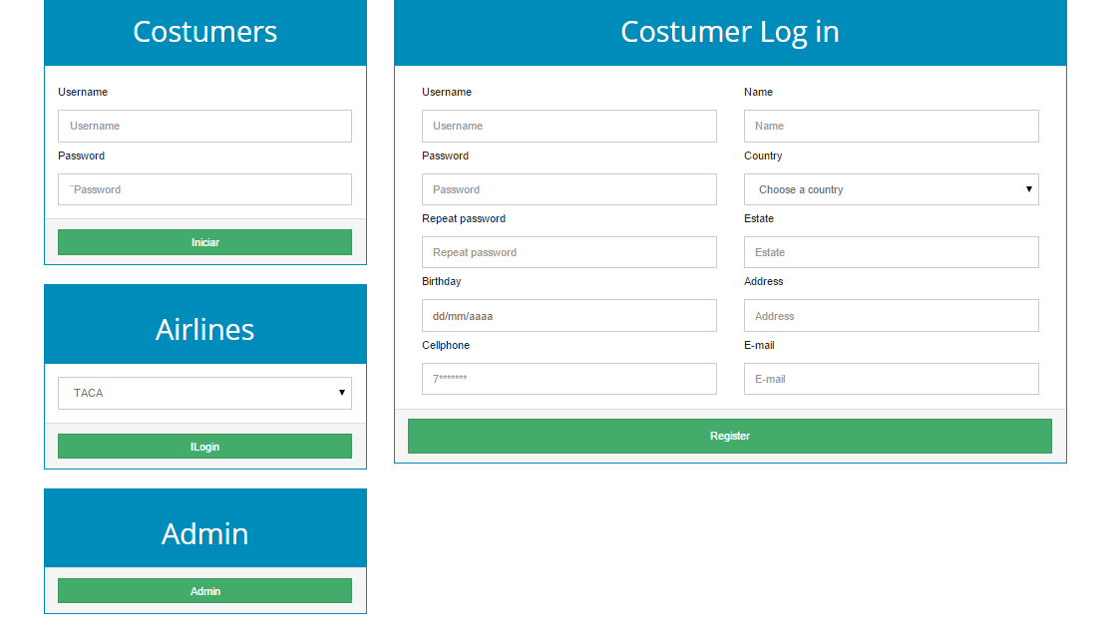

* Then is going to be showed the next screen in the platform we login.

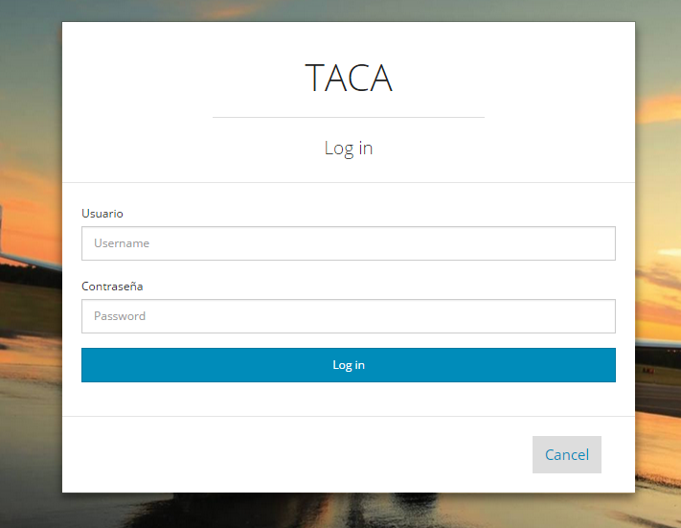

* Then this going to take us to the virtual platform of the administrator as we can see there is the flights in real time.

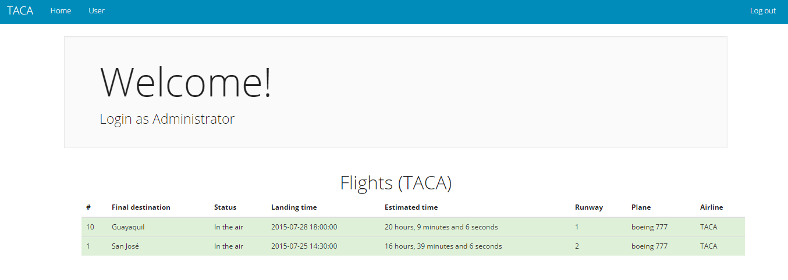

* Right it will show all the maintenance.
* Airplanes

This is the list of airplanes that have been register in the platform.

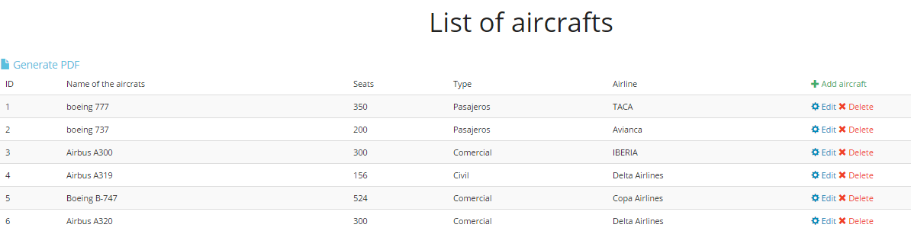

For register an airplane is need it to insert all the information that is required in this form.

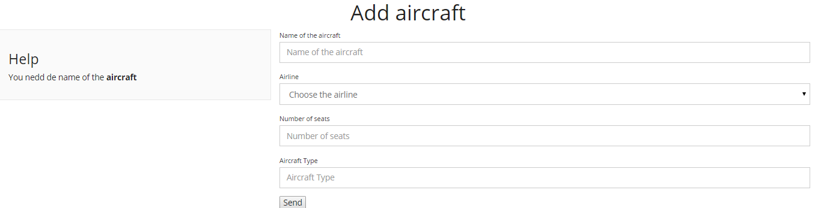

Here we can edit all the information for airplane.

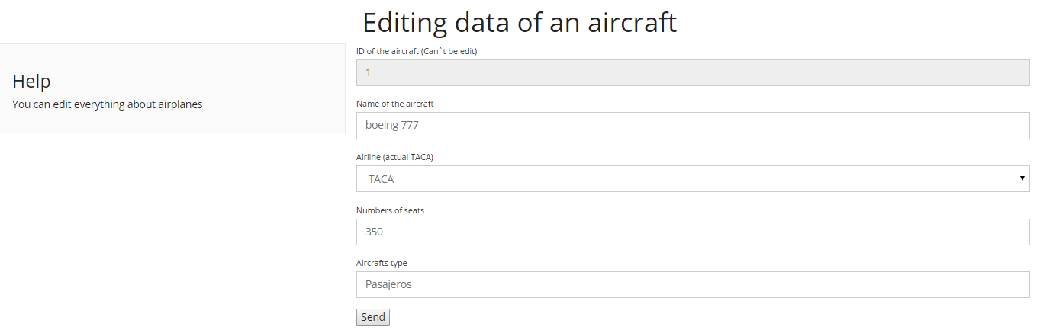

* Flights

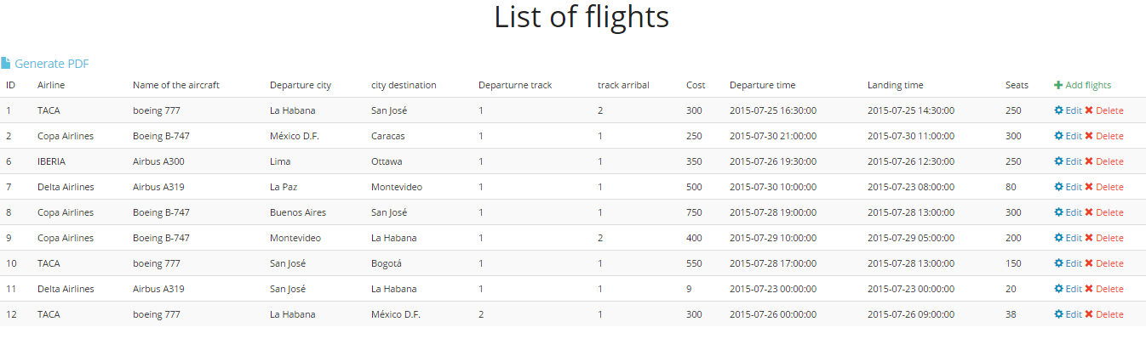This is the list of flights that have been register in the platform.

For register a flight is need it to insert all the information that is required in this form.

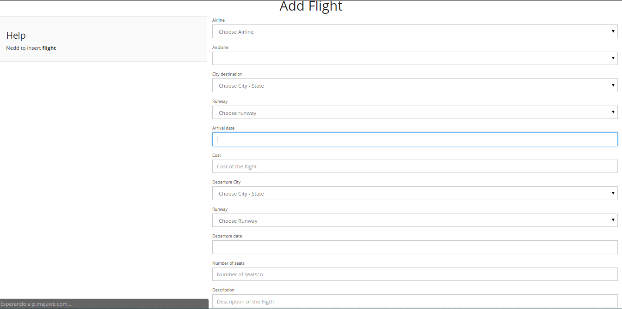

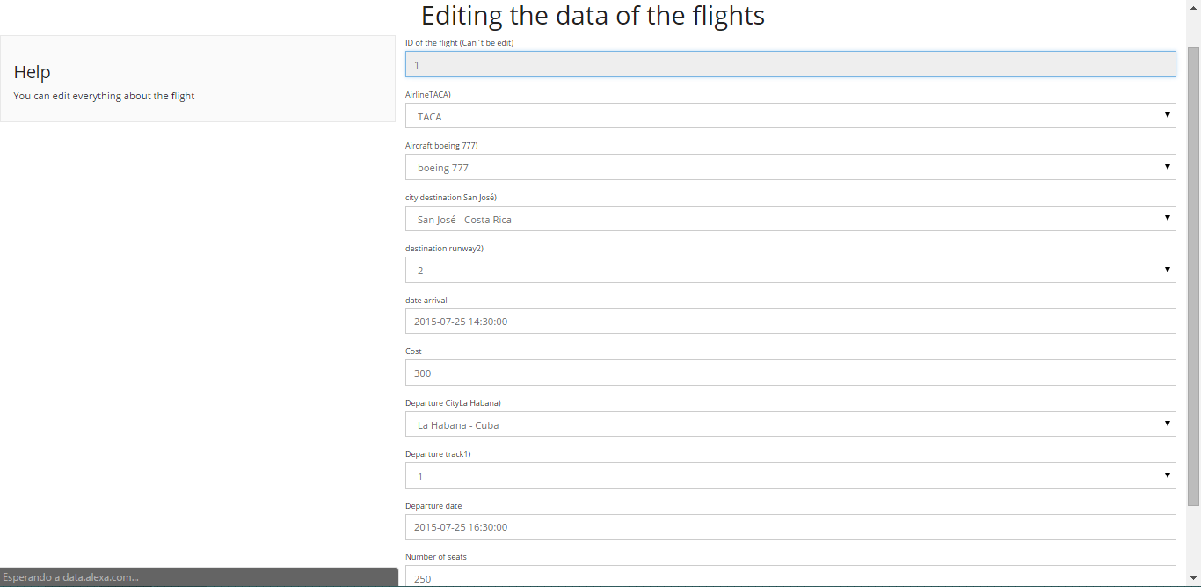In the platform is allow to edit some flights because this can be postponed for bad weather or mechanical failure ,etc.

* **Runways**

This is the list of runways that have been register in the platform.

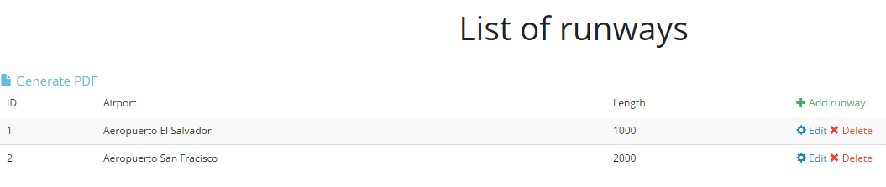

First we need to know in which airport is and the length.

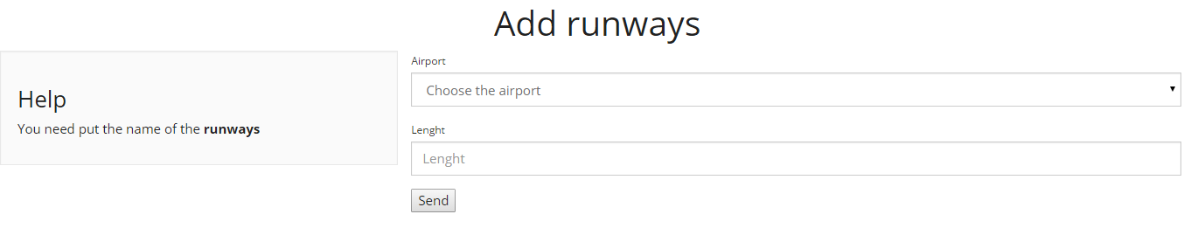

Here we can edit all the information for each runway.

