1. **Execution of command line with run command.**

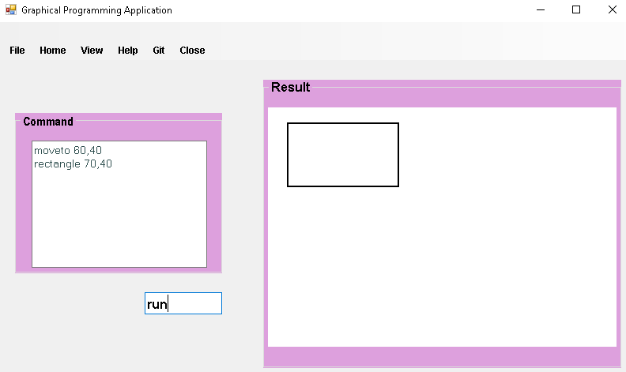

Entering the command and type run so the triangle is shown in results.

1. **Saving the file**

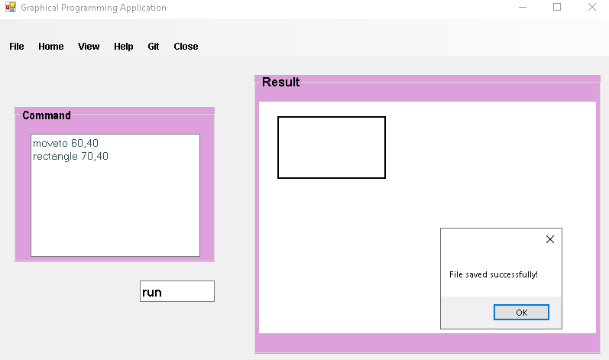

1. **Browse**

When you go to File and click browse and choose the saved file, the command is automatically shown like below.



1. **Checking for valid commands**

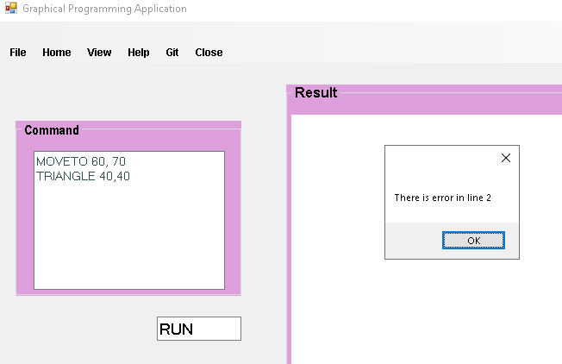

1. **Checking for valid parameters**

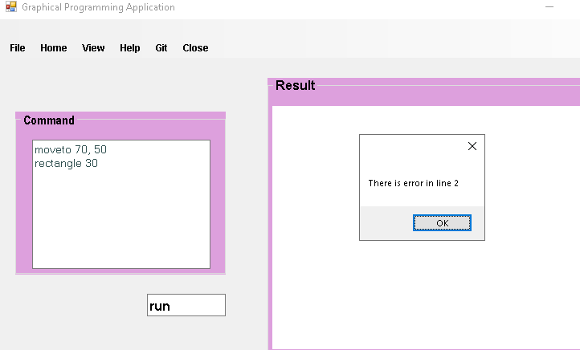

1. **Pen position moveto**

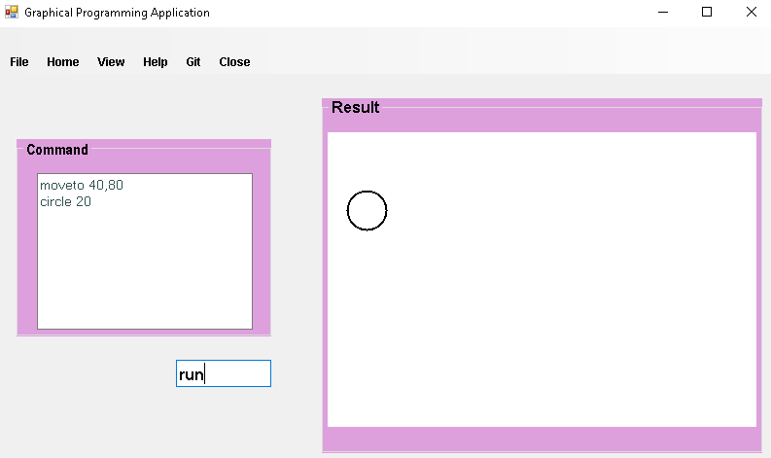

1. **Pen draw drawto**

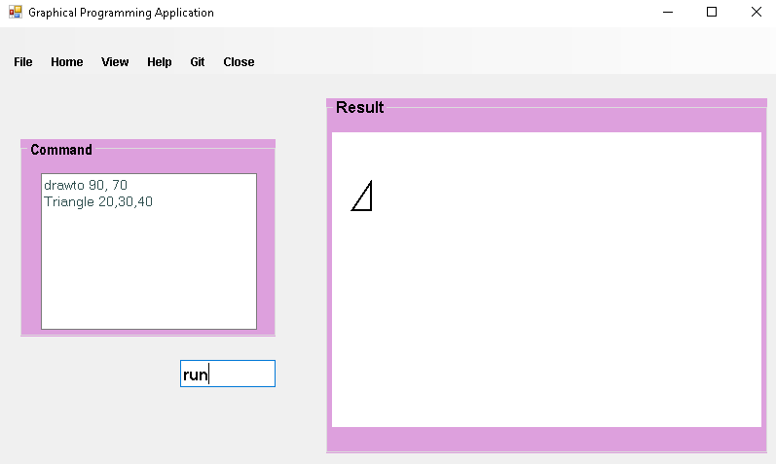

1. **Using clear command**

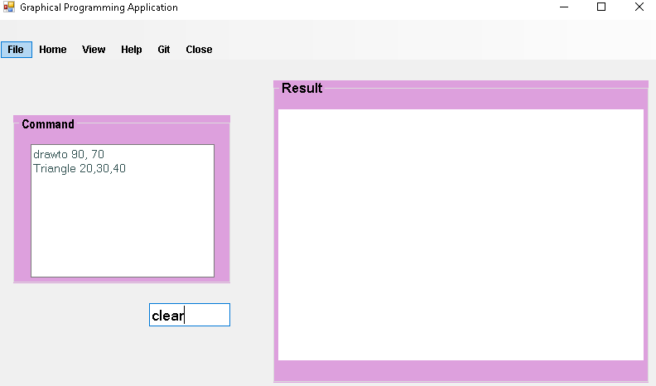

1. **Reset command**

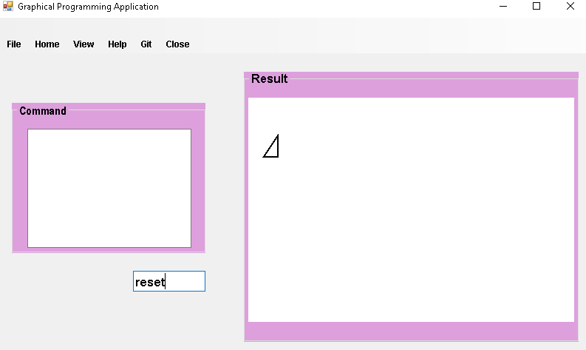

1. Using loop to draw rectangle containing variables

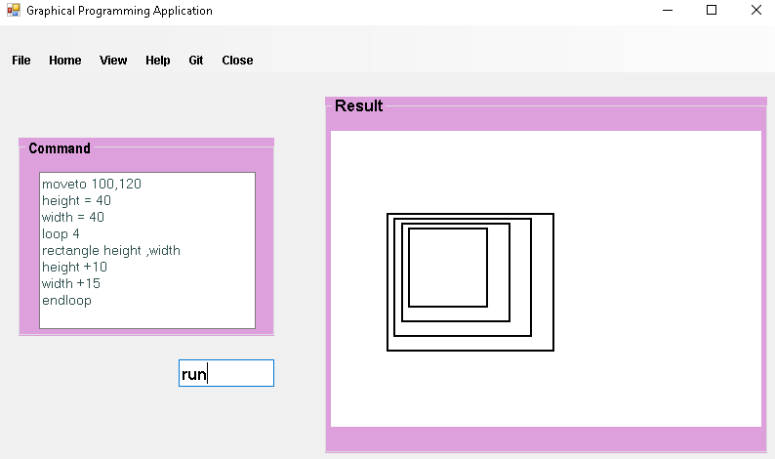

1. Loop between first and last line

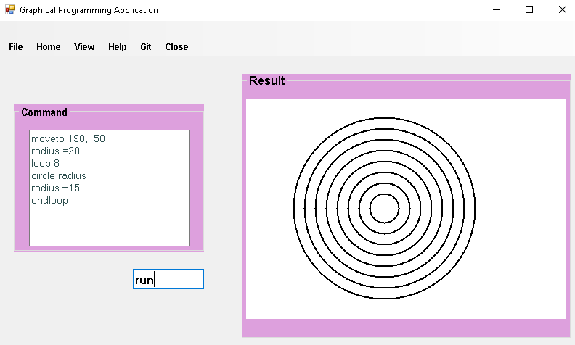

1. Controlling by using If and endif

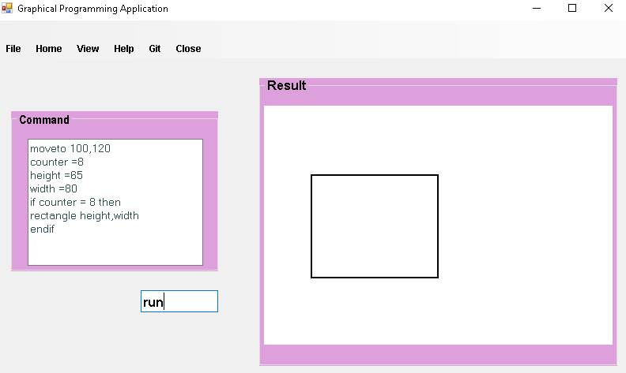

1. Syntax check

