A Digital Twin-Driven Framework for Low-Power DRAM Optimization Using PySpice and Machine Learning
A configuration-driven, end-to-end framework that couples automated NGSpice characterisation of a 1T1C DRAM bit cell with machine-learning surrogates, a deployable digital twin, robust multi-objective optimisation and explainable-AI analysis. Every reported number is produced by the accompanying code from executed simulations.
Generated 2026-07-23T13:46:25+00:00

Contents
- 1. Introduction
- 2. Related work (2021-2026)
- 3. Framework
- 4. Experimental setup
- 5. Dataset and physical validation
- 6. Surrogate models and the digital twin
- 7. Multi-objective optimisation
- 8. Explainability, robustness and assist techniques
- 9. Limitations and threats to validity
- 10. Reproduction

1. Introduction
DRAM bit-cell design is a genuinely multi-objective problem. Retention time, read latency, read margin and power cannot be improved independently: raising the storage capacitance improves retention and sense margin but costs area and access energy; boosting the wordline enables a full '1' write but increases both power and gate-oxide stress; lowering the bitline precharge level saves precharge energy but erodes the margin for one of the two data polarities. Exploring that space directly with a circuit simulator is expensive, and the expense grows multiplicatively once process corners, temperature and statistical variation enter.
This work builds a complete framework that makes such exploration tractable. A parameterised 1T1C cell, its bitline pair, boosted precharge network, CMOS write driver and cross-coupled sense amplifier are generated from configuration and characterised in NGSpice. A space-filling design of 50000 points is simulated, machine-learning surrogates are fitted to the resulting responses, and the best surrogate per response is deployed as a digital twin. The twin then drives a robust multi-objective search whose solutions are returned to the circuit simulator for verification.
What is contributed. (i) A configuration-driven pipeline in which no DRAM architectural constant is hard-coded, so retargeting to another cell or technology node means editing YAML, not Python. (ii) A retention model that is measured rather than assumed: the storage-node leakage characteristic is extracted by a DC sweep of a leakage replica inside the same simulation, and the charge-loss ODE is integrated over it -- with the result cross-checked against direct long-window transient simulation. (iii) A broad, statistically tested comparison of 14 surrogate families and six optimisers under identical budgets. (iv) A published dataset of every simulated design point. (v) Explainability and robustness analyses that turn the surrogate from a black box into a source of design guidance.
What is deliberately not claimed. The device models are the public PTM BSIM4 cards for a general-purpose low-power logic process, not a DRAM-specific process. Absolute retention times therefore reflect those cards and are not predictions about any commercial part; the framework, the relative trends and the methodology are the contribution. Section 9 states the limitations in full.

2. Related work (2021-2026)
Machine learning for analog and mixed-signal design has converged on two families: simulation-in-the-loop methods, which call the simulator inside the optimiser, and surrogate-based methods, which replace most of those calls with a learned model. Recent surveys of the area place both families side by side, and recent optimisation studies report reductions in SPICE calls of roughly 56-83 %, with multi-fidelity schemes reporting an order-of-magnitude reduction in total simulation time while still matching ground-truth Pareto fronts. This framework sits in the surrogate family and adopts the same discipline of returning to the simulator for verification.
On the tooling side, programmatic SPICE deck generation with PySpice has recently been used both to build datasets for learning and to drive complete simulation studies, which supports the toolchain adopted here. On the DRAM side, published work concentrates on the architecture and system levels -- refresh scheduling, retention profiling, data mapping and measurement infrastructure -- and on demonstrating that DRAM modelling accuracy must be validated rather than assumed. The present study works one level below those, at the bit cell and its column periphery, and adopts the same validation discipline: the retention model is checked against direct transient simulation before it is used.
The gap this work addresses is the absence of an end-to-end, reproducible and openly-data-backed pipeline that takes a configurable DRAM cell from netlist generation through surrogate modelling, digital-twin deployment, robust multi-objective optimisation, explainability and statistical validation.
Table 1. Recent works positioning this study.
Work | Year | Focus
Multi-Fidelity Surrogate Models for Accelerated Multi-Objective Analog Circuit | 2025 | surrogate modelling; multi-objective circuit optimisation
Analog Design and Machine Learning: A Review | 2025 | review of ML in analog design
Analog circuit sizing based on Evolutionary Algorithms and deep learning | 2024 | evolutionary sizing with learned models
Machine Learning Driven Global Optimisation Framework for Analog Circuit Desig | 2024 | ML-guided global optimisation
Performance Evaluation of Evolutionary Algorithms for Analog Integrated Circui | 2023 | benchmarking evolutionary optimisers on circuit problems
The Dawn of AI-Native EDA: Opportunities and Challenges of Large Circuit Model | 2024 | AI-native EDA landscape
When Device Modeling Meets Machine Learning: Opportunities and Challenges | 2024 | ML for compact/device modelling
Digital Twin for Secure Semiconductor Lifecycle Management: Prospects and Appl | 2022 | digital twins in the semiconductor lifecycle
SPICEPilot: Navigating SPICE Code Generation and Simulation with AI Guidance | 2024 | automated SPICE deck generation, PySpice-based datasets
Python Framework for Modular and Parametric SPICE Netlists Generation | 2023 | parametric netlist generation
PySpice-Simulated In Situ Learning with Memristor Emulation for Single-Layer S | 2024 | PySpice/NGSpice in a research pipeline
EasyDRAM: An FPGA-based Infrastructure for Fast and Accurate End-to-End Evalua | 2025 | DRAM characterisation infrastructure
Re-Evaluating the Real-System Modeling Accuracy of Ramulator 2.0 | 2026 | DRAM simulator fidelity
PENDRAM: Enabling High-Performance and Energy-Efficient Processing of Deep Neu | 2024 | DRAM energy optimisation at the architecture level

Full bibliographic records and retrieval URLs are in docs/literature/references.yaml.

3. Framework
The framework follows the seven stages of the proposed method.
Stage 1 -- cell design and parameterisation. dramdt.models.cell emits the BSIM4 deck for a 1T1C cell, a lumped bitline pair, a boosted precharge/equalise network, a CMOS transmission-gate write driver and a cross-coupled sense amplifier. Two design details are worth stating because they are easy to get wrong and both were found by simulation during development: the precharge pass devices must be driven from the boosted rail, because a VDD-level gate leaves Vgs = VDD/2 < Vth and cannot pull the bitline to VDD/2; and the access device needs VPP > VDD + Vth,eff to store a full '1', which is why the wordline-boost range extends to 1.2 V.
Stage 2 -- automated simulation. Each deck runs three analyses in one NGSpice invocation: an operating point for standby current, a transient covering write / precharge / read / sense, and a DC sweep of a leakage replica -- an identical access device whose storage node is driven by a probe source -- yielding the storage-node leakage characteristic. Tolerances are set per analysis, because a single ABSTOL cannot resolve femto-ampere leakage and micro-ampere switching in the same deck.
Stage 3 -- dataset. Latin hypercube sampling over 15 variables, decoded through the configuration's derived expressions. Design points that fail to write or to sense are retained and labelled, not discarded: a surrogate that has never seen an infeasible design cannot steer an optimiser away from one.
Stage 4 -- surrogates. A zoo spanning linear, kernel, neighbour, ensemble, boosting and neural families is cross-validated on train+val; the test split is touched once per model.
Stage 5 -- optimisation. Six optimisers under an identical evaluation budget, each repeated 7 times. Objectives and constraints are reduced pessimistically over the configured PVT conditions, making the search a robust-design problem.
Stage 6 -- digital twin. The best surrogate per response is packaged with the full input-preparation pipeline behind one predict call.
Stage 7 -- analysis. Assist-technique comparison, SHAP/ALE explainability, Monte-Carlo yield, corner sweeps and Sobol' sensitivity.
The pseudocode for the six core algorithms is in reports/algorithms/.

4. Experimental setup
Item | Value
Simulator | NGSpice
Device models | PTM BSIM4 (level 54), ? nm
Model-card fingerprint | ?
Process corners
Design variables | 15
Samples | 50000
Sampler | lhs
Master seed | 20260723
Configuration hash | e22061fdb47e16e7
Platform | ?

Corner cards for SS/FF/SF/FS are synthesised from the typical PTM card by the first-order vth0/u0/tox shifts declared in the configuration; they are explicitly not foundry sign-off corners. A solver convergence study (Table: solverconvergencestudy) shows the production setting differs from a 20 ps GEAR reference by at most 0.70 % at the 95th percentile on every metric, with pass/fail labels unchanged.
All randomness derives from the single master seed through a pure (seed, label, index) hash, so results are independent of worker count and completion order.

5. Dataset and physical validation
The campaign completed 50000 simulations (71428027540.329 per second on 18 workers, 0.0 min total), of which 49999 produced measurements (100.00 %). Preprocessing retained 49987 of 50000 rows (99.97 %); the removals were {'simulationfailed': 1, 'notconverged': 3, 'incomplete_measurements': 9}. 57.9 % of the retained points are feasible (both write and read succeed); the remainder are kept and labelled as infeasible.
The Latin hypercube achieved a centred-L2 discrepancy of 0.00680435 and a minimum pairwise distance of 0.4115 (both on a 4000-point subsample).
Two independent physics checks were run before trusting the dataset.
First, the measured bitline differential was compared with the analytical charge-sharing law dV = (V_SN - V_BLpre)*Cs/(Cs+Cbl): median relative error 3.802 %, 95th percentile 17.992 % over 120 design points.
Second, the quasi-static retention model was checked against direct long-window transient simulation on 200 designs: Pearson r = 0.99974 in log10 space, Spearman rho = 0.9995, median absolute error 0.0107 decades, and 100.0 % of designs within a factor of two. The retention numbers in this study are therefore integrations of a measured leakage characteristic whose accuracy has been quantified, not an analytical shortcut.
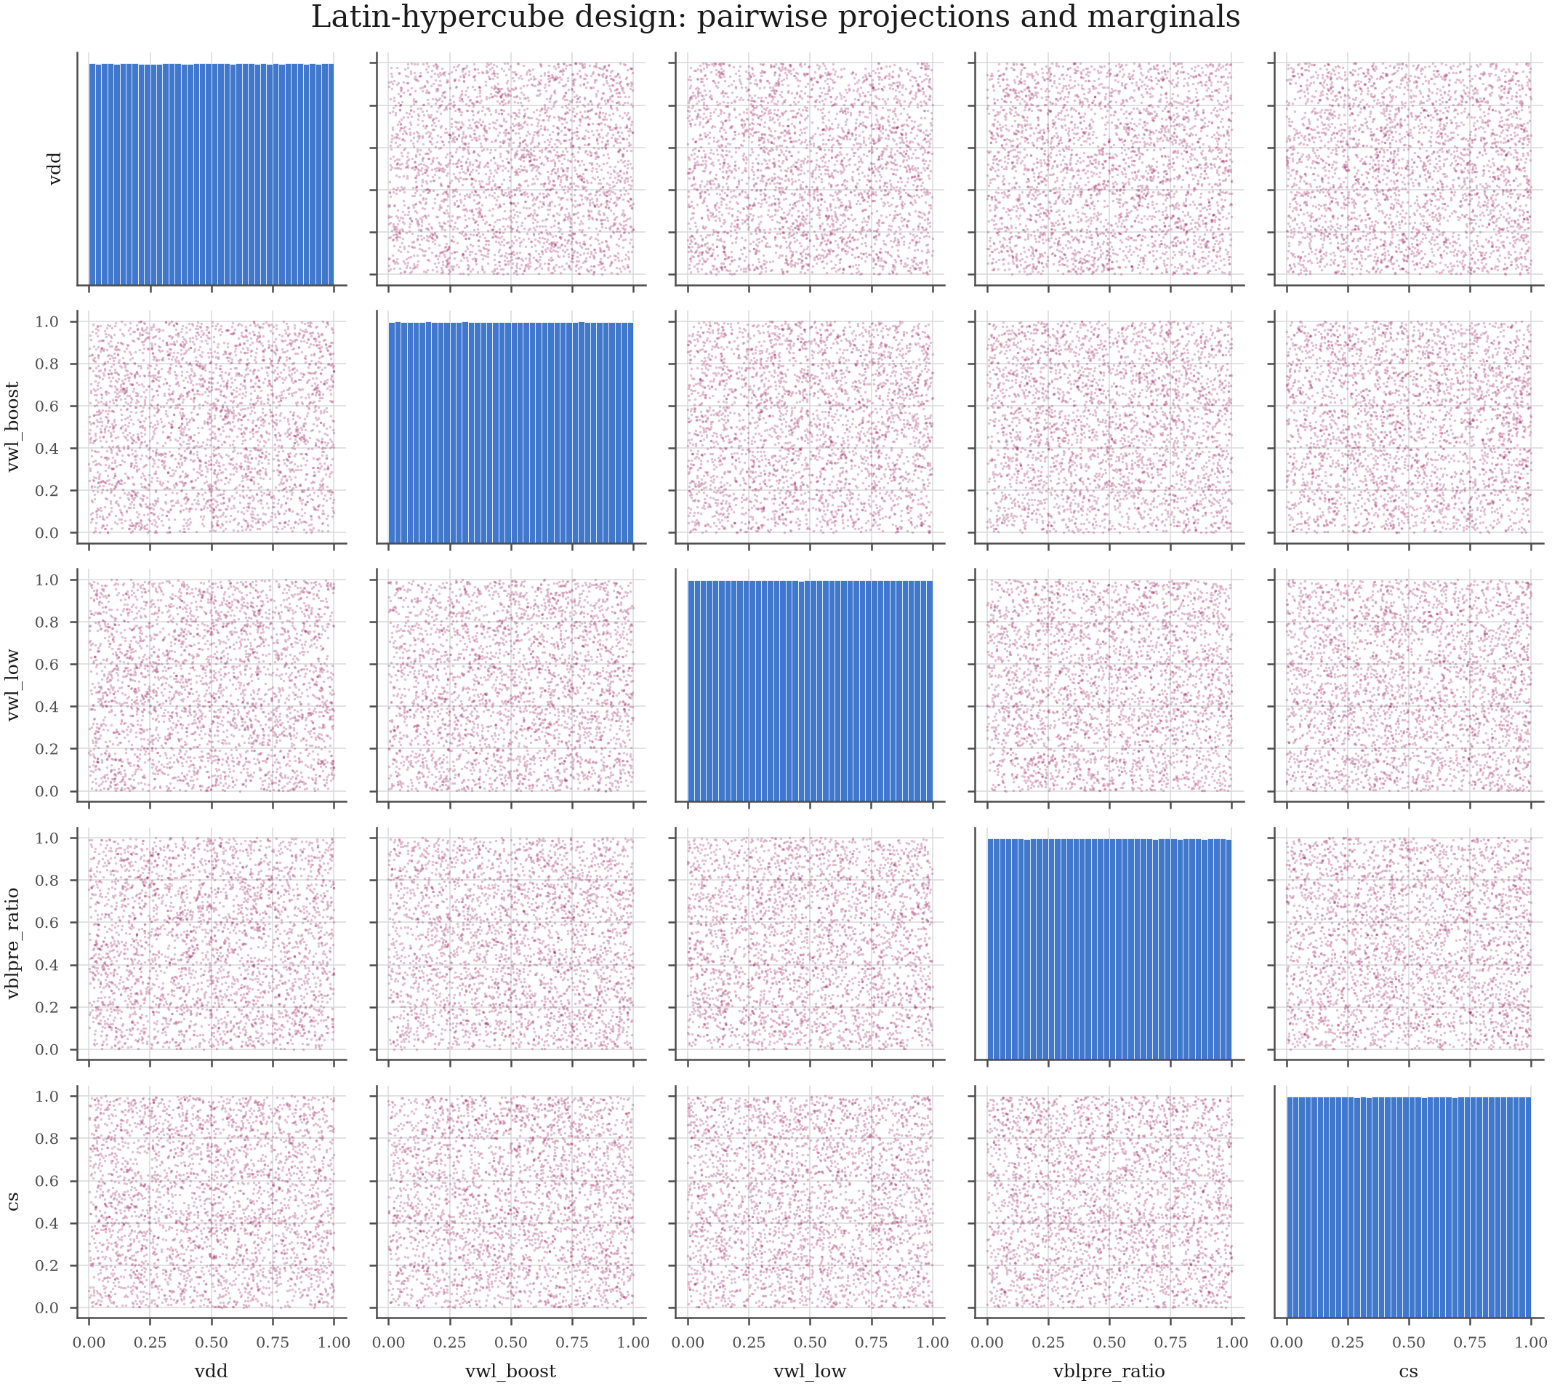
Figure 1. Latin-hypercube design: pairwise projections and marginals.
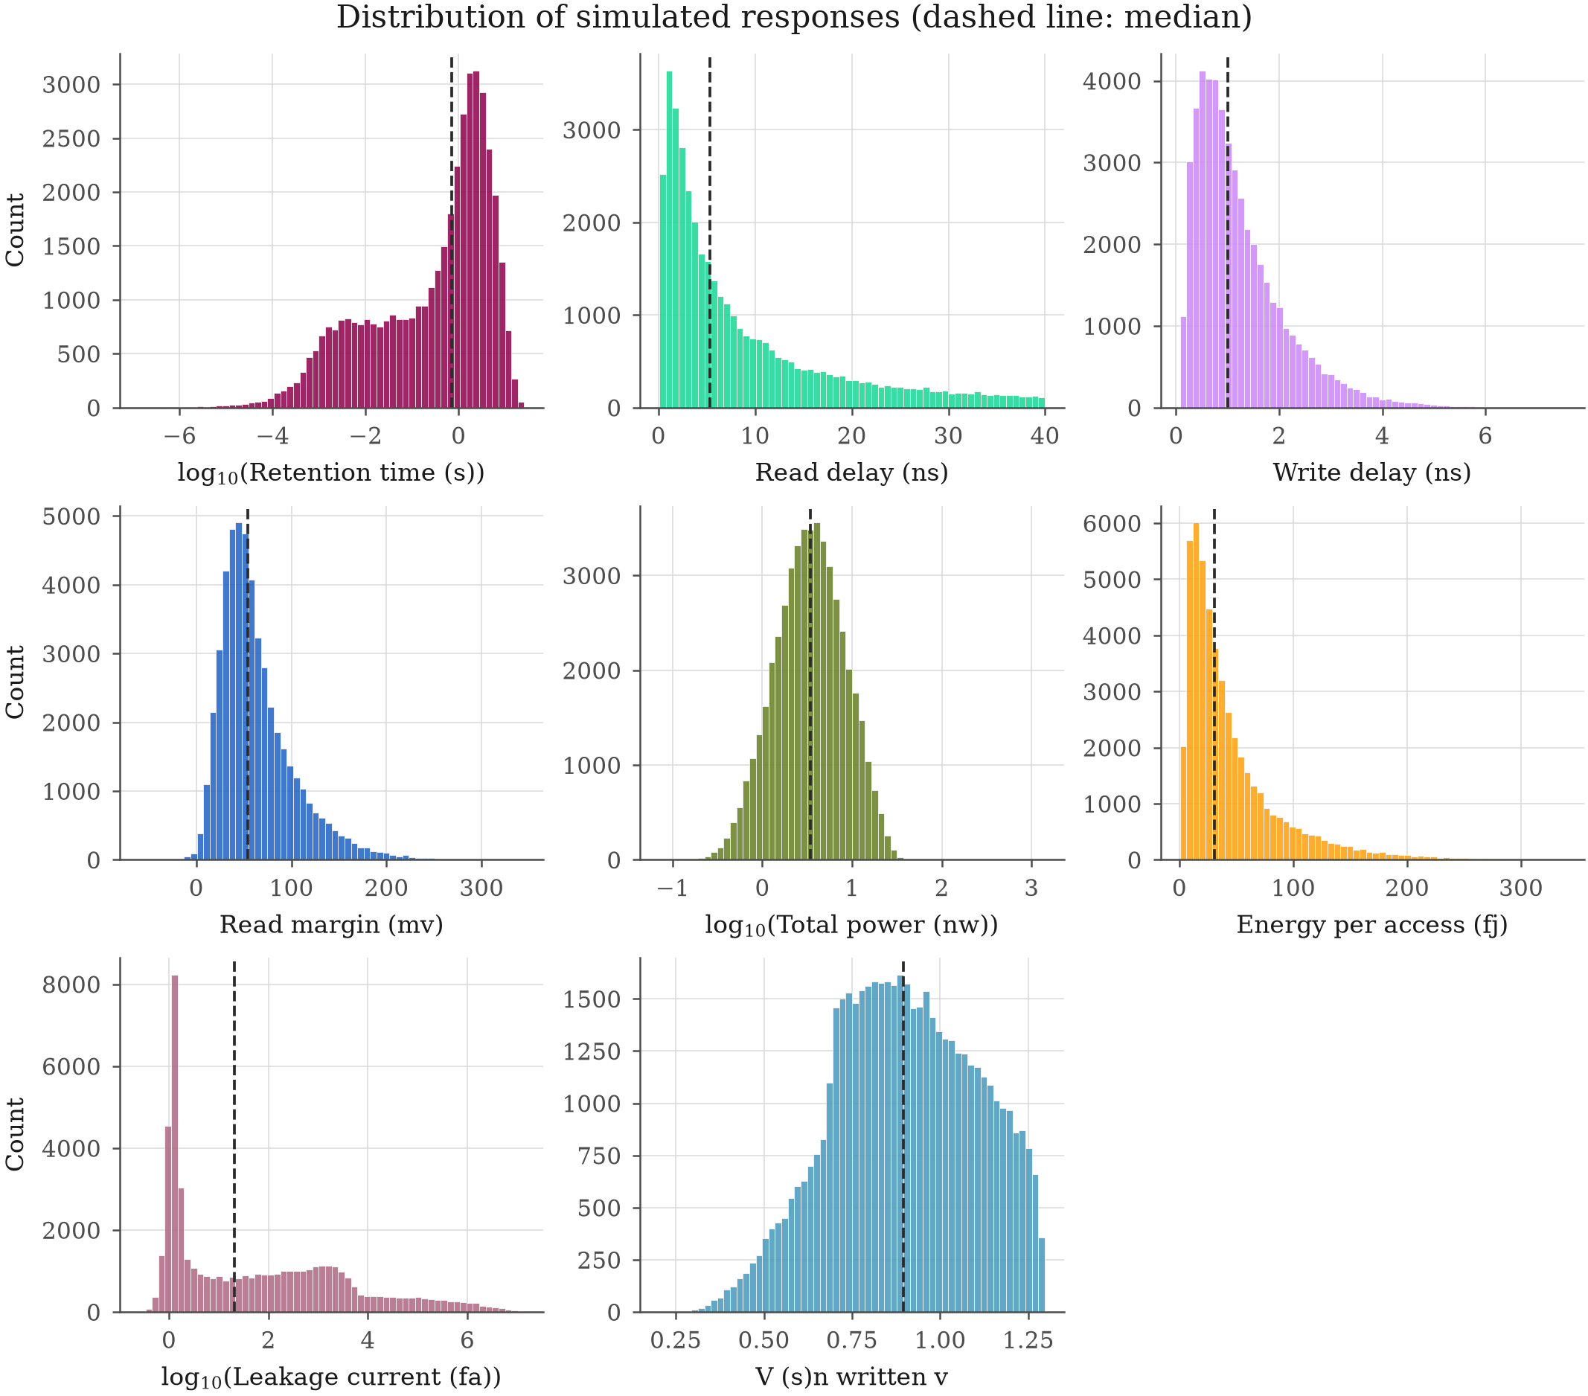
Figure 2. Distribution of the simulated responses.
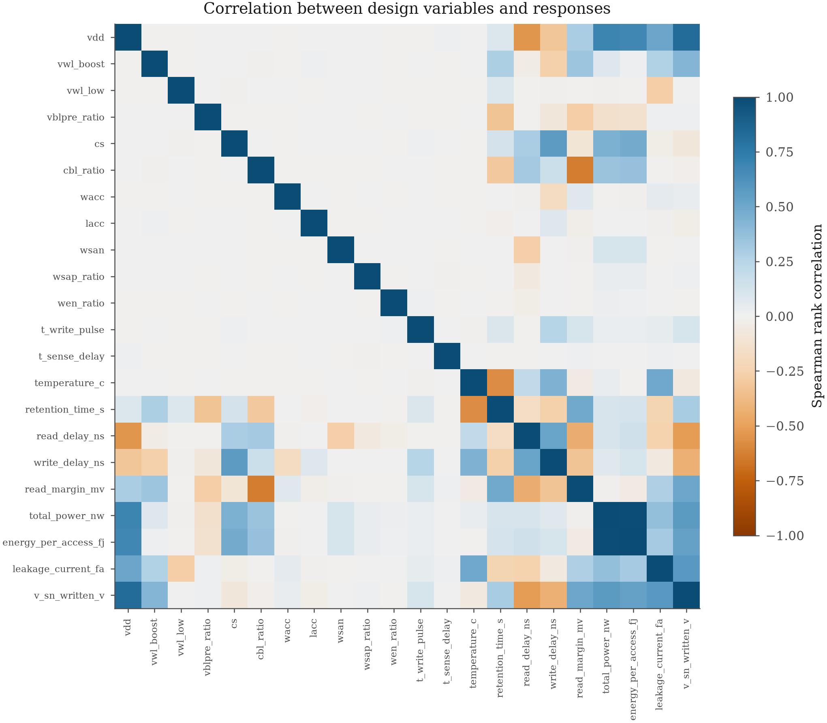
Figure 3. Rank correlation between design variables and responses.
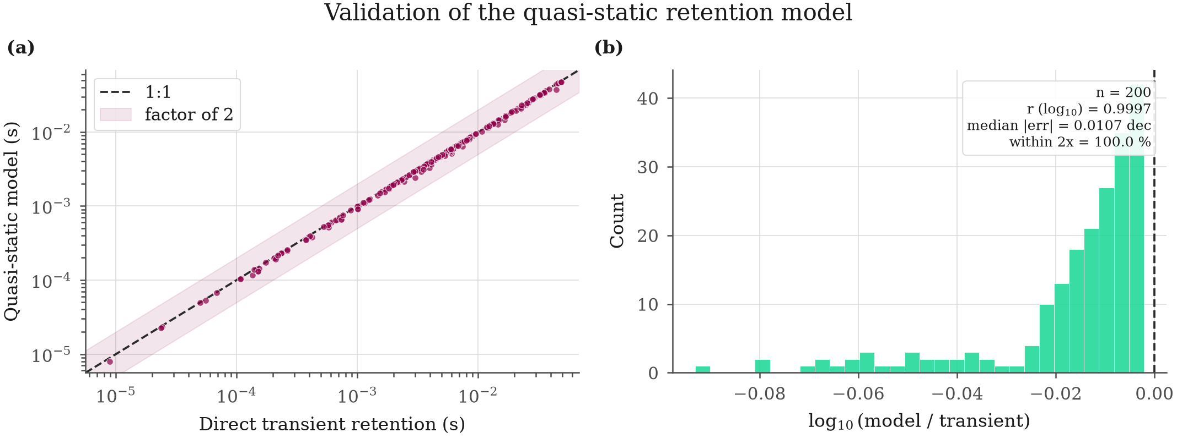
Figure 4. Validation of the quasi-static retention model against direct transient simulation.
Table 2. Measured bitline differential against the charge-sharing law.
sample | corner | temperature_c | cs_ff | cbl_ff | vsnwritten_v | measureddvmv | analyticaldvmv | relativeerrorpct
0 | TT | 79.61 | 23.49 | 198.7 | 0.7813 | 45.07 | 44.86 | 0.4685
1 | TT | -3.646 | 11.11 | 45.92 | 0.5546 | 48.81 | 47.59 | 2.568
2 | TT | -7.444 | 9.672 | 109.0 | 1.098 | 48.88 | 47.21 | 3.536
3 | FF | -38.56 | 29.77 | 171.6 | 0.8018 | 53.41 | 52.43 | 1.880
4 | TT | 107.9 | 7.442 | 76.53 | 0.9565 | 51.70 | 43.63 | 18.52
5 | SF | -32.83 | 6.146 | 47.00 | 0.8195 | 57.01 | 51.13 | 11.49
6 | SF | -17.01 | 10.88 | 109.1 | 0.8089 | 33.23 | 30.24 | 9.903
7 | TT | 55.37 | 23.79 | 52.85 | 0.8160 | 133.5 | 131.7 | 1.342
8 | TT | 73.93 | 7.127 | 33.60 | 1.199 | 132.5 | 125.2 | 5.789
9 | SF | 105.0 | 22.11 | 263.0 | 1.023 | 40.31 | 39.78 | 1.337
10 | FS | 36.83 | 27.30 | 143.9 | 1.198 | 101.0 | 101.8 | 0.8056
11 | FF | 29.88 | 29.98 | 189.1 | 0.9430 | 51.65 | 49.84 | 3.643
12 | FS | 60.77 | 6.861 | 16.15 | 0.6082 | 55.07 | 49.24 | 11.84
13 | TT | -12.90 | 9.340 | 90.63 | 0.8712 | 31.93 | 30.82 | 3.627
14 | SF | 62.23 | 22.65 | 184.2 | 0.8458 | 58.98 | 57.44 | 2.687
15 | FS | 6.565 | 7.282 | 75.56 | 0.6259 | 23.95 | 23.33 | 2.682
16 | SS | 35.24 | 24.73 | 264.2 | 0.7510 | 14.23 | 14.02 | 1.493
17 | SS | 26.37 | 7.676 | 15.74 | 0.7849 | 112.1 | 115.9 | 3.254
18 | FF | 11.36 | 39.13 | 290.9 | 0.7774 | 44.35 | 43.67 | 1.576
19 | SF | 85.20 | 20.63 | 202.2 | 0.6425 | 24.96 | 13.87 | 79.99
20 | FF | 102.0 | 37.45 | 352.0 | 0.7889 | 12.61 | 12.16 | 3.704
21 | SF | -34.42 | 8.131 | 77.02 | 1.010 | 55.09 | 50.40 | 9.315
22 | TT | 4.035 | 5.239 | 32.38 | 1.054 | 66.10 | 62.05 | 6.527
23 | SF | 23.43 | 10.68 | 59.74 | 0.6586 | 36.17 | 32.82 | 10.20
24 | FF | -22.83 | 8.069 | 53.13 | 1.239 | 98.29 | 97.00 | 1.325
25 | SF | 8.580 | 26.03 | 90.16 | 0.6933 | 54.90 | 52.71 | 4.164
26 | FS | -16.47 | 19.22 | 132.8 | 1.165 | 87.14 | 86.24 | 1.042
27 | FS | 0.8620 | 20.24 | 88.55 | 0.7496 | 57.41 | 55.76 | 2.973
28 | TT | 103.1 | 8.589 | 59.99 | 0.8577 | 42.46 | 37.28 | 13.89
29 | FS | 48.46 | 11.56 | 24.74 | 1.009 | 133.3 | 129.9 | 2.625
30 | FS | -34.86 | 10.06 | 50.22 | 1.269 | 122.1 | 117.2 | 4.215
31 | FF | -24.10 | 13.05 | 152.1 | 1.028 | 40.87 | 38.42 | 6.371
32 | SS | 15.50 | 5.412 | 52.07 | 0.6150 | 31.65 | 27.84 | 13.69
33 | FF | 67.51 | 8.909 | 73.46 | 0.7312 | 32.71 | 30.88 | 5.947
34 | SS | -18.96 | 16.88 | 151.1 | 0.8777 | 33.45 | 33.55 | 0.3045
35 | FF | 113.0 | 28.36 | 235.7 | 0.8158 | 50.98 | 49.23 | 3.553
36 | TT | -9.444 | 9.053 | 95.62 | 0.5893 | 18.31 | 17.07 | 7.227
37 | SF | -6.491 | 12.07 | 51.77 | 1.059 | 83.05 | 78.52 | 5.777
38 | FS | 84.65 | 5.324 | 24.22 | 1.036 | 67.91 | 61.52 | 10.40
39 | TT | 107.0 | 16.36 | 63.41 | 1.071 | 111.2 | 106.8 | 4.091

Relative error between the simulated VBL - VBLB at the sense-amplifier firing instant and (VSN - VBLpre)*Cs/(Cs+Cbl).
Table 3. Agreement statistics for the retention model.
statistic | value
n_pairs | 18
pearsonrlog10 | 1.0000
spearman_rho | 1
medianabslog10_error | 0.009786
meanlog10error | -0.01160
geometricmeanratio | 0.9736
p90abslog10_error | 0.02026
withinfactor2_pct | 100
withinfactor10_pct | 100

Table 4. Solver convergence study.
setting | mspersample | speedupvsreference | readmarginmvmedianerr_pct | readmarginmvp95err_pct | readdelaynsmedianerr_pct | readdelaynsp95err_pct | writedelaynsmedianerr_pct | writedelaynsp95err_pct | vsnwrittenvmedianerrpct | vsnwrittenvp95errpct | retentiontimesmedianerr_pct | retentiontimesp95err_pct | energyperaccessfjmedianerrpct | energyperaccessfjp95errpct | totalpowernwmedianerr_pct | totalpowernwp95err_pct | readsuccessagreement_pct | writesuccessagreement_pct
50 ps / GEAR | 63 | 1.693 | 0.009100 | 0.1449 | 0.01530 | 0.2420 | 0.1520 | 0.7592 | 0.003800 | 0.04200 | 0.001800 | 0.4649 | 0.05650 | 0.3348 | 0.05490 | 0.3300 | 100 | 100
50 ps / TRAP | 60.90 | 1.752 | 0.003100 | 0.02840 | 0.01110 | 0.1547 | 0.03910 | 0.6964 | 7.000e-4 | 0.005800 | 3.000e-4 | 0.05170 | 0.02130 | 0.1653 | 0.02070 | 0.1591 | 100 | 100
100 ps / GEAR | 47.40 | 2.249 | 0.01990 | 0.5967 | 0.1581 | 0.8344 | 0.3680 | 1.367 | 0.01190 | 0.1842 | 0.003400 | 1.738 | 0.1905 | 0.5836 | 0.1788 | 0.5444 | 100 | 100

Percentages are relative errors against the 20 ps GEAR setting over the same design points; agreement columns give the share of points whose pass/fail label is unchanged.

6. Surrogate models and the digital twin
The surrogate comparison is summarised below.
Response | Selected model | CV R2 | Test R2 | Test RMSE | Test MAE
write_efficiency | mlp_deep | 0.99308 | 0.99859 | 0.004596 | 0.003023
energyperaccess_fj | mlp_deep | 0.98961 | 0.99614 | 2.674 | 1.237
log10totalpower_nw | mlp_deep | 0.97362 | 0.98266 | 0.05173 | 0.02065
readdelayns | mlp_deep | 0.97108 | 0.98778 | 1.031 | 0.4237
readmarginmv | mlp | 0.96139 | 0.98966 | 3.978 | 1.659
log10retentiontime_s | mlp_deep | 0.91140 | 0.95098 | 0.9212 | 0.2123

The model in each row is the one selected by cross-validation on the train+val partition and deployed in the digital twin; the test columns are the single, untouched-until-then evaluation of that choice.
By family, the median held-out R2 ranks as: neural 0.9887, boosting 0.9635, ensemble 0.9041, kernel 0.8642, neighbour 0.7236, linear 0.7097.
Ranked by mean Friedman rank across every response (lower is better): mlpdeep (1.40), mlp (2.23), catboost (2.73), lightgbm (4.20), histgbr (4.83).
Digital twin cost. At a batch size of 10000 the twin evaluates a design in 0.03248 ms (30,786 designs/s), a 37,009x speed-up over the measured mean SPICE evaluation time. This is what makes the optimisation, the Monte-Carlo yield study and the Sobol' analysis affordable.
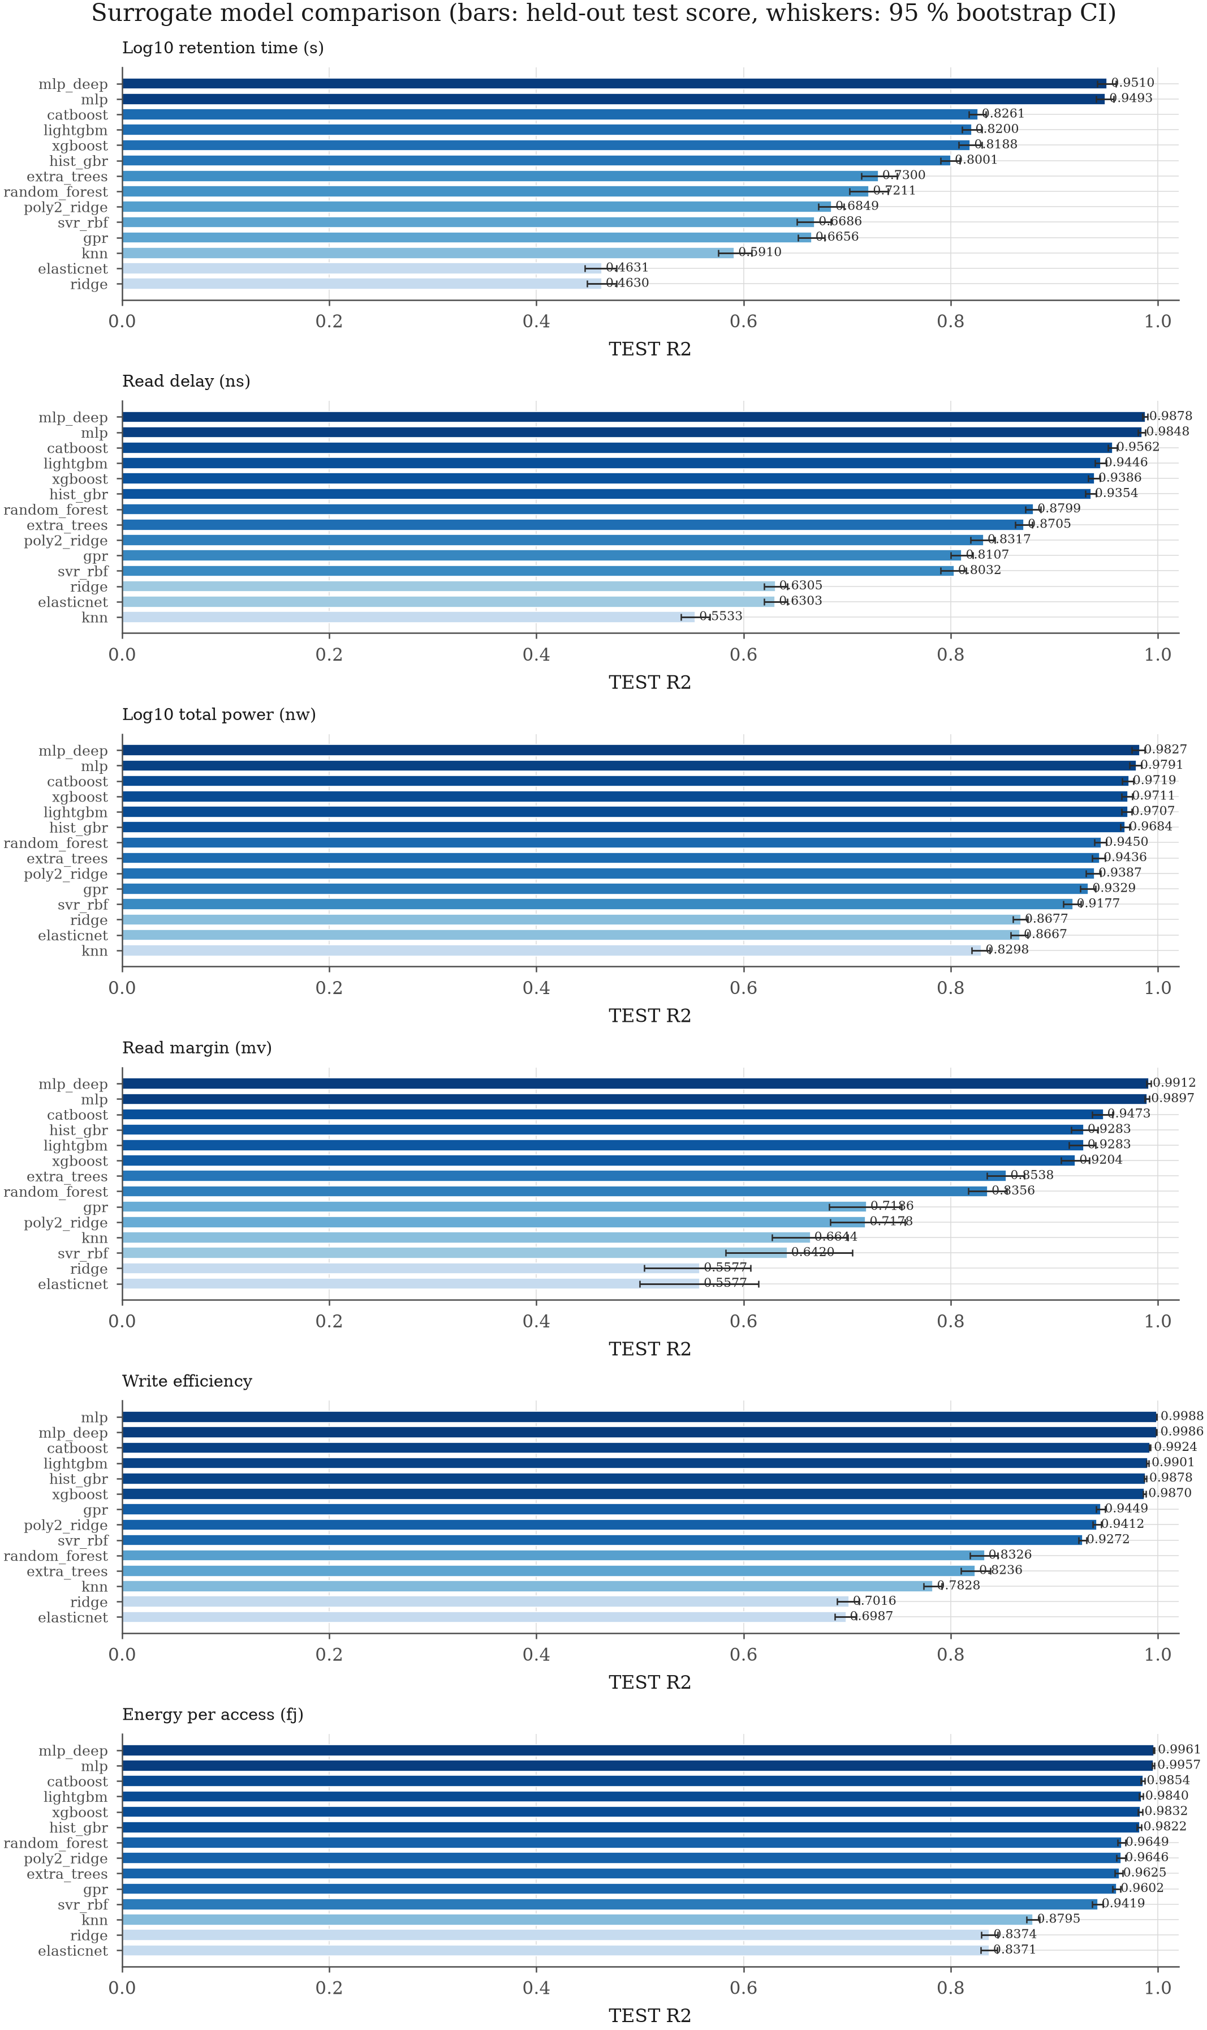
Figure 5. Surrogate model comparison per response.
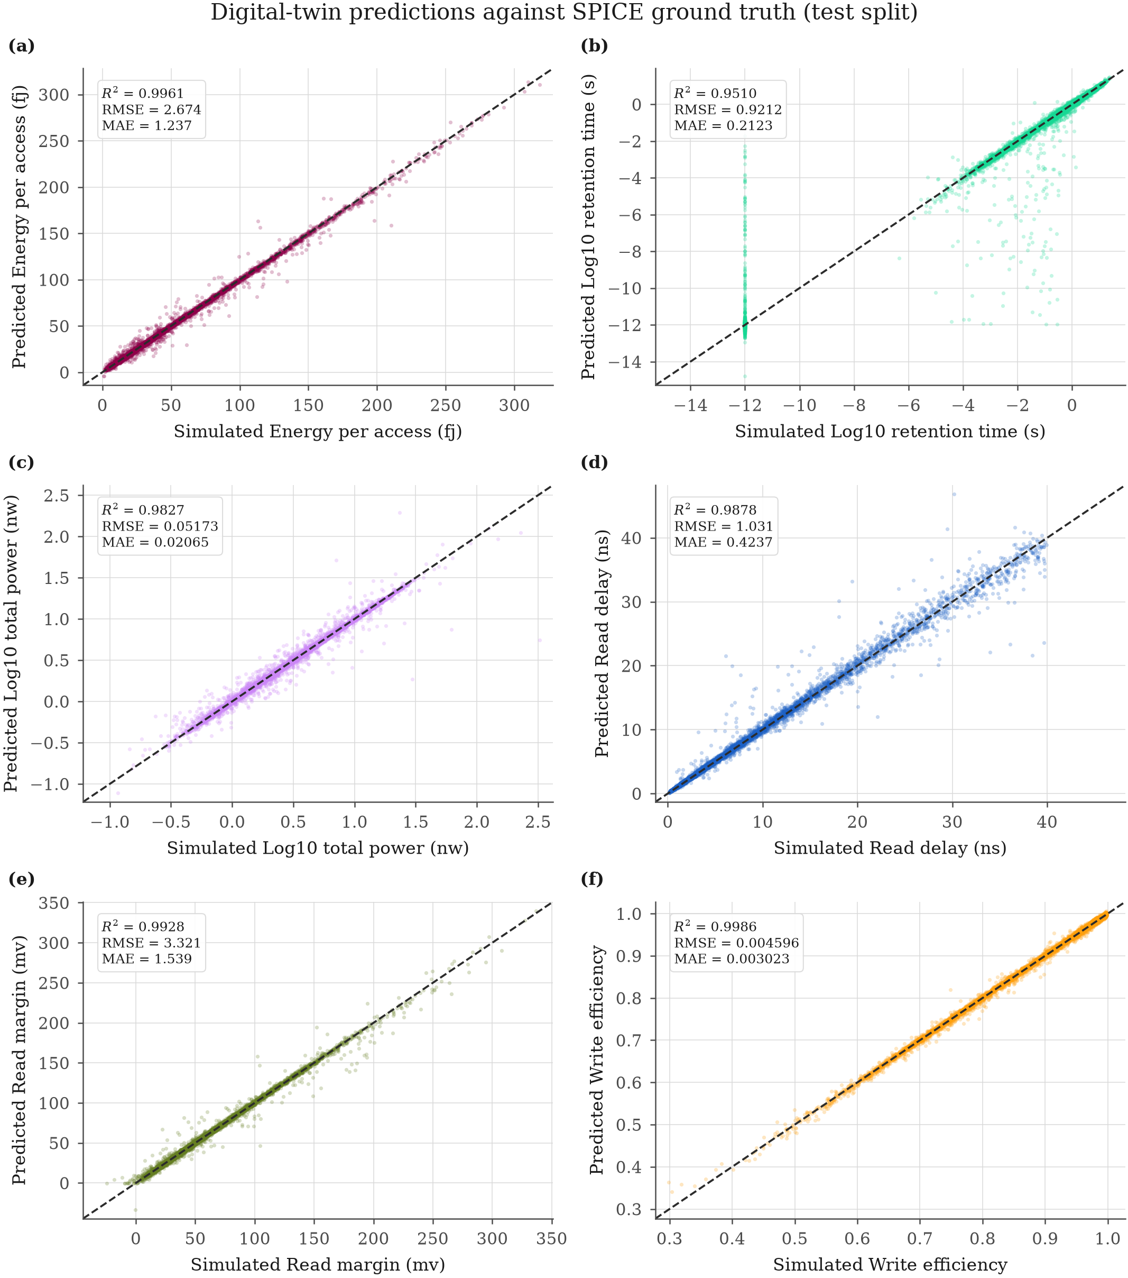
Figure 6. Twin predictions against SPICE ground truth (test split).
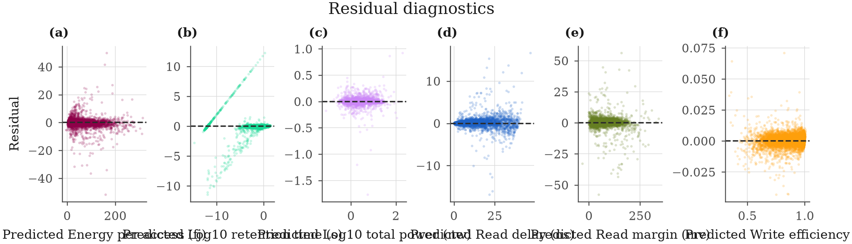
Figure 7. Residual diagnostics.
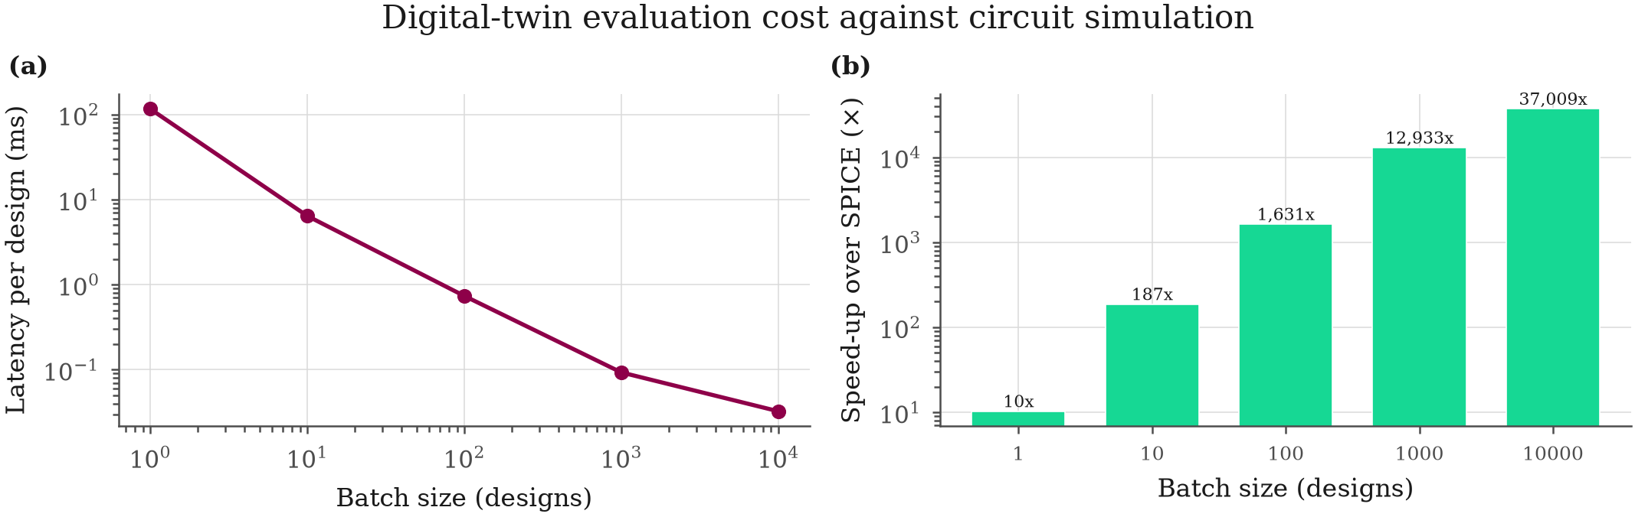
Figure 8. Digital-twin evaluation cost against circuit simulation.
Table 5. Full surrogate comparison.
target | model | family | n_compare | n_train | cvr2mean | cvr2std | test_r2 | test_rmse | test_mae | test_mape | fittimes | predictusper_sample
energyperaccess_fj | mlp_deep | neural | 15000 | 42491 | 0.9896 | 0.002397 | 0.9961 | 2.674 | 1.237 | 4.853 | 31.34 | 2.165
energyperaccess_fj | mlp | neural | 15000 | 42491 | 0.9890 | 0.001231 | 0.9957 | 2.834 | 1.340 | 5.731 | 45.74 | 2.783
energyperaccess_fj | catboost | boosting | 15000 | 42491 | 0.9783 | 0.001605 | 0.9854 | 5.197 | 2.723 | 9.891 | 6.184 | 2.185
energyperaccess_fj | lightgbm | boosting | 15000 | 42491 | 0.9745 | 0.002647 | 0.9840 | 5.451 | 2.769 | 9.904 | 1.496 | 5.291
energyperaccess_fj | xgboost | boosting | 15000 | 42491 | 0.9725 | 0.003525 | 0.9832 | 5.576 | 2.663 | 9.468 | 17.40 | 22.10
energyperaccess_fj | hist_gbr | ensemble | 15000 | 42491 | 0.9738 | 0.002531 | 0.9822 | 5.747 | 3.135 | 11.21 | 4.710 | 50.43
energyperaccess_fj | random_forest | ensemble | 15000 | 42491 | 0.9426 | 0.002066 | 0.9649 | 8.071 | 4.125 | 13.75 | 7.148 | 22.22
energyperaccess_fj | poly2_ridge | linear | 15000 | 42491 | 0.9611 | 0.003995 | 0.9646 | 8.098 | 4.732 | 19.88 | 0.3578 | 3.625
energyperaccess_fj | extra_trees | ensemble | 15000 | 42491 | 0.9401 | 0.002139 | 0.9625 | 8.331 | 4.404 | 14.72 | 3.164 | 19.97
energyperaccess_fj | gpr | kernel | 15000 | 2000 | 0.9557 | 0.002277 | 0.9602 | 8.593 | 5.239 | 20.98 | 27.14 | 89.03
energyperaccess_fj | svr_rbf | kernel | 15000 | 5000 | 0.9417 | 0.003392 | 0.9419 | 10.38 | 5.438 | 19.77 | 1.580 | 250.8
energyperaccess_fj | knn | neighbour | 15000 | 42491 | 0.8526 | 0.004291 | 0.8795 | 14.95 | 9.556 | 37.58 | 0.08240 | 119.1
energyperaccess_fj | ridge | linear | 15000 | 42491 | 0.8358 | 0.006533 | 0.8374 | 17.36 | 12.06 | 56.32 | 0.08970 | 0.9928
energyperaccess_fj | elasticnet | linear | 15000 | 42491 | 0.8357 | 0.006336 | 0.8371 | 17.37 | 12.07 | 56.37 | 15.65 | 1.093
log10retentiontime_s | mlp_deep | neural | 15000 | 42491 | 0.9114 | 0.01097 | 0.9510 | 0.9212 | 0.2123 | 46.75 | 49.85 | 2.363
log10retentiontime_s | mlp | neural | 15000 | 42491 | 0.9059 | 0.01186 | 0.9493 | 0.9370 | 0.2988 | 88.48 | 19.23 | 2.406
log10retentiontime_s | catboost | boosting | 15000 | 42491 | 0.7972 | 0.008134 | 0.8261 | 1.735 | 1.016 | 415.5 | 6.069 | 1.976
log10retentiontime_s | lightgbm | boosting | 15000 | 42491 | 0.7849 | 0.006946 | 0.8200 | 1.765 | 0.9577 | 346.0 | 1.595 | 5.624
log10retentiontime_s | xgboost | boosting | 15000 | 42491 | 0.7785 | 0.01049 | 0.8188 | 1.771 | 0.9347 | 340.0 | 16.90 | 21.51
log10retentiontime_s | hist_gbr | ensemble | 15000 | 42491 | 0.7756 | 0.008489 | 0.8001 | 1.860 | 1.057 | 427.9 | 2.420 | 29.09
log10retentiontime_s | extra_trees | ensemble | 15000 | 42491 | 0.6933 | 0.007082 | 0.7300 | 2.162 | 1.097 | 367.7 | 3.098 | 17.68
log10retentiontime_s | random_forest | ensemble | 15000 | 42491 | 0.6802 | 0.01042 | 0.7211 | 2.197 | 1.090 | 399.6 | 8.088 | 13.02
log10retentiontime_s | poly2_ridge | linear | 15000 | 42491 | 0.6837 | 0.004772 | 0.6849 | 2.336 | 1.693 | 888.7 | 0.5985 | 4.384
log10retentiontime_s | svr_rbf | kernel | 15000 | 5000 | 0.6615 | 0.01527 | 0.6686 | 2.395 | 1.402 | 581.1 | 5.830 | 399.1
log10retentiontime_s | gpr | kernel | 15000 | 2000 | 0.6716 | 0.01009 | 0.6656 | 2.406 | 1.708 | 878.6 | 53.41 | 80.99
log10retentiontime_s | knn | neighbour | 15000 | 42491 | 0.5388 | 0.01262 | 0.5910 | 2.661 | 1.538 | 568.2 | 0.08190 | 123.2
log10retentiontime_s | elasticnet | linear | 15000 | 42491 | 0.4629 | 0.008114 | 0.4631 | 3.049 | 2.404 | 1252 | 10.59 | 1.562
log10retentiontime_s | ridge | linear | 15000 | 42491 | 0.4630 | 0.008211 | 0.4630 | 3.049 | 2.403 | 1251 | 0.09520 | 1.018
log10totalpower_nw | mlp_deep | neural | 15000 | 42491 | 0.9736 | 0.002399 | 0.9827 | 0.05173 | 0.02065 | 17.02 | 53.72 | 3.662
log10totalpower_nw | mlp | neural | 15000 | 42491 | 0.9637 | 0.002229 | 0.9791 | 0.05678 | 0.02659 | 25.50 | 13.32 | 1.522
log10totalpower_nw | catboost | boosting | 15000 | 42491 | 0.9702 | 0.002310 | 0.9719 | 0.06586 | 0.03814 | 37.11 | 6.397 | 2.177
log10totalpower_nw | xgboost | boosting | 15000 | 42491 | 0.9638 | 0.002412 | 0.9711 | 0.06678 | 0.03805 | 36.45 | 14.47 | 21.99
log10totalpower_nw | lightgbm | boosting | 15000 | 42491 | 0.9658 | 0.002232 | 0.9707 | 0.06719 | 0.03936 | 38.57 | 2.471 | 7.269
log10totalpower_nw | hist_gbr | ensemble | 15000 | 42491 | 0.9640 | 0.001720 | 0.9684 | 0.06985 | 0.04259 | 41.68 | 3.567 | 32.45
log10totalpower_nw | random_forest | ensemble | 15000 | 42491 | 0.9280 | 0.002960 | 0.9450 | 0.09209 | 0.05806 | 61.11 | 7.011 | 18.96
log10totalpower_nw | extra_trees | ensemble | 15000 | 42491 | 0.9243 | 0.004048 | 0.9436 | 0.09326 | 0.06036 | 65.00 | 3.813 | 20.65
log10totalpower_nw | poly2_ridge | linear | 15000 | 42491 | 0.9404 | 0.003131 | 0.9387 | 0.09727 | 0.06661 | 53.90 | 0.3759 | 3.514
log10totalpower_nw | gpr | kernel | 15000 | 2000 | 0.9350 | 0.003826 | 0.9329 | 0.1018 | 0.06806 | 56.30 | 43.79 | 136.6
log10totalpower_nw | svr_rbf | kernel | 15000 | 5000 | 0.9274 | 0.002894 | 0.9177 | 0.1127 | 0.07915 | 66.56 | 2.832 | 833.3
log10totalpower_nw | ridge | linear | 15000 | 42491 | 0.8645 | 0.002016 | 0.8677 | 0.1429 | 0.1074 | 93.88 | 0.1306 | 1.167
log10totalpower_nw | elasticnet | linear | 15000 | 42491 | 0.8635 | 0.002125 | 0.8667 | 0.1434 | 0.1080 | 95.44 | 2.135 | 0.9677
log10totalpower_nw | knn | neighbour | 15000 | 42491 | 0.7906 | 0.002597 | 0.8298 | 0.1621 | 0.1159 | 131.7 | 0.08870 | 120.7
readdelayns | mlp_deep | neural | 15000 | 33374 | 0.9711 | 0.004094 | 0.9878 | 1.031 | 0.4237 | 6.293 | 29.44 | 2.390
readdelayns | mlp | neural | 15000 | 33374 | 0.9679 | 0.003776 | 0.9848 | 1.150 | 0.5135 | 10.50 | 11.78 | 1.693
readdelayns | catboost | boosting | 15000 | 33374 | 0.9366 | 0.002128 | 0.9562 | 1.952 | 1.052 | 17.98 | 6.032 | 2.390
readdelayns | lightgbm | boosting | 15000 | 33374 | 0.9189 | 0.004328 | 0.9446 | 2.195 | 1.137 | 16.85 | 1.978 | 6.740
readdelayns | xgboost | boosting | 15000 | 33374 | 0.9063 | 0.003089 | 0.9386 | 2.311 | 1.167 | 15.39 | 16.20 | 20.61
readdelayns | hist_gbr | ensemble | 15000 | 33374 | 0.9197 | 0.002455 | 0.9354 | 2.372 | 1.328 | 22.73 | 4.517 | 53.75
readdelayns | random_forest | ensemble | 15000 | 33374 | 0.8495 | 0.004194 | 0.8799 | 3.233 | 1.766 | 21.50 | 5.359 | 24.07
readdelayns | extra_trees | ensemble | 15000 | 33374 | 0.8459 | 0.002685 | 0.8705 | 3.356 | 1.840 | 23.42 | 2.511 | 21.45
readdelayns | poly2_ridge | linear | 15000 | 33374 | 0.8294 | 0.004340 | 0.8317 | 3.827 | 2.525 | 84.66 | 0.4378 | 5.099
readdelayns | gpr | kernel | 15000 | 2000 | 0.7990 | 0.007361 | 0.8107 | 4.059 | 2.788 | 82.67 | 52.07 | 136.7
readdelayns | svr_rbf | kernel | 15000 | 5000 | 0.8102 | 0.005736 | 0.8032 | 4.138 | 2.392 | 51.82 | 4.648 | 464.6
readdelayns | ridge | linear | 15000 | 33374 | 0.6327 | 0.005134 | 0.6305 | 5.670 | 4.256 | 161.6 | 0.07190 | 1.203
readdelayns | elasticnet | linear | 15000 | 33374 | 0.6327 | 0.005058 | 0.6303 | 5.672 | 4.255 | 161.8 | 21.89 | 2.052
readdelayns | knn | neighbour | 15000 | 33374 | 0.5226 | 0.007825 | 0.5533 | 6.234 | 4.076 | 74.97 | 0.1332 | 205.7
readmarginmv | mlp_deep | neural | 15000 | 42491 | 0.9510 | 0.01216 | 0.9912 | 3.675 | 1.132 | 4.439 | 57.49 | 2.367
readmarginmv | mlp | neural | 15000 | 42491 | 0.9614 | 0.004524 | 0.9897 | 3.978 | 1.659 | 6.609 | 36.49 | 2.261
readmarginmv | catboost | boosting | 15000 | 42491 | 0.9336 | 0.004673 | 0.9473 | 8.983 | 3.386 | 17.62 | 6.559 | 2.569
readmarginmv | hist_gbr | ensemble | 15000 | 42491 | 0.9046 | 0.008269 | 0.9283 | 10.47 | 4.057 | 18.63 | 4.978 | 53.03
readmarginmv | lightgbm | boosting | 15000 | 42491 | 0.8916 | 0.01184 | 0.9283 | 10.48 | 3.648 | 17.72 | 1.726 | 5.991
readmarginmv | xgboost | boosting | 15000 | 42491 | 0.8839 | 0.01471 | 0.9204 | 11.04 | 3.967 | 19.11 | 17.05 | 21.78
readmarginmv | extra_trees | ensemble | 15000 | 42491 | 0.8357 | 0.008539 | 0.8538 | 14.96 | 7.094 | 38.52 | 3.438 | 22.42
readmarginmv | random_forest | ensemble | 15000 | 42491 | 0.8080 | 0.01371 | 0.8356 | 15.86 | 7.500 | 39.36 | 6.988 | 17.41
readmarginmv | gpr | kernel | 15000 | 2000 | 0.7372 | 0.01299 | 0.7186 | 20.75 | 10.57 | 39.31 | 58.02 | 126.2
readmarginmv | poly2_ridge | linear | 15000 | 42491 | 0.7473 | 0.01231 | 0.7178 | 20.78 | 9.720 | 34.72 | 0.3419 | 3.575
readmarginmv | knn | neighbour | 15000 | 42491 | 0.6497 | 0.01848 | 0.6644 | 22.66 | 11.61 | 42.97 | 0.08430 | 123.5
readmarginmv | svr_rbf | kernel | 15000 | 5000 | 0.6926 | 0.02552 | 0.6420 | 23.40 | 6.339 | 17.29 | 2.409 | 450.3
readmarginmv | ridge | linear | 15000 | 42491 | 0.6106 | 0.02354 | 0.5577 | 26.01 | 12.60 | 40.29 | 0.2018 | 1.751
readmarginmv | elasticnet | linear | 15000 | 42491 | 0.6104 | 0.02377 | 0.5577 | 26.02 | 12.52 | 40.14 | 23.02 | 1.013
write_efficiency | mlp | neural | 15000 | 42491 | 0.9880 | 0.004424 | 0.9988 | 0.004309 | 0.002680 | 0.3280 | 40.56 | 1.779
write_efficiency | mlp_deep | neural | 15000 | 42491 | 0.9931 | 0.002262 | 0.9986 | 0.004596 | 0.003023 | 0.3674 | 80.50 | 2.752
write_efficiency | catboost | boosting | 15000 | 42491 | 0.9846 | 0.001761 | 0.9924 | 0.01068 | 0.006261 | 0.7495 | 5.534 | 1.594
write_efficiency | lightgbm | boosting | 15000 | 42491 | 0.9788 | 0.002283 | 0.9901 | 0.01217 | 0.006683 | 0.8245 | 1.402 | 5.353
write_efficiency | hist_gbr | ensemble | 15000 | 42491 | 0.9780 | 0.002281 | 0.9878 | 0.01350 | 0.007959 | 0.9693 | 2.835 | 32.42
write_efficiency | xgboost | boosting | 15000 | 42491 | 0.9707 | 0.003061 | 0.9870 | 0.01396 | 0.007417 | 0.9326 | 10.26 | 9.803
write_efficiency | gpr | kernel | 15000 | 2000 | 0.9405 | 0.003055 | 0.9449 | 0.02871 | 0.02047 | 2.419 | 30.50 | 72.07
write_efficiency | poly2_ridge | linear | 15000 | 42491 | 0.9330 | 0.003018 | 0.9412 | 0.02967 | 0.02172 | 2.574 | 0.3446 | 3.663
write_efficiency | svr_rbf | kernel | 15000 | 5000 | 0.9268 | 0.004381 | 0.9272 | 0.03299 | 0.02446 | 2.911 | 0.3353 | 74.83
write_efficiency | random_forest | ensemble | 15000 | 42491 | 0.8115 | 0.007213 | 0.8326 | 0.05004 | 0.02968 | 3.796 | 7.803 | 17.87
write_efficiency | extra_trees | ensemble | 15000 | 42491 | 0.8035 | 0.008971 | 0.8236 | 0.05137 | 0.03042 | 3.906 | 3.020 | 18.00
write_efficiency | knn | neighbour | 15000 | 42491 | 0.7358 | 0.005847 | 0.7828 | 0.05700 | 0.03677 | 4.861 | 0.08340 | 119.1
write_efficiency | ridge | linear | 15000 | 42491 | 0.6884 | 0.002428 | 0.7016 | 0.06681 | 0.05356 | 6.432 | 0.09010 | 1.065
write_efficiency | elasticnet | linear | 15000 | 42491 | 0.6850 | 0.002234 | 0.6987 | 0.06713 | 0.05354 | 6.455 | 0.8738 | 1.127

cv* are 5-fold cross-validated means over ncompare rows of the train+val partition; the model is then refitted on all ntrain rows and scored once on the held-out test partition. Kernel methods carry a further per-model cap (see the notes column)._
Table 6. Best surrogate per response with bootstrap CIs.
response | best model | family | n train | n test | test r2 | test rmse | test mae | test mape | test max_error | test r2 95% CI | test rmse 95% CI | test mae 95% CI
log10retentiontime_s | mlp_deep | neural | 42491 | 7496 | 0.9510 | 0.9212 | 0.2123 | 46.75 | 12.24 | [0.9413, 0.9594] | [0.8323, 1.0117] | [0.1927, 0.2322]
readdelayns | mlp_deep | neural | 33374 | 5915 | 0.9878 | 1.031 | 0.4237 | 6.293 | 16.84 | [0.9852, 0.9901] | [0.9037, 1.1546] | [0.4002, 0.4489]
log10totalpower_nw | mlp_deep | neural | 42491 | 7496 | 0.9827 | 0.05173 | 0.02065 | 17.02 | 1.767 | [0.9750, 0.9875] | [0.0431, 0.0606] | [0.0197, 0.0218]
readmarginmv | mlp | neural | 42491 | 7496 | 0.9928 | 3.321 | 1.539 | 6.071 | 57.69 | [0.9915, 0.9943] | [2.9430, 3.6440] | [1.4719, 1.6086]
write_efficiency | mlp_deep | neural | 42491 | 7496 | 0.9986 | 0.004596 | 0.003023 | 0.3674 | 0.07089 | [0.9984, 0.9987] | [0.0043, 0.0049] | [0.0029, 0.0031]
energyperaccess_fj | mlp_deep | neural | 42491 | 7496 | 0.9961 | 2.674 | 1.237 | 4.853 | 51.67 | [0.9954, 0.9968] | [2.4045, 2.9008] | [1.1827, 1.2955]

Table 7. Digital-twin latency and speed-up.
batch_size | total_ms | msperdesign | designspersecond | spicemsper_design | speedupvsspice
1 | 116.3 | 116.3 | 8.600 | 1202 | 10.30
10 | 64.25 | 6.425 | 155.6 | 1202 | 187.1
100 | 73.71 | 0.7371 | 1357 | 1202 | 1631
1000 | 92.95 | 0.09295 | 10758 | 1202 | 12933
10000 | 324.8 | 0.03248 | 30786 | 1202 | 37009

The SPICE reference is the mean simulation time actually recorded while generating the training dataset.

7. Multi-objective optimisation
Six optimisers were each run 7 times under an identical budget of 4000 surrogate evaluations. Ranked by median hypervolume, NSGA-II leads (2851.5).
Algorithm | Median HV | Median IGD+ | Median spacing | Median solutions | Median runtime (s)
NSGA-II | 2851.5 | 8.8681 | 3.375 | 100 | 4.4
NSGA-III | 2700.3 | 9.5737 | 6.094 | 40 | 4.5
Bayesian optimisation (multi-objective TPE) | 2461.8 | 11.986 | 2.611 | 245 | 551.4
Differential evolution | 905.67 | 31.3 | 8.877 | 12 | 4.6
Particle-swarm optimisation | 891.45 | 33.442 | 8.088 | 13 | 4.9
MOEA/D | 434.56 | 0.1903 | 0.2041 | 99 | 249.2

The Friedman/Nemenyi analysis on hypervolume gives a critical difference of 2.850; algorithms whose mean ranks differ by less than that are statistically indistinguishable at alpha = 0.05 and are joined in the critical-difference diagram.
SPICE verification of the selected designs. The Pareto designs were returned to NGSpice and re-simulated at every operating condition. Median relative error between twin prediction and simulation: retentiontimes 46.33 %, readdelayns 30.82 %, totalpowernw 10.31 %, readmarginmv 3.04 %.
12 representative designs were selected (knee point, weighted compromise and per-objective extremes); they are tabulated below and carried into the robustness study.
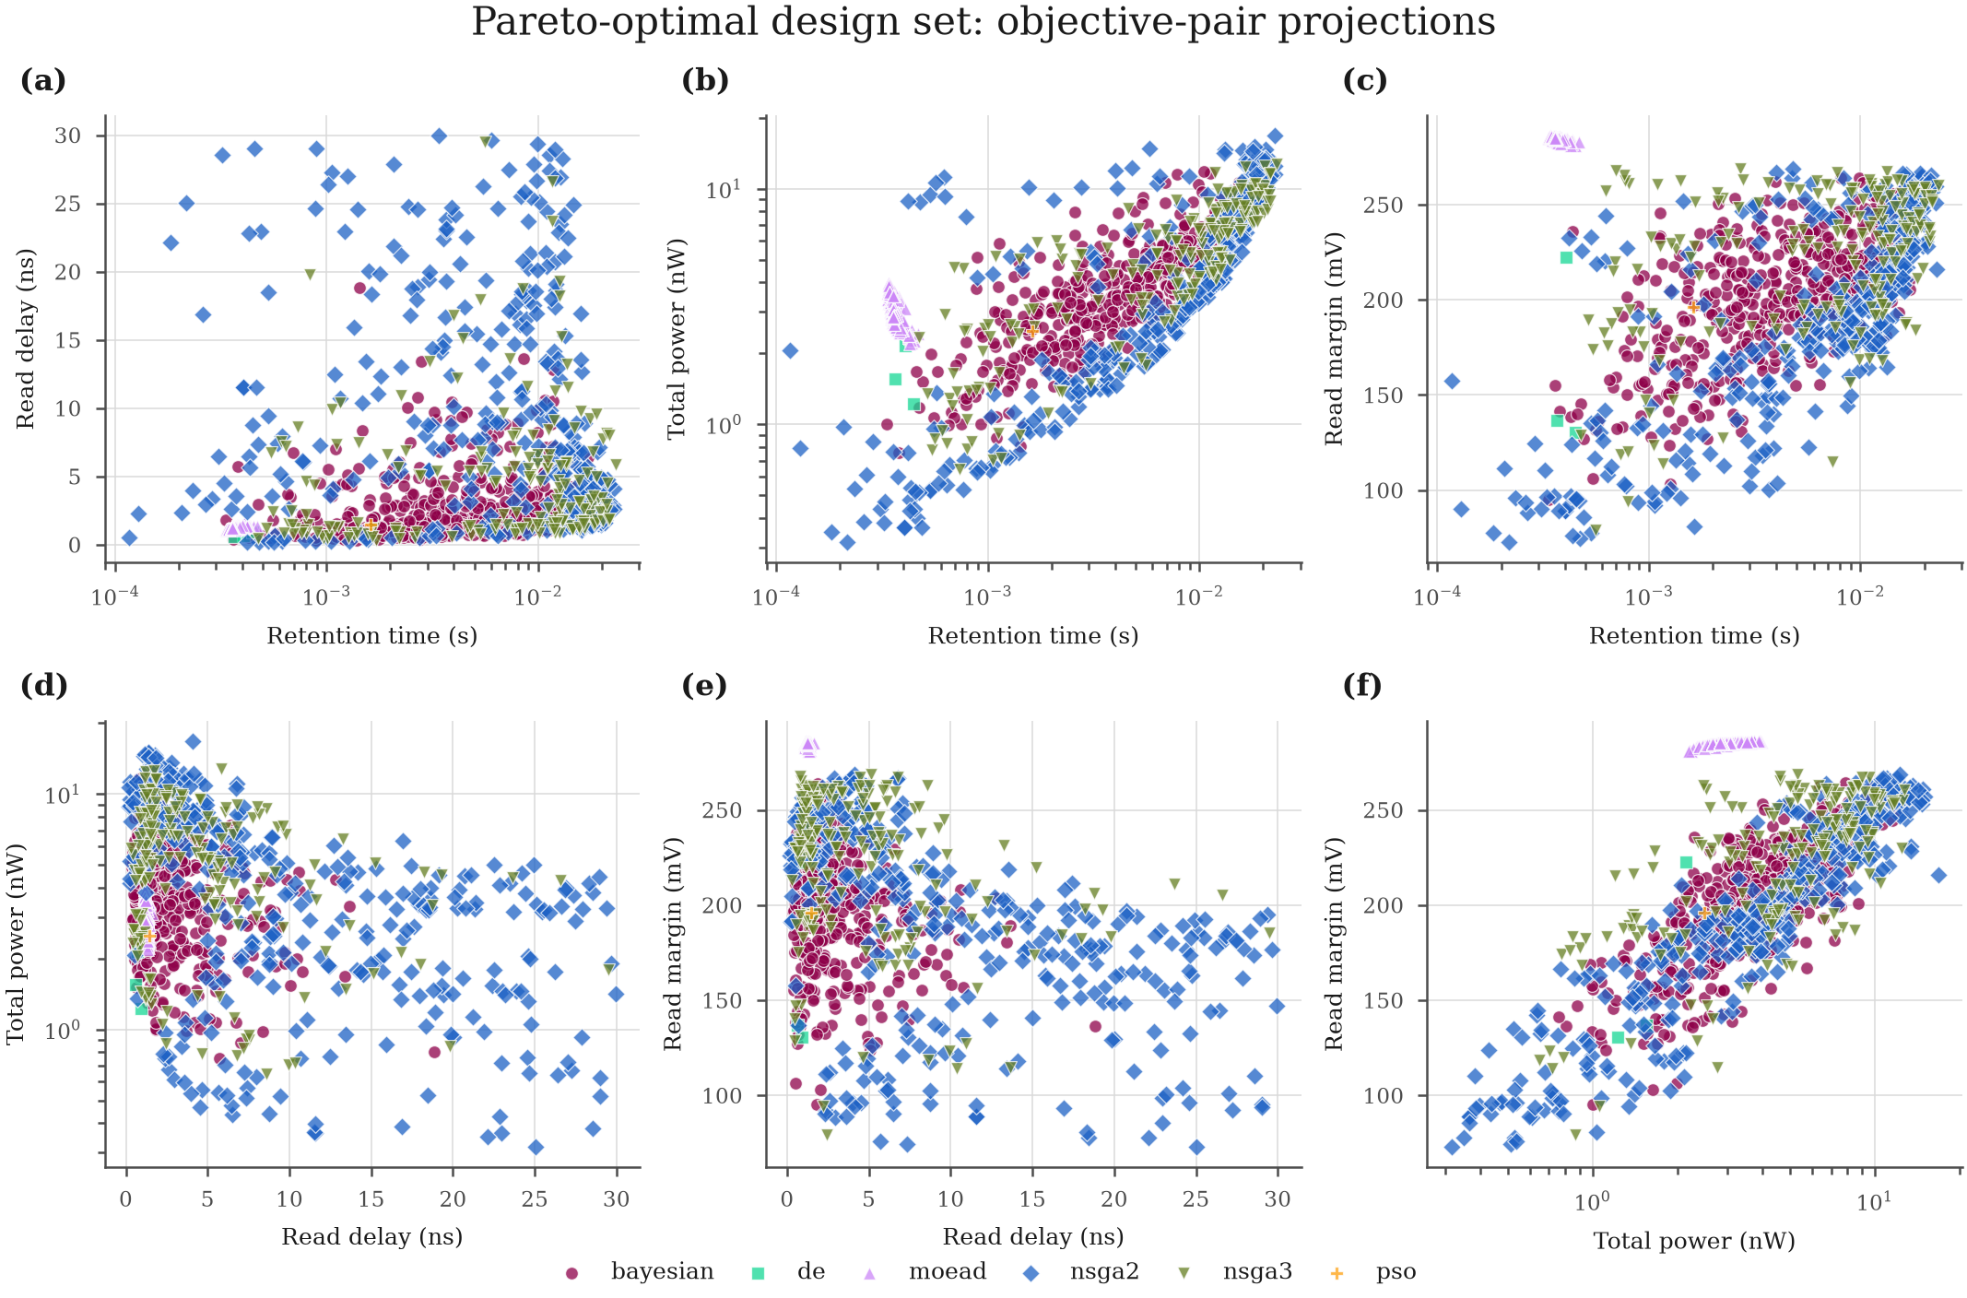
Figure 9. Pareto-optimal design set, objective-pair projections.
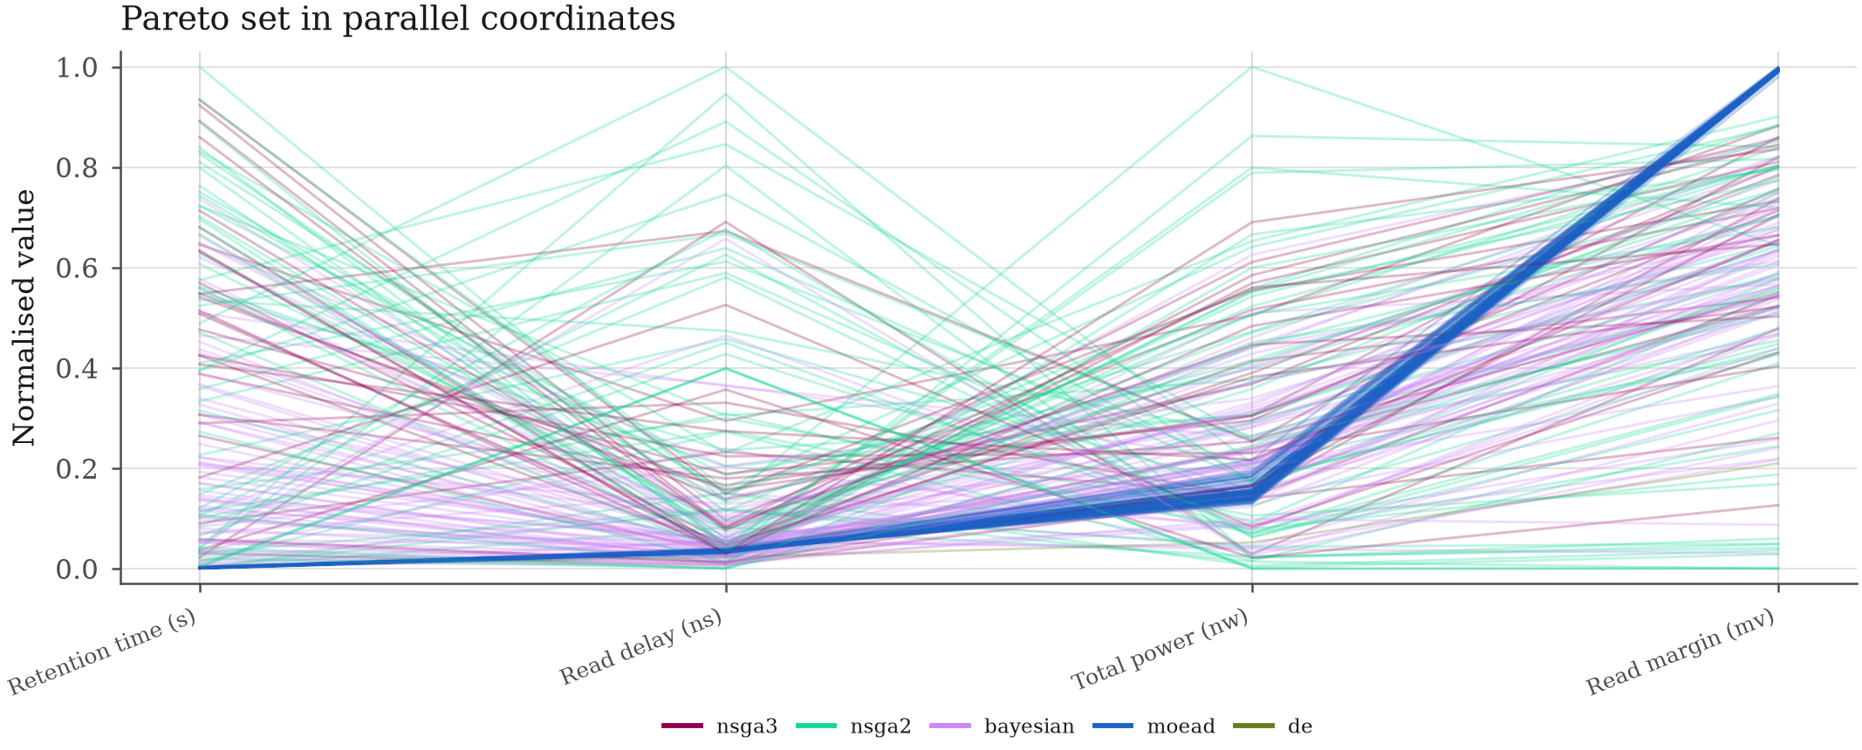
Figure 10. Pareto set in parallel coordinates.
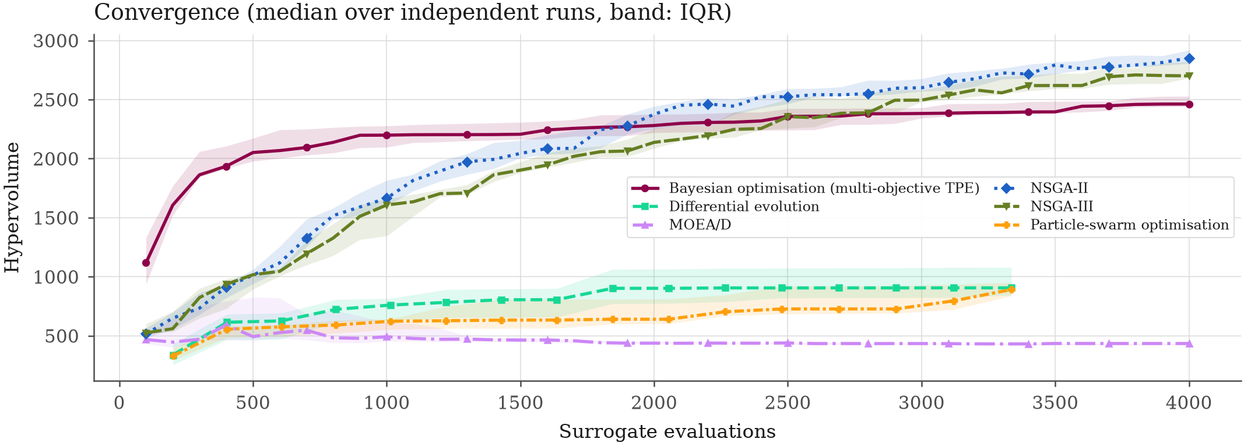
Figure 11. Hypervolume convergence (median over runs, IQR band).
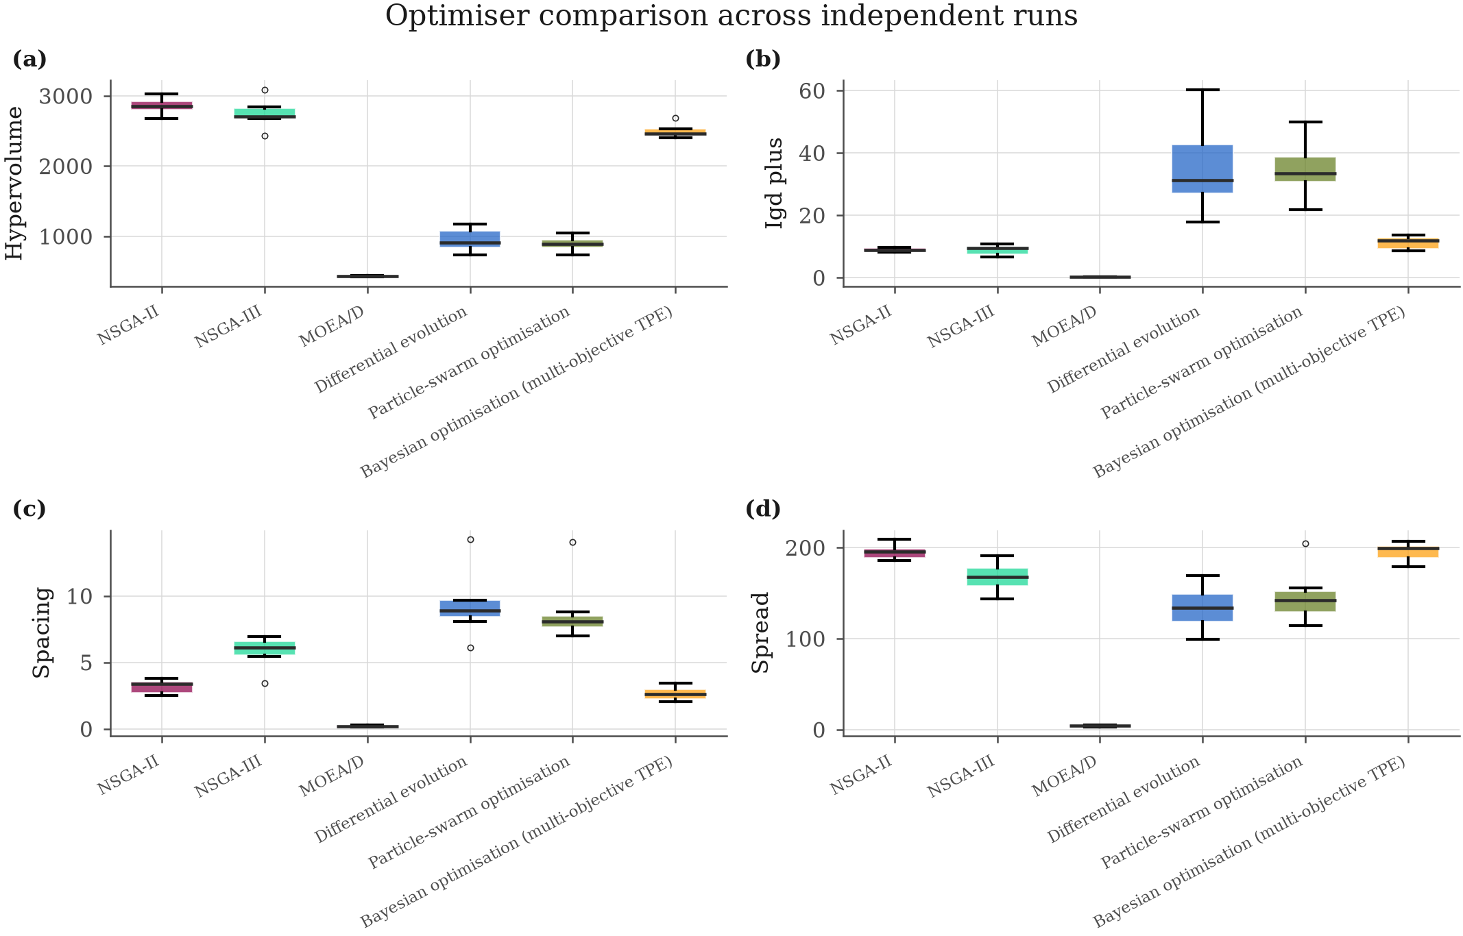
Figure 12. Optimiser comparison across independent runs.
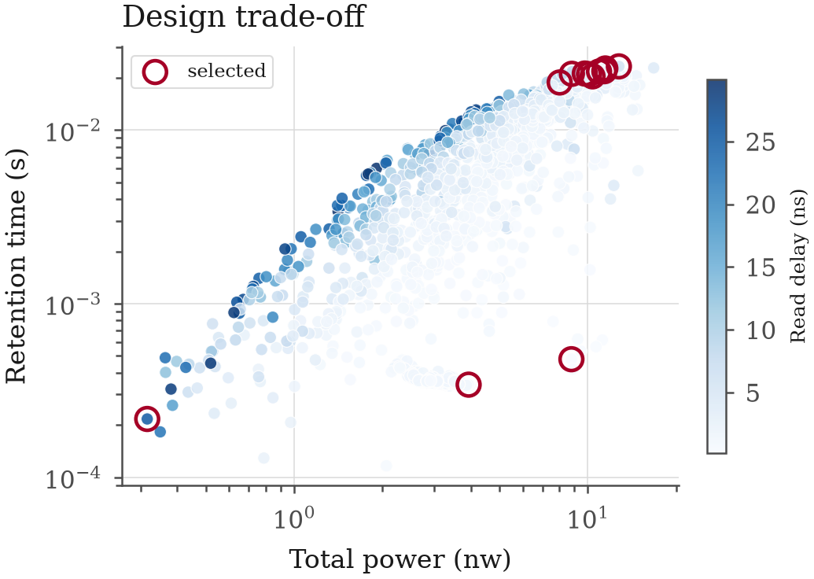
Figure 13. Design trade-off with the selected designs highlighted.
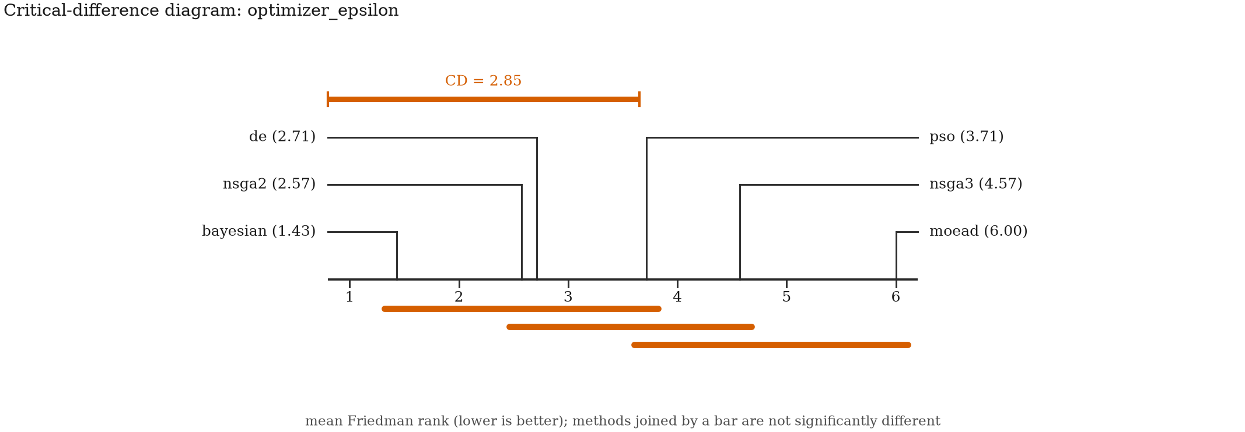
Figure 14. Critical-difference diagram (Nemenyi post-hoc).
Table 8. Optimiser comparison.
algorithm | label | runs | hv_median | hv_mean | hv_std | igdplusmedian | spacing_median | spread_median | nsolutionsmedian | runtimesmedian
nsga2 | NSGA-II | 7 | 2851 | 2857 | 118.0 | 8.868 | 3.375 | 195.2 | 100 | 4.351
nsga3 | NSGA-III | 7 | 2700 | 2748 | 198.2 | 9.574 | 6.094 | 167.9 | 40 | 4.467
bayesian | Bayesian optimisation (multi-objective TPE) | 7 | 2462 | 2498 | 93.49 | 11.99 | 2.611 | 198.9 | 245 | 551.4
de | Differential evolution | 7 | 905.7 | 950.5 | 163.2 | 31.30 | 8.877 | 134.0 | 12 | 4.564
pso | Particle-swarm optimisation | 7 | 891.4 | 892.2 | 109.0 | 33.44 | 8.088 | 142.4 | 13 | 4.878
moead | MOEA/D | 7 | 434.6 | 429.4 | 7.685 | 0.1903 | 0.2041 | 4.208 | 99 | 249.2

Budget 4000 surrogate evaluations per run, 7 runs per algorithm. Hypervolume and IGD+ use a reference front built from the non-dominated union of every run.
Table 9. Representative Pareto-optimal designs.
selection | found_by | vdd | vwl_boost | vwl_low | vblpre_ratio | cs | cbl_ratio | wacc | lacc | wsan | wsap_ratio | wen_ratio | twritepulse | tsensedelay | retentiontimes | readdelayns | totalpowernw | readmarginmv
knee | nsga3 | 1.299 | 0.8995 | -0.008576 | 0.3569 | 3.527e-14 | 2.074 | 6.015e-8 | 5.846e-8 | 1.415e-7 | 2.474 | 1.234 | 8.694e-9 | 8.593e-9 | 0.01879 | 4.997 | 8.018 | 245.9
weighted | nsga3 | 1.227 | 0.9809 | -0.03507 | 0.3500 | 3.987e-14 | 2.004 | 6.534e-8 | 8.104e-8 | 2.015e-7 | 2.987 | 3.802 | 9.602e-9 | 1.949e-9 | 0.02108 | 2.993 | 8.824 | 230.6
bestretentiontime_s | nsga3 | 1.287 | 1.121 | -0.02329 | 0.3504 | 3.996e-14 | 2.071 | 6.240e-8 | 6.565e-8 | 1.083e-7 | 2.724 | 3.823 | 9.511e-9 | 8.503e-9 | 0.02326 | 5.849 | 12.75 | 260.3
bestreaddelay_ns | nsga2 | 1.294 | 1.088 | -0.1159 | 0.3565 | 5.162e-15 | 2.037 | 2.096e-7 | 6.416e-8 | 4.790e-7 | 1.857 | 3.148 | 6.320e-9 | 5.981e-9 | 4.789e-4 | 0.1995 | 8.790 | 225.8
besttotalpower_nw | nsga2 | 0.7090 | 0.6362 | -0.05650 | 0.6335 | 5.308e-15 | 2.005 | 8.936e-8 | 8.232e-8 | 1.442e-7 | 2.313 | 1.531 | 9.667e-9 | 3.176e-9 | 2.168e-4 | 25.04 | 0.3161 | 72.80
bestreadmargin_mv | moead | 1.300 | 0.9965 | -0.3998 | 0.3500 | 5.006e-15 | 2.000 | 2.200e-7 | 1.200e-7 | 9.000e-8 | 1.000 | 2.208 | 5.071e-9 | 1.287e-9 | 3.418e-4 | 1.171 | 3.928 | 286.2
compromise | nsga2 | 1.285 | 0.9786 | -0.05926 | 0.3514 | 3.939e-14 | 2.005 | 6.544e-8 | 6.237e-8 | 1.819e-7 | 2.797 | 3.942 | 9.569e-9 | 9.594e-9 | 0.02097 | 2.940 | 10.09 | 261.5
compromise | nsga2 | 1.300 | 1.053 | -0.003787 | 0.3531 | 3.967e-14 | 2.004 | 6.278e-8 | 7.494e-8 | 1.764e-7 | 2.976 | 3.641 | 9.298e-9 | 6.105e-9 | 0.02263 | 2.899 | 11.47 | 259.5
compromise | nsga3 | 1.247 | 1.023 | -0.02545 | 0.3536 | 3.953e-14 | 2.002 | 6.494e-8 | 8.826e-8 | 2.318e-7 | 2.940 | 3.885 | 9.612e-9 | 2.477e-9 | 0.02116 | 2.464 | 9.764 | 237.0
compromise | nsga2 | 1.270 | 1.059 | -0.002686 | 0.3531 | 3.967e-14 | 2.046 | 6.260e-8 | 6.869e-8 | 1.766e-7 | 2.978 | 3.641 | 9.630e-9 | 6.105e-9 | 0.02172 | 3.141 | 10.92 | 256.5
compromise | nsga2 | 1.280 | 1.082 | -0.03865 | 0.3525 | 3.998e-14 | 2.002 | 6.077e-8 | 6.114e-8 | 2.301e-7 | 2.790 | 2.998 | 9.200e-9 | 8.914e-9 | 0.02183 | 2.553 | 11.38 | 259.1
compromise | nsga3 | 1.299 | 1.019 | -0.02442 | 0.3548 | 3.790e-14 | 2.041 | 6.038e-8 | 6.712e-8 | 2.494e-7 | 1.948 | 2.911 | 9.293e-9 | 5.807e-9 | 0.02039 | 2.583 | 10.37 | 258.0

Objective values are worst case over the configured PVT conditions.
Table 10. Twin prediction versus SPICE for the selected designs.
selection | found_by | temperature_c | corner | retentiontimes_predicted | retentiontimes_simulated | readdelayns_predicted | readdelayns_simulated | totalpowernw_predicted | totalpowernw_simulated | readmarginmv_predicted | readmarginmv_simulated | writeefficiencysimulated | read_success | write_success | retentiontimesrelerror_pct | readdelaynsrelerror_pct | totalpowernwrelerror_pct | readmarginmvrelerror_pct
knee | nsga3 | 27 | TT | 36.21 | 24.58 | 2.128 | 1.766 | 6.830 | 6.788 | 259.6 | 267.8 | 0.9979 | yes | yes | 47.29 | 20.51 | 0.6225 | 3.066
knee | nsga3 | 85 | SS | 1.151 | 0.8101 | 3.792 | 2.861 | 6.225 | 6.974 | 253.0 | 264.3 | 0.9893 | yes | yes | 42.07 | 32.56 | 10.75 | 4.260
knee | nsga3 | 125 | SS | 0.01879 | 0.01220 | 4.997 | 3.800 | 6.488 | 7.232 | 245.9 | 259.4 | 0.9772 | yes | yes | 54.10 | 31.50 | 10.28 | 5.207
knee | nsga3 | 85 | FF | 1.044 | 0.8101 | 2.682 | 2.861 | 8.018 | 6.974 | 260.2 | 264.3 | 0.9893 | yes | yes | 28.83 | 6.255 | 14.96 | 1.531
weighted | nsga3 | 27 | TT | 46.47 | 29.23 | 1.211 | 1.013 | 7.356 | 7.084 | 255.7 | 260.1 | 0.9988 | yes | yes | 58.99 | 19.57 | 3.829 | 1.713
weighted | nsga3 | 85 | SS | 1.300 | 0.8570 | 2.243 | 1.598 | 6.974 | 7.367 | 242.5 | 247.0 | 0.9927 | yes | yes | 51.65 | 40.41 | 5.340 | 1.823
weighted | nsga3 | 125 | SS | 0.02108 | 0.01238 | 2.993 | 2.116 | 7.352 | 7.845 | 230.6 | 224.1 | 0.9795 | yes | yes | 70.28 | 41.43 | 6.279 | 2.899
weighted | nsga3 | 85 | FF | 1.218 | 0.8570 | 1.598 | 1.598 | 8.824 | 7.367 | 249.0 | 247.0 | 0.9927 | yes | yes | 42.08 | 0.03369 | 19.78 | 0.7901
bestretentiontime_s | nsga3 | 27 | TT | 44.02 | 28.48 | 2.394 | 1.884 | 10.41 | 9.432 | 261.3 | 270.1 | 0.9989 | yes | yes | 54.56 | 27.12 | 10.34 | 3.276
bestretentiontime_s | nsga3 | 85 | SS | 1.275 | 0.8977 | 4.414 | 2.984 | 8.856 | 9.808 | 261.2 | 269.9 | 0.9982 | yes | yes | 42.02 | 47.93 | 9.704 | 3.215
bestretentiontime_s | nsga3 | 125 | SS | 0.02326 | 0.01383 | 5.849 | 3.909 | 9.521 | 10.25 | 260.3 | 268.3 | 0.9941 | yes | yes | 68.19 | 49.61 | 7.105 | 3.001
bestretentiontime_s | nsga3 | 85 | FF | 1.202 | 0.8977 | 3.241 | 2.984 | 12.75 | 9.808 | 261.6 | 269.9 | 0.9982 | yes | yes | 33.86 | 8.624 | 30.05 | 3.089
bestreaddelay_ns | nsga2 | 27 | TT | 2.981 | 3.154 | 0.008666 | 0.1192 | 4.933 | 4.450 | 225.8 | 239.7 | 0.9711 | yes | yes | 5.467 | 92.73 | 10.85 | 5.800
bestreaddelay_ns | nsga2 | 85 | SS | 0.03029 | 0.03603 | 0.1609 | 0.1834 | 4.272 | 4.977 | 229.6 | 241.1 | 0.9705 | yes | yes | 15.92 | 12.31 | 14.18 | 4.771
bestreaddelay_ns | nsga2 | 125 | SS | 4.789e-4 | 5.853e-4 | 0.1995 | 0.2356 | 4.992 | 5.903 | 230.6 | 242.0 | 0.9701 | yes | yes | 18.18 | 15.31 | 15.44 | 4.731
bestreaddelay_ns | nsga2 | 85 | FF | 0.03192 | 0.03603 | 0.04727 | 0.1834 | 8.790 | 4.977 | 228.0 | 241.1 | 0.9705 | yes | yes | 11.41 | 74.23 | 76.62 | 5.426
besttotalpower_nw | nsga2 | 27 | TT | 0.8199 | 1.045 | 9.173 | 10.34 | 0.2754 | 0.2564 | 79.17 | 82.72 | 0.9863 | yes | yes | 21.53 | 11.25 | 7.402 | 4.285
besttotalpower_nw | nsga2 | 85 | SS | 0.01185 | 0.02169 | 25.04 | 10.91 | 0.2540 | 0.2777 | 72.80 | 82.54 | 0.9846 | yes | yes | 45.38 | 129.4 | 8.512 | 11.80
besttotalpower_nw | nsga2 | 125 | SS | 2.168e-4 | 3.136e-4 | 23.79 | 11.17 | 0.2762 | 0.3488 | 74.60 | 82.49 | 0.9834 | yes | yes | 30.86 | 113.1 | 20.82 | 9.563
besttotalpower_nw | nsga2 | 85 | FF | 0.02051 | 0.02169 | 4.950 | 10.91 | 0.3161 | 0.2777 | 84.88 | 82.54 | 0.9846 | yes | yes | 5.470 | 54.65 | 13.84 | 2.829
bestreadmargin_mv | moead | 27 | TT | 1.988 | 1.959 | 0.5659 | 0.6243 | 2.707 | 2.721 | 286.2 | 295.5 | 0.9495 | yes | yes | 1.506 | 9.351 | 0.5139 | 3.136
bestreadmargin_mv | moead | 85 | SS | 0.01821 | 0.01834 | 0.9472 | 1.006 | 2.210 | 2.937 | 286.2 | 297.2 | 0.9489 | yes | yes | 0.6982 | 5.867 | 24.75 | 3.708
bestreadmargin_mv | moead | 125 | SS | 3.418e-4 | 3.363e-4 | 1.171 | 1.321 | 2.473 | 3.277 | 286.2 | 298.2 | 0.9484 | yes | yes | 1.638 | 11.36 | 24.54 | 4.024
bestreadmargin_mv | moead | 85 | FF | 0.01756 | 0.01834 | 0.7144 | 1.006 | 3.928 | 2.937 | 287.1 | 297.2 | 0.9489 | yes | yes | 4.237 | 29.00 | 33.71 | 3.374
compromise | nsga2 | 27 | TT | 42.05 | 27.26 | 1.331 | 1.023 | 8.232 | 7.824 | 264.8 | 273.1 | 0.9990 | yes | yes | 54.24 | 30.14 | 5.221 | 3.025
compromise | nsga2 | 85 | SS | 1.228 | 0.8148 | 2.246 | 1.613 | 7.473 | 8.126 | 264.6 | 272.1 | 0.9964 | yes | yes | 50.72 | 39.22 | 8.036 | 2.756
compromise | nsga2 | 125 | SS | 0.02097 | 0.01294 | 2.940 | 2.113 | 8.033 | 8.604 | 261.5 | 269.3 | 0.9894 | yes | yes | 62.06 | 39.12 | 6.638 | 2.888
compromise | nsga2 | 85 | FF | 1.206 | 0.8148 | 1.666 | 1.613 | 10.09 | 8.126 | 265.2 | 272.1 | 0.9964 | yes | yes | 48.05 | 3.289 | 24.18 | 2.527
compromise | nsga2 | 27 | TT | 48.06 | 28.35 | 1.349 | 1.020 | 9.370 | 8.749 | 266.5 | 275.6 | 0.9989 | yes | yes | 69.50 | 32.27 | 7.102 | 3.299
compromise | nsga2 | 85 | SS | 1.291 | 0.9013 | 2.272 | 1.610 | 8.436 | 9.112 | 266.1 | 274.4 | 0.9959 | yes | yes | 43.27 | 41.11 | 7.427 | 3.023
compromise | nsga2 | 125 | SS | 0.02263 | 0.01362 | 2.899 | 2.114 | 8.949 | 9.632 | 259.5 | 270.4 | 0.9863 | yes | yes | 66.13 | 37.10 | 7.096 | 3.998
compromise | nsga2 | 85 | FF | 1.237 | 0.9013 | 1.683 | 1.610 | 11.47 | 9.112 | 266.4 | 274.4 | 0.9959 | yes | yes | 37.29 | 4.527 | 25.83 | 2.915
compromise | nsga3 | 27 | TT | 47.51 | 28.45 | 0.9784 | 0.8406 | 7.887 | 7.665 | 257.4 | 262.8 | 0.9988 | yes | yes | 67.01 | 16.40 | 2.897 | 2.049
compromise | nsga3 | 85 | SS | 1.288 | 0.8467 | 1.845 | 1.317 | 7.506 | 8.004 | 248.7 | 255.7 | 0.9935 | yes | yes | 52.09 | 40.08 | 6.222 | 2.737
compromise | nsga3 | 125 | SS | 0.02116 | 0.01249 | 2.464 | 1.740 | 7.918 | 8.565 | 237.0 | 238.3 | 0.9802 | yes | yes | 69.40 | 41.63 | 7.552 | 0.5459
compromise | nsga3 | 85 | FF | 1.158 | 0.8467 | 1.367 | 1.317 | 9.764 | 8.004 | 254.2 | 255.7 | 0.9935 | yes | yes | 36.78 | 3.772 | 21.99 | 0.5813
compromise | nsga2 | 27 | TT | 47.01 | 28.68 | 1.398 | 1.107 | 8.951 | 8.375 | 258.4 | 265.7 | 0.9990 | yes | yes | 63.89 | 26.30 | 6.888 | 2.731
compromise | nsga2 | 85 | SS | 1.330 | 0.8904 | 2.428 | 1.742 | 8.114 | 8.709 | 258.2 | 265.1 | 0.9974 | yes | yes | 49.39 | 39.39 | 6.827 | 2.580
compromise | nsga2 | 125 | SS | 0.02172 | 0.01315 | 3.141 | 2.277 | 8.599 | 9.188 | 256.5 | 262.6 | 0.9911 | yes | yes | 65.13 | 37.97 | 6.413 | 2.296
compromise | nsga2 | 85 | FF | 1.224 | 0.8904 | 1.751 | 1.742 | 10.92 | 8.709 | 258.7 | 265.1 | 0.9974 | yes | yes | 37.53 | 0.5426 | 25.35 | 2.418

Table 11. Friedman ranks of the optimisers.
indicator | group | mean_rank | rank_position | critical_difference
hypervolume | nsga2 | 1.286 | 1 | 2.850
hypervolume | nsga3 | 1.857 | 2 | 2.850
hypervolume | bayesian | 2.857 | 3 | 2.850
hypervolume | de | 4.286 | 4 | 2.850
hypervolume | pso | 4.714 | 5 | 2.850
hypervolume | moead | 6 | 6 | 2.850
igd | nsga2 | 1.714 | 1 | 2.850
igd | bayesian | 2.143 | 2 | 2.850
igd | nsga3 | 2.143 | 3 | 2.850
igd | de | 4.571 | 4 | 2.850
igd | pso | 4.714 | 5 | 2.850
igd | moead | 5.714 | 6 | 2.850
igd_plus | moead | 1 | 1 | 2.850
igd_plus | nsga3 | 2.571 | 2 | 2.850
igd_plus | nsga2 | 3 | 3 | 2.850
igd_plus | bayesian | 3.429 | 4 | 2.850
igd_plus | de | 5.429 | 5 | 2.850
igd_plus | pso | 5.571 | 6 | 2.850
spacing | moead | 1 | 1 | 2.850
spacing | bayesian | 2.143 | 2 | 2.850
spacing | nsga2 | 3 | 3 | 2.850
spacing | nsga3 | 4 | 4 | 2.850
spacing | pso | 5.286 | 5 | 2.850
spacing | de | 5.571 | 6 | 2.850
spread | bayesian | 1.571 | 1 | 2.850
spread | nsga2 | 1.857 | 2 | 2.850
spread | nsga3 | 3.429 | 3 | 2.850
spread | pso | 3.857 | 4 | 2.850
spread | de | 4.286 | 5 | 2.850
spread | moead | 6 | 6 | 2.850
epsilon | bayesian | 1.429 | 1 | 2.850
epsilon | nsga2 | 2.571 | 2 | 2.850
epsilon | de | 2.714 | 3 | 2.850
epsilon | pso | 3.714 | 4 | 2.850
epsilon | nsga3 | 4.571 | 5 | 2.850
epsilon | moead | 6 | 6 | 2.850
n_solutions | bayesian | 1 | 1 | 2.850
n_solutions | nsga2 | 2.143 | 2 | 2.850
n_solutions | moead | 2.857 | 3 | 2.850
n_solutions | nsga3 | 4 | 4 | 2.850
n_solutions | pso | 5.429 | 5 | 2.850
n_solutions | de | 5.571 | 6 | 2.850

Ranks are computed per run after orienting each indicator so that a smaller value is better.

8. Explainability, robustness and assist techniques
Explainability. Across all modelled responses the highest-attribution design variables are num__vdd, num__vwl_overdrive, num__signal_charge_c, num__charge_share_ratio, num__vwl_boost, num__t_write_pulse. SHAP gives the global ranking and the direction of each effect; ALE is reported alongside partial dependence because the derived design variables are correlated by construction, which is exactly the situation in which partial dependence becomes misleading.
Sensitivity. Sobol' total-effect indices per response:
- read_delay_ns: vdd (ST = 0.761, interaction 0.141), cblratio (ST = 0.172, interaction 0.106), cs (ST = 0.108, interaction 0.075)
- read_margin_mv: cblratio (ST = 0.510, interaction 0.145), vwlboost (ST = 0.317, interaction 0.097), vblpreratio (ST = 0.203, interaction 0.140)
- retention_time_s: cs (ST = 0.384, interaction 0.203), vblpreratio (ST = 0.348, interaction 0.134), cblratio (S_T = 0.288, interaction 0.079)
- total_power_nw: vdd (ST = 0.652, interaction 0.291), cs (ST = 0.344, interaction 0.156), vwllow (ST = 0.315, interaction 0.311)
A large S_T - S_1 gap identifies variables whose influence is mostly through interaction, which one-variable-at-a-time sweeps cannot reveal.
Robustness. Joint Monte-Carlo yield of the selected designs ranges from 100.00 % to 100.00 % (median 100.00 %) under the configured process sigmas. A random subset of the same Monte-Carlo trials was re-simulated in NGSpice; the largest twin-versus-SPICE yield discrepancy was 0.00 percentage points.
Assist techniques. Median change against the unassisted baseline:
Technique | retentiontimes (%) | readdelayns (%) | readmarginmv (%) | totalpowernw (%)
bitlineprechargeopt | +213.9 | -2.1 | +24.8 | +14.7
combinedlowpower | -1.8 | -6.2 | +70.9 | +90.3
highkcapacitor | -81.2 | +41.6 | -8.6 | +50.5
negative_wordline | -37.0 | +0.1 | -0.0 | -0.0
refreshintervalopt | +0.0 | +0.0 | +0.0 | +0.0
senseampupsize | -0.0 | -31.6 | -1.1 | +12.5
wordline_boost | +346.7 | -9.7 | +55.9 | +6.3

The study is paired: every technique is applied to the same base designs and simulated in NGSpice, and the differences are tested with paired Wilcoxon signed-rank tests under Holm correction.
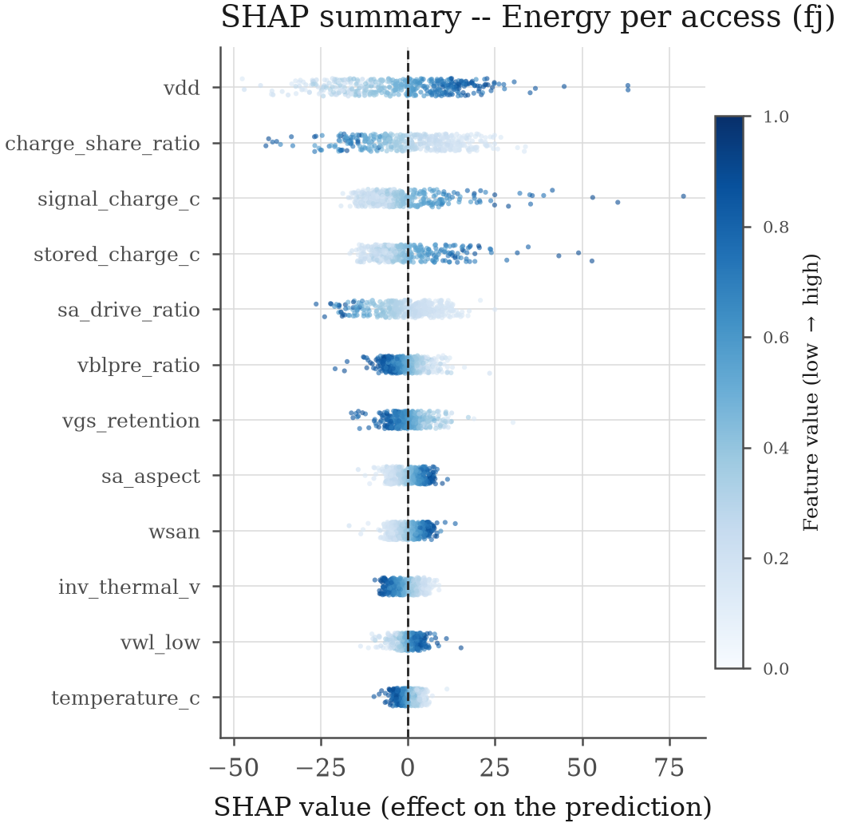
Figure 15. SHAP summary: direction and magnitude of each effect.
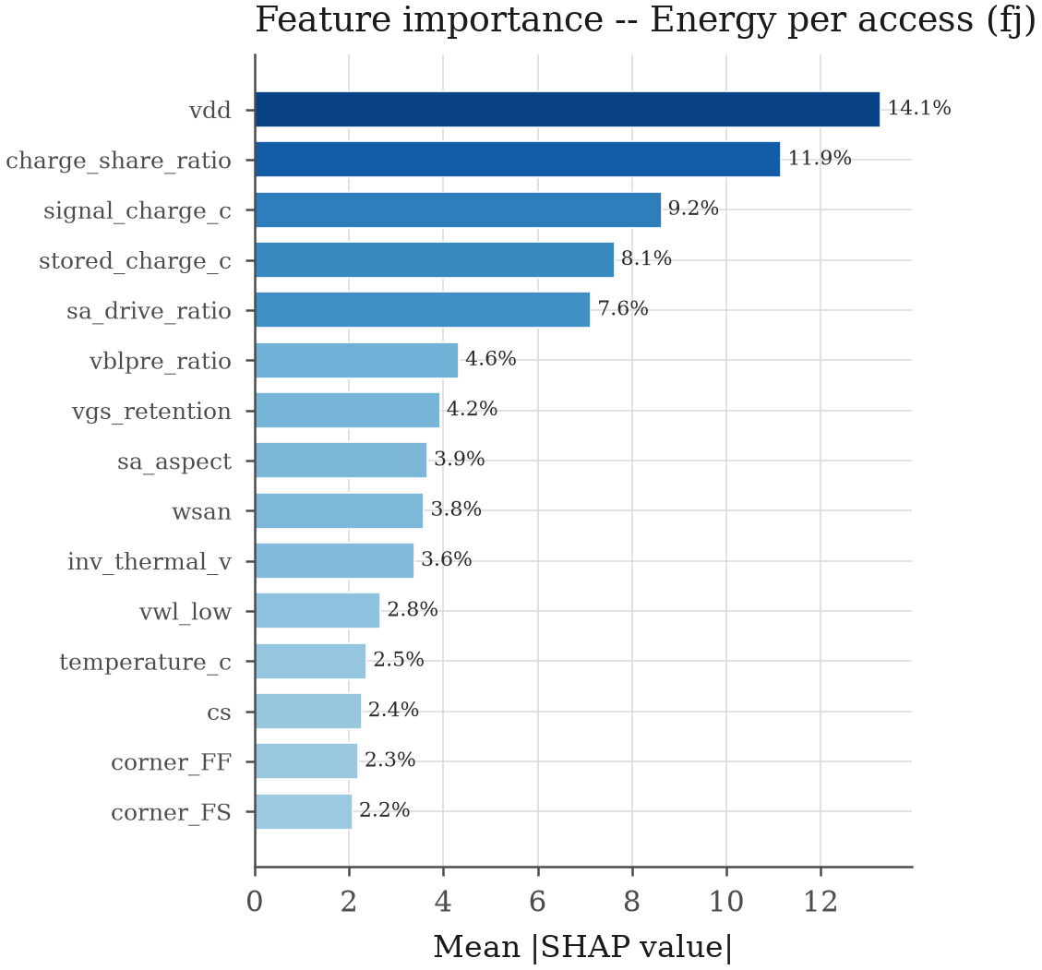
Figure 16. Global SHAP feature importance.
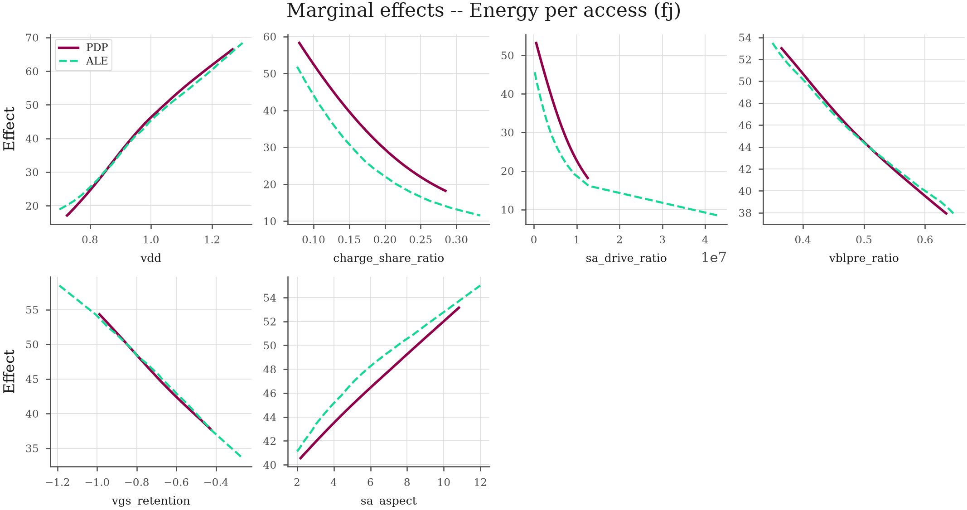
Figure 17. Marginal effects (partial dependence with ALE overlay).
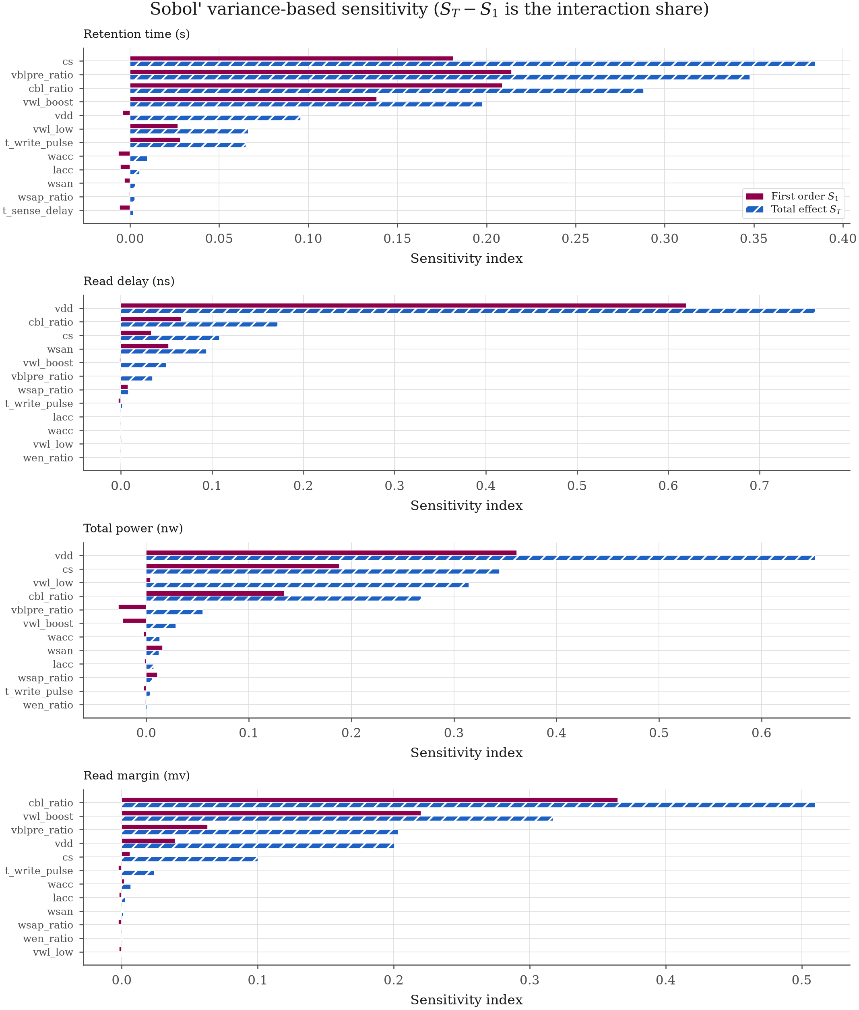
Figure 18. Sobol' first-order and total-effect sensitivity indices.
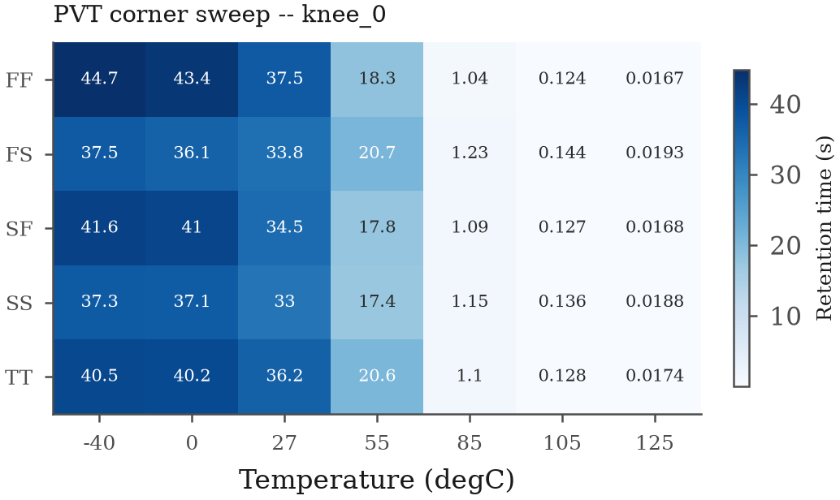
Figure 19. PVT corner sweep of a selected design.
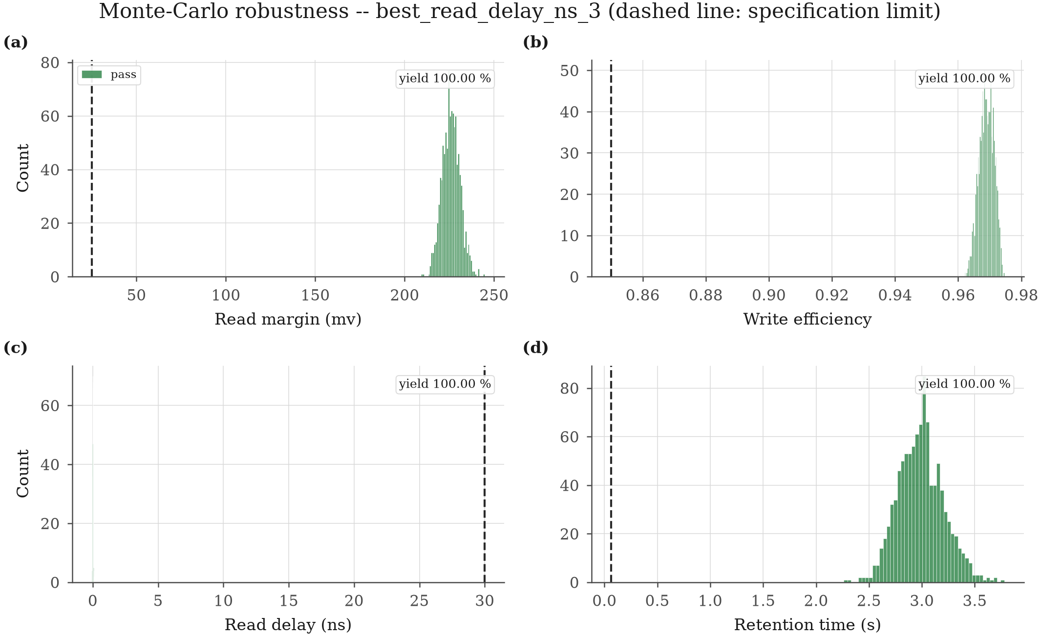
Figure 20. Monte-Carlo robustness with specification limits.
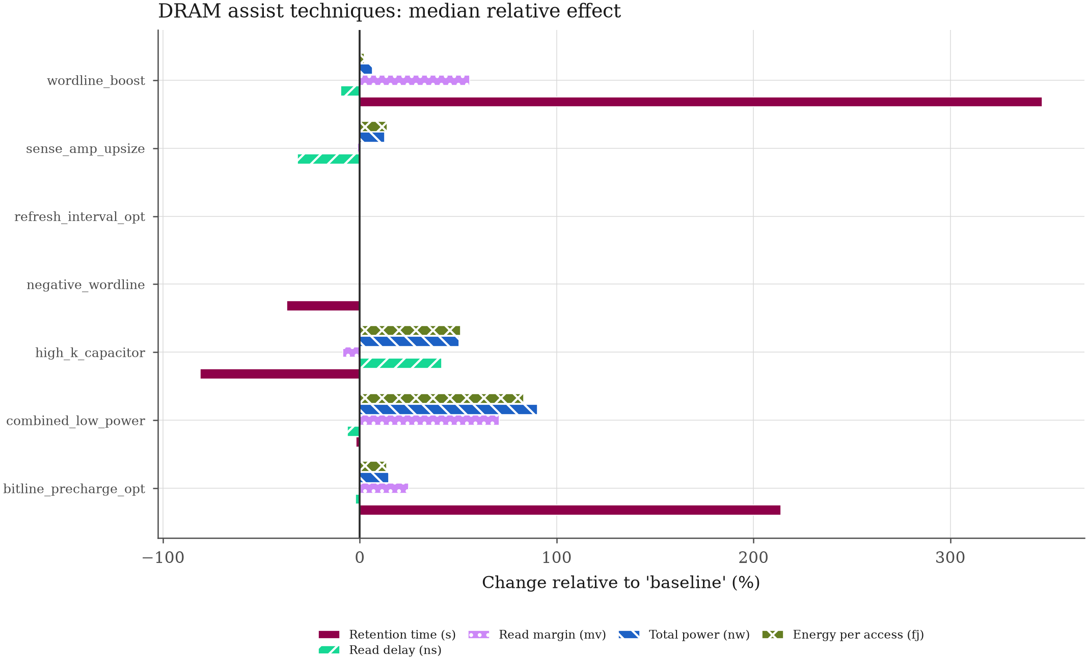
Figure 21. DRAM assist techniques: median relative effect.
Table 12. SHAP importance across responses.
feature | energyperaccess_fj | log10retentiontime_s | log10totalpower_nw | readdelayns | readmarginmv | write_efficiency | meanimportancepct
num__vdd | 14.14 | 8.865 | 18.96 | 21.48 | 11.65 | 2.535 | 12.94
num_vwloverdrive | -- | 9.324 | 3.158 | -- | 5.538 | 15.95 | 8.494
num_signalcharge_c | 9.183 | -- | 5.060 | -- | -- | -- | 7.121
num_chargeshare_ratio | 11.89 | -- | 7.108 | 6.464 | 5.121 | 1.899 | 6.496
num_vwlboost | -- | 8.887 | -- | -- | 5.592 | 4.613 | 6.364
num_twrite_pulse | -- | 6.996 | -- | -- | 3.844 | 7.805 | 6.215
num_vblpreratio | 4.609 | 8.901 | 6.180 | 3.722 | 5.077 | -- | 5.698
num_sadrive_ratio | 7.592 | -- | 5.789 | 3.283 | -- | -- | 5.555
num_cblover_cs | -- | 6.844 | -- | 2.230 | 7.402 | -- | 5.492
num_storedcharge_c | 8.120 | -- | 5.525 | 2.540 | -- | -- | 5.395
num_vgsretention | 4.186 | 2.572 | 5.336 | 7.500 | 6.657 | -- | 5.250
num_cblratio | -- | 6.814 | -- | 2.824 | 7.523 | 2.379 | 4.885
cat_cornerFF | 2.332 | 2.482 | 4.010 | 5.017 | 4.358 | 10.34 | 4.757
cat_cornerSF | -- | -- | 2.635 | -- | 4.192 | 6.972 | 4.599
num__cs | 2.410 | 4.017 | 2.849 | 8.951 | -- | 4.262 | 4.498
num__wsan | 3.824 | -- | 4.620 | 4.952 | -- | 4.268 | 4.416
cat_cornerTT | -- | 2.794 | 3.112 | -- | 3.961 | 7.187 | 4.264
cat_cornerFS | 2.207 | 2.261 | -- | -- | 3.902 | 8.529 | 4.224
cat_cornerSS | -- | -- | -- | -- | 4.069 | 4.356 | 4.213
num_vwllow | 2.840 | -- | 3.494 | 5.431 | 4.592 | -- | 4.089

Blank entries mean the feature did not enter that response's top-15 ranking.
Table 13. Monte-Carlo yield of the selected designs.
design_id | selection | yieldreadmargin_mv | yieldwriteefficiency | yieldreaddelay_ns | yieldretentiontime_s | yield_joint
knee_0 | knee | 100 | 100 | 100 | 100 | 100
weighted_1 | weighted | 100 | 100 | 100 | 100 | 100
bestretentiontimes2 | bestretentiontime_s | 100 | 100 | 100 | 100 | 100
bestreaddelayns3 | bestreaddelay_ns | 100 | 100 | 100 | 100 | 100
besttotalpowernw4 | besttotalpower_nw | 100 | 100 | 100 | 100 | 100
bestreadmarginmv5 | bestreadmargin_mv | 100 | 100 | 100 | 100 | 100

yieldjoint is the fraction of trials meeting every specification simultaneously, not the product of the individual yields._
Table 14. Worst-case PVT performance.
design_id | readmarginmv_worst | readmarginmv_margin | readmarginmvworstcorner | readmarginmvworsttemp_c | writeefficiencyworst | writeefficiencymargin | writeefficiencyworst_corner | writeefficiencyworsttempc | readdelayns_worst | readdelayns_margin | readdelaynsworstcorner | readdelaynsworsttemp_c | retentiontimes_worst | retentiontimes_margin | retentiontimesworstcorner | retentiontimesworsttemp_c | passesallcorners
knee_0 | 245.9 | 220.9 | SS | 125 | 0.9679 | 0.1179 | SF | 125 | 4.997 | 25.00 | SS | 125 | 0.01671 | -0.04729 | FF | 125 | no
weighted_1 | 230.2 | 205.2 | SF | 125 | 0.9638 | 0.1138 | SF | 125 | 2.993 | 27.01 | SS | 125 | 0.01738 | -0.04662 | SF | 125 | no
bestretentiontimes2 | 260.2 | 235.2 | SF | 125 | 0.9775 | 0.1275 | SF | 125 | 5.849 | 24.15 | SS | 125 | 0.02050 | -0.04350 | FF | 125 | no
bestreaddelayns3 | 224.2 | 199.2 | FS | -40 | 0.9658 | 0.1158 | TT | 125 | 0.1995 | 29.80 | SS | 125 | 4.558e-4 | -0.06354 | SF | 125 | no
besttotalpowernw4 | 72.44 | 47.44 | SS | 55 | 0.9596 | 0.1096 | SS | 27 | 27.03 | 2.967 | SS | 0 | 2.164e-4 | -0.06378 | SF | 125 | no
bestreadmarginmv5 | 284.2 | 259.2 | FS | -40 | 0.9608 | 0.1108 | TT | 125 | 1.233 | 28.77 | FS | 125 | 3.170e-4 | -0.06368 | FF | 125 | no

Table 15. Sobol' sensitivity indices.
response | variable | S1 | ST | interaction
retentiontimes | cs | 0.1813 | 0.3844 | 0.2031
retentiontimes | vblpre_ratio | 0.2141 | 0.3479 | 0.1338
retentiontimes | cbl_ratio | 0.2088 | 0.2883 | 0.07943
retentiontimes | vwl_boost | 0.1384 | 0.1977 | 0.05929
retentiontimes | vdd | -0.004126 | 0.09581 | 0.09994
retentiontimes | vwl_low | 0.02684 | 0.06639 | 0.03955
retentiontimes | twritepulse | 0.02829 | 0.06508 | 0.03679
retentiontimes | wacc | -0.006677 | 0.009693 | 0.01637
retentiontimes | lacc | -0.005466 | 0.005441 | 0.01091
retentiontimes | wsan | -0.003113 | 0.002814 | 0.005927
retentiontimes | wsap_ratio | -4.605e-4 | 0.002716 | 0.003176
retentiontimes | tsensedelay | -0.005824 | 0.001719 | 0.007543
retentiontimes | wen_ratio | -0.005061 | 0.001633 | 0.006694
readdelayns | vdd | 0.6197 | 0.7608 | 0.1412
readdelayns | cbl_ratio | 0.06615 | 0.1722 | 0.1060
readdelayns | cs | 0.03327 | 0.1082 | 0.07495
readdelayns | wsan | 0.05227 | 0.09406 | 0.04178
readdelayns | vwl_boost | -0.001565 | 0.04998 | 0.05154
readdelayns | vblpre_ratio | -1.808e-4 | 0.03477 | 0.03495
readdelayns | wsap_ratio | 0.007755 | 0.008498 | 7.430e-4
readdelayns | twritepulse | -0.002909 | 0.001667 | 0.004575
readdelayns | lacc | 1.063e-4 | 5.544e-4 | 4.481e-4
readdelayns | wacc | 5.884e-4 | 4.605e-4 | 0
readdelayns | vwl_low | 7.424e-4 | 4.396e-4 | 0
readdelayns | wen_ratio | 1.238e-4 | 4.138e-4 | 2.900e-4
readdelayns | tsensedelay | -7.915e-4 | 2.875e-4 | 0.001079
totalpowernw | vdd | 0.3614 | 0.6522 | 0.2908
totalpowernw | cs | 0.1883 | 0.3444 | 0.1561
totalpowernw | vwl_low | 0.004153 | 0.3148 | 0.3107
totalpowernw | cbl_ratio | 0.1346 | 0.2679 | 0.1333
totalpowernw | vblpre_ratio | -0.02740 | 0.05535 | 0.08274
totalpowernw | vwl_boost | -0.02303 | 0.02883 | 0.05185
totalpowernw | wacc | -0.002682 | 0.01325 | 0.01593
totalpowernw | wsan | 0.01580 | 0.01232 | 0
totalpowernw | lacc | -0.001696 | 0.007411 | 0.009107
totalpowernw | wsap_ratio | 0.01099 | 0.005609 | 0
totalpowernw | twritepulse | -0.002658 | 0.003762 | 0.006420
totalpowernw | wen_ratio | -0.001124 | 8.805e-4 | 0.002004
totalpowernw | tsensedelay | 1.108e-4 | 5.662e-4 | 4.554e-4
readmarginmv | cbl_ratio | 0.3650 | 0.5099 | 0.1449
readmarginmv | vwl_boost | 0.2201 | 0.3173 | 0.09717
readmarginmv | vblpre_ratio | 0.06325 | 0.2031 | 0.1399
readmarginmv | vdd | 0.03910 | 0.2006 | 0.1615
readmarginmv | cs | 0.006200 | 0.1002 | 0.09403
readmarginmv | twritepulse | -0.002541 | 0.02397 | 0.02651
readmarginmv | wacc | 0.001916 | 0.006645 | 0.004729
readmarginmv | lacc | -0.001892 | 0.002452 | 0.004344
readmarginmv | wsan | -3.742e-5 | 0.001032 | 0.001070
readmarginmv | wsap_ratio | -0.002617 | 5.567e-4 | 0.003174
readmarginmv | wen_ratio | -1.310e-4 | 3.589e-4 | 4.899e-4
readmarginmv | vwl_low | -0.001813 | 3.054e-4 | 0.002119
readmarginmv | tsensedelay | -0.001700 | 1.052e-4 | 0.001805

ST - S1 is the share of variance a variable contributes through interactions rather than on its own.
Table 16. Assist-technique comparison.
assist_config | retentiontimes | readdelayns | writedelayns | readmarginmv | totalpowernw | energyperaccess_fj | leakagecurrentfa | refreshintervalms | feasible_pct
baseline | 0.2865 | 5.829 | 1.224 | 39.72 | 3.040 | 28.65 | 1.509 | 301.7 | 26.33
bitlineprechargeopt | 0.8992 | 5.706 | 1.264 | 49.58 | 3.486 | 32.54 | 1.515 | 531.8 | 25.33
combinedlowpower | 0.2812 | 5.468 | 1.359 | 67.90 | 5.784 | 52.51 | 486.4 | 151.2 | 74
highkcapacitor | 0.05399 | 8.256 | 1.524 | 36.31 | 4.574 | 43.31 | 19.58 | 69.27 | 17
negative_wordline | 0.1806 | 5.835 | 1.222 | 39.72 | 3.039 | 28.63 | 18.18 | 212.1 | 25.33
refreshintervalopt | 0.2865 | 5.829 | 1.224 | 39.72 | 3.040 | 28.65 | 1.509 | 301.7 | 26.33
senseampupsize | 0.2865 | 3.989 | 1.225 | 39.28 | 3.420 | 32.66 | 1.508 | 301.7 | 28.00
wordline_boost | 1.280 | 5.266 | 0.8842 | 61.93 | 3.233 | 29.26 | 2.674 | 675.5 | 76.33

Paired study: every technique is applied to the identical set of 300 base designs and simulated in NGSpice.
Table 17. Paired significance tests of the assist techniques.
metric | group_1 | group_2 | n_pairs | statistic | p_value | median_1 | median_2 | cliffs_delta | effect_magnitude | a12 | pvalueholm | significant
retentiontimes | baseline | bitlineprechargeopt | 300 | 0 | 2.418e-47 | 0.2865 | 0.8992 | -0.2034 | small | 0.3983 | 1.451e-46 | yes
retentiontimes | baseline | combinedlowpower | 300 | 13647 | 4.143e-7 | 0.2865 | 0.2812 | 0.01107 | negligible | 0.5055 | 8.285e-7 | yes
retentiontimes | baseline | highkcapacitor | 300 | 1549 | 1.130e-34 | 0.2865 | 0.05399 | 0.3107 | small | 0.6553 | 3.390e-34 | yes
retentiontimes | baseline | negative_wordline | 300 | 61 | 4.118e-42 | 0.2865 | 0.1806 | 0.05938 | negligible | 0.5297 | 2.059e-41 | yes
retentiontimes | baseline | refreshintervalopt | 300 | -- | 1 | 0.2865 | 0.2865 | 0 | negligible | 0.5000 | 1 | no
retentiontimes | baseline | senseampupsize | 300 | 171 | 1.565e-40 | 0.2865 | 0.2865 | 0.002733 | negligible | 0.5014 | 6.262e-40 | yes
retentiontimes | baseline | wordline_boost | 300 | 0 | 1.805e-49 | 0.2865 | 1.280 | -0.3052 | small | 0.3474 | 1.263e-48 | yes
readdelayns | baseline | bitlineprechargeopt | 192 | 3031 | 6.252e-16 | 4.665 | 4.614 | 0.04411 | negligible | 0.5221 | 2.501e-15 | yes
readdelayns | baseline | combinedlowpower | 192 | 4405 | 2.934e-10 | 4.665 | 4.332 | 0.07319 | negligible | 0.5366 | 5.869e-10 | yes
readdelayns | baseline | highkcapacitor | 192 | 0 | 2.943e-33 | 4.665 | 8.256 | -0.2723 | small | 0.3639 | 2.060e-32 | yes
readdelayns | baseline | negative_wordline | 192 | 3910 | 3.788e-12 | 4.665 | 4.660 | 0.003364 | negligible | 0.5017 | 1.136e-11 | yes
readdelayns | baseline | refreshintervalopt | 192 | -- | 1 | 4.665 | 4.665 | 0 | negligible | 0.5000 | 1 | no
readdelayns | baseline | senseampupsize | 192 | 0 | 2.943e-33 | 4.665 | 2.973 | 0.2536 | small | 0.6268 | 2.060e-32 | yes
readdelayns | baseline | wordline_boost | 192 | 0 | 2.943e-33 | 4.665 | 4.003 | 0.1010 | negligible | 0.5505 | 2.060e-32 | yes
writedelayns | baseline | bitlineprechargeopt | 300 | 3 | 6.269e-51 | 1.224 | 1.264 | -0.04060 | negligible | 0.4797 | 4.389e-50 | yes
writedelayns | baseline | combinedlowpower | 300 | 8100 | 6.214e-22 | 1.224 | 1.359 | -0.1321 | negligible | 0.4339 | 1.864e-21 | yes
writedelayns | baseline | highkcapacitor | 300 | 271 | 9.063e-50 | 1.224 | 1.524 | -0.2210 | small | 0.3895 | 5.438e-49 | yes
writedelayns | baseline | negative_wordline | 300 | 11089 | 2.202e-14 | 1.224 | 1.222 | -0.006111 | negligible | 0.4969 | 4.404e-14 | yes
writedelayns | baseline | refreshintervalopt | 300 | -- | 1 | 1.224 | 1.224 | 0 | negligible | 0.5000 | 1 | no
writedelayns | baseline | senseampupsize | 300 | 797 | 1.563e-47 | 1.224 | 1.225 | -0.004289 | negligible | 0.4979 | 7.817e-47 | yes
writedelayns | baseline | wordline_boost | 300 | 7661 | 3.481e-23 | 1.224 | 0.8842 | 0.2477 | small | 0.6238 | 1.392e-22 | yes
readmarginmv | baseline | bitlineprechargeopt | 300 | 0 | 6.084e-51 | 39.72 | 49.58 | -0.2450 | small | 0.3775 | 4.258e-50 | yes
readmarginmv | baseline | combinedlowpower | 300 | 35 | 8.639e-51 | 39.72 | 67.90 | -0.5309 | large | 0.2346 | 4.258e-50 | yes
readmarginmv | baseline | highkcapacitor | 300 | 15 | 7.071e-51 | 39.72 | 36.31 | 0.1170 | negligible | 0.5585 | 4.258e-50 | yes
readmarginmv | baseline | negative_wordline | 300 | 12786 | 7.512e-11 | 39.72 | 39.72 | -0.001844 | negligible | 0.4991 | 1.502e-10 | yes
readmarginmv | baseline | refreshintervalopt | 300 | -- | 1 | 39.72 | 39.72 | 0 | negligible | 0.5000 | 1 | no
readmarginmv | baseline | senseampupsize | 300 | 0 | 6.083e-51 | 39.72 | 39.28 | 0.01672 | negligible | 0.5084 | 4.258e-50 | yes
readmarginmv | baseline | wordline_boost | 300 | 0 | 6.084e-51 | 39.72 | 61.93 | -0.4746 | large | 0.2627 | 4.258e-50 | yes
totalpowernw | baseline | bitlineprechargeopt | 300 | 858 | 2.820e-47 | 3.040 | 3.486 | -0.07580 | negligible | 0.4621 | 1.410e-46 | yes
totalpowernw | baseline | combinedlowpower | 300 | 196 | 4.305e-50 | 3.040 | 5.784 | -0.3601 | medium | 0.3200 | 2.583e-49 | yes
totalpowernw | baseline | highkcapacitor | 300 | 2589 | 2.618e-40 | 3.040 | 4.574 | -0.1991 | small | 0.4004 | 1.047e-39 | yes
totalpowernw | baseline | negative_wordline | 300 | 17290 | 4.405e-4 | 3.040 | 3.039 | 0.001733 | negligible | 0.5009 | 8.810e-4 | yes
totalpowernw | baseline | refreshintervalopt | 300 | -- | 1 | 3.040 | 3.040 | 0 | negligible | 0.5000 | 1 | no
totalpowernw | baseline | senseampupsize | 300 | 0 | 6.084e-51 | 3.040 | 3.420 | -0.08831 | negligible | 0.4558 | 4.258e-50 | yes
totalpowernw | baseline | wordline_boost | 300 | 14413 | 5.706e-8 | 3.040 | 3.233 | -0.03324 | negligible | 0.4834 | 1.712e-7 | yes
energyperaccess_fj | baseline | bitlineprechargeopt | 300 | 315 | 1.401e-49 | 28.65 | 32.54 | -0.07740 | negligible | 0.4613 | 7.005e-49 | yes
energyperaccess_fj | baseline | combinedlowpower | 300 | 212 | 5.047e-50 | 28.65 | 52.51 | -0.3418 | medium | 0.3291 | 3.028e-49 | yes
energyperaccess_fj | baseline | highkcapacitor | 300 | 2286 | 1.737e-41 | 28.65 | 43.31 | -0.2047 | small | 0.3977 | 6.946e-41 | yes
energyperaccess_fj | baseline | negative_wordline | 300 | 7177 | 1.316e-24 | 28.65 | 28.63 | 0.003222 | negligible | 0.5016 | 3.948e-24 | yes
energyperaccess_fj | baseline | refreshintervalopt | 300 | -- | 1 | 28.65 | 28.65 | 0 | negligible | 0.5000 | 1 | no
energyperaccess_fj | baseline | senseampupsize | 300 | 0 | 6.084e-51 | 28.65 | 32.66 | -0.08038 | negligible | 0.4598 | 4.258e-50 | yes
energyperaccess_fj | baseline | wordline_boost | 300 | 8254 | 1.674e-21 | 28.65 | 29.26 | -0.003533 | negligible | 0.4982 | 3.348e-21 | yes
leakagecurrentfa | baseline | bitlineprechargeopt | 300 | 18349 | 0.004949 | 1.509 | 1.515 | 4.667e-4 | negligible | 0.5002 | 0.009899 | yes
leakagecurrentfa | baseline | combinedlowpower | 300 | 7 | 6.526e-51 | 1.509 | 486.4 | -0.7191 | large | 0.1404 | 4.258e-50 | yes
leakagecurrentfa | baseline | highkcapacitor | 300 | 8 | 6.592e-51 | 1.509 | 19.58 | -0.4765 | large | 0.2617 | 4.258e-50 | yes
leakagecurrentfa | baseline | negative_wordline | 300 | 14618 | 1.214e-7 | 1.509 | 18.18 | -0.1968 | small | 0.4016 | 3.641e-7 | yes
leakagecurrentfa | baseline | refreshintervalopt | 300 | -- | 1 | 1.509 | 1.509 | 0 | negligible | 0.5000 | 1 | no
leakagecurrentfa | baseline | senseampupsize | 300 | 149 | 3.903e-49 | 1.509 | 1.508 | 0.003211 | negligible | 0.5016 | 1.561e-48 | yes
leakagecurrentfa | baseline | wordline_boost | 300 | 0 | 6.084e-51 | 1.509 | 2.674 | -0.2034 | small | 0.3983 | 4.258e-50 | yes
refreshintervalms | baseline | bitlineprechargeopt | 221 | 0 | 5.197e-38 | 424.3 | 740.9 | -0.1745 | small | 0.4128 | 3.638e-37 | yes
refreshintervalms | baseline | combinedlowpower | 221 | 4823 | 5.250e-15 | 424.3 | 190.1 | 0.2203 | small | 0.6102 | 1.050e-14 | yes
refreshintervalms | baseline | highkcapacitor | 221 | 1329 | 1.441e-30 | 424.3 | 69.27 | 0.4366 | medium | 0.7183 | 4.323e-30 | yes
refreshintervalms | baseline | negative_wordline | 221 | 53 | 1.068e-37 | 424.3 | 274.5 | 0.09662 | negligible | 0.5483 | 5.341e-37 | yes
refreshintervalms | baseline | refreshintervalopt | 221 | -- | 1 | 424.3 | 424.3 | 0 | negligible | 0.5000 | 1 | no
refreshintervalms | baseline | senseampupsize | 221 | 154 | 4.260e-36 | 424.3 | 424.1 | 0.004361 | negligible | 0.5022 | 1.704e-35 | yes
refreshintervalms | baseline | wordline_boost | 221 | 0 | 5.197e-38 | 424.3 | 790.4 | -0.2059 | small | 0.3970 | 3.638e-37 | yes

9. Limitations and threats to validity
These are stated plainly because they bound what the numbers mean.
- Device models are logic models, not DRAM models. Every simulation uses the
public PTM BSIM4 cards for a ? nm logic process. Real DRAM access devices are engineered differently -- notably much stronger GIDL at the storage node -- so the absolute retention times here are longer than a production part would show. Relative trends, the ranking of design variables and the methodology are unaffected; absolute retention values should not be read as predictions about any commercial device.
- Process corners are synthesised, not signed off. SS/FF/SF/FS are first-order
vth0/u0/tox shifts applied to the typical card, with the shift magnitudes declared in configuration. They are a reasonable spread, not foundry corners.
- Retention is quasi-static. The model integrates the charge-loss ODE over a
measured leakage characteristic and is exact for an isolated capacitor whose leakage depends only on the instantaneous node voltage. Its agreement with direct transient simulation is quantified in Section 5. It does not model variable-retention-time behaviour or trap-assisted transients, which are time-dependent phenomena outside a quasi-static description.
- The bitline is lumped. Cbl is a lumped capacitance rather than a
distributed RC line with the other cells attached, so bitline resistance and neighbour coupling are not modelled.
- Power is reported per simulated slice. The slice is one cell plus its column
periphery, and the active-power component depends on the configured access_rate_hz. All three components are reported separately so results can be reweighted for a different access profile without re-simulating.
- The optimiser searches the surrogate, and that shows. A multi-objective search drives towards the edges of the design space, which is exactly where a surrogate has least support -- and any region in which it over-predicts will be exploited. The effect is measurable here. Against the held-out test split the twin reaches R2 = 0.95-0.999, but on the optimiser-selected Pareto designs the median twin-versus-SPICE error is 3.0 % (readmarginmv), 10.3 % (totalpowernw), 30.8 % (readdelayns), 46.3 % (retentiontimes). Read margin and power -- the smoothest responses -- stay accurate; read delay and retention, which span decades and turn sharply near the feasibility boundary, degrade most. Expressed on the scale the quantity actually lives on, the retention discrepancy is 0.169 decades, a factor of 1.48. Two things make this manageable rather than fatal. First it is measured: every selected design is returned to NGSpice, so the error is a reported quantity, not an assumption. Second, the constraints survive the round trip -- 100 % of the selected designs pass both the read and the write check under full circuit simulation. The practical reading is that the twin is a search accelerator whose proposals must be confirmed in SPICE, not a replacement for it; re-simulating the Pareto region and refitting is the natural next iteration, and is what the framework's feedback path exists for.
- A single technology node was run end-to-end. Configurations for 32 nm and
22 nm ship with the framework and the pipeline is node-agnostic, but the results presented here are for the ? nm node.

10. Reproduction
python -m venv .venv && .venv/Scripts/activate # Windows
pip install -e .
python scripts/00_setup_environment.py # NGSpice + PTM models
python scripts/run_all.py --tag main # the whole pipeline
Determinism: master seed 20260723, configuration hash e22061fdb47e16e7, model-card fingerprint ?. Every stage writes a manifest to logs/manifest_*.json recording its seeds, inputs, outputs, package versions and wall-clock time. See REPRODUCIBILITY.md for the full protocol and supplementary/environment_lock.txt for the exact package versions used.

References
[1] "Re-Evaluating the Real-System Modeling Accuracy of Ramulator 2.0", arXiv, 2026 <https://arxiv.org/abs/2606.14566>
[2] "Analog Design and Machine Learning: A Review", Electronics (MDPI), 2025 <https://doi.org/10.3390/electronics14173541>
[3] "EasyDRAM: An FPGA-based Infrastructure for Fast and Accurate End-to-End Evaluation of Emerging DRAM Techniques", arXiv, 2025 <https://arxiv.org/abs/2506.10441>
[4] "Multi-Fidelity Surrogate Models for Accelerated Multi-Objective Analog Circuit Design and Optimization", Electronics (MDPI), 2025 <https://doi.org/10.3390/electronics15010105>
[5] "Analog circuit sizing based on Evolutionary Algorithms and deep learning", Expert Systems with Applications (Elsevier), 2024 <https://www.sciencedirect.com/science/article/abs/pii/S0957417423019826>
[6] "Machine Learning Driven Global Optimisation Framework for Analog Circuit Design", arXiv, 2024 <https://arxiv.org/abs/2404.02911>
[7] "PENDRAM: Enabling High-Performance and Energy-Efficient Processing of Deep Neural Networks through a Generalized DRAM Data Mapping Policy", arXiv, 2024 <https://arxiv.org/abs/2408.02412>
[8] "PySpice-Simulated In Situ Learning with Memristor Emulation for Single-Layer Spiking Neural Networks", Electronics (MDPI) 13(23), 4665, 2024 <https://www.mdpi.com/2079-9292/13/23/4665>
[9] "SPICEPilot: Navigating SPICE Code Generation and Simulation with AI Guidance", arXiv, 2024 <https://arxiv.org/abs/2410.20553>
[10] "The Dawn of AI-Native EDA: Opportunities and Challenges of Large Circuit Models", arXiv, 2024 <https://arxiv.org/abs/2403.07257>
[11] "When Device Modeling Meets Machine Learning: Opportunities and Challenges", ACM/IEEE International Symposium on Machine Learning for CAD (MLCAD), 2024 <https://dl.acm.org/doi/10.1145/3670474.3685972>
[12] "Performance Evaluation of Evolutionary Algorithms for Analog Integrated Circuit Design Optimisation", arXiv, 2023 <https://arxiv.org/abs/2310.12440>
[13] "Python Framework for Modular and Parametric SPICE Netlists Generation", arXiv, 2023 <https://arxiv.org/abs/2306.12224>
[14] "Digital Twin for Secure Semiconductor Lifecycle Management: Prospects and Applications", arXiv, 2022 <https://arxiv.org/abs/2205.10962>
[15] D. W. Apley and J. Zhu, "Visualizing the Effects of Predictor Variables in Black Box Supervised Learning Models", Journal of the Royal Statistical Society Series B, vol. 82, no. 4, pp. 1059-1086, 2020 <https://doi.org/10.1111/rssb.12377>
[16] J. Blank and K. Deb, "pymoo: Multi-Objective Optimization in Python", IEEE Access, vol. 8, pp. 89497-89509, 2020 <https://doi.org/10.1109/ACCESS.2020.2990567>
[17] S. M. Lundberg et al., "From Local Explanations to Global Understanding with Explainable AI for Trees", Nature Machine Intelligence, vol. 2, pp. 56-67, 2020 <https://doi.org/10.1038/s42256-019-0138-9>
[18] T. Akiba, S. Sano, T. Yanase, T. Ohta and M. Koyama, "Optuna: A Next-generation Hyperparameter Optimization Framework", Proceedings of the 25th ACM SIGKDD International Conference on Knowledge Discovery and Data Mining, 2019 <https://doi.org/10.1145/3292500.3330701>
[19] L. Prokhorenkova, G. Gusev, A. Vorobev, A. V. Dorogush and A. Gulin, "CatBoost: unbiased boosting with categorical features", Advances in Neural Information Processing Systems (NeurIPS) 31, 2018 <https://arxiv.org/abs/1706.09516>
[20] G. Ke et al., "LightGBM: A Highly Efficient Gradient Boosting Decision Tree", Advances in Neural Information Processing Systems (NeurIPS) 30, 2017 <https://papers.nips.cc/paper/6907-lightgbm-a-highly-efficient-gradient-boosting-decision-tree>
[21] S. M. Lundberg and S.-I. Lee, "A Unified Approach to Interpreting Model Predictions", Advances in Neural Information Processing Systems (NeurIPS) 30, 2017 <https://arxiv.org/abs/1705.07874>
[22] T. Chen and C. Guestrin, "XGBoost: A Scalable Tree Boosting System", Proceedings of the 22nd ACM SIGKDD International Conference on Knowledge Discovery and Data Mining, 2016 <https://doi.org/10.1145/2939672.2939785>
[23] K. Deb and H. Jain, "An Evolutionary Many-Objective Optimization Algorithm Using Reference-Point-Based Nondominated Sorting Approach, Part I", IEEE Transactions on Evolutionary Computation, vol. 18, no. 4, pp. 577-601, 2014 <https://doi.org/10.1109/TEVC.2013.2281535>
[24] J. Bergstra, R. Bardenet, Y. Bengio and B. Kegl, "Algorithms for Hyper-Parameter Optimization", Advances in Neural Information Processing Systems (NeurIPS) 24, 2011 <https://papers.nips.cc/paper/4443-algorithms-for-hyper-parameter-optimization>
[25] A. Saltelli et al., "Variance based sensitivity analysis of model output: Design and estimator for the total sensitivity index", Computer Physics Communications, vol. 181, no. 2, pp. 259-270, 2010 <https://doi.org/10.1016/j.cpc.2009.09.018>
[26] M. Okabe and K. Ito, "Color Universal Design - How to make figures and presentations that are friendly to colorblind people", 2008 <https://jfly.uni-koeln.de/color/>
[27] Q. Zhang and H. Li, "MOEA/D - A Multiobjective Evolutionary Algorithm Based on Decomposition", IEEE Transactions on Evolutionary Computation, vol. 11, no. 6, pp. 712-731, 2007 <https://doi.org/10.1109/TEVC.2007.892759>
[28] J. Demsar, "Statistical Comparisons of Classifiers over Multiple Data Sets", Journal of Machine Learning Research, vol. 7, pp. 1-30, 2006 <https://www.jmlr.org/papers/v7/demsar06a.html>
[29] W. Zhao and Y. Cao, "New Generation of Predictive Technology Model for Sub-45 nm Early Design Exploration", IEEE Transactions on Electron Devices, vol. 53, no. 11, pp. 2816-2823, 2006 <https://doi.org/10.1109/TED.2006.884077>
[30] K. Deb, A. Pratap, S. Agarwal and T. Meyarivan, "A Fast and Elitist Multiobjective Genetic Algorithm - NSGA-II", IEEE Transactions on Evolutionary Computation, vol. 6, no. 2, pp. 182-197, 2002 <https://doi.org/10.1109/4235.996017>
[31] R. Storn and K. Price, "Differential Evolution - A Simple and Efficient Heuristic for Global Optimization", Journal of Global Optimization, vol. 11, pp. 341-359, 1997 <https://doi.org/10.1023/A:1008202821328>
[32] J. Kennedy and R. Eberhart, "Particle Swarm Optimization", Proceedings of ICNN'95 - International Conference on Neural Networks, pp. 1942-1948, 1995 <https://doi.org/10.1109/ICNN.1995.488968>
[33] M. J. M. Pelgrom, A. C. J. Duinmaijer and A. P. G. Welbers, "Matching Properties of MOS Transistors", IEEE Journal of Solid-State Circuits, vol. 24, no. 5, pp. 1433-1439, 1989 <https://doi.org/10.1109/JSSC.1989.572629>
[34] M. D. McKay, R. J. Beckman and W. J. Conover, "A Comparison of Three Methods for Selecting Values of Input Variables in the Analysis of Output from a Computer Code", Technometrics, vol. 21, no. 2, pp. 239-245, 1979 <https://doi.org/10.2307/1268522>
[35] BSIM Group, University of California, Berkeley, "BSIM4 MOSFET Model User's Manual", UC Berkeley Device Group <https://bsim.berkeley.edu/models/bsim4/>
[36] F. Salvaire, "PySpice: Simulate electronic circuits using Python and the Ngspice / Xyce simulators" <https://github.com/PySpice-org/PySpice>
[37] Ngspice development team, "Ngspice: open-source mixed-level/mixed-signal circuit simulator" <https://ngspice.sourceforge.io/>

