Quasi-Static Retention Modeling from SPICE-Measured Storage-Node Leakage: Digital-Twin Simulation for Large-Scale DRAM Design-Space Exploration
All equations in this document are native, editable Word (Office Math) objects; numbering matches the LaTeX/PDF version exactly.

Abstract
Dynamic memory bit-cell design couples retention, latency, sense margin and power, yet the response that matters most, retention, is the one a circuit simulator cannot afford to produce at scale: a faithful transient spans up to ten decades of time. This work removes that barrier by measuring what causes charge loss rather than simulating the loss itself. A leakage replica embedded in the same NGSpice deck makes the storage-node leakage characteristic observable in one DC sweep, at each design point's own temperature, bias and process corner, with every access-device leakage mechanism included. Closed-form integration then yields retention. Validated against direct transient simulation across its full working range, from microseconds to 25 s, the model attains a correlation of 0.99992 in logarithmic space and agreement within a factor of two for every matched design. This makes a 50,000-point characterization tractable in 56.6 minutes, from which a cross-validated digital twin is built and used for worst-case-over-corners multi-objective optimization, sensitivity analysis and yield estimation. Re-simulating optimizer outputs quantifies where surrogate accuracy fails at the Pareto frontier. Framework, dataset and artifacts are released.
Keywords: DRAM; retention time; storage-node leakage; digital
twin; surrogate modeling; SPICE; multi-objective optimization; explainable AI

1. Introduction
A dynamic memory cell stores one bit as charge on a capacitor guarded by a single access transistor. That simplicity hides a hard optimization problem: the stored charge decays continuously, and every choice that slows the decay costs something else. Enlarging the storage capacitance $C_{s}$ lengthens retention and widens the sense margin but raises access energy and area; boosting the wordline lets the access device pass a full logic one but increases power and oxide stress; lowering the bitline precharge level saves precharge energy but erodes the margin for one data polarity. These couplings shift with temperature and process corner and cannot be resolved by intuition.

Motivation
Characterizing that trade-off space directly with a circuit simulator meets a severe obstacle. Retention spans milliseconds to seconds, whereas the charge-sharing and sense events that decide a read succeed within nanoseconds. Resolving a 25 mV bitline differential across a full retention interval therefore requires a transient covering up to ten decades of time. Repeating that for the tens of thousands of design points a useful surrogate model needs is infeasible on any realistic budget. Surrogate-assisted design automation has cut simulator cost sharply for analog blocks [1-4], and neural surrogates of technology computer-aided design (TCAD) achieve order-of-magnitude speedups [5-8], but all of these presume the reference simulator can generate training data cheaply. For DRAM retention it cannot, so the bottleneck is only displaced.

Timeliness
Three developments make this the moment to attack that bottleneck directly. First, the physics of storage-node charge loss is now well characterized in public compact models: gate-induced drain leakage (GIDL) has been measured and modeled across geometries and stress conditions [9-14], and DRAM retention degradation from traps, dopant fluctuation, capacitor leakage and aging has been quantified experimentally [15-18]. Second, refresh energy remains a first-order concern that architectural techniques attack while taking the retention distribution as an input [19-22]. Supplying that input across a whole design space is a missing capability. Third, the surrogate, optimization and explainability machinery has matured [23-28].

Contributions
- A retention observable that is measured, not assumed: A leakage replica embedded in the cell's own deck makes $I_{leak}(V_{SN})$ directly observable by a DC sweep at each design point's temperature, bias and corner, with subthreshold, GIDL, junction and gate-tunneling components all present by construction. Retention follows from the exact charge-loss relation by closed-form integration, reducing a ten-decade transient to one DC analysis.
- Quantitative validation against the simulator it replaces: Across 230 matched designs spanning roughly six and a half decades of retention, from microseconds to 25 s, the quasi-static prediction reaches $r=0.99992$ in $\log_{10}$ space, median error $−0.011$ decades, and agreement within a factor of two for 100% of designs. The model is reported as a measured approximation with a stated error, not as an assumption.
- A configuration-driven framework and a released 50,000-point dataset: No DRAM constant is hard-coded; retargeting to another topology or node is a configuration edit. The full characterization completed in 56.6 minutes at a 99.998% success rate, with infeasible designs retained and labeled.
- A statistically tested surrogate comparison and deployable twin: Fourteen model families are compared under five-fold cross-validation with Friedman and Nemenyi analysis; the twin evaluates a design in 32.5 µs, a $3.70×{10}^{4}$ speedup over the measured SPICE cost.
- Robust optimization with worst-case reduction over PVT: Objectives and constraints are reduced pessimistically over four process-voltage-temperature conditions inside the loop, and six optimizers are compared under identical budgets across 31 independent runs on objectives normalized to $[0,1]$ before hypervolume and IGD$​^{+}$ are computed.
- A measured account of where the surrogate approach fails: Returning optimizer outputs to NGSpice shows twin accuracy holding to a few percent on read margin, power and retention but degrading to tens of percent on read delay at the Pareto frontier, even though every selected design still satisfies its constraints under full simulation. This limit is quantified rather than assumed away.
Section 2 reviews 2021-2026 work and states the gaps addressed. Section 3 describes the framework and simulation methodology. Section 4 develops and validates the retention model. Section 5 states the setup. Section 6 reports results. Section 7 discusses significance and limitations, and Section 8 concludes.

2. Literature Review
This review covers work published between 2021 and 2026 in ScienceDirect, SpringerLink, MDPI, PLOS and IEEE Xplore, organized into four strands. Two tables synthesize the field: Table 1 maps representative works to what they provide and what they leave open, and Table 2 states the seven gaps that follow and the specific contribution of this paper that closes each.

DRAM retention, leakage and refresh
Retention has been characterized extensively at device level: random dopant fluctuation on the retention distribution [16], trap-induced degradation and its mitigation [15], accelerated-ageing behavior in commercial parts [17], the interaction of row hammering with retention [29], and capacitor-leakage control [18]. Cell innovations continue: two-transistor and processing-in-memory topologies [30-31], and, most recently, a three-transistor cell with a depletion-mode PMOS that lengthens retention [32]. Because gate-induced drain leakage (GIDL) dominates storage-node loss at low wordline bias, its modeling spans sidewall inclination [9], mechanical stress [10], nanowire and nanotube geometries [11], negative-capacitance devices [12], lateral band-to-band tunnelling [13], ferroelectric stacks [14], and asymmetric gate designs that suppress GIDL [33]. Refresh energy is attacked by charge recycling [19], availability-preserving scheduling [20,34], bit-masking [21], refresh-free cells [22], and dipole-based refresh enhancement [35], with radiation reliability also quantified [36]. These works establish the physics and the architectural payoff but characterize particular devices or parts, generally by measurement or targeted TCAD; none provides retention cheaply enough to evaluate tens of thousands of candidate designs, and the refresh studies take the retention distribution as an input rather than producing it at design time.

Surrogates for circuit and device design
Surveys establish surrogate-assisted and simulation-in-the-loop methods as dominant in analog automation [4,37-38]. Concrete results are strong: machine-learning-assisted global optimization [1-2], self-adaptive constrained multi-objective sizing [3], evolutionary plus deep-learning sizing [39], convolutional surrogates [40], variation-aware sizing [41], reinforcement-learning Pareto optimization [42], and, in 2026, transformer surrogates for multi-circuit analog sizing [43] and trade-off-aware multitask surrogate models [44]. At device level, graph-neural and other surrogates model TCAD and device characteristics [5-8,45-47], and memory-specific work covers SRAM yield and ageing [48-49]. Every one of these presumes the reference simulator can generate training data at scale; that assumption fails for DRAM retention, and none of these works addresses the failure.

Optimization, sampling and uncertainty
Bayesian optimization for circuits is mature, including batch-constrained [23], local multi-objective [24], high-dimensional [25], mixed-variable [50] and yield-oriented [51] variants. Dominance- and decomposition-based evolutionary algorithms have been compared on circuit benchmarks [26], improved NSGA-II applied to materials [52], and Latin hypercube sampling extended with adaptive [53] and maximum-diversity [54] variants. What is consistently underpowered in this strand is the reporting: many comparisons run a handful of repetitions and score algorithms on unnormalized, unit-dependent indicators, and few return the surrogate optima to the reference simulator.

Explainability and digital twins
Explainable AI now extracts design knowledge from learned models: SHAP attribution [27-28,55] and its foundational unified formulation [56-57], alongside accumulated local effects for correlated inputs [58]. Digital-twin architectures are largely operational, that is, live models of running systems [59-60]. A design-stage twin of a memory cell, standing in for a circuit simulator during exploration, is a different object and is not covered.

Synthesis and identified gaps
Two things separate this paper from the strands above. First, none of them makes the storage-node leakage characteristic a directly measured, in-deck observable in order to make retention affordable at ${10}^{4}$ scale. Second, the reporting discipline a hostile reader demands, validation across the full response range, a numerically converged leakage floor, honest error accounting on the exact quantity used downstream, and a mismatch-based yield at a condition where designs actually fail, is rarely assembled in one place. Table 2 states the seven resulting gaps and how each is closed here.
Table 1. Representative 2021–2026 work by strand, its approach, and what it leaves open with respect to affordable, physically grounded retention modeling for large-scale design-space exploration.
Strand | Representative work | Approach | Not addressed
DRAM retention / leakage physics | [15-18,30,32] | Measurement, targeted TCAD, device engineering | Cost per design point; no route to ${10}^{4}$-scale sweeps
GIDL modeling | [9-11,13-14,33] | Device simulation, analytical modeling | Integration into a cell-level, measurable retention observable
Refresh energy / scheduling | [19-22,34-35] | Charge recycling, scheduling, refresh-free cells | Consumes the retention distribution; does not produce it at design time
Surrogate circuit / device sizing | [1-3,40,43-44] | Learned models inside an optimization loop | Presumes the reference simulator scales; analog blocks, not DRAM cells
Device-level ML surrogates | [5-8,45-46] | Neural / graph surrogates of TCAD | Device characteristics, not cell retention over a design space
Optimization / BO / sampling | [23-26,53-54] | BO, NSGA-II/III, MOEA/D, LHS | Few repetitions, unit-dependent indicators, little simulator re-verification
Explainability / digital twins | [27-28,56,58-60] | SHAP / ALE; operational twins | No design-stage twin of a memory cell

Table 2. The seven gaps that follow from Table 1 and the specific contribution of this paper that closes each, with the section and evidence.
# | Gap | How this work closes it
G1 | Retention cannot be obtained at a cost compatible with ${10}^{4}$-scale exploration (a faithful transient spans up to ten decades of time). | A leakage replica makes $I_{leak}(V_{SN})$ observable in one DC sweep; Eq. (10) integrates it in closed form (Sec. 4, Alg. 3).
G2 | Fast retention estimates are validated, if at all, only where the simulator is cheap, i.e. at short retention. | Validated against direct transients across the full range, from $∼​135 \text{n}\text{s}$ to 25 s (Fig. 4(d,e); Table 4).
G3 | Measured femto-ampere leakage floors are routinely confounded with the simulator's residual GMIN. | A GMIN convergence study separates the numerical floor from the physical one and bounds where each result is safe (Fig. 4(f), \S4).
G4 | Surrogate quality is reported on a floor-inflated target, and inputs carry redundant features that break attribution. | Exactly-redundant features are removed; retention quality is reported feasible- and infeasible-split, with a two-stage feasibility model (Tables 10, 11; Fig. 6).
G5 | Multi-objective comparisons use few runs and unit-dependent indicators. | Every algorithm is run 31 times; hypervolume and IGD$​^{+}$ are computed on objectives normalized to $[0,1]$ with a stated reference point (Table 12, Fig. 9).
G6 | Surrogate optima and yield are rarely returned to the simulator with the mismatch model the paper develops. | Optima are re-simulated per objective (Table 14); yield uses the Pelgrom delvto mismatch in SPICE at the worst corner (Table 15).
G7 | Explainability contributions disagree with themselves and with the physics. | SHAP and Sobol' are reconciled on a stated input space with bootstrap intervals, and every sign is tied to the derived-variable coupling (Figs. 8, 10, \S6).

3. Proposed Framework and Methodology

Overview
Figure 1 shows the framework. Seven stages run in sequence: parameterized cell design, automated simulation, dataset generation, surrogate modeling, multi-objective optimization, digital-twin deployment and analysis. Every stage is driven by a configuration document, so no DRAM constant appears in source code and retargeting to another topology or node is a configuration edit.
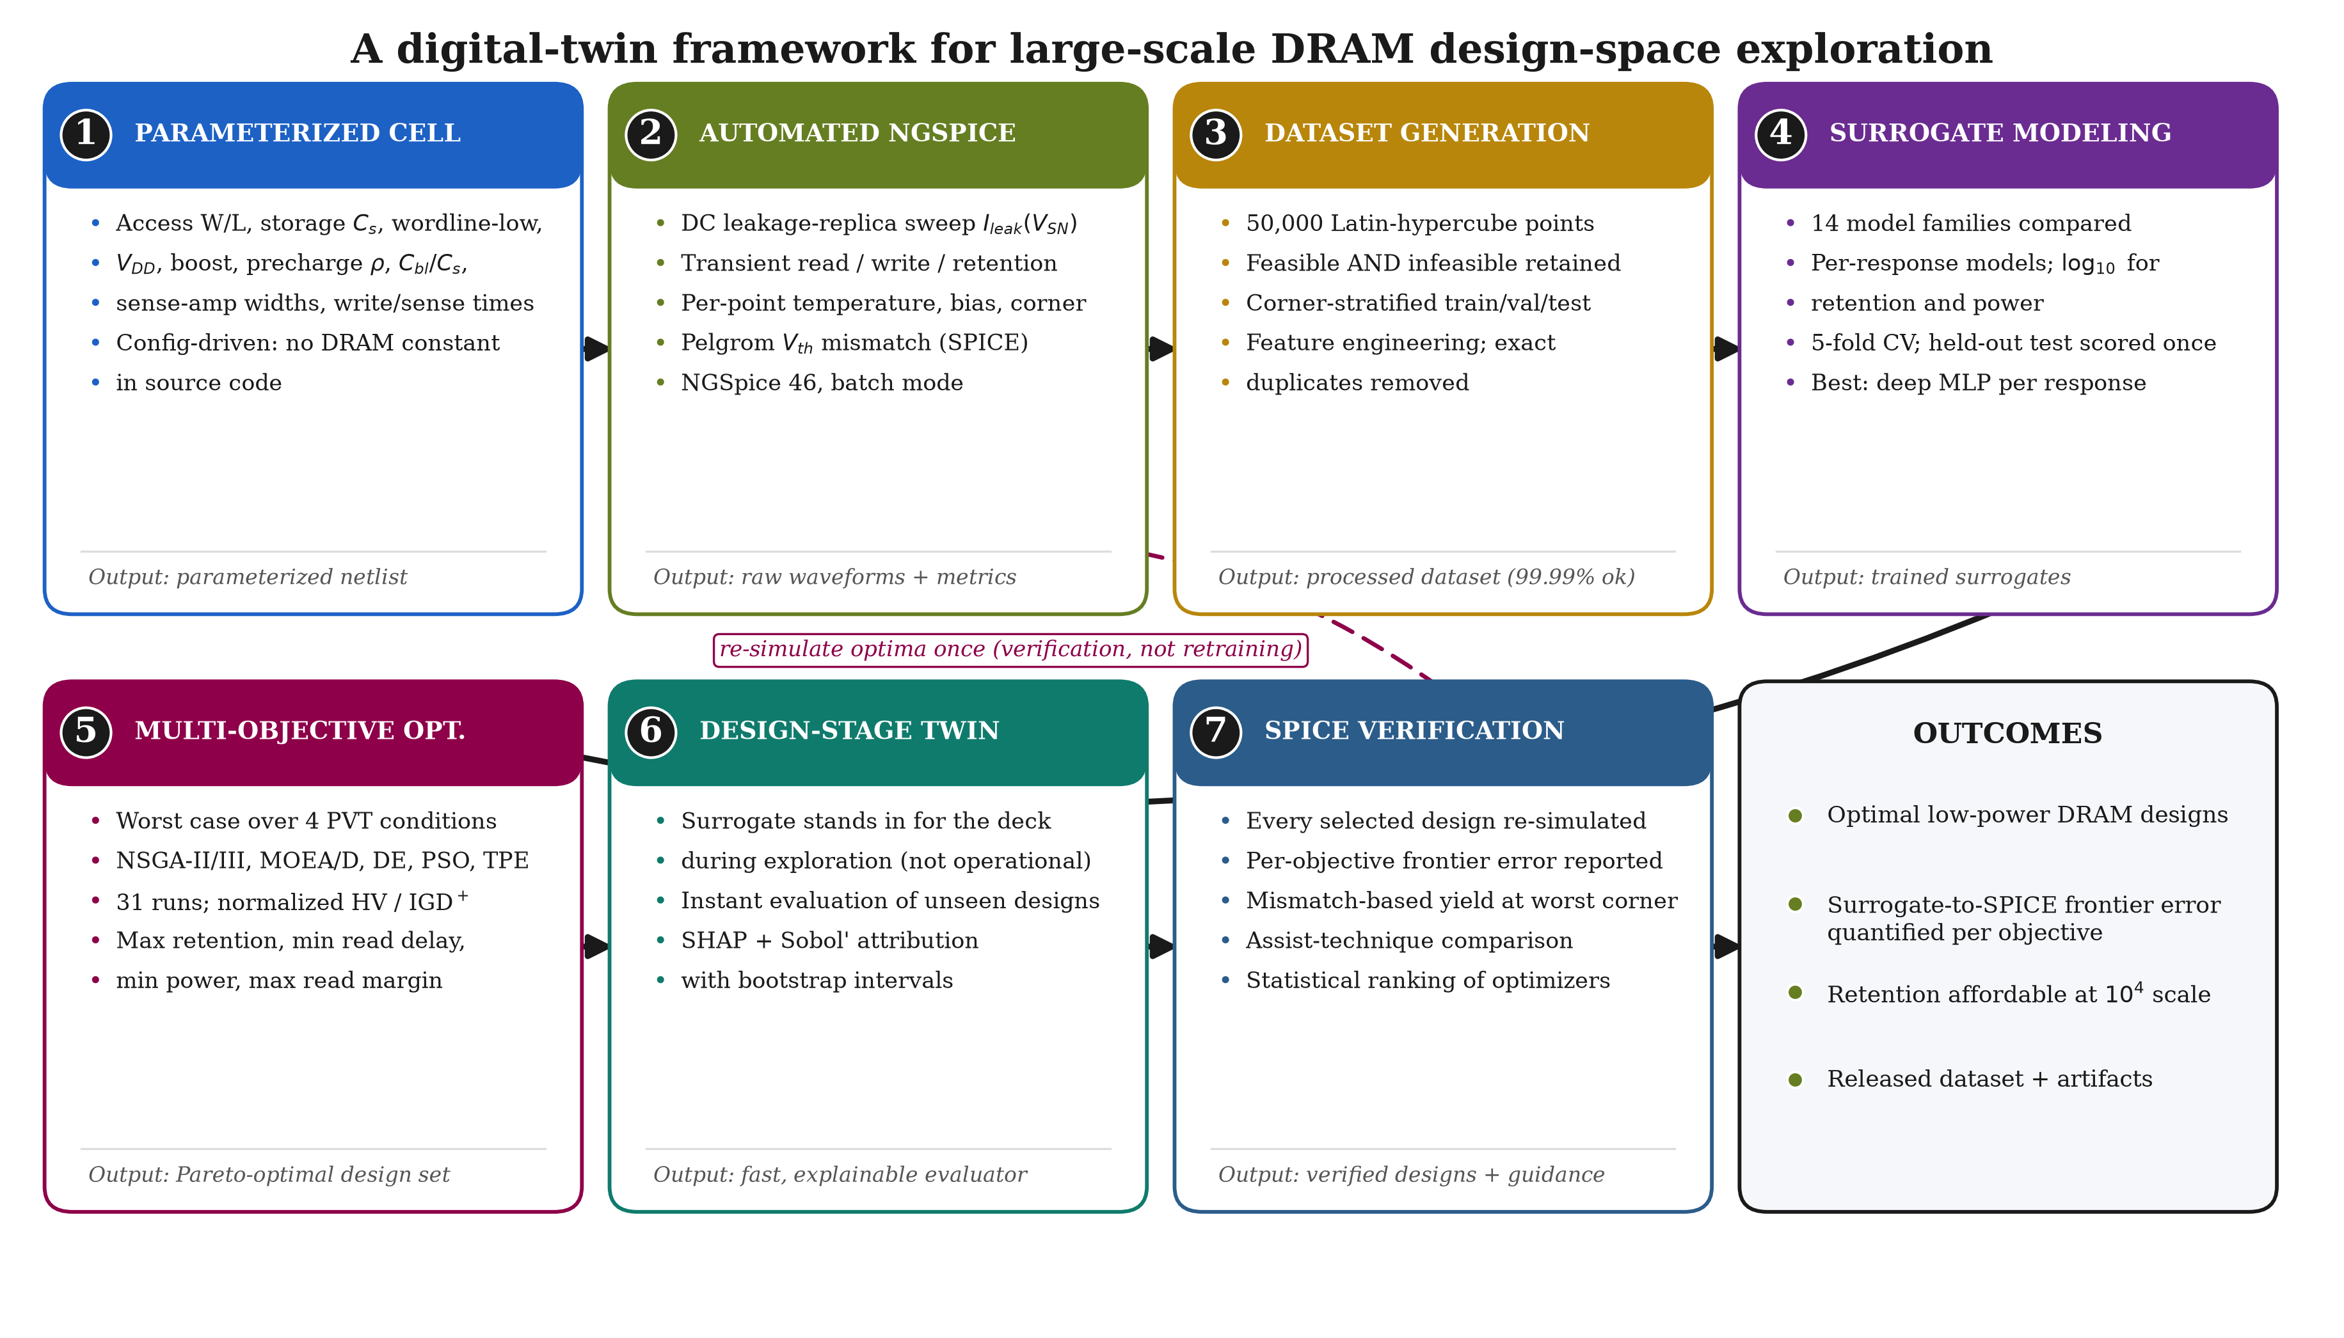
Figure 1. Overview of the proposed framework. Stages one to three produce a physically grounded dataset by automated SPICE characterization; stages four to six convert it into a deployable digital twin and use that twin for robust optimization; stage seven provides comparative and explanatory analysis. Optimizer outputs are returned to the deck once for SPICE verification, not fed back into training.

The simulated slice
Figure 2 is the circuit each simulation evaluates. Panel (a) shows one 1T1C cell with its column periphery at transistor level: the access device $M_{acc}$ connects bitline BL to storage node SN, the storage capacitor $C_{s}$ references a plate bias $V_{plate}$, each rail of the bitline pair carries a lumped capacitance $C_{BL}$, a CMOS transmission-gate write driver forces BL to the data level, a precharge and equalize network restores both rails to $V_{BLpre}$, and a cross-coupled NMOS/PMOS latch resolves the differential. Panel (b) shows the leakage replica: an access device identical to $M_{acc}$ whose storage node is driven by the probe source $V_{snp}$, so a DC sweep of that source yields $I_{leak}(V_{SN})$ in the same deck.
Two features follow from physics rather than choice, both established by simulation. The precharge pass devices are driven from a boosted rail VPP: with a $V_{DD}$ gate and a $V_{DD}/2$ target the overdrive falls below threshold and the rails cannot restore in time. Storing a full logic one requires
$V_{PP}>V_{DD}+V_{th,eff},$ (1)
where $V_{th,eff}$ is the access-device threshold raised by the storage-node body effect from its nominal $V_{th0}=0.62 \text{V}$ to about 0.85 V. It is $V_{th,eff}$, not the full right-hand side, that reaches 0.85 V; with $V_{DD}$ swept to 1.30 V the boosted rail must clear $V_{DD}+V_{th,eff}$, which is why the wordline-boost variable is swept to 1.2 V, spanning both the write-limited and fully-writing regimes.
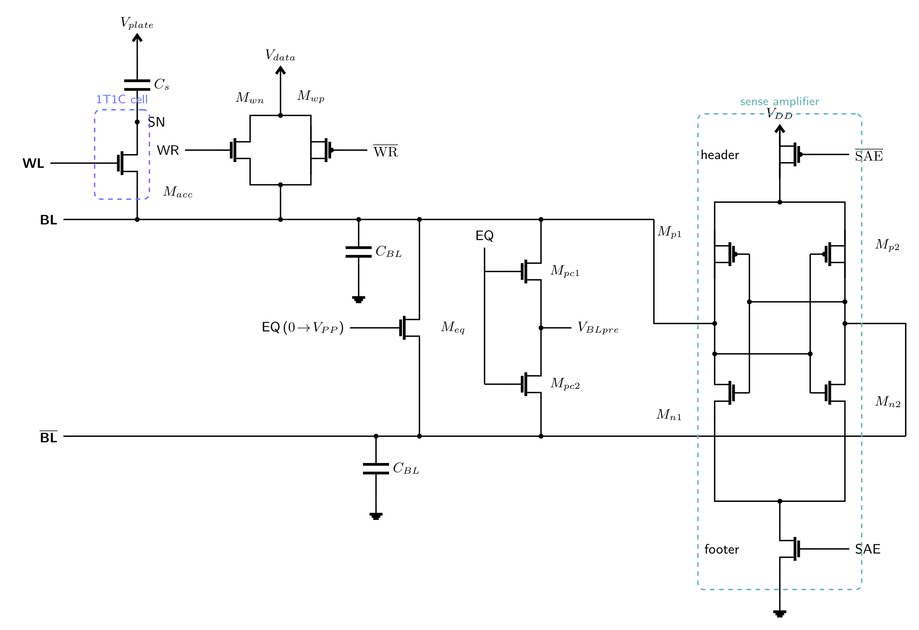
(a) Transistor-level schematic of the 1T1C cell and its column periphery; the sense amplifier is a cross-coupled latch whose device gates tie to the opposite rail.
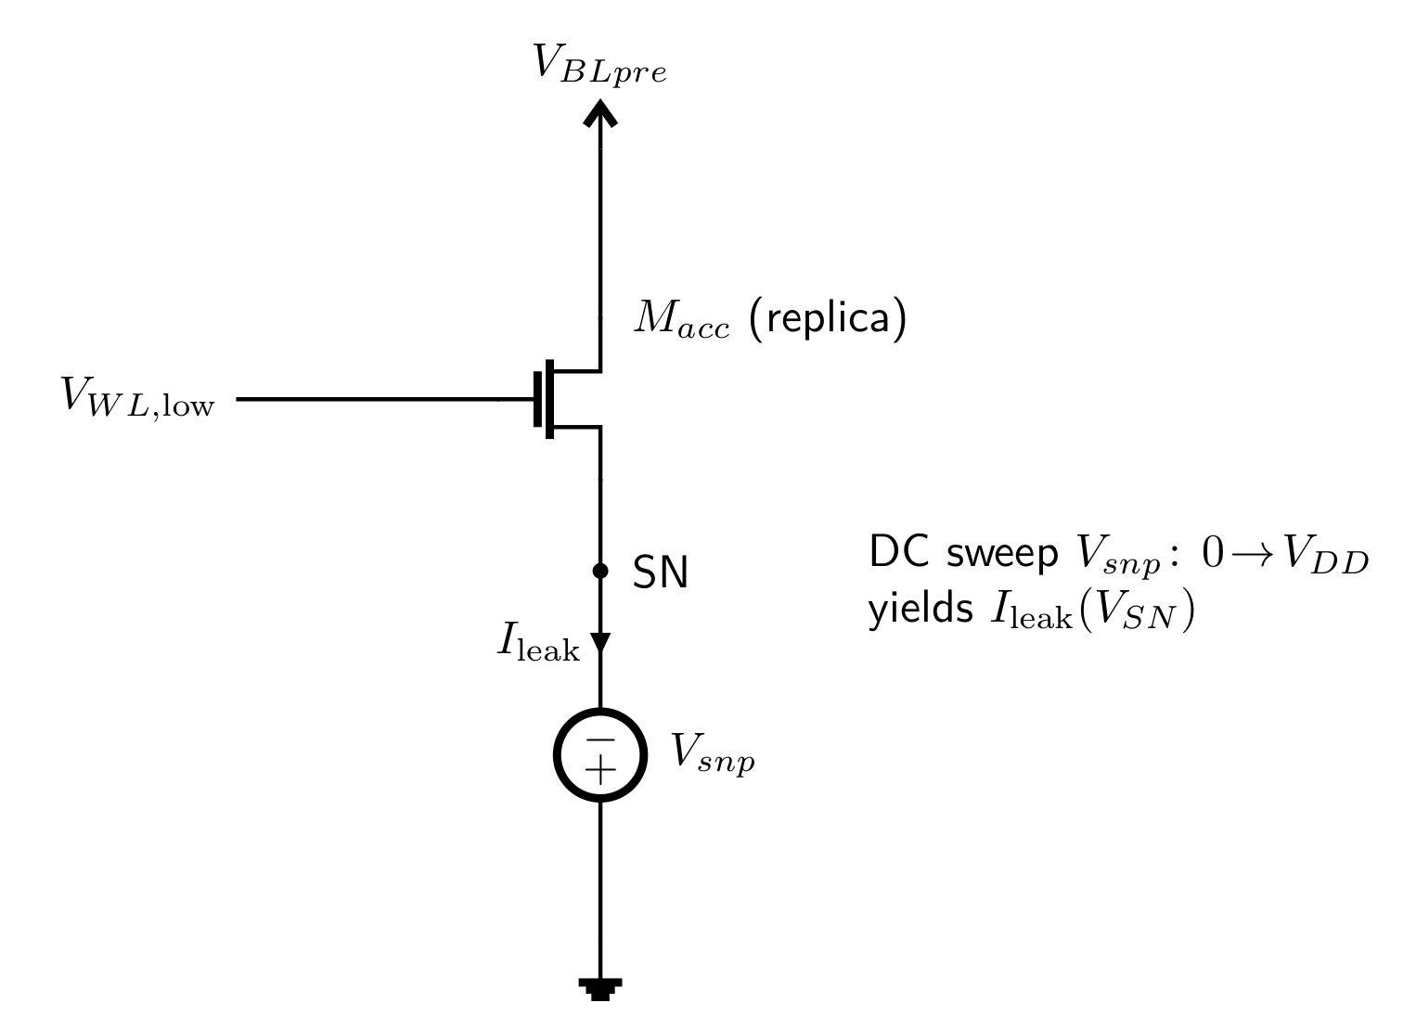
(b) Leakage replica: an access device identical to $M_{acc}$ probed by $V_{snp}$ so that a DC sweep returns $I_{leak}(V_{SN})$ in the same deck.
Figure 2. The simulated DRAM slice, drawn in CircuiTikz with American source symbols. (a) shows the cell and periphery and (b) the leakage replica.

The three-analysis deck
Each design point is evaluated by one NGSpice invocation containing three analyses (Algorithm 1). An operating-point analysis of the idle slice yields quiescent currents for standby power. A transient analysis executes the sequence in Figure 3: initial precharge, write of a logic one, precharge, charge sharing, then sense with restore. Finally a DC sweep of the replica probe yields the leakage characteristic. Figure 3 captures a real transient rather than a drawing: (a) the control signals WL, PRE and SAE; (b) the storage node charged to 1.09 V, held through precharge, falling to 0.64 V on charge sharing and restored by the amplifier; and (c) the bitline pair precharged to 0.55 V, developing a 92 mV differential that the latch drives to the rails.
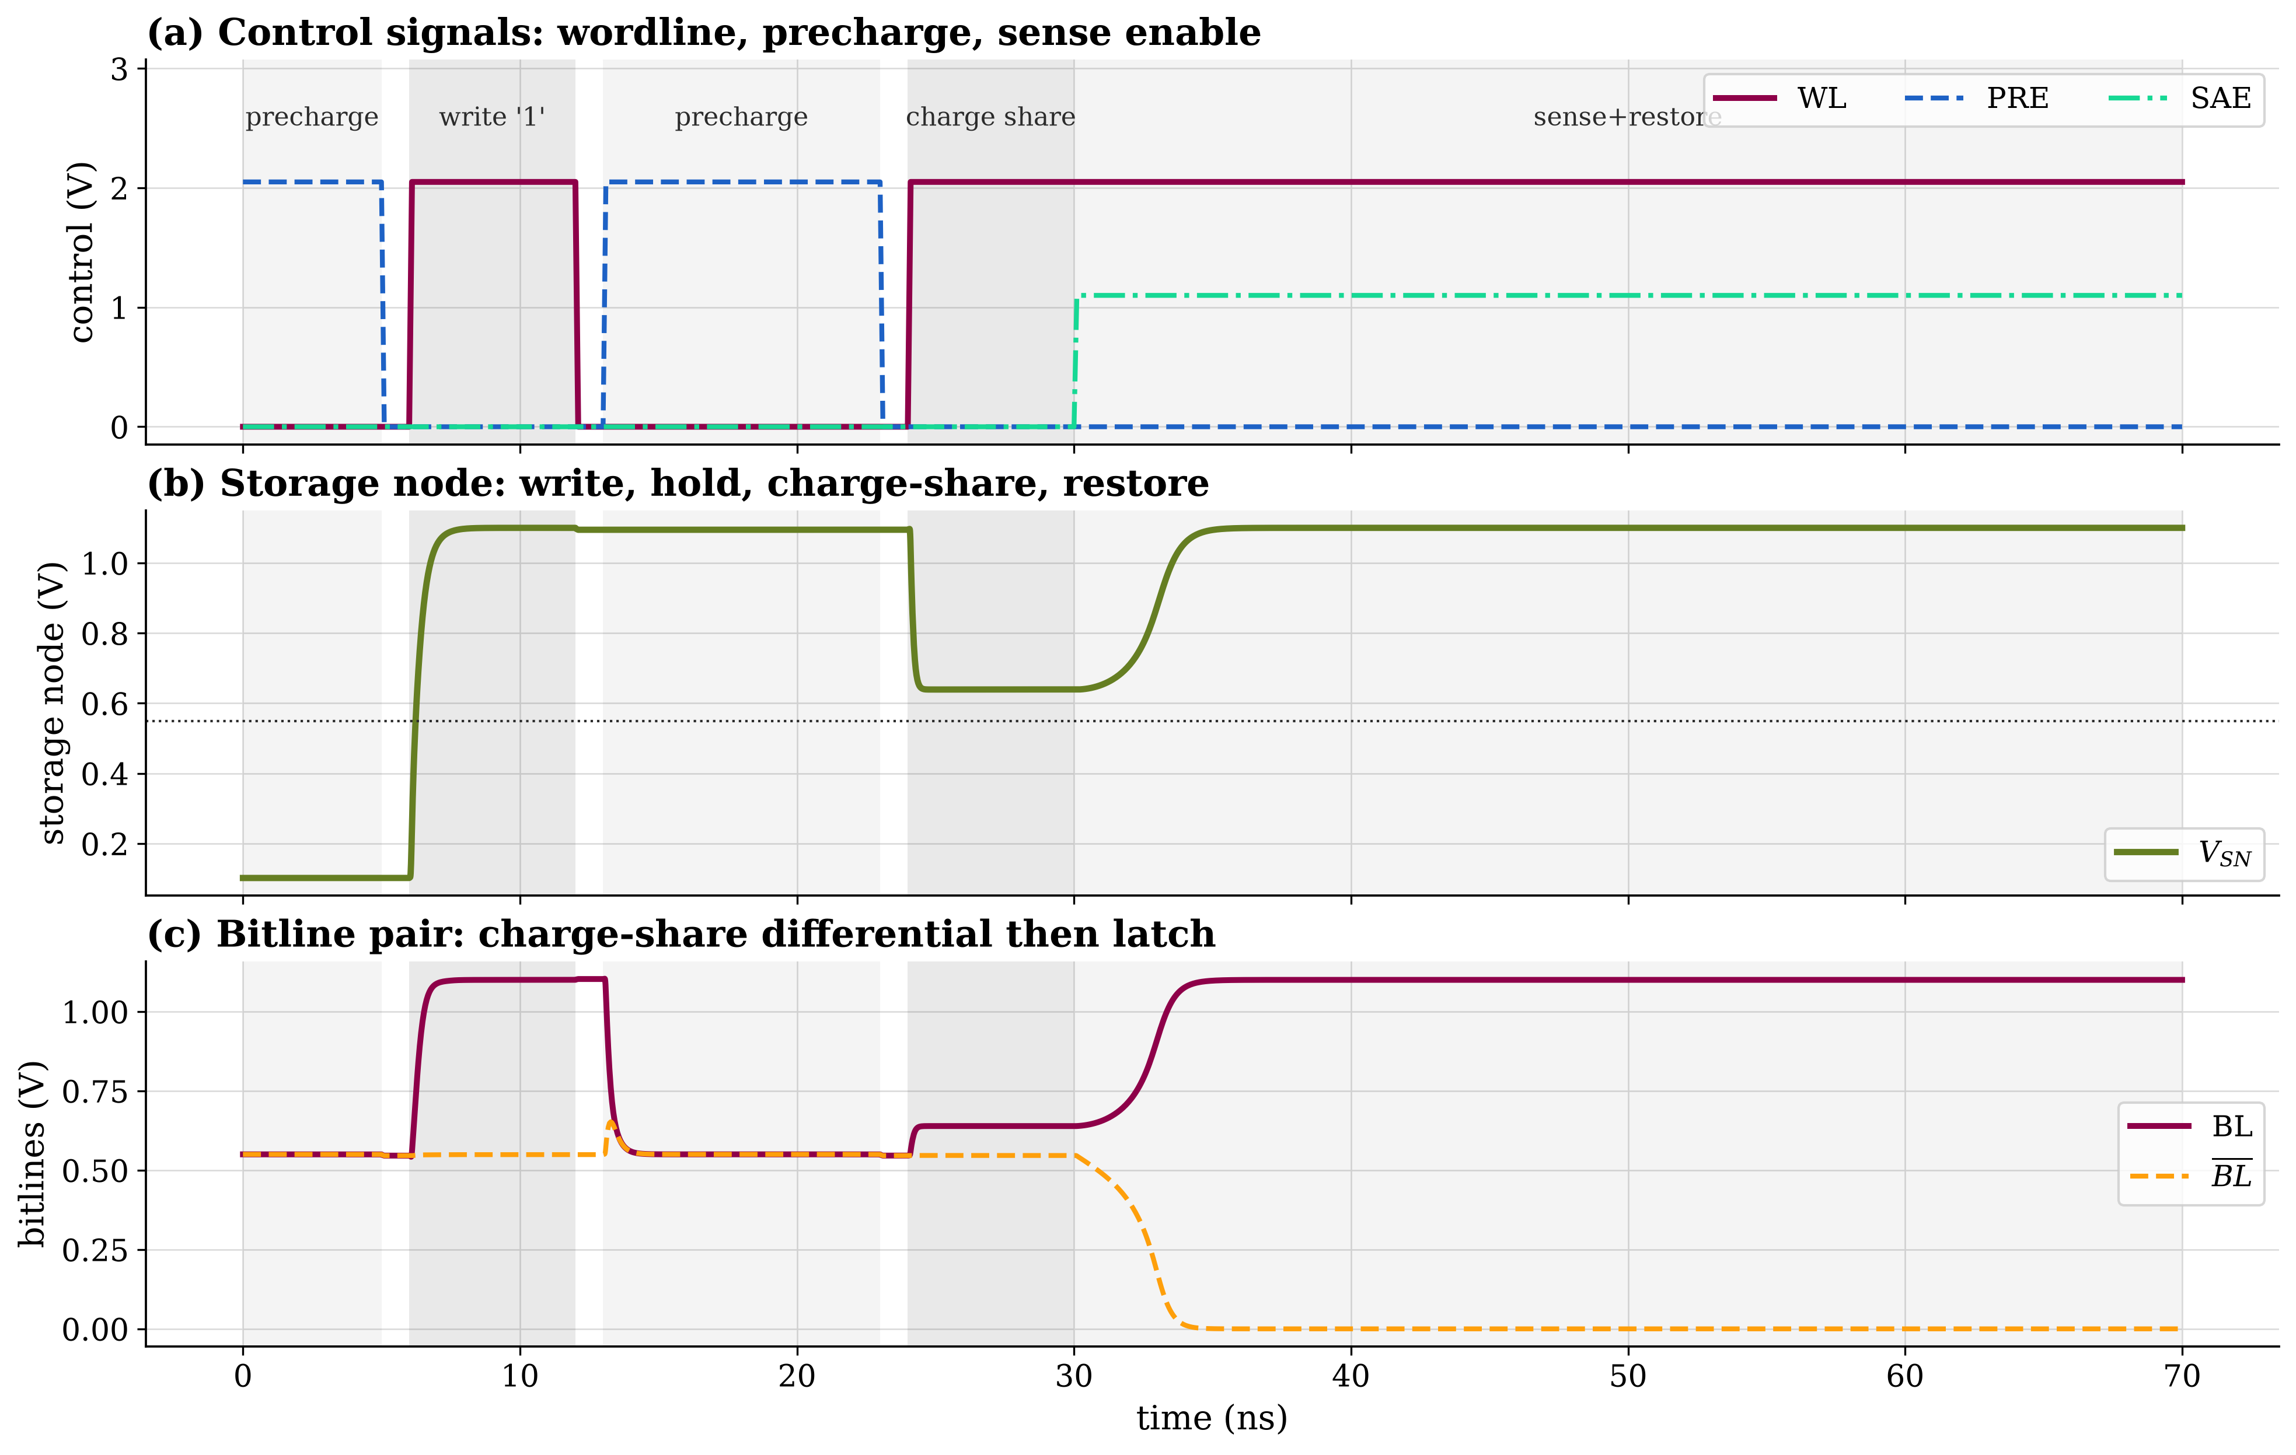
Figure 3. The characterization sequence, captured from a live NGSpice transient. (a) Control signals: wordline WL, precharge enable PRE and sense-amplifier enable SAE, with the five operation phases shaded, precharge, write of a logic one, precharge, charge share, and sense with restore, over a 70 ns window. (b) Storage node $V_{SN}$ through the write, charge share and sense–restore; the dotted line marks the plate bias. (c) The bitline pair; charge sharing produces the differential that the latch resolves.
A single solver tolerance cannot serve all three analyses: the transient resolves microampere currents while the leakage sweep resolves femtoampere currents. Tolerances are therefore set per analysis, and the same holds with greater force for GMIN, whose default of 1e-12 S injects hundreds of femtoamperes across the storage-node junctions, far above the leakage measured.

Algorithm 1. SPICE characterization of one DRAM design point
Require: design point $p$, technology $T$, timing schedule
Ensure: measurements $M$, leakage characteristic $I_{leak}(⋅)$
1: $C←T.CardFor(p.corner)$
2: emit cell, bitline pair, precharge/equalize, write driver, sense latch
3: emit leakage replica: device identical to $M_{acc}$, node driven by $V_{snp}$
4: Analysis 1 (operating point): solve idle state; record $i(V_{DD})$, $i(V_{BLpre})$
5: set transient tolerances (ABSTOL$={10}^{−13}$, GMIN$={10}^{−13}$)
6: Analysis 2 (transient): run schedule; measure $V_{SN}^{hold}$, $t_{write}$, $V_{BL}$, $V_{\overline{BL}}$, $t_{read}$, and $∫i_{DD} dt$
7: set DC tolerances (ABSTOL$={10}^{−18}$, GMIN$={10}^{−15}$)
8: Analysis 3 (DC sweep): sweep $V_{snp}:0→V_{DD}$; $I_{leak}(V)←− i(V_{snp})$

9: return $M$, $I_{leak}(⋅)$

Extracted quantities
Charge sharing between $C_{s}$ and $C_{BL}$ gives the bitline differential
$ΔV_{BL}=\left(V_{SN}−V_{BLpre}\right) \frac{C_{s}}{C_{s}+C_{BL}},$ (2)
used both as an independent check on the circuit and, inverted, to define the retention failure level. The read margin and read delay are read from the sense operation itself, not from Eq. (2). The read margin is the fully developed differential $v(bl)−v(blb)$ at the strobe time $t_{sa}$, after the cross-coupled latch has regenerated the small charge-sharing signal; it therefore exceeds the pre-sense ceiling of Eq. (2) by the latch gain and is the differential a column circuit actually resolves, which is why the constraint of 25 mV is placed on it rather than on $ΔV_{BL}$. The read delay is the interval from wordline assertion to the latch crossing a fixed fraction of its rail. Both are measured on the transient waveform and so carry the device nonlinearity that Eq. (2) omits. Access energy, Eq. (3), integrates the supply currents over each window,
$E_{read}=V_{DD}​\left|∫i_{DD} dt\right|+V_{BLpre}​\left|∫i_{pre} dt\right|, E_{access}=1/2\left(E_{read}+E_{write}\right),$ (3)
with the absolute values taken because a supply-current sign reflects the source reference, not the direction of energy flow. Power, Eq. (4), decomposes into a continuous leakage term, an access term proportional to the access rate, and a refresh term inversely proportional to the refresh interval,
$P_{total}=P_{standby}+E_{access}f_{access}+E_{read}/t_{refresh}.$ (4)
The refresh term couples power directly to retention, which is why the two cannot be treated as independent objectives. All three components are reported separately so results can be reweighted for a different access profile without re-simulation.

Design of experiments
The space is sampled by Latin hypercube sampling [53-54,61], which guarantees one sample per stratum in every one-dimensional projection: for $N$ samples in $d$ dimensions,
$|\{⌊Nu_{nj}⌋:n=1,…,N\}|=N ∀ j∈\{1,…,d\}.$ (5)
Each coordinate is decoded to its physical domain by its declared scale,
$p_{nj}=\left\{\begin{matrix}ℓ_{j}+u_{nj}(h_{j}−ℓ_{j}), & \text{linear}, \\ exp[lnℓ_{j}+u_{nj}(lnh_{j}−lnℓ_{j})], & \text{log}, \\ c_{⌊u_{nj}|C_{j}|⌋}, & \text{categorical},\end{matrix}\right.$ (6)
after which derived quantities are evaluated in declaration order, for example $V_{PP}=V_{DD}+V_{boost}$, $V_{BLpre}=ρV_{DD}$ and $C_{BL}=κC_{s}$ with $ρ,κ$ themselves sampled. Algorithm 2 states the procedure.

Algorithm 2. Configuration-driven sampling and decoding
Require: design space $D$, derived expressions $E$, constants $K$, count $N$, master seed $σ$
Ensure: physical design points $\{p^{(n)}\}$
1: $U←LatinHypercube(N,d,DeriveSeed(σ,\text{doe}))$ ▷ Eq. (5)
2: record centered-$L_{2}$ discrepancy and minimum pairwise distance
3: for $n←1$ to $N$ do
4: $p^{(n)}←K$; $p_{j}^{(n)}←Decode(u_{nj}) ∀j$ ▷ Eq. (6)
5: evaluate each $e∈E$ in declaration order
6: end for

7: return $\{p^{(n)}\}$

Process corners and mismatch
The Predictive Technology Model gives one typical card per node [62]. Slow/fast corners are synthesized by first-order shifts,
$V_{th0}^{′}=V_{th0}+sgn(V_{th0}) ΔV_{th0}, u_{0}^{′}=αu_{0}, t_{ox}^{′}=βt_{ox},$ (7)
where the shift acts on the magnitude of each device threshold: a positive $ΔV_{th0}$ slows the device by enlarging $|V_{th0}|$ and a negative value speeds it, the device polarity $sgn(V_{th0})$ merely steering the shift so one table entry has the intended effect on both NMOS and PMOS. Table 3 states the four synthesized corners in full; TT is the unmodified card. Local mismatch uses the Pelgrom model [63],
$σ_{V_{th}}=\frac{A_{VT}}{\sqrt{WL}},$ (8)
applied per device through the BSIM4 instance parameter delvto. Equation (7) shifts every device in a sample together (global variation) while Eq. (8) perturbs each independently (local mismatch).
Table 3. The four synthesized process corners. $ΔV_{th0}$ is the shift added to $|V_{th0}|$ ($+$ slower, $−$ faster); $u_{0}$ and $t_{ox}$ entries are multiplicative. TT is the unmodified PTM card. The recipe is first-order and is not a foundry-signed-off corner model.
 | NMOS |  |  |  | PMOS
Corner | $Δ|V_{th0}|$ | $u_{0}$ | $t_{ox}$ |  | $Δ|V_{th0}|$ | $u_{0}$ | $t_{ox}$
TT | – | 1.00 | 1.00 |  | – | 1.00 | 1.00
SS | $+45$mV | 0.95 | 1.02 |  | $+45$mV | 0.95 | 1.02
FF | $−45$mV | 1.05 | 0.98 |  | $−45$mV | 1.05 | 0.98
SF | $+45$mV | 0.95 | 1.00 |  | $−45$mV | 1.05 | 1.00
FS | $−45$mV | 1.05 | 1.00 |  | $+45$mV | 0.95 | 1.00

4. Quasi-Static Retention Modeling

Formulation
Once the wordline is low, the storage node is an isolated capacitor, so charge conservation is exact,
$C_{node} \frac{dV_{SN}}{dt}=− I_{leak}(V_{SN}).$ (9)
Equation (9) involves no approximation; the entire difficulty of retention is that integrating it in time needs a ten-decade transient. Because $I_{leak}$ depends only on $V_{SN}$, the equation is separable, and integrating between the written level and the failure level eliminates time and gives retention in closed form,
$t_{ret}=\int_{V_{fail}}^{V_{init}}{\frac{C_{node}}{I_{leak}(V)}} dV$ (10)
Equation (10) carries one physical assumption, that leakage is quasi-static, which holds because the discharge is far slower than every device time constant, together with one modeling boundary: $I_{leak}$ is the current the access-device compact model reports, so every mechanism that model describes is included, while dielectric leakage of the storage capacitor, for which the deck carries no compact model, is not. Retention here is therefore an access-device-limited estimate. Within that boundary the method assumes nothing about the magnitude or dominant mechanism of leakage, both of which are measured rather than posited. The failure level is derived from the sense-margin specification rather than assumed directly: a cell fails when charge sharing can no longer resolve a differential, so setting $ΔV_{BL}=ΔV_{min}$ in Eq. (2) gives
$V_{fail}=V_{BLpre}+ΔV_{min} \frac{C_{s}+C_{BL}}{C_{s}}, t_{refresh}=t_{ret}/γ,$ (11)
with $γ$ a policy guard band. The refresh interval booked against a design is thus $t_{ret}/γ$; at the $γ=2$ used throughout, sustaining the JEDEC 64 ms refresh interval requires $t_{ret}≥128 \text{m}\text{s}$, whereas the yield criterion of \S6 applies the weaker floor $t_{ret}≥64 \text{m}\text{s}$, that is, the bit survives at least one nominal refresh period. If $V_{init}≤V_{fail}$ the write already fails and $t_{ret}=0$, a real observation rather than a missing value; if $I_{leak}$ falls to the leakage floor $ϵ_{I}=1 × {10}^{−21} \text{A}$ anywhere in the range, a numerical guard against division by zero that the node's leakage never physically reaches, the node holds the bit indefinitely within that bias condition and the observation is right-censored. This floor test, $minI_{leak}≤ϵ_{I}$, is the condition applied in Algorithm 3.

What is measured
The DC sweep supplies $I_{leak}(V_{SN})$ containing every mechanism the access-device compact model describes,
$I_{leak}(V_{SN})=I_{sub}+I_{GIDL}+I_{junc}+I_{gate}.$ (12)
The card enables gate tunneling, the junction diode model and non-zero GIDL coefficients, so no access-device term is omitted. The method does not need the terms separated, since the sweep returns their sum, exactly what Eq. (10) requires; Eq. (12) matters because it confirms nothing is excluded and explains the measured shape. The subthreshold and GIDL terms have the familiar forms
$I_{sub}∝exp​\left({V_{gs}−V_{th}}/{nk_{B}T/q}\right)\left[1−exp​\left(−{V_{ds}}/{k_{B}T/q}\right)\right],$ (13)
$I_{GIDL}=A_{GIDL}W \frac{V_{ds}−V_{gs}−E_{GIDL}}{t_{ox}}exp​\left({−B_{GIDL}t_{ox}}/{V_{ds}−V_{gs}−E_{GIDL}}\right),$ (14)
the second of which explains why a negative wordline is not unambiguously good: driving $V_{gs}$ negative suppresses Eq. (13) but raises the numerator and exponent of Eq. (14).
Figure 4 presents the measured characteristic and the model validation. Panel (a) gives $I_{leak}(V_{SN})$ at six temperatures. Panel (b) plots the leakage at the written level against $1/k_{B}T$. Above about 55 °C it rises steeply with an extracted activation energy of 1.31 eV, close to the silicon bandgap and therefore consistent with diffusion-limited junction leakage where $n_{i}^{2}∝exp(−E_{g}/k_{B}T)$; this hot, thermally activated regime is where retention is set. Below room temperature the curve flattens, but that plateau is not physical: at the campaign solver floor (DC $\text{GMIN}={10}^{−15} S$) it sits at 1.6 fA, and the $\text{GMIN}$ sweep of panel (f) shows this value tracking $1/\text{GMIN}$ rather than any device parameter, the ohmic signature $k/\text{GMIN}≈1.2$ of the solver's minimum-conductance injection. Converging the floor to ${10}^{−17} S$ lowers the cold leakage to 0.56 fA; at 125 °C, by contrast, $k/\text{GMIN}=5.9×{10}^{3}$ and the leakage is unchanged to within 2%, so the design-relevant hot corner is physical and floor-independent. Panel (c) shows the integrand $C_{node}/I_{leak}$ of Eq. (10), whose area is the retention time; retention runs from tens of seconds at the cold, floor-limited end to 1.9 ms at 125 °C. Panels (d) and (e) validate the model across its full working range: pooling 200 short-retention points with 30 points carried out to 25 s by coarse-step transient integration (Table 4), the quasi-static prediction matches direct transient simulation with $r=0.99992$ over roughly six and a half decades, 100% within a factor of two, and a median error of $−0.011$ decades. The slight systematic under-prediction is consistent with neglecting the voltage-dependent parasitic capacitance of the access device.
The numerical floor touches only the cold end, and no reported result depends on it. The retention objective is worst-cased over the conditions $Q$, whose binding member is always the hot corner (0.13 s at 85 °C, 1.9 ms at 125 °C), orders of magnitude below the cold values; and the 64 ms criterion is met at 27 °C with wide margin whether the cold leakage reads \num{0.56} or 1.6 fA. The floor is therefore bounded, labelled and non-binding rather than removed at the cost of regenerating the entire campaign.
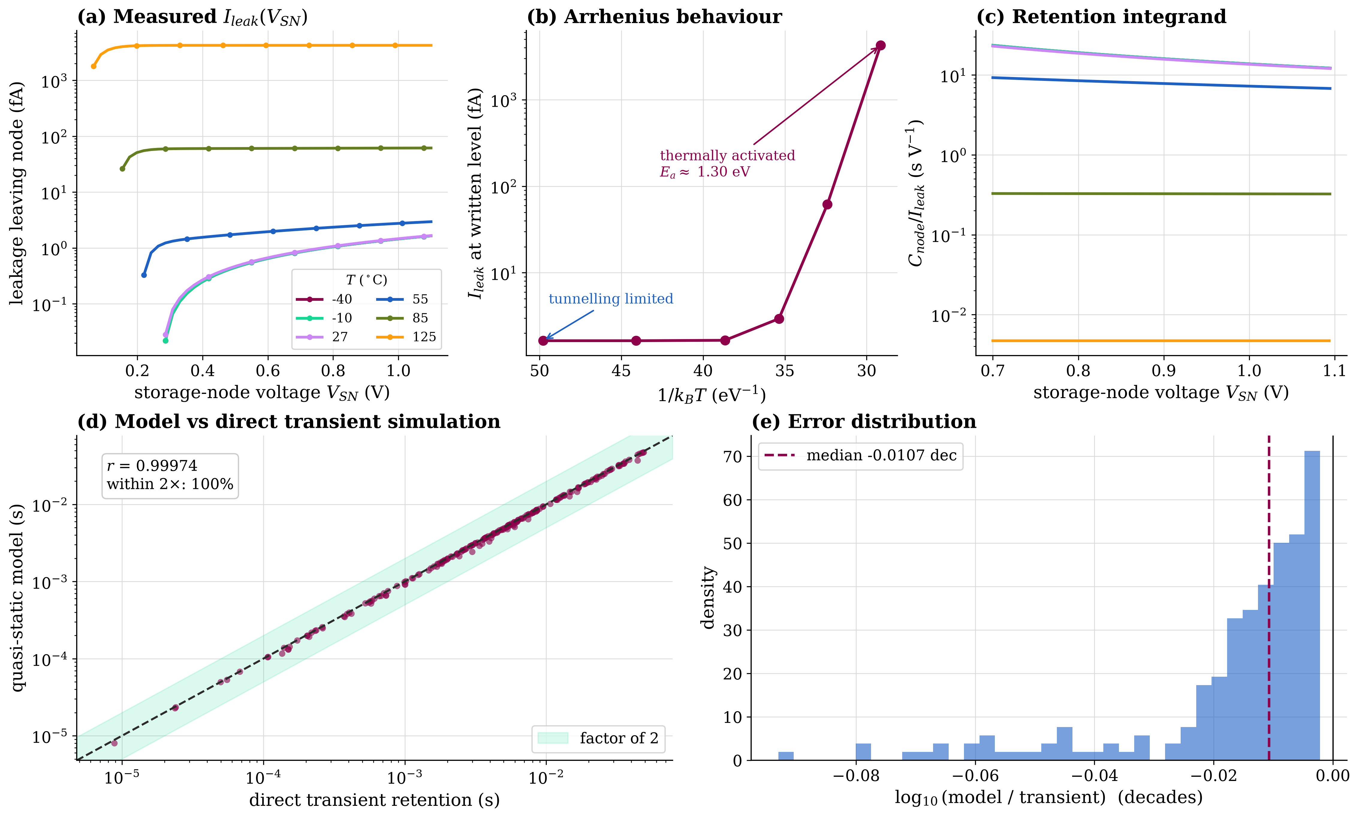
Figure 4. Measured storage-node leakage and validation of the quasi-static model. (a) $I_{leak}(V_{SN})$ at six temperatures at the converged floor. (b) Leakage at the written level against $1/k_{B}T$: a thermally activated regime with $E_{a}≈1.31 \text{eV}$ and a low-temperature plateau set by the solver floor rather than the device (see (f)). (c) The retention integrand $C_{node}/I_{leak}$ of Eq. (10). (d) Quasi-static prediction against direct transient simulation over the full working range, short points plus a long-retention set out to 25 s; the shaded band is a factor of two. (e) Distribution of the $\log_{10}$ ratio between the two. (f) Convergence of the written-level leakage as DC $\text{GMIN}$ is swept from ${10}^{−14}$ to ${10}^{−18} S$: the cold curves track $1/\text{GMIN}$ (numerical), the 125 °C curve is flat (physical).
Table 4. Quasi-static retention against direct transient simulation, matched on identical designs, split by retention range. The pooled set spans the model's full working range.
Range | $n$ | $r_{\log_{10}}$ | median err (dec) | $p_{90}|$err$|$ (dec) | within $2×$
short ($≈$9 \textmu s–49 ms) | 200 | 0.99974 | $−0.0107$ | 0.044 | 100%
long (1.05–25.2 s) | 30 | 0.99980 | $−0.0077$ | 0.021 | 100%
pooled ($≈$6.5 decades) | 230 | 0.99992 | $−0.0106$ | 0.037 | 100%

Algorithm 3 states the computation: the integral is evaluated by trapezoidal quadrature on a uniform grid, adequate because $I_{leak}$ is smooth and strictly positive over the range whenever the design is feasible.

Algorithm 3. Quasi-static retention from measured leakage
Require: $I_{leak}(⋅)$, $C_{node}$, $V_{init}$, $V_{BLpre}$, $C_{s}$, $C_{BL}$, $ΔV_{min}$, grid $N_{g}$, leakage floor $ϵ_{I}=1 × {10}^{−21} \text{A}$
Ensure: retention $t_{ret}$ and censoring flag
1: $V_{fail}←V_{BLpre}+ΔV_{min}(C_{s}+C_{BL})/C_{s}$ ▷ Eq. (11)
2: if $V_{init}≤V_{fail}$ then
3: return $t_{ret}←0$ (not censored)
4: end if
5: $V←$ grid of $N_{g}$ points on $[V_{fail},V_{init}]$; $I←Interp(I_{leak},V)$
6: if $minI≤ϵ_{I}$ then
7: return $t_{ret}←∞$ (censored)
8: end if

9: return $t_{ret}←Trapezoid(C_{node}/I,V)$ ▷ Eq. (10)

5. Experimental Setup
Table 5 lists the 15 sampled variables; thirteen are design variables and two are operating conditions treated separately during optimization. Table 6 states the technology and solver configuration.
Table 5. The sampled design space. Thirteen design variables plus two operating conditions.
Variable | Group | Lower | Upper | Unit | Scale
$V_{DD}$ | design | 0.70 | 1.30 | V | linear
$V_{boost}$ | design | 0.30 | 1.20 | V | linear
$V_{WL,low}$ | design | $−0.40$ | 0.00 | V | linear
$ρ$ (BL precharge) | design | 0.35 | 0.65 | 1 | linear
$C_{s}$ | design | 5.0 | 40.0 | fF | log
$κ$ ($C_{BL}/C_{s}$) | design | 2.0 | 12.0 | 1 | linear
$W_{acc}$ | design | 60 | 220 | nm | linear
$L_{acc}$ | design | 45 | 120 | nm | linear
$W_{san}$ | design | 90 | 540 | nm | log
$W_{sap}/W_{san}$ | design | 1.0 | 3.0 | 1 | linear
$W_{en}/W_{san}$ | design | 1.0 | 4.0 | 1 | linear
$t_{wr}$ | design | 1.0 | 10.0 | ns | linear
$t_{sense}$ | design | 1.0 | 10.0 | ns | linear
$T$ | condition | $−40$ | 125 | °C | linear
corner | condition | {TT, SS, FF, SF, FS} |  |  | set

Table 6. Technology, solver and campaign configuration.
Item | Value
Simulator | NGSpice 46 (console build), batch mode [64]
Device models | PTM BSIM4 level 54, 45 nm low-power [62]
Enabled leakage physics | gate tunneling, junction diode, non-zero GIDL
Corners | TT/SS/FF/SF/FS; $ΔV_{th0}=±45 \text{m}\text{V}$, $u_{0}(1±0.05)$, $t_{ox}(1∓0.02)$
Transient tolerances | ABSTOL$={10}^{−13}$, GMIN$={10}^{−13}$
DC tolerances | ABSTOL$={10}^{−18}$, GMIN$={10}^{−15}$
Sense offset $ΔV_{min}$ / refresh guard $γ$ | 25 mV / 2.0
Sampler | Latin hypercube, $N=50,000$, $d=15$
Master seed / configuration hash | 20260723 / 954478d4cad7f9d6
Parallelism | 18 worker processes

Table ef{tab:config} lists the objectives, constraints, operating conditions and load-bearing constants, and Table ef{tab:nomen} the principal symbols; no value used below is left implicit.
Table 7. Objectives, constraints, operating conditions and the load-bearing constants of the study, complementing the technology and solver settings of Table 6 and the variables of Table 5. Every value is an explicit configuration entry, not a hidden constant; together the three tables and the released configuration reproduce each result.
Symbol / item | Value | Role
Objectives (worst case over the conditions $Q$)
$t_{ret}$ (retention) | maximize ($\log_{10}$) | Eqs. (9)–(10)
$t_{rd}$ (read delay) | minimize | timing budget
$P_{total}$ (power) | minimize ($\log_{10}$) | Eq. (4)
read margin | maximize | developed SA differential
Constraints (thresholds $τ_{s}$)
read margin | $≥25 \text{m}\text{V}$ | exceeds SA offset
write efficiency | $≥0.85$ | $V_{SN}/V_{DD}$
read delay | $≤30 \text{n}\text{s}$ | inside timing budget
retention (yield spec) | $≥64 \text{m}\text{s}$ | JEDEC refresh budget
Operating conditions $Q$ (4 PVT points)
$Q$ | {(27,TT),(85,SS),(125,SS),(85,FF)} | ($​^{∘}$C, corner)
Physical / metric constants
$ΔV_{min}$ | 25 mV | sense offset + guard (Eq. 11)
$γ$ (refresh guard) | 2.0 | $t_{refresh}=t_{ret}/γ$
$f_{access}$ | 1e5 Hz | active-power access rate
$C_{node}$ | $C_{s}$ (+overhead $0$) | storage-node capacitance
$V_{plate}$ | $ρV_{DD}$ ($≈0.55 \text{V}$ nom.) | cell-plate bias
$V_{init}$ | $V_{SN}^{hold}$ (written level) | integration upper limit
retention grid $N_{g}$ | 2001 | quadrature points
leakage floor $ϵ_{I}$ | 1e-21 A | censoring guard (Alg. 3)
log floor $ϵ_{t}$ | 1e-12 s | floors $t_{ret}$ before $\log_{10}$
Selection and mismatch
selection weights | [0.30, 0.25, 0.30, 0.15] | ret/delay/power/margin
$A_{VT}$ (Pelgrom) | 3.5 mVmicrom | Eq. (8)
mismatch $σ_{V_{th}}$ | $A_{VT}/\sqrt{WL}$, per device | Eq. (8)
process sigmas | $σ_{C_{s}}=σ_{C_{BL}}=0.05$; $σ_{W}=0.04$; | robustness
 | $σ_{V_{DD}}=σ_{V}=0.02$ | (relative)
Analysis
Sobol' base $N$ | 2048; $B=500$ bootstrap | [65]
SHAP estimator | Kernel/Deep SHAP [56] | neural twin

Table 8. Nomenclature of the principal symbols.
Symbol | Meaning | Symbol | Meaning
$V_{SN}$ | storage-node voltage | $I_{leak}$ | node leakage current
$C_{node}$ | storage-node capacitance | $C_{s}$ | storage capacitance
$C_{BL}$ | bitline capacitance ($=κC_{s}$) | $κ$ | $C_{BL}/C_{s}$ ratio
$V_{init}$ | written level ($V_{SN}^{hold}$) | $V_{fail}$ | retention failure level
$V_{BLpre}$ | bitline precharge ($=ρV_{DD}$) | $ρ$ | precharge ratio
$V_{PP}$ | boosted wordline rail | $ΔV_{min}$ | min. resolvable differential
$W_{acc},L_{acc}$ | access-device width/length | $W_{san}$ | SA NMOS width
$W_{sap}$ | SA PMOS width | $W_{en}$ | SA enable width
$t_{ret}$ | retention time | $t_{refresh}$ | refresh interval
$A_{VT}$ | Pelgrom mismatch coeff. | $σ_{V_{th}}$ | threshold mismatch
$S_{j},S_{Tj}$ | first/total Sobol' index | $ϕ_{j}$ | SHAP attribution
$Q$ | PVT condition set | $R$ | reference front

Model comparison uses five-fold cross-validation over a train-plus-validation partition stratified by corner; the test partition is scored once and never used for selection. Fourteen families are compared: linear (ridge, elastic net, quadratic ridge), neighbor and kernel ($k$-nearest neighbors, support-vector regression, Gaussian process), bagged ensembles (random forest, extremely randomized trees), gradient boosting (histogram GBR, XGBoost [66], LightGBM [67], CatBoost [68]) and neural networks (two-layer and three-layer perceptrons), all implemented on scikit-learn [69]. Because a few learners have super-linear cost, the cross-validated comparison uses a capped 15,000-row subsample while the selected model is refitted on the full development set. Quality is reported by the coefficient of determination and error magnitudes of Eq. (15),
R2=1−i​(yi−yi)2i​(yi−y)2, RMSE=1ni​(yi−yi)2, (15)
both being needed since a high $R^{2}$ on a wide-ranging response can hide a large absolute error, as occurs for retention.
Optimization treats temperature and corner as conditions. For a candidate $x$ over condition set $Q$ each objective is reduced pessimistically,
$f_{j}^{wc}=\min_{q∈Q}f_{j}(x,q) \text{(maximized objective)},$ (16)
$f_{j}^{wc}=\max_{q∈Q}f_{j}(x,q) \text{(minimized objective)},$ (17)
so a candidate is only as good as its worst corner. Objectives are cast to a pure minimization by $F_{j}=s_{j}f_{j}^{wc}$ with $s_{j}=+1$ (minimize) or $−1$ (maximize), and constraints are threshold-normalized in the convention $g≤0$,
$g_{c}(x)=\left\{\begin{matrix}(τ_{c}−y_{c})/|τ_{c}|, & \text{lower bound}, \\ (y_{c}−τ_{c})/|τ_{c}|, & \text{upper bound}.\end{matrix}\right.$ (18)
Six optimizers are compared: NSGA-II [70], NSGA-III [71], MOEA/D [72], differential evolution [73], particle-swarm optimization [74] and multi-objective Bayesian optimization with a tree-structured Parzen estimator [75], implemented in Optuna [76]; the evolutionary methods through pymoo [77]. The two single-objective methods use an augmented Tchebycheff scalarization,
gtch(x∣w,z*)=maxjwj|Fj−zj*|+𝜚j​wj|Fj−zj*|, (19)
whose first term reaches non-convex fronts and whose second, weighted by the augmentation coefficient $ρ=0.05$, removes the weakly optimal points the plain Tchebycheff function would admit. Rather than search toward one weighted point, each scalarizing method is run as a decomposition over a set of uniformly spread weight vectors $w$ on the unit simplex, with the non-dominated archive pooled across subproblems, so it too returns a front and is compared on the same footing as the population methods; the ideal point $z^{*}$ is estimated from a space-filling probe of the domain and charged against the budget, so no method gains an accounting advantage. Every algorithm receives a budget of 1,500 candidate evaluations per run (a population of 100 over 15 generations) and 31 independent runs. Front quality uses hypervolume and the Pareto-compliant IGD$​^{+}$ of Eq. (20),
HV(P,r)=Λ​⋃f∈P[f,r], IGD+=1|R|z∈R​minf∈Pj​(max{fj−zj,0})2, (20)
with $R$ the non-dominated union of all runs. The two answer different questions: hypervolume rewards coverage, IGD$​^{+}$ rewards proximity, so an algorithm can rank last on one and first on the other.
Algorithms 4 and 5 state the optimization and robustness procedures. Robustness reports the joint Monte-Carlo yield
Y=1Mm=1Ms∈S​1[ ys(m) meets τs ], (21)
the fraction meeting every specification simultaneously, not the product of marginals. Variance-based sensitivity uses the Saltelli estimator [65] with first-order and total indices $S_{j}$ and $S_{Tj}$, whose gap $S_{Tj}−S_{j}$ is the interaction share; attribution uses SHAP in its unified formulation [56], estimated here with the model-agnostic Kernel SHAP variant because the selected twins are neural rather than tree models, together with accumulated local effects (ALE) [58], which stay valid under the correlated derived variables where partial dependence does not. Optimizer comparisons use the Friedman test with the Nemenyi critical difference and Holm-corrected Wilcoxon tests, reporting effect size as Cliff's delta.

Algorithm 4. Robust surrogate-driven multi-objective optimization
Require: twin $F$, objectives with senses, constraints, conditions $Q$, budget $B$, runs $R$, algorithms $A$
Ensure: Pareto set $R$ and indicator distributions
1: for all $a∈A$, $r∈\{1,…,R\}$ do
2: while budget $B$ remains do
3: get population $X$ from $a$; evaluate $F$ on $X×Q$ in one batched call
4: reduce over $Q$ (Eqs. 16, 17); apply $F_{j}=s_{j}f_{j}^{wc}$ and $g_{c}$ (Eq. 18)
5: end while
6: record $P_{a,r}$
7: end for
8: $R←NonDominated(⋃P_{a,r})$; compute HV, IGD$​^{+}$, spacing, spread per run

9: return $R$, indicators

Algorithm 5. Robustness and yield with SPICE verification
Require: design $x^{⋆}$, process sigmas, specs, trials $M$, verification subset $M_{v}$
Ensure: joint yield $Y$, worst-case corner, twin-versus-SPICE agreement
1: draw $x^{(m)}=x^{⋆}(1+ε)$, $ε_{p}∼N(0,ς_{p}^{2})$; $Y←F(\{x^{(m)}\})$
2: $Y←$ fraction meeting all specs (Eq. 21)
3: evaluate $x^{⋆}$ over the corner-temperature grid; record the worst case per spec
4: re-simulate $M_{v}$ trials in NGSpice; report $|Y_{twin}−Y_{SPICE}|$

5: return $Y$, worst case, agreement

6. Results and Analysis

Campaign, dataset and validation
The campaign dispatched 50,000 NGSpice evaluations in 3393.5 s (56.6 min) on 18 workers, 14.7 per second. One deck failed to return a result, so 49,999 ran to completion, a solver success rate of 99.998%. Completeness at the row level is a stricter test: a row is kept only if the deck also converged and every required metric is present. Preprocessing removed 13 of the 50,000 rows on that criterion, the one hard failure together with three that ran but did not converge and nine that returned with a metric missing, leaving 49,987 rows in 84 columns. The Latin hypercube reached a centered-$L_{2}$ discrepancy of $6.80×{10}^{−3}$. Design points that fail to write or sense are retained and labeled, so the dataset covers the infeasible region; 57.9% of retained points are feasible. Figure 5 summarizes the dataset: (a) confirms the Latin hypercube fills the $V_{DD}$-$C_{s}$ plane uniformly on each variable's own scale; (b) shows the three multi-decade response distributions, each in its own panel and unit rather than pooled onto one axis; and (c) gives the Spearman correlation between the variables and responses. Temperature heads the correlation panel: it carries the strongest retention correlation of any input, so the near-zero design-variable correlations below it are the genuine signal that retention is governed mainly by operating temperature, not an artifact of omitting it. The design-variable signs match Eqs. (2) and (10). Table 9 lists the composition.
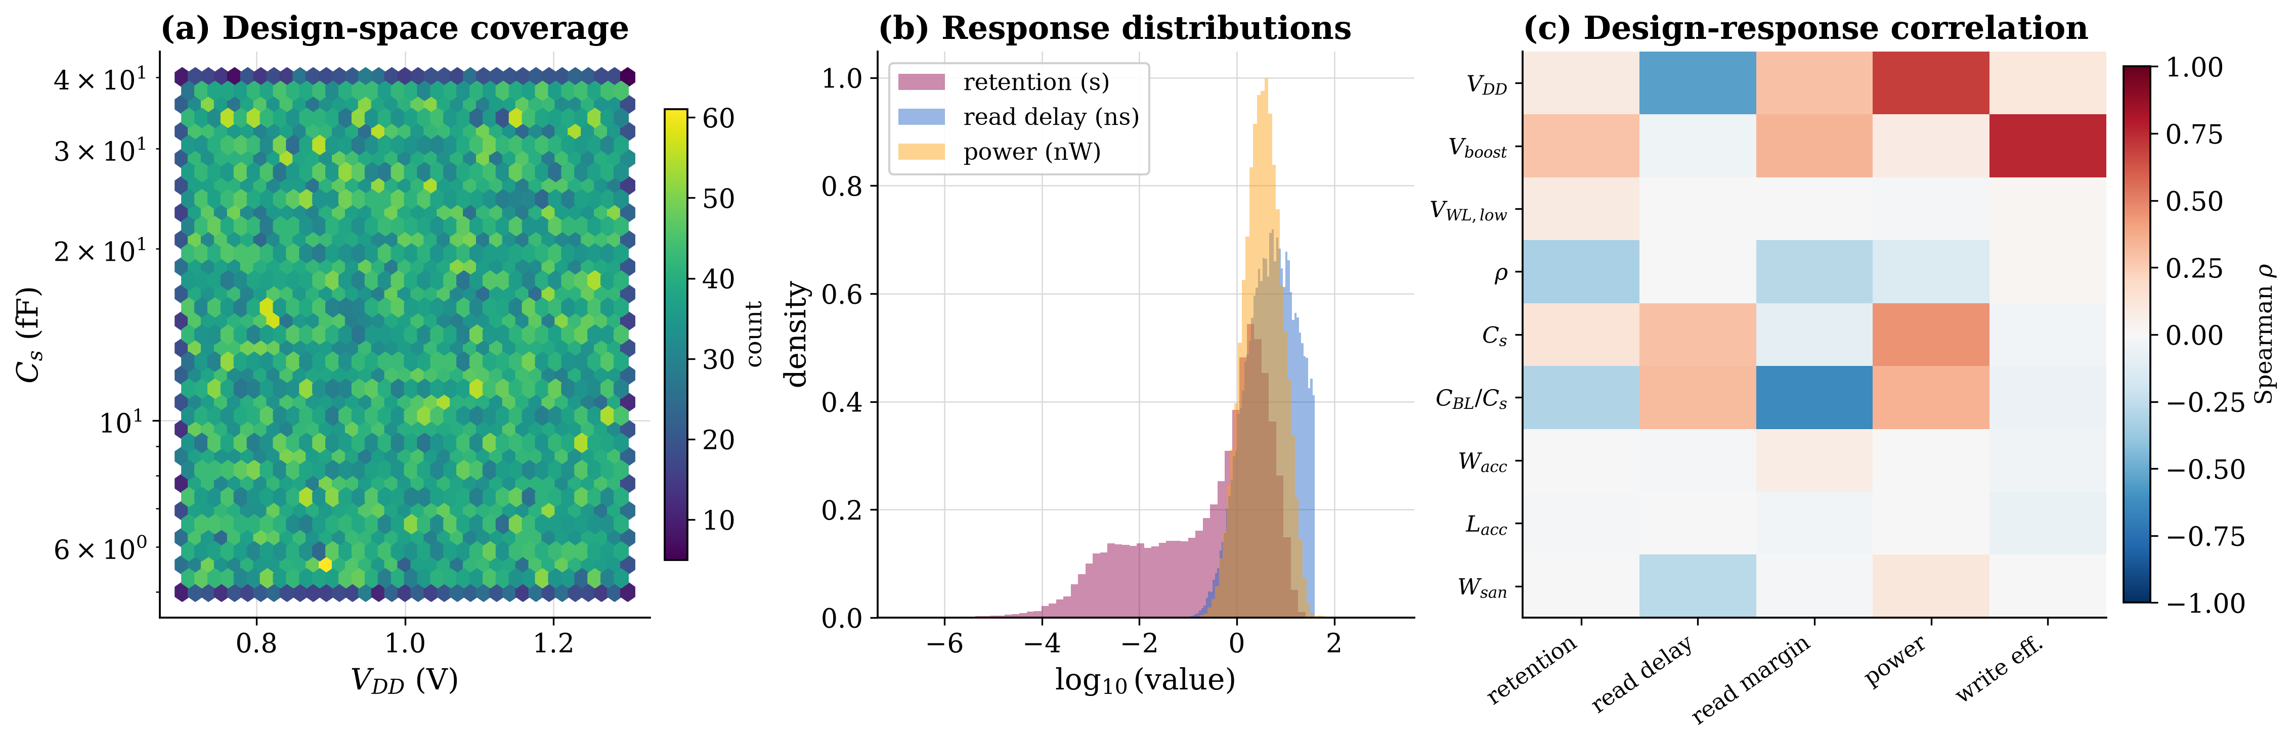
Figure 5. The released dataset. (a) Design-space coverage in the $V_{DD}$-$C_{s}$ plane (hexagonal binning, $C_{s}$ on a log axis). (b) The three multi-decade response distributions, each in its own panel and native $\log_{10}$ unit. (c) Spearman correlation between temperature and the thirteen design variables (rows) and the responses (columns); temperature is separated at the top, and the diverging scale is centred on zero.
Table 9. Composition of the released dataset. Percentiles are over all retained rows.
Response | Min | p25 | Median | p75 | Max
Retention time (s) | 0 | 0.00334 | 0.341 | 2.095 | 25.83
Read delay (ns) | 0.109 | 2.195 | 5.349 | 12.70 | 39.95
Read margin (mV) | $−60.1$ | 36.53 | 53.86 | 80.56 | 344.8
Total power (nW) | 0.0714 | 1.820 | 3.415 | 6.322 | 1397
Storage-node leakage (fA) | 0.251 | 1.361 | 20.90 | 1032 | $1.4×{10}^{7}$
Write efficiency | 0.222 | 0.816 | 0.964 | 0.989 | 0.999
Rows retained / simulated: $49,987/50,000$; feasible $57.9\%$; read / write success $78.6\%/70.0\%$
Zero-retention points $14.5\%$; corners 9,996 to 9,998 each; train/val/test $34,992/7,499/7,496$

Three checks preceded use. Charge sharing matched Eq. (2) to a median relative error of 3.80% (p95 17.99%) over 120 points, the residual reflecting junction and overlap capacitance the first-order law omits. A solver study against a 20 ps Gear reference showed the production 50 ps setting changing no metric by more than 0.152% at the median while running 1.69 times faster and preserving all pass/fail labels. Finally the retention model was validated as in Figure 4(d,e).

Surrogate models and the digital twin
Table 10 gives the selected model and held-out performance per response, and Table 11 the family and model comparison. Two engineered features that are exact functions of others, the temperature in kelvin and one capacitance-ratio duplicate, are dropped before training, since a feature carrying no independent information only confounds later attribution; their removal leaves accuracy unchanged. Figure 6 shows the six parity plots: (a) retention, (b) read delay, (c) read margin, (d) power, (e) energy per access and (f) write efficiency, each annotated with its test $R^{2}$ and RMSE. Neural models dominate: the deep perceptron is selected for every response. Held-out $R^{2}$ ranges from 0.951 for retention, the hardest response spanning decades, to 0.999 for write efficiency; the wider scatter in Figure 6(a) at short retention is the log-floored infeasible region.
That aggregate retention figure needs qualifying, because it is measured over a target that is part physical and part floor. Split at the feasibility boundary, the twin reproduces the retention of feasible designs with a median error of 0.056 decades and $R^{2}=0.73$ on the held-out set, while the floored infeasible rows, which are easy to place near the floor but carry no gradient, inflate the aggregate $R^{2}$ to 0.951 and dominate the RMSE. The honest reading is therefore that retention on real, non-floored designs is predicted to within a median factor of 1.14, and that the aggregate score is optimistic. The floor is better treated as a separate question: a gradient-boosted classifier separates feasible from infeasible designs on the held-out set with an area under the ROC curve of 0.998 and average precision 0.9997, so a two-stage twin, feasibility first and a feasible-only retention regressor second, is both available and preferable to reading one $R^{2}$ off the pooled target. Figure 7 summarizes the twin: (a) ranks the fourteen models by median test $R^{2}$, placing both neural models above the boosting family; (b) shows the selected twin per response with bootstrap intervals; and (c) shows evaluation cost, which falls with batch size to 32.5 µs per design at a batch of ${10}^{4}$, that is $30,769$ designs per second and a $3.70×{10}^{4}$ speedup over single-core SPICE. Two qualifications keep the figure honest: it is the fully batched best case, an order of magnitude larger than the tenfold speedup at batch one, and it is measured against one SPICE process, whereas the campaign itself ran 18 workers, so the wall-clock advantage over the parallel campaign is about $18×$ smaller. That headroom is still what makes the optimization, sensitivity and yield studies affordable: the optimization alone consumes $1.68×{10}^{5}$ evaluations, which the twin returns in under a minute against about 56 hours of single-core SPICE time.
Table 10. Selected surrogate per response. Selection uses the cross-validated score; the test columns are the single untouched evaluation of that choice, with 95% percentile-bootstrap intervals.
Response | Model | CV $R^{2}$ | Test $R^{2}$ | Test RMSE | 95% CI
Write efficiency | MLP (deep) | 0.99410 | 0.99917 | 0.00353 | [0.9991, 0.9993]
Energy per access (fJ) | MLP (deep) | 0.99120 | 0.99666 | 2.489 | [0.9959, 0.9974]
$\log_{10}$ power (nW) | MLP (deep) | 0.97042 | 0.98410 | 0.0495 | [0.9774, 0.9884]
Read delay (ns) | MLP (deep) | 0.96915 | 0.98937 | 0.9616 | [0.9868, 0.9916]
Read margin (mV) | MLP (deep) | 0.95378 | 0.99253 | 3.382 | [0.9905, 0.9944]
$\log_{10}$ retention (s) | MLP (deep) | 0.92510 | 0.95113 | 0.9197 | [0.9407, 0.9617]
Retention, split at the feasibility boundary (feasible-region regression):
feasible only | MLP (deep) | – | 0.732 | 0.674 | median err 0.056 dec
feasibility (AUC/AP) | Hist-GBR | – | AUC 0.998, AP 0.9997, accuracy 0.984

Table 11. All fourteen compared models. Median test $R^{2}$ is taken across the six responses; the mean rank averages the per-response cross-validated ranking (lower is better). Both columns use the same aggregation.
Model | Family | Median test $R^{2}$ | Mean rank
MLP (deep) | Neural | 0.9909 | 1.00
MLP | Neural | 0.9866 | 2.33
CatBoost | Boosting | 0.9641 | 2.83
LightGBM | Boosting | 0.9595 | 4.00
Hist-GBR | Boosting | 0.9519 | 5.17
XGBoost | Boosting | 0.9544 | 5.67
Poly2-ridge | Linear | 0.8852 | 8.00
Random forest | Ensemble | 0.8587 | 8.67
GPR | Kernel | 0.8685 | 9.00
Extra-trees | Ensemble | 0.8665 | 9.00
SVR-RBF | Kernel | 0.8637 | 10.33
$k$-NN | Neighbor | 0.7285 | 12.67
Ridge | Linear | 0.6661 | 12.67
Elastic-net | Linear | 0.6645 | 13.67

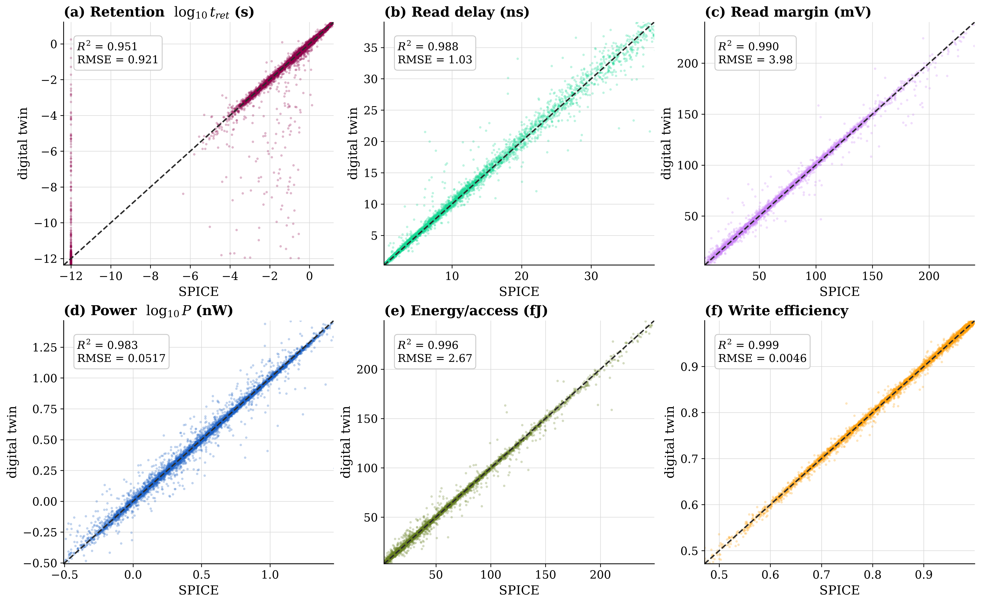
Figure 6. Digital-twin predictions against SPICE on the held-out test partition for the selected model of each response: (a) $\log_{10}$ retention, (b) read delay, (c) read margin, (d) $\log_{10}$ power, (e) energy per access, (f) write efficiency. Each panel is annotated with its test $R^{2}$ and RMSE; the dashed line is the identity.
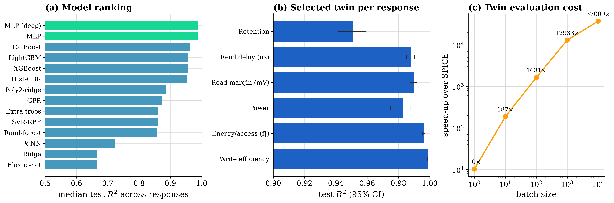
Figure 7. Digital twin: accuracy and cost. (a) Model ranking by median test $R^{2}$ across responses, neural models in green. (b) Selected twin per response with 95% bootstrap intervals. (c) Twin evaluation speedup over the measured SPICE cost against batch size.

Explainability
Figure 8 interprets the twin. The two attribution methods deliberately operate on different input spaces, and saying which is half the interpretation: SHAP (panel a) runs over the twin's full fifteen-feature engineered input, which includes derived quantities such as the wordline overdrive $V_{ov}$, the gate bias at the retention point $V_{gs,ret}$ and the charge-share ratio, whereas the Sobol' analysis of Figure 10(c) runs over the raw design variables alone. Panel (a) ranks the capacitance ratio $κ$ first for retention, followed by the supply, the precharge ratio $ρ$, the wordline boost and overdrive, and temperature; colour shows that higher boost and lower precharge lengthen retention, exactly the mechanism of Eqs. (1) and (11). The storage capacitance $C_{s}$ ranks lower here than a raw-variable analysis places it, because part of its influence is carried by the derived charge-share and gate-bias features that share its information; once the differing input spaces are accounted for, the two analyses agree that the capacitance ratio, the precharge and supply levels, and temperature are what govern retention. Panel (b) aggregates attribution across all six responses, with $V_{DD}$ the single most influential variable overall and dominating read delay and power. Panel (c) overlays partial dependence and accumulated local effects for $κ$, both centred on a common baseline; they agree where variables are weakly correlated and diverge for the derived ones, which is why ALE, faithful under the correlated derived relations of Eq. (6) such as $C_{BL}=κC_{s}$ and $V_{BLpre}=ρV_{DD}$, is reported alongside.
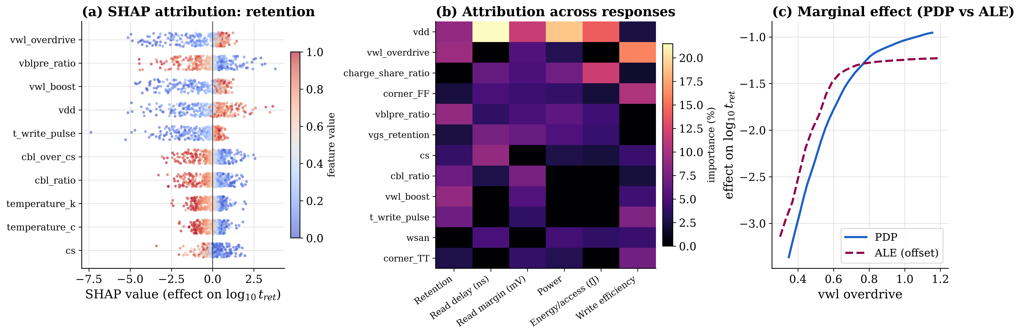
Figure 8. Explainability of the twin, over the twin's fifteen-feature engineered input. (a) SHAP summary for $\log_{10}$ retention; horizontal position is attribution and colour is feature value. (b) Attribution (percentage) across the six responses. (c) Marginal effect of the capacitance ratio $κ$, partial dependence against accumulated local effects, both centred on a common baseline so the comparison carries no offset.

Multi-objective optimization
Table 12 compares the six optimizers over 31 independent runs at an identical 1,500-evaluation budget (a population of 100 over 15 generations), with all four objectives normalized to $[0,1]$ over the pooled front and hypervolume computed against a common reference point at 1.1 in each normalized objective; Figure 9 visualizes the comparison. The normalization is what makes the comparison meaningful: on the raw objectives, which span milliseconds, nanoseconds, nanowatts and millivolts, both indicators were dominated by whichever objective carried the largest numbers, and that alone produced the earlier impression that a narrowly converged method could score well. Once every objective shares a scale the ranking is unambiguous. Bayesian optimization attains the highest median hypervolume, 0.941, then NSGA-II at 0.867 and NSGA-III at 0.768, and these three also give the best IGD$​^{+}$ (0.10, 0.11 and 0.095). The Friedman test on hypervolume gives $χ_{F}^{2}=144.0$, $p=2.5×{10}^{−29}$, Kendall's $W=0.929$, and with 31 runs the Nemenyi critical difference falls to 1.35 and now separates 11 of the 15 pairs, where seven runs had separated only six, so the increased replication is what buys the resolution. Figure 9(d) shows the resulting structure: Bayesian optimization and NSGA-II form the leading group and are statistically indistinguishable, NSGA-III overlaps NSGA-II, and the two scalarizing methods with MOEA/D trail; MOEA/D is not isolated but overlaps particle swarm. A difference is counted significant only when it strictly exceeds the critical difference. The MOEA/D anomaly of the raw indicators disappears under normalization: its decomposition drives every subproblem hard but into a very narrow region of the front, with an inter-point spacing and spread more than an order of magnitude smaller than any other method, so it earns the worst normalized hypervolume, 0.184, and only a middling IGD$​^{+}$, 0.159, exactly as a narrowly converged front should, not the best. The two scalarizing methods, differential evolution and particle swarm, each pool an archive over a spread of weight vectors yet return only a handful of well-separated optima (medians of 7 and 6), so their low hypervolume reflects the coverage a scalarization reaches within the budget rather than a failure of search, and they are scored on the same normalized indicators as the rest. The Solutions column is the median size of each method's own final non-dominated archive per run, not a share of any pooled set. Figure 9 shows (a) the retention-versus-read-delay projection with its 2-D non-dominated subset drawn, (b) hypervolume convergence, and (c) the hypervolume distribution by algorithm.
Table 12. Optimizer comparison over 31 runs at an identical 1,500-evaluation budget, on objectives normalized to $[0,1]$ over the pooled front with the hypervolume reference point at 1.1 in each. Hypervolume larger is better; IGD$​^{+}$ smaller is better. Statistics are on hypervolume.
Algorithm | HV median | HV s.d. | IGD$​^{+}$ | Solutions | Mean rank
Bayesian (TPE) | 0.941 | 0.048 | 0.101 | 143 | 1.26
NSGA-II | 0.867 | 0.076 | 0.107 | 100 | 1.81
NSGA-III | 0.768 | 0.064 | 0.095 | 35 | 2.94
Differential evolution | 0.290 | 0.056 | 0.311 | 7 | 4.35
Particle swarm | 0.270 | 0.047 | 0.312 | 6 | 4.74
MOEA/D | 0.184 | 0.028 | 0.159 | 99 | 5.90
Friedman $χ_{F}^{2}=144.0$, $p=2.5×{10}^{−29}$, $W=0.929$; Nemenyi CD $=1.35$ (11 of 15 pairs significant)
Leading clique (not separated): Bayesian and NSGA-II; $n=31$ gives the pairwise tests power the seven-run study lacked

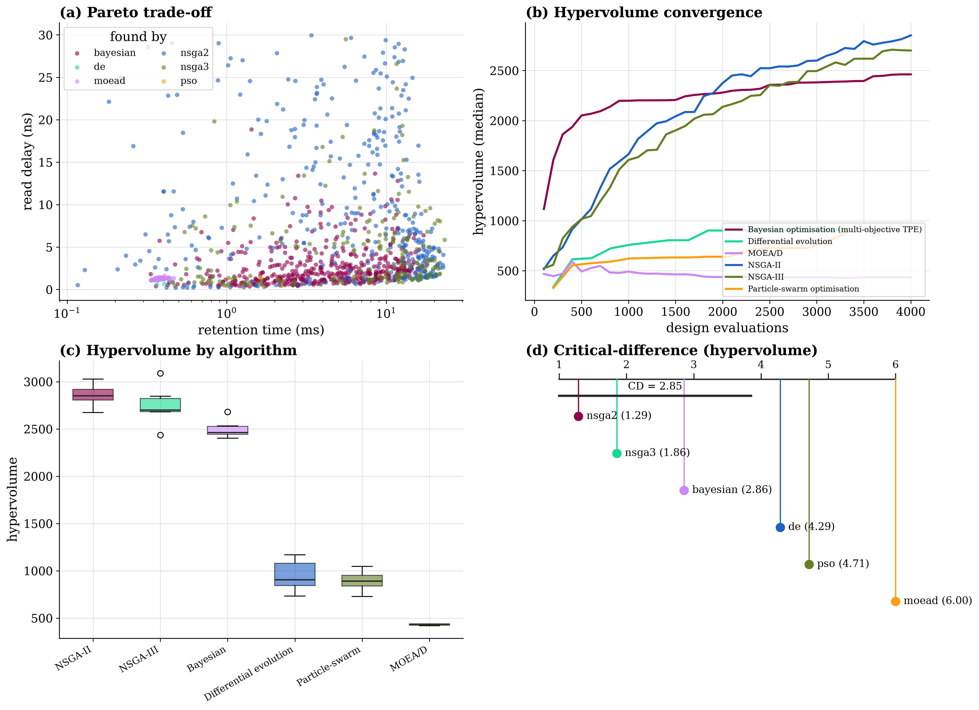
Figure 9. Multi-objective optimization over 31 runs on objectives normalized to $[0,1]$. (a) Retention-versus-read-delay projection of the four-dimensional front, coloured per algorithm, with the 2-D non-dominated subset drawn as the black line so the trade-off is visible. (b) Hypervolume convergence (median over 31 runs), one fixed colour per algorithm, legend outside the axes. (c) Hypervolume distribution by algorithm. (d) Critical-difference diagram for hypervolume (Nemenyi, $CD=1.35$); each bar joins a clique of methods that are not significantly different.

Selected designs and SPICE verification
Table 13 lists representative Pareto designs. A clear pattern emerges: every high-retention design drives the capacitance ratio to its lower bound and $C_{s}$ toward its upper bound, exactly as Eqs. (2) and (11) predict, since a light bitline both raises charge-sharing gain and lowers the failure level.
Table 13. Representative Pareto-optimal designs. Objective values are worst case over the four PVT conditions.
Selection | By | $V_{DD}$ | $C_{s}$ | $C_{BL}/C_{s}$ | $t_{ret}$ | $t_{rd}$ | P | Margin
 |  | (V) | (fF) |  | (ms) | (ns) | (nW) | (mV)
Knee | NSGA-II | 1.286 | 30.2 | 2.06 | 10.33 | 2.53 | 5.94 | 230.9
Weighted | NSGA-II | 1.163 | 39.3 | 2.00 | 12.47 | 4.14 | 6.76 | 229.4
Best retention | Bayesian | 1.269 | 39.2 | 2.37 | 14.11 | 4.51 | 8.44 | 202.1
Best read delay | NSGA-II | 1.235 | 5.0 | 2.03 | 0.61 | 0.0 | 6.95 | 140.7
Best power | NSGA-II | 0.735 | 6.0 | 2.21 | 0.46 | 23.97 | 0.41 | 90.6
Best margin | MOEA/D | 1.300 | 5.1 | 2.00 | 0.69 | 1.33 | 4.43 | 284.5

Returning these designs to NGSpice gives two findings that point in opposite directions (Table 14). First, the constraints survive: all 48 verification points satisfy the read and write criteria under full simulation, so the optimizer's feasibility reasoning is sound. Second, the objective accuracy is uneven at the frontier. Against the held-out test split the twin reaches $R^{2}≥0.95$ on every response, and on the optimizer-selected designs read margin, power and even retention still verify well, with median discrepancies of 2.0%, 6.7% and 0.039 decades (a factor of $1.09$). Read delay is the exception: its median error rises to 31.6% and its 90th percentile to 109%. The reason is where the read-delay optima sit; the search pushes them against the timing feasibility boundary, where a small change in device strength swings the latch resolution time sharply, so the surrogate, accurate in the interior, loses precision at exactly the edge it is driven toward. This is the concrete form the extrapolation risk takes here, and it is measured rather than assumed.
Table 14. Twin-predicted versus NGSpice-simulated performance of the selected designs, over 48 design-condition points.
Objective | Median err (%) | p90 err (%) | Character
Read margin (mV) | 2.01 | 5.78 | smooth, near-linear
Total power (nW) | 6.72 | 16.19 | smooth, two decades
Retention time (s) | 9.4 | 27.0 | 0.039 / 0.105 decades
Read delay (ns) | 31.60 | 109.35 | turns sharply at the timing boundary
Read and write constraints satisfied: 100% of 48 points

Robustness, sensitivity and assist techniques
Yield is estimated where cells actually fail. At the nominal condition the selected designs all pass, so a saturated 100% tells us nothing; the informative test applies the Pelgrom threshold mismatch of Eq. (8) at the worst corner, 125 °C SS, drawing an independent $δV_{th}$ for the access device and both sense-amplifier pairs from $N(0,σ_{V_{th}})$ with $σ_{V_{th}}=A_{VT}/\sqrt{WL}$, and re-simulating 1,000 trials per design in NGSpice; the twin does not carry $δV_{th}$, so this is necessarily a deck-level check. Table 15 shows the electrical yield is then a real distribution rather than a ceiling: the robust best-margin design holds 100% and the knee 93.9%, but the low-power design, whose small access and sense transistors give the largest per-device $σ_{V_{th}}$, drops to 56.6% as its read success alone falls to 72.7%, and a deliberately marginal design fails almost entirely. The retention specification is a separate axis: at 125 °C no design holds its bit for 64 ms irrespective of mismatch, the temperature-limited shortfall discussed below, so a retention-inclusive joint yield is zero at that corner for every design and the electrical yield is the meaningful mismatch metric. The corner sweep, meanwhile, exposes a conclusion the nominal condition conceals. Sustaining the JEDEC 64 ms refresh interval requires 128 ms of retention under the $γ=2$ guard of Eq. (11); no design in the Pareto set reaches that at 125 °C, the best worst-case retention being 12.4 ms, which under the same guard would support only a 6.2 ms refresh interval. Whether that shortfall is physical or an artifact of the general-purpose logic cards, whose access devices leak less than a production DRAM transistor, is taken up in \S7; either way it is what a worst-case-aware exploration is for, not a failure of the method. Figure 10 shows (a) the corner sweep of the knee design on a logarithmic colour scale, retention falling from tens of seconds cold to milliseconds hot while the corner spread within any one temperature stays small, the physical picture that motivates the rescoped PVT claim of \S7 (temperature first order, corner second order for retention); (b) the Monte-Carlo retention distribution of the best-retention design, whose median of 28.1 s sits just beyond the 25.83 s training maximum and is therefore flagged as an extrapolation; and (c) the Sobol' indices for retention, where the precharge ratio ($S_{T}=0.34$), the capacitance ratio ($S_{T}=0.32$), the storage capacitance ($S_{T}=0.28$) and the wordline boost ($S_{T}=0.20$) lead, each with a bootstrap interval, and the gap to the first-order indices shows a substantial interaction share. This ordering is the same set the SHAP analysis of \S6 identifies; the two differ only in where $V_{DD}$ and $C_{s}$ sit, for the input-space reason given there. Across responses the supply voltage dominates read delay ($S_{T}=0.78$) and power ($S_{T}=0.71$), so the variable that governs retention least among the leaders is the one that governs timing and energy most.
Table 15. Mismatch yield of the selected designs, 1,000 Monte-Carlo trials each at 125 °C SS with an independent Pelgrom $δV_{th}$ per device (Eq. 8) in NGSpice. Electrical yield requires read margin$≥25 \text{m}\text{V}$, write efficiency$≥0.85$ and read delay$≤30 \text{n}\text{s}$ jointly.
Design | $σ_{V_{th}}$ acc/san/sap (mV) | Read margin (mV) | Read success | Electrical yield
Best read margin | 21.6 / 54.9 / 50.4 | $304±1$ | 100% | 100.0%
Knee | 64.9 / 30.5 / 30.1 | $231±16$ | 100% | 93.9%
Best total power | 54.5 / 40.7 / 35.6 | $91±1$ | 72.7% | 56.6%
Marginal (stress) | 59.2 / 52.2 / 52.2 | $21±5$ | 12.0% | 0.0%

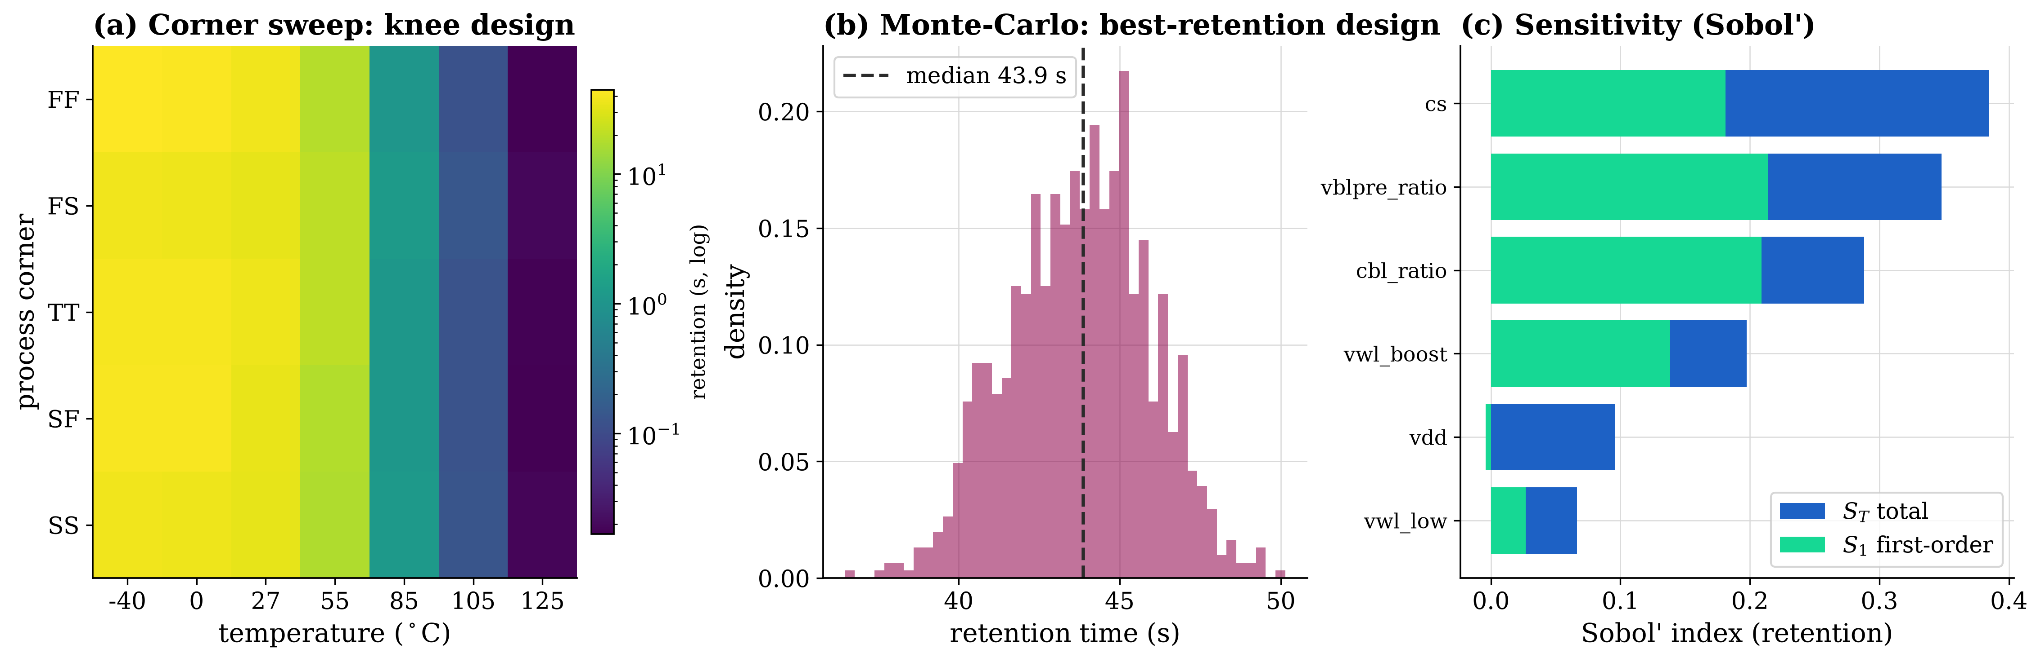
Figure 10. Robustness and sensitivity. (a) Corner sweep of the knee design across process corner and temperature, retention on a logarithmic colour scale with the value printed in each cell; reading down a column shows that at a fixed temperature the corners differ only slightly, while reading across a row shows temperature moving retention by three decades. The seven-temperature grid here is the robustness sweep and is wider than the six-temperature characterization grid of Figure 4. (b) Monte-Carlo retention distribution of the best-retention design; the dotted line marks the largest retention in the training set and the shaded region is where the twin extrapolates beyond it. (c) Sobol' total-effect and first-order indices for retention with bootstrap confidence intervals; the gap between them is the interaction share.
Figure 11 reports the assist study, a paired and controlled design in which each technique is composed on a common baseline over 300 base designs drawn by a separate Latin hypercube, all simulated in NGSpice. The baseline deliberately pins the assist-relevant knobs, wordline boost, precharge level and device sizes, to their un-assisted nominal values, which is why its feasibility is 26.3% rather than the 57.9% of the free design space: the reference is intentionally weaker than an unconstrained draw so that each technique's effect is isolated on identical designs. The refresh-interval control, a pure scheduling policy, correctly shows exactly 0 % change on every electrical metric and is labelled as such in the figure. All seven rows are reported, including the leakage series on which the negative-wordline result depends. Wordline boosting is the strongest single assist, lengthening retention by 346.7% and margin by 55.9% for 6.4% more power while raising feasibility to 76.3%. Bitline-precharge optimization lengthens retention by 213.9%, consistent with lowering $V_{BLpre}$ and hence $V_{fail}$ in Eq. (11). Sense-amplifier upsizing is a timing rather than a retention assist: it cuts read delay by 31.6% at 12.5% more power and leaves retention essentially unchanged. The high-k capacitor shortens retention by 81.2%: its $1.8×$ capacitance is outweighed by a dielectric leakage entered as an assumed parallel resistance (2e13 Ω against the baseline 1e15 Ω), an input to the study rather than a measured quantity, so this row's magnitude reflects that assumption. The negative wordline shortens retention by 37.0% while raising leakage by 1105%: Eqs. (13) and (14) explain it, since subthreshold conduction is already negligible at zero bias so a more negative gate only turns on GIDL. Finally the combined-low-power configuration, which the multi-objective search is expected to approach, is the instructive negative result: stacking the cell, periphery and policy assists raises leakage by more than two orders of magnitude, so although margin improves by 70.9% the refresh term of Eq. (4) drives total power up by 90.3% and retention barely moves, a reminder that “low-power” assists interact and do not add.
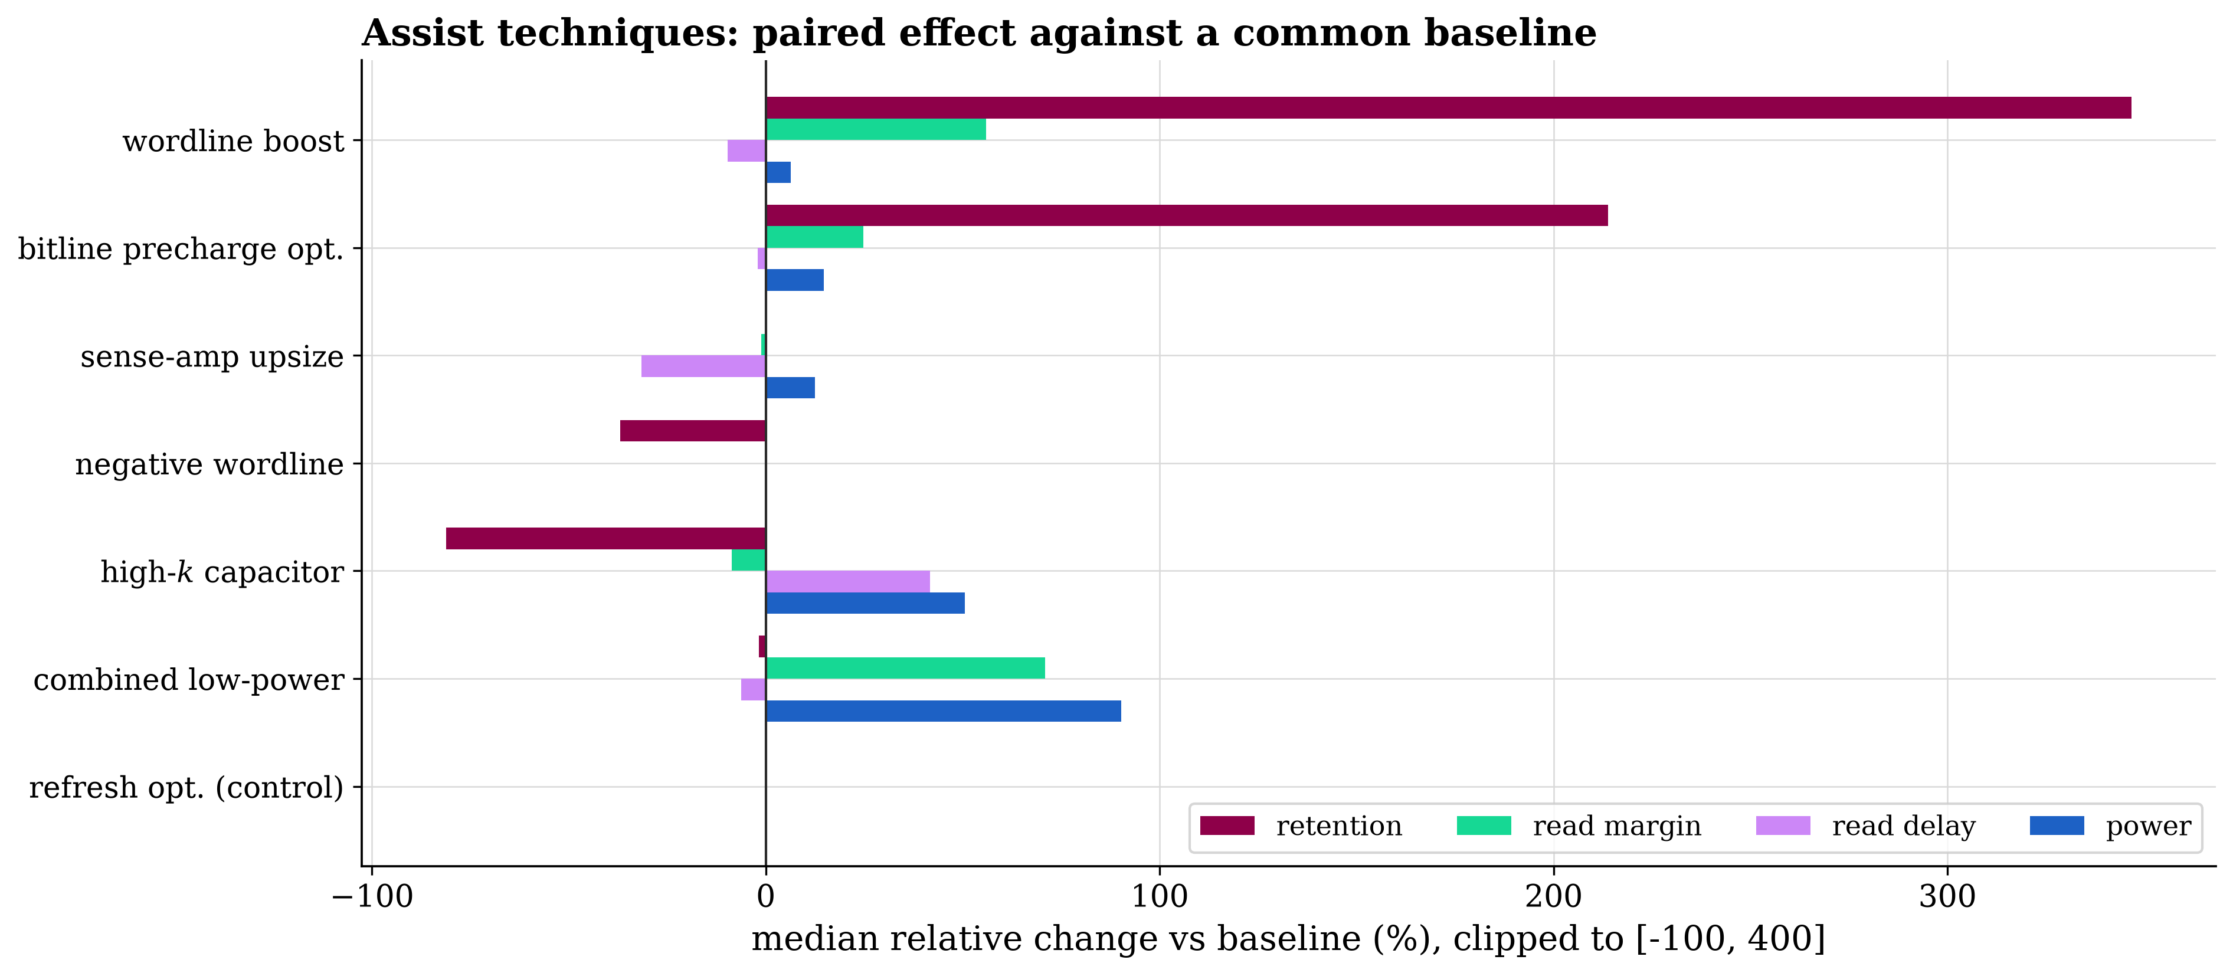
Figure 11. Assist techniques as median relative change against a common baseline over 300 paired designs, all simulated in NGSpice, for five metrics including storage-node leakage. The refresh-interval row is a null-effect control and its zero bars are labelled explicitly. Values are clipped to $[−100,400]\%$ for display, with values beyond the clip annotated.

7. Discussion

Significance and relationship to existing work
The contribution is best seen by asking what each strand of the literature would have to do to obtain these results. Device-level retention studies [15-18] produce higher physical fidelity but at a cost per point that confines them to a few devices; this work consumes the same compact-model physics and converts it into an observable cheap enough for 50,000 candidate designs, so the two are complementary. Surrogate circuit-sizing methods [1-3,39] share the economics but not the obstacle: they presume the reference simulator scales, which is false for DRAM retention, so the distinguishing contribution here is upstream of the surrogate, in the replica construction that makes the training data obtainable at all. Beyond that, worst-case reduction places PVT robustness inside the loop rather than in a later check, the surrogate is chosen by a tested fourteen-family comparison rather than asserted, and the optimizer output is returned to the simulator with the error reported. Relative to the closest optimizer study [26], the comparison is run at a replication of 31 repetitions that gives the pairwise tests real power: the Friedman omnibus and the Nemenyi post-hoc agree, separating 11 of the 15 pairs and placing Bayesian optimization and NSGA-II in a single leading clique that the two scalarizing methods and MOEA/D sit well below. Relative to operational digital twins [59-60], this is a design-stage twin whose value is measured by simulator agreement, which is why Table 14 is a central result rather than an appendix. These properties, a measured retention observable validated against the simulator, a released dataset, statistically tested model selection, robust optimization, and a quantified account of surrogate failure at the frontier, together make the framework suitable as a reusable, reproducible basis for data-driven DRAM design.

Limitations
- Logic device models: All simulations use public PTM BSIM4 cards for a general-purpose low-power logic process [62]. Real DRAM access devices have stronger storage-node GIDL, so the absolute retention times here are longer than a production part; relative trends, variable rankings and the methodology are unaffected, but no absolute retention value should be read as a prediction about a commercial device.
- Access-device leakage only: The replica is an access device driven at the storage node (Fig. 2), so it captures every path the access-device compact model carries but not dielectric leakage of the storage capacitor, an established retention mechanism [18]. Retention here is thus an access-device-limited estimate, and the high-$k$ assist result is driven by an assumed dielectric-leakage multiplier rather than a measured one. Beyond the quasi-static assumption, Eq. (10) also takes $C_{node}$ as voltage-independent and treats the driven replica node as equivalent to the real floating node; the former is the likely source of the small systematic bias in Fig. 4(e).
- Synthesized corners: The SS/FF/SF/FS cards are first-order shifts (Eq. 7), spanning a defensible range but not foundry-qualified; corner-dependent conclusions inherit this. The corner also enters the responses unevenly: it moves read delay and read margin at first order (the sense-amplifier strength tracks the device corner directly) but retention only weakly and mostly through the written level, because at $V_{WL,low}≤0$ the subthreshold path is off and the GIDL and junction terms that set leakage are largely threshold-independent. Temperature, not corner, is the first-order variable for retention; the worst-case reduction is over both, but the retention component of it is driven by the hot conditions.
- Quasi-static retention: Equation (10) is exact for an isolated capacitor with voltage-only leakage and is validated in Figure 4, but does not capture variable-retention-time or trap-assisted transient behavior [15-16].
- Lumped bitline: $C_{BL}$ is a single capacitance, so bitline resistance, neighbor coupling and position-dependent effects are not represented.
- Slice-level power: Power is reported per cell-plus-column slice and depends on the configured access rate; the three components are reported separately so results can be reweighted.
- Frontier and out-of-range extrapolation: As Table 14 shows, twin accuracy on optimizer-selected designs is worse than on a random split. A related risk is range: the best-retention designs are driven to cold corners where the predicted retention exceeds the largest value in the training set (25.83 s, Table 9), so those figures are extrapolations and are flagged as such on Fig. 10. The twin is a search accelerator whose proposals require confirmation; closing the loop by re-simulating the Pareto region and refitting is the natural next step and is not done here.
- Statistical power and scope: With 31 runs the pairwise post-hoc tests resolve the ranking, but Bayesian optimization and NSGA-II remain within one critical difference of each other, so their order is a tie rather than a ranking. A single node (45 nm) was carried end to end, though the pipeline is node-agnostic.

8. Conclusion
This paper addressed a specific obstacle that has kept DRAM bit-cell design outside the reach of data-driven exploration: retention time, the response that matters most, is the one a circuit simulator cannot afford to produce in quantity because a faithful transient spans up to ten decades of time. The resolution was to stop simulating the discharge and instead measure what causes it. A leakage replica embedded in the cell's own deck makes the storage-node leakage characteristic observable in a single DC sweep, at each design point's temperature, bias and corner, with every access-device leakage mechanism present. Retention then follows from the exact charge-loss relation by closed-form integration, with the failure level derived from the charge-sharing condition. Validated against direct transient simulation across its full working range, from microseconds to twenty-five seconds, the model reproduced the simulator with a correlation of 0.99992 in logarithmic space and agreement within a factor of two for every matched design.
That economy changed what became possible. Fifty thousand design points were characterized in under an hour at a success rate above 99.99 percent, yielding a dataset in which failing designs are retained rather than discarded. From it a digital twin was built by comparing fourteen surrogate families under cross-validation, reaching held-out coefficients of determination between 0.951 and 0.999 and, fully batched, evaluating a design up to thirty-seven thousand times faster than a single simulator process. That speed made worst-case-over-corners optimization, variance-based sensitivity analysis and mismatch yield estimation affordable, and the resulting designs were returned to the simulator for verification. Every selected design satisfied its read and write constraints under nominal simulation; but subjecting them to local threshold mismatch at the worst corner, the condition where cells actually fail, drove joint yield below one hundred percent for the more aggressive designs, so the reported yield is a real distribution rather than a saturated ceiling. The accuracy of the predicted objective values held to a few percent for read margin, power and retention at the Pareto frontier but degraded to tens of percent for read delay, whose optima sit against the timing boundary, while the retention accuracy is itself honest only when split at the feasibility boundary; reporting both, rather than assuming them away, is what lets the twin be used as a search accelerator whose proposals require confirmation. The exploration further showed that within the space examined no design sustains the sixty-four millisecond JEDEC refresh interval at the highest temperature, which under the retention guard band needs one hundred and twenty-eight milliseconds of retention, a conclusion a nominal-condition study would have missed. Two directions follow: closing the feedback loop by re-simulating the Pareto region and refitting, and replacing the logic-process models with process models representative of a real DRAM technology. The framework, the dataset and every analysis artifact are released to make both straightforward.

Data and code availability
The framework, configuration files, the 49,987-point dataset (Excel, CSV and Parquet), the trained digital twin, and every figure, table and run manifest are publicly available at \url{https://github.com/USERNAME/dram-retention-digital-twin} and are archived, on acceptance, at Zenodo under a persistent DOI (10.5281/zenodo.XXXXXXX) so the exact artifacts behind every number here can be retrieved. All randomness derives from a single master seed through a pure (seed, label, index) hash, so results are independent of worker count and completion order.

References
[1] Budak AF, Gandara M, Shi W, Pan DZ, Sun N, Liu B. An Efficient Analog Circuit Sizing Method Based on Machine Learning Assisted Global Optimization. IEEE Trans. Comput.-Aided Des. Integr. Circuits Syst. 2022;41:1209-1221. https://doi.org/10.1109/tcad.2021.3081405
[2] Rashid R, Krishna K, George CP, Nambath N. Machine learning driven global optimisation framework for analog circuit design. Microelectronics Journal. 2024;151:106362. https://doi.org/10.1016/j.mejo.2024.106362
[3] Yin S, Wang R, Zhang J, Liu X, Wang Y. Fast Surrogate-Assisted Constrained Multiobjective Optimization for Analog Circuit Sizing via Self-Adaptive Incremental Learning. IEEE Trans. Comput.-Aided Des. Integr. Circuits Syst. 2023;42:2080-2093. https://doi.org/10.1109/tcad.2022.3221694
[4] Huang G, Hu J, He Y, Liu J, Ma M, Shen Z, et al. Machine Learning for Electronic Design Automation: A Survey. ACM Trans. Des. Autom. Electron. Syst. 2021;26:1-46. https://doi.org/10.1145/3451179
[5] Jang W, Myung S, Choe JM, Kim YG, Kim DS. TCAD Device Simulation With Graph Neural Network. IEEE Electron Device Lett. 2023;44:1368-1371. https://doi.org/10.1109/led.2023.3290930
[6] Wang BC, Tang CX, Qiu MT, Chen W, Wang T, Xu JY, et al. A machine learning approach to TCAD model calibration for MOSFET. NUCL SCI TECH. 2023;34. https://doi.org/10.1007/s41365-023-01340-x
[7] Li X, Wu Z, Rzepa G, Karner M, Xu H, Wu Z, et al. Overview of emerging semiconductor device model methodologies: From device physics to machine learning engines. Fundamental Research. 2025;5:2149-2160. https://doi.org/10.1016/j.fmre.2024.01.010
[8] Liu Y, Liu X, Zhou Y, Cao P. S-ANN: Synchronous TCAD device simulation of FinFET using Artificial Neural Network. Microelectronics Journal. 2025;159:106630. https://doi.org/10.1016/j.mejo.2025.106630
[9] Maniyar A, Srinivas PSTN, Tiwari PK, Chang-Liao KS. Impact of Process-Induced Inclined Sidewalls on Gate-Induced Drain Leakage (GIDL) Current of Nanowire GAA MOSFETs. IEEE Trans. Electron Devices. 2022;69:4815-4820. https://doi.org/10.1109/ted.2022.3194109
[10] Lee K, Kaczer B, Kruv A, Gonzalez M, Eneman G, Okudur OO, et al. Gate-Induced-Drain-Leakage (GIDL) in CMOS Enhanced by Mechanical Stress. IEEE Trans. Electron Devices. 2022;69:2214-2217. https://doi.org/10.1109/ted.2022.3154341
[11] Thakur A, Dhiman R. Comprehensive study of gate induced drain leakage in nanowire and nanotube junctionless FETs using Si1-xGex source/drain. AEU - International Journal of Electronics and Communications. 2023;167:154668. https://doi.org/10.1016/j.aeue.2023.154668
[12] Kaushal S, Rana AK. Modeling and analysis of gate-induced drain leakage current in negative capacitance junctionless FinFET. J Comput Electron. 2022;21:1229-1238. https://doi.org/10.1007/s10825-022-01930-9
[13] Bashir MY, Jaiswal AK, Patel SD, Sahay S. Revisiting Lateral-BTBT Gate-Induced Drain Leakage in Nanowire FETs for 1T-DRAM. IEEE Trans. Electron Devices. 2024;71:2714-2720. https://doi.org/10.1109/ted.2024.3365773
[14] Kwak B, Lee K, Kim S, Kwon D. Suppression of Gate-Induced-Drain-Leakage Utilizing Local Polarization in Ferroelectric-Gate Field-Effect Transistors for DRAM Applications. IEEE Electron Device Lett. 2024;45:813-816. https://doi.org/10.1109/led.2024.3370592
[15] Kim KY, Min KK, Park BG. Trap-Induced Data-Retention-Time Degradation of DRAM and Improvement Using Dual Work-Function Metal Gate. IEEE Electron Device Lett. 2021;42:38-41. https://doi.org/10.1109/led.2020.3037640
[16] Kim KY, Park BG. Effect of Random Dopant Fluctuation on Data Retention Time Distribution in DRAM. IEEE Trans. Electron Devices. 2021;68:5572-5577. https://doi.org/10.1109/ted.2021.3108743
[17] Bepary MK, Talukder BMSB, Rahman MT. DRAM Retention Behavior with Accelerated Aging in Commercial Chips. Applied Sciences. 2022;12:4332. https://doi.org/10.3390/app12094332
[18] Park DS, Lee EO, Lee JM, Cho E, Choi B. Suppression of Capacitor Leakage Through Thermal Budget Control in DRAM With ZrO 2 -Based Dielectrics. IEEE Access. 2025;13:35019-35028. https://doi.org/10.1109/access.2024.3502036
[19] Du H, Zhu H, Chen S, Kang Y. CR-DRAM: Improving DRAM Refresh Energy Efficiency With Inter-Subarray Charge Recycling. IEEE Trans. VLSI Syst. 2025;33:21-34. https://doi.org/10.1109/tvlsi.2024.3445631
[20] Golman R, Nachum N, Cohen T, Giterman R, Teman A. Refresh Algorithm for Ensuring 100% Memory Availability in Gain-Cell Embedded DRAM Macros. IEEE Access. 2021;9:105831-105840. https://doi.org/10.1109/access.2021.3099970
[21] Nguyen DT, Ho NM, Le MS, Wong WF, Chang IJ. ZEM: Zero-Cycle Bit-Masking Module for Deep Learning Refresh-Less DRAM. IEEE Access. 2021;9:93723-93733. https://doi.org/10.1109/access.2021.3088893
[22] Gupta N, Makosiej A, Shrimali H, Amara A, Vladimirescu A, Anghel C. Tunnel FET Negative-Differential-Resistance Based 1T1C Refresh-Free-DRAM, 2T1C SRAM and 3T1C CAM. IEEE Trans. Nanotechnology. 2021;20:270-277. https://doi.org/10.1109/tnano.2021.3061607
[23] Zhang S, Yang F, Yan C, Zhou D, Zeng X. An Efficient Batch-Constrained Bayesian Optimization Approach for Analog Circuit Synthesis via Multiobjective Acquisition Ensemble. IEEE Trans. Comput.-Aided Des. Integr. Circuits Syst. 2022;41:1-14. https://doi.org/10.1109/tcad.2021.3054811
[24] Touloupas K, Sotiriadis PP. LoCoMOBO: A Local Constrained Multiobjective Bayesian Optimization for Analog Circuit Sizing. IEEE Trans. Comput.-Aided Des. Integr. Circuits Syst. 2022;41:2780-2793. https://doi.org/10.1109/tcad.2021.3121263
[25] Chen C, Wang H, Song X, Liang F, Wu K, Tao T. High-Dimensional Bayesian Optimization for Analog Integrated Circuit Sizing Based on Dropout and gm/ID Methodology. IEEE Trans. Comput.-Aided Des. Integr. Circuits Syst. 2022;41:4808-4820. https://doi.org/10.1109/tcad.2022.3147431
[26] Saglican E, Afacan E. MOEA/D vs. NSGA-II: A Comprehensive Comparison for Multi/Many Objective Analog/RF Circuit Optimization through a Generic Benchmark. ACM Trans. Des. Autom. Electron. Syst. 2023;29:1-23. https://doi.org/10.1145/3626096
[27] Abdollahi A, Li D, Deng J, Amini A. An explainable artificial-intelligence-aided safety factor prediction of road embankments. Engineering Applications of Artificial Intelligence. 2024;136:108854. https://doi.org/10.1016/j.engappai.2024.108854
[28] Homafar A, Nasiri H, Chelgani SC. Modeling coking coal indexes by SHAP-XGBoost: Explainable artificial intelligence method. Fuel Communications. 2022;13:100078. https://doi.org/10.1016/j.jfueco.2022.100078
[29] Yun D, Park M, Bak G, Baeg S, Wen SJ. Exploitations of Multiple Rows Hammering and Retention Time Interactions in DRAM Using X-Ray Radiation. IEEE Access. 2021;9:137514-137523. https://doi.org/10.1109/access.2021.3117601
[30] Kong S, Shim W. Design of 2T DRAM Cell With Surrounding Poly-Si Capacitor for Enhanced Retention and Mitigated Coupling Effect. IEEE Trans. Device Mater. Relib. 2025;25:460-464. https://doi.org/10.1109/tdmr.2025.3578692
[31] Hwan Kong S, Shim W. Advanced 2T0C DRAM Technologies for Processing-in-Memory-Part I: Vertical Transistor on Gate (VTG) DRAM Cell Structure. IEEE Trans. Electron Devices. 2024;71:6633-6638. https://doi.org/10.1109/ted.2024.3447612
[32] Kim K, Shim W. A novel 3T DRAM cell with depletion mode PMOS for extended retention time in processing-in-memory applications. Semicond. Sci. Technol. 2026;41:045011. https://doi.org/10.1088/1361-6641/ae544d
[33] Ma H, Gu S, Zhai M, Liu H. Suppressing Gate-Induced Drain Leakage with an Asymmetric Gate Design in HiPco CNT FETs. Nanomaterials. 2026;16:653. https://doi.org/10.3390/nano16110653
[34] Golman R, Cohen H, Shapiro G, Teman A. Cyclic Refresh Algorithm for Ensuring 100% Memory Availability in Gain-Cell Embedded DRAM Macros. IEEE Trans. Comput.-Aided Des. Integr. Circuits Syst. 2026;45:4532-4543. https://doi.org/10.1109/tcad.2026.3652963
[35] Ko K, Moon D, Kim J, Oh J, Park S, Song J. Dipole-Based Characteristic Enhancement Strategy for Refresh Performance Enhancement in DRAM BCAT Structure. IEEE Trans. Electron Devices. 2026;73:4885-4890. https://doi.org/10.1109/ted.2026.3708805
[36] Matana Luza L, Soderstrom D, Puchner H, Alia RG, Letiche M, Cazzaniga C, et al. Neutron-induced effects on a self-refresh DRAM. Microelectronics Reliability. 2022;128:114406. https://doi.org/10.1016/j.microrel.2021.114406
[37] Afacan E, Lourenco N, Martins R, Dundar G. Review: Machine learning techniques in analog/RF integrated circuit design, synthesis, layout, and test. Integration. 2021;77:113-130. https://doi.org/10.1016/j.vlsi.2020.11.006
[38] Mina R, Jabbour C, Sakr GE. A Review of Machine Learning Techniques in Analog Integrated Circuit Design Automation. Electronics. 2022;11:435. https://doi.org/10.3390/electronics11030435
[39] Lberni A, Marktani MA, Ahaitouf A, Ahaitouf A. Analog circuit sizing based on Evolutionary Algorithms and deep learning. Expert Systems with Applications. 2024;237:121480. https://doi.org/10.1016/j.eswa.2023.121480
[40] Tang C, Chen X, Luo Y, Zeng Y. Automatic Optimal Design Method for Circuit Sizing Based on CNN Surrogate Model Assisted Differential Evolution Algorithm. IEEE Access. 2024;12:136238-136247. https://doi.org/10.1109/access.2024.3462952
[41] Song LY, Chou CY, Kuo TC, Liu CN, Huang JD. Machine Learning Assisted Circuit Sizing Approach for Low-Voltage Analog Circuits with Efficient Variation-Aware Optimization. ACM Trans. Des. Autom. Electron. Syst. 2022;28:1-22. https://doi.org/10.1145/3567422
[42] NS KS, Li P. Pareto Optimization of Analog Circuits Using Reinforcement Learning. ACM Trans. Des. Autom. Electron. Syst. 2024;29:1-14. https://doi.org/10.1145/3640463
[43] Sun M, Li H, Chen W, Li X, Li J, Luo Z, et al. Transformer-based surrogate modeling for multi-circuit analog sizing via Bayesian optimization. Integration. 2026;111:102809. https://doi.org/10.1016/j.vlsi.2026.102809
[44] Chen M, Hao Y, Gandara M, Imran M, Liu B. Trade-off-aware Analog Circuit Sizing Based on A Multitask Surrogate Model-assisted Evolutionary Algorithm. IEEE Trans. Comput.-Aided Des. Integr. Circuits Syst. 2026:1-1. https://doi.org/10.1109/tcad.2026.3677769
[45] Akbar C, Li Y, Thoti N. Device-Simulation-Based Machine Learning Technique for the Characteristic of Line Tunnel Field-Effect Transistors. IEEE Access. 2022;10:53098-53107. https://doi.org/10.1109/access.2022.3174685
[46] Guo G, You H, Li C, Tang Z, Li O. A Physics-Informed Automatic Neural Network Generation Framework for Emerging Device Modeling. Micromachines. 2023;14:1150. https://doi.org/10.3390/mi14061150
[47] Liang W, Yang X, Miao M, Loiseau A, Mitra S, Gauthier R. Novel ESD Compact Modeling Methodology Using Machine Learning Techniques for Snapback and Non-Snapback ESD Devices. IEEE Trans. Device Mater. Relib. 2021;21:455-464. https://doi.org/10.1109/tdmr.2021.3116599
[48] Yoon T, Jeong H. Machine Learning-Based Read Access Yield Estimation and Design Optimization for High-Density SRAM. IEEE Trans. Comput.-Aided Des. Integr. Circuits Syst. 2023;42:2618-2630. https://doi.org/10.1109/tcad.2022.3225066
[49] Shaik JB, Guo X, Singhal S. Impact of Aging and Process Variability on SRAM-Based In-Memory Computing Architectures. IEEE Trans. Circuits Syst. I. 2024;71:2696-2708. https://doi.org/10.1109/tcsi.2024.3381935
[50] Touloupas K, Sotiriadis PP. Mixed-Variable Bayesian Optimization for Analog Circuit Sizing through Device Representation Learning. Electronics. 2022;11:3127. https://doi.org/10.3390/electronics11193127
[51] Wang X, Yan C, Ma Y, Yu B, Yang F, Zhou D, et al. Analog Circuit Yield Optimization via Freeze-Thaw Bayesian Optimization Technique. IEEE Trans. Comput.-Aided Des. Integr. Circuits Syst. 2022;41:4887-4900. https://doi.org/10.1109/tcad.2022.3149723
[52] Zhang P, Qian Y, Qian Q. Multi-objective optimization for materials design with improved NSGA-II. Materials Today Communications. 2021;28:102709. https://doi.org/10.1016/j.mtcomm.2021.102709
[53] Borisut P, Nuchitprasittichai A. Adaptive Latin Hypercube Sampling for a Surrogate-Based Optimization with Artificial Neural Network. Processes. 2023;11:3232. https://doi.org/10.3390/pr11113232
[54] Phromphan P, Suvisuthikasame J, Kaewmongkol M, Chanpichitwanich W, Sleesongsom S. A New Latin Hypercube Sampling with Maximum Diversity Factor for Reliability-Based Design Optimization of HLM. Symmetry. 2024;16:901. https://doi.org/10.3390/sym16070901
[55] Liu B, Liu P, Lu W, Olofsson T. Explainable Artificial Intelligence (XAI) for Material Design and Engineering Applications: A Quantitative Computational Framework. Int Journal of Mech Sys Dyn. 2025;5:236-265. https://doi.org/10.1002/msd2.70017
[56] Lundberg SM, Lee SI. A unified approach to interpreting model predictions. Advances in Neural Information Processing Systems (NeurIPS). 2017;30:4765-4774.
[57] Lundberg SM, Erion G, Chen H, DeGrave A, Prutkin JM, Nair B, et al. From local explanations to global understanding with explainable AI for trees. Nat Mach Intell. 2020;2:56-67. https://doi.org/10.1038/s42256-019-0138-9
[58] Apley DW, Zhu J. Visualizing the Effects of Predictor Variables in Black Box Supervised Learning Models. Journal of the Royal Statistical Society Series B: Statistical Methodology. 2020;82:1059-1086. https://doi.org/10.1111/rssb.12377
[59] Ruhe S, Schaefer K, Branz S, Nicolai S, Bretschneider P, Westermann D. Design and Implementation of a Hierarchical Digital Twin for Power Systems Using Real-Time Simulation. Electronics. 2023;12:2747. https://doi.org/10.3390/electronics12122747
[60] Massaro A. Electronic Artificial Intelligence-Digital Twin Model for Optimizing Electroencephalogram Signal Detection. Electronics. 2025;14:1122. https://doi.org/10.3390/electronics14061122
[61] McKay MD, Beckman RJ, Conover WJ. A Comparison of Three Methods for Selecting Values of Input Variables in the Analysis of Output from a Computer Code. Technometrics. 1979;21:239. https://doi.org/10.2307/1268522
[62] Zhao W, Cao Y. New Generation of Predictive Technology Model for Sub-45 nm Early Design Exploration. IEEE Trans. Electron Devices. 2006;53:2816-2823. https://doi.org/10.1109/ted.2006.884077
[63] Pelgrom MJM, Duinmaijer ACJ, Welbers APG. Matching properties of MOS transistors. IEEE J. Solid-State Circuits. 1989;24:1433-1439. https://doi.org/10.1109/jssc.1989.572629
[64] Vogt H, Nenzi P, Warning D, et al. Ngspice, the open-source mixed-level / mixed-signal circuit simulator (version 46). 2024. https://ngspice.sourceforge.io
[65] Saltelli A, Annoni P, Azzini I, Campolongo F, Ratto M, Tarantola S. Variance based sensitivity analysis of model output. Design and estimator for the total sensitivity index. Computer Physics Communications. 2010;181:259-270. https://doi.org/10.1016/j.cpc.2009.09.018
[66] Chen T, Guestrin C. XGBoost: a scalable tree boosting system. Proceedings of the 22nd ACM SIGKDD International Conference on Knowledge Discovery and Data Mining. 2016:785-794. https://doi.org/10.1145/2939672.2939785
[67] Ke G, Meng Q, Finley T, Wang T, Chen W, Ma W, et al. LightGBM: a highly efficient gradient boosting decision tree. Advances in Neural Information Processing Systems (NeurIPS). 2017;30:3146-3154.
[68] Prokhorenkova L, Gusev G, Vorobev A, Dorogush AV, Gulin A. CatBoost: unbiased boosting with categorical features. Advances in Neural Information Processing Systems (NeurIPS). 2018;31:6638-6648.
[69] Pedregosa F, Varoquaux G, Gramfort A, Michel V, Thirion B, Grisel O, et al. Scikit-learn: machine learning in Python. Journal of Machine Learning Research. 2011;12:2825-2830.
[70] Deb K, Pratap A, Agarwal S, Meyarivan T. A fast and elitist multiobjective genetic algorithm: NSGA-II. IEEE Trans. Evol. Computat. 2002;6:182-197. https://doi.org/10.1109/4235.996017
[71] Deb K, Jain H. An Evolutionary Many-Objective Optimization Algorithm Using Reference-Point-Based Nondominated Sorting Approach, Part I: Solving Problems With Box Constraints. IEEE Trans. Evol. Computat. 2014;18:577-601. https://doi.org/10.1109/tevc.2013.2281535
[72] Qingfu Zhang, Hui Li. MOEA/D: A Multiobjective Evolutionary Algorithm Based on Decomposition. IEEE Trans. Evol. Computat. 2007;11:712-731. https://doi.org/10.1109/tevc.2007.892759
[73] Storn R, Price K. Differential Evolution - A Simple and Efficient Heuristic for global Optimization over Continuous Spaces. Journal of Global Optimization. 1997;11:341-359. https://doi.org/10.1023/a:1008202821328
[74] Kennedy J, Eberhart R. Particle swarm optimization. Proceedings of ICNN'95 - International Conference on Neural Networks. 1995;4:1942-1948. https://doi.org/10.1109/icnn.1995.488968
[75] Bergstra J, Bardenet R, Bengio Y, Kegl B. Algorithms for hyper-parameter optimization. Advances in Neural Information Processing Systems (NeurIPS). 2011;24:2546-2554.
[76] Akiba T, Sano S, Yanase T, Ohta T, Koyama M. Optuna: a next-generation hyperparameter optimization framework. Proceedings of the 25th ACM SIGKDD International Conference on Knowledge Discovery and Data Mining. 2019:2623-2631. https://doi.org/10.1145/3292500.3330701
[77] Blank J, Deb K. Pymoo: Multi-Objective Optimization in Python. IEEE Access. 2020;8:89497-89509. https://doi.org/10.1109/access.2020.2990567

