СloudeRate(CloudeRating)- this application will help you find out what other people think about the music you love and you can provide your comments and ratings. You can use this tip to get started:

1. First you need to register and log in.

-In this menu, after entering your password and login, you can log in:

After that, you will be taken to the main page:

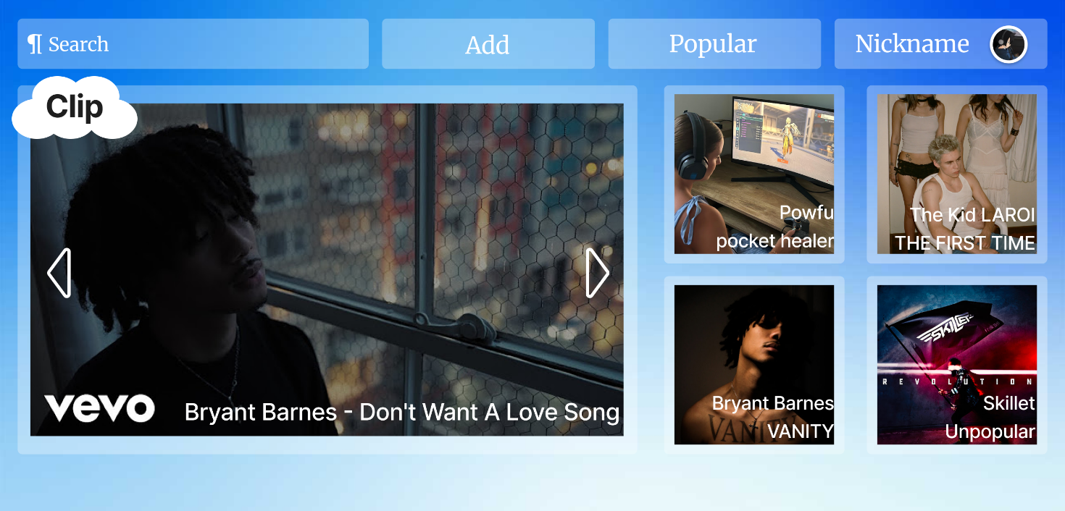

1. Secondly, find out if your song, album, video or artist is available on the server.

-On the top left we can find all music by album, clips or artist:

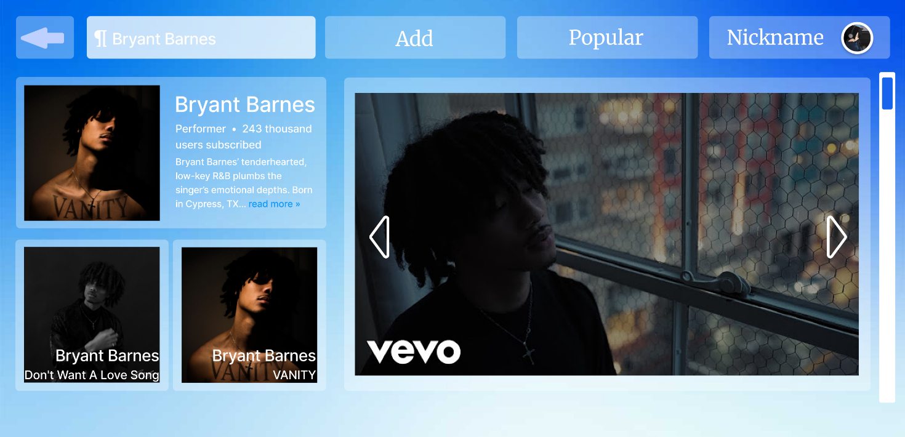

1. Thirdly, if your artist or music is not in the album clip, you can add it.

-To add something new, click on the add button and choose what you want:

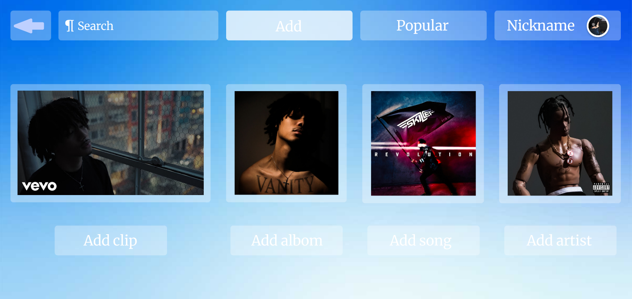

-After selecting, for example, adding a clip, select the artist name, clip name, add the clip url on YouTube and additional information, and save:

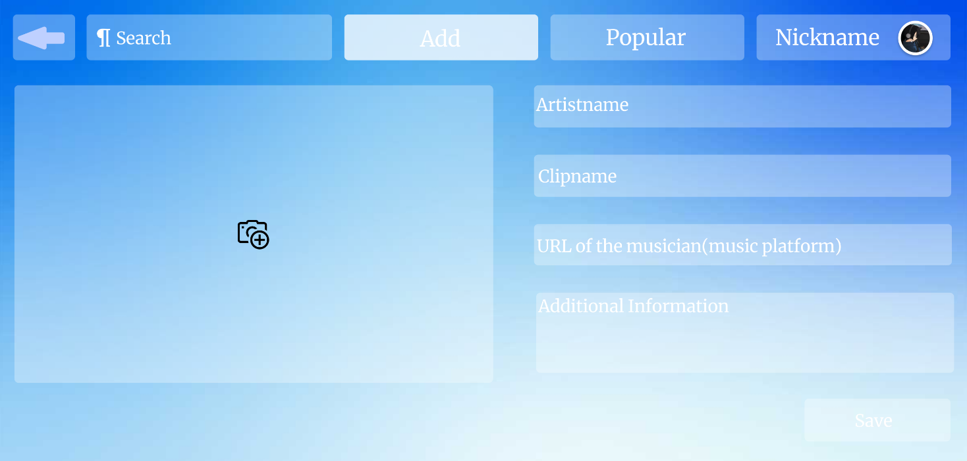

1. Fourth, if the artist or track album clip is already available, you can read reviews, see ratings and you can also write a review and leave a rating.

-When we go to the favorite music page, we see a picture of the artist's name, title and average rating from all reviews:

-If we scroll down to the bottom, we will see the reviews and ratings of each person:

