# **INTRODUCTION.**

 Analysis is the process of considering something carefully or using statistical method in order to understand it or explain it. Analysis helps to determine the exact needs of the stake holder and at the same time it enables the development team to communicate with the stakeholders in the language they understand such as charts, models instead of pages of text. It is a team effort that demands combination of hardware, software and human factors engineering expertise as well as skills in dealing with people. The activities involved in analysis process are:

* Feasibility study.
* Requirement.
* Use case.
* Prioritization.
* Architecture.

It is important to clearly identify the needs and specify the requirements of a project before starting it. The main purpose of analysis is to research the needs of people for particular work. With the help of statistical data, analysis helps to keep the biasness away from research conclusion.

SWOT Analysis.

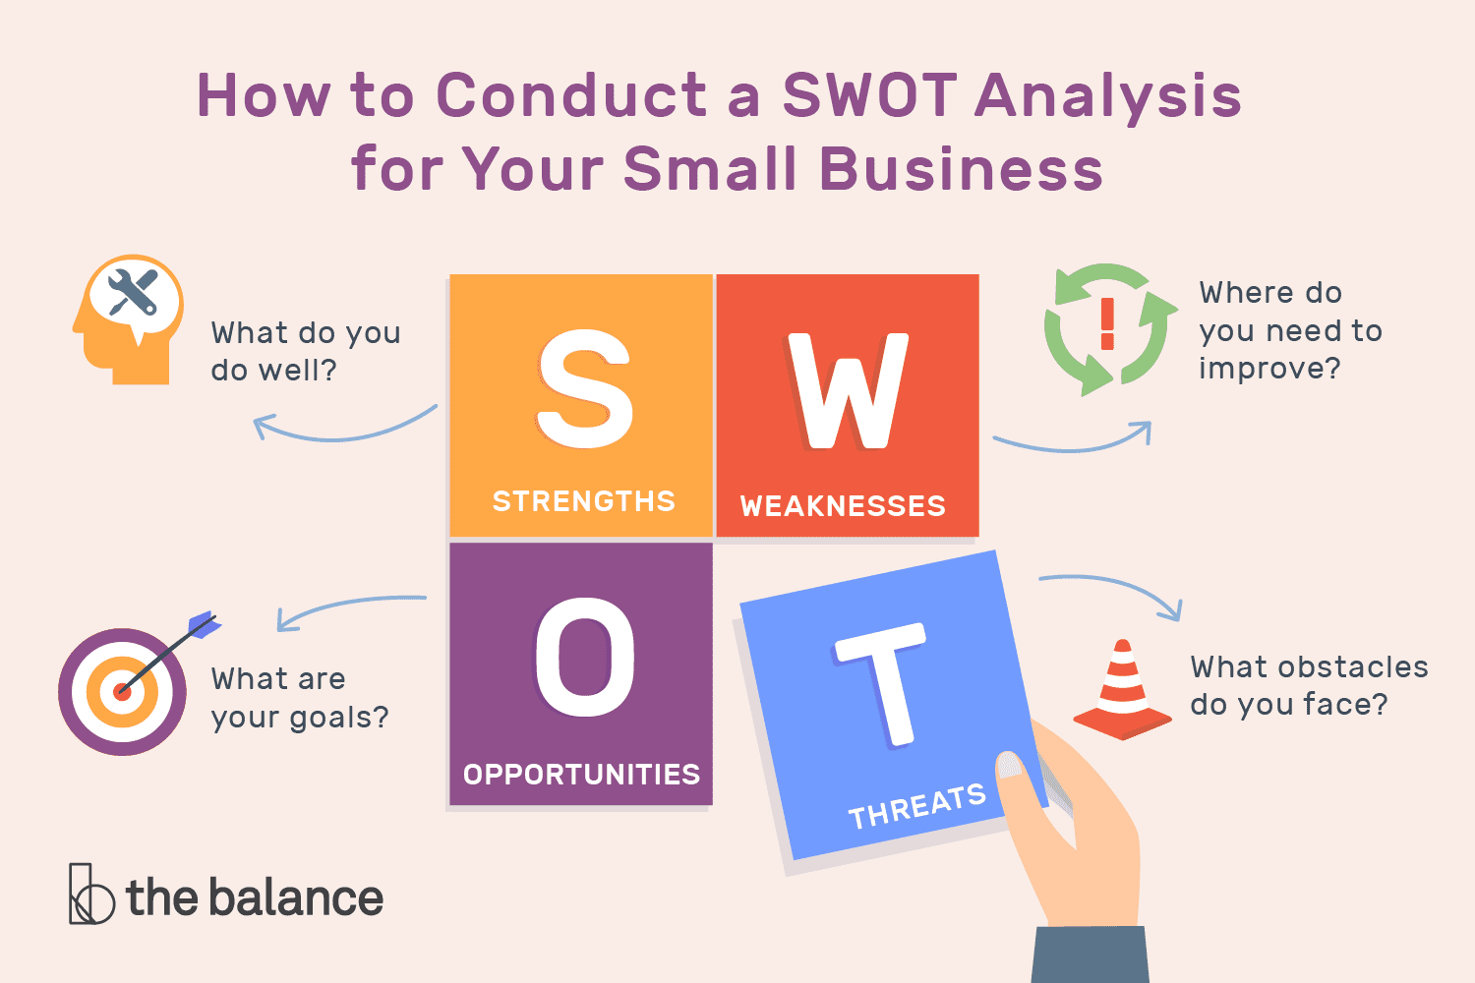

Figure 1: SWOT analysis

SWOT Analysis is an incredibly simple, yet powerful tool to help you develop your business strategy, whether you’re building a startup or guiding an existing company. SWOT stands for Strength, Weakness, Opportunities, Threat. Strength and Weakness are internal to a company whereas Opportunities and Threat are external. I have used this analysis because, SWOT (strengths, weaknesses, opportunities and threats) analysis can help us identify and understand key issues affecting our project, but it does not necessarily offer solutions. One should be aware of the limitations as well as the benefits of a SWOT analysis before they decide to conduct one.

Strength: Strengths are internal, positive attributes of my project. These are things that are within my control.

Weakness: Weaknesses are negative factors that detract from our strengths. These are things that we might need to improve on to be competitive.

Opportunities: Opportunities are external factors in our project environment that are likely to contribute to our success.

Threat: Threats are external factors that we have no control over. We may want to consider putting in place contingency plans for dealing them if they occur.

***Rich Picture***

Rich picture is a diagrammatic way of relating your own relation and perceptions to a given problem situation through identification and linking series of concepts. The creation of rich picture provides a forum in which to think about given situation. It is also possible to produce rich pictures as part of a group. By having everybody contribute to a rich picture they can be used to help develop a shared understanding of a given situation.

This document of analysis consists of different parts such as Feasibility study, Use-case, Requirement specification, Class diagram, Analysis Specification. Feasibility study section is described in Section 1, Requirement specification is described in Section 3 and similarly Class diagram is described in Section 4 and 5 respectively.

# **Feasibility Study.**

Feasibility study is counted as one of the important parts in the process of software development. It is important as it examines/determines whether a project is socially, technically, economically feasible or not. It also determines whether a project is cost effective or not, for this it undertakes cost-benefit analysis. There are may types of feasibility study, some of them are:

* ***Technical Feasibility:*** Does the company have the technological resources to undertake the project? Are the processes and procedures conducive to project success?
* ***Economic Feasibility:*** The economic feasibility study is more commonly called cost/benefit analysis. The project I have undertaken can be easily completed. I shall not face any economical problem.
* ***Legal/Ethical Feasibility:*** The project I am working on is an online news portal, this portal will provide news of local, global and regional. And I have made sure that project meets all legal and ethical requirements before the project is on the table.
* ***Schedule Feasibility:*** To complete this project resources such as OS, Web-browsers and XAMMP server are easily available. So, I can manage all these and hence it is feasible.

# **Requirement.**

Requirement Analysis is the process of defining the expectations of the users for an application that is to be built or modified, Requirement analysis involves all the tasks that are conducted to identify the needs of different stake holders. For the success of a project, it is utmost important to analyze the project requirements when they are gathered as well as throughout the lifecycle of the project. Requirement analysis helps to keep the requirement in line with the need of the business. For gathering the requirement, I have used following process and information planning is also done in a similar way.

* ***Questionnaire.***

Questionnaire are the set of questions that are typically used for research purpose which can be both qualitative as well as quantitative in nature. It should always consist of open minded and multiple-choice questions so that it would be much easier for a person to answer the questions. Questionnaires provide a relatively cheap, quick and efficient way of obtaining large amounts of information from a large sample of people. Data can be collected relatively quickly because the researcher would not need to be present when the questionnaires were completed.

* ***Interview.***

Interview is the easiest way to gather information. Interview helps to investigate issues in depth. It also helps to discover how an individual think and feel about the topic as well as they will also be able to discuss about sensitive topics which they are not able to discuss in focus groups. Though interviews are time consuming, we can get high response rate.

# 

# **Functional Requirement.**

Functional requirement defines fundamental action that a system must perform. Functional requirement specifies behavior and function of a system. some functional requirements of the system are:

* Registration.
* Login.
* Comment.
* Forum.
* Search post.
* Post Blog.
* Social media interaction.
* Space for advertisement.
* Delete.

|  |  |  |  |  |
| --- | --- | --- | --- | --- |
| Function ID | Title | Description | Purpose | Impact  (MoSCoW) |
| F1 | Registration | Admin of the page registers if he/she is new so that they can login later | To use the features of a system. | Must have |
| F2 | Login | Registered users can login to the system. | To access the system in a safe way. | Must have |
| F3 | Comment | Anyone can present their point of view to certain news. | To present a person’s point of view. | Should have |
| F4 | Forum | Medium where ideas and vies can be exchanged. | To exchange ideas with others. | Should have |
| F5 | Search Post | Allows to search for previous posts. | To search post. | Must have |
| F6 | Post Blog | Describes about certain issues. | To write about issues. | Should have |
| F7 | Advertisement | Allows different brand representation. | To advertise different rented brands. | Must Have |
| F8 | Social media interaction. | Can spread news to those who don’t read news. | To spread news to all people. | Must have |
| F9 | Delete. | Advertisement is deleted after it is rented up. | To delete advertisement after it is rented up | Should have |

Figure 2:Functional requirement.

# **Non-Functional Requirement.**

Those requirements that specifies how the system performs a certain function is called non-functional requirement. Non-functional requirements generally specify the system’s quality attributes or characteristics. Some of the non-functional requirements of Online News Portal are:

* Reliability.
* Availability.
* Security.
* Maintainability.

Reliability.

This specifies the factor required to establish the required reliability of the website system at time of response and proper security of authentication login.

Availability.

This system will be available through all the time.

Security.

All users will see the respective news without any security check. But if any user want to comment on specific news article, then the user have to be login with security check.

Maintainability.

This website is being developed in PHP framework. PHP is an object-oriented language and it is easy to maintain.

# **SRS.**

SRS stand for Software Requirement Specification of the system that is to be developed with functional and non-functional requirement. To make an agreement on requirement provided by client this is done between client and developer.

Software Requirement.

***Programming Language:*** PHP.

***Database:*** My SQL.

***UI Design:*** HTML, AJAX, JQUERY, JAVASCRIPT, BOOTSTRAP.

***Web Browser:*** Mozilla, Google Chrome/Other compatible browsers.

***Software Used:*** XAMPP Server.

# **MoSCoW Prioritization.**

One of the most common reasons to prioritize is to label the order in which work items are completed under the constraints of the project. **Prioritization helps you manage your requirements and your resources**. This includes people, time and budget**. With prioritization, you improve communication because you’re taking the guesswork out of the project. Prioritization also helps manage the unknown unknowns. With prioritization, people tend to rethink their requirements. Prioritization is also helpful when releasing software in phases.**If your project is such that you can deliver your software in increments, prioritization helps you determine what to include in each release.

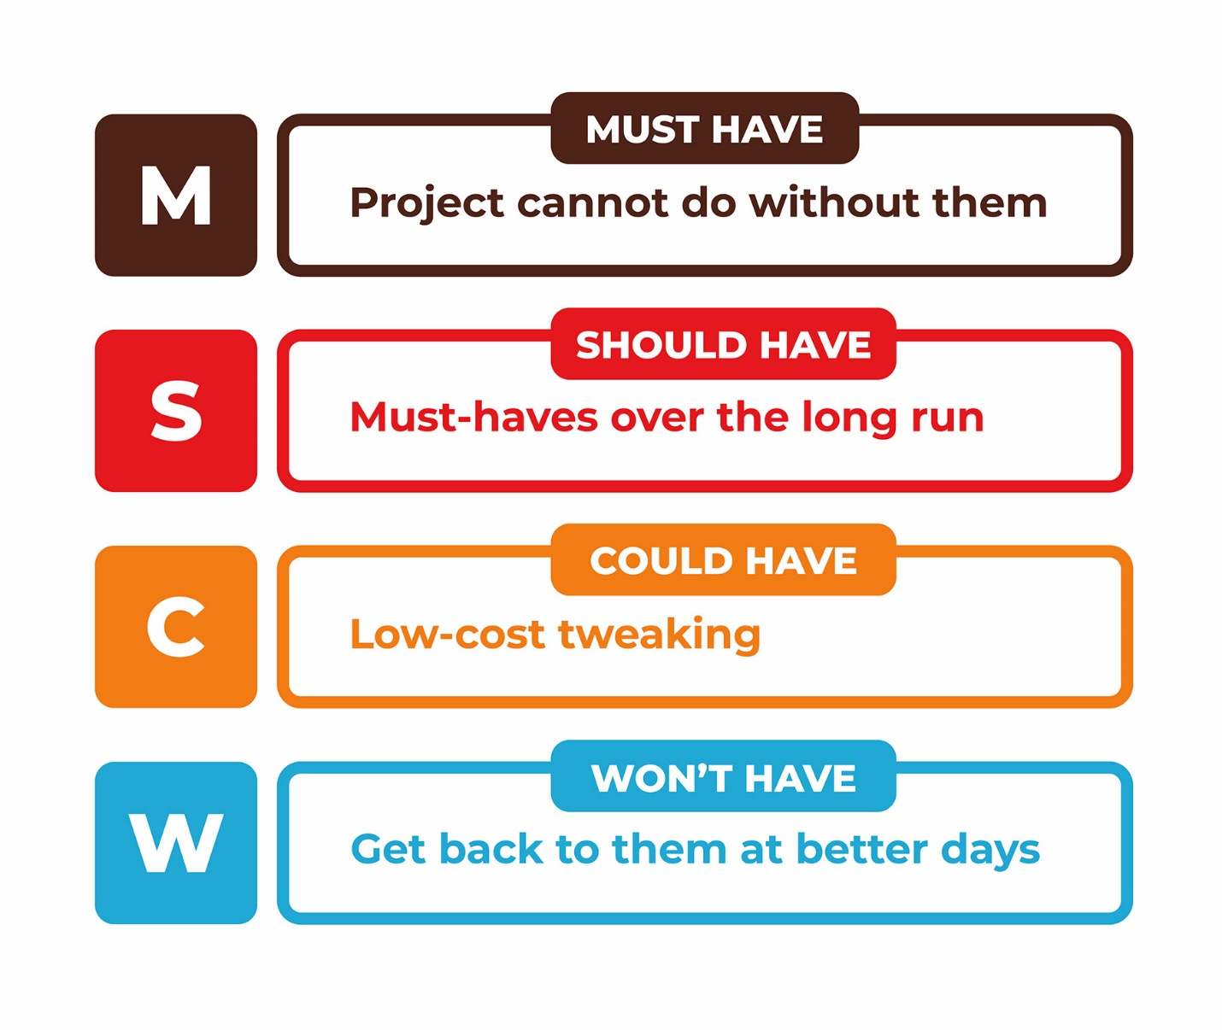

Figure 3:MoSCoW Prioritization Technique.

MoSCoW method is the prioritization technique that is originating from the dynamic software development method (DSDM). According to this technique, we can categorize our list of requirements into the following groups:

M – Must have. These requirements are non-negotiable. And the project will fail without them.

S – Should have. These requirements occupy the second place in the priority list.

C – Could have. A requirement that is desirable but not necessary. According to the method, this point will be removed first from scope if the project’s timescales are at risk.

W – Won’t have. A requirement that will not be implemented in a current release but may be included in a future stage of development. Such requirements usually do not affect the project success.

After this classification, all requirements are ranked in order of preference within every category.

Let’s take an example that I am going to buy a motorbike with an extra seat to travel with my friend on the weekends. The bike should have a low seat and a four-cylinder engine. Unlimited mobility is also important. My favorite color is red, so I want to have a red color body. I also want to get good wind protection.

It would be also nice to have Bluetooth connectivity for your iPod. In addition, you are fond of having a helmet with a double ventilation system…

Prioritization for this would be:

**M** – a new bike for traveling, an extra seat.

**S** – a low seat, a four-cylinder engine. Unlimited mobility.

**C** – a red color body, extra wind protection.

**W** – Bluetooth and a helmet with a double ventilation system.

|  |  |  |
| --- | --- | --- |
| ID | TITLE | PRIORITY |
| FR01 | Registration | Must Have |
| FR02 | Login | Must Have |
| FR03 | Comment | Should Have |
| FR04 | Forum | Should Have |
| FR05 | Search Post | Must Have |
| FR06 | Post Blog | Should Have |
| FR07 | Advertisement | Must Have |
| FR08 | Social Media interaction | Must Have |
| FR09 | Delete | Should Have |

Figure 4:MoSCoW Prioritization.

# **Use case.**

A use case diagram is a graphic depiction of the interactions among the elements of a system. Use case helps to capture the functional requirement of the system. Use cases have proved to be easily understandable by business users, and so have proven an excellent bridge between software developers and end users. Below is the interaction between admin and the user.

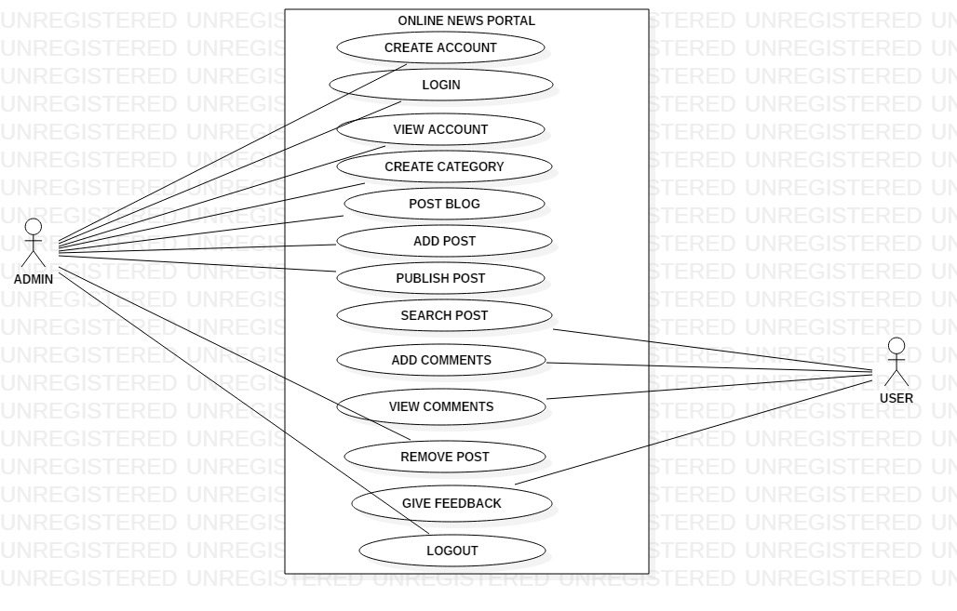

Figure 5: Use-case.

# **Initial Class Diagram (NLA).**

|  |  |
| --- | --- |
| Noun | Verb |
| Content, Role, Permission, User,  Advertisement, Media, Latest Post | Add, Edit, Search, Delete, Assign |

Figure 6:NLA.

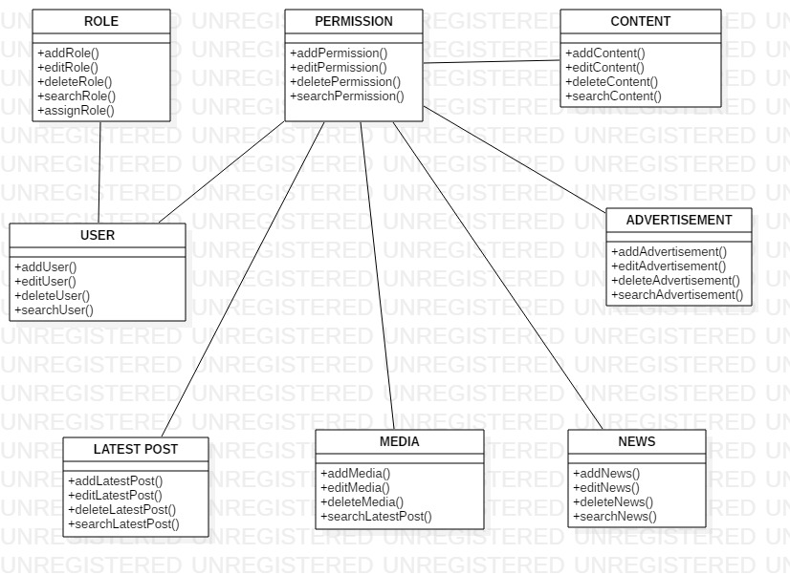

Figure 7:Initial Class Diagram.