TESTING.

Introduction.

Testing simply means the process of accessing features as well as functionality of the software. Testing can be called as a part in software development that consists of programming code and other documents. Testing helps in validation and verification of the software after we develop it.

In Software Development Life Cycle (SDLC), testing is an important phase. Testing comes when we finish the development of application by writing the code. Testing is done so that we can make sure that the system meets all the requirements that we specified in requirement phase before.

Importance of Testing.

Testing ensures the quality of product and quality product helps to gain the confidence of customers. Testing ensures the effective performance of the application. It can be expensive in future if there are any failure or the application doesn’t show result. Testing ensures the satisfaction and reliability of customer over the product. Users shall not be inclined to use the software that has pretty much bugs in it. So, testing is required to stay in a business.

Types of Testing.

To ensure that the application runs properly different test cases are run to ensure system performs as it is designed to. There are different types of testing and they are Blackbox Testing, Whitebox Testing, Unit Testing, Regression Testing etc. among all these testing, here I have performed two types of testing and they are Blackbox Testing and Unit Testing.

Blackbox Testing.

Blackbox testing is known as the high-level method of testing. In this testing only input and output are noticed by the users. Inner code, design, implementation etc. is not visible to the user.

Test name: Admin register.

|  |  |  |  |  |  |
| --- | --- | --- | --- | --- | --- |
| Test  ID. | Test Scenario. | Test Data. | Expected Result. | Actual Result. | Results. |
| Test1 | Registering new admin if not registered. | Name, email, password. | Register is successful if all the data is valid. | Result as expected. | Pass. |

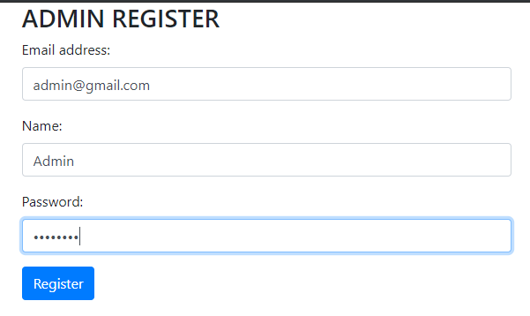

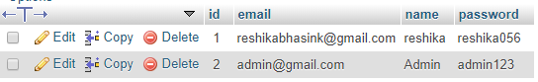

Test name: Admin login.

|  |  |  |  |  |  |
| --- | --- | --- | --- | --- | --- |
| Test  ID. | Test Scenario. | Test Data. | Expected Result. | Actual Result. | Results. |
| Test2 | Admin who registered logs in to system. | Username/email and password. | Login successful. | Result as expected. | Pass. |

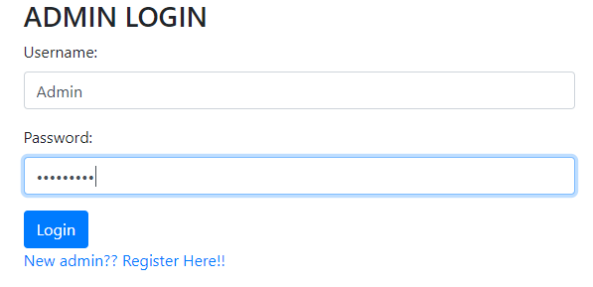

Test name: Adding category.

|  |  |  |  |  |  |
| --- | --- | --- | --- | --- | --- |
| Test  ID. | Test Scenario. | Test Data. | Expected Result. | Actual Result. | Results. |
| Test3 | Category needs to be added if we have to add new one. | Category name,  Description. | Category added. | Same as expected. | Pass. |

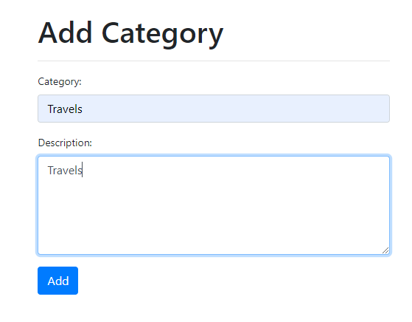

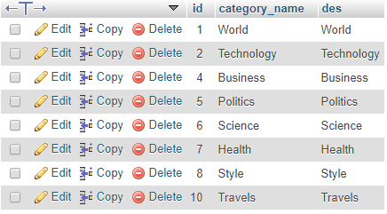

Test name: Delete Category.

|  |  |  |  |  |  |
| --- | --- | --- | --- | --- | --- |
| Test  ID. | Test Scenario. | Test Data. | Expected Result. | Actual Result. | Results. |
| Test4 | If we don’t want that category then we can delete it. | Category name,  Description. | Category deleted. | Same as expected. | Pass. |

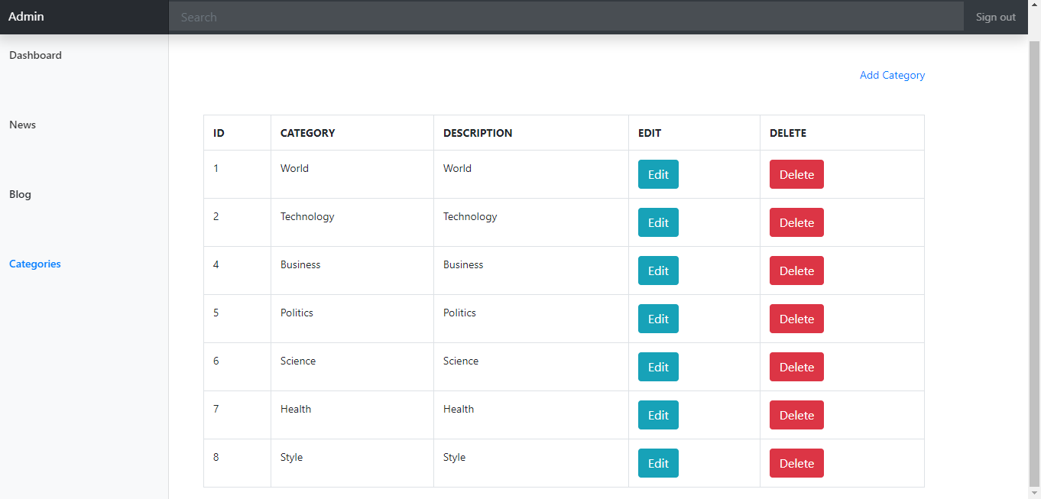

Test name: Add News.

|  |  |  |  |  |  |
| --- | --- | --- | --- | --- | --- |
| Test  ID. | Test Scenario. | Test Data. | Expected Result. | Actual Result. | Results. |
| Test5 | Add new News by admin. | Title,  Description,  Date,  Category,  Image. | News added. | Same as expected. | Pass. |

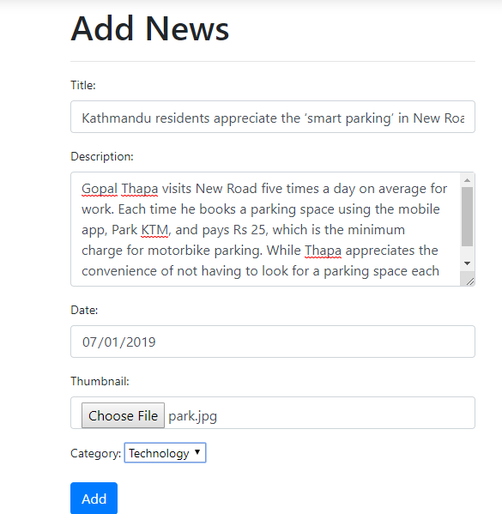

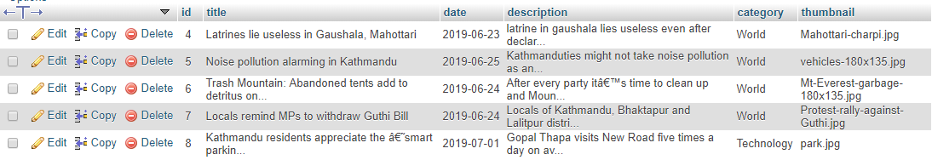

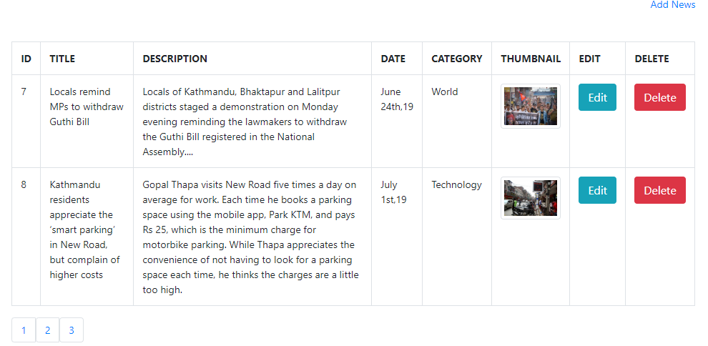

Test name: Delete News.

|  |  |  |  |  |  |
| --- | --- | --- | --- | --- | --- |
| Test  ID. | Test Scenario. | Test Data. | Expected Result. | Actual Result. | Results. |
| Test6 | Delete added News. | Title,  Description,  Date,  Category,  Image. | News deleted. | Same as expected. | Pass. |

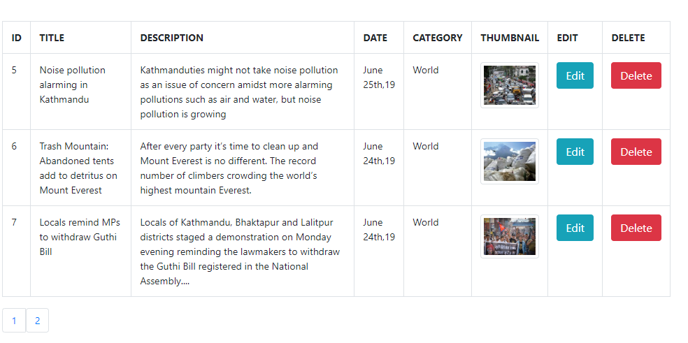

Test name: Same email.

|  |  |  |  |  |  |
| --- | --- | --- | --- | --- | --- |
| Test  ID. | Test Scenario. | Test Data. | Expected Result. | Actual Result. | Results. |
| Test7 | If admin inserts used email id. | Email,  Name,  Password. | Email already exists. | Same as expected. | Pass. |

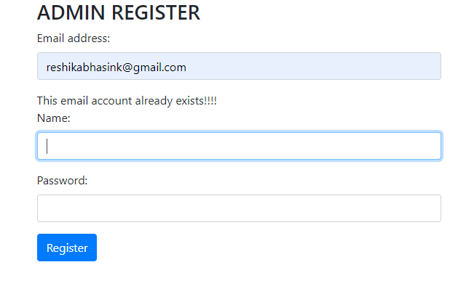

Test name: Adding category that exists.

|  |  |  |  |  |  |
| --- | --- | --- | --- | --- | --- |
| Test  ID. | Test Scenario. | Test Data. | Expected Result. | Actual Result. | Results. |
| Test8 | If category already exists. | Category name,  Description. | Category already exists. | Same as expected. | Pass. |

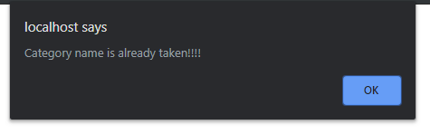

Test name: Logout.

|  |  |  |  |  |  |
| --- | --- | --- | --- | --- | --- |
| Test  ID. | Test Scenario. | Test Data. | Expected Result. | Actual Result. | Results. |
| Test9 | Admin logout. | Username,  Password. | Redirects page to Login page. | Same as expected. | Pass. |

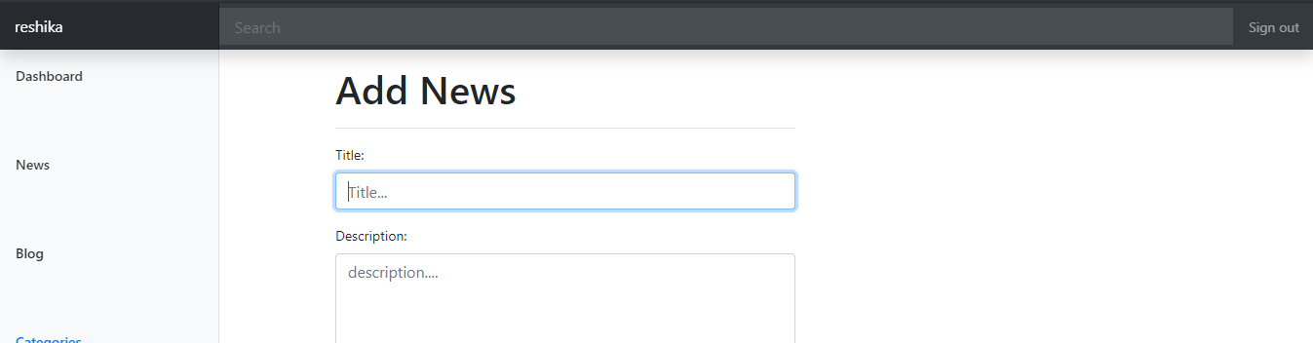

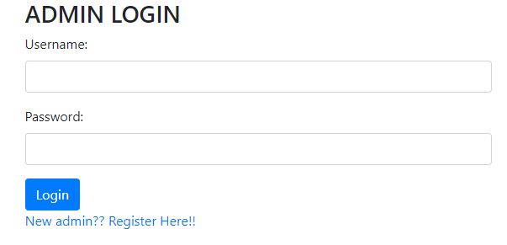

Test name: User profile update.

|  |  |  |  |  |  |
| --- | --- | --- | --- | --- | --- |
| Test  ID. | Test Scenario. | Test Data. | Expected Result. | Actual Result. | Results. |
| Test10 | Update user profile. | Email,  Username,  Password. | Updates the user information. | Same as expected. | Pass. |

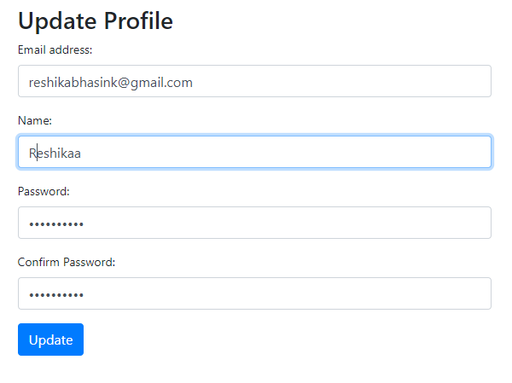

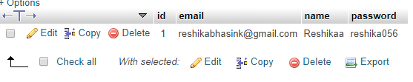

Unit Testing.

In unit testing, various components of the application are tested. This is done to make sure that every unit of system performs as it is designed for. By testing the code in this way, the code will be re-useable and reliable for the process of debugging. Some of the unit test that I have performed are given below:

Test name: Update.

|  |  |  |  |  |  |
| --- | --- | --- | --- | --- | --- |
| Test  ID. | Test Scenario. | Test Data. | Expected Result. | Actual Result. | Results. |
| Test1 | Updating data in system. | User data,  News,  Category. | Updated. | Same as expected. | Pass. |

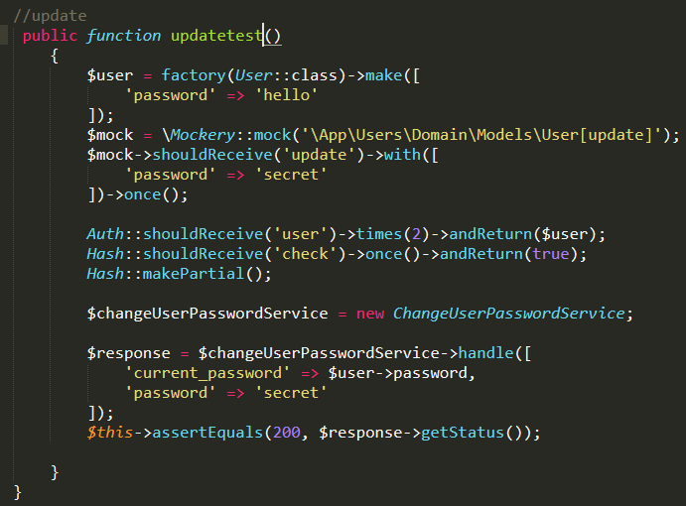

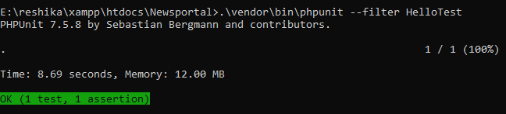

Test name: Login.

|  |  |  |  |  |  |
| --- | --- | --- | --- | --- | --- |
| Test  ID. | Test Scenario. | Test Data. | Expected Result. | Actual Result. | Results. |
| Test2 | logging in to system. | Name/Email,  password. | Logged in. | Same as expected. | Pass. |

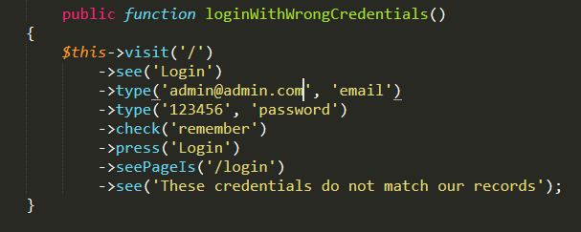

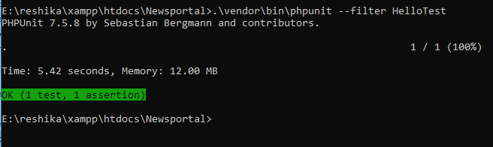

Test name: Register.

|  |  |  |  |  |  |
| --- | --- | --- | --- | --- | --- |
| Test  ID. | Test Scenario. | Test Data. | Expected Result. | Actual Result. | Results. |
| Test3 | Registering in to system. | Name,  Email,  password. | Registered. | Same as expected. | Pass. |

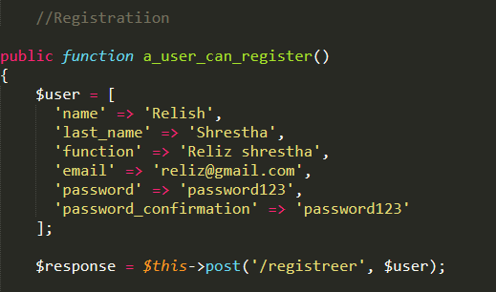

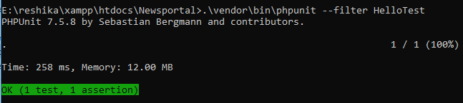

Test name: Delete.

|  |  |  |  |  |  |
| --- | --- | --- | --- | --- | --- |
| Test  ID. | Test Scenario. | Test Data. | Expected Result. | Actual Result. | Results. |
| Test4 | Deleting the data in system. | Name,  Email,  password. | Deleted. | Same as expected. | Pass. |

