Department of Electrical & Electronics Engineering
Microcontroller Lab – III Semester

MINI PROJECT SYNOPSIS

ELECTRIC THEFT DETECTION SYSTEM USING AN 8051 MICROCONTROLLER

Submitted by

Name | Roll Number | Reg No | Batch | Signature
ATLA DURGA HARSHA VARDHAN | 03 | 240906010 | C-1
HRISHIKESH DHABADE | 04 | 240906022 | C-1
ARAVINDAN S P | 08 | 240906104 | C-1
MEGHA SARALAYA | 14 | 240906260 | C-1

Date of Submission: 06-09-2025

 | CONTENTS | Page No.
1. | Problem Statement, Abstract | 1
2. | Methodology, Block Diagram | 2
3. | Hardware Requirements, Applications, Advantages | 3
4. | Expected outcomes, Conclusion | 4
5. | References | 5

PROBLEM STATEMENT
Design system level solutions or processes for engineering problems that meet the specified needs with appropriate consideration for public health and safety, and cultural, societal, and environmental considerations with an understanding of the limitations.

ABSTRACT
Electric power theft is a significant problem that causes heavy losses to utility companies and affects genuine consumers by overloading distribution systems. Consumers often bypass or tamper with energy meters to use electricity illegally, which traditional meters cannot effectively detect. To address this issue, the proposed project implements an Electricity Theft Detection System using an 8051-Microcontroller.

The system monitors energy flow between the power distribution line and the consumer meter using two current transformers (CTs) placed before and after the meter. The microcontroller continuously compares the input and output readings, and if discrepancies are detected—indicating unauthorized usage through illegal tapping or meter tampering—it immediately triggers an alert using a buzzer or LED.

This approach provides a low-cost, reliable, and efficient solution to detect electricity theft, reduce revenue losses, and promote fair energy usage. The system can also be extended with communication modules for remote monitoring and reporting to authorities.

METHODOLOGY
- Two current sensors (CT1 before the meter, CT2 after the meter).
- Signals conditioned with comparator (LM393).
- 8051 compares both readings.
- If CT1 > CT2 → theft detected.
- Output alert via buzzer/LED.

BLOCK DIAGRAM
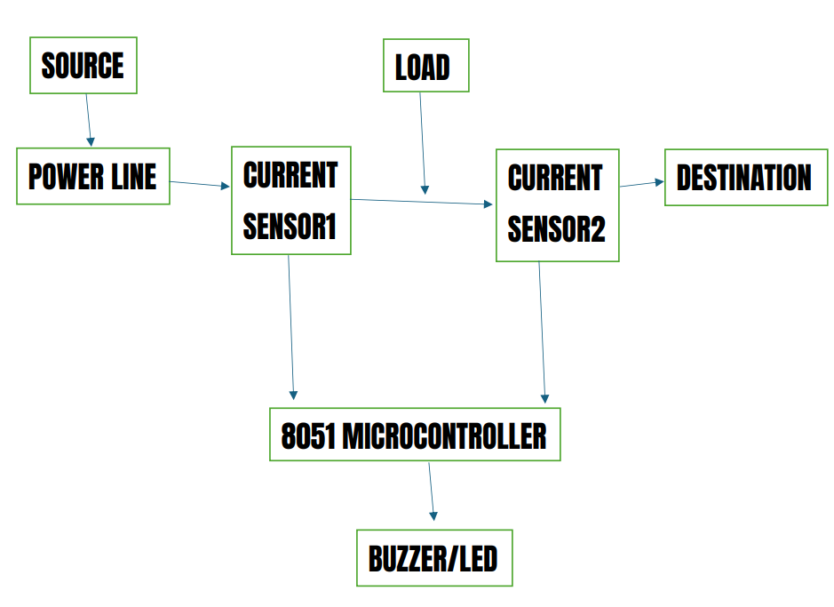

HARDWARE REQUIREMENTS
- 8051 Microcontroller (AT89S52 / AT89C51)
- Crystal Oscillator (11.0592 MHz) with Capacitors and Reset Circuit
- Current Sensors (2 × CTs or ACS712 modules)
- Comparator IC (LM393) (if CTs are used)
- 16×2 LCD Display (for real-time monitoring, optional)
- Buzzer (alert indicator)
- Resistors, Diodes, and Capacitors (supporting components)
- Regulated Power Supply
- Breadboard / PCB and jumper wires for connections

APPLICATIONS
- Domestic and industrial electricity meters.
- Power distribution monitoring.

ADVANTAGES
- Low-cost, simple to implement.
- Helps utilities reduce power theft.
- Can be scaled with GSM / IoT modules.

EXPECTED OUTCOMES
- The system will successfully detect electricity theft by comparing current values before and after the energy meter using two current sensors.
- In case of illegal tapping or meter tampering, the 8051 microcontroller will identify discrepancies and immediately activate a buzzer and/or LED to indicate theft.

CONCLUSION
The project successfully detects electricity theft by comparing currents before and after the meter and alerts with a buzzer.

Scope for extension: wireless communication, automatic disconnection, cloud monitoring.

REFERENCES
[1] K. B. Geetha, “Identification of power theft using micro controller,” International Journal of Trend in Scientific Research and Development (IJTSRD), vol. 2, no. 1, pp. 1767–1772, Dec. 2017. [Online].
https://www.ijtsrd.com/engineering/electronics-and-communication-engineering/7134/identification-of-power-theft-using-micro-controller/geetha-k-b

[2] T. Wable, C. R. Gawandhe, S. M. Bhabad, S. T. Gaikwad, Y. B. Tambe, and K. V. Shirole, “Microcontroller based system to detect power theft by using CT and PT,” International Journal for Research in Applied Science & Engineering Technology (IJRASET), vol. 13, no. 5, May 2025. [Online].
https://www.ijraset.com/research-paper/microcontroller-based-system-to-detect-power-theft-by-using-ct-and-pt

[3] R. Kavyashree, B. P. Namratha, M. Nayana, and N. S. Raikar, “Power theft detection and monitoring system,” TIJER – International Research Journal, vol. 10, no. 6, Jun. 2023. [Online].
https://tijer.org/tijer/papers/TIJER2306280.pdf

[4] S. M. Raghute, A. K. Chakole, S. R. Kharde, and R. G. Solanke, “Power stolen prevention by using PIC16882 microcontroller,” International Research Journal of Engineering and Technology (IRJET), vol. 5, no. 3, pp. 2924–2928, Mar. 2018. [Online].
https://www.irjet.net/archives/V5/i3/IRJET-V5I3670.pdf

