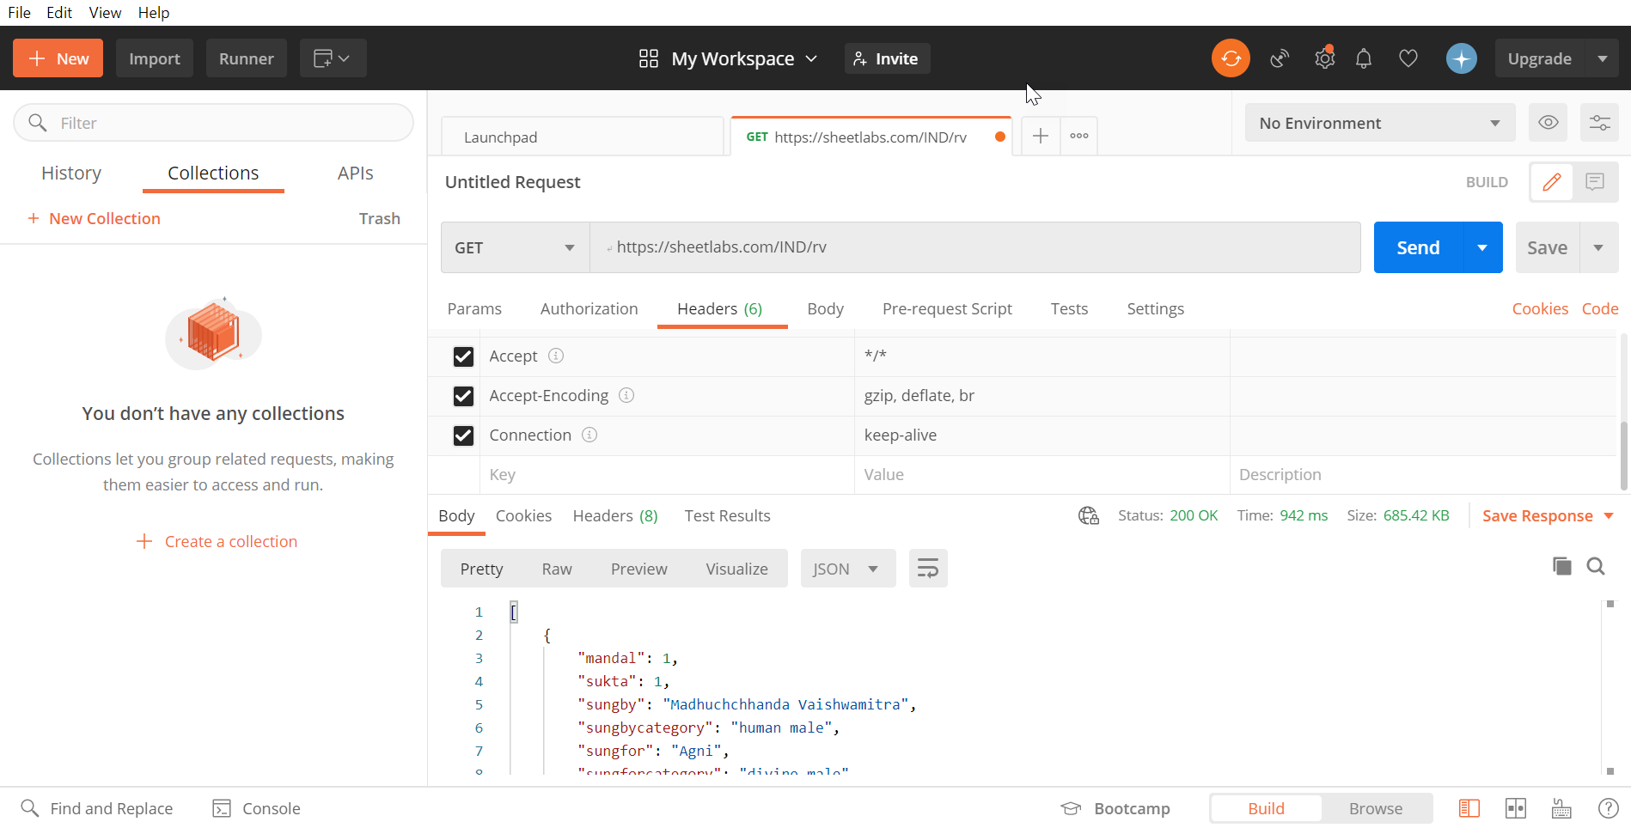

# Overview of Vedic APIs

These APIs make available to you two kinds of data: data regarding the gods and poets, their categories, and poem meters used in all the Rig Veda verses, and data regarding the descriptions of all the nouns (except proper nouns) mentioned in Vedic literature. All the data in the Vedas, presented as JSON or XML objects through APIs.

# Making requests to the APIs

The following APIs are available:

* rv: The Rig Veda API. Returns the gods and poets, their categories, and the meters from all the Rig Veda verses, together with the mandal and sukta number.
* vs: The Vedic Society API. Returns the descriptions of all nouns (names, places, animals, things) from the entire Vedic literature.

# Authentication and Authorization

Not needed. These are open APIs.

# Rate limits

The APIs are hosted on [Sheetlabs](https://www.sheetlabs.com/), which limits the monthly API calls (for free accounts like mine) to 10,000. This limit includes all of us making all our calls to all these APIs.

# Response Codes

The status of a response can be determined from the HTTP status code.

|  |  |  |
| --- | --- | --- |
| **Code** | **Status** | **Description** |
| 200 | OK | Request successful |
| 400 | Bad Request | Request was invalid |
| 401 | Unauthorized | User does not have permission |
| 403 | Forbidden | Request not authenticated |

# Getting started

This article explains how to return information of Gods and Poets.

# Request URL

Get api/rv

This endpoint allows you to learn aboutthe Rig Ved. Returns the gods and poets, their categories, and the meters from all the Rig Veda verses, together with the mandal and sukta number.

# Endpoints

JSON output is returned by the following endpoints:

* Method: Get
* URL: https://sheetlabs.com/IND/rv

# Parameters

|  |  |  |  |  |
| --- | --- | --- | --- | --- |
| **Parameter** | **Value** | **Description** | **Parameter Type** | **Data Type** |
| mandal | Optional | ID of the mandala book in Rig Veda. | query | integer |
| sukta | Optional | ID of the hymn in Rig Veda. | query | integer |
| sungby | Optional | Name of the poet who has sung the hymn. | query | string |
| sungbycategory | Optional | Category of the poet. | query | string |
| sungfor | Optional | The God to whom the hymn is sung. | query | string |
| sungforcategory | Optional | Category of the Gods to whom the hymn is dedicated to. | query | string |
| meter | Optional | poetic meter in the Vedic literature. | query | string |

# Response Header: 200

# Response Content Type: JSON

# Sample Response:

[

{

"mandal": 7,

"sukta": 43,

"sungby": "Vasishth Maitravaruni",

"sungbycategory": "human male",

"sungfor": "Vishwadeva",

"sungforcategory": "divine male",

"meter": "Trishtup"

},

{

"mandal": 7,

"sukta": 43,

"sungby": "Vasishth Maitravaruni",

"sungbycategory": "human male",

"sungfor": "Agni",

"sungforcategory": "divine male",

"meter": "Trishtup"

},

{

"mandal": 7,

"sukta": 44,

"sungby": "Vasishth Maitravaruni",

"sungbycategory": "human male",

"sungfor": "Dadhikra",

"sungforcategory": "animal",

"meter": "Jagati"

}

]