 | Action | Narration
1
2
3
4
5
6
7
8
9
10
11
12

Tips for using this script template: (Delete everything after this, when using)
There are a few different types of script templates you can use. This template is excellent for narration-driven videos that are focused on learning, like a tutorial.

The numbers are helpful for keeping track of each line and for reference purposes. If you need to translate your script into multiple languages, the numbers can also keep each piece of narration connected to the right line.

In the action column, make notes of what should be happening or use the space to connect to your storyboard. If you are creating a screen video, you may want to drop in screenshots of the action.

For the narration column, try to keep each cell to a single sentence at most. This makes it easier for the narrator to read. It also helps with translation and editing. If you are using a narrative style, each line should be one action, one shot, or one character’s dialog.

If you need more lines, add them. Or if you want to have translations in this document, add another column for the translated version of the script.

Example – Tutorial, Narration Driven
 | Action | Narration
1 | Built-in narration to be cut out later during editing… | Hello and welcome to this video tutorial on how to use the Microsoft Windows® calculator.
2 | Optional: insert a title slide during this audio, and then transition to recording | I’m going to show you how to copy calculations made on the Windows calculator and paste the results into a Notepad document.
3 | An opportunity to use callouts to point to different parts of the screen | As you can see, Notepad is open on the left side of my screen, and the calculator is here on the right.
4 | Zoom in on the calculator  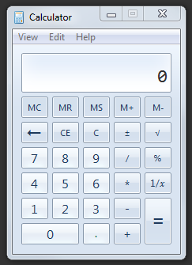 | For this demonstration, let’s just perform a simple subtraction problem.
5 | Silence the “Ummm” during editing… | Ummm…Enter the current year, and then subtract the year you were born…and click equals.
6

This example could continue, but it gives you an idea of how to set up anarration-driven tutorial (how-to).

Example – Narrative, Dialogue-Driven
 | Action | Narration
1 | Establishing shot, music plays
2 | Matt & Kyle in studio (Storyboard 3) Music fades
3 | Matt | Kyle, thanks for making time to show me how to create a green screen video.
4 | Kyle | No problem. What is it you want to know.
5 | (Storyboard 4) Matt | You know, I don’t even know where to begin.
6 | (storyboard) Camera swings to Kyle
7 | Kyle | Well, let’s get started.
8

This example is very limited but gives an idea of how you might set up your script and how it may differ from a tutorial, narration-driven video script.

