Overview
A value assignment rule contains the following components:
- Value Assignment Rule: A powerful set of rules to enact bulk changes based on the set of applicability criteria.
- Comparison Rule: Criteria based on which the source datasets are compared against the target datasets.
- Applicability Criteria: Criteria based on which the VAR runs. For example, if you add Client X as an applicability criteria then, the documents associated with that client are extracted or compared when the VAR runs.
- Dependencies: All the value assignment rules dependent on a specific rule. If you run this rule, all its dependent rules are also triggered.

To create a value assignment rule, you must perform the following steps:
- Add a value assignment rule in inactive status.
- Add a comparison rule, only if you want to compare two datasets.
- Add the applicability criteria.
- Modify the value assignment rule to activate it.
- Run the value assignment rule if you want to instantly run the rule without waiting for standard 30 minutes cycle.

About Value Assignment Rules
A value assignment rule (VAR) is an automated rule that enact bulk changes on the transactions and reduce the human effort to manually update their status/field values.
The existing VARs are common for all the clients. If you want to add a VAR for a specific client, you can add the client’s name as an applicability criterion. For more information, refer to the ‘Adding an Applicability Criteria’ topic.
To view the Document Distribution, navigate to Solvas|Digitize > System Setup > Dataset > Value Assignment.
You can use this tab for:
- Adding a Value Assignment Rule
- Modifying a Value Assignment Rule
- Deleting a Value Assignment Rule
- Runing a Value Assignment Rule

Important: You must have Administrator privilege with valid permissions to add, delete, and run a value assignment rule.

Adding a Value Assignment Rule
You can create a value assignment rule whenever you want to implement rules for a specific dataset.
To add a value assignment rule:
- Go to Solvas|Digitize > System Setup > Dataset > Value Assignment.
The Value Assignment Rule Set page appears.
- Click Add.
The Add Assignment Rule Set window appears.
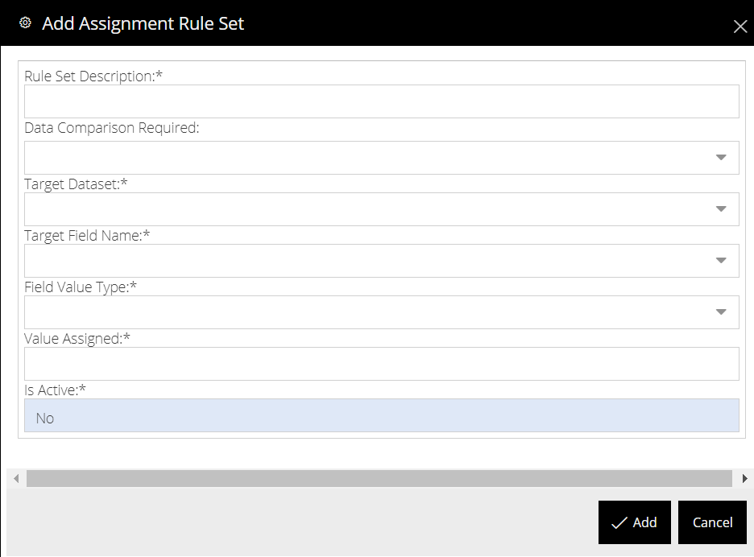
- In the Add Assignment Rule Set window, specify the appropriate options as described in the following table.
Field | Description
Rule Set Description | Enter a sequence number and a description of the rule. The sequence number specifies the order in which the rule runs. For example, to run a rule first in the order, include 01.00 as the sequence number followed by the description of the rule.
Data Comparison Required | Select a value from this drop-down list to denote if a data comparison is required.  Note: Select Yes only if you are creating a comparison between two datasets.
Target Dataset | Select a dataset of the target field from this drop-down list, for example, Loan Notices. The source dataset is compared with the target dataset.
Source Dataset | Select a dataset for the source field from this drop-down list. This field appears only when you select Yes in the Data Comparison Required drop-down list.
Target Field Name | Select a target field from this drop-down list.
Field Value Type | Select the type of rule that you wish to create. The available options are Value and Field.
Value Dataset | Select the dataset to which the value belongs.  Note: This field will appear if you select Field in the Field Value Type drop-down.
Value Assigned | Specify the value that you want to assign.
Is Active | Select a value to denote if the value assignment rule is active. By default, the value selected in this drop-down list is No. It is recommended that you create a VAR in inactive state and then assign the applicability criteria, dependencies, and comparison rules, if required, and then activate it.

- Click Add.
The value assignment rule is created.

Next Steps
Perform the following tasks to complete a value assignment rule.
Adding a Comparison Rule
Adding Applicability Criteria
Understanding Dependencies

Modifying a Value Assignment Rule
You can modify a value assignment rule whenever you want to update a rule. Modifying the value assignment rules do not modify the corresponding applicability criteria and comparison rules.
To modify a value assignment rule:
- Go to Solvas|Digitize > System Setup > Dataset > Value Assignment.
The Value Assignment Rule Set page appears, displaying a list of existing value assignment rules.
- Select a rule that you want to modify, and then click Edit.
The Edit Value Assignment Rule Set window appears.
- As needed, modify the appropriate values, and then click Update.
Note: If you have previously created a value assignment rule and want to activate it, select Yes in the Is Active drop-down list.
The changes made to the value assignment rule is saved.

Deleting a Value Assignment Rule
If you no longer want to use a value assignment rule, you can delete it. You can delete more than one VARs at a time.
To delete:
- Go to Solvas|Digitize > System Setup > Dataset > Value Assignment.
The Value Assignment Rule Set page appears, displaying a list of existing value assignment rules.
- Select the rule that you want to delete.
- Click Delete.
A message appears asking you to confirm.
- Click Continue.
The value assignment rule and the corresponding applicability criteria and comparison rules are deleted.

Running a Value Assignment Rule
The value assignment rules run every 30 minutes when the documents are imported to Solvas|Digitize and on the completion of the data extraction and review process. These value assignment rules run in the sequence in which they are defined.
However, you can also run a rule instantaneously after you create it without waiting for the next schedule. It is recommended to be extremely cautious while running a rule as it can trigger the rest of the dependent rules.

To run a VAR manually:
- Go to Solvas|Digitize > System Setup > Dataset > Value Assignment.
The Value Assignment Rule Set page appears, displaying a list of existing value assignment rules.
- Select the value assignment rule that you want to run.
- Click Run.
The selected value assignment rule runs and triggers all the dependent rules associated with this rule.

About Comparison Rules
A comparison rule denotes the criteria based on which the source datasets are compared against the target datasets.
Using this tab, you can:
- Add a Comparison Rule
- Modify a Comparison Rule
- Delete a Comparison Rule

Adding a Comparison Rule
You can add a comparison rule when you want to compare two datasets. In general, the source dataset is compared against the target dataset. Before you create a comparison rule, you must determine the target and source datasets.
Note: The Comparison Rule tab is enabled only when you have specified the Data Comparison Required as Yes, while creating a VAR.

To add a comparison rule:
- Go to Solvas|Digitize > System Setup > Dataset > Value Assignment.
The Value Assignment Rule Set page appears, displaying a list of existing value assignment rules.
- Select the value assignment rule to which you want to add the comparison rule.
- Click the Comparison Rule tab. The Comparison Rule pane appears.
- Click Add in the Comparison Rule pane. The Add Comparison Rule window appears.
- In the Add Comparison Rule window, provide the values as specified in the following table.the
Field | Description
Target Dataset Field | Select the dataset of the target field.
Operator | Select the appropriate operator from the following list:
  Operator | Description
  = | Checks if the values of target and source dataset fields are equal.
  > | Checks if the value of the source dataset field is greater than the value in the target dataset field.
  < | Checks if the value of the source dataset field is lesser than the value in the target dataset field.
  >= | Checks if the value of the source dataset field is greater than or equal to the value in the target dataset field.
  <= | Checks if the value of the source dataset field is lesser than or equal to the value in the target dataset field.
  <> | Checks if the value of the source dataset field is not equal to the value in the target dataset field.
  Between | Checks if the value of the source dataset field lies in between the value of the target dataset field.
  In List | Checks if the value in the source dataset field is available in the list.
  Not in List | Checks if the value in the source dataset field is not available in the list.
  Empty | Checks if the value in the source dataset field is empty.
  Not Empty | Checks if the value in the source dataset field is not empty.
Source Dataset Field | Select the dataset of the source field.
Function | Select the appropriate logical functions from the following list:  Note: This option will not appear for the first comparison rule. If you create a comparison rule for an existing value assignment rule, the default function appears as ‘And’.
  Function | Description
  AND | Checks if two or more comparison rules are true.
  OR | Checks if at least one of the comparison rules is true.
Threshold | Select a value from this drop-down list to denote the maximum threshold or deviation of the source dataset field value from the target dataset field value. This field appears only for a few target dataset fields. For example, All In Rate.
- Click Add.
The comparison rule is created.

Next Steps
Adding Applicability Criteria
Understanding Dependencies

Modifying a Comparison Rule
You can modify a comparison rule whenever you want to modify the comparison criteria between two datasets.
To modify a comparison rule:
- Go to Solvas|Digitize > System Setup > Dataset > Value Assignment.
The Value Assignment Rule Set page appears.
- Select the value assignment rule whose comparison rule you want to modify.
- Select the comparison rule that you want to modify, and then click Edit.
The Edit Comparison Rule window appears.
- As needed, modify the appropriate values, and then click Update.
The changes made to the comparison rule are saved.

Deleting a Comparison Rule
If you no longer want to use a comparison rule, you can delete it.
To delete a comparison rule:
- Go to Solvas|Digitize > System Setup > Dataset > Value Assignment.
The Value Assignment Rule Set page appears, displaying a list of existing value assignment rules.
- Select the value assignment rule whose comparison rule you want to delete.
- Select the comparison rule that you want to delete, and then click Delete.
A message appears, asking you to confirm.
- Click Continue.
The selected comparison rule is deleted.

About Applicability Criteria
The Applicability criteria are the conditions based on which the value assignment rules run. For example, if you add Client X as an applicability criteria then, the documents associated with that client are extracted or compared when the VAR runs.
Using the Applicability Criteria tab, you can perform the following tasks:
- Add an Applicability Criteria to a value assignment rule.
- Modify an Applicability Criteria
- Delete an Applicability Criteria

Adding Applicability Criteria
You can define applicability criteria to define the criteria for specific dataset fields based on which the rule runs. You can also run the rule whenever there a dataset field is modified.

To add applicability criteria:
- Go to Solvas|Digitize > System Setup > Dataset > Value Assignment.
The Value Assignment Rule Set page appears, displaying a list of existing value assignment rules.
- Select the value assignment rule to which to want to add the applicability criteria.
- Click the Applicability Criteria tab.
The Applicability Criteria pane appears.
- Click Add in the Applicability Criteria pane. The Add Applicability Criteria window appears.
- In the Add Applicability Criteria window, provide values as specified in the following table.
Field | Description
Dataset Name | Select the dataset name from this drop-down list.
Dataset Field | Select a field from this drop-down list.
Operator | Select the appropriate operator from the following list:
  Operator | Description
  = | Checks if the dataset field value is equal to the value you defined in the Value field.
  > | Checks if the dataset field value is greater than the specified value.
  < | Checks if the dataset field value is lesser than the specified value.
  >= | Checks if the dataset field value is greater than or equal to the specified value.
  <= | Checks if the dataset field value is lesser than or equal to the specified value.
  <> | Checks if the dataset field value is not equal to the specified value.
  Between | Checks if the dataset field value lies in between range of the Value and Value 2 fields.
  Empty | Checks if the dataset field value is empty.
  Not Empty | Checks if the dataset field value is not empty.
Value | Specify a value for the field selected.
Function | Select the appropriate logical functions from the following list:
  Function | Description
  AND | Checks if all the applicability criteria are true.
  OR | Checks if one of the applicability criteria is true
Execute upon Field Modification | Select the appropriate option to run the value assignment rule whenever the value of the dataset field changes. By default, the value selected in this drop-down list is No.
  Option | Denotes
  Yes | The assignment rule runs whenever the field is ever modified
  No | The assignment rule will run during the traditional 30 minute sync time frame.
- Click Add.
The applicability criteria is created for the selected value assignment rule.

Next Steps
Understanding Dependencies

Modifying Applicability Criteria
You can modify an applicability criteria whenever you want to modify how a rule is applied for the selected dataset.
To modify:
- Go to Solvas|Digitize > System Setup > Dataset > Value Assignment.
The Value Assignment Rule Set page appears.
- Select the value assignment whose applicability criteria you want to modify.
- Click the Applicability Criteria tab.
- Select an applicability criteria from the list, and then click Edit.
The Edit Applicability Criteria window appears.
- As needed, modify the appropriate values, and then click Update.
The changes made to the applicability criteria are saved.

Deleting an Applicability Criteria
If you no longer want to use applicability criteria, you can delete it.
To delete:
- Go to Solvas|Digitize > System Setup > Dataset > Value Assignment.
The Value Assignment Rule Set page appears.
- Select the value assignment whose applicability criteria you want to delete.
- Select an applicability criteria from the list, and then click and then click Delete.
A message appears, asking you to confirm that you want to delete the applicability criteria.
- Click Continue.
The selected applicability criteria is deleted.

Understanding Dependencies
The Dependencies in a value assignment rule denotes a list of all the value assignment rules which have references to the dataset field mapped while creating the rules. If you run a specific rule, all its dependent rules are also triggered.
To view the dependencies of a value assignment rule:
- Go to System Setup > Configuration > Value Assignment.
The Value Assignment Rule Set page appears, displaying a list of existing value assignment rules.
- Select the value assignment rule from the list.
- Click the Dependencies tab.
A list of dependencies associated with the dataset fields used in this value assignment rule appears.

