Preinstallation Requirements

Software Requirements

- Microsoft .NET Framework 4.7
- Docker version 18.0 or later
- Windows 10 (64-bit) or later
- Windows Server 2016
- SQL Server 2016 (64 bit) for discrete (not required for process)
- Browsers
  - Chrome v65.0+
  - Ubuntu

- RabbitMQ
- Cloud Foundry UAA
  - UAAC_setup script. Run on the UAA server.
  - This will create the UAA groups required for the Universal Client.
- Apache CouchDB

Hardware Requirements

Install Docker and Set up the Requirements
Before you begin installing the PA Installer, you must install Docker version 18.0 or later and make the following settings.
- Download the Docker application from download.docker.com.
- Follow the install wizard to accept the license, authorize the installer, and proceed with the installation.
- Right-click the Docker icon in the task bar and select Settings.
The General screen appears.
- In the Shared Drives screen, select C drive as your preferred local drive for the container. If you do not select the C drive, an error message appears that there is not enough memory while launching the Plant Applications services.
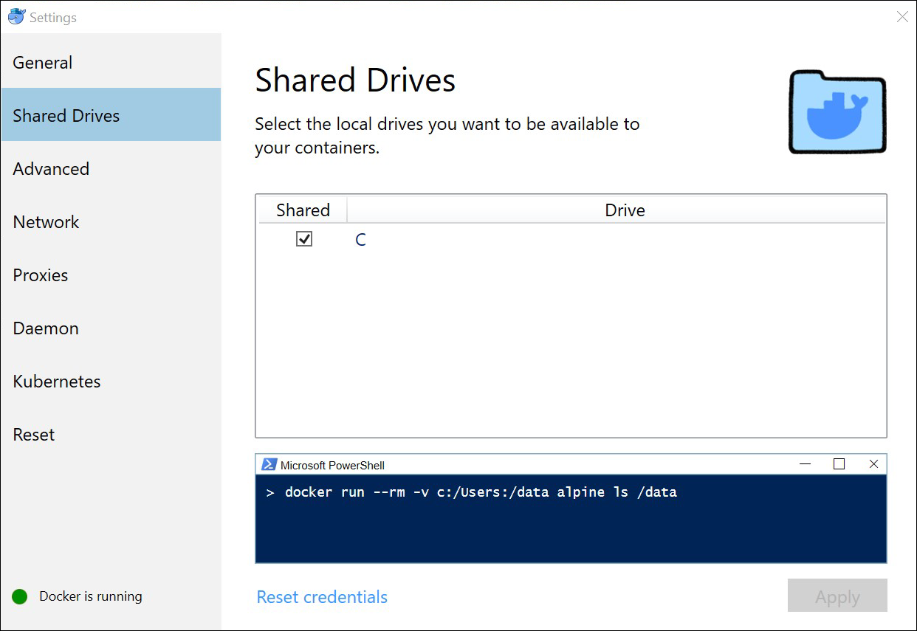
- In the Advanced screen, specify CPUs as 2 and Memory as 8192 MB. This is necessary to have enough space to run the images.
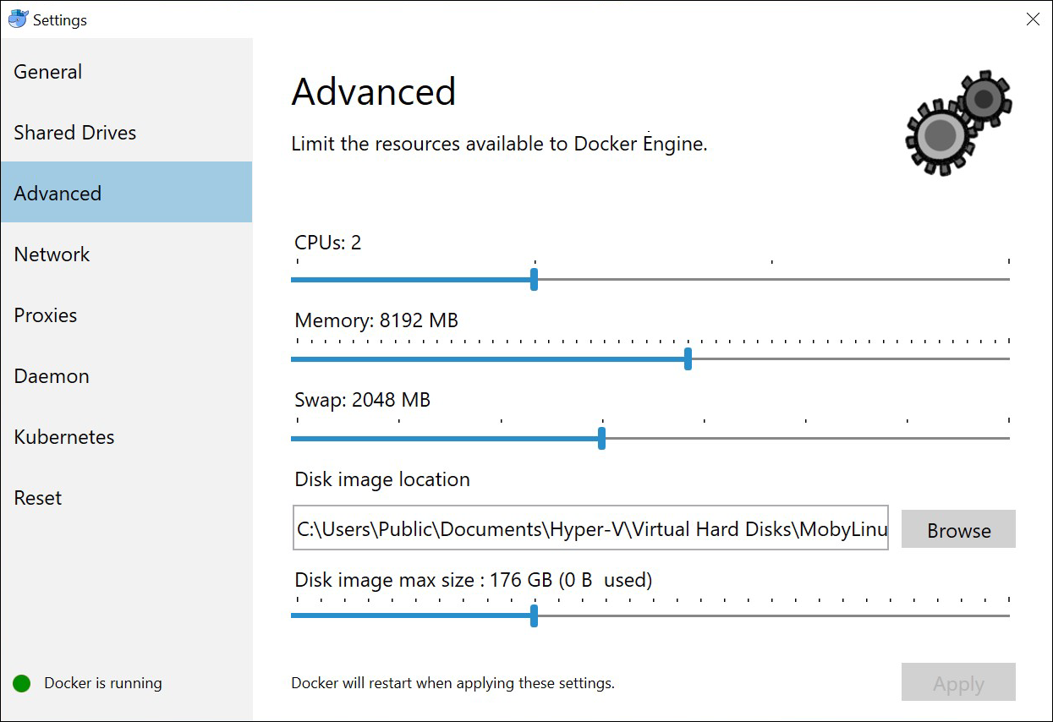
- In the Proxies screen, select the Manual proxy configuration radio button and enter the proxy settings of your environment. By default, the No Proxy radio button is selected.
Important! In the bypass for hosts and domains box, you must add the IP address of your DTR machine, if you want to use the existing DTR account. (Update screenshot and remove GE details)
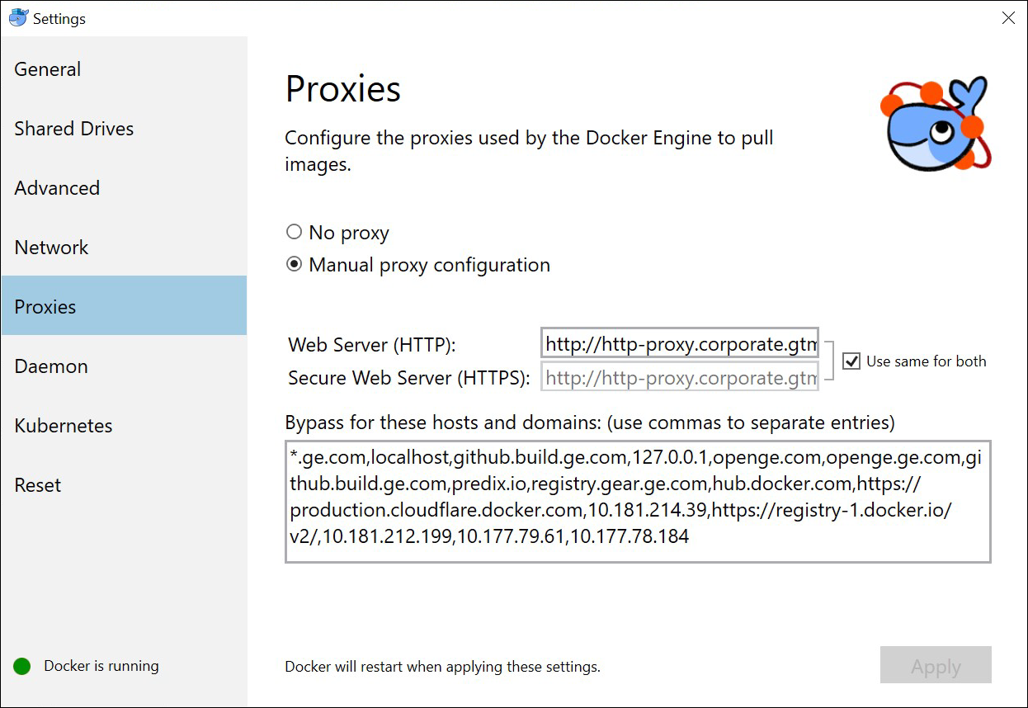
- In the Daemon screen, Specify the IP address of your machine in the Insecure Registries box for creating a local DTR account.
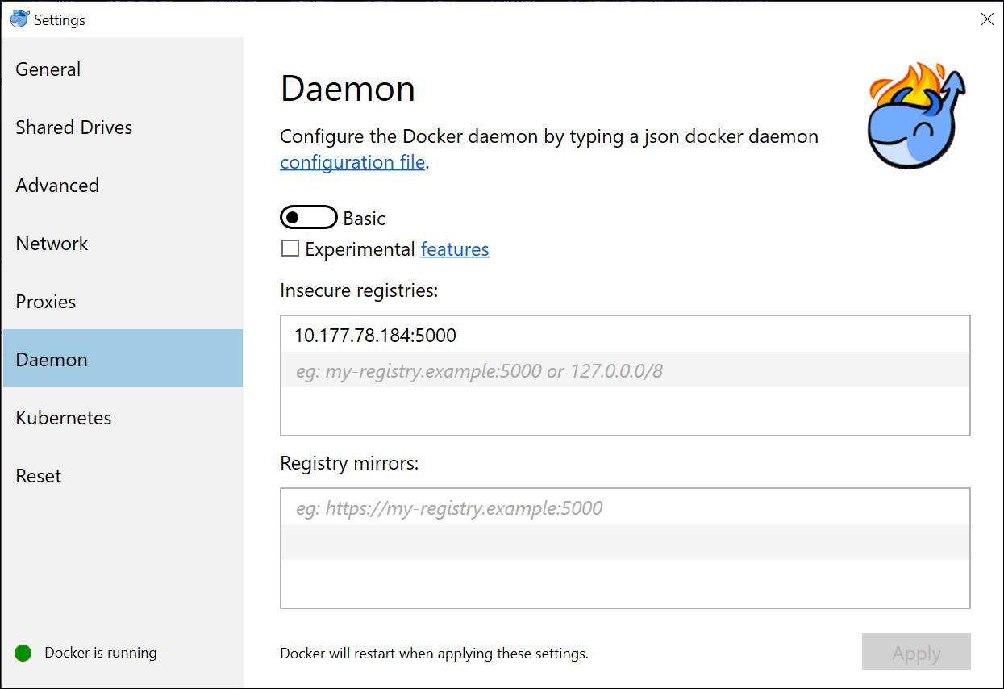
- Click Apply.
The Docker settings are saved.

Installing Plant Applications Docker
Exe must be run on a windows box. You can then choose to install or export. Export -> Univeral Client Docker of Linux... -> then copy files and add to linux box.
To access the Plant Applications, you must install Plant Application Docker 8.0 on your computer.
Before you can run the Installer, you must:
- Ensure that your system meets the system requirements.
- Ensure that you have the required certificates in your system.
- Access the installation package.

- Download the software and extract the files to the machine where you want to install Plant Applications Docker and then run Plant Application Docker 8.0.exe as an Administrator.
The Welcome screen appears.
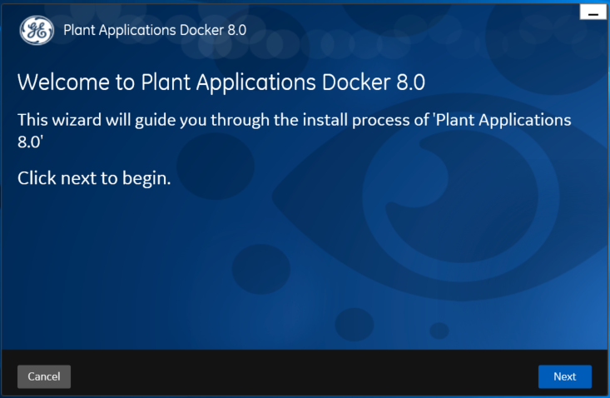
- Click Next in the welcome screen.
- In the License Agreement screen, accept the license agreement by selecting the I agree the terms in the license agreement check box and then click Next.
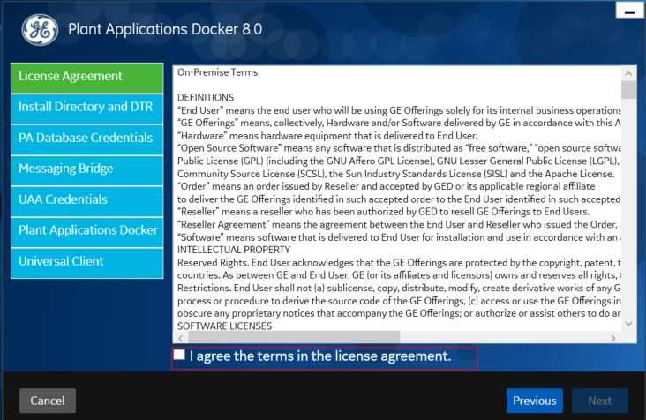
- In the Install Directory and DTR screen, choose the location of the installation directory and select one of the options to enter the Docker details, and then select Validate to validate your credentials.
- For an existing Docker Trusted Registry (DTR) user, enter your docker login details as described in the following table.
Credential | Description
Hostname | Enter the host name where the Docker server is installed in the format HOST_NAME\PORT_NUMBER, where HOST_NAME is either a fully qualified domain name or IP address of the server, and PORT_NUMBER is the port number of the server. This hostname format allows you to access DTR web user interface, to connect with DTR API remotely to push and pull images and access the applications hosted on the DTR cluster.
Username | Enter the username that has permissions to access docker.
Password | Enter the password of your Docker Trusted Registry account.
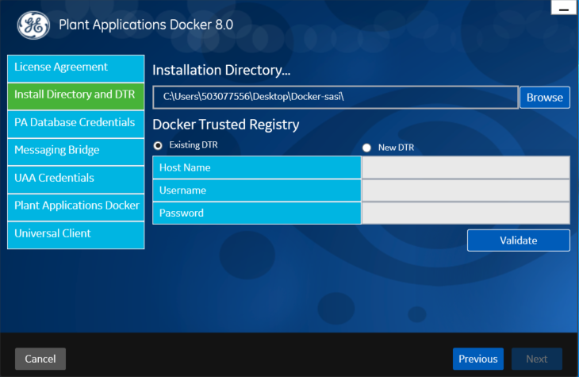
- For a New DTR account, by default, the Hostname appears.
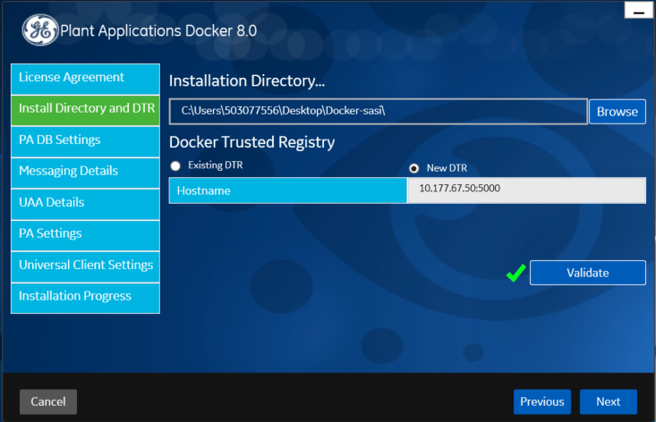
- In the PA DB Settings screen, enter the appropriate values, and then select Validate to validate the database connections.
- In the Plant Applications DB tab, enter the details as described in the following table. The Plant Applications database settings enables you to run the service specific scripts by using the MS OLE DB tool, which is automatically installed with this installer file.
Credential | Description
Server Name | Enter the IP address of the SOA database in the format PORT_NUMBER/INSTANCE_NAME.
Database | Enter the name of the SOA database that you want to connect with the Plant Applications Universal Client.
Instance | Enter the name of the instance of the SQL server. Entering an instance is optional.  Note: You can specify values for either Instance or Port #.
Port | Enter the number of the port that the instance uses to listen for client connections.
Username | Enter the user name that has permissions to access the database you entered in the DB name box. By default, the user name appears as sa.
Password | Enter the password for the user you entered in the Username box.
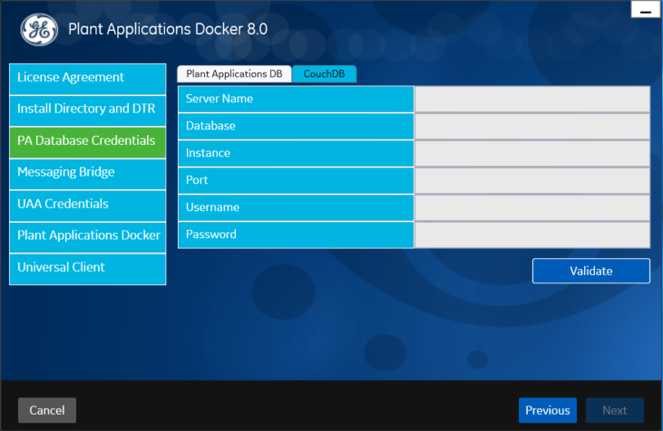
- In the CouchDB tab, enter your CouchDB details as described in the following table.
Credential | Description
CouchDB Server Uri | Enter the fully qualified web address of the CouchDB in the format HTTP://PORT_NUMBER/INSTANCE_NAME.
Database | Enter the name of the CouchDB database that you want to connect with the Plant Applications Universal Client.
Node | Enter the name of the node where the CouchDB is running. This is an optional field and by default, the node value appears.
Username | Enter the user name that has permissions to access the database you entered in the Database box.
Password | Enter the password for the user you entered in the Username box.

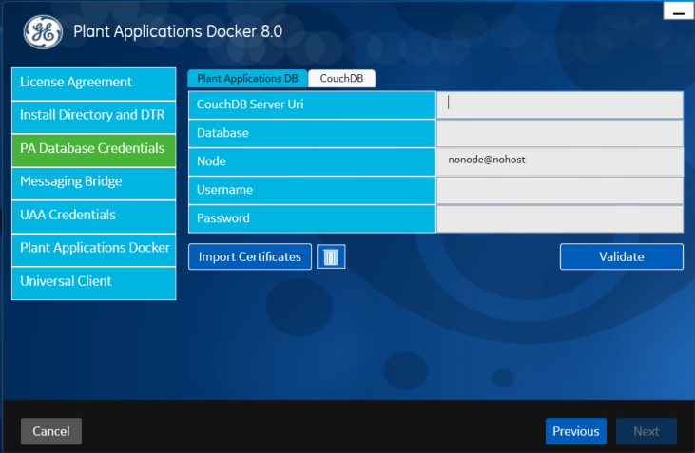
- Select Import Certificates to import the UAA server and CouchDB server certificates (uaa_server.crt, uaa_server.pem, uaa_server.key, and couch_cert_crt.crt) to the Secrets folder.
- In the Messaging Bridge screen, enter the user name and password of your RabbitMQ Administrator account credentials for queuing the messages as described in the following table, and then select Validate.
Credential | Description
Server name | Enter the IP address of RabbitMQ.
Username | Enter the user name that has permissions to access the RabbitMQ Administrator.
Password | Enter the password for the user you entered in the Username box.
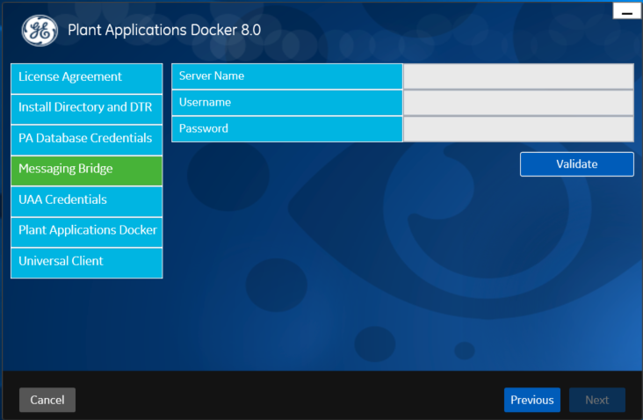
- In the UAA Credentials screen, enter the Cloud Foundry User Account and Authentication Service (UAA) details for authentication purpose, and then select Validate to validate the credentials.
Credential | Description
UAA Server Uri | Enter the fully qualified IP address of the CloudFoundry UAA server.
Admin Client ID | Enter the unique identifier used for authenticating the OAuth client in the UAA server.
Admin Client Secret | Enter the unique password of the OAuth client.
Admin User | Enter the user name that has permissions to access the UAA server.
Admin Password | Enter the unique password to authenticate and obtain an access token for the admin user from the UAA server.
Import Certificates | Click to import Upload the UAA server and CouchDB server certificates (uaa_server.crt, uaa_server.pem, uaa_server.key, and couch_cert_crt.crt) to the Secrets folder.
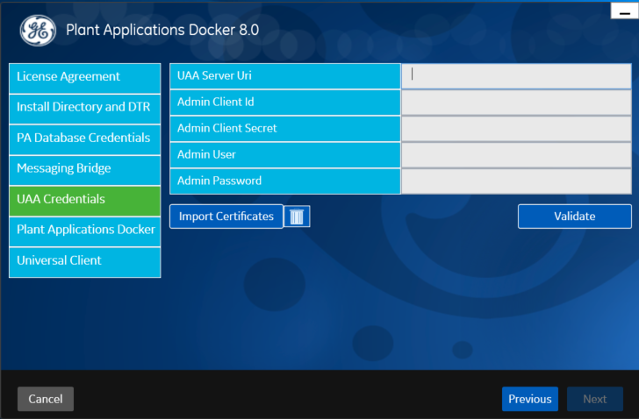
- In the Plant Applications Docker screen, by default, all the discrete applications and services are selected. Press Validate to validate the ports, and then click Next. 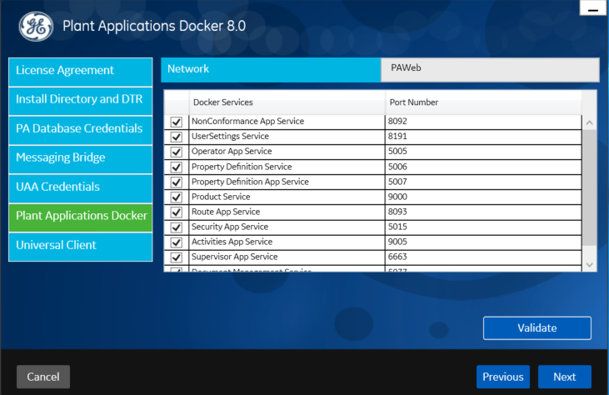
- In the Universal Client screen, by default, the host name and port number appear. The enables you to access the all the Universal Client apps in the port.
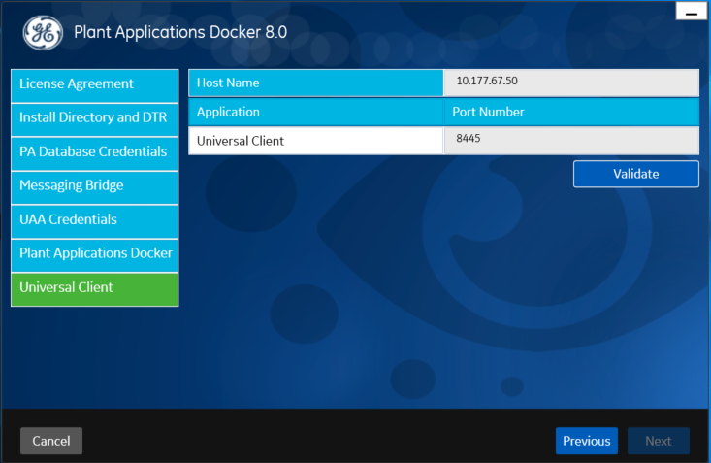
- Select Next.
The You are ready to install screen appears.
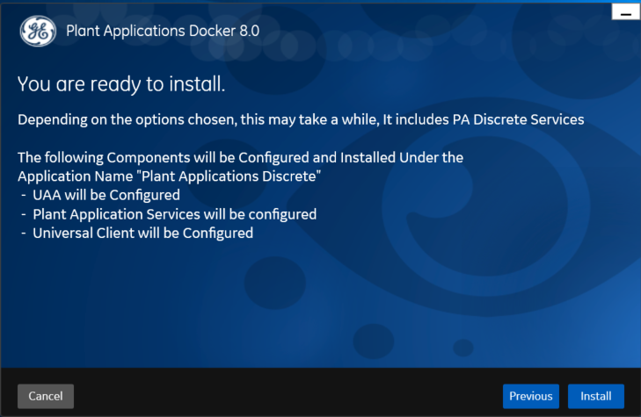
- Select Install to install Plant Applications Discrete 8.0.
Note: Depending on the options selected, the installation process may take some time. The installer displays the status updates.
On successful installation, the Installation Successful screen appears.

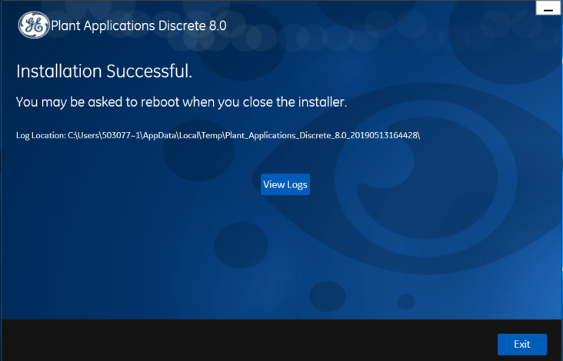

Installing Plant Applications in the Linux System

System Requirements for Linux Installation

Contents of the Installation Package
Plant Applications creates and delivers an installation package that provides the files and folders needed for a successful installation of the Plant Applications in the Linux system. The following table describes the files included in your installation package.
File Name | Description
Tar.zip | This file contains the docker images of the services, applications, and Apphub.
SQL.zip | This file contains the schema, database, stored procedures, table creation scripts to make the applications work.
PA-webdocker.zip | This file contains the script files, YAML files, certificates necessary to make the docker images of the microservice applications up and running.
PA-universal.zip | This file contains script files and YAML files necessary to make the Apphub and applications up and running.

Install Plant Applications in the Linux System
To install Plant Applications in the Linux system, you must do the following:
- Ensure that your system meets the system requirements.
- Ensure that you have the required certificates in your system.
- Download the installation package from XXX location and extract the package to your preferred location.

You must perform the following steps in the order in which they are listed.
- Access the Tar.zip file and upload all the files to your local registry, if exists. To do this:
- In the Power shell, add the location and then enter the following command.
docker load --input <name of the file>.tar
- Else, you can point the location to the GE registry, in case you have access to the GE registry.
- Access the SQL zip file and run all the SQL files (in any order). You must go to the node of the plant apps SQL server, for example, SOADB, and then run the Stored Procedures one after the other.
- Access the Plantapps-web-docker.zip file and perform the following steps in the given order.
- Upload the UAA server and CouchDB server certificates (uaa_server.crt, uaa_server.pem, uaa_server.key, and couch_cert_crt.crt) to the Secrets folder.
- If you have these certificates with different names, go to PAStart.sh file and replace these certificate names with the names of your certificates in the following records.
  - docker secret create uaa_cert_pem ./Secrets/uaa_server.pem
  - docker secret create uaa_cert_crt ./Secrets/uaa_server.crt
  - docker secret create uaa_cert_key ./Secrets/uaa_server.key
  - docker secret create couch_cert_crt ./Secrets/couch_cert_crt.crt
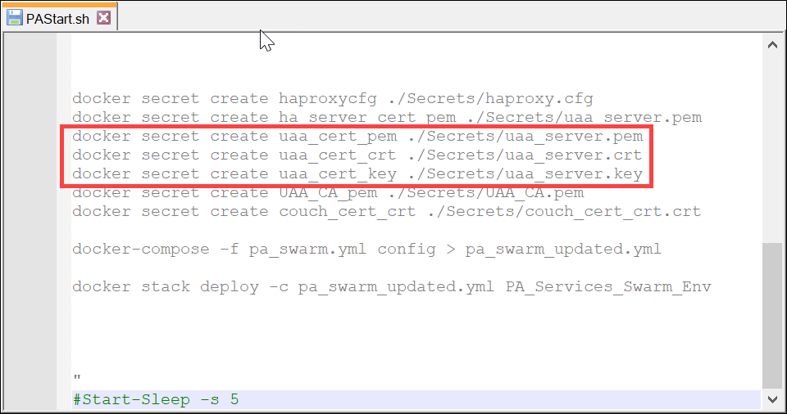
- Open the .env (environment) file and replace the existing value with a fully qualified UAA URI to the UAA_SERVICE_ORIGIN key as shown in yellow.
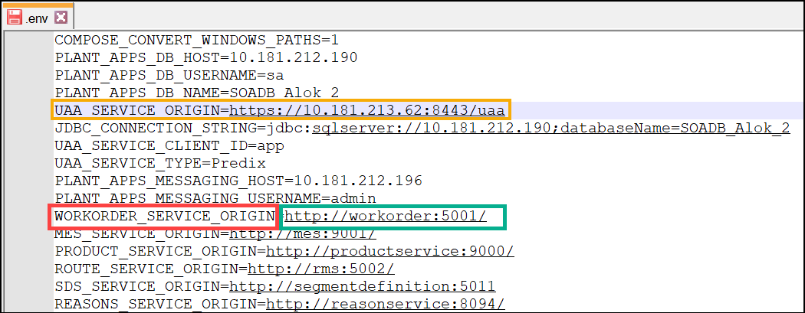
Note: Do NOT to make any changes to any keys, you can, however, modify the values of these keys. You can however update the value of the UAA_SERVICE_ORIGIN key. For example, in the Image above, the red box with **_**_ORIGIN denotes an ORIGIN key and the green box denotes its value. The installer will not work if you make any changes to the keys.
- Modify the values for the rest of the keys with the appropriate locations to your servers, image paths, Plant Applications database credentials, UAA credentials, hosts, database names, and service user name.
- Specify the appropriate locations for the **_**_PATHS keys based on your settings.
- Run the PAStart.sh file in the Shell command.
- Ensure that the Apache ZooKeeper and Apache Kafka builds are up and running, and then make the following updates:
- Go to plantapps-web-docker > mnt > paweb > config and open the workorder_entrypoint.sh file.
- In the docker run --rm --network MES_Services_PAWeb -v "//C/Program Files/GE Digital/PlantApplicationsUniversalClient/plantapps-web-docker/mnt/paweb/config:/scripts" confluentinc/cp-kafka:5.1.2 /scripts/setup-kafka-topics.sh -z zookeeper:2181 line, change the highlighted path with the location of your binary file. For example, if your binary files are in the D:\PA Installer\Ref\PA80_Linux_BinaryFiles\PA80_Linux_BinaryFiles\plantapps-web-docker\mnt\paweb\config location, replace the highlighted text in the given line, with this location. This is necessary for creating the Kafka messages available in the Plant Applications.
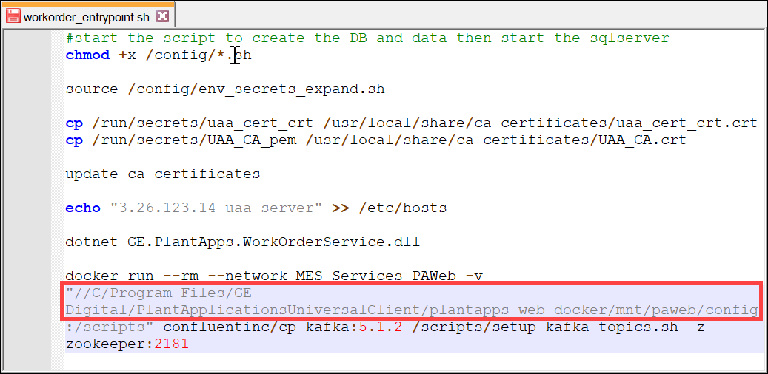
- Access the Plantapps-universal.zip file and perform the following steps in the given order.
- Upload the UAA server and CouchDB server certificates (uaa_server.crt, uaa_server.pem, uaa_server.key, and couch_cert_crt.crt) in the Secrets folder.
- If you have these certificates with different names, go to PAStart.sh file and replace these certificate names with the names of your certificates in the following records.
  - docker secret create uaa_cert_pem ./Secrets/uaa_server.pem
  - docker secret create uaa_cert_crt ./Secrets/uaa_server.crt
  - docker secret create uaa_cert_key ./Secrets/uaa_server.key
  - docker secret create couch_cert_crt ./Secrets/couch_cert_crt.crt
- Run the PAStart.sh file in the Shell command.
Note: Do NOT to make any changes to any files or keys, you can, however, modify the values of the keys. The installer will not work if you make any changes to the keys.
- Open the .env (environment) file, update the location of all the IMAGE keys with the appropriate values. For example, the box in red denotes the image key and the green box denotes its value. Make the similar changes to all the IMAGE keys.
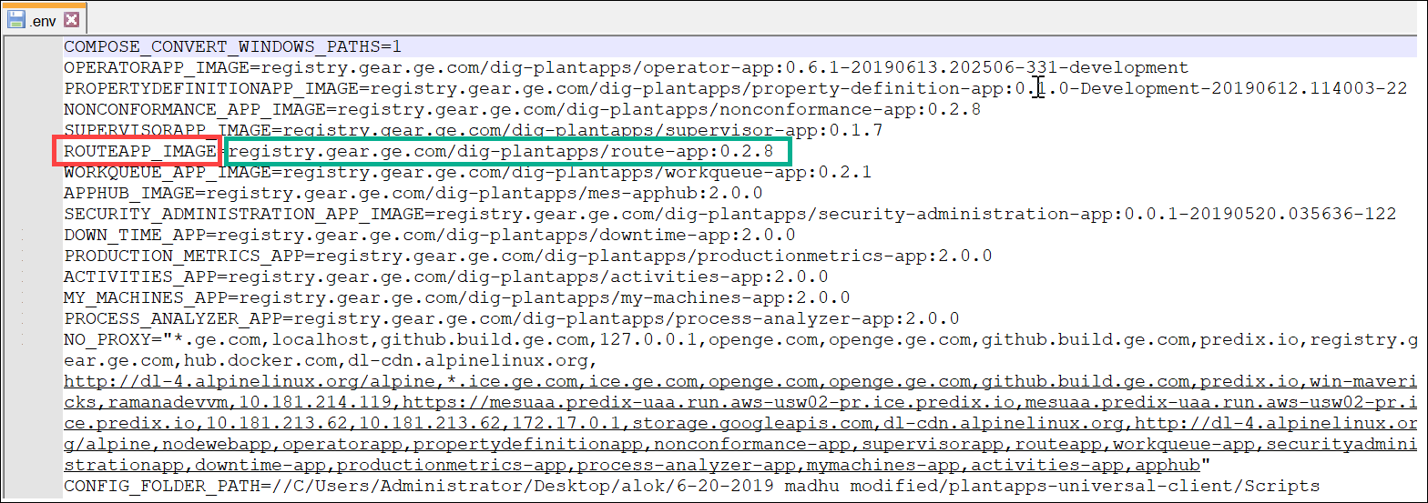
- In the **_**_PATH and **_**_FILE, you must update the values with your app.properties.json locations.
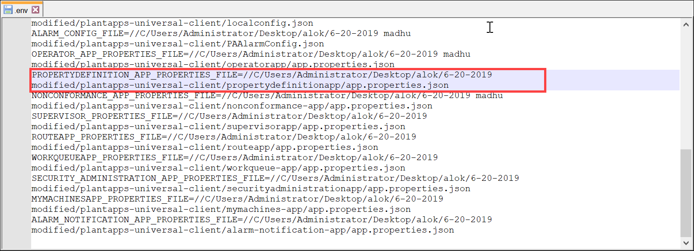
- Open the localconfig.json file and modify the IP addresses for the Keys, wherever required.
Note: Do not modify the ports.
- Run the PAStart.sh file in the Shell command.

Result
The Plant Applications is installed in the Linux system.

